Symposium/Forum

TITLE

New Perspectives on Ideal Point Measures in Personality Assessment

SHORTENED TITLE

New Perspectives on Ideal Point Measures

ABSTRACT

Ideal point measures including content reflecting moderate and extreme trait levels have received increased attention among researchers and practitioners for assessing personality. This symposium explores new issues in ideal point measurement, including: use of a simpler scoring model, application of network models, detection of faking, and applicant reactions to ideal point personality measures.

PRESS PARAGRAPH

Ideal point measures that include item content reflecting moderate and extreme trait levels have received attention among researchers and practitioners for assessing personality. This symposium focuses on new issues in ideal point measurement in research and practical contexts. Presentations consider (a) merits of a more simple item response model relative to the more popular, more complex generalized graded unfolding model; (b) the use of network analysis to analyze ideal point measures to enhance our understanding of personality structure; (c) a technique to identify faking in ideal point measures using appropriateness measurement; and (d) test-taker reactions (affective reactions, and perceived accuracy, difficulty, and validity) to ideal point versus traditional dominance assessments.

WORD COUNT

[Final word count]

**SUMMARY ABSTRACT**

**New Perspectives on Ideal Point Measurement for Theory and Practice**

Alexandra M. Harris1, Rachel L. Williamson1, and Christopher M. Castille2

1University of Georgia

2Nicholls State University

The last decade has seen an increased interest in the use of ideal point measurement techniques, particularly for personality assessment. In ideal point measurement, individuals are assumed to endorse items that reflect their precise standing on a trait, and thus promotes the use of item content that spans the trait continuum (high, moderate, and low). In contrast, traditional dominance measurement assumes higher standing on a trait results in stronger agreement to an item with content reflecting high trait levels, and thus is prohibitive of items with content reflecting moderate levels. For example, under a dominance assumption, an individual who is very high in achievement motivation would be more likely to endorse the item “I prefer to be above average at things but don’t have to be the very best” than someone with more moderate trait standing. However, under ideal assumptions, an individual who is more moderate in achievement motivation would be more likely to endorse this item than someone with very high in conscientiousness. This is because the person with extreme achievement motivation would disagree “from above” the item (Roberts, Laughlin, & Wedell, 1999).

Notably, ideal point *measures* include moderately-worded items which reflect average trait standings as well as traditional extreme-worded items such as “I always go above and beyond what is expected”). Dominance measures include only extreme-worded items due to the fact that items with moderate content violate the assumption of *monotonicity* (i.e., that those with higher traits will always be more likely to endorse all positive items and less likely to endorse negative items). In contrast, ideal point measurement *models* can be applied to measures built under either dominance *or* ideal point assumptions, due to their ability to flexibly handle both moderate and extreme item content (Stark et al., 2006).

Although dominance-based measurement remains the most pervasive personality assessment approach, research increasingly supports the theoretical (LaPalme, Tay, & Wang, 2017) and empirical (Stark et al., 2006) fit of ideal point models to personality test responses, and their ability to more accurately detect complex relationships (Carter et al., 2017). Further, the use of ideal point *measures* – built to include moderate and extreme item content – has been shown to increase reliability of measurement across the trait continuum (Chernyshekno et al., 2007). The advantages of measures built to ideal point specification have spurred interest both within the psychometric literature, and among practitioners. Given the increasing implementation of ideal point measures, the proposed symposium focuses on underexplored issues in this area.

First, **Lowery and Carter** consider the use of the normal probability density function (PDF) model relative to the more popular Generalized Graded Unfolding Model. The authors note that while the complex GGUM may more accurately reflect the complexities ideal point response processes, the PDF model allows for multidimensionality, global fit indices in the R ‘mirt’ package, and the potential for scale development in smaller samples…

Second, **Simonet and Castille** apply psychometric network analysis to an ideal point measure to better understand the structure of personality.The authors explore the centrality of items within traits as well as the importance of moderate items for connecting, or bridging, different traits in the five-factor model. Further, they suggest such networks can inform employee coaching programs.

Third, **Foster** extends prior research utilizing IRT-based appropriateness measurement to identify faking on ideal point personality assessments using the likelihood ratio statistic to identify response patterns inconsistent with the ideal point responding. Foster applies the approach to ideal point models and considers a range of false positive cutoffs as well as their corresponding sensitivity and specificity. Results suggest the approach may have utility for identifying faking.

Finally, **Harris, McMillan, and Carter** present an experimental investigation of respondent reactions to ideal point personality measures and implications for the use of ideal point measures in organizations. The authors find no differences in reactions to traditional and ideal point measures for perceived face validity, predictive validity, or appropriateness. However, they do find evidence of differences in affective reactions, and perceived accuracy and difficulty. The authors emphasize the implications for selection systems and the need for a better understanding of applicants’ perceptions ideal point personality measures.

The proposed symposium will conclude with our discussant, Dr. **Michael Zickar**, Professor and Chair of Psychology at Bowling Green State University. Dr. Zickar is a leading scholar in IRT and ideal point measurement whose work on the topic has appeared in several outlets, including *Applied Psychological Measurement, Organizational Research Methods,* and *Educational and Psychological Measurement.*

References

Carter, N. T., Dalal, D. K., Boyce, A. S., O’Connell, M. S., Kung, M.-C., & Delgado, K. M.

(2014). Uncovering curvilinear relationships between conscientiousness and job performance: How theoretically appropriate measurement makes an empirical difference. *Journal of Applied Psychology, 99*(4), 564-586.

Carter, N. T., Dalal, D. K., Guan, L., LoPilato, A. C., & Withrow, S. A. (2017). Item response

theory scoring and detection of curvilinear relationships. *Psychological Methods, 22*, 191-203.

Chernyshenko, O. S., Stark, S., Drasgow, F., & Roberts, B. W. (2007). Constructing personality

scales under the assumptions of an ideal point response process: Toward increasing the flexibility of personality measures. *Psychological assessment, 19*(1), 88.

LaPalme, M., Tay, L., & Wang, W. (2017). A within-person examination of the ideal point response process. *Psychological Assessment*. doi: 10.1037/pas0000499

Maydeu-Oliveras, A., Hernandex, A., & McDonald, R. (2006). A multidimensional ideal point

item response theory model for binary data. *Multivariate Behavioral Research, 41*(4), 445-472.

Roberts, J. S., Donoghue, J. R., & Laughlin, J. E. (2000). A general item response theory model

for unfolding unidimensional polytomous responses. *Applied Psychological Measurement,* *24*, 3-32.

Stark, S., Chernyshenko, O. S., Drasgow, F., & Williams, B. A. (2006). Examining assumptions

about item responding in personality assessment: should ideal point methods be considered for scale development and scoring? *Journal of Applied Psychology, 91*(1), 25-39.

Zickar, M. J., & Drasgow, F. (1996). Detecting faking on a personality instrument using

appropriateness measurement. *Applied Psychological Measurement, 20*(1), 71-87.

**[PLACE HOLDER FOR LOWERY & CARTER SIMULATION PAPER]**

**How Might We Develop Individuals into Ideal Employees?**

Dan Simonet1 and Christopher M. Castille2

1Montclair State University

2Nicholls State University

Though ideal point assessments have allowed a finer-grained portrait of a given individual’s noncognitive functioning (Carter et al., 2014), we have not yet considered how these methods might inform developmental interventions (e.g., coaching). Indeed, it is well-known that under realistic employee selection scenarios who is hired is often a slight deviation from who is ideal for a given position (e.g., the most highly-valued candidates may take a position elsewhere). In short, methods are need to develop employees into local ideals to optimize performance. We start the conversation on using ideal point personality assessments to inform developmental interventions. Responses to ideal point personality assessments, when analyzed appropriately, may help practitioners craft interventions (e.g., via motivational interviewing; Lundahl, Kunz, Brownell, Tollefson, & Burke, 2010) to more closely align employee behaviors with local work demands.

Here, we apply psychometric network analysis––which emphasizes the cognitive, motivational, and functional dynamics between items as characterizing a personality system––to ideal point personality inventory items. From the network perspective, discrete actions like working hard to attain long-term goals, planning one’s week, and focusing on a task, for a person high on conscientiousness occur because deciding to care about a long-term goal leads to disciplined allocation of personal resources. Each component is believed to be causally autonomous, carry unique developmental trajectories, and, as a network, suggests pathways through which the Big Five changes (Asendorpf, 2016). In particular, the moderately-worded items used in ideal point measures may offer further insight into individual development by pinpointing proximal points on a trait continuum which “bridge” personality components across distinct clusters (Borsboom & Cramer, 2013). For instance, the conscientiousness item “I tend to be disorderly but also like to keep certain things tidy” may bridge the agreeableness item “I don’t like to let others down” to the remaining conscientiousness network because gains in compassion may require one to bring personal affairs into order. In a similar vein, moderate items may be more central, serving as hubs linking disparate thoughts, feelings, and actions. Longitudinal studies suggest central items influence the development, change, and potential interventions of psychological networks (Boschloo, van Borkulo, Borsboom, & Schoevers, 2016). Bridging and centrality may be less evident among extreme items (e.g., I always keep my affairs in order) which do not capture the more gradual actions through which developmental processes unfold.

**Methods and Results**

The data for this study come from a sample (*n* = 677) of working employees from Amazon’s Mechanical Turk (MTurk) who completed a suite of ideal point personality assessments capturing the Big Five Aspects (see Castille, 2017; DeYoung, 2015). The marginal reliabilities of these assessments were all acceptable (ρ > .82).Psychometric network analyses (see Constantini et al., 2015) involved casting items as “nodes” in a network connected by “edges,” the strength of which corresponds to the strength of the GLASSO *regularized* partial correlations between items. The initial network is presented in Figure 1 (item labels provided in Table 1).

Generally, connected items along Big Five borders may identify feedback loops through which trait change spreads. Consider conscientiousness and openness. The nodes in the lower left suggesting enjoyment of complex problems (O2, O3, O8) is positively linked to a high drive for achievement (Co17, Co18, Co19), whereas nodes in the center left show tolerance for variety (O9, O10, O11) as negatively linked to preference for order (Co8, Co7, Co6, Co9). In the theory of psychometric network models, this implies that mutually-reinforcing gains in two openness components may be associated with diverging effects in a person’s conscientiousness network (e.g., more industrious but lower order).

A typical way of assessing node importance is centrality, which is determined by indices of strength, betweenness, and closeness (Costantini et al., 2015). The centrality plots appear in Figure 2. Several agreeableness and conscientiousness items were highly influential, especially those items dealing with manipulation (Ag25, Ag26), deliberate decision making (Co1, Co5, Co20), or holding “moderate” amounts of motivation (Co31, Co25). The most central conscientiousness items reflect both the “inhibitive” pole of the trait, recognized in facets broadly referring to control over one’s impulses, and “modest” levels of the “proactive” pole, reflected in ideal point versions of facets labeled “achievement striving” (Costa, McCrae, & Dye, 1991). Similar to past network analyses (Constantini et al., 2015), changes in inhibitory tendencies are more likely to influence the wider personality network whereas changes in other portions of the personality network would similarly impact tendencies towards restraint. More interesting, the moderately-worded conscientiousness items suggesting proactivity (Co31, Co25) had higher centrality indices due to their role in linking the conscientiousness network to agreeableness and extraversion. Items from additional traits also had relatively high betweenness-centrality, meaning they occupied strategic positions connecting several node groups. These include Ex9, Ex16, Es18, Es11, and, to a lesser extent, O7. By examining Figure 1, one can visualize how these nodes serve as mediators connecting items. For instance, E9’s focus on optimism helps bridge multiple components of extraversion with fear and self-evaluative components of emotional stability (Es28, Es27, Es18).

Figure 3 illustrates possible bridges between emotional stability and conscientiousness by highlighting their shortest paths to one another. First, the nodes Co21, Es13, and, more indirectly, Es18, Es14, and Ex16 are primary hubs indirectly linking both item sets. Interestingly, several of these moderately-worded items share a self-reflective, guilt-laden connection, such that thinking about outcomes lessens the likelihood of impulsive acts and low self-esteem. This suggests the link between emotional regulation and self-control is explained by a realization that hasty acts lead to bad consequences.

**Conclusion**

Our results suggest that there is promise in exploring the application of psychometric network analysis to ideal point measurement inventories and their potential for developmental applications. Many plausible bridges exist linking developmental trajectories across the personality system. Future research investigating these bridges is needed. Importantly for this symposium, the results indicate personality networks assessed by ideal point inventories are more clearly organized than dominance-based questionnaires (see Constantini et al., 2015), further bolstering the notion that ideal point assessments offer a more realistic depiction of personality, and thus may hold promise for the use of ideal point assessments in helping practitioners develop ideal employees.

References

Asendorpf, J. B. (2016). Causal unity of broader traits is an illusion. *European Journal of Personality, 30,* 304–340.

Borsboom, D., & Cramer, A.O.J. (2013). Network analysis: An integrative approach to the structure of psychopathology. *Annual Review of Clinical Psychology*, *9*, 91–121.

Boschloo, L., van Borkulo, C. D., Borsboom, D., & Schoevers, R. A. (2016). A prospective study on how symptoms in a network predict the onset of depression. *Psychotherapy and Psychosomatics*, *85*(3), 183-184.

Carter, N. T., Dalal, D. K., Boyce, A. S., O'Connell, M. S., Kung, M.-C., & Delgado, K. M. (2014). Uncovering curvilinear relationships between conscientiousness and job performance: How theoretically appropriate measurement makes an empirical difference. *Journal of Applied Psychology, 99*(4), 564-586. http://dx.doi.org/10.1037/a0034688

Carter, N. T., Dalal, D. K., Guan, L., LoPilato, A. C., & Withrow, S. A. (2017). Item response theory scoring and the detection of curvilinear relationships. *Psychological Methods, 22*(1), 191-203. [http://dx.doi.org/10.1037/met0000101](http://psycnet.apa.org/doi/10.1037/met0000101)

Cramer, A.O.J., van der Sluis, S., Noordhof, A., Wichers, M., Geschwind, N., Aggen, S.H...Borsboom, D. (2012). Dimensions of normal personality as networks in search of equilibrium: You can’t like parties if you don’t like people. *European Journal of Personality*, *26*: 414-431.

Costa, P. T., McCrae, R. R., & Dye, D. A. (1991). Facet scales for agreeableness and conscientiousness: A revision of the NEO personality inventory. *Personality and Individual Differences, 12*(9), 21–50.

Costantini, G., Epskamp, S., Borsboom, D., Perugini, M., Mõttus, R., Waldorp, L. J., & Cramer, A. O. (2015). State of the aRt personality research: A tutorial on network analysis of personality data in R. *Journal of Research in Personality, 54*, 13-29.

Epskamp, S., Maris, G.K.J., Waldorp, L.J., & Borsboom, D. (2016). Network psychometrics. Retrieved 28 June 2017 from <https://arxiv.org/pdf/1609.02818.pdf>

Fleeson, W., & Gallagher, P. (2009). The Implications of Big Five Standing for the Distribution of Trait Manifestation in Behavior: Fifteen Experience-Sampling Studies and a Meta-Analysis. *Journal of Personality and Social Psychology*, *97*(6), 1097-1114

Ilies, R., Arvey, R. D., & Bouchard, T. J. (2006). Darwinism, behavioral genetics, and organizational behavior: A review and agenda for future research. *Journal of Organizational Behavior*, *27*(2), 121-141.

Jackson, J. J., Wood, D., Bogg, T., Walton, K. E., Harms, P. D., & Roberts, B. W. (2010). What do conscientious people do? Development and validation of the Behavioral Indicators of Conscientiousness (BIC). *Journal of Research in Personality, 44*(4), 501-511.

Le, H., Oh, I. S., Robbins, S. B., Ilies, R. Holland, E., & Westrick, P. (2011). Too much of a good thing: Curvilinear relationships between personality traits and job performance. *Journal of Applied Psychology, 96,* 113-133.

Lundahl, B. W., Kunz, C., Brownell, C., Tollefson, D., & Burke, B. L. (2010). A meta-analysis of motivational interviewing: Twenty-five years of empirical studies. *Research on Social Work Practice*, *20*(2), 137-160.

Roberts, B. W., Chernyshenko, O. S., Stark, S., & Goldberg, L. R. (2005). The structure of conscientiousness: An empirical investigation based on seven major personality questionnaires. *Personnel Psychology, 58,* 103–139.

Robinaugh, D. J., Millner, A. J., & McNally, R. J. (2016). Identifying highly influential nodes in the complicated grief network. *Journal of Abnormal Psychology*, *125*(6), 747-757.

Tett, R. P., & Burnett, D. D. (2003). A personality trait-based interactionist model of job performance. *Journal of Applied Psychology, 88,* 500–517.

Weick, K. (1984). Small wins: Redefining the scale of social problems. *American Psychologist, 39,* 40-49.

Wood, D., Gardner, M. H., & Harms, P. D. (2015). How functionalist and process approaches to behavior can explain trait covariation. *Psychological Review*, *122*(1), 84-111.

Table 1

*Legend for Item Labels and Content*

|  |  |
| --- | --- |
| **Labels** | **Item Content** |
| O1 | I find theoretical conversations extremely boring |
| O2 | I dislike focusing on difficult problems |
| O3 | I dislike thinking too hard about things |
| O4 | I prefer to focus on mentally stimulating projects but sometimes it is nice to have time to mentally relax |
| O5 | Sometimes I enjoy solving complex problems |
| O6 | I enjoy solving complex problems |
| O7 | I enjoy having abstract or philosophical conversations |
| O8 | I really enjoy trying to tackle the most complex problems imaginable |
| O9 | I prefer stability or consistency to variety and change |
| O10 | I like change but I also need stability |
| O11 | While I do somewhat prefer variety I also enjoy stability or consistency |
| O12 | I find all artwork to be similar |
| O13 | Listening to poetry or music seems to be a waste of time |
| O14 | While listening to music is nice it is pointless |
| O15 | From time to time I like to appreciate the beauty around me |
| O16 | There have been times when a song has made me emotional |
| O17 | I see some value in art and beauty |
| O18 | I like to think about real world problems |
| O19 | People have told me I am emotionally inept |
| O20 | I am unable to reciprocate when someone talks about their feelings |
| O21 | It takes me a long time to understand other people’s emotions |
| O22 | Unless someone tells me how they feel I won’t know for sure |
| O23 | I sometimes can tell how people feel |
| O24 | If an emotion is really obvious then I can probably identify it |
| O25 | For the most part I understand others emotions |
| O26 | People talk to me because I can empathize with how they feel |
| O27 | I have a deep understanding of others emotions |
| Es1 | I am rarely frustrated by anything |
| Es2 | I like to consider myself as a very easygoing person |
| Es3 | I rarely get irritated by others |
| Es4 | I am somewhat balanced in my experience of anger |
| Es5 | I am somewhat balanced in my experience of frustration |
| Es6 | I get angry easily |
| Es7 | I get frustrated easily |
| Es8 | I have a very short temper |
| Es9 | I often resist my temptations |
| Es10 | People say I have great self-control |
| Es11 | I have a good amount of control on my cravings |
| Es12 | I indulge reasonably when I feel inclined to do so |
| Es13 | Sometimes I do things I later regret |
| Es14 | I feel most alive when I give into my urges |
| Es15 | I rarely get stressed out about things |
| Es16 | Sometimes I get caught up in my problems & other try not to worry about things that have already happened |
| Es17 | I get caught up in my problems |
| Es18 | I always feel great about the person that I am |
| Es19 | I seldom feel down in the dumps |
| Es20 | On occasion I feel blue but most of the time I don’t feel blue |
| Es21 | My mood changes about half the time |
| Es22 | My mood changes all the time |
| Es23 | I rarely become embarrassed |
| Es24 | I am always extremely afraid that I will do the wrong thing |
| Es25 | I rarely panic |
| Es26 | Occasionally I panic but I usually do not |
| Es27 | Sometimes I panic easily and other times I do not |
| Es28 | My emotions usually get the best of me |
| Ex1 | I am a socially awkward person |
| Ex2 | I sometimes feel uncomfortable when surrounded by a big crowd |
| Ex3 | I prefer to socialize in small groups |
| Ex4 | I like to do most things in large groups |
| Ex5 | I constantly try to engage with different people |
| Ex6 | People often refer to me as a downer |
| Ex7 | I am somewhat of a fun person to be around |
| Ex8 | I like to focus on the positive side of things |
| Ex9 | I always look at the bright side of life |
| Ex10 | I am an incredibly joyful person to be around |
| Ex11 | I am incredibly uptight around others |
| Ex12 | I always hide my true feelings from people |
| Ex13 | I usually find it hard to make friends |
| Ex14 | I am usually quiet when I meet new people |
| Ex15 | I usually find it easy to make friends |
| Ex16 | I am always friendly to people |
| Ex17 | I don’t mind loud parties but I don’t prefer them either |
| Ex18 | I tend to seek adventure |
| Ex19 | Loud parties can definitely be fun |
| Ex20 | I couldn’t live without adventure |
| Ex21 | I always take my time even when a faster pace may be needed |
| Ex22 | I generally prefer activities that require little energy |
| Ex23 | Half of the time I prefer leisurely activities and half of the time I prefer activities to be fast paced |
| Ex24 | Compared to extremely energetic people I am somewhat less energetic |
| Ex25 | My fast paced lifestyle keeps me more busy than most |
| Ex26 | My lifestyle requires a high energy level |
| Ex27 | I always try to live life to the fullest extent that I possibly can |
| Ex28 | Compared to most people I live a very fast paced life |
| Ex29 | I hate leading groups |
| Ex30 | I have no interest in leadership |
| Ex31 | I would rather follow directions than lead |
| Ex32 | From time to time I enjoy taking charge on projects but some other times I prefer others to take the lead |
| Ex33 | I am often the person to take charge of a group |
| Ex34 | I enjoy taking the lead on new projects |
| Ex35 | I can always persuade people to follow my lead |
| Ex36 | I always end up leading the groups I participate in |
| Co1 | I find that most all of my decisions are impulsive |
| Co2 | I sometimes make decisions based on instinct rather than facts and sometimes I prefer facts |
| Co3 | On occasion it can be helpful to consider all options when making decisions |
| Co4 | I prefer to have backup plans |
| Co5 | It is best to be careful when a decision has significant consequences |
| Co6 | I have difficulties working on a clean and organized desk |
| Co7 | Organization is not a priority for me |
| Co8 | While I like order and regularity I also enjoy when things are a bit chaotic |
| Co9 | I keep my workstation somewhat clean and tidy |
| Co10 | I like to plan my days in advance |
| Co11 | I have lied to protect other people |
| Co12 | I aim to tell the truth as often as possible but numerous situations have required me to bend the truth |
| Co13 | I try to keep all of the promises I make but sometimes I am unable to deliver on them |
| Co14 | Regardless of the situation I always tell the truth |
| Co15 | I avoid setting goals but when I do I set extremely easy goals |
| Co16 | I am fine being an average worker |
| Co17 | I have a drive to succeed in my work |
| Co18 | I aspire to do well in more areas compared to most people |
| Co19 | I work extremely hard to be the very best at everything I do |
| Co20 | I put little thought into my actions |
| Co21 | I have a tendency to misjudge situations |
| Co22 | I tend to perform in most areas at the average level of other people |
| Co23 | While I often excel in what I do I also have much to learn to be better |
| Co24 | I pride myself on my unwavering ability to act responsibly |
| Co25 | Although I am capable of motivating myself to complete tasks I prefer to have someone else prompting me |
| Co26 | More often than not I depend on myself rather than others for the motivation to successfully complete a task |
| Co27 | Even when tasks are difficult I find a way to complete them |
| Co28 | I always get my work in on time |
| Co31 | I do just enough work to get by |
| Co32 | I find it difficult to start my work |
| Co33 | I prefer making decisions quickly rather than after thoroughly thinking things through |
| Ag1 | Being a winner is much more important than being cooperative |
| Ag2 | Cooperating with others is equally as important as winning |
| Ag3 | When someone is in need I feel as though I have to help |
| Ag4 | Cooperating with others is more important than winning |
| Ag5 | I always put the needs of others before my own |
| Ag6 | I am extremely self-centered |
| Ag7 | I sometimes help a friend because it’s the right thing to do other times is because I want something in return |
| Ag8 | I frequently think about how others are doing |
| Ag9 | I worry about how people are doing |
| Ag10 | I live to serve others |
| Ag11 | Everyone has hidden intentions |
| Ag12 | I find it easier to trust in some people than in others |
| Ag13 | Honesty is the foundation of any good relationship |
| Ag14 | I feel the urge to confide in others |
| Ag15 | If someone wrongs me it is difficult for me to forgive them |
| Ag16 | Sometimes I am easy to satisfy but other times I can seem a bit pushy |
| Ag17 | While I sometimes forgive others to avoid confrontation I also often challenge others |
| Ag18 | People who know me would likely say I am generally a forgiving person |
| Ag19 | I usually try to satisfy others needs rather than my own when I sense conflict emerging |
| Ag20 | People who know me would say I am an extremely forgiving person |
| Ag21 | I shy away from credit sometimes but other times it is nice to be recognized |
| Ag22 | Sometimes the work I do is really excellent other times it is mediocre |
| Ag23 | When I give money to a charity I am fine with being anonymous |
| Ag24 | I always share the credit I receive on teamwork |
| Ag25 | I always hide my motives to get what I want |
| Ag26 | Manipulating others can be helpful |
| Ag27 | I use flattery on occasion when dealing with others |
| Ag28 | People often tell me that I am a genuine person |

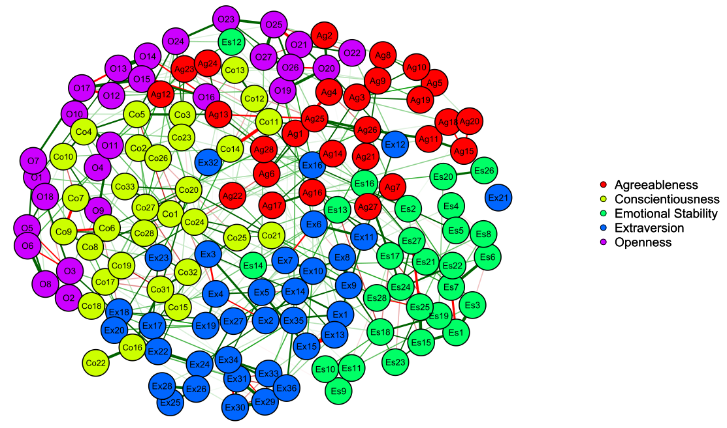

*Figure 1.* Network representation of 150 ideal point inventory modeled after the NEO-PI facet structure. Each item is represented by a node, and the node number corresponds to the item statements in Table 1. Nodes are connected by green (red) lines if they are positively (negatively) correlated. Line thickness corresponds to correlation strength. The spring-bsaed algorithm (Fruchterman & Reingold, 1991) used to generate the graph places strongly correlated nodes closely together and towards the middle of the graph.

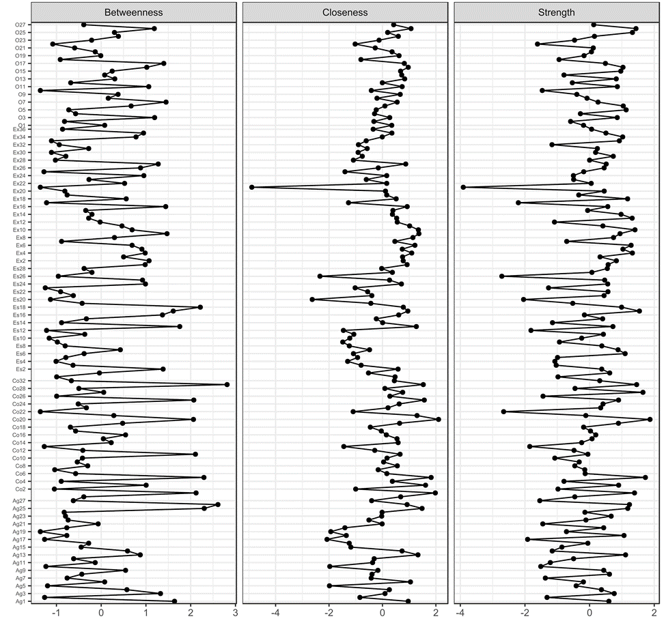

*Figure 2.* Centrality plot depicting the betweenness, closeness, and strength of each node.

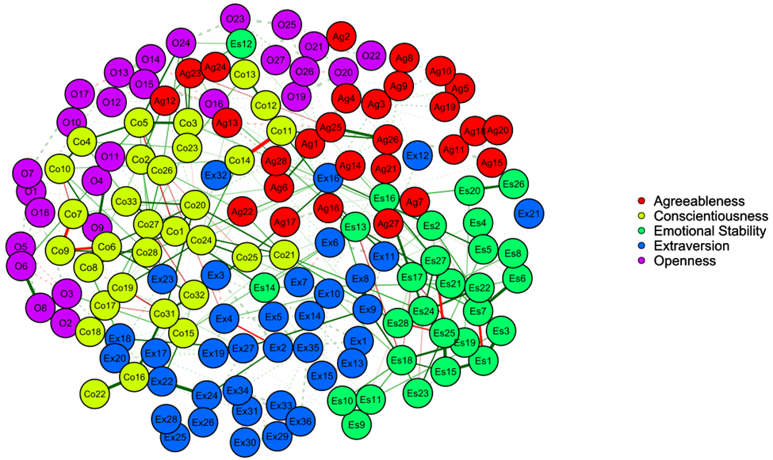

*Figure 3.* Network depicting the shortest paths between Conscientiousness and Emotional Stability items. Edges belonging to the shortest-paths are full, while the other edges are dashed.

**Appropriate or Ideal? Detecting Faking with Unfolding and Appropriateness Measurement**

Garett C. Foster, Ph.D.

Univeristy of Missouri – St. Louis

Faking is the act of distorting one’s responses or presenting false information to appear more desirable (Levin & Zickar, 2002). In a selection setting, applicants may endorse items reflecting positive behaviors (e.g. “I am always on time”) regardless of whether or not that item is an accurate description of their own typical behavior. Zickar and Robie (1999) denoted three areas of faking research: people’s ability to fake, the impact of faking on a test’s psychometric properties, and the prevalence of faking among test-takers. The current research will address the first area. It is important to note that there is debate over the substantive importance of addressing faking, with some researchers suggesting that faking does not matter (e.g. Hogan, Barrett, & Hogan, 2007), and other researchers saying it has an important impact that should be studied and better understood (e.g. Goffin & Boyd, 2009). The current research operates under the assumption that faking presents a problem that must be addressed.

Supporting the assertion that faking has an important impact on the decisions made by organizations and the outcomes of those choices, Furnham (1990) used an experimental Latin-square design to show that not only could personality items be faked, but they could be faked in intentional and unique patterns based on the desired responses. Participants were told to respond to the questionnaire 1) as if they were a librarian, 2) as if they were a banker, 3) as if they were an advertising executive, or 4) honestly (as a control). Results indicated that lay persons could generate faked profiles that were not only distinguishable across scenarios but consistent within each one. This raises many worries about the validity of personality instruments.

Item response theory can be utilized to gain a deeper and more precise understanding of what happens to test-taker scores, tests, and individual items when test-takers fake. When examining the effects of faking using IRT, most research can be classified as using a theta-shift or delta-shift paradigm. The former approach assumes that when faking occurs it is representative of alterations of the test-taker’s level of the underlying latent trait (represented in IRT literature with the Greek letter θ); higher trait levels make it easier to endorse items when the item location is held constant, thus raising observed scores. The latter approach assumes that faking is a function of differential interpretation of items which yields different item locations on the latent continuum (represented with the Greek letter δ); lower item locations make it easier for individuals to endorse an item, even when true trait level is held constant, thus inflating observed scale scores.

A third approach, which utilizes information from both delta-shift (which items are fakable) and theta-shift (how much people improve their scores) research, involves methods of detecting faking. Zickar and Drasgow (1996) used appropriateness measurement, a person-fit analysis used to detect aberrant response patterns in individual test responses, to identify persons who were instructed to intentionally fake good when mixed among a group of persons who were instructed to respond honestly to a military selection personality test. Their results showed that, when calibrated to result in lower rates of false positives, IRT methods were more successful at identifying faked responses than approaches using a social desirability scale. However, the converse was true when higher rates of false positives were allowed. This study looks to replicate the successful faking detection of Zickar and Drasgow (1996) using ideal point scales and modeling for the appropriateness measurement calculations.

This study utilized a within-subjects design, with all respondents taking a personality assessment with instructions to be honest and instructions to fake. Counter-balancing was used to control order effects. Participants (N = 1160) were recruited from Amazon’s Mechanical Turk. The sample was 50.5% female, 84.1% white, and primarily between the ages of 25 to 44. 62.9% were employed full-time and 89.6% had completed at least some college. The order scale from Wang (2013), which measures a sub-facet of conscientiousness, was used because it was developed from an ideal point response perspective, and the Generalized Graded Unfolding Model (GGUM; Roberts, Donoghue, & Laughlin, 2000) was used for analyses.

The goal of appropriateness measurement is to identify individuals whose responses are not in line with the psychometric expectations of the model. In this case, misalignment indicates that the responses are likely to have been faked. This is quantified as a likelihood ratio statistic, using the likelihood of a given individual’s response set under a normal (honest) model and an aberrant model with an altered logit containing an adjusted theta score based on average theta shift. Because even honest responses will vary in the degree to which they follow the model (Reise & Waller, 1993), cutoff scores were set empirically based on tolerable false positive rates (i.e. the proportion of honest responses misclassified as faked). Following the methods of Zickar and Drasgow (1996), six cutoff scores were used at false positive rates of 0.5%, 1%, 2%, 3%, 4%, and 5%. These cutoffs were supported with practitioner interviews approving their tolerability in application. At each of these levels for each scale, likelihood ratios of the honest responses were used to find the score at which that percentage of honest responses were incorrectly flagged as faked but the rest were considered honest. Any response pattern for which the likelihood ratio exceeded these cutoffs was classified as faked. Using this classification, plus the known response condition from which the response pattern was generated, detection rates were computed and the sensitivity and specificity of the appropriateness measurement test was calculated.

Results indicate that faking could be detected at modest rates compared to the false positive rates used (see Table 1). At all levels, detection was 3-5 times higher than false positives, indicating some potential industrial utility for appropriateness measurement and ideal point scales. Potential improvements and implications will be discussed.

References

Furnham, A. (1990). Faking personality questionnaires: Fabricating different profiles for different purposes. *Current Psychology: Research & Reviews, 9*(1), 46-55.

Goffin, R. D., & Boyd, A. C. (2009). Faking and personality assessment in personnel selection: Advancing models of faking. *Canadian Psychology*, *50*(3), 151-160.

Hogan, J., Barrett, P., & Hogan, R. (2007). Personality measurement, faking, and employment selection. *Journal of Applied Psychology*, *92*(5), 1270-1285.

Levin, R. A., & Zickar, M. J. (2002). Investigating self-presentation, lies, and bullshit: Understanding faking and its effects on selection decisions using theory, field research, and simulation. *The psychology of work: Theoretically based empirical research*, 253-276.

Reise, S. P., & Waller, N. G. (1993). Traitedness and the assessment of response pattern scalability. *Journal of Personality and Social Psychology*, *65*(1), 143-151.

Roberts, J. S., Donoghue, J. R., & Laughlin, J. E. (2000). A general item response theory model for unfolding unidimensional polytomous responses. *Applied Psychological Measurement*, *24*(1), 3-32.

Wang, W. (2013). *A Bayesian Markov-Chain Monte-Carlo approach to the generalized graded unfolding model estimation: The future of non-cognitive measurement* (Unpublished doctoral dissertation). University of Illinois at Urbana-Champaign.

Zickar, M. J., & Drasgow, F. (1996). Detecting faking on a personality instrument using appropriateness measurement. *Applied Psychological Measurement, 20*(1), 71-87.

Zickar, M. J., & Robie, C. (1999). Modeling faking good on personality items: An item-level analysis. *Journal of Applied Psychology*, *84*(4), 551-563.

Table 1

*Appropriateness Measurement Accuracy*

|  |  |  |
| --- | --- | --- |
| False Positive Rate | Sensitivity | Specificity |
| 0.5% | 2.41% | 99.57% |
| 1.0% | 3.10% | 99.05% |
| 2.0% | 6.98% | 98.02% |
| 3.0% | 11.38% | 97.07% |
| 4.0% | 20.95% | 96.03% |
| 5.0% | 25.17% | 95.00% |

**Reactions to Ideal Point Measures of Personality**

Alexandra M. Harris, Jeremiah T. McMillan, and Nathan T. Carter

University of Georgia

Researchers agree that applicant reactions to selection procedures are associated with risk of litigation, intentions to accept a job offer, and broader perceptions of the organization (Bauer et al., 2001; Hausknecht et al., 2004; Ryan & Ployhart, 2000). Although previous research suggests respondents react neutrally to personality measures (Ryan & Sackett, 1987; Rynes & Connerley, 1993), recent research shows affective reactions toward personality measures varies by measure type. For example, Converse et al. (2008) found applicants react more negatively to forced-choice measures than traditional measures.

Recently, there has been interest in the use of ideal point measures of personality that include item content that reflects all levels of the trait, including moderate, rather than just low and high levels of trait standing as in traditional measures (see Table 1). Given past evidence for differential reactions by measure type, understanding reactions to ideal point measures is particularly important. Applicants may react negatively to moderate items included in ideal point measures due to their unfamiliarity, or may be frustrated by an inability to determine the socially desirable response. Indeed, LaPalme, Tay, and Wang (2017) showed that participants low in verbal ability and conscientiousness showed response patterns that were less consistent with an ideal point response process than more capable and motivated participants. Alternatively, one could speculate that inclusion of moderate items may elicit positive reactions, because test-takers will see themselves reflected in moderate items (the average person is most likely to strongly endorse average items). Because no studies known to the authors have investigated reactions to ideal point measures, the current study is exploratory. We investigate a variety of reaction types to both ideal point and traditional measures in an experiment comparing reactions in “honest” and “applicant” conditions. It should be noted that this analysis is preliminary and data collection is ongoing.

**Method**

We utilized a 2(Measure Type: Dominance v. Ideal Point) x 2(Instruction Set: Honest v. Applicant) factorial design in which 155 participants (49.7% female, *M*age=35.5) were randomly assigned to personality measure type and instruction set conditions. Participants completed either an ideal point or a dominance measure (Table 1). Both measures included 10 items per five factor model trait. Participants were either asked to respond honestly, or shown a job description and asked to respond as if if they really wanted the job. Reaction measures included: positive affect toward the measure, perceived accuracy, perceived difficulty, face validity, perceived predictive validity (Table 2; Smither et al., 1993) and test appropriateness (Ryan & Sackett, 1987). Participants in the honest condition where shown the job description prior to completing the face validity, predictive validity, and appropriateness measures and asked to respond with how they would feel if they had taken the test for the job.

**Results and Discussion**

Descriptive statistics, internal consistency, and correlations for reaction measures are shown in Table 2. Between-subjects ANOVAs were conducted for each reaction measure (Table 3). Here we focus on significant main effects for positive affect, perceived accuracy, and perceived difficulty. Although no interactions between measure type and instruction set were significant, we review graphical patterns consistent with interactions (Figure 1). Marginal means for these constructs are shown in Table 4.

For affective reactions toward the measure, analyses showed a significant main effect of instruction set such that participants in the honest condition reported liking both personality measures better than those in the applicant condition. There was no main effect of measure type. However, Figure 1 shows participants preferred the dominance-based measure in the applicant condition.

For perceived accuracy of the measure, analyses showed a main effect of instruction set such that participants in the honest condition perceived greater accuracy than participants in the job description. There was a marginally significant main effect of measure type such that the dominance measure was perceived as more accurate than the ideal point measure. Figure 1 suggests the difference in perceived accuracy was largest in the honest condition.

For perceived difficulty, analyses showed a main effect of measure type such that participants who completed the ideal point measure reported greater difficulty identifying a “correct” response than those who completed the dominance measure. There was no main effect of instruction set. Figure 1 reveals that the difference in perceived difficulty between measure types decreased in the applicant condition.

**Conclusion**

Results suggest ideal point measures yield different reactions than traditional measures. Participants appear to prefer traditional measures when applying for a job but not when asked to respond honestly. However, participants in both conditions perceived traditional measures as more accurate than ideal point measures. One possible explanation for this result is test-takers’ unfamiliarity with moderate items. Test-takers may question how moderate items work and, therefore, whether they can accurately assess personality. Notably, perceived accuracy also showed a high correlation with positive affect (*r =* .61), which suggests perceived accuracy may be strongly influenced by overall affect toward the measure or vice versa. Additional research is needed to clarify this relationship.

Results also show participants had greater difficulty identifying a “correct” response to items in ideal point relative to dominance measures. It is possible that because moderate items obscure trait direction and therefore the response option that would be consistent with the socially desirable trait extreme (e.g., low vs. high conscientiousness), ideal point measures are more difficult to fake. These results are consistent with prior findings that responses under faking conditions shows a response pattern more consistent with an ability test (i.e., dominance responding), whereas honest responding is consistent with ideal point model assumptions (Guan & Carter, 2016).

The lack of significant differences for face validity, perceived predictive validity, and appropriateness bodes well for the risk of litigation from using ideal point measures. However, there is also evidence of differential reactions to ideal point and traditional measures for perceived accuracy and perceived difficulty, which may in turn influence affective reactions toward the measure. These preliminary findings emphasize the need for further research on the cognitive and affective processes of applicants’ reactions to ideal point measures, and possible solutions for minimizing negative reactions.

References

Bauer, T. N., Truxillo, D. M., Sanchez, R. J., Craig, J. M., Ferrara, P., & Campion, M. A. (2001).

Applicant reactions to selection: Development of the selection procedural justice scale (SPJS). *Personnel psychology*, *54*(2), 387-419.

Converse, P. D., Oswald, F. L., Imus, A., Hedricks, C., Roy, R., & Butera, H. (2008). Comparing

Personality Test Formats and Warnings: Effects on criterion‐related validity and test‐taker reactions. *International Journal of Selection and Assessment, 16*(2), 155-169.

Guan, L., & Carter, N.T. (April, 2016). Does faking shift the response process? A comparison across testing formats. In J. Seybert and L. Guan (Chairs), Recent advances in forced choice personality assessment. Symposium presented at the 2016 Meeting of the Society for Industrial and Organizational Psychology: Anaheim, CA.

Hausknecht, J. P., Day, D. V., & Thomas, S. C. (2004). Applicant reactions to selection procedures: An updated model and meta‐analysis. *Personnel Psychology, 57*(3), 639-683.

Ni, Y., & Hauenstein, N. M. (1998). Applicant reactions to personality tests: Effects of item invasiveness and face validity. *Journal of Business and Psychology*, *12*(4), 391-406.

Ryan, A. M., & Ployhart, R. E. (2000). Applicants’ perceptions of selection procedures and

decisions: A critical review and agenda for the future. *Journal of Management, 26*(3), 565-606.

Ryan, A. M., & Sackett, P. R. (1987). Pre-employment honesty testing: Fakability, reactions of

test takers, and company image. *Journal of Business and Psychology, 1*(3), 248-256.

Rynes, S. L., & Connerley, M. L. (1993). Applicant reactions to alternative selection procedures.

*Journal of Business and Psychology, 7*(3), 261-277.

Smither, J. W., Reilly, R. R., Millsap, R. E., Pearlman, K., & Stoffey, R. W. (1993). Applicant

reactions to selection procedures. *Personnel Psychology, 46*(1), 49-76.

Table 1

*Item Content for Conscientiousness Ideal Point and Traditional Dominance Measures*

|  |  |  |  |
| --- | --- | --- | --- |
| Ideal Point Measure | | Traditional Dominance Measure | |
| Item Content | Location | Item Content | Location |
| 1. I enjoy being reckless. | Low | 1. I enjoy being reckless. | Low |
| 2. I have very little to contribute. | Low | 2. I have very little to contribute. | Low |
| 3. I love to win, but I am not a sore loser. | Moderate | 3. I do not keep my room clean. | Low |
| 4. Sometimes I plan ahead, and other times I like to be spontaneous. | Moderate | 4. I procrastinate a lot. | Low |
| 5. I follow the rules about as much as most people. | Moderate | 5. I tend to do just enough work to get by. | Low |
| 6. I wouldn’t describe myself as messy or clean, my organization is average. | Moderate | 6. I always respect authority, even if I disagree with them. | High |
| 7. I am good about getting things done on time but sometimes I do not manage my time well. | Moderate | 7. I am very well organized. | High |
| 8. I prefer to be above average at things but don’t have to be the very best. | Moderate | 8. If there is a problem, I can usually solve it. | High |
| 9. I always go above and beyond what is expected. | High | 9. I always go above and beyond what is expected. | High |
| 10. I always follow through with my plans | High | 10. I always follow through with my plans. | High |

Table 2

*Descriptive statistics, internal consistency estimates, and correlations for reaction scales*

|  |  |  |  |  |  |  |  |  |  |
| --- | --- | --- | --- | --- | --- | --- | --- | --- | --- |
|  | *k* | Mean | SD | 1. | 2. | 3. | 4. | 5. | 6. |
| 1. Positive Affect | 4 | 4.89 | 0.90 | .77 |  |  |  |  |  |
| 2. Perceived Accuracy | 4 | 4.68 | 0.88 | **.61** | .77 |  |  |  |  |
| 3. Perceived Difficulty | 3 | 3.93 | 1.13 | **.26** | **.30** | .70 |  |  |  |
| 4. Face Validitya | 5 | 4.27 | 1.17 | **.33** | **.29** | **.28** | .92 |  |  |
| 5. Predictive Validitya | 5 | 3.29 | 1.18 | **.40** | **.37** | **.36** | **.56** | .91 |  |
| 6. Perceived Appropriatenessa | 10 | 4.37 | 0.96 | **.50** | **.46** | **.28** | **.54** | **.57** | .90 |

*Note.* Boldface indicates significance at the .05 level. Values on diagonal are internal reliability estimates. *k* = number of items in scale. Participants indicated agreement with each reaction item (1 = strongly disagree, 6 = strongly agree). Scale composites were created by averaging items.

a*N* = 153 due to missing data.

Table 3

*2(Measure Type: Dominance v. Ideal Point) x 2(Instruction Set: Honest v. Applicant) Between-Subjects ANOVA Results for Reactions by Instruction Set and Personality Measure*

|  |  |  |  |  |  |
| --- | --- | --- | --- | --- | --- |
|  | **Predictor** | ***df*** | **F** | ***p*** | **η²** |
| Positive Affect | **Instruction Set** | **1** | **5.99** | **0.02** | **0.04** |
|  | Personality Measure | 1 | 1.30 | 0.26 | 0.01 |
|  | Interaction | 1 | 2.57 | 0.11 | 0.02 |
|  | Error | 151 |  |  |  |
|  |  |  |  |  |  |
| Perceived Accuracy | **Instruction Set** | **1** | **5.84** | **0.02** | **0.04** |
|  | *Personality Measure* | *1* | *3.30* | *0.07* | *0.02* |
|  | Interaction | 1 | 1.40 | 0.24 | 0.01 |
|  | Error | 151 |  |  |  |
|  |  |  |  |  |  |
| Perceived Difficulty | Instruction Set | 1 | 1.43 | 0.23 | 0.01 |
|  | **Personality Measure** | **1** | **11.26** | **0.00** | **0.07** |
|  | Interaction | 151 | 1.41 | 0.24 | 0.01 |
|  | Error |  |  |  |  |
|  |  |  |  |  |  |
| Face Validity | **Instruction Set** | **1** | **4.35** | **0.04** | **0.03** |
|  | Personality Measure | 1 | 0.08 | 0.78 | 0.00 |
|  | Interaction | 1 | 0.47 | 0.49 | 0.00 |
|  | Error | 149 |  |  |  |
|  |  |  |  |  |  |
| Perceived Predictive Validity | Instruction Set | 1 | 0.58 | 0.45 | 0.00 |
|  | Personality Measure | 1 | 0.02 | 0.90 | 0.00 |
|  | Interaction | 1 | 1.19 | 0.28 | 0.01 |
|  | Error | 149 |  |  |  |
|  |  |  |  |  |  |
| Perceived Appropriateness | Instruction Set | 1 | 0.00 | 0.95 | 0.00 |
|  | Personality Measure | 1 | 0.03 | 0.85 | 0.00 |
|  | Interaction | 1 | 0.93 | 0.34 | 0.01 |
|  | Error | 149 |  |  |  |

*Note.* Boldface indicates significance at the .05 level. Italics indicates marginal significance at the .10 level.

Table 4

*Marginal means, standard error, and confidence intervals for positive affect, perceived accuracy, and perceived difficulty in each instruction set and personality measure condition*

|  |  |  |  |  |  |  |  |
| --- | --- | --- | --- | --- | --- | --- | --- |
|  |  |  |  | |  | **95% CI** | |
|  | **Instructions** | **Measure Type** | | **Mean** | **SE** | Lower Bound | Upper Bound |
| Positive Affect | Honest | Ideal Point | | 5.00 | 0.13 | 4.75 | 5.26 |
|  |  | Dominance | | 5.07 | 0.14 | 4.79 | 5.34 |
|  | Job Description | Ideal Point | | 4.88 | 0.15 | 4.59 | 5.17 |
|  |  | Dominance | | 4.48 | 0.16 | 4.16 | 4.80 |
| Perceived Accuracy | Honest | Ideal Point | | 5.04 | 0.12 | 4.80 | 5.29 |
|  |  | Dominance | | 4.60 | 0.13 | 4.34 | 4.86 |
|  | Job Description | Ideal Point | | 4.51 | 0.14 | 4.24 | 4.79 |
|  |  | Dominance | | 4.43 | 0.16 | 4.12 | 4.73 |
| Perceived Difficulty | Honest | Ideal Point | | 4.21 | 0.16 | 3.89 | 4.52 |
|  |  | Dominance | | 3.43 | 0.17 | 3.09 | 3.77 |
|  | Job Description | Ideal Point | | 4.21 | 0.18 | 3.85 | 4.56 |
|  |  | Dominance | | 3.82 | 0.20 | 3.43 | 4.22 |

*Note.* Participants indicated agreement with each reaction item (1 = strongly disagree, 6 = strongly agree). Scale composites were created by averaging items.

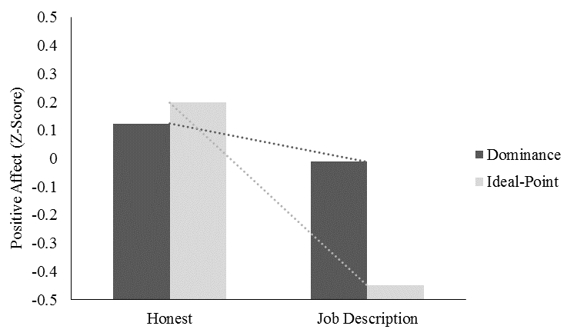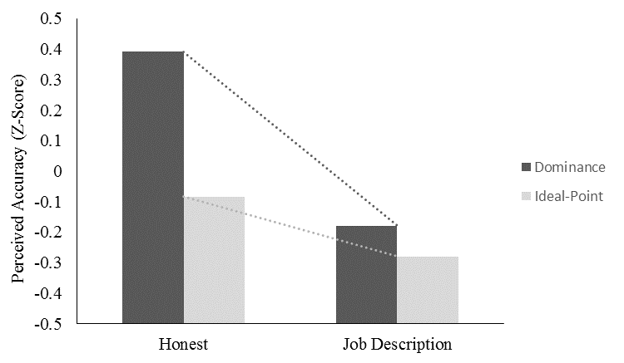

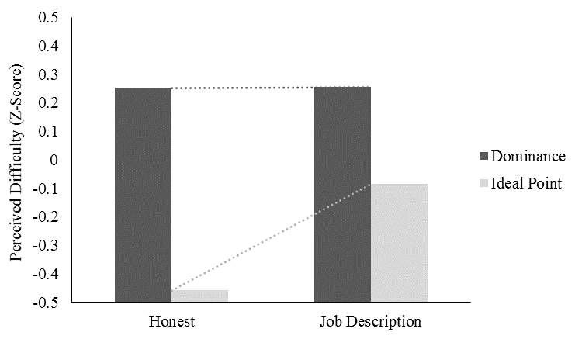

*Figure 1.* Positive affect (upper left), perceived accuracy (upper right), and perceived difficulty (lower) by instruction set and personality measure conditions.

**Participant List**

**(in alphabetical order)**

Christopher M. Castille

Assistant Professor

College of Business Administration

Nicholls State University

P.O. Box 2015

Thibodaux, LA 70301

Email: christopher.castille@nicholls.edu

SIOP Member

Role: Co-chair, co-author

Nathan T. Carter

Assistant Professor

Department of Psychology

University of Georgia

125 Baldwin Street

Athens, GA 30602

Email: ntcarter@uga.edu

SIOP Member

Role: Co-author

Garett C. Foster

Assistant Teaching Professor

Psychological Sciences

University of Missouri – St. Louis

1 University Blvd, 325 Stadler Hall

St. Louis, MO 63121

Phone: 314.516.5417

Email: fostergc@umsl.edu

SIOP Member

Role: Presenter

Megan R. Lowery

Doctoral Student

Department of Psychology

University of Georgia

125 Baldwin Street

Athens, GA 30602

Phone: 540-290-5761

Email: meganlowery20@gmail.com

SIOP Student Affiliate

Role: Co-chair, Presenter

Alexandra M. Harris

Doctoral Student

Department of Psychology

University of Georgia

125 Baldwin Street

Athens, GA 30602

Email: alexandra.harris25@uga.edu

SIOP Student Affiliate

Role: Co-chair, Presenter

Dan Simonet

Assistant Professor

Psychology

Montclair State University

1 Normal Ave Montclair, NJ 07043

Phone: 651-214-9384

Email: simonetd@montclair.edu

SIOP Member

Role: Presenter

Rachel L. Williamson

Doctoral Candidate

Department of Psychology

University of Georgia

125 Baldwin Street

Athens, GA 30602

Phone: (704) 724-6820

Email: will2493@uga.edu

SIOP Student Member

Role: Co-chair

Michael J. Zickar

Professor and Department Chair

Psychology

Bowling Green State University

Psychology 233, Bowling Green State University

Bowling Green, OH 43403

Phone Number: 419.382.9984

Email: mzickar@bgsu.edu

SIOP Status: Fellow

Role: Discussant