# **NETWORK DIAGRAM**

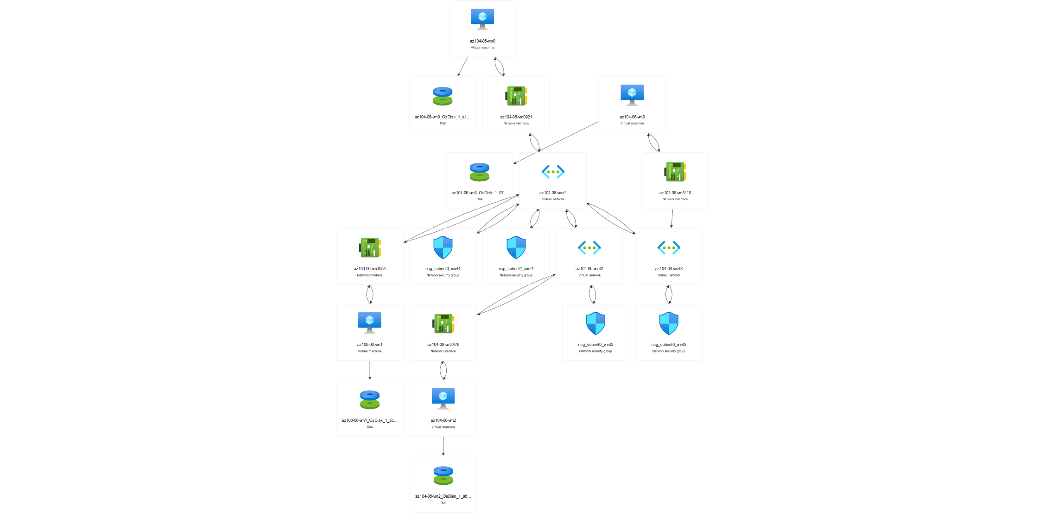

## **First try to connect VMs under load balancer directly, which will fail**

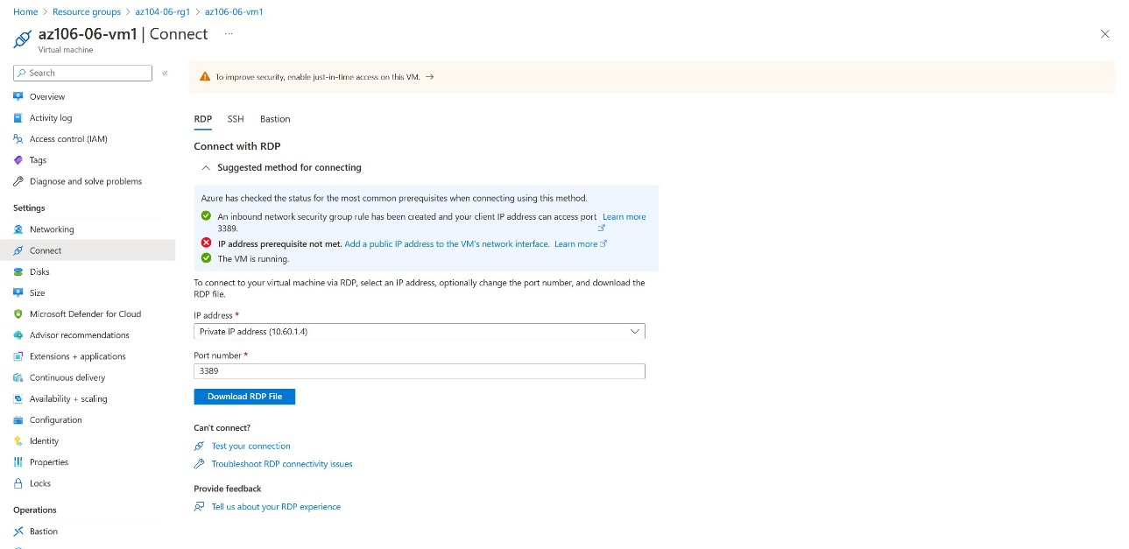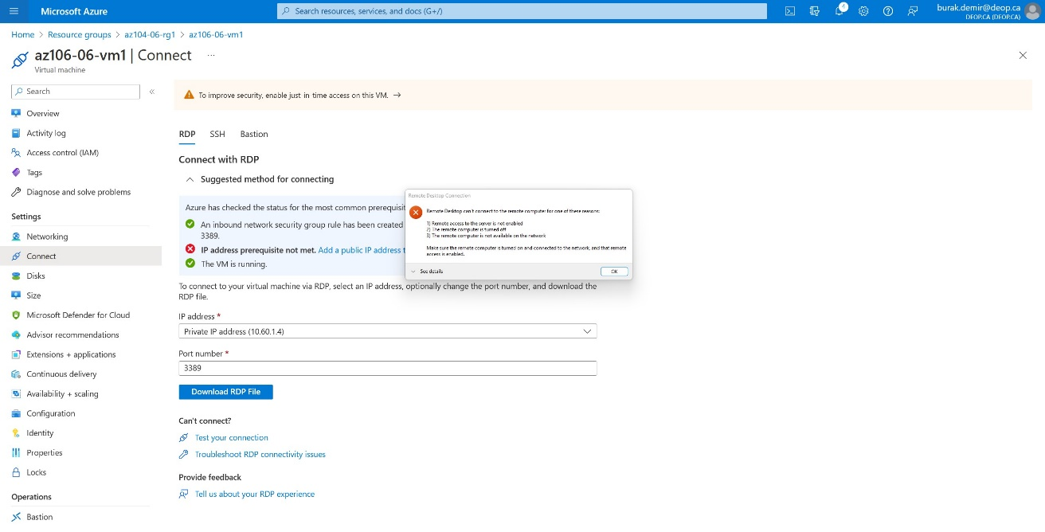

## **Connection through Load Balancer**

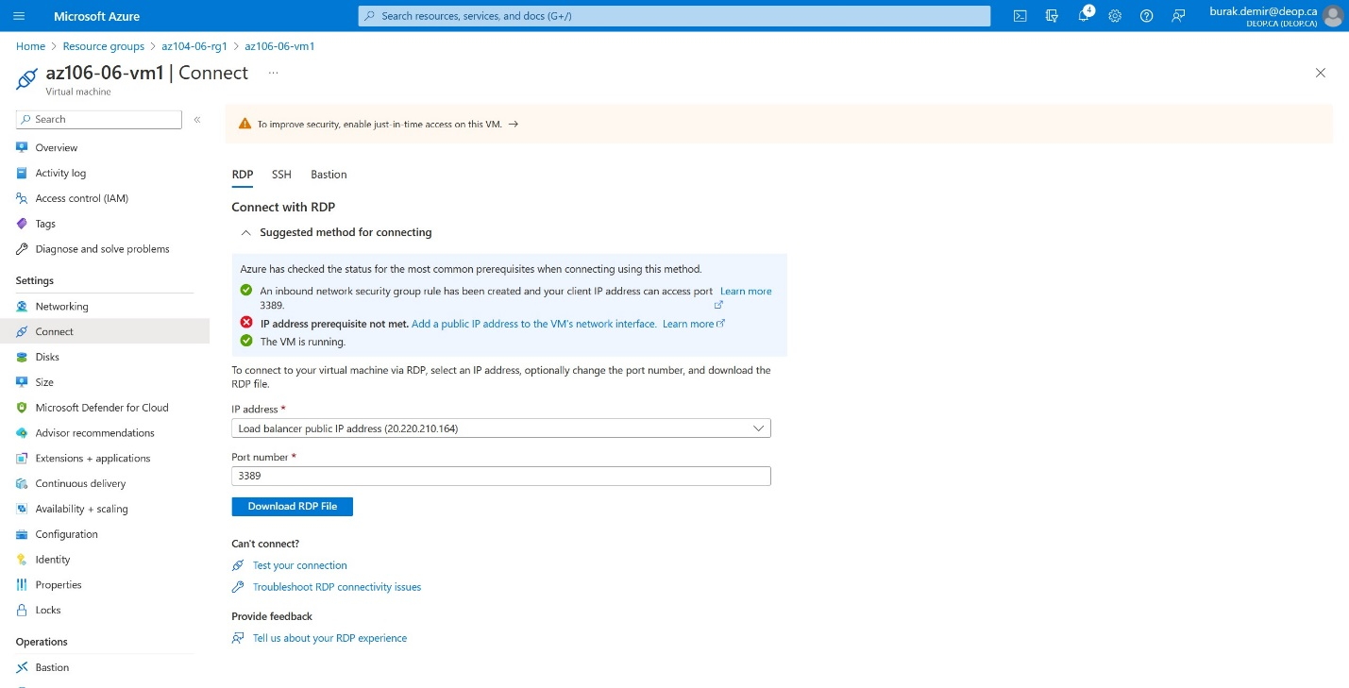

# **Graphical user interface Description automatically generatedVIRTUAL NETWORKS**

**