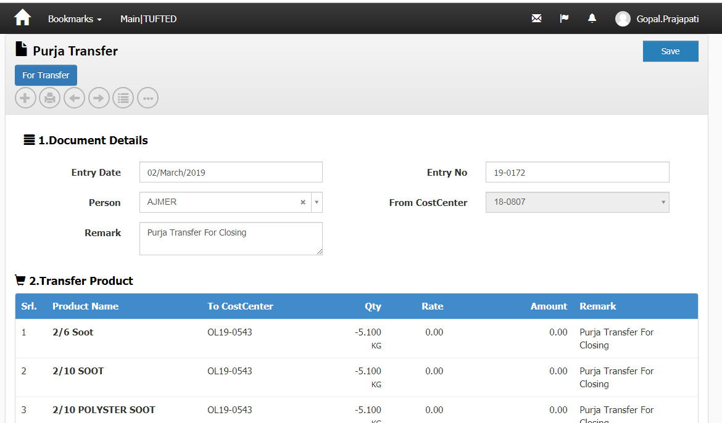

change entry date should be affect in stock Process doc date.

timepenalty,Incentive in ledges not proper lineid

Material Issue For Weaving List (close purja also show)

Close List Purja(which not updated incentive,small chunk)

Cloth consumption issue in weaving Order.

Sale Invocie Report (changes on 5 Apr 19)

Debit Note Amount show in Purchase invoice Print.(Nair)

Issue In Material Plan For Weaving.(Shivam)

Gatepass Print (Name with address)Hrd

Correction in Contractor out standing Report.

Barcode status (new report,and List Page)

Perk Update Query.

Document of Noida.

Plan No in Product Module (Job Order) noida

Working on Issue list of Noida.