Time Penalty of Rs. 10.00 per Sq. Yard will be deducted if all pcs of Weaving Order will not be delivered after 20 days of delivery date.

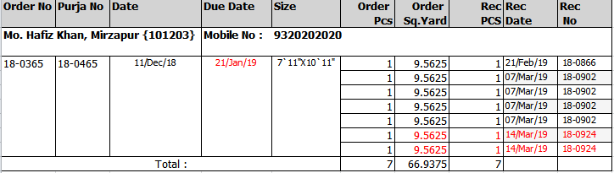

Penalty Amount=19.125 (Over the 20 days of Delivery date) \* 10 (Penalty Rate) = 191.25 Rs.

