**Design Flow:**

* UI
* Business Logic
* Data Logic
* Custom Controls
* Dependencies
* WORK FLOW ( View -> Controller -> Model -> Entity )

**Code Flow:**

* UI design pattern – (HTML, Scripts)
* Coding standard and guidelines (Controller, business logic and data access)

**Database objects & Schema:**

* Database
* Table – Purpose, ER diagram, Model class
* Procedure, Functions, view , custom type

**Backlog:**

|  |  |  |  |  |
| --- | --- | --- | --- | --- |
| **Sort Description** | **Detailed Description** | **Effort** | **Type (Functional/Technical)** | **Requested By** |
|  |  |  |  |  |
|  |  |  |  |  |

|  |  |  |  |
| --- | --- | --- | --- |
| **Created Date** | **Created by** | **Review Date** | **Review by** |
|  |  |  |  |
|  |  |  |  |

Login UI:

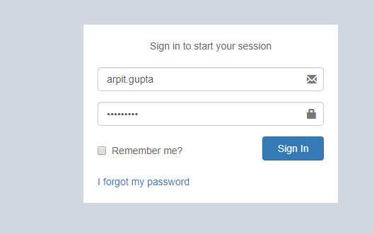

Business Logic and Module: We use Microsoft Asp.net Identity 2.0 Feature for Login Credential.

Click on Sign in Button 🡪 Open below Screen shot (SiteSelection Page).

**Dependencies**: Microsoft Asp.net Identity 2.0 (Only for login)

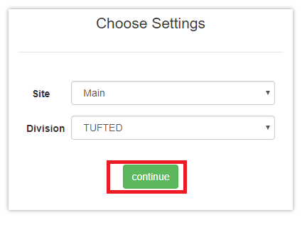Screen Shot no.1

**Business Logic:**

1: Controller Name -> SiteSelectionController: SiteSelection controller has seven services for use.

1. ISiteSelectionService
2. IUserRolesService
3. ImoduleService
4. IUserBookMarkService
5. ICompanySettingsService
6. ICompanyService
7. IRolesControllerActionService

Action Method -> SiteSelection: To display site selection screen we use GetUserId method of SiteSelection controller and after that we identify for particular Roles.

Below Methods are given for User Role and Roles list.

1. GetUserRolesList()
2. GetRolesList()

To bind dropdown list we use below method.

1. GetSiteList()
2. GetDivisionList()

**Data Logic🡪 1: For Roles.**

**View Model Name/Model:** UserRoleViewModel, UserRole, UserProfile, UserReferral:

In this View Model and Model we declare all property related to roles.

2: **For Site & Division.**

**View Model Name/Model:** Site/ Division

In this view model and model we declare all property related site and Division.

**Entity Framework/Services->1:** for Roles

**Services Name:** UserService: In this service has GetUserRolesList ()

In which is define in UserReferralService interface.

2: For Site & Division

**Service Name**: SiteService: In this service has GetSiteList () in which is define in SiteService interface.  
  
 DivisionService: In this service has GetDivisionList () in which is define in

DivisionService interface.

**Dependencies**:

**Data Access Layer  
 (**UserService **&** SiteService & DivisionService)

**Business Logic**

(SiteSelection Controller)

**Presentation Layer (View layer)**

(SiteSelection.chtml)

**Work Flow: View 🡪 Controller 🡪Model**

**View**: SiteSelection.chtml -> clearly we can see design of page in screen shot no .1

**Controller**: SiteSelectionController

**Model**: UserRoleViewModel, UserRole, UserProfile and UserReferral

**Database (Table/Stored procedure /View):**

|  |  |  |
| --- | --- | --- |
| 1. | **Web.Menus** |  |
| MenuId | INT IDENTITY NOT NULL, | PRIMARY KEY |
| MenuName | NVARCHAR (50) NOT NULL, |  |
| Srl | NVARCHAR (5) NOT NULL, |  |
| IconName | NVARCHAR (100) NOT NULL, |  |
| Description | NVARCHAR (100) NOT NULL, |  |
| ModuleId | INT NOT NULL, |  |
| SubModuleId | INT NOT NULL, |  |
| ControllerActionId | INT NOT NULL, |  |
| RouteId | NVARCHAR (max), |  |
| IsActive | BIT DEFAULT ((1)) NOT NULL, |  |
| CreatedBy | NVARCHAR (max), |  |
| ModifiedBy | NVARCHAR (max), |  |
| CreatedDate | DATETIME NOT NULL, |  |
| ModifiedDate | DATETIME NOT NULL, |  |
| URL | NVARCHAR (100), |  |
| IsVisible | BIT, |  |
| isDivisionBased | BIT DEFAULT ((0)), |  |
| isSiteBased | BIT DEFAULT ((0)), |  |
| AreaName | NVARCHAR (50), |  |
| ControllerName | NVARCHAR (100), |  |
| ActionName | NVARCHAR (100), |  |

|  |  |  |
| --- | --- | --- |
| 2. | **Web.RolesMenus** |  |
| RolesMenuId | INT IDENTITY NOT NULL, | PRIMARY KEY |
| RoleId | NVARCHAR (128), |  |
| MenuId | INT NOT NULL, |  |
| CreatedBy | NVARCHAR (max), |  |
| ModifiedBy | NVARCHAR (max), |  |
| CreatedDate | DATETIME NOT NULL, |  |
| ModifiedDate | DATETIME NOT NULL, |  |
| FullHeaderPermission | BIT DEFAULT ((0)) NOT NULL, |  |
| FullLinePermission | BIT DEFAULT ((0)) NOT NULL, |  |
| DivisionId | INT DEFAULT ((1)) NOT NULL, |  |
| SiteId | INT DEFAULT ((17)) NOT NULL, |  |

|  |  |  |
| --- | --- | --- |
| 3. | **Web.Sites** |  |
| SiteId | INT IDENTITY NOT NULL, | PRIMARY KEY |
| SiteName | NVARCHAR (50) NOT NULL, |  |
| Address | NVARCHAR (250), |  |
| PhoneNo | NVARCHAR (50), |  |
| CityId | INT, |  |
| IsActive | BIT DEFAULT ((1)) NOT NULL, |  |
| IsSystemDefine | BIT DEFAULT ((0)) NOT NULL, |  |
| CreatedBy | NVARCHAR (max), |  |
| ModifiedBy | NVARCHAR (max), |  |
| CreatedDate | DATETIME NOT NULL, |  |
| ModifiedDate | DATETIME NOT NULL, |  |
| OMSId | NVARCHAR (50), |  |
| SiteCode | NVARCHAR (20), |  |
| DefaultDivisionId | INT, |  |
| ThemeColour | NVARCHAR (25), |  |
| PersonId | INT, |  |
| DefaultGodownId | INT, |  |
| DocTypeId | INT, |  |
| SiteShortCode | NVARCHAR (2), |  |

|  |  |  |
| --- | --- | --- |
| 4. | **Web.RolesSites** |  |
| RolesSiteId | INT IDENTITY NOT NULL, | PRIMARY KEY |
| RoleId | NVARCHAR (128), |  |
| SiteId | INT NOT NULL, |  |
| CreatedBy | NVARCHAR (max), |  |
| ModifiedBy | NVARCHAR (max), |  |
| CreatedDate | DATETIME NOT NULL, |  |
| ModifiedDate | DATETIME NOT NULL, |  |

|  |  |  |
| --- | --- | --- |
| 5. | **Web.Divisions** |  |
| DivisionId | INT IDENTITY NOT NULL, | PRIMARY KEY |
| DivisionName | NVARCHAR (50) NOT NULL, |  |
| Address | NVARCHAR (250), |  |
| LstNo | NVARCHAR (20), |  |
| CstNo | NVARCHAR (20), |  |
| IsActive | BIT DEFAULT ((1)) NOT NULL, |  |
| IsSystemDefine | BIT DEFAULT ((0)) NOT NULL, |  |
| CreatedBy | NVARCHAR (max), |  |
| ModifiedBy | NVARCHAR (max), |  |
| CreatedDate | DATETIME NOT NULL, |  |
| ModifiedDate | DATETIME NOT NULL, |  |
| OMSId | NVARCHAR (50), |  |
| CompanyId | INT, |  |
| ThemeColour | NVARCHAR (25), |  |
| ReportHeaderTextRight1 | NVARCHAR (max), |  |
| ReportHeaderTextRight2 | NVARCHAR (max), |  |
| ReportHeaderTextRight3 | NVARCHAR (max), |  |
| ReportHeaderTextRight4 | NVARCHAR (max), |  |
| DivisionShortCode | NVARCHAR (2), |  |
| LogoBlob | NVARCHAR (max), |  |

|  |  |  |
| --- | --- | --- |
| 6 | **Web.RolesDivisions** |  |
| RolesDivisionId | INT IDENTITY NOT NULL, | PRIMARY KEY |
| RoleId | NVARCHAR (128), |  |
| DivisionId | INT NOT NULL, |  |
| CreatedBy | NVARCHAR (max), |  |
| ModifiedBy | NVARCHAR (max), |  |
| CreatedDate | DATETIME NOT NULL, |  |
| ModifiedDate | DATETIME NOT NULL, |  |

**Selection of Godown**-> In Screen shot no.1, click on 🡪Continue Button 🡪open Below Screen.

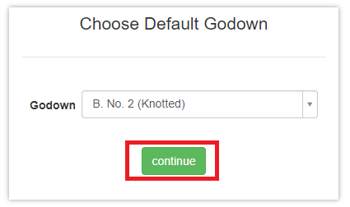

(Screen Shot no.2)

**Business logic -> Controller Name:** SiteSelectionController

**Action Method**: DefaultGodownSelection: To display Godown screen we use GetGodownList () function of SiteSelectionController.

To bind the Godown dropdown list using below method.

GetGodownList (): This function is define in IGodownService services.

**Data Logic->**

**View Model Name/Model:** Godown.cs

**Entity Formwork / Services**🡪

Service Name: ISiteSelectionService, ICompanySettingsService, IGodownService.

**Dependencies**:

**Data Access Layer  
 (**IGodownService, ICompanySettingsService, ISiteSelectionService)

**Business Logic**

(SiteSelection Controller)

**Presentation Layer (View layer)**

(DefaultGodownSelection)

**Work Flow: View 🡪 Controller 🡪Model**

**View:** DefaultGodownSelection.chtml

**Controller Name:** SiteSelectionController

**Model Name:** Godown.cs

**Database (Table/Stored procedure /View):**

|  |  |  |
| --- | --- | --- |
|  | **Web.Godowns** |  |
| GodownId | INT IDENTITY NOT NULL, | PRIMARY KEY |
| GodownName | NVARCHAR (50) NOT NULL, |  |
| SiteId | INT NOT NULL, |  |
| IsActive | BIT DEFAULT ((1)) NOT NULL, |  |
| CreatedBy | NVARCHAR (max), |  |
| ModifiedBy | NVARCHAR (max), |  |
| CreatedDate | DATETIME NOT NULL, |  |
| ModifiedDate | DATETIME NOT NULL, |  |
| OMSId | NVARCHAR (50), |  |
| Site_SiteId | INT, |  |
| GateId | INT, |  |
| DocTypeId | INT, |  |
| GodownCode | NVARCHAR (10), |  |
| PersonId | INT, |  |

Inventory UI:

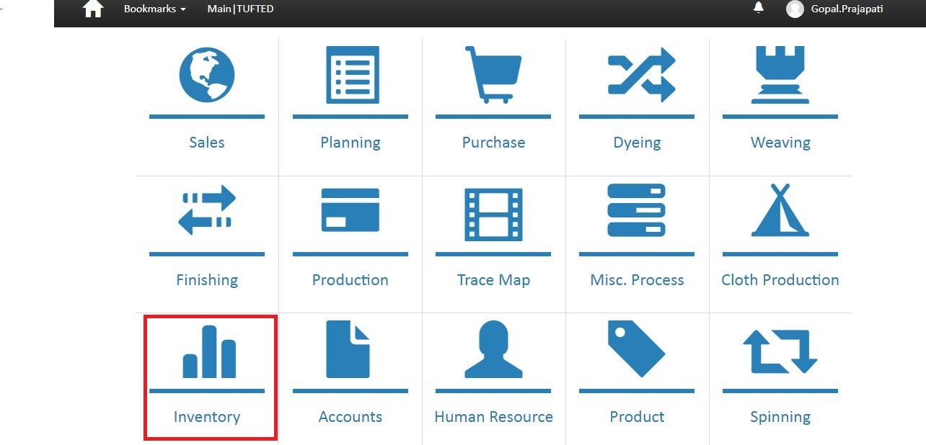

Business Logic:

**Controller Name**-> MenuController : Menu controller has three services for display menu

a)-IModuleService

b)-ISubModuleService

c)- IUnitOfWork

1. **Action Method**-> Module: To display menu we use GetModules function of ImoduleService interface. In Module Action we stored all menu in Moduleslist variable and check condition if Moduleslist == 1 then open SubModule otherwise Module

Data Logic:

Model Name: MenuModouleViewModel.cs

Entity Framework/ Services: ImoduleService.cs ' In this Service we define

GetModules() .

**Dependencies**:

**Data Access Layer  
 (**Module services)

**Business Logic**

(menu Controller)

**Presentation Layer (View layer)**

(module.chtml)

|  |  |  |  |
| --- | --- | --- | --- |
|  | web.menu module |  |  |
| **Fields** | **DataType** | **Constrain** | **Remark** |
| **ModuleId** | **INT IDENTITY NOT NULL,** | **PRIMARY KEY** |  |
| ModuleName | NVARCHAR (50) NOT NULL, |  |  |
| Srl | INT NOT NULL, |  |  |
| IconName | NVARCHAR (100) NOT NULL, |  |  |
| IsActive | BIT DEFAULT ((1)) NOT NULL, |  |  |
| CreatedBy | NVARCHAR (max), |  |  |
| ModifiedBy | NVARCHAR (max), |  |  |
| CreatedDate | DATETIME NOT NULL, |  |  |
| ModifiedDate | DATETIME NOT NULL, |  |  |
| URL | NVARCHAR (100), |  |  |

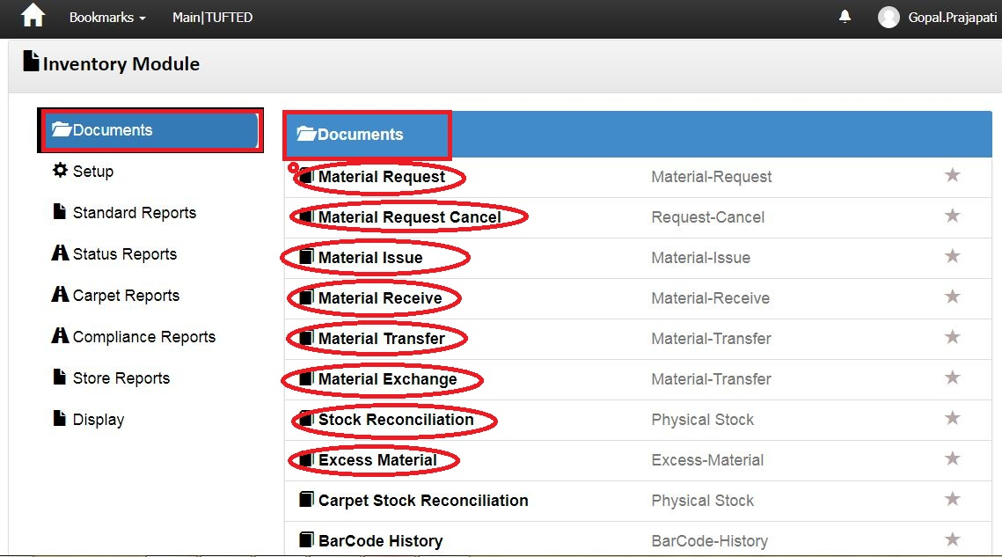

Screen shot no-2

Business Logic:

1. **Controller Name**-> MenuController : Menu controller has three services for display menu

**a)-** IModuleService

b)-ISubModuleService

c)- IUnitOfWork

Action Method: Module: In this Action method we identify particular user Role and then execute GetModuleList () and GetModuleListForUser ().

Finally Return Module and SubModule View based on condition.

DataLogic-

ModelName- SubModuleViewModel.cs

**Dependencies**:

**Data Access Layer  
 (**SubModuleService)

**Business Logic**

(Menu Controller)

**Presentation Layer (View layer)**

(Submodule.chtml)

**Work Flow: View 🡪 Controller 🡪Model**

**View**: Submodule.chtml -> clearly us can see design of page

**Controller**: Menu Controller

**Model**: MenuViewModel / SubModuleViewModel

**Database (Table/Stored procedure/View)**

|  |  |  |  |
| --- | --- | --- | --- |
|  | web.MenuSubModules |  |  |
| **Fields** | **DataType** | **Constrain** | **Remark** |
| SubModuleId | INT IDENTITY NOT NULL, | PRIMARY KEY |  |
| SubModuleName | NVARCHAR (50) NOT NULL, |  |  |
| IconName | NVARCHAR (100) NOT NULL, |  |  |
| IsActive | BIT DEFAULT ((1)) NOT NULL, |  |  |
| CreatedBy | NVARCHAR (max), |  |  |
| ModifiedBy | NVARCHAR (max), |  |  |
| CreatedDate | DATETIME NOT NULL, |  |  |
| ModifiedDate | DATETIME NOT NULL, |  |  |
| OMSId | NVARCHAR (50), |  |  |

Note: In Screen shot no. 2, Click on “Material Request” Hyperlink 🡪Open below Screen Shot.

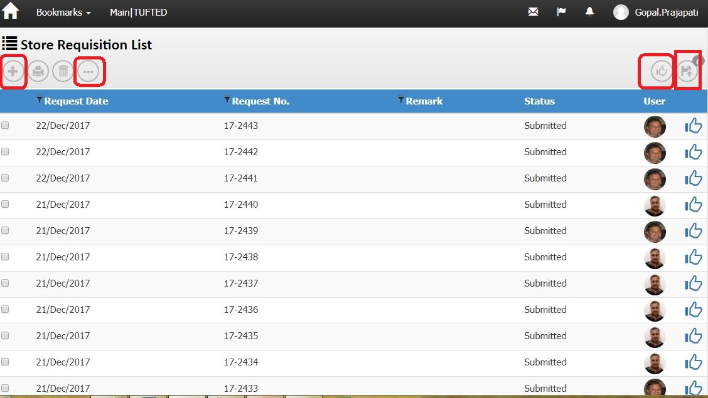 Screen shot no-3  
Business Logic:

1. **Controller Name**-> MaterialRequestHeaderController: This controller has four services for display Material List

a) IRequisitionHeaderService

b) IActivityLogService

c) IUnitOfWork

d) IExceptionHandlingService

Action Method:

Action Method Name :-> Index: In this Action we get Material list using GetRequisitionHeaderList () method

DataLogic-

ModelName-RequisitionHeader and RequisitionHeaderViewModel

For wizard

Action Method:

A) Index_PendingToSubmit () ‘For Pending submit record.

B) Index_PendingToReview () ’ For Pending Review Record.

c) Delete () ‘for delete a row from list

E) Report () ' For Report

h) Edit () for modify record

i) create () for create new header row

**Dependencies**:

**Data Access Layer  
 (**RequisitionHeaderService)

**Business Logic**(MaterialRequestHeaderController Controller)

**Presentation Layer (View layer)**

(Index.chtml)

**Work Flow: View 🡪 Controller 🡪Model**

**View**: Index.chtml -> clearly us can see design of page ()

**Controller**: MaterialRequestHeaderController Controller

**Model**: RequisitionHeader and RequisitionHeaderViewModel

**Database (Table/Stored procedure/View)**

|  |  |  |  |
| --- | --- | --- | --- |
| **Web.RequisitionHeader** | | | |
|
| ColumnName | Datatype | ReferencedTable | ReferencedColumn |
| RequisitionHeaderId | int |  |  |
| DocTypeId | int | Web.DocumentTypes | DocumentTypeId (FK) |
| DocDate | datetime |  |  |
| DocNo | nvarchar |  |  |
| DivisionId | int | Web.Divisions | DivisionId (FK) |
| SiteId | int | Web.Sites | SiteId (FK) |
| Remark | nvarchar |  |  |
| Status | int |  |  |
| CreatedBy | nvarchar |  |  |
| CreatedDate | datetime |  |  |
| ModifiedBy | nvarchar |  |  |
| ModifiedDate | datetime |  |  |
| OMSId | nvarchar |  |  |
| PersonId | int | Web.People | PersonID (FK) |
| CostCenterId | int | Web.CostCenters | CostCenterId (FK) |
| ReasonId | int | Web.Reasons | ReasonId (FK) |
| ReferenceDocTypeId | int | Web.DocumentTypes | DocumentTypeId (FK) |
| ReferenceDocId | int |  |  |
| ReviewCount | int |  |  |
| ReviewBy | nvarchar |  |  |
| LockReason | nvarchar |  |  |

(2) Material Request Cancel –

Note: In Screen shot no. 2, Double Click on “Material Request Cancel” Hyperlink 🡪Open below Screen Shot.

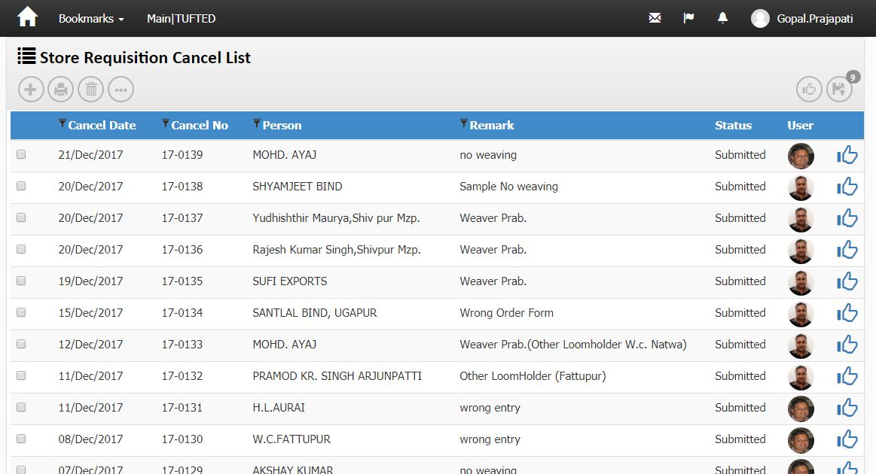

Screen Shot no-4

Business Logic:

1. **Controller Name**-> MaterialRequestCancelHeaderController : this controller has three services for display Material request cancel List
2. IRequisitionCancelHeaderService
3. IUnitOfWork
4. IExceptionHandlingService

Action Method: Index: In this Action we get Material request cancelList use method GetRequisitionCancelHeaderList ()

**Entity Framework/Services->**

**Services Name:** RequisitionCancelHeaderService 🡪 In this services we define GetRequisitionCancelHeaderList ().

DataLogic-

ModelName- RequisitionCancelHeaderViewModel.cs/ RequisitionCancelHeader.cs

For wizard

Action Method:

A) Index_PendingToSubmit () ‘For Pending submit record.

B) Index_PendingToReview () ’ For Pending Review Record.

c) Delete () ‘for delete a row from list

E) Report () ' For Report

h) Edit () for modify record

i) create ( ) ‘ create new header row

**Dependencies**:

**Data Access Layer  
 (**RequisitionCancelHeaderService)

**Business Logic**(MaterialRequestCancelHeaderController

Controller)

**Presentation Layer (View layer)**

(Index.chtml)

**Work Flow: View 🡪 Controller 🡪Model**

**View**: index.chtml -> clearly us can see design of page

**Controller**: MaterialRequestcancelHeader Controller

**Model**: RequisitionCancelHeaderViewModel. cs / RequisitionCancelHeader.cs

Note: In Screen shot no. 4, Double Click on “gridview row of store request cancel list ” Hyperlink 🡪Open below Screen Shot.

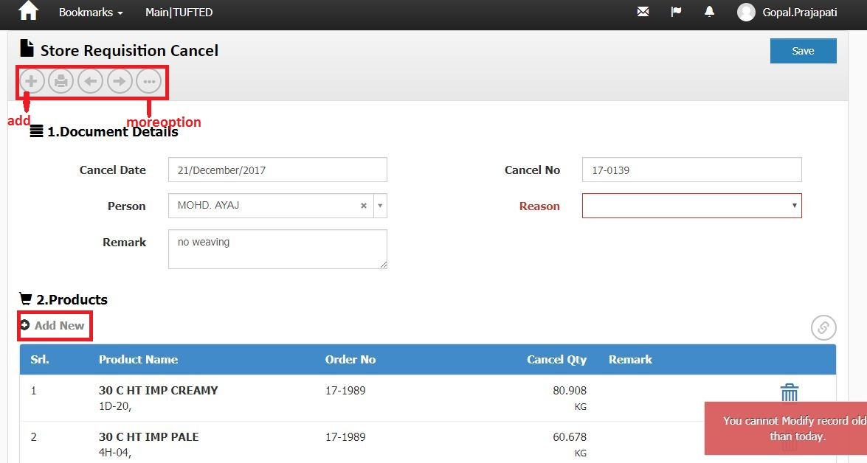

Screen shot No-5

Business Logic:

**Controller Name**->

1. MaterialRequestCancelHeaderController : This Controller has three services for display Material request cancel List
2. IRequisitionCancelHeaderService
3. IUnitOfWork

c. IExceptionHandlingService

1. MaterialRequestCancelLineController: This Controller has three services for display Material request cancel List

a. IRequisitionCancelHeaderService

b. IUnitOfWork

c. IExceptionHandlingService

Action Method: ModifyAfter_Submit and Index: In this Action we get Store Requisition and Products use method GetRequisitionCancelHeaderList () and GetRequisitionCancelLineForHeader ()

**Entity Framework/Services->**

**Services Name:** RequisitionCancelHeaderService and RequisitionCancelLineService 🡪 In this services we define GetRequisitionCancelHeaderList() and GetRequisitionCancelLineForHeader().

DataLogic-

ModelName- RequisitionCancelHeaderViewModel, RequisitionCancelHeader and RequisitionCancelLineViewModel, RequisitionCancelLine

**Dependencies**:

**Data Access Layer  
 (**RequisitionCancelHeaderService & RequisitionCancelLineService)

**Business Logic**(MaterialRequestCancelHeaderController & MaterialRequestCancelLineController

Controller)

**Presentation Layer (View layer)**

(Create. cstml & Index.cshtml)

**Work Flow: View 🡪 Controller 🡪Model**

**View**: Create. Chtml and index.cshtml-> clearly us can see design of page

**Controller**: MaterialRequestcancelHeader Controller and MaterialRequestCancelLineController

**Model**: RequisitionCancelHeaderViewModel, RequisitionCancelHeader and RequisitionCancelLineViewModel, RequisitionCancelLine

**Code Flow**: HTML/Java Script:

For Line' we use Java Script function on Create.chtml page ' materialrequestcancelheaderController.cs

Syntax' var link="/MaterialRequestCancelLine/Index/"+groupId;

**Database (Table/Stored procedure/View)**

**(I)->**

|  |  |  |  |
| --- | --- | --- | --- |
| **Web.** **RequisitionCancelHeaders** | | | |
|
| ColumnName | Datatype | ReferencedTable | ReferencedColumn |
| RequisitionCancelHeaderId | int |  |  |
| DocTypeId | int | Web.DocumentTypes | DocumentTypeId (FK) |
| DocDate | datetime |  |  |
| DocNo | nvarchar |  |  |
| DivisionId | int | Web.Divisions | DivisionId (FK) |
| SiteId | int | Web.Sites | SiteId (FK) |
| PersonId | int | Web.People | PersonID (FK) |
| ReasonId | int | Web.Reasons | ReasonId (FK) |
| ReferenceDocTypeId | int | Web.DocumentTypes | DocumentTypeId (FK) |
| ReferenceDocId | int |  |  |
| Remark | nvarchar |  |  |
| Status | int |  |  |
| CreatedBy | nvarchar |  |  |
| CreatedDate | datetime |  |  |
| ModifiedBy | nvarchar |  |  |
| ModifiedDate | datetime |  |  |
| OMSId | nvarchar |  |  |
| ReviewCount | int |  |  |
| ReviewBy | nvarchar |  |  |
| LockReason | nvarchar |  |  |

(II)->

|  |  |  |  |
| --- | --- | --- | --- |
| **Web.** RequisitionCancelLines | | | |
|
| ColumnName | Datatype | ReferencedTable | ReferencedColumn |
| RequisitionCancelLineId | int |  |  |
| RequisitionCancelHeaderId | int | Web.RequisitionCancelHeaders | RequisitionCancelHeaderId (FK) |
| RequisitionLineId | int | Web.RequisitionLines | RequisitionLineId (FK) |
| Qty | decimal |  |  |
| Remark | nvarchar |  |  |
| CreatedBy | nvarchar |  |  |
| ModifiedBy | nvarchar |  |  |
| CreatedDate | datetime |  |  |
| ModifiedDate | datetime |  |  |
| OMSId | nvarchar |  |  |
| LockReason | nvarchar |  |  |

Material issue : ->

Note: In Screen shot no. 2, Double Click on “Material issue” Hyperlink 🡪Open below Screen Shot.

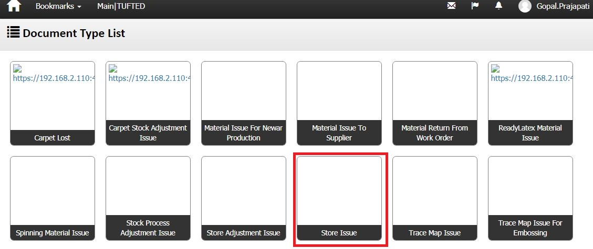

Screen shot No-6

Business Logic:

1. **Controller Name**-> StockissueHeaderController : This controller has four services for display Material issue List

a) IStockHeaderService

b) IActivityLogService

c) IUnitOfWork

d) IExceptionHandlingService

Action Method:-

Action Method Name :-> DocumentTypeIndex: In this Action we get Material issue list using GetStockHeaderList () method

**Entity Framework/Services->**

**Services Name:** StockHeaderService🡪 In this services we define GetStockHeaderList ().

DataLogic-

ModelName- StockHeaderViewModel **and** StockHeaderViewModel

**Dependencies**:

**Data Access Layer  
 (**StockHeaderService)

**Business Logic**(StockissueHeaderController)

Controller)

**Presentation Layer (View layer)**

(DocumentTypeIndex.chtml)

**Work Flow: View 🡪 Controller 🡪Model**

**View**: DocumentTypeIndex.chtml -> clearly us can see design of page

**Controller** StockissueHeaderController Controller

**Model** : StockHeaderViewModel **and** StockHeaderViewModel

Note: In Screen shot no. 6, DoubleClick on “Store Issue” Hyperlink 🡪Open below Screen Shot.

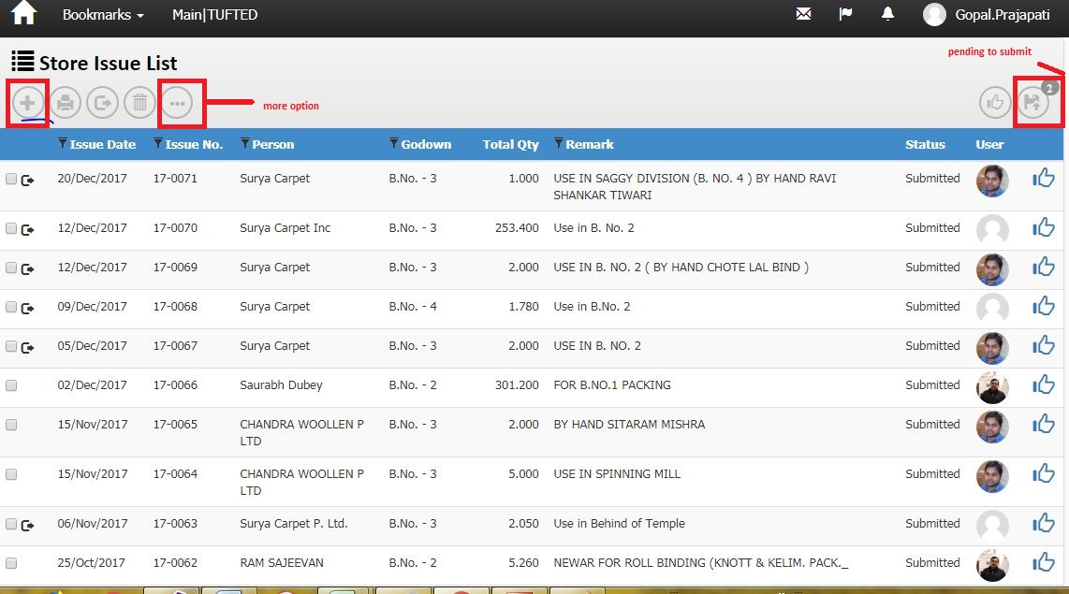

Screen Shot No-7

Business Logic:

**1)-Controller Name**-> StockIssueHeaderController: This controller has four Services for display Material issue List

a) IStockHeaderService

b) IActivityLogService

c) IUnitOfWork

d) IExceptionHandlingService

2)-Action Method:

Action Method Name :-> Index: In this Action we get Material issue list using GetStockHeaderList () method

**3)-Entity Framework/Services->**

**Services Name:** StockHeaderService 🡪 In this services we define GetStockHeaderList ().

DataLogic-

ModelName- StockHeaderViewModel

For wizard

Action Method:

A) Index_PendingToSubmit () ‘For Pending submit record.

B) Index_PendingToReview () ’ For Pending Review Record.

c) Delete () ‘for delete a row from list

E) Report () ' For Report

h) Edit () for modify record

i) create () create new header row

j) gatepass () for generate gatepass

**Dependencies**:

**Data Access Layer  
 (**StockHeaderService)

**Business Logic**(StockIssueHeaderController)

**Presentation Layer (View layer)**

(Index.chtml)

**Work Flow: View 🡪 Controller 🡪Model**

**View**: Index.chtml -> clearly us can see design of page

**Controller** StockIssueHeaderController Controller

**Model**: StockHeaderViewModel.cs

**Database (Table/Stored procedure/View)**

|  |  |  |  |
| --- | --- | --- | --- |
| **Web.StockHeaders** | | | |
|
| ColumnName | Datatype | ReferencedTable | ReferencedColumn |
| StockHeaderId | int |  |  |
| DocHeaderId | int |  |  |
| DocTypeId | int | Web.DocumentTypes | DocumentTypeId (FK) |
| DocDate | datetime |  |  |
| DocNo | nvarchar |  |  |
| DivisionId | int | Web.Divisions | DivisionId (FK) |
| SiteId | int | Web.Sites | SiteId (FK) |
| CurrencyId | int | Web.Currencies | ID (FK) |
| PersonId | int | Web.People | PersonID (FK) |
| ProcessId | int | Web.Processes | ProcessId (FK) |
| FromGodownId | int | Web.Godowns | GodownId (FK) |
| GodownId | int | Web.Godowns | GodownId (FK) |
| Remark | nvarchar |  |  |
| Status | int |  |  |
| CreatedBy | nvarchar |  |  |
| CreatedDate | datetime |  |  |
| ModifiedBy | nvarchar |  |  |
| ModifiedDate | datetime |  |  |
| OMSId | nvarchar |  |  |
| CostCenterId | int | Web.CostCenters | CostCenterId (FK) |
| MachineId | int | Web.Machines | MachineId (FK) |
| GatePassHeaderId | int | Web.GatePassHeaders | GatePassHeaderId (FK) |
| LedgerHeaderId | int | Web.LedgerHeaders | LedgerHeaderId (FK) |
| ContraLedgerAccountId | int | Web.LedgerAccounts | LedgerAccountId (FK) |
| ReferenceDocTypeId | int | Web.DocumentTypes | DocumentTypeId (FK) |
| ReferenceDocId | int |  |  |
| LockReason | nvarchar |  |  |
| LedgerAccountId | int |  |  |
| ReviewCount | int |  |  |
| ReviewBy | nvarchar |  |  |
| IsGatePassPrinted | bit |  |  |

Note: In Screen shot no. 7, Double Click on “ gridview of Store issue list ” Hyperlink 🡪Open below Screen Shot.

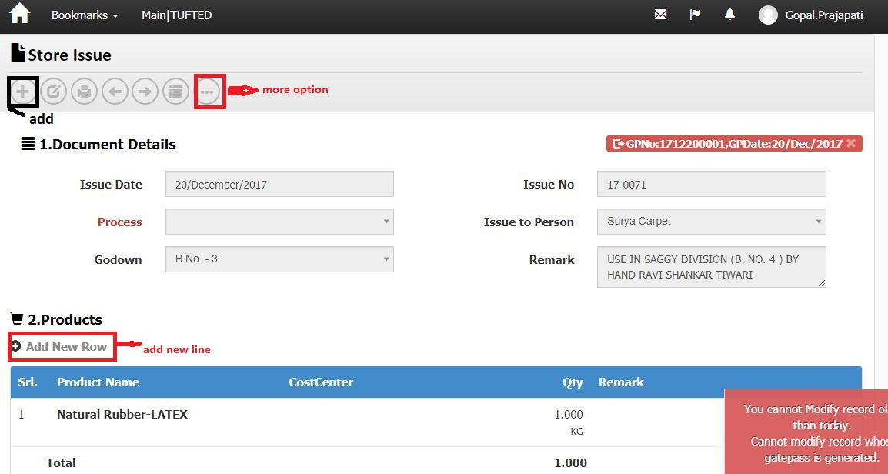

Screen Shot No-8

Business Logic:

**Controller Name**->

1)-StockIssueHeaderController: This controller has four services for display Material issue (store issue) List

a) IStockHeaderService

b) IActivityLogService

c) IUnitOfWork

d) IExceptionHandlingService

2)-StockIssueLineController: This controller has four services for display Material issue (store issue) List

a) IStockHeaderService

b) IActivityLogService

c) IUnitOfWork

d) IExceptionHandlingService

Action Method: Detail and Index: In this Action we get Store issue and Products use method GetStockLineListForIndex () and GetStockHeader ()

**Entity Framework/Services->**

**Services Name:** StockLineService and StockHeaderService 🡪 In this services we define GetStockLineListForIndex () and GetStockHeader ().

DataLogic-

ModelName- StockHeaderViewModel and StockHeaderViewModel

Action Method for headers:

a) NextPage () ' For Next page

b) PrevPage ()' For Previous page

c) Report () ' For Report

d) GeneratePrints () ' For Generate print.

e) HeaderPost () ' for save record of header.

f) Edit () for modify record

g) index () for list

h) create () for create new header row

**Dependencies**:

**Data Access Layer  
 (**StockLineService & StockHeaderService)

**Business Logic**(StockIssueHeaderController & StockIssueLineController

Controller)

**Presentation Layer (View layer)**

(Detail. cstml & Index.cshtml)

**Work Flow: View 🡪 Controller 🡪Model**

**View**: Detail. Chtml & index.cshtml -> clearly us can see design of page

**Controller**: StockIssueHeaderController and StockIssueLineController

**Model** : StockHeaderViewModel and StockHeaderViewModel

**Code Flow**: HTML/Java Script:

Page Name: Create.chtml: In this Page, Make a LoadProducts () function for get Stockline.

Path: ~store/View/stockissueheader. var link="/StockIssueLine/Index/"+groupId;: In This Syntax, StockIssueLine is Controller Name and Index is Action Method of StockissueLineController.cs.

Action Method for Line:

Action Method:'

1. Create ()
2. ModifyLine()
3. ModifyLineAfterSubmit()
4. ModifyLineAfterApprove()
5. Delete()

Edit () for modified record

For Post '

a) FilterPost ()

b) ResultsPost ()

c) CreatePost ()

**Database (Table/Stored procedure/View):-**

**1)-**

|  |  |  |  |
| --- | --- | --- | --- |
| **Web.StockHeaders** | | | |
|
| ColumnName | Datatype | ReferencedTable | ReferencedColumn |
| StockHeaderId | int |  |  |
| DocHeaderId | int |  |  |
| DocTypeId | int | Web.DocumentTypes | DocumentTypeId (FK) |
| DocDate | datetime |  |  |
| DocNo | nvarchar |  |  |
| DivisionId | int | Web.Divisions | DivisionId (FK) |
| SiteId | int | Web.Sites | SiteId (FK) |
| CurrencyId | int | Web.Currencies | ID (FK) |
| PersonId | int | Web.People | PersonID (FK) |
| ProcessId | int | Web.Processes | ProcessId (FK) |
| FromGodownId | int | Web.Godowns | GodownId (FK) |
| GodownId | int | Web.Godowns | GodownId (FK) |
| Remark | nvarchar |  |  |
| Status | int |  |  |
| CreatedBy | nvarchar |  |  |
| CreatedDate | datetime |  |  |
| ModifiedBy | nvarchar |  |  |
| ModifiedDate | datetime |  |  |
| OMSId | nvarchar |  |  |
| CostCenterId | int | Web.CostCenters | CostCenterId (FK) |
| MachineId | int | Web.Machines | MachineId (FK) |
| GatePassHeaderId | int | Web.GatePassHeaders | GatePassHeaderId (FK) |
| LedgerHeaderId | int | Web.LedgerHeaders | LedgerHeaderId (FK) |
| ContraLedgerAccountId | int | Web.LedgerAccounts | LedgerAccountId (FK) |
| ReferenceDocTypeId | int | Web.DocumentTypes | DocumentTypeId (FK) |
| ReferenceDocId | int |  |  |
| LockReason | nvarchar |  |  |
| LedgerAccountId | int |  |  |
| ReviewCount | int |  |  |
| ReviewBy | nvarchar |  |  |
| IsGatePassPrinted | bit |  |  |

|  |  |  |  |
| --- | --- | --- | --- |
| **Web.StockLines** | | | |
|
| ColumnName | Datatype | ReferencedTable | ReferencedColumn |
| StockLineId | int |  |  |
| StockHeaderId | int | Web.StockHeaders | StockHeaderId (FK) |
| ProductUidId | int | Web.ProductUids | ProductUIDId (FK) |
| RequisitionLineId | int | Web.RequisitionLines | RequisitionLineId (FK) |
| ProductId | int | Web.Products | ProductId (FK) |
| FromProcessId | int | Web.Processes | ProcessId (FK) |
| LotNo | nvarchar |  |  |
| Qty | decimal |  |  |
| Remark | nvarchar |  |  |
| Dimension1Id | int | Web.Dimension1 | Dimension1Id (FK) |
| Dimension2Id | int |  |  |
| Specification | nvarchar |  |  |
| Rate | decimal |  |  |
| Amount | decimal |  |  |
| CreatedBy | nvarchar |  |  |
| ModifiedBy | nvarchar |  |  |
| CreatedDate | datetime |  |  |
| ModifiedDate | datetime |  |  |
| OMSId | nvarchar |  |  |
| DocProductId | int | Web.Products | ProductId (FK) |
| DocDimension1 | int | Web.Dimension1 | Dimension1Id (FK) |
| DocDimension2 | int |  |  |
| FromStockId | int | Web.Stocks | StockId (FK) |
| StockId | int | Web.Stocks | StockId (FK) |
| StockProcessHeader_StockProcessHeaderId | int | Web.Stocks | StockId (FK) |
| StockProcessId | int | Web.StockProcesses | StockProcessId (FK) |
| CostCenterId | int | Web.CostCenters | CostCenterId (FK) |
| DocNature | nvarchar |  |  |
| ReferenceDocTypeId | int | Web.DocumentTypes | DocumentTypeId (FK) |
| ReferenceDocId | int |  |  |
| ReferenceDocLineId | int |  |  |
| LockReason | nvarchar |  |  |
| FromStockProcessid | int | Web.StockProcesses | StockProcessId (FK) |
| Sr | int |  |  |
| ProductUidLastTransactionDocId | int |  |  |
| ProductUidLastTransactionDocNo | nvarchar |  |  |
| ProductUidLastTransactionDocTypeId | int | Web.DocumentTypes | DocumentTypeId (FK) |
| ProductUidLastTransactionDocDate | smalldatetime |  |  |
| ProductUidLastTransactionPersonId | int | Web.People | PersonID (FK) |
| ProductUidCurrentGodownId | int | Web.Godowns | GodownId (FK) |
| ProductUidCurrentProcessId | int | Web.Processes | ProcessId (FK) |
| ProductUidStatus | nvarchar |  |  |
| Weight | decimal |  |  |
| Dimension3Id | int | Web.Dimension3 | Dimension3Id (FK) |
| Dimension4Id | int | Web.Dimension4 | Dimension4Id (FK) |
| StockInId | int |  |  |

**3)-**

|  |  |  |  |
| --- | --- | --- | --- |
| **Web.Stocks** | | | |
|
| ColumnName | Datatype | ReferencedTable | ReferencedColumn |
| StockId | int |  |  |
| StockHeaderId | int | Web.StockHeaders | StockHeaderId (FK) |
| ProductId | int | Web.Products | ProductId (FK) |
| ProcessId | int | Web.Processes | ProcessId (FK) |
| GodownId | int | Web.Godowns | GodownId (FK) |
| LotNo | nvarchar |  |  |
| CostCenterId | int | Web.CostCenters | CostCenterId (FK) |
| Qty_Iss | decimal |  |  |
| Qty_Rec | decimal |  |  |
| Rate | decimal |  |  |
| ExpiryDate | datetime |  |  |
| Specification | nvarchar |  |  |
| Dimension1Id | int | Web.Dimension1 | Dimension1Id (FK) |
| Dimension2Id | int |  |  |
| OMSId | nvarchar |  |  |
| CreatedBy | nvarchar |  |  |
| ModifiedBy | nvarchar |  |  |
| CreatedDate | datetime |  |  |
| ModifiedDate | datetime |  |  |
| DocDate | datetime |  |  |
| ProductUidId | int | Web.ProductUids | ProductUIDId (FK) |
| DocLineId | int |  |  |
| DocQty_Iss | decimal |  |  |
| DocQty_Rec | decimal |  |  |
| ReferenceDocTypeId | int | Web.DocumentTypes | DocumentTypeId (FK) |
| ReferenceDocId | int |  |  |
| Remark | nvarchar |  |  |
| Weight_Iss | decimal |  |  |
| Weight_Rec | decimal |  |  |
| DeveloperNotes | nvarchar |  |  |
| StockStatus | nvarchar |  |  |
| Dimension3Id | int | Web.Dimension3 | Dimension3Id (FK) |
| Dimension4Id | int | Web.Dimension4 | Dimension4Id (FK) |
| MfgDate | datetime |  |  |

Material Receive : ->

Note: In Screen shot no. 2, Double Click on “Material Receive” Hyperlink 🡪Open below Screen Shot.

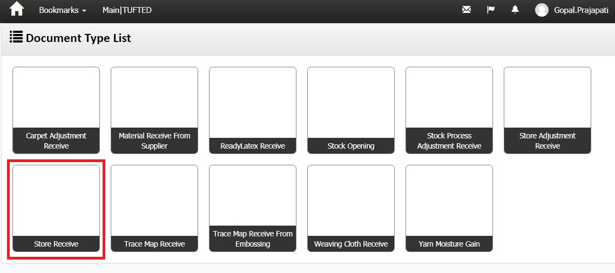

Screen shot no-9

Business Logic:

1. **Controller Name**-> StockReceiveHeaderController: This controller has four services for display Material Receive List

a) IStockHeaderService

b) IActivityLogService

c) IUnitOfWork

d) IExceptionHandlingService

Action Method:-

Action Method Name :-> DocumentTypeIndex: In this Action we get Material receive list using GetStockHeaderList () method

**Entity Framework/Services->Services Name:** StockHeaderService 🡪 In this services we define GetStockHeaderList ().

DataLogic-

ModelName- StockHeaderViewModel

**Dependencies**:

**Data Access Layer  
 (**StockHeaderService)

**Business Logic**(StockReceiveeHeaderController)

Controller)

**Presentation Layer (View layer)**

(DocumentTypeIndex.chtml)

**Work Flow: View 🡪 Controller 🡪Model**

**View**: DocumentTypeIndex.chtml -> clearly us can see design of page

**Controller** StockReceiveHeaderController Controller

**Model** : StockHeaderViewModel **and** StockHeaderViewModel

Note: In Screen shot no. 9, DoubleClick on “Store Receive” Hyperlink 🡪Open below Screen Shot.

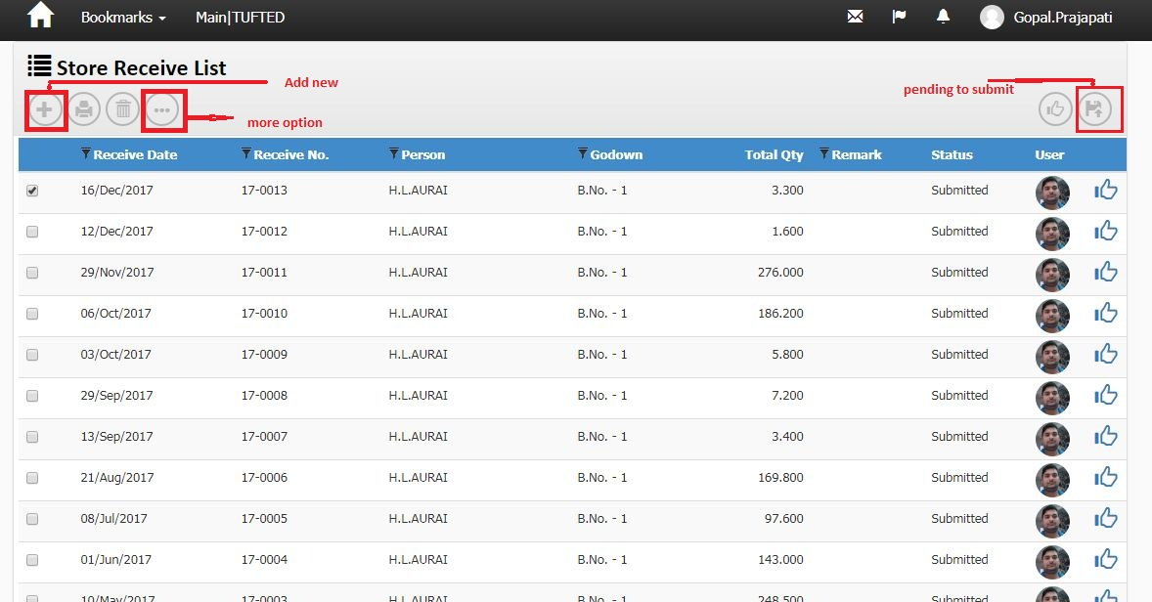

Screen shot No-10

Business Logic:

**1)-Controller Name**-> StockReceiveHeaderController: This controller has four Services for display Material receive List

a) IStockHeaderService

b) IActivityLogService

c) IUnitOfWork

d) IExceptionHandlingService

2)-Action Method:

Action Method Name :-> Index: In this Action we get Material receive list using GetStockHeaderList () method

**3)-Entity Framework/Services->**

**Services Name:** StockHeaderService 🡪 In this services we define GetStockHeaderList ().

DataLogic-

ModelName- StockHeaderViewModel

For wizard

Action Method:

A) Index_PendingToSubmit () ‘For Pending submit record.

B) Index_PendingToReview () ’ For Pending Review Record.

c) Delete () ‘for delete a row from list

E) Report () ' For Report

h) Edit () for modify record

**i) create () ‘for new row header**

**Dependencies**:

**Data Access Layer  
 (**StockHeaderService)

**Business Logic**(StockReceiveHeaderController)

**Presentation Layer (View layer)**

(Index.chtml)

**Work Flow: View 🡪 Controller 🡪Model**

**View**: Index.chtml -> clearly us can see design of page

**Controller** StockReceiveHeaderController Controller

**Model**: StockHeaderViewModel.cs

**Database (Table/Stored procedure/View):-**

|  |  |  |  |
| --- | --- | --- | --- |
| **Web.StockHeaders** | | | |
|
| ColumnName | Datatype | ReferencedTable | ReferencedColumn |
| StockHeaderId | int |  |  |
| DocHeaderId | int |  |  |
| DocTypeId | int | Web.DocumentTypes | DocumentTypeId (FK) |
| DocDate | datetime |  |  |
| DocNo | nvarchar |  |  |
| DivisionId | int | Web.Divisions | DivisionId (FK) |
| SiteId | int | Web.Sites | SiteId (FK) |
| CurrencyId | int | Web.Currencies | ID (FK) |
| PersonId | int | Web.People | PersonID (FK) |
| ProcessId | int | Web.Processes | ProcessId (FK) |
| FromGodownId | int | Web.Godowns | GodownId (FK) |
| GodownId | int | Web.Godowns | GodownId (FK) |
| Remark | nvarchar |  |  |
| Status | int |  |  |
| CreatedBy | nvarchar |  |  |
| CreatedDate | datetime |  |  |
| ModifiedBy | nvarchar |  |  |
| ModifiedDate | datetime |  |  |
| OMSId | nvarchar |  |  |
| CostCenterId | int | Web.CostCenters | CostCenterId (FK) |
| MachineId | int | Web.Machines | MachineId (FK) |
| GatePassHeaderId | int | Web.GatePassHeaders | GatePassHeaderId (FK) |
| LedgerHeaderId | int | Web.LedgerHeaders | LedgerHeaderId (FK) |
| ContraLedgerAccountId | int | Web.LedgerAccounts | LedgerAccountId (FK) |
| ReferenceDocTypeId | int | Web.DocumentTypes | DocumentTypeId (FK) |
| ReferenceDocId | int |  |  |
| LockReason | nvarchar |  |  |
| LedgerAccountId | int |  |  |
| ReviewCount | int |  |  |
| ReviewBy | nvarchar |  |  |
| IsGatePassPrinted | bit |  |  |

Note: In Screen shot no.10, Double Click on “ gridview of Store Receive list ” Hyperlink 🡪Open below Screen Shot.

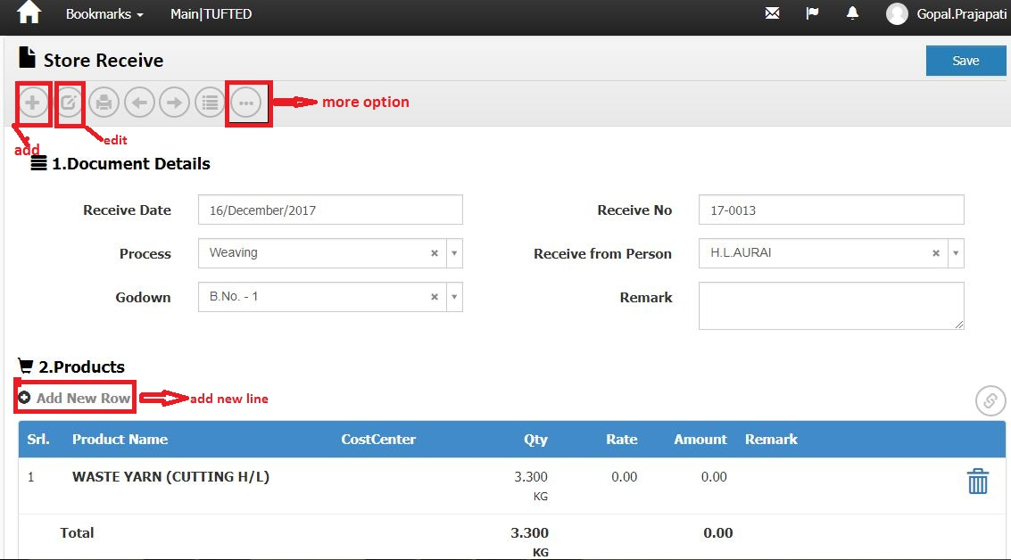

Screenshot No-11

Note: In Screen shot no.11, Double Click on “ Add new Line ” Hyperlink 🡪Open below Screen Shot.

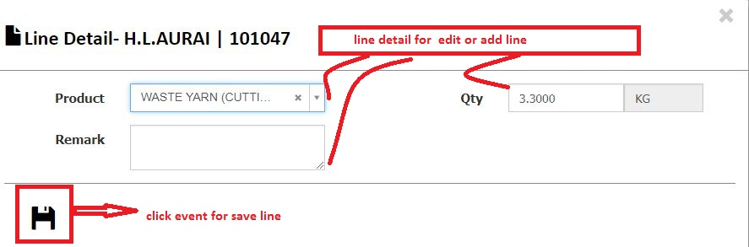

Screen shot no-11A

Business Logic:

**Controller Name**->

1)– StockReceiveHeaderController : This controller has four services for display Material receive List

a) IStockHeaderService

b) IActivityLogService

c) IUnitOfWork

d) IExceptionHandlingService

2)- StockReceiveLineController : This controller has three services for display Material receive List

a) IStockLineService

b) IUnitOfWork

c) IExceptionHandlingService

Action Method: ModifyAfter_Submit (for header) and Index (for Line ) on Edit event: In this Action we get Store receive and Products use method GetStockHeader () and GetStockLineListForIndex ()

**Entity Framework/Services->**

**Services Name:** StockHeaderService and StockLineService 🡪 In this services we define GetStockLineListForIndex () and GetStockHeader ().

DataLogic-

ModelName- StockHeaderViewModel and StockLineViewModel

Action Method for headers:

a) NextPage () ' For Next page

b) PrevPage ()' For Previous page

c) Report () ' For Report

d) GeneratePrints () ' For Generate print.

e) Edit () for modify record

f) index () for list

g) Post () For save record of header

h) create () for create header row

**Dependencies**:

**Data Access Layer  
 (** StockHeaderService & StockLineService )

**Business Logic**(StockReceiveHeaderController & StockReceiveLineController

Controller)

**Presentation Layer (View layer)**

(ModifyAfter_Submit. cstml & Index.cshtml)

**Work Flow: View 🡪 Controller 🡪Model**

**View**: Detail. Chtml & index.cshtml -> clearly us can see design of page

**Controller**: StockReceiveHeaderController and StockReceiveLineController

**Model** : StockHeaderViewModel and StockLineViewModel

**Code Flow**: HTML/Java Script:

Page Name: Create.chtml: In this Page, Make a LoadProducts () function for get Stockline.

Path: ~store/View/stockReceiveheader. var link="/StockReceiveLine/Index/"+groupId;: In This Syntax, StockReceiveLine is Controller Name and Index is Action Method of StockReceiveLineController.cs.

Action Method for Line:

Action Method:'

1. Create ()
2. ModifyLine()
3. ModifyLineAfterSubmit()
4. ModifyLineAfterApprove()
5. Delete()

Edit () for modified record

For Post '

a) FilterPost ()

b) ResultsPost ()

c) CreatePost ()

**Database (Table/Stored procedure/View):-**

**1)-**

|  |  |  |  |
| --- | --- | --- | --- |
| **Web.StockHeaders** | | | |
|
| ColumnName | Datatype | ReferencedTable | ReferencedColumn |
| StockHeaderId | int |  |  |
| DocHeaderId | int |  |  |
| DocTypeId | int | Web.DocumentTypes | DocumentTypeId (FK) |
| DocDate | datetime |  |  |
| DocNo | nvarchar |  |  |
| DivisionId | int | Web.Divisions | DivisionId (FK) |
| SiteId | int | Web.Sites | SiteId (FK) |
| CurrencyId | int | Web.Currencies | ID (FK) |
| PersonId | int | Web.People | PersonID (FK) |
| ProcessId | int | Web.Processes | ProcessId (FK) |
| FromGodownId | int | Web.Godowns | GodownId (FK) |
| GodownId | int | Web.Godowns | GodownId (FK) |
| Remark | nvarchar |  |  |
| Status | int |  |  |
| CreatedBy | nvarchar |  |  |
| CreatedDate | datetime |  |  |
| ModifiedBy | nvarchar |  |  |
| ModifiedDate | datetime |  |  |
| OMSId | nvarchar |  |  |
| CostCenterId | int | Web.CostCenters | CostCenterId (FK) |
| MachineId | int | Web.Machines | MachineId (FK) |
| GatePassHeaderId | int | Web.GatePassHeaders | GatePassHeaderId (FK) |
| LedgerHeaderId | int | Web.LedgerHeaders | LedgerHeaderId (FK) |
| ContraLedgerAccountId | int | Web.LedgerAccounts | LedgerAccountId (FK) |
| ReferenceDocTypeId | int | Web.DocumentTypes | DocumentTypeId (FK) |
| ReferenceDocId | int |  |  |
| LockReason | nvarchar |  |  |
| LedgerAccountId | int |  |  |
| ReviewCount | int |  |  |
| ReviewBy | nvarchar |  |  |
| IsGatePassPrinted | bit |  |  |

|  |  |  |  |
| --- | --- | --- | --- |
| **Web.StockLines** | | | |
|
| ColumnName | Datatype | ReferencedTable | ReferencedColumn |
| StockLineId | int |  |  |
| StockHeaderId | int | Web.StockHeaders | StockHeaderId (FK) |
| ProductUidId | int | Web.ProductUids | ProductUIDId (FK) |
| RequisitionLineId | int | Web.RequisitionLines | RequisitionLineId (FK) |
| ProductId | int | Web.Products | ProductId (FK) |
| FromProcessId | int | Web.Processes | ProcessId (FK) |
| LotNo | nvarchar |  |  |
| Qty | decimal |  |  |
| Remark | nvarchar |  |  |
| Dimension1Id | int | Web.Dimension1 | Dimension1Id (FK) |
| Dimension2Id | int |  |  |
| Specification | nvarchar |  |  |
| Rate | decimal |  |  |
| Amount | decimal |  |  |
| CreatedBy | nvarchar |  |  |
| ModifiedBy | nvarchar |  |  |
| CreatedDate | datetime |  |  |
| ModifiedDate | datetime |  |  |
| OMSId | nvarchar |  |  |
| DocProductId | int | Web.Products | ProductId (FK) |
| DocDimension1 | int | Web.Dimension1 | Dimension1Id (FK) |
| DocDimension2 | int |  |  |
| FromStockId | int | Web.Stocks | StockId (FK) |
| StockId | int | Web.Stocks | StockId (FK) |
| StockProcessHeader_StockProcessHeaderId | int | Web.Stocks | StockId (FK) |
| StockProcessId | int | Web.StockProcesses | StockProcessId (FK) |
| CostCenterId | int | Web.CostCenters | CostCenterId (FK) |
| DocNature | nvarchar |  |  |
| ReferenceDocTypeId | int | Web.DocumentTypes | DocumentTypeId (FK) |
| ReferenceDocId | int |  |  |
| ReferenceDocLineId | int |  |  |
| LockReason | nvarchar |  |  |
| FromStockProcessid | int | Web.StockProcesses | StockProcessId (FK) |
| Sr | int |  |  |
| ProductUidLastTransactionDocId | int |  |  |
| ProductUidLastTransactionDocNo | nvarchar |  |  |
| ProductUidLastTransactionDocTypeId | int | Web.DocumentTypes | DocumentTypeId (FK) |
| ProductUidLastTransactionDocDate | smalldatetime |  |  |
| ProductUidLastTransactionPersonId | int | Web.People | PersonID (FK) |
| ProductUidCurrentGodownId | int | Web.Godowns | GodownId (FK) |
| ProductUidCurrentProcessId | int | Web.Processes | ProcessId (FK) |
| ProductUidStatus | nvarchar |  |  |
| Weight | decimal |  |  |
| Dimension3Id | int | Web.Dimension3 | Dimension3Id (FK) |
| Dimension4Id | int | Web.Dimension4 | Dimension4Id (FK) |
| StockInId | int |  |  |

**3)-**

|  |  |  |  |
| --- | --- | --- | --- |
| **Web.Stocks** | | | |
|
| ColumnName | Datatype | ReferencedTable | ReferencedColumn |
| StockId | int |  |  |
| StockHeaderId | int | Web.StockHeaders | StockHeaderId (FK) |
| ProductId | int | Web.Products | ProductId (FK) |
| ProcessId | int | Web.Processes | ProcessId (FK) |
| GodownId | int | Web.Godowns | GodownId (FK) |
| LotNo | nvarchar |  |  |
| CostCenterId | int | Web.CostCenters | CostCenterId (FK) |
| Qty_Iss | decimal |  |  |
| Qty_Rec | decimal |  |  |
| Rate | decimal |  |  |
| ExpiryDate | datetime |  |  |
| Specification | nvarchar |  |  |
| Dimension1Id | int | Web.Dimension1 | Dimension1Id (FK) |
| Dimension2Id | int |  |  |
| OMSId | nvarchar |  |  |
| CreatedBy | nvarchar |  |  |
| ModifiedBy | nvarchar |  |  |
| CreatedDate | datetime |  |  |
| ModifiedDate | datetime |  |  |
| DocDate | datetime |  |  |
| ProductUidId | int | Web.ProductUids | ProductUIDId (FK) |
| DocLineId | int |  |  |
| DocQty_Iss | decimal |  |  |
| DocQty_Rec | decimal |  |  |
| ReferenceDocTypeId | int | Web.DocumentTypes | DocumentTypeId (FK) |
| ReferenceDocId | int |  |  |
| Remark | nvarchar |  |  |
| Weight_Iss | decimal |  |  |
| Weight_Rec | decimal |  |  |
| DeveloperNotes | nvarchar |  |  |
| StockStatus | nvarchar |  |  |
| Dimension3Id | int | Web.Dimension3 | Dimension3Id (FK) |
| Dimension4Id | int | Web.Dimension4 | Dimension4Id (FK) |
| MfgDate | datetime |  |  |

Material Transfer :->

Note: In Screen shot no. 2, Double Click on “Material Transfer” Hyperlink 🡪Open below Screen Shot.

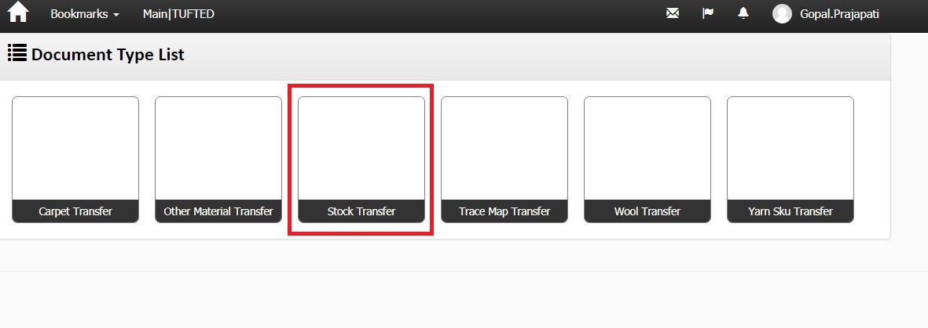

Screenshot No-12

Business Logic:

1. **Controller Name**-> MaterialTransferHeaderController: This controller has four services for display document type list List

a) IStockHeaderService

b) IActivityLogService

c) IUnitOfWork

d) IExceptionHandlingService

Action Method:-

Action Method Name :-> DocumentTypeIndex: In this Action we get document type list list using GetStockHeaderList () method

**Entity Framework/Services->Services Name:** StockHeaderService 🡪 In this services we define GetStockHeaderList ().

DataLogic-

ModelName- StockHeaderViewModel

**Dependencies**:

**Data Access Layer  
 (**StockHeaderService)

**Business Logic**( MaterialTransferHeader Controller )

**Presentation Layer (View layer)**

(DocumentTypeIndex.chtml)

**Work Flow: View 🡪 Controller 🡪Model**

**View**: DocumentTypeIndex.chtml -> clearly us can see design of page

**Controller** MaterialTransferHeaderController Controller

**Model** : StockHeaderViewModel

Note: In Screen shot no. 12, DoubleClick on “Stock transfer” Hyperlink 🡪Open below Screen Shot.

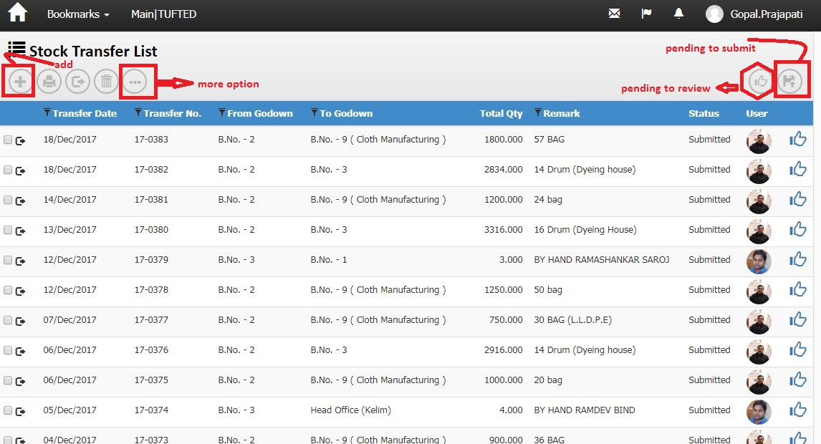

Screenshot No-13

Business Logic:

**1)-Controller Name**-> StockReceiveHeaderController: This controller has four Services for display Material transfer List

a) IStockHeaderService

b) IActivityLogService

c) IUnitOfWork

d) IExceptionHandlingService

2)-Action Method:

Action Method Name :-> Index: In this Action we get Material transfer list using GetStockHeaderList () method

**3)-Entity Framework/Services->**

**Services Name:** StockHeaderService 🡪 In this services we define GetStockHeaderList ().

DataLogic-

ModelName- StockHeaderViewModel

For wizard

Action Method:

A) Index_PendingToSubmit () ‘For Pending submit record.

B) Index_PendingToReview () ’ For Pending Review Record.

c) Delete () ‘for delete a row from list

E) Report () ' For Report

h) Edit () for modify record

i) create () ‘create new row header.

**Dependencies**:

**Data Access Layer  
 (**StockHeaderService)

**Business Logic**(MaterialTransferHeaderController)

**Presentation Layer (View layer)**

(Index.chtml)

**Work Flow: View 🡪 Controller 🡪Model**

**View**: Index.chtml -> clearly us can see design of page

**Controller** MaterialTransferHeaderController

**Model**: StockHeaderViewModel.cs

**Database (Table/Stored procedure/View):-**

|  |  |  |  |
| --- | --- | --- | --- |
| **Web.StockHeaders** | | | |
|
| ColumnName | Datatype | ReferencedTable | ReferencedColumn |
| StockHeaderId | int |  |  |
| DocHeaderId | int |  |  |
| DocTypeId | int | Web.DocumentTypes | DocumentTypeId (FK) |
| DocDate | datetime |  |  |
| DocNo | nvarchar |  |  |
| DivisionId | int | Web.Divisions | DivisionId (FK) |
| SiteId | int | Web.Sites | SiteId (FK) |
| CurrencyId | int | Web.Currencies | ID (FK) |
| PersonId | int | Web.People | PersonID (FK) |
| ProcessId | int | Web.Processes | ProcessId (FK) |
| FromGodownId | int | Web.Godowns | GodownId (FK) |
| GodownId | int | Web.Godowns | GodownId (FK) |
| Remark | nvarchar |  |  |
| Status | int |  |  |
| CreatedBy | nvarchar |  |  |
| CreatedDate | datetime |  |  |
| ModifiedBy | nvarchar |  |  |
| ModifiedDate | datetime |  |  |
| OMSId | nvarchar |  |  |
| CostCenterId | int | Web.CostCenters | CostCenterId (FK) |
| MachineId | int | Web.Machines | MachineId (FK) |
| GatePassHeaderId | int | Web.GatePassHeaders | GatePassHeaderId (FK) |
| LedgerHeaderId | int | Web.LedgerHeaders | LedgerHeaderId (FK) |
| ContraLedgerAccountId | int | Web.LedgerAccounts | LedgerAccountId (FK) |
| ReferenceDocTypeId | int | Web.DocumentTypes | DocumentTypeId (FK) |
| ReferenceDocId | int |  |  |
| LockReason | nvarchar |  |  |
| LedgerAccountId | int |  |  |
| ReviewCount | int |  |  |
| ReviewBy | nvarchar |  |  |
| IsGatePassPrinted | bit |  |  |

Note: In Screen shot no.13, Double Click on “ gridview row ofStock transfer list ” Hyperlink 🡪Open below Screen Shot.

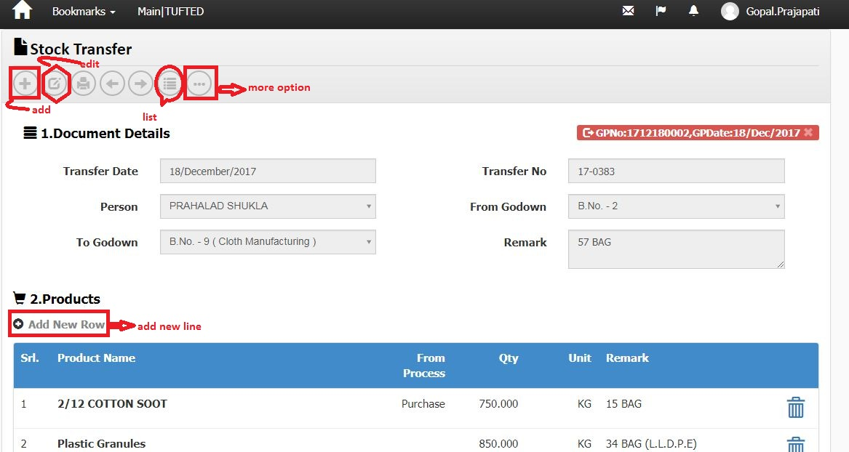

Screenshot No-14

Business Logic:

**Controller Name**->

1)- MaterialTransferHeaderController: This controller has four services for display Material transfer List

a) IStockHeaderService

b) IActivityLogService

c) IUnitOfWork

d) IExceptionHandlingService

2)- MaterialTransferLineController: This controller has three services for display Material transfer List

a) IStockLineService

b) IUnitOfWork

c) IExceptionHandlingService

Action Method: Detail (for header) and Index (for Line ) on Edit event: In this Action we get stock transfer and Products use method GetStockHeader () and GetStockLineListForIndex()

**Entity Framework/Services->**

**Services Name:** StockHeaderService and StockLineService 🡪 In this services we define GetStockLineListForIndex () and GetStockHeader ().

DataLogic-

ModelName- StockHeaderViewModel and StockLineViewModel

Action Method for headers

a) create () create new header row

b) NextPage () ' For Next page

c) PrevPage ()' For Previous page

d) Report () ' For Report

e) GeneratePrints () ' For Generate print.

f) HeaderPost () ' for save record of header.

g) Edit () for modify record

h) index () for list

**Dependencies**:

**Data Access Layer  
 (** StockHeaderService & StockLineService )

**Business Logic**(MaterialTransferHeaderController & MaterialTransferLineController

Controller)

**Presentation Layer (View layer)**

(Detail. cstml & Index.cshtml)

**Work Flow: View 🡪 Controller 🡪Model**

**View**: Detail. Chtml & index.cshtml -> clearly us can see design of page

**Controller**: MaterialTransferHeaderController and MaterialTransferLineController

**Model** : StockHeaderViewModel and StockLineViewModel

**Code Flow**: HTML/Java Script:

Page Name: Create.chtml: In this Page,Make a LoadProducts () function for get Stockline. Path: ~store/View/materialTransferHeader. Var link="/MaterialTransferLine/Index/"+groupId; : In This Syntax, MaterialTransferLine is Controller Name and Index is Action Method of MaterialTransferLineController.cs.

Action Method for Line:

Action Method:'

1. Create ()
2. ModifyLine()
3. ModifyLineAfterSubmit()
4. ModifyLineAfterApprove()
5. Delete()

Edit () for modified record

For Post '

a) FilterPost ()

b) ResultsPost ()

c) CreatePost ()

**Database (Table/Stored procedure/View):-**

**1)-**

|  |  |  |  |
| --- | --- | --- | --- |
| **Web.StockHeaders** | | | |
|
| ColumnName | Datatype | ReferencedTable | ReferencedColumn |
| StockHeaderId | int |  |  |
| DocHeaderId | int |  |  |
| DocTypeId | int | Web.DocumentTypes | DocumentTypeId (FK) |
| DocDate | datetime |  |  |
| DocNo | nvarchar |  |  |
| DivisionId | int | Web.Divisions | DivisionId (FK) |
| SiteId | int | Web.Sites | SiteId (FK) |
| CurrencyId | int | Web.Currencies | ID (FK) |
| PersonId | int | Web.People | PersonID (FK) |
| ProcessId | int | Web.Processes | ProcessId (FK) |
| FromGodownId | int | Web.Godowns | GodownId (FK) |
| GodownId | int | Web.Godowns | GodownId (FK) |
| Remark | nvarchar |  |  |
| Status | int |  |  |
| CreatedBy | nvarchar |  |  |
| CreatedDate | datetime |  |  |
| ModifiedBy | nvarchar |  |  |
| ModifiedDate | datetime |  |  |
| OMSId | nvarchar |  |  |
| CostCenterId | int | Web.CostCenters | CostCenterId (FK) |
| MachineId | int | Web.Machines | MachineId (FK) |
| GatePassHeaderId | int | Web.GatePassHeaders | GatePassHeaderId (FK) |
| LedgerHeaderId | int | Web.LedgerHeaders | LedgerHeaderId (FK) |
| ContraLedgerAccountId | int | Web.LedgerAccounts | LedgerAccountId (FK) |
| ReferenceDocTypeId | int | Web.DocumentTypes | DocumentTypeId (FK) |
| ReferenceDocId | int |  |  |
| LockReason | nvarchar |  |  |
| LedgerAccountId | int |  |  |
| ReviewCount | int |  |  |
| ReviewBy | nvarchar |  |  |
| IsGatePassPrinted | bit |  |  |

2)-

|  |  |  |  |
| --- | --- | --- | --- |
| **Web.StockLines** | | | |
|
| ColumnName | Datatype | ReferencedTable | ReferencedColumn |
| StockLineId | int |  |  |
| StockHeaderId | int | Web.StockHeaders | StockHeaderId (FK) |
| ProductUidId | int | Web.ProductUids | ProductUIDId (FK) |
| RequisitionLineId | int | Web.RequisitionLines | RequisitionLineId (FK) |
| ProductId | int | Web.Products | ProductId (FK) |
| FromProcessId | int | Web.Processes | ProcessId (FK) |
| LotNo | nvarchar |  |  |
| Qty | decimal |  |  |
| Remark | nvarchar |  |  |
| Dimension1Id | int | Web.Dimension1 | Dimension1Id (FK) |
| Dimension2Id | int |  |  |
| Specification | nvarchar |  |  |
| Rate | decimal |  |  |
| Amount | decimal |  |  |
| CreatedBy | nvarchar |  |  |
| ModifiedBy | nvarchar |  |  |
| CreatedDate | datetime |  |  |
| ModifiedDate | datetime |  |  |
| OMSId | nvarchar |  |  |
| DocProductId | int | Web.Products | ProductId (FK) |
| DocDimension1 | int | Web.Dimension1 | Dimension1Id (FK) |
| DocDimension2 | int |  |  |
| FromStockId | int | Web.Stocks | StockId (FK) |
| StockId | int | Web.Stocks | StockId (FK) |
| StockProcessHeader_StockProcessHeaderId | int | Web.Stocks | StockId (FK) |
| StockProcessId | int | Web.StockProcesses | StockProcessId (FK) |
| CostCenterId | int | Web.CostCenters | CostCenterId (FK) |
| DocNature | nvarchar |  |  |
| ReferenceDocTypeId | int | Web.DocumentTypes | DocumentTypeId (FK) |
| ReferenceDocId | int |  |  |
| ReferenceDocLineId | int |  |  |
| LockReason | nvarchar |  |  |
| FromStockProcessid | int | Web.StockProcesses | StockProcessId (FK) |
| Sr | int |  |  |
| ProductUidLastTransactionDocId | int |  |  |
| ProductUidLastTransactionDocNo | nvarchar |  |  |
| ProductUidLastTransactionDocTypeId | int | Web.DocumentTypes | DocumentTypeId (FK) |
| ProductUidLastTransactionDocDate | smalldatetime |  |  |
| ProductUidLastTransactionPersonId | int | Web.People | PersonID (FK) |
| ProductUidCurrentGodownId | int | Web.Godowns | GodownId (FK) |
| ProductUidCurrentProcessId | int | Web.Processes | ProcessId (FK) |
| ProductUidStatus | nvarchar |  |  |
| Weight | decimal |  |  |
| Dimension3Id | int | Web.Dimension3 | Dimension3Id (FK) |
| Dimension4Id | int | Web.Dimension4 | Dimension4Id (FK) |
| StockInId | int |  |  |

**3)-**

|  |  |  |  |
| --- | --- | --- | --- |
| **Web.Stocks** | | | |
|
| ColumnName | Datatype | ReferencedTable | ReferencedColumn |
| StockId | int |  |  |
| StockHeaderId | int | Web.StockHeaders | StockHeaderId (FK) |
| ProductId | int | Web.Products | ProductId (FK) |
| ProcessId | int | Web.Processes | ProcessId (FK) |
| GodownId | int | Web.Godowns | GodownId (FK) |
| LotNo | nvarchar |  |  |
| CostCenterId | int | Web.CostCenters | CostCenterId (FK) |
| Qty_Iss | decimal |  |  |
| Qty_Rec | decimal |  |  |
| Rate | decimal |  |  |
| ExpiryDate | datetime |  |  |
| Specification | nvarchar |  |  |
| Dimension1Id | int | Web.Dimension1 | Dimension1Id (FK) |
| Dimension2Id | int |  |  |
| OMSId | nvarchar |  |  |
| CreatedBy | nvarchar |  |  |
| ModifiedBy | nvarchar |  |  |
| CreatedDate | datetime |  |  |
| ModifiedDate | datetime |  |  |
| DocDate | datetime |  |  |
| ProductUidId | int | Web.ProductUids | ProductUIDId (FK) |
| DocLineId | int |  |  |
| DocQty_Iss | decimal |  |  |
| DocQty_Rec | decimal |  |  |
| ReferenceDocTypeId | int | Web.DocumentTypes | DocumentTypeId (FK) |
| ReferenceDocId | int |  |  |
| Remark | nvarchar |  |  |
| Weight_Iss | decimal |  |  |
| Weight_Rec | decimal |  |  |
| DeveloperNotes | nvarchar |  |  |
| StockStatus | nvarchar |  |  |
| Dimension3Id | int | Web.Dimension3 | Dimension3Id (FK) |
| Dimension4Id | int | Web.Dimension4 | Dimension4Id (FK) |
| MfgDate | datetime |  |  |

Material Exchange:->

NOTE:-> in this section -> (Stock Exchange Controller has been used for both HEADER controller & LINE controller)

Note: In Screen shot no. 2, Double Click on “Material Exchange” Hyperlink 🡪Open below Screen Shot.

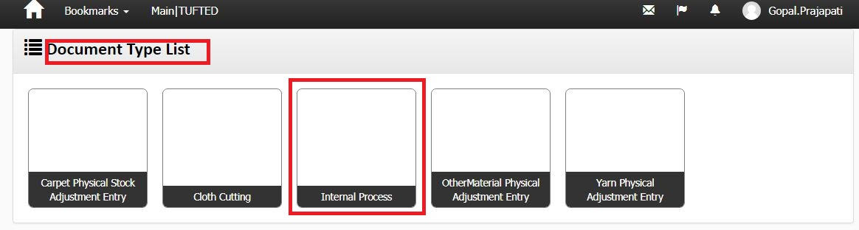

Screen shot No-15

Business Logic:

1. **Controller Name**-> StockExchangeController: This controller has four services for display Material exchange(document type list) List
2. IStockHeaderService

b) IActivityLogService

c) IUnitOfWork

d) IExceptionHandlingService

Action Method:-

Action Method Name :-> DocumentTypeIndex: In this Action we get Materialexchange (document type list) using GetStockHeaderList () method

**Entity Framework/Services->Services Name:** StockHeaderService 🡪 In this services we define GetStockHeaderList ().

DataLogic-

ModelName- StockHeaderViewModel

**Dependencies**:

**Data Access Layer  
 (**StockHeaderService)

**Business Logic**(StockExchangeController )

**Presentation Layer (View layer)**

(DocumentTypeIndex.chtml)

**Work Flow: View 🡪 Controller 🡪Model**

**View**: DocumentTypeIndex.chtml -> clearly us can see design of page

**Controller** StockExchangeController

**Model** : StockHeaderViewModel

Note: In Screen shot no. 15, DoubleClick on “internal process” Hyperlink 🡪Open below Screen Shot.

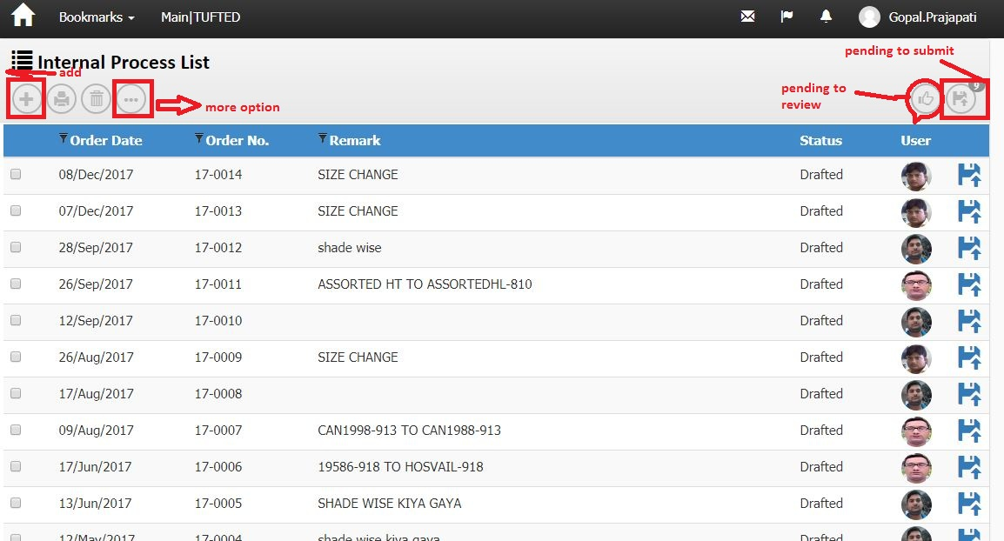

Screenshot No-16

Business Logic:

**1)-Controller Name**-> StockExchangeController: This controller has four Services for display Material exchange List

a) IStockHeaderService

b) IActivityLogService

c) IUnitOfWork

d) IExceptionHandlingService

2)-Action Method:

Action Method Name :-> Index: In this Action we get internalprocesslist (for material list) using GetStockHeaderList () method

**3)-Entity Framework/Services->**

**Services Name:** StockHeaderService 🡪 In this services we define GetStockHeaderList ().

DataLogic-

ModelName- StockHeaderViewModel

For wizard

Action Method:

A) Index_PendingToSubmit () ‘For Pending submit record.

B) Index_PendingToReview () ’ For Pending Review Record.

c) Delete () ‘for delete a row from list

E) Report () ' For Report

h) Edit () for modify record

i) create () ‘create new row header.

**Dependencies**:

**Data Access Layer  
 (**StockHeaderService)

**Business Logic**(StockExchangeController)

**Presentation Layer (View layer)**

(Index.chtml)

**Work Flow: View 🡪 Controller 🡪Model**

**View**: Index.chtml -> clearly us can see design of page

**Controller** StockExchangeController

**Model**: StockHeaderViewModel.cs

**Database (Table/Stored procedure/View):-**

|  |  |  |  |
| --- | --- | --- | --- |
| **Web.StockHeaders** | | | |
|
| ColumnName | Datatype | ReferencedTable | ReferencedColumn |
| StockHeaderId | int |  |  |
| DocHeaderId | int |  |  |
| DocTypeId | int | Web.DocumentTypes | DocumentTypeId (FK) |
| DocDate | datetime |  |  |
| DocNo | nvarchar |  |  |
| DivisionId | int | Web.Divisions | DivisionId (FK) |
| SiteId | int | Web.Sites | SiteId (FK) |
| CurrencyId | int | Web.Currencies | ID (FK) |
| PersonId | int | Web.People | PersonID (FK) |
| ProcessId | int | Web.Processes | ProcessId (FK) |
| FromGodownId | int | Web.Godowns | GodownId (FK) |
| GodownId | int | Web.Godowns | GodownId (FK) |
| Remark | nvarchar |  |  |
| Status | int |  |  |
| CreatedBy | nvarchar |  |  |
| CreatedDate | datetime |  |  |
| ModifiedBy | nvarchar |  |  |
| ModifiedDate | datetime |  |  |
| OMSId | nvarchar |  |  |
| CostCenterId | int | Web.CostCenters | CostCenterId (FK) |
| MachineId | int | Web.Machines | MachineId (FK) |
| GatePassHeaderId | int | Web.GatePassHeaders | GatePassHeaderId (FK) |
| LedgerHeaderId | int | Web.LedgerHeaders | LedgerHeaderId (FK) |
| ContraLedgerAccountId | int | Web.LedgerAccounts | LedgerAccountId (FK) |
| ReferenceDocTypeId | int | Web.DocumentTypes | DocumentTypeId (FK) |
| ReferenceDocId | int |  |  |
| LockReason | nvarchar |  |  |
| LedgerAccountId | int |  |  |
| ReviewCount | int |  |  |
| ReviewBy | nvarchar |  |  |
| IsGatePassPrinted | bit |  |  |

Note: In Screen shot no.16, Double Click on “ gridview row of internal process list ” Hyperlink 🡪Open below Screen Shot.

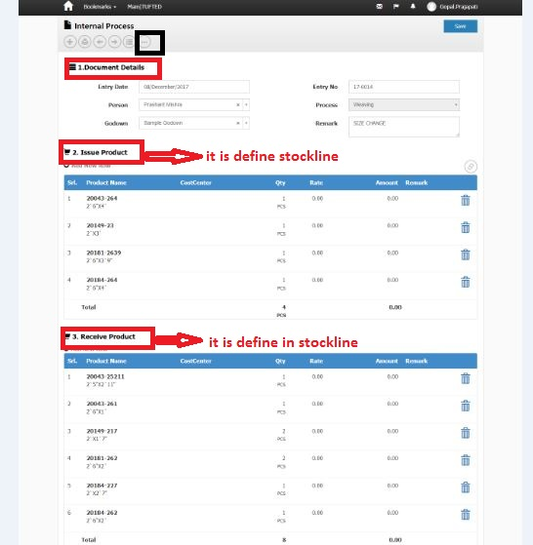

Screen shot no-17

Stock Exchange Controller has been used for both HEADER controller & LINE controller

Business Logic:

**Controller Name**->

1)- StockExchangeController: This controller has four services for display Material exchange (internal process)

a) IStockHeaderService

b) IActivityLogService

c) IUnitOfWork

d) IExceptionHandlingService

2)- StockExchangeController: This controller has four services for display Material transfer List

a) IStocklineService

b) IActivityLogService

c) IUnitOfWork

d) IExceptionHandlingService

Action Method: Modify (for header) and Index (for Line ) on Edit event: In this Action we get material exchange and Products use method GetStockHeader () and GetStockLineListForIndex()

**Entity Framework/Services->**

**Services Name:** StockHeaderService and StockLineService 🡪 In this services we define GetStockLineListForIndex () and GetStockHeader ().

DataLogic-

ModelName- StockHeaderViewModel and StockLineViewModel

Action Method for headers:

a) NextPage () ' For Next page

b) PrevPage ()' For Previous page

c) Report () ' For Report

d) GeneratePrints () ' For Generate print.

e) HeaderPost () ' for save record of header.

f) index () for list

g) Post () For save record of header

h) create () for create header row

**Dependencies**:

**Data Access Layer  
 (** StockHeaderService & StockLineService )

**Business Logic**(StockExchangeController & this single controller use for both Header & Line Controller)

**Presentation Layer (View layer)**

(Modify. cstml & Index.cshtml)

**Work Flow: View 🡪 Controller 🡪Model**

**View**: Modify. Chtml & index.cshtml -> clearly us can see design of page

**Controller**: StockExchangeController (this single controller use for both Header & Line)

**Model** : StockHeaderViewModel and StockLineViewModel

**Code Flow**: HTML/Java Script:

For Line' we use Java Script function on Create.chtml page ' stockexchange’.cs

url: '/StockExchange/ReceiveIndex/'+groupId,

Action Method:'

1. Create ()
2. ModifyLine()
3. ModifyLineAfterSubmit()
4. ModifyLineAfterApprove()
5. Delete()

Edit () for modified record

For Post '

a) FilterPost ()

b) ResultsPost ()

c) CreatePost ()

**Database (Table/Stored procedure/View):-**

**1)-**

|  |  |  |  |
| --- | --- | --- | --- |
| **Web.StockHeaders** | | | |
|
| ColumnName | Datatype | ReferencedTable | ReferencedColumn |
| StockHeaderId | int |  |  |
| DocHeaderId | int |  |  |
| DocTypeId | int | Web.DocumentTypes | DocumentTypeId (FK) |
| DocDate | datetime |  |  |
| DocNo | nvarchar |  |  |
| DivisionId | int | Web.Divisions | DivisionId (FK) |
| SiteId | int | Web.Sites | SiteId (FK) |
| CurrencyId | int | Web.Currencies | ID (FK) |
| PersonId | int | Web.People | PersonID (FK) |
| ProcessId | int | Web.Processes | ProcessId (FK) |
| FromGodownId | int | Web.Godowns | GodownId (FK) |
| GodownId | int | Web.Godowns | GodownId (FK) |
| Remark | nvarchar |  |  |
| Status | int |  |  |
| CreatedBy | nvarchar |  |  |
| CreatedDate | datetime |  |  |
| ModifiedBy | nvarchar |  |  |
| ModifiedDate | datetime |  |  |
| OMSId | nvarchar |  |  |
| CostCenterId | int | Web.CostCenters | CostCenterId (FK) |
| MachineId | int | Web.Machines | MachineId (FK) |
| GatePassHeaderId | int | Web.GatePassHeaders | GatePassHeaderId (FK) |
| LedgerHeaderId | int | Web.LedgerHeaders | LedgerHeaderId (FK) |
| ContraLedgerAccountId | int | Web.LedgerAccounts | LedgerAccountId (FK) |
| ReferenceDocTypeId | int | Web.DocumentTypes | DocumentTypeId (FK) |
| ReferenceDocId | int |  |  |
| LockReason | nvarchar |  |  |
| LedgerAccountId | int |  |  |
| ReviewCount | int |  |  |
| ReviewBy | nvarchar |  |  |
| IsGatePassPrinted | bit |  |  |

2)-

|  |  |  |  |
| --- | --- | --- | --- |
| **Web.StockLines** | | | |
|
| ColumnName | Datatype | ReferencedTable | ReferencedColumn |
| StockLineId | int |  |  |
| StockHeaderId | int | Web.StockHeaders | StockHeaderId (FK) |
| ProductUidId | int | Web.ProductUids | ProductUIDId (FK) |
| RequisitionLineId | int | Web.RequisitionLines | RequisitionLineId (FK) |
| ProductId | int | Web.Products | ProductId (FK) |
| FromProcessId | int | Web.Processes | ProcessId (FK) |
| LotNo | nvarchar |  |  |
| Qty | decimal |  |  |
| Remark | nvarchar |  |  |
| Dimension1Id | int | Web.Dimension1 | Dimension1Id (FK) |
| Dimension2Id | int |  |  |
| Specification | nvarchar |  |  |
| Rate | decimal |  |  |
| Amount | decimal |  |  |
| CreatedBy | nvarchar |  |  |
| ModifiedBy | nvarchar |  |  |
| CreatedDate | datetime |  |  |
| ModifiedDate | datetime |  |  |
| OMSId | nvarchar |  |  |
| DocProductId | int | Web.Products | ProductId (FK) |
| DocDimension1 | int | Web.Dimension1 | Dimension1Id (FK) |
| DocDimension2 | int |  |  |
| FromStockId | int | Web.Stocks | StockId (FK) |
| StockId | int | Web.Stocks | StockId (FK) |
| StockProcessHeader_StockProcessHeaderId | int | Web.Stocks | StockId (FK) |
| StockProcessId | int | Web.StockProcesses | StockProcessId (FK) |
| CostCenterId | int | Web.CostCenters | CostCenterId (FK) |
| DocNature | nvarchar |  |  |
| ReferenceDocTypeId | int | Web.DocumentTypes | DocumentTypeId (FK) |
| ReferenceDocId | int |  |  |
| ReferenceDocLineId | int |  |  |
| LockReason | nvarchar |  |  |
| FromStockProcessid | int | Web.StockProcesses | StockProcessId (FK) |
| Sr | int |  |  |
| ProductUidLastTransactionDocId | int |  |  |
| ProductUidLastTransactionDocNo | nvarchar |  |  |
| ProductUidLastTransactionDocTypeId | int | Web.DocumentTypes | DocumentTypeId (FK) |
| ProductUidLastTransactionDocDate | smalldatetime |  |  |
| ProductUidLastTransactionPersonId | int | Web.People | PersonID (FK) |
| ProductUidCurrentGodownId | int | Web.Godowns | GodownId (FK) |
| ProductUidCurrentProcessId | int | Web.Processes | ProcessId (FK) |
| ProductUidStatus | nvarchar |  |  |
| Weight | decimal |  |  |
| Dimension3Id | int | Web.Dimension3 | Dimension3Id (FK) |
| Dimension4Id | int | Web.Dimension4 | Dimension4Id (FK) |
| StockInId | int |  |  |

**3)-**

|  |  |  |  |
| --- | --- | --- | --- |
| **Web.Stocks** | | | |
|
| ColumnName | Datatype | ReferencedTable | ReferencedColumn |
| StockId | int |  |  |
| StockHeaderId | int | Web.StockHeaders | StockHeaderId (FK) |
| ProductId | int | Web.Products | ProductId (FK) |
| ProcessId | int | Web.Processes | ProcessId (FK) |
| GodownId | int | Web.Godowns | GodownId (FK) |
| LotNo | nvarchar |  |  |
| CostCenterId | int | Web.CostCenters | CostCenterId (FK) |
| Qty_Iss | decimal |  |  |
| Qty_Rec | decimal |  |  |
| Rate | decimal |  |  |
| ExpiryDate | datetime |  |  |
| Specification | nvarchar |  |  |
| Dimension1Id | int | Web.Dimension1 | Dimension1Id (FK) |
| Dimension2Id | int |  |  |
| OMSId | nvarchar |  |  |
| CreatedBy | nvarchar |  |  |
| ModifiedBy | nvarchar |  |  |
| CreatedDate | datetime |  |  |
| ModifiedDate | datetime |  |  |
| DocDate | datetime |  |  |
| ProductUidId | int | Web.ProductUids | ProductUIDId (FK) |
| DocLineId | int |  |  |
| DocQty_Iss | decimal |  |  |
| DocQty_Rec | decimal |  |  |
| ReferenceDocTypeId | int | Web.DocumentTypes | DocumentTypeId (FK) |
| ReferenceDocId | int |  |  |
| Remark | nvarchar |  |  |
| Weight_Iss | decimal |  |  |
| Weight_Rec | decimal |  |  |
| DeveloperNotes | nvarchar |  |  |
| StockStatus | nvarchar |  |  |
| Dimension3Id | int | Web.Dimension3 | Dimension3Id (FK) |
| Dimension4Id | int | Web.Dimension4 | Dimension4Id (FK) |
| MfgDate | datetime |  |  |

Stock Reconciliation:->

Note: In Screen shot no. 2, Double Click on “ StockReconcilition ” Hyperlink 🡪Open below Screen Shot.

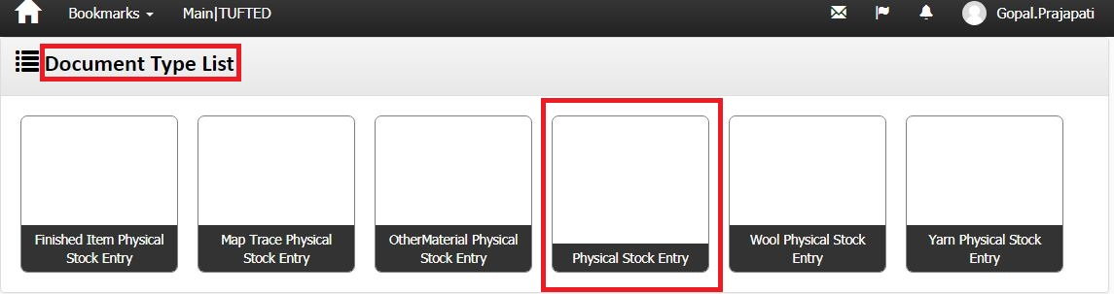

Screenshot no-18

1. **Controller Name**-> StockHeaderController: This controller has four services for display document type list(stock reconcilition) List
2. IStockHeaderService

b) IActivityLogService

c) IUnitOfWork

d) IExceptionHandlingService

Action Method:-

Action Method Name :-> DocumentTypeIndex: In this Action we get stock reconcilition list using GetStockHeaderList () method

**Entity Framework/Services->Services Name:** StockHeaderService 🡪 In this services we define GetStockHeaderList ().

DataLogic-

ModelName- StockHeaderViewModel

**Dependencies**:

**Data Access Layer  
 (**StockHeaderService)

**Business Logic**(StockHeaderController)

**Presentation Layer (View layer)**

(DocumentTypeIndex.chtml)

**Work Flow: View 🡪 Controller 🡪Model**

**View**: DocumentTypeIndex.chtml -> clearly us can see design of page

**Controller** StockHeaderController

**Model** : StockHeaderViewModel

Note: In Screen shot no. 15, DoubleClick on “physical stock entry” Hyperlink 🡪Open below Screen Shot

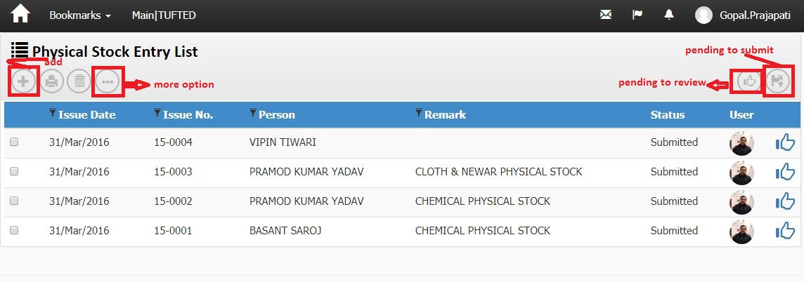

Screenshot no-19

Business Logic:

**1)-Controller Name**-> StockHeaderController: This controller has four Services for display physical stock entry List

a) IStockHeaderService

b) IActivityLogService

c) IUnitOfWork

d) IExceptionHandlingService

2)-Action Method:

Action Method Name :-> Index: In this Action we get physical Stock Entry List (for Stock entry) using GetStockHeaderList () method

**3)-Entity Framework/Services->**

**Services Name:** StockHeaderService 🡪 In this services we define GetStockHeaderList ().  
DataLogic-

ModelName- StockHeaderViewModel

For wizard

Action Method:

A) Index_PendingToSubmit () ‘For Pending submit record.

B) Index_PendingToReview () ’ For Pending Review Record.

c) Delete () ‘for delete a row from list

E) Report () ' For Report

h) Edit () for modify record

i) create () ‘create new row header.

**Dependencies**:

**Data Access Layer  
 (**StockHeaderService)

**Business Logic**(StockHeaderController)

**Presentation Layer (View layer)**

(Index.chtml)

**Work Flow: View 🡪 Controller 🡪Model**

**View**: Index.chtml -> clearly us can see design of page

**Controller** StockHeaderController

**Model**: StockHeaderViewModel.cs

**Database (Table/Stored procedure/View):-**

|  |  |  |  |
| --- | --- | --- | --- |
| **Web.StockHeaders** | | | |
|
| ColumnName | Datatype | ReferencedTable | ReferencedColumn |
| StockHeaderId | int |  |  |
| DocHeaderId | int |  |  |
| DocTypeId | int | Web.DocumentTypes | DocumentTypeId (FK) |
| DocDate | datetime |  |  |
| DocNo | nvarchar |  |  |
| DivisionId | int | Web.Divisions | DivisionId (FK) |
| SiteId | int | Web.Sites | SiteId (FK) |
| CurrencyId | int | Web.Currencies | ID (FK) |
| PersonId | int | Web.People | PersonID (FK) |
| ProcessId | int | Web.Processes | ProcessId (FK) |
| FromGodownId | int | Web.Godowns | GodownId (FK) |
| GodownId | int | Web.Godowns | GodownId (FK) |
| Remark | nvarchar |  |  |
| Status | int |  |  |
| CreatedBy | nvarchar |  |  |
| CreatedDate | datetime |  |  |
| ModifiedBy | nvarchar |  |  |
| ModifiedDate | datetime |  |  |
| OMSId | nvarchar |  |  |
| CostCenterId | int | Web.CostCenters | CostCenterId (FK) |
| MachineId | int | Web.Machines | MachineId (FK) |
| GatePassHeaderId | int | Web.GatePassHeaders | GatePassHeaderId (FK) |
| LedgerHeaderId | int | Web.LedgerHeaders | LedgerHeaderId (FK) |
| ContraLedgerAccountId | int | Web.LedgerAccounts | LedgerAccountId (FK) |
| ReferenceDocTypeId | int | Web.DocumentTypes | DocumentTypeId (FK) |
| ReferenceDocId | int |  |  |
| LockReason | nvarchar |  |  |
| LedgerAccountId | int |  |  |
| ReviewCount | int |  |  |
| ReviewBy | nvarchar |  |  |
| IsGatePassPrinted | bit |  |  |

Note: In Screen shot no.19, Double Click on “ gridviewrow of Physical stock entry list ” Hyperlink 🡪Open below Screen Shot. 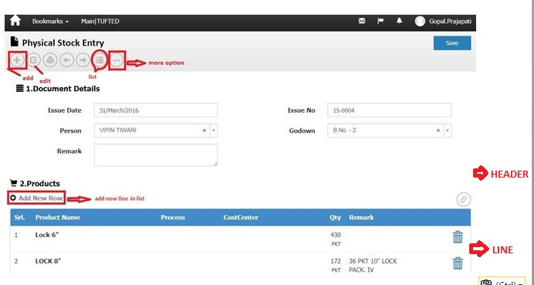 Screenshot no-20

Note: In Screen shot no.20, Double Click on “ Add new line” Hyperlink 🡪Open below Screen Shot.

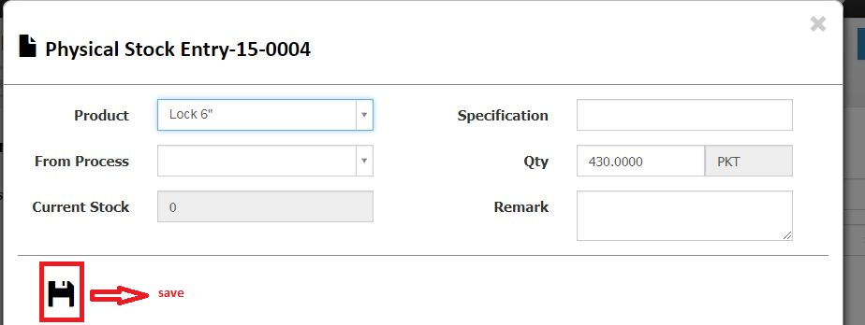

SCREENSHOT NO-20(A)

Business Logic:

**Controller Name**->

1)- StockHeaderController: This controller has four services for display stock reconciliation (physical stock entry)

a) IStockHeaderService

b) IActivityLogService

c) IUnitOfWork

d) IExceptionHandlingService

2)- StockLineController: This controller has three services for display stock reconciliation (physical stock entry)

a) IStocklineService

b) IUnitOfWork

c) IExceptionHandlingService

Action Method: Modify after submit (for header) and Index (for Line ) on Edit event: In this Action we get stock transfer and Products use method GetStockHeader () and GetStockLineListForIndex()

**Entity Framework/Services->**

**Services Name:** StockHeaderService and StockLineService 🡪 In this services we define GetStockLineListForIndex () and GetStockHeader ().

DataLogic-

ModelName- StockHeaderViewModel and StockLineViewModel

Action Method for headers:

a) NextPage () ' For Next page

b) PrevPage ()' For Previous page

c) Report () ' For Report

d) GeneratePrints () ' For Generate print.

e) HeaderPost () ' for save record of header.

f) index () for list

g) Post () For save record of header

h) create () for create header row

i) Edit () for edit a record

**Dependencies**:

**Data Access Layer  
 (** StockHeaderService & StockLineService )

**Business Logic**(StockHeaderController & StockLineController)

**Presentation Layer (View layer)**

(Modify after_submit. cstml & Index.cshtml)

**Work Flow: View 🡪 Controller 🡪Model**

**View**: Modify after_submit . Chtml & index.cshtml -> clearly us can see design of page

**Controller**: StockHeaderController & StockLineController

**Model** : StockHeaderViewModel and StockLineViewModel

**Code Flow**: HTML/Java Script:

For Line' we use Java Script function on Create.chtml page ' stockHeaderController.cs

Syntax' var link="/StockLine/Index/"+groupId;

Action Method:'

1. Create ()
2. ModifyLine()
3. ModifyLineAfterSubmit()
4. ModifyLineAfterApprove()
5. Delete()

Edit () for modified record

For Post '

a) FilterPost ()

b) ResultsPost ()

c) CreatePost ()

**Database (Table/Stored procedure/View):-**

**1)-**

|  |  |  |  |
| --- | --- | --- | --- |
| **Web.StockHeaders** | | | |
|
| ColumnName | Datatype | ReferencedTable | ReferencedColumn |
| StockHeaderId | int |  |  |
| DocHeaderId | int |  |  |
| DocTypeId | int | Web.DocumentTypes | DocumentTypeId (FK) |
| DocDate | datetime |  |  |
| DocNo | nvarchar |  |  |
| DivisionId | int | Web.Divisions | DivisionId (FK) |
| SiteId | int | Web.Sites | SiteId (FK) |
| CurrencyId | int | Web.Currencies | ID (FK) |
| PersonId | int | Web.People | PersonID (FK) |
| ProcessId | int | Web.Processes | ProcessId (FK) |
| FromGodownId | int | Web.Godowns | GodownId (FK) |
| GodownId | int | Web.Godowns | GodownId (FK) |
| Remark | nvarchar |  |  |
| Status | int |  |  |
| CreatedBy | nvarchar |  |  |
| CreatedDate | datetime |  |  |
| ModifiedBy | nvarchar |  |  |
| ModifiedDate | datetime |  |  |
| OMSId | nvarchar |  |  |
| CostCenterId | int | Web.CostCenters | CostCenterId (FK) |
| MachineId | int | Web.Machines | MachineId (FK) |
| GatePassHeaderId | int | Web.GatePassHeaders | GatePassHeaderId (FK) |
| LedgerHeaderId | int | Web.LedgerHeaders | LedgerHeaderId (FK) |
| ContraLedgerAccountId | int | Web.LedgerAccounts | LedgerAccountId (FK) |
| ReferenceDocTypeId | int | Web.DocumentTypes | DocumentTypeId (FK) |
| ReferenceDocId | int |  |  |
| LockReason | nvarchar |  |  |
| LedgerAccountId | int |  |  |
| ReviewCount | int |  |  |
| ReviewBy | nvarchar |  |  |
| IsGatePassPrinted | bit |  |  |

2)-

|  |  |  |  |
| --- | --- | --- | --- |
| **Web.StockLines** | | | |
|
| ColumnName | Datatype | ReferencedTable | ReferencedColumn |
| StockLineId | int |  |  |
| StockHeaderId | int | Web.StockHeaders | StockHeaderId (FK) |
| ProductUidId | int | Web.ProductUids | ProductUIDId (FK) |
| RequisitionLineId | int | Web.RequisitionLines | RequisitionLineId (FK) |
| ProductId | int | Web.Products | ProductId (FK) |
| FromProcessId | int | Web.Processes | ProcessId (FK) |
| LotNo | nvarchar |  |  |
| Qty | decimal |  |  |
| Remark | nvarchar |  |  |
| Dimension1Id | int | Web.Dimension1 | Dimension1Id (FK) |
| Dimension2Id | int |  |  |
| Specification | nvarchar |  |  |
| Rate | decimal |  |  |
| Amount | decimal |  |  |
| CreatedBy | nvarchar |  |  |
| ModifiedBy | nvarchar |  |  |
| CreatedDate | datetime |  |  |
| ModifiedDate | datetime |  |  |
| OMSId | nvarchar |  |  |
| DocProductId | int | Web.Products | ProductId (FK) |
| DocDimension1 | int | Web.Dimension1 | Dimension1Id (FK) |
| DocDimension2 | int |  |  |
| FromStockId | int | Web.Stocks | StockId (FK) |
| StockId | int | Web.Stocks | StockId (FK) |
| StockProcessHeader_StockProcessHeaderId | int | Web.Stocks | StockId (FK) |
| StockProcessId | int | Web.StockProcesses | StockProcessId (FK) |
| CostCenterId | int | Web.CostCenters | CostCenterId (FK) |
| DocNature | nvarchar |  |  |
| ReferenceDocTypeId | int | Web.DocumentTypes | DocumentTypeId (FK) |
| ReferenceDocId | int |  |  |
| ReferenceDocLineId | int |  |  |
| LockReason | nvarchar |  |  |
| FromStockProcessid | int | Web.StockProcesses | StockProcessId (FK) |
| Sr | int |  |  |
| ProductUidLastTransactionDocId | int |  |  |
| ProductUidLastTransactionDocNo | nvarchar |  |  |
| ProductUidLastTransactionDocTypeId | int | Web.DocumentTypes | DocumentTypeId (FK) |
| ProductUidLastTransactionDocDate | smalldatetime |  |  |
| ProductUidLastTransactionPersonId | int | Web.People | PersonID (FK) |
| ProductUidCurrentGodownId | int | Web.Godowns | GodownId (FK) |
| ProductUidCurrentProcessId | int | Web.Processes | ProcessId (FK) |
| ProductUidStatus | nvarchar |  |  |
| Weight | decimal |  |  |
| Dimension3Id | int | Web.Dimension3 | Dimension3Id (FK) |
| Dimension4Id | int | Web.Dimension4 | Dimension4Id (FK) |
| StockInId | int |  |  |

Carpet stock reconciliation:->

Note: In Screen shot no. 2, Double Click on “ Carpet StockReconcilition ” Hyperlink 🡪Open below Screen Shot.

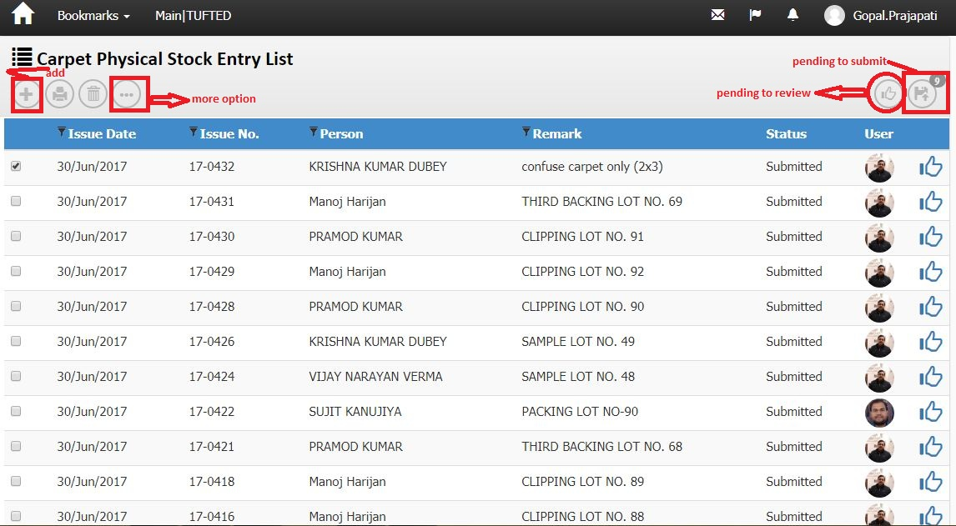

Screenshot no-21

Business Logic:

**1)-Controller Name**-> StockHeaderController: This controller has four Services for display carpet physical stock entry List

a) IStockHeaderService

b) IActivityLogService

c) IUnitOfWork

d) IExceptionHandlingService

2)-Action Method:

Action Method Name :-> Index: In this Action we get carpet physical stock entry List(for Stock entry) using GetStockHeaderList () method

**3)-Entity Framework/Services->**

**Services Name:** StockHeaderService 🡪 In this services we define GetStockHeaderList ().  
DataLogic-

ModelName- StockHeaderViewModel

For wizard

Action Method:

A) Index_PendingToSubmit () ‘For Pending submit record.

B) Index_PendingToReview () ’ For Pending Review Record.

c) Delete () ‘for delete a row from list

E) Report () ' For Report

h) Edit () for modify record

i) create () ‘create new row header.

**Dependencies**:

**Data Access Layer  
 (**StockHeaderService)

**Business Logic**(StockHeaderController)

**Presentation Layer (View layer)**

(Index.chtml)

**Work Flow: View 🡪 Controller 🡪Model**

**View**: Index.chtml -> clearly us can see design of page

**Controller** StockHeaderController

**Model**: StockHeaderViewModel.cs

**Database (Table/Stored procedure/View):-**

|  |  |  |  |
| --- | --- | --- | --- |
| **Web.StockHeaders** | | | |
|
| ColumnName | Datatype | ReferencedTable | ReferencedColumn |
| StockHeaderId | int |  |  |
| DocHeaderId | int |  |  |
| DocTypeId | int | Web.DocumentTypes | DocumentTypeId (FK) |
| DocDate | datetime |  |  |
| DocNo | nvarchar |  |  |
| DivisionId | int | Web.Divisions | DivisionId (FK) |
| SiteId | int | Web.Sites | SiteId (FK) |
| CurrencyId | int | Web.Currencies | ID (FK) |
| PersonId | int | Web.People | PersonID (FK) |
| ProcessId | int | Web.Processes | ProcessId (FK) |
| FromGodownId | int | Web.Godowns | GodownId (FK) |
| GodownId | int | Web.Godowns | GodownId (FK) |
| Remark | nvarchar |  |  |
| Status | int |  |  |
| CreatedBy | nvarchar |  |  |
| CreatedDate | datetime |  |  |
| ModifiedBy | nvarchar |  |  |
| ModifiedDate | datetime |  |  |
| OMSId | nvarchar |  |  |
| CostCenterId | int | Web.CostCenters | CostCenterId (FK) |
| MachineId | int | Web.Machines | MachineId (FK) |
| GatePassHeaderId | int | Web.GatePassHeaders | GatePassHeaderId (FK) |
| LedgerHeaderId | int | Web.LedgerHeaders | LedgerHeaderId (FK) |
| ContraLedgerAccountId | int | Web.LedgerAccounts | LedgerAccountId (FK) |
| ReferenceDocTypeId | int | Web.DocumentTypes | DocumentTypeId (FK) |
| ReferenceDocId | int |  |  |
| LockReason | nvarchar |  |  |
| LedgerAccountId | int |  |  |
| ReviewCount | int |  |  |
| ReviewBy | nvarchar |  |  |
| IsGatePassPrinted | bit |  |  |

Note: In Screen shot no.21, Double Click on “ gridview row of Carpet Physical stock entry ” Hyperlink 🡪Open below Screen Shot. 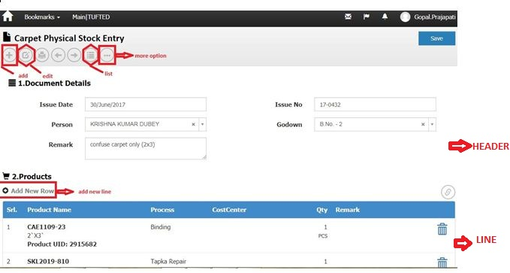Screenshot no-22

**Controller Name**->

1)- StockHeaderController: This controller has four services for display carpet physical stock reconciliation product

a) IStockHeaderService

b) IActivityLogService

c) IUnitOfWork

d) IExceptionHandlingService

2)- StockLineController: This controller has three services for display carpet physical stock reconciliation

a) IStocklineService

b) IUnitOfWork

c) IExceptionHandlingService

Action Method: Modify after submit (for header) and Index (for Line ) on Edit event: In this Action we get carpet physical stock reconcilition and Products use method GetStockHeader () and GetStockLineListForIndex()

**Entity Framework/Services->**

**Services Name:** StockHeaderService and StockLineService 🡪 In this services we define GetStockLineListForIndex () and GetStockHeader ().

DataLogic-

ModelName- StockHeaderViewModel and StockLineViewModel

Action Method for headers:

a) NextPage () ' For Next page

b) PrevPage ()' For Previous page

c) Report () ' For Report

d) GeneratePrints () ' For Generate print.

e) HeaderPost () ' for save record of header.

f) index () for list

g) Post () For save record of header

h) create () for create header row

i) Edit () for edit a record

**Dependencies**:

**Data Access Layer  
 (** StockHeaderService & StockLineService )

**Business Logic**(StockHeaderController & StockLineController)

**Presentation Layer (View layer)**

(Modify after_submit. cstml & Index.cshtml)

**Work Flow: View 🡪 Controller 🡪Model**

**View**: Modify after_submit . Chtml & index.cshtml -> clearly us can see design of page

**Controller**: StockHeaderController & StockLineController

**Model** : StockHeaderViewModel and StockLineViewModel

**Code Flow**: HTML/Java Script:

For Line' we use Java Script function on Create.chtml page ' stockheadercontroller.cs

Syntax' var link="/StockLine/Index/"+groupId;

Action Method:'

1. Create ()
2. ModifyLine()
3. ModifyLineAfterSubmit()
4. ModifyLineAfterApprove()
5. Delete()

Edit () for modified record

For Post '

a) FilterPost ()

b) ResultsPost ()

c) CreatePost ()

**Database (Table/Stored procedure/View):-**

**1)-**

|  |  |  |  |
| --- | --- | --- | --- |
| **Web.StockHeaders** | | | |
|
| ColumnName | Datatype | ReferencedTable | ReferencedColumn |
| StockHeaderId | int |  |  |
| DocHeaderId | int |  |  |
| DocTypeId | int | Web.DocumentTypes | DocumentTypeId (FK) |
| DocDate | datetime |  |  |
| DocNo | nvarchar |  |  |
| DivisionId | int | Web.Divisions | DivisionId (FK) |
| SiteId | int | Web.Sites | SiteId (FK) |
| CurrencyId | int | Web.Currencies | ID (FK) |
| PersonId | int | Web.People | PersonID (FK) |
| ProcessId | int | Web.Processes | ProcessId (FK) |
| FromGodownId | int | Web.Godowns | GodownId (FK) |
| GodownId | int | Web.Godowns | GodownId (FK) |
| Remark | nvarchar |  |  |
| Status | int |  |  |
| CreatedBy | nvarchar |  |  |
| CreatedDate | datetime |  |  |
| ModifiedBy | nvarchar |  |  |
| ModifiedDate | datetime |  |  |
| OMSId | nvarchar |  |  |
| CostCenterId | int | Web.CostCenters | CostCenterId (FK) |
| MachineId | int | Web.Machines | MachineId (FK) |
| GatePassHeaderId | int | Web.GatePassHeaders | GatePassHeaderId (FK) |
| LedgerHeaderId | int | Web.LedgerHeaders | LedgerHeaderId (FK) |
| ContraLedgerAccountId | int | Web.LedgerAccounts | LedgerAccountId (FK) |
| ReferenceDocTypeId | int | Web.DocumentTypes | DocumentTypeId (FK) |
| ReferenceDocId | int |  |  |
| LockReason | nvarchar |  |  |
| LedgerAccountId | int |  |  |
| ReviewCount | int |  |  |
| ReviewBy | nvarchar |  |  |
| IsGatePassPrinted | bit |  |  |

2)-

|  |  |  |  |
| --- | --- | --- | --- |
| **Web.StockLines** | | | |
|
| ColumnName | Datatype | ReferencedTable | ReferencedColumn |
| StockLineId | int |  |  |
| StockHeaderId | int | Web.StockHeaders | StockHeaderId (FK) |
| ProductUidId | int | Web.ProductUids | ProductUIDId (FK) |
| RequisitionLineId | int | Web.RequisitionLines | RequisitionLineId (FK) |
| ProductId | int | Web.Products | ProductId (FK) |
| FromProcessId | int | Web.Processes | ProcessId (FK) |
| LotNo | nvarchar |  |  |
| Qty | decimal |  |  |
| Remark | nvarchar |  |  |
| Dimension1Id | int | Web.Dimension1 | Dimension1Id (FK) |
| Dimension2Id | int |  |  |
| Specification | nvarchar |  |  |
| Rate | decimal |  |  |
| Amount | decimal |  |  |
| CreatedBy | nvarchar |  |  |
| ModifiedBy | nvarchar |  |  |
| CreatedDate | datetime |  |  |
| ModifiedDate | datetime |  |  |
| OMSId | nvarchar |  |  |
| DocProductId | int | Web.Products | ProductId (FK) |
| DocDimension1 | int | Web.Dimension1 | Dimension1Id (FK) |
| DocDimension2 | int |  |  |
| FromStockId | int | Web.Stocks | StockId (FK) |
| StockId | int | Web.Stocks | StockId (FK) |
| StockProcessHeader_StockProcessHeaderId | int | Web.Stocks | StockId (FK) |
| StockProcessId | int | Web.StockProcesses | StockProcessId (FK) |
| CostCenterId | int | Web.CostCenters | CostCenterId (FK) |
| DocNature | nvarchar |  |  |
| ReferenceDocTypeId | int | Web.DocumentTypes | DocumentTypeId (FK) |
| ReferenceDocId | int |  |  |
| ReferenceDocLineId | int |  |  |
| LockReason | nvarchar |  |  |
| FromStockProcessid | int | Web.StockProcesses | StockProcessId (FK) |
| Sr | int |  |  |
| ProductUidLastTransactionDocId | int |  |  |
| ProductUidLastTransactionDocNo | nvarchar |  |  |
| ProductUidLastTransactionDocTypeId | int | Web.DocumentTypes | DocumentTypeId (FK) |
| ProductUidLastTransactionDocDate | smalldatetime |  |  |
| ProductUidLastTransactionPersonId | int | Web.People | PersonID (FK) |
| ProductUidCurrentGodownId | int | Web.Godowns | GodownId (FK) |
| ProductUidCurrentProcessId | int | Web.Processes | ProcessId (FK) |
| ProductUidStatus | nvarchar |  |  |
| Weight | decimal |  |  |
| Dimension3Id | int | Web.Dimension3 | Dimension3Id (FK) |
| Dimension4Id | int | Web.Dimension4 | Dimension4Id (FK) |
| StockInId | int |  |  |

Bar Code History:->

Note: In Screen shot no. 2, Double Click on “Bar code History” Hyperlink 🡪Open below Screen Shot.

### C:\Users\Madan\Contacts\Desktop\Capture barcode.JPG

Screenshot no-23

Business Logic:

**1)-Controller Name**-> BarCodeHistoryController : This controller has two Services for display carpet physical BarCode Detail

a) IUnitOfWork

b) IExceptionHandlingService

2)-Action Method:

Action Method Name :-> Index: In this Action we get only show the detail or history of BarCode

And we get history from stock table and generated (show) BarCode number in productUidtable.

**Database (Table/Stored procedure/View):-**

1):->

|  |  |  |  |
| --- | --- | --- | --- |
| **Web.Stocks** | | | |
|
| ColumnName | Datatype | ReferencedTable | ReferencedColumn |
| StockId | int |  |  |
| StockHeaderId | int | Web.StockHeaders | StockHeaderId (FK) |
| ProductId | int | Web.Products | ProductId (FK) |
| ProcessId | int | Web.Processes | ProcessId (FK) |
| GodownId | int | Web.Godowns | GodownId (FK) |
| LotNo | nvarchar |  |  |
| CostCenterId | int | Web.CostCenters | CostCenterId (FK) |
| Qty_Iss | decimal |  |  |
| Qty_Rec | decimal |  |  |
| Rate | decimal |  |  |
| ExpiryDate | datetime |  |  |
| Specification | nvarchar |  |  |
| Dimension1Id | int | Web.Dimension1 | Dimension1Id (FK) |
| Dimension2Id | int |  |  |
| OMSId | nvarchar |  |  |
| CreatedBy | nvarchar |  |  |
| ModifiedBy | nvarchar |  |  |
| CreatedDate | datetime |  |  |
| ModifiedDate | datetime |  |  |
| DocDate | datetime |  |  |
| ProductUidId | int | Web.ProductUids | ProductUIDId (FK) |
| DocLineId | int |  |  |
| DocQty_Iss | decimal |  |  |
| DocQty_Rec | decimal |  |  |
| ReferenceDocTypeId | int | Web.DocumentTypes | DocumentTypeId (FK) |
| ReferenceDocId | int |  |  |
| Remark | nvarchar |  |  |
| Weight_Iss | decimal |  |  |
| Weight_Rec | decimal |  |  |
| DeveloperNotes | nvarchar |  |  |
| StockStatus | nvarchar |  |  |
| Dimension3Id | int | Web.Dimension3 | Dimension3Id (FK) |
| Dimension4Id | int | Web.Dimension4 | Dimension4Id (FK) |
| MfgDate | datetime |  |  |

2):->

|  |  |  |  |
| --- | --- | --- | --- |
| **web.ProductUids** | | | |
|
| ColumnName | Datatype | ReferencedTable | ReferencedColumn |
| ProductUIDId | int |  |  |
| ProductUidName | nvarchar |  |  |
| ProductId | int | Web.Products | ProductId (FK) |
| IsActive | bit |  |  |
| CreatedBy | nvarchar |  |  |
| ModifiedBy | nvarchar |  |  |
| CreatedDate | datetime |  |  |
| ModifiedDate | datetime |  |  |
| OMSId | nvarchar |  |  |
| GenDocId | int |  |  |
| GenDocNo | nvarchar |  |  |
| GenDocTypeId | int |  |  |
| GenDocDate | smalldatetime |  |  |
| GenPersonId | int | Web.People | PersonID (FK) |
| LastTransactionDocId | int |  |  |
| LastTransactionDocNo | nvarchar |  |  |
| LastTransactionDocTypeId | int |  |  |
| LastTransactionDocDate | smalldatetime |  |  |
| LastTransactionPersonId | int | Web.People | PersonID (FK) |
| CurrenctGodownId | int |  |  |
| CurrenctProcessId | int |  |  |
| Status | nvarchar |  |  |
| Dimension1Id | int |  |  |
| LotNo | nvarchar |  |  |
| Dimension2Id | int |  |  |
| GenLineId | int |  |  |
| ProcessesDone | nvarchar |  |  |
| Special_Marks | nvarchar |  |  |
| LastTransactionLineId | int |  |  |
| ProductUidHeaderId | int | Web.ProductUidHeaders | ProductUIDHeaderId (FK) |
| Dimension3Id | int | Web.Dimension3 | Dimension3Id (FK) |
| Dimension4Id | int | Web.Dimension4 | Dimension4Id (FK) |
| ProductUidSpecification | nvarchar |  |  |
| MfgDate | datetime |  |  |
| ProductUidSpecification1 | nvarchar |  |  |
| SaleOrderLineId | int | Web.SaleOrderLines | SaleOrderLineId (FK) |

Setup:->

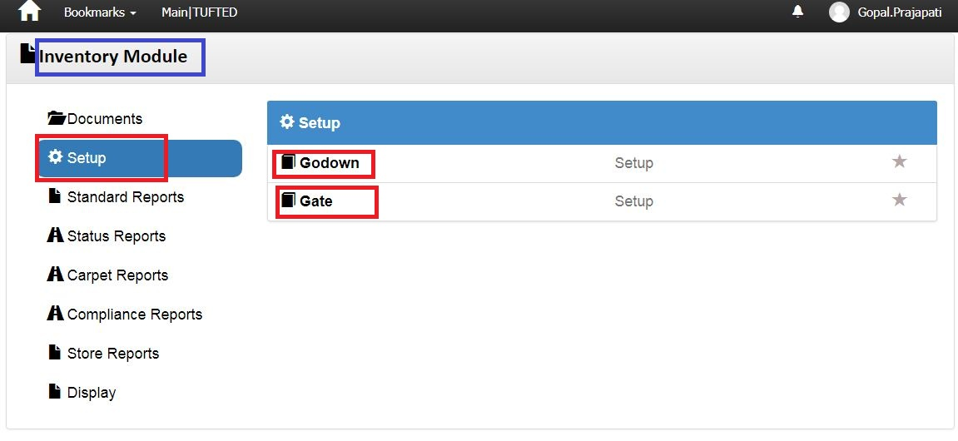

Screenshot no-24

Business Logic:

1. **Controller Name**-> MenuController : Menu controller has two services for display menu

**a)-** IModuleService

b)-ISubModuleService

c)- IUnitOfWork

Action Method: Module: In this Action method we identify particular user Role and then execute GetModuleList () and GetModuleListForUser ().

Finally Return Module and SubModule View based on condition.

DataLogic-

ModelName- SubModuleViewModel.cs

**Dependencies**:

**Data Access Layer  
 (**SubModuleService)

**Business Logic**

(Menu Controller)

**Presentation Layer (View layer)**

(Submodule.chtml)

**Work Flow: View 🡪 Controller 🡪Model**

**View**: Submodule.chtml -> clearly us can see design of page

**Controller**: Menu Controller

**Model**: MenuViewModel / SubModuleViewModel

**Database (Table/Stored procedure/View)**

|  |  |  |  |
| --- | --- | --- | --- |
|  | web.MenuSubModules |  |  |
| **Fields** | **DataType** | **Constrain** | **Remark** |
| SubModuleId | INT IDENTITY NOT NULL, | PRIMARY KEY |  |
| SubModuleName | NVARCHAR (50) NOT NULL, |  |  |
| IconName | NVARCHAR (100) NOT NULL, |  |  |
| IsActive | BIT DEFAULT ((1)) NOT NULL, |  |  |
| CreatedBy | NVARCHAR (max), |  |  |
| ModifiedBy | NVARCHAR (max), |  |  |
| CreatedDate | DATETIME NOT NULL, |  |  |
| ModifiedDate | DATETIME NOT NULL, |  |  |
| OMSId | NVARCHAR (50), |  |  |

Godown:->

Note: In Screen shot no. 24, DoubleClick on “Godown” Hyperlink 🡪Open below Screen Shot.

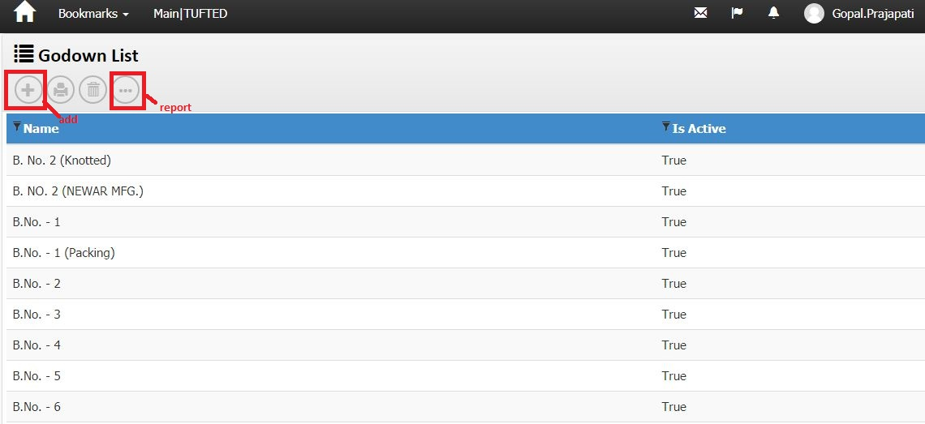

Screenshot no-25

Business Logic:

**1)-Controller Name**-> GodownController: This controller has three Services for display Godown List

a) IGodownService

b) IUnitOfWork

c) IExceptionHandlingService

2)-Action Method:

Action Method Name :-> Index: In this Action we get Godown list using GetGodownList () method

**3)-Entity Framework/Services->**

**Services Name:->** GodownService:🡪 In this services we define GetGodownList ().

DataLogic-

ModelName- Godown

For wizard

Action Method:

c) Delete () ‘for delete a row from list

E) Report () ' For Report

h) Edit () for modify record

i) create () ‘create new row header.

**Dependencies**:

**Data Access Layer  
 (**GodownService)

**Business Logic**(GodownController)

**Presentation Layer (View layer)**

(Index.chtml)

**Work Flow: View 🡪 Controller 🡪Model**

**View**: Index.chtml -> clearly us can see design of page

**Controller** GodownController

**Model**:-> Godown

**Database (Table/Stored procedure/View)**

|  |  |  |  |
| --- | --- | --- | --- |
| **web.Godowns** | | | |
|
| ColumnName | Datatype | ReferencedTable | ReferencedColumn |
| GodownId | int |  |  |
| GodownName | nvarchar |  |  |
| SiteId | int | Web.Sites | SiteId (FK) |
| IsActive | bit |  |  |
| CreatedBy | nvarchar |  |  |
| ModifiedBy | nvarchar |  |  |
| CreatedDate | datetime |  |  |
| ModifiedDate | datetime |  |  |
| OMSId | nvarchar |  |  |
| Site_SiteId | int |  |  |
| GateId | int | Web.Gates | GateId (FK) |
| DocTypeId | int | Web.DocumentTypes | DocumentTypeId (FK) |
| GodownCode | nvarchar |  |  |
| PersonId | int | Web.People | PersonID (FK) |

Gate:->

Note: In Screen shot no. 24, DoubleClick on “Gate” Hyperlink 🡪Open below Screen Shot.

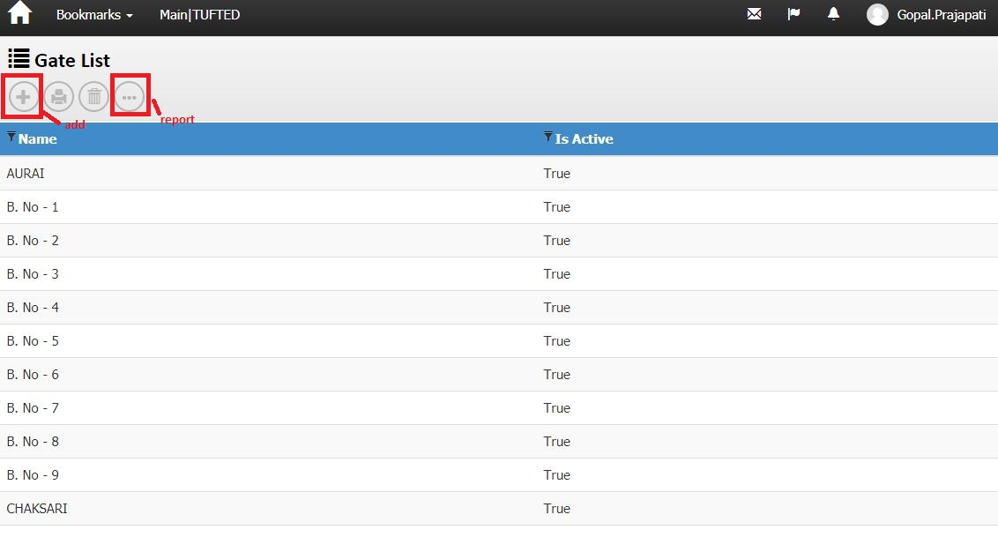

Screenshot no-26

Business Logic:

**1)-Controller Name**-> GateController: This controller has three Services for display Gate List

a) IGateService

b) IUnitOfWork

c) IExceptionHandlingService

2)-Action Method:

Action Method Name :-> Index: In this Action we get Gate list using GetGateList() method

**3)-Entity Framework/Services->**

**Services Name:->** GateService:🡪 In this services we define GetGateList().

DataLogic-

ModelName- Gate

For wizard

Action Method:

c) Delete () ‘for delete a row from list

E) Report () ' For Report

h) Edit () for modify record

i) create () ‘create new row header.

**Dependencies**:

**Data Access Layer  
 (**GateService)

**Business Logic**(GateController)

**Presentation Layer (View layer)**

(Index.chtml)

**Work Flow: View 🡪 Controller 🡪Model**

**View**: Index.chtml -> clearly us can see design of page

**Controller** GateController

**Model**:-> Gate

**Database (Table/Stored procedure/View)**

|  |  |  |  |
| --- | --- | --- | --- |
| **web.** **Gates** | | | |
|
| ColumnName | Datatype | ReferencedTable | ReferencedColumn |
| GateId | int |  |  |
| GateName | nvarchar |  |  |
| SiteId | int | Web.Sites | SiteId (FK) |
| IsActive | bit |  |  |
| CreatedBy | nvarchar |  |  |
| ModifiedBy | nvarchar |  |  |
| CreatedDate | datetime |  |  |
| ModifiedDate | datetime |  |  |
| OMSId | nvarchar |  |  |
| Site_SiteId | int |  |  |

Note: In Screen shot no. 24, DoubleClick on “Gate” Hyperlink 🡪Open below Screen Shot.

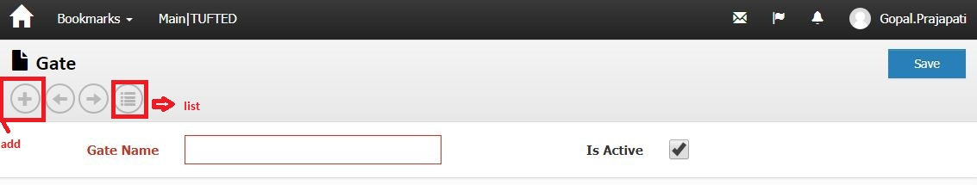

**Controller Name**-> GateController

Action Method Name :-> Create