Design Flow:
- UI
- Business Logic
- Data Logic
- Custom Controls
- Dependencies
- WORK FLOW ( View -> Controller -> Model -> Entity )
Code Flow:
- UI design pattern – (HTML, Scripts)
- Coding standard and guidelines (Controller, business logic and data access)
Database objects & Schema:
- Database
- Table – Purpose, ER diagram, Model class
- Procedure, Functions, view , custom type
Backlog:
Sort Description | Detailed Description | Effort | Type (Functional/Technical) | Requested By

Created Date | Created by | Review Date | Review by

Login UI:
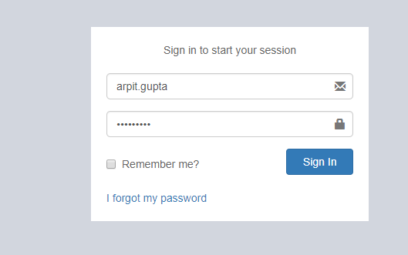

Business Logic and Module: We use Microsoft Asp.net Identity 2.0 Feature for Login Credential.
Click on Sign in Button → Open below Screen shot (SiteSelection Page).
Dependencies: Microsoft Asp.net Identity 2.0 (Only for login)

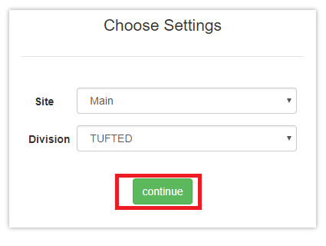Screen Shot no.1

Business Logic:
1: Controller Name -> SiteSelectionController: SiteSelection controller has seven services for use.
- ISiteSelectionService
- IUserRolesService
- ImoduleService
- IUserBookMarkService
- ICompanySettingsService
- ICompanyService
- IRolesControllerActionService
Action Method -> SiteSelection: To display site selection screen we use GetUserId method of SiteSelection controller and after that we identify for particular Roles.
Below Methods are given for User Role and Roles list.
- GetUserRolesList()
- GetRolesList()
To bind dropdown list we use below method.
- GetSiteList()
- GetDivisionList()
Data Logic→ 1: For Roles.
View Model Name/Model: UserRoleViewModel, UserRole, UserProfile, UserReferral:
In this View Model and Model we declare all property related to roles.
2: For Site & Division.
View Model Name/Model: Site/ Division
In this view model and model we declare all property related site and Division.
Entity Framework/Services->1: for Roles
Services Name: UserService: In this service has GetUserRolesList ()
In which is define in UserReferralService interface.
2: For Site & Division
Service Name: SiteService: In this service has GetSiteList () in which is define in SiteService interface.
DivisionService: In this service has GetDivisionList () in which is define in
DivisionService interface.
Dependencies:
Data Access Layer
(UserService & SiteService & DivisionService)

Business Logic
(SiteSelection Controller)

Presentation Layer (View layer)
(SiteSelection.chtml)

Work Flow: View → Controller →Model
View: SiteSelection.chtml -> clearly we can see design of page in screen shot no .1
Controller: SiteSelectionController
Model: UserRoleViewModel, UserRole, UserProfile and UserReferral

Database (Table/Stored procedure /View):
1. | Web.Menus
MenuId | INT IDENTITY NOT NULL, | PRIMARY KEY
MenuName | NVARCHAR (50) NOT NULL,
Srl | NVARCHAR (5) NOT NULL,
IconName | NVARCHAR (100) NOT NULL,
Description | NVARCHAR (100) NOT NULL,
ModuleId | INT NOT NULL,
SubModuleId | INT NOT NULL,
ControllerActionId | INT NOT NULL,
RouteId | NVARCHAR (max),
IsActive | BIT DEFAULT ((1)) NOT NULL,
CreatedBy | NVARCHAR (max),
ModifiedBy | NVARCHAR (max),
CreatedDate | DATETIME NOT NULL,
ModifiedDate | DATETIME NOT NULL,
URL | NVARCHAR (100),
IsVisible | BIT,
isDivisionBased | BIT DEFAULT ((0)),
isSiteBased | BIT DEFAULT ((0)),
AreaName | NVARCHAR (50),
ControllerName | NVARCHAR (100),
ActionName | NVARCHAR (100),

2. | Web.RolesMenus
RolesMenuId | INT IDENTITY NOT NULL, | PRIMARY KEY
RoleId | NVARCHAR (128),
MenuId | INT NOT NULL,
CreatedBy | NVARCHAR (max),
ModifiedBy | NVARCHAR (max),
CreatedDate | DATETIME NOT NULL,
ModifiedDate | DATETIME NOT NULL,
FullHeaderPermission | BIT DEFAULT ((0)) NOT NULL,
FullLinePermission | BIT DEFAULT ((0)) NOT NULL,
DivisionId | INT DEFAULT ((1)) NOT NULL,
SiteId | INT DEFAULT ((17)) NOT NULL,

3. | Web.Sites
SiteId | INT IDENTITY NOT NULL, | PRIMARY KEY
SiteName | NVARCHAR (50) NOT NULL,
Address | NVARCHAR (250),
PhoneNo | NVARCHAR (50),
CityId | INT,
IsActive | BIT DEFAULT ((1)) NOT NULL,
IsSystemDefine | BIT DEFAULT ((0)) NOT NULL,
CreatedBy | NVARCHAR (max),
ModifiedBy | NVARCHAR (max),
CreatedDate | DATETIME NOT NULL,
ModifiedDate | DATETIME NOT NULL,
OMSId | NVARCHAR (50),
SiteCode | NVARCHAR (20),
DefaultDivisionId | INT,
ThemeColour | NVARCHAR (25),
PersonId | INT,
DefaultGodownId | INT,
DocTypeId | INT,
SiteShortCode | NVARCHAR (2),

4. | Web.RolesSites
RolesSiteId | INT IDENTITY NOT NULL, | PRIMARY KEY
RoleId | NVARCHAR (128),
SiteId | INT NOT NULL,
CreatedBy | NVARCHAR (max),
ModifiedBy | NVARCHAR (max),
CreatedDate | DATETIME NOT NULL,
ModifiedDate | DATETIME NOT NULL,

5. | Web.Divisions
DivisionId | INT IDENTITY NOT NULL, | PRIMARY KEY
DivisionName | NVARCHAR (50) NOT NULL,
Address | NVARCHAR (250),
LstNo | NVARCHAR (20),
CstNo | NVARCHAR (20),
IsActive | BIT DEFAULT ((1)) NOT NULL,
IsSystemDefine | BIT DEFAULT ((0)) NOT NULL,
CreatedBy | NVARCHAR (max),
ModifiedBy | NVARCHAR (max),
CreatedDate | DATETIME NOT NULL,
ModifiedDate | DATETIME NOT NULL,
OMSId | NVARCHAR (50),
CompanyId | INT,
ThemeColour | NVARCHAR (25),
ReportHeaderTextRight1 | NVARCHAR (max),
ReportHeaderTextRight2 | NVARCHAR (max),
ReportHeaderTextRight3 | NVARCHAR (max),
ReportHeaderTextRight4 | NVARCHAR (max),
DivisionShortCode | NVARCHAR (2),
LogoBlob | NVARCHAR (max),

6 | Web.RolesDivisions
RolesDivisionId | INT IDENTITY NOT NULL, | PRIMARY KEY
RoleId | NVARCHAR (128),
DivisionId | INT NOT NULL,
CreatedBy | NVARCHAR (max),
ModifiedBy | NVARCHAR (max),
CreatedDate | DATETIME NOT NULL,
ModifiedDate | DATETIME NOT NULL,

Selection of Godown-> In Screen shot no.1, click on →Continue Button →open Below Screen.
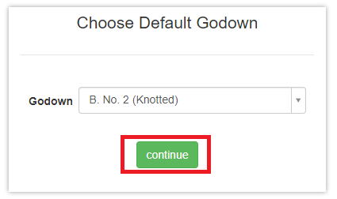
(Screen Shot no.2)
Business logic -> Controller Name: SiteSelectionController
Action Method: DefaultGodownSelection: To display Godown screen we use GetGodownList () function of SiteSelectionController.
To bind the Godown dropdown list using below method.
GetGodownList (): This function is define in IGodownService services.
Data Logic->
View Model Name/Model: Godown.cs
Entity Formwork / Services→
Service Name: ISiteSelectionService, ICompanySettingsService, IGodownService.
Dependencies:
Data Access Layer
(IGodownService, ICompanySettingsService, ISiteSelectionService)

Business Logic
(SiteSelection Controller)

Presentation Layer (View layer)
(DefaultGodownSelection)

Work Flow: View → Controller →Model
View: DefaultGodownSelection.chtml
Controller Name: SiteSelectionController
Model Name: Godown.cs
Database (Table/Stored procedure /View):
 | Web.Godowns
GodownId | INT IDENTITY NOT NULL, | PRIMARY KEY
GodownName | NVARCHAR (50) NOT NULL,
SiteId | INT NOT NULL,
IsActive | BIT DEFAULT ((1)) NOT NULL,
CreatedBy | NVARCHAR (max),
ModifiedBy | NVARCHAR (max),
CreatedDate | DATETIME NOT NULL,
ModifiedDate | DATETIME NOT NULL,
OMSId | NVARCHAR (50),
Site_SiteId | INT,
GateId | INT,
DocTypeId | INT,
GodownCode | NVARCHAR (10),
PersonId | INT,

ACCOUNTS UI:
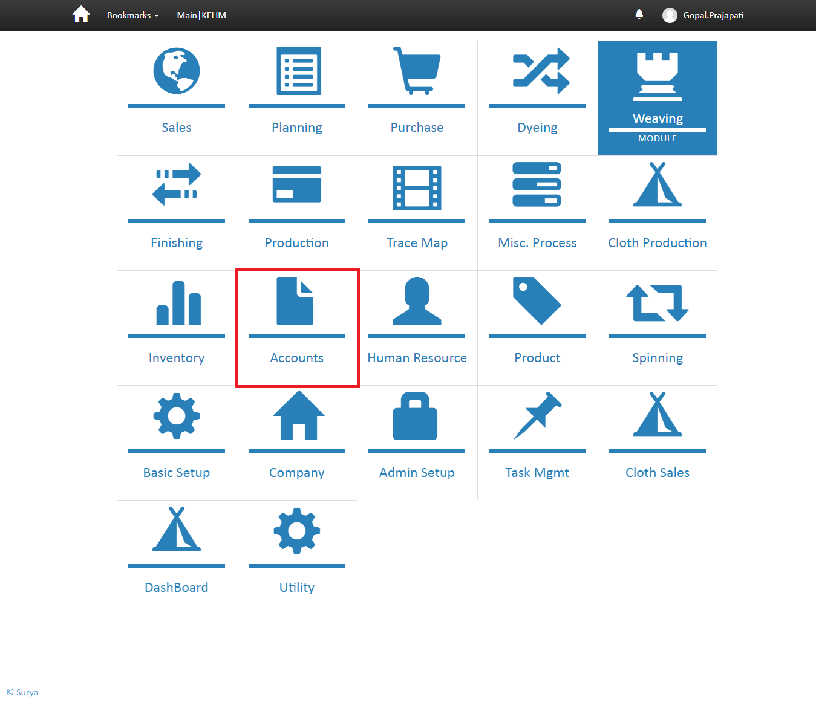
(screen shot No-03)
Business Logic:
Controller Name-> MenuController : Menu controller has three services for display menu
a)-IModuleService
b)-ISubModuleService
c)- IUnitOfWork
- Action Method-> Module: To display menu we use GetModules function of ImoduleService interface. In Module Action we stored all menu in Moduleslist variable and check condition if Moduleslist == 1 then open SubModule otherwise Module
Data Logic:
Model Name: MenuModouleViewModel.cs
Entity Framework/ Services: ImoduleService.cs ' In this Service we define
GetModules() .

Dependencies:
Data Access Layer
(Module services)

Business Logic
(menu Controller)
Presentation Layer (View layer)
(module.chtml)

 | web.menu module
Fields | DataType | Constrain | Remark
ModuleId | INT IDENTITY NOT NULL, | PRIMARY KEY
ModuleName | NVARCHAR (50) NOT NULL,
Srl | INT NOT NULL,
IconName | NVARCHAR (100) NOT NULL,
IsActive | BIT DEFAULT ((1)) NOT NULL,
CreatedBy | NVARCHAR (max),
ModifiedBy | NVARCHAR (max),
CreatedDate | DATETIME NOT NULL,
ModifiedDate | DATETIME NOT NULL,
URL | NVARCHAR (100),

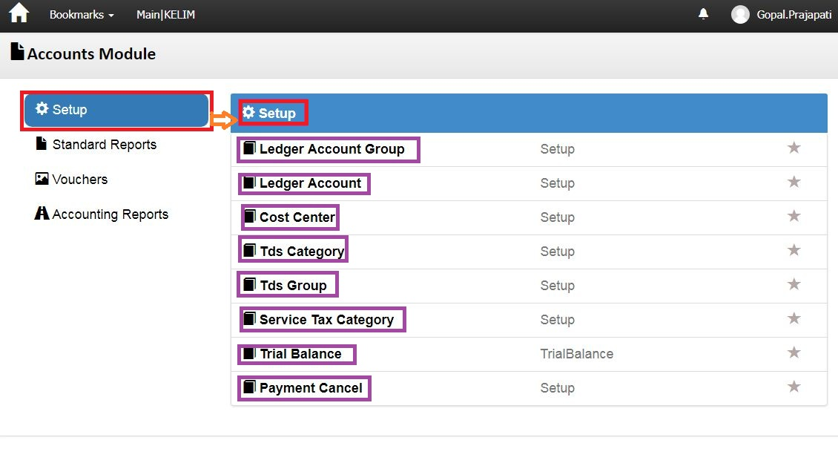 (Screen shot no-04)
Business Logic:
- Controller Name-> MenuController : Menu controller has three services for display menu
a)- IModuleService
b)-ISubModuleService
c)- IUnitOfWork
Action Method: Module: In this Action method we identify particular user Role and then execute GetModuleList () and GetModuleListForUser ().
Finally Return Module and SubModule View based on condition.
DataLogic-
ModelName- SubModuleViewModel.cs
Dependencies:
Data Access Layer
(SubModuleService)

Business Logic
(Menu Controller)

Presentation Layer (View layer)
(Submodule.chtml)

Work Flow: View → Controller →Model
View: Submodule.chtml -> clearly us can see design of page
Controller: Menu Controller
Model: MenuViewModel / SubModuleViewModel

Database (Table/Stored procedure/View)
 | web.MenuSubModules
Fields | DataType | Constrain | Remark
SubModuleId | INT IDENTITY NOT NULL, | PRIMARY KEY
SubModuleName | NVARCHAR (50) NOT NULL,
IconName | NVARCHAR (100) NOT NULL,
IsActive | BIT DEFAULT ((1)) NOT NULL,
CreatedBy | NVARCHAR (max),
ModifiedBy | NVARCHAR (max),
CreatedDate | DATETIME NOT NULL,
ModifiedDate | DATETIME NOT NULL,
OMSId | NVARCHAR (50),

Note: In Screen shot no. 04, DoubleClick on “Ledger Account Group” Hyperlink →Open below Screen Shot.
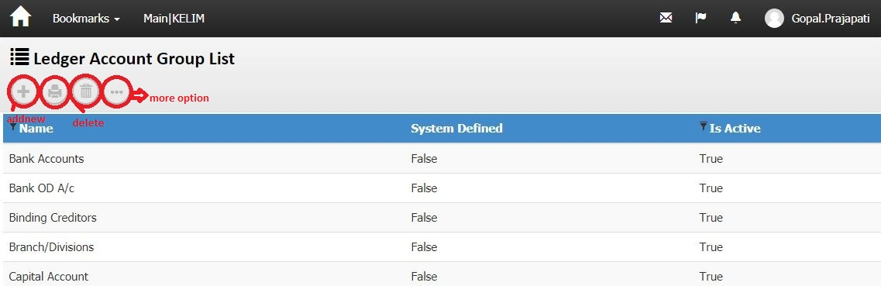
Screenshot No-05
Business Logic:
1)-Controller Name-> LedgerAccountGroupController: This controller has three Services for display ledger account group list.
a) ILedgerAccountGroupService
b) IUnitOfWork
c) IExceptionHandlingService
2)-Action Method:

Action Method Name :-> Index: In this Action we get ledger account group list using GetLedgerAccountGroupList () method of LedgerAccountGroupController
3)-Entity Framework/Services->
Services Name: LedgerAccountGroupService →In this services we define GetLedgerAccountGroupList ().
DataLogic-
View Model Name/Model - LedgerAccountGroup
For wizard
Action Method:
a) Delete () ‘for delete a row from list
b) Report () ' For Report
c) Prints () ' For print.
d) addnew () ‘for create new row

Dependencies:
Data Access Layer
(LedgerAccountGroupService)

Business Logic
(LedgerAccountGroupController)

Presentation Layer (View layer)
(Index.chtml)

Work Flow: View → Controller →Model
View: Index.chtml -> clearly us can see design of page
Controller: LedgerAccountGroupController
Model: LedgerAccountGroup

Note: In Screen shot no. 04, DoubleClick on “gridviewrow of Ledger Account Group” Hyperlink →Open below Screen Shot.
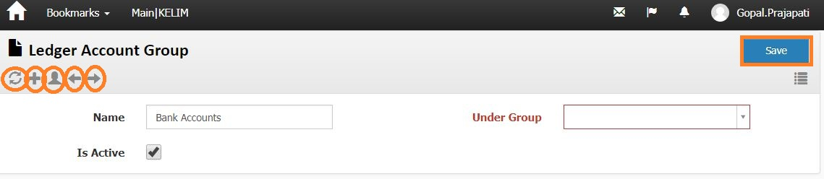
Screenshot No-06
Business Logic:
1)-Controller Name-> LedgerAccountGroupController: This controller has three Services for display ledger account group list.
a) ILedgerAccountGroupService
b) IUnitOfWork
c) IExceptionHandlingService
2)-Action Method:
Action Method Name :-> Edit: In this Action we get ledger account group using Find () method of LedgerAccountGroupController
3)-Entity Framework/Services->
Services Name: _LedgerAccountGroupService→In this services we define Find ().
DataLogic-
View Model Name/Model - LedgerAccountGroup
For wizard
Action Method:
    - NextPage () ' For Next page
    - PrevPage ()' For Previous page
    - save () ' for save record of header.
    - CREATE () FOR CREATE A NEW HEADER ROW
    - Refresh() for refresh

Dependencies:
Data Access Layer
(LedgerAccountGroupService)

Business Logic
(LedgerAccountGroupController)

Presentation Layer (View layer)
(Edit.chtml)

Work Flow: View → Controller →Model
View: Edit.chtml -> clearly us can see design of page
Controller: LedgerAccountGroupController
Model: LedgerAccountGroup
Database (Table/Stored procedure/View)
Web.Ledgeraccountgroups
ColumnName | Datatype | ReferencedTable | ReferencedColumn
LedgerAccountGroupId | int
LedgerAccountGroupName | nvarchar
IsActive | bit
IsSystemDefine | bit
LedgerAccountType | nvarchar
LedgerAccountNature | nvarchar
CreatedBy | nvarchar
ModifiedBy | nvarchar
CreatedDate | datetime
ModifiedDate | datetime
OMSId | nvarchar
ParentLedgerAccountGroupId | int
BSNature | nvarchar
BSSr | int
TradingNature | nvarchar
TradingSr | int
PLNature | nvarchar
PLSr | int
Weightage | tinyint

Note: In Screen shot no. 04, DoubleClick on “Ledger Account List” Hyperlink →Open below Screen Shot.
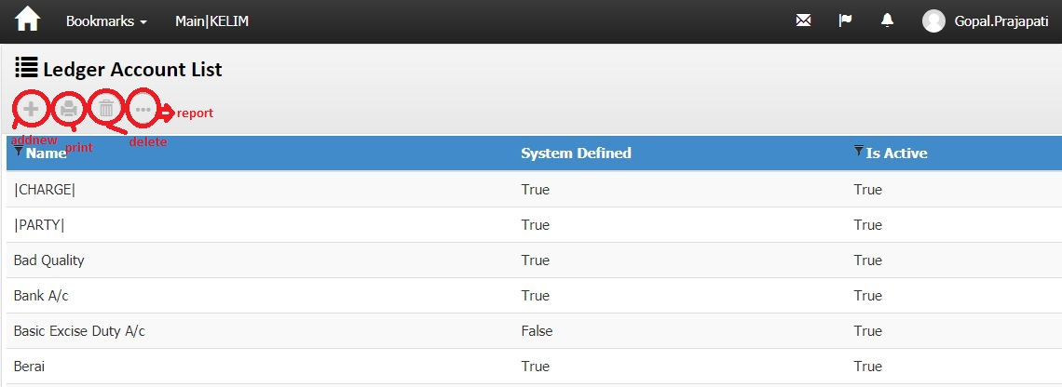
Screenshot No-07
Business Logic:
1)-Controller Name-> LedgerAccountController: This controller has three Services for display ledger account list.
a) ILedgerAccountService
b) IUnitOfWork
c) IExceptionHandlingService
2)-Action Method:

Action Method Name :-> Index: In this Action we get ledger account list using GetLedgerAccountList () method of LedgerAccountController
3)-Entity Framework/Services->
Services Name: LedgerAccountService →In this services we define GetLedgerAccountList ().
DataLogic-
View Model Name/Model - LedgerAccount
For wizard
Action Method:
a) Delete () ‘for delete a row from list
b) Report () ' For Report
c) Prints () ' For print.
d) addnew () ‘for create new row

Dependencies:
Data Access Layer
(LedgerAccountService)

Business Logic
(LedgerAccountController)

Presentation Layer (View layer)
(Index.chtml)

Work Flow: View → Controller →Model
View: Index.chtml -> clearly us can see design of page
Controller: LedgerAccountController
Model: LedgerAccount

Note: In Screen shot no. 07, DoubleClick on “gridviewrow of Ledger Account list” Hyperlink →Open below Screen Shot.
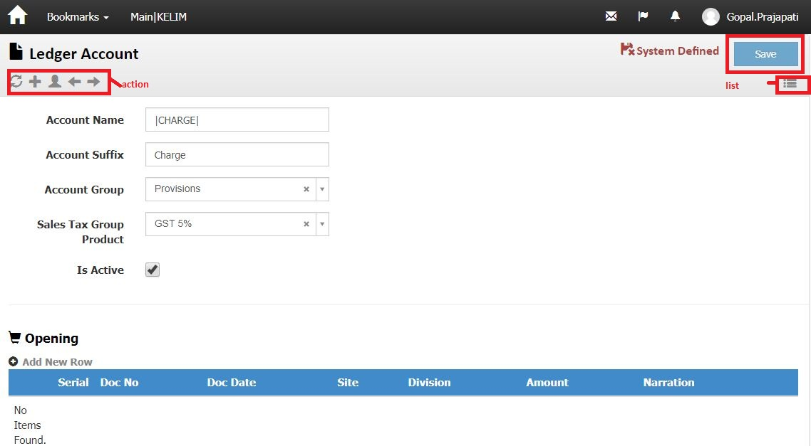
Screenshot No-08
Business Logic:
1)-Controller Name-> LedgerAccountController: This controller has three Services for display ledger account list.
a) ILedgerAccountService
b) IUnitOfWork
c) IExceptionHandlingService
2)-Action Method:
Action Method Name :-> Edit: In this Action we get ledger account using GetLedgerAccountForEdit () method of LedgerAccountController
3)-Entity Framework/Services->
Services Name: LedgerAccountService →In this services we define GetLedgerAccountForEdit ().
DataLogic-
View Model Name/Model - LedgerAccount
For wizard
Action Method:
    - NextPage () ' For Next page
    - PrevPage ()' For Previous page
    - save () ' for save record of header.
    - CREATE () FOR CREATE A NEW HEADER ROW
    - Refresh() for refresh
    - List () for

Dependencies:
Data Access Layer
(LedgerAccountService)

Business Logic
(LedgerAccountController)

Presentation Layer (View layer)
(Edit.chtml)

Work Flow: View → Controller →Model
View: Edit.chtml -> clearly us can see design of page
Controller: LedgerAccountController
Model: LedgerAccount
Database (Table/Stored procedure/View):-
Web.Ledgeraccount
ColumnName | Datatype | ReferencedTable | ReferencedColumn
LedgerAccountId | int |  | PRIMARY KEY
LedgerAccountName | nvarchar
LedgerAccountSuffix | nvarchar
PersonId | int | Web.People | PersonID (FK)
LedgerAccountGroupId | int | Web.LedgerAccountGroups | LedgerAccountGroupId (FK)
IsActive | bit
IsSystemDefine | bit
CreatedBy | nvarchar
ModifiedBy | nvarchar
CreatedDate | datetime
ModifiedDate | datetime
OMSId | nvarchar
ProductId | int | Web.Products | ProductId (FK)

Note: In Screen shot no. 04, DoubleClick on “costcenter” Hyperlink →Open below Screen Shot.
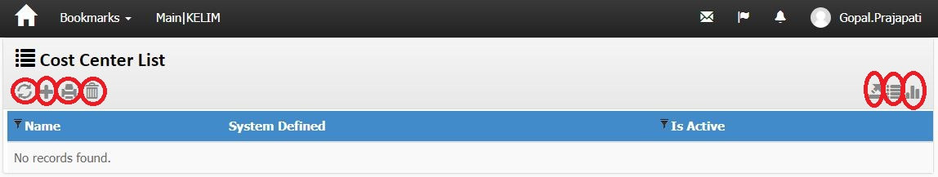
Screenshot No-09
Business Logic:
1)-Controller Name-> CostCenterController: This controller has three Services for display ledger account list.
a) ICostCenterService
b) IUnitOfWork
c) IExceptionHandlingService
2)-Action Method:
Action Method Name :-> Index: In this Action we get ledger account list using GetCostCenterList () method of CostCenterController
3)-Entity Framework/Services->
Services Name: CostCenterService →In this services we define GetCostCenterList ().
DataLogic-
View Model Name/Model - CostCenter
For wizard
Action Method:
a) Delete () ‘for delete a row from list
b) Report () ' For Report
c) Prints () ' For print.
d) addnew () ‘for create new row
e) list () for list
f) export () for excel

Dependencies:
Data Access Layer
(CostCenterService)

Business Logic
(CostCenterController)

Presentation Layer (View layer)
(Index.chtml)

Work Flow: View → Controller →Model
View: Index.chtml -> clearly us can see design of page
Controller: CostCenterController
Model: CostCenter

Database (Table/Stored procedure/View):-
Web.costcenter
ColumnName | Datatype | ReferencedTable | ReferencedColumn
CostCenterId | int |  | PRIMARY KEY
CostCenterName | nvarchar
IsActive | bit
IsSystemDefine | bit
CreatedBy | nvarchar
ModifiedBy | nvarchar
CreatedDate | datetime
ModifiedDate | datetime
OMSId | nvarchar
DivisionId | int | Web.Divisions | DivisionId (FK)
SiteId | int | Web.Sites | SiteId (FK)
LedgerAccountId | int | Web.LedgerAccounts | LedgerAccountId (FK)
ParentCostCenterId | int | Web.CostCenters | CostCenterId (FK)
DocTypeId | int | Web.DocumentTypes | DocumentTypeId (FK)
StartDate | smalldatetime
CloseDate | smalldatetime
ReferenceDocTypeId | int | Web.DocumentTypes | DocumentTypeId (FK)
ReferenceDocId | int
ReferenceDocNo | nvarchar
ProcessId | int | Web.Processes | ProcessId (FK)
Status | int
Discriminator | nvarchar
ProductUidId | int

Note: In Screen shot no. 04, DoubleClick on “TDS category” Hyperlink →Open below Screen Shot.
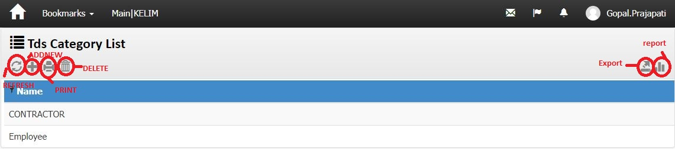
Screenshot No-10
Business Logic:
1)-Controller Name-> TdsCategoryController: This controller has three Services for display TdsCategorylist list.
a) ITdsCategoryService
b) IUnitOfWork
c) IExceptionHandlingService
2)-Action Method:
Action Method Name :-> Index: In this Action we get TdsCategorylist using GetTdsCategoryList () method of TdsCategoryController
3)-Entity Framework/Services->
Services Name: _TdsCategoryService →In this services we define GetTdsCategoryList ().
DataLogic-
View Model Name/Model - TdsCategory
For wizard
Action Method:
a) Delete () ‘for delete a row from list
b) Report () ' For Report
c) Prints () ' For print.
d) addnew () ‘for create new row
e) refresh () ‘for page refresh
f) export () for excel

Dependencies:
Data Access Layer
(TdsCategoryService)

Business Logic
(TdsCategoryController)

Presentation Layer (View layer)
(Index.chtml)

Work Flow: View → Controller →Model
View: Index.chtml -> clearly us can see design of page
Controller: TdsCategoryController
Model: TdsCategory

Database (Table/Stored procedure/View):-
Web.tdscategory
ColumnName | Datatype | ReferencedTable | ReferencedColumn
TdsCategoryId | int |  | PRIMARY KEY
TdsCategoryName | nvarchar
CreatedBy | nvarchar
ModifiedBy | nvarchar
CreatedDate | datetime
ModifiedDate | datetime
OMSId | nvarchar

Note: In Screen shot no. 04, DoubleClick on “TDS Group” Hyperlink →Open below Screen Shot.
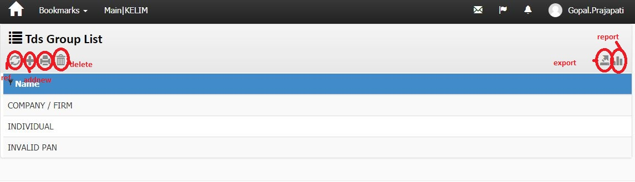
Screenshot No-11
Business Logic:
1)-Controller Name-> TdsGroupController: This controller has three Services for display TdsCategorylist list.
a) ITdsGroupService
b) IUnitOfWork
c) IExceptionHandlingService
2)-Action Method:
Action Method Name :-> Index: In this Action we get TdsCategorylist using GetTdsGroupList () method of TdsGroupController
3)-Entity Framework/Services->
Services Name: TdsGroupService →In this services we define GetTdsGroupList ().
DataLogic-
View Model Name/Model - TdsGroup
For wizard
Action Method:
a) Delete () ‘for delete a row from list
b) Report () ' For Report
c) Prints () ' For print.
d) addnew () ‘for create new row
e) refresh () ‘for page refresh
f) export () for excel

Dependencies:
Data Access Layer
(TdsGroupService)

Business Logic
(TdsGroupController)

Presentation Layer (View layer)
(Index.chtml)

Work Flow: View → Controller →Model
View: Index.chtml -> clearly us can see design of page
Controller: TdsGroupController
Model: TdsGroup

Database (Table/Stored procedure/View):-
Web.TDSgroups
ColumnName | Datatype | ReferencedTable | ReferencedColumn
TdsGroupId | int |  | primary
TdsGroupName | nvarchar
CreatedBy | nvarchar
ModifiedBy | nvarchar
CreatedDate | datetime
ModifiedDate | datetime
OMSId | nvarchar

Note: In Screen shot no. 07, DoubleClick on “gridviewrow of TDS group list” Hyperlink →Open below Screen Shot.
Screenshot No-12
Business Logic:
1)-Controller Name-> TdsGroupController: This controller has three Services for display ledger account list.
a) ITdsGroupService
b) IUnitOfWork
c) IExceptionHandlingService
2)-Action Method:
Action Method Name :-> Edit: In this Action we get ledger account using GetTdsGroup () method of TdsGroupController
3)-Entity Framework/Services->
Services Name: TdsGroupService →In this services we define GetTdsGroup ().
DataLogic-
View Model Name/Model - TdsGroup
For wizard
Action Method:
    - NextPage () ' For Next page
    - PrevPage ()' For Previous page
    - save () ' for save record of header.
    - CREATE () FOR CREATE A NEW HEADER ROW
    - Refresh() for refresh
    - List () for

Dependencies:
Data Access Layer
(TdsGroupService)

Business Logic
(TdsGroupController)

Presentation Layer (View layer)
(Edit.chtml)

Work Flow: View → Controller →Model
View: Edit.chtml -> clearly us can see design of page
Controller: TdsGroupController
Model: TdsGroup
Database (Table/Stored procedure/View):-

Web.TDSgroups
ColumnName | Datatype | ReferencedTable | ReferencedColumn
TdsGroupId | int |  | primary
TdsGroupName | nvarchar
CreatedBy | nvarchar
ModifiedBy | nvarchar
CreatedDate | datetime
ModifiedDate | datetime
OMSId | nvarchar

Note: In Screen shot no. 04, DoubleClick on “Payment Cancel” Hyperlink →Open below Screen Shot.
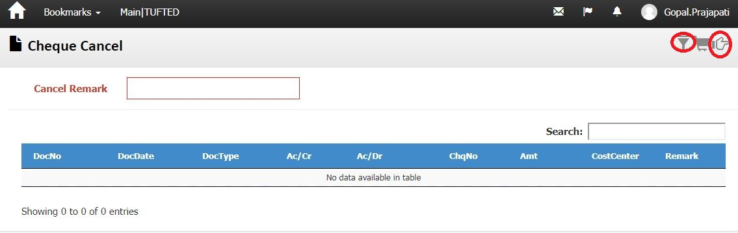
Screenshot No-13
Business Logic:
1)-Controller Name-> PaymentCancelWizardController: This controller has two Services for display cheque cancel list.
b) IUnitOfWork
c) IExceptionHandlingService
2)-Action Method:
Action Method Name :-> PaymentCancelWizard: In this Action we get TdsCategorylist using GetLedgerSettingForDocument () method of PaymentCancelWizardController
3)-Entity Framework/Services->
Services Name: LedgerSettingService →In this services we define GetLedgerSettingForDocument ().
DataLogic-
View Model Name/Model - LedgerSetting
For wizard
Action Method:
a)frilter()for filter

Dependencies:
Data Access Layer
(LedgerSettingService)

Business Logic
(PaymentCancelWizardController)

Presentation Layer (View layer)
(PaymentCancelWizard.chtml)

Work Flow: View → Controller →Model
View: PaymentCancelWizard.chtml -> clearly us can see design of page
Controller: PaymentCancelWizardController
Model: LedgerSetting

Vouchers:->
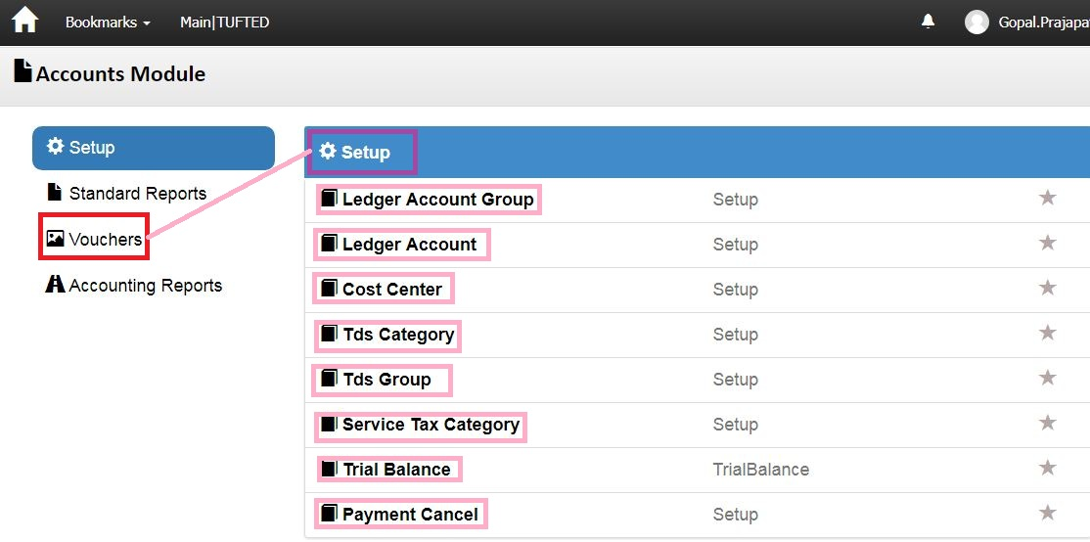

Screenshotno-14
Business Logic:
- Controller Name-> MenuController : Menu controller has three services for display menu
a)- IModuleService
b)-ISubModuleService
c)- IUnitOfWork
Action Method: Module: In this Action method we identify particular user Role and then execute GetModuleList () and GetModuleListForUser ().
Finally Return Module and SubModule View based on condition.
DataLogic-
ModelName- SubModuleViewModel.cs
Dependencies:
Data Access Layer
(SubModuleService)

Business Logic
(Menu Controller)

Presentation Layer (View layer)
(Submodule.chtml)

Work Flow: View → Controller →Model
View: Submodule.chtml -> clearly us can see design of page
Controller: Menu Controller
Model: MenuViewModel / SubModuleViewModel

Database (Table/Stored procedure/View)
 | web.MenuSubModules
Fields | DataType | Constrain | Remark
SubModuleId | INT IDENTITY NOT NULL, | PRIMARY KEY
SubModuleName | NVARCHAR (50) NOT NULL,
IconName | NVARCHAR (100) NOT NULL,
IsActive | BIT DEFAULT ((1)) NOT NULL,
CreatedBy | NVARCHAR (max),
ModifiedBy | NVARCHAR (max),
CreatedDate | DATETIME NOT NULL,
ModifiedDate | DATETIME NOT NULL,
OMSId | NVARCHAR (50),

Note: In Screen shot no. 14, DoubleClick on “Payment Vouchers” Hyperlink →Open below Screen Shot.
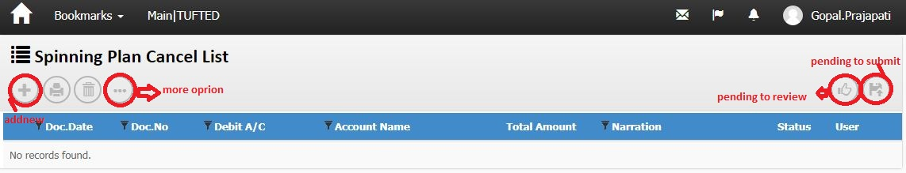
Screenshot No-15
Business Logic:
1)-Controller Name-> LedgerHeaderController: This controller has three Services for display spinning plan cancel list.
a) ILedgerHeaderService
b) IUnitOfWork
c) IExceptionHandlingService
2)-Action Method:
Action Method Name :-> Index: In this Action we get ledger account group list using GetLedgerHeaderList () method of LedgerHeaderController
3)-Entity Framework/Services->
Services Name: _LedgerHeaderService →In this services we define GetLedgerHeaderList ().
DataLogic-
View Model Name/Model - LedgerHeader
For wizard
Action Method:
a) Index_PendingToSubmit () ‘For Pending submit record.
b) Index_PendingToReview () ’ For Pending Review Record.
c) Delete () ‘for delete a row from list
d) Report () ' For Report
e) Prints () ' For print.
f) addnew () ‘for create new row

Dependencies:
Data Access Layer
(LedgerHeaderService)

Business Logic
(LedgerHeaderController)

Presentation Layer (View layer)
(Index.chtml)

Work Flow: View → Controller →Model
View: Index.chtml -> clearly us can see design of page
Controller: LedgerHeaderController
Model: LedgerHeader
Database (Table/Stored procedure/View)
Web.Ledgerheaders
ColumnName | Datatype | ReferencedTable | ReferencedColumn
LedgerHeaderId | int |  | PRIMARY KEY
DocHeaderId | int
DocTypeId | int | Web.DocumentTypes | DocumentTypeId (FK)
DocDate | datetime
DocNo | nvarchar
DivisionId | int | Web.Divisions | DivisionId (FK)
SiteId | int | Web.Sites | SiteId (FK)
LedgerAccountId | int | Web.LedgerAccounts | LedgerAccountId (FK)
CreditDays | int
Narration | nvarchar
Remark | nvarchar
Status | int
CreatedBy | nvarchar
CreatedDate | datetime
ModifiedBy | nvarchar
ModifiedDate | datetime
OMSId | nvarchar
ProcessId | int | Web.Processes | ProcessId (FK)
CostCenterId | int | Web.CostCenters | CostCenterId (FK)
AdjustmentType | nvarchar
ReviewCount | int
ReviewBy | nvarchar
PaymentFor | datetime
LockReason | nvarchar
GodownId | int | Web.Godowns | GodownId (FK)
ReferenceDocTypeId | int | Web.DocumentTypes | DocumentTypeId (FK)
ReferenceDocId | int
DrCr | nvarchar
PartyDocNo | nvarchar
PartyDocDate | datetime
CnacelLedgerHeaderId | int | Web.LedgerHeaders | LedgerHeaderId (FK)
ForLedgerHeaderId | int | Web.LedgerHeaders | LedgerHeaderId (FK)

Web.LedgerLines
ColumnName | Datatype | ReferencedTable | ReferencedColumn
LedgerLineId | int |  | PRIMARY KEY
LedgerHeaderId | int | Web.LedgerHeaders | LedgerHeaderId (FK)
LedgerAccountId | int | Web.LedgerAccounts | LedgerAccountId (FK)
ReferenceId | int | Web.Ledgers | LedgerId (FK)
ChqNo | nvarchar
ChqDate | smalldatetime
CostCenterId | int | Web.CostCenters | CostCenterId (FK)
Amount | decimal
Remark | nvarchar
CreatedBy | nvarchar
ModifiedBy | nvarchar
CreatedDate | datetime
ModifiedDate | datetime
OMSId | nvarchar
ReferenceDocTypeId | int
ReferenceDocId | int
ReferenceDocLineId | int
BaseValue | decimal
BaseRate | decimal
LockReason | nvarchar
DeveloperNotes | nvarchar
ProductUidId | int | Web.ProductUids | ProductUIDId (FK)
DrCr | nvarchar

Cheque Cencel:->
Note: In Screen shot no. 15, Double Click on “ Cheque Cencel ” Hyperlink →Open below Screen Shot.

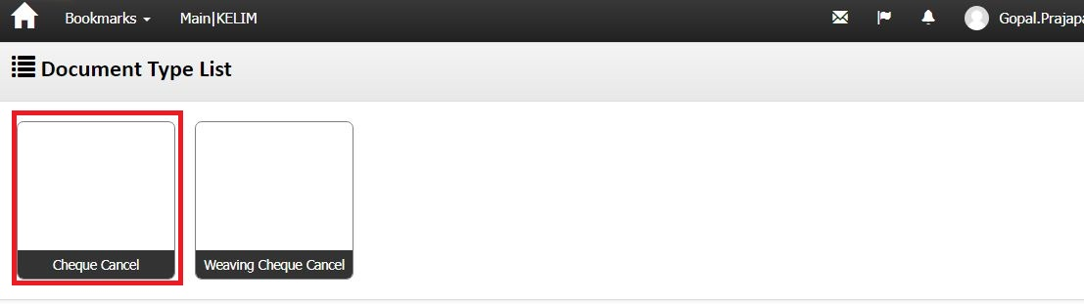

screenshotNo-16
Business Logic:
- Controller Name-> LedgerHeaderController: This controller has three services for display document type List
a) ILedgerHeaderService
b) IUnitOfWork
c) IExceptionHandlingService
Action Method:-
Action Method Name :-> DocumentTypeIndex: In this Action we get document type list using GetLedgerHeaderList () method
Entity Framework/Services->Services Name: LedgerHeaderService→ In this services we define GetLedgerHeaderList ().
DataLogic-
View Model Name/Model – LedgerHeader
Dependencies:
Data Access Layer
(LedgerHeaderService)

Business Logic
(LedgerHeaderController)

Presentation Layer (View layer)
(DocumentTypeIndex.chtml)
Work Flow: View → Controller →Model
View: DocumentTypeIndex.chtml -> clearly us can see design of page
Controller: LedgerHeaderController
Model : LedgerHeader

Note: In Screen shot no. 16, DoubleClick on “Cheque Cencel ” Hyperlink →Open below Screen Shot.
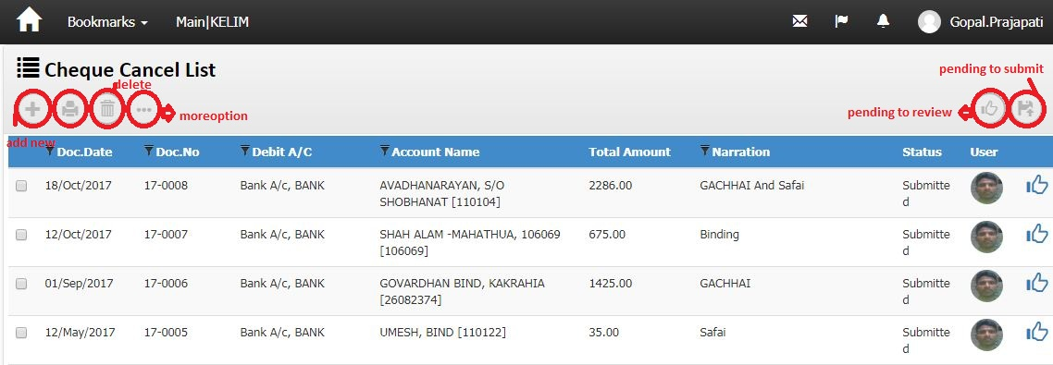
screenshotNo-17
Business Logic:

1)-Controller Name-> LedgerHeaderController: This controller has three Services for display cheque cancel List.

a) ILedgerHeaderService
b) IUnitOfWork
c) IExceptionHandlingService
2)-Action Method:
Action Method Name :-> Index: In this Action we get cheque cancel list using GetLedgerHeaderList () method of LedgerHeaderController
3)-Entity Framework/Services->
Services Name: LedgerHeaderService →In this services we define GetLedgerHeaderList ().
DataLogic-
View Model Name/Model - LedgerHeader
Dependencies:
Data Access Layer
(LedgerHeaderService)

Business Logic
( LedgerHeaderController)

Presentation Layer (View layer)
(Index.chtml)

Work Flow: View → Controller →Model
View: Index.chtml -> clearly us can see design of page
Controller: LedgerHeaderController
Model: LedgerHeader

Note: In Screen shot no.17, Double Click on “ gridview cheque cancel list” Hyperlink →Open below Screen
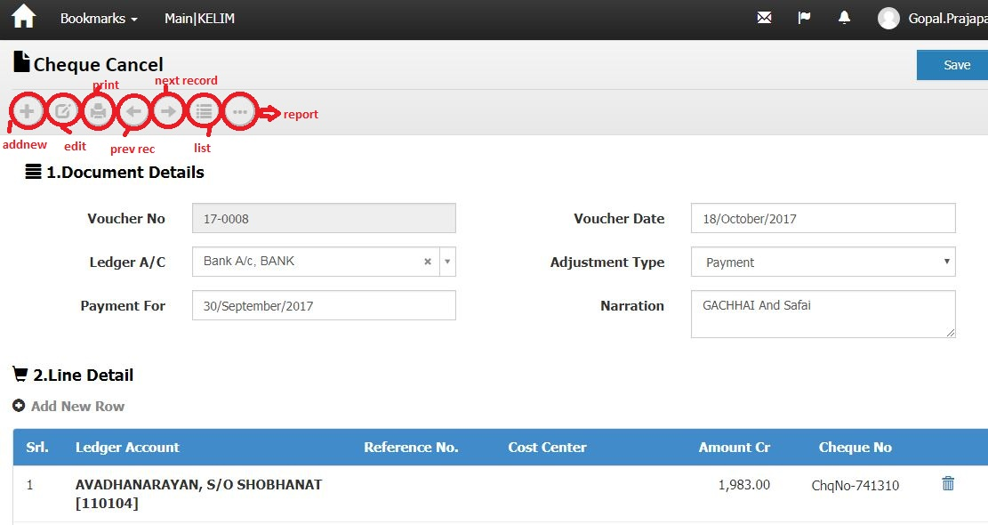
ScreenShotNo-18
Business Logic:
Controller Name->
1)- LedgerHeaderController: This controller has three Services for display Cheque Cancel.
a) ILedgerHeaderService
b) IUnitOfWork
c) IExceptionHandlingService
2)- LedgerLineController: This controller has three services for display Cheque Cancel.
a) ILedgerService
b) IUnitOfWork
c) IExceptionHandlingService

Action Method: ModifyAfter_Submit (Edit) (for header) and Index (for Line )on event:In this Action we get Cheque Cancel. and Products use method Find ()(for header) and GetLineListForReceiptVoucher ()(for Line )
Entity Framework/Services->
Services Name: LedgerHeaderService (for header) and LedgerService (for Line) → In this services we define method Find ()(for header) and GetLineListForReceiptVoucher ()(for Line )
DataLogic-
View Model Name/Model – LedgerHeader (FOR HEADER) and LedgersViewModel (FOR LINE)

.Action Method for headers:
    - NextPage () ' For Next page
    - PrevPage ()' For Previous page
    - Report () ' For Report
    - GeneratePrints () ' For Generate print.
    - Save () ' for save record of header.
    - Edit () for modify record
    - List () for index
    - Add new () Create a new header row

Dependencies:
Data Access Layer
( LedgerHeaderService & LedgerService)

Business Logic
(LedgerHeaderController & LedgerLineController)

Presentation Layer (View layer)
(ModifyAfter_Submit. cstml & Index.cshtml)

Work Flow: View → Controller →Model
View: ModifyAfter_Submit. Chtml & index.cshtml -> clearly us can see design of page Screenshot-05
Controller: LedgerHeaderController and LedgerLineController
Model : LedgerHeader (FOR HEADER) and LedgersViewModel (FOR LINE)
Code Flow: HTML/Java Script:
For Line' we use Java Script function on Create.chtml page-> LedgerHeaderController.cs
Syntax' var link="/LedgerLine/Index/"+groupId;
Action Method for Line:
For LINE
Action Method:'
- Create ()
- ModifyLine()
- ModifyLineAfterSubmit()
- ModifyLineAfterApprove()
- Delete()

For Post '
  - FilterPost ()
  - ResultsPost ()
  - CreatePost ()

Database (Table/Stored procedure/View)
Web.Ledgerheaders
ColumnName | Datatype | ReferencedTable | ReferencedColumn
LedgerHeaderId | int |  | PRIMARY KEY
DocHeaderId | int
DocTypeId | int | Web.DocumentTypes | DocumentTypeId (FK)
DocDate | datetime
DocNo | nvarchar
DivisionId | int | Web.Divisions | DivisionId (FK)
SiteId | int | Web.Sites | SiteId (FK)
LedgerAccountId | int | Web.LedgerAccounts | LedgerAccountId (FK)
CreditDays | int
Narration | nvarchar
Remark | nvarchar
Status | int
CreatedBy | nvarchar
CreatedDate | datetime
ModifiedBy | nvarchar
ModifiedDate | datetime
OMSId | nvarchar
ProcessId | int | Web.Processes | ProcessId (FK)
CostCenterId | int | Web.CostCenters | CostCenterId (FK)
AdjustmentType | nvarchar
ReviewCount | int
ReviewBy | nvarchar
PaymentFor | datetime
LockReason | nvarchar
GodownId | int | Web.Godowns | GodownId (FK)
ReferenceDocTypeId | int | Web.DocumentTypes | DocumentTypeId (FK)
ReferenceDocId | int
DrCr | nvarchar
PartyDocNo | nvarchar
PartyDocDate | datetime
CnacelLedgerHeaderId | int | Web.LedgerHeaders | LedgerHeaderId (FK)
ForLedgerHeaderId | int | Web.LedgerHeaders | LedgerHeaderId (FK)

Web.LedgerLines
ColumnName | Datatype | ReferencedTable | ReferencedColumn
LedgerLineId | int |  | PRIMARY KEY
LedgerHeaderId | int | Web.LedgerHeaders | LedgerHeaderId (FK)
LedgerAccountId | int | Web.LedgerAccounts | LedgerAccountId (FK)
ReferenceId | int | Web.Ledgers | LedgerId (FK)
ChqNo | nvarchar
ChqDate | smalldatetime
CostCenterId | int | Web.CostCenters | CostCenterId (FK)
Amount | decimal
Remark | nvarchar
CreatedBy | nvarchar
ModifiedBy | nvarchar
CreatedDate | datetime
ModifiedDate | datetime
OMSId | nvarchar
ReferenceDocTypeId | int
ReferenceDocId | int
ReferenceDocLineId | int
BaseValue | decimal
BaseRate | decimal
LockReason | nvarchar
DeveloperNotes | nvarchar
ProductUidId | int | Web.ProductUids | ProductUIDId (FK)
DrCr | nvarchar

Receipt Voucher:->
Note: In Screen shot no. 14, Double Click on “Receipt Voucher” Hyperlink →Open below Screen Shot.

screenshotNo-18
Business Logic:
- Controller Name-> LedgerHeaderController: This controller has three services for display document type List
a) ILedgerHeaderService
b) IUnitOfWork
c) IExceptionHandlingService

Action Method:-
Action Method Name :-> DocumentTypeIndex: In this Action we get document type list using GetLedgerHeaderList () method
Entity Framework/Services->Services Name: LedgerHeaderService→ In this services we define GetLedgerHeaderList ().
DataLogic-
View Model Name/Model – LedgerHeader
Dependencies:

Data Access Layer
(LedgerHeaderService)

Business Logic
(LedgerHeaderController)

Presentation Layer (View layer)
(DocumentTypeIndex.chtml)

Work Flow: View → Controller →Model
View: DocumentTypeIndex.chtml -> clearly us can see design of page
Controller: LedgerHeaderController
Model : LedgerHeader

Note: In Screen shot no. 18, DoubleClick on “Bank Receipt ” Hyperlink →Open below Screen Shot.
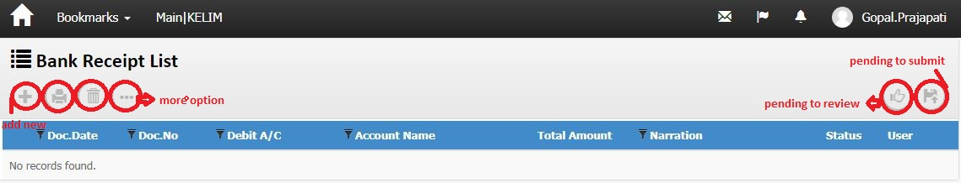
screenshotNo-19
Business Logic:

1)-Controller Name-> LedgerHeaderController: This controller has three Services for display Bank receipt List.

a) ILedgerHeaderService
b) IUnitOfWork
c) IExceptionHandlingService
2)-Action Method:
Action Method Name :-> Index: In this Action we get Bank receipt list using GetLedgerHeaderList () method of LedgerHeaderController
3)-Entity Framework/Services->
Services Name: LedgerHeaderService →In this services we define GetLedgerHeaderList ().
DataLogic-
View Model Name/Model - LedgerHeader
Dependencies:
Data Access Layer
(LedgerHeaderService)

Business Logic
(LedgerHeaderController)

Presentation Layer (View layer)
(Index.chtml)
Work Flow: View → Controller →Model
View: Index.chtml -> clearly us can see design of page 19
Controller: LedgerHeaderController
Model: LedgerHeader

Database (Table/Stored procedure/View)
Web.Ledgerheaders
ColumnName | Datatype | ReferencedTable | ReferencedColumn
LedgerHeaderId | int |  | PRIMARY KEY
DocHeaderId | int
DocTypeId | int | Web.DocumentTypes | DocumentTypeId (FK)
DocDate | datetime
DocNo | nvarchar
DivisionId | int | Web.Divisions | DivisionId (FK)
SiteId | int | Web.Sites | SiteId (FK)
LedgerAccountId | int | Web.LedgerAccounts | LedgerAccountId (FK)
CreditDays | int
Narration | nvarchar
Remark | nvarchar
Status | int
CreatedBy | nvarchar
CreatedDate | datetime
ModifiedBy | nvarchar
ModifiedDate | datetime
OMSId | nvarchar
ProcessId | int | Web.Processes | ProcessId (FK)
CostCenterId | int | Web.CostCenters | CostCenterId (FK)
AdjustmentType | nvarchar
ReviewCount | int
ReviewBy | nvarchar
PaymentFor | datetime
LockReason | nvarchar
GodownId | int | Web.Godowns | GodownId (FK)
ReferenceDocTypeId | int | Web.DocumentTypes | DocumentTypeId (FK)
ReferenceDocId | int
DrCr | nvarchar
PartyDocNo | nvarchar
PartyDocDate | datetime
CnacelLedgerHeaderId | int | Web.LedgerHeaders | LedgerHeaderId (FK)
ForLedgerHeaderId | int | Web.LedgerHeaders | LedgerHeaderId (FK)

Web.LedgerLines
ColumnName | Datatype | ReferencedTable | ReferencedColumn
LedgerLineId | int |  | PRIMARY KEY
LedgerHeaderId | int | Web.LedgerHeaders | LedgerHeaderId (FK)
LedgerAccountId | int | Web.LedgerAccounts | LedgerAccountId (FK)
ReferenceId | int | Web.Ledgers | LedgerId (FK)
ChqNo | nvarchar
ChqDate | smalldatetime
CostCenterId | int | Web.CostCenters | CostCenterId (FK)
Amount | decimal
Remark | nvarchar
CreatedBy | nvarchar
ModifiedBy | nvarchar
CreatedDate | datetime
ModifiedDate | datetime
OMSId | nvarchar
ReferenceDocTypeId | int
ReferenceDocId | int
ReferenceDocLineId | int
BaseValue | decimal
BaseRate | decimal
LockReason | nvarchar
DeveloperNotes | nvarchar
ProductUidId | int | Web.ProductUids | ProductUIDId (FK)
DrCr | nvarchar

Debit Note Voucher:->

Note: In Screen shot no. 14, DoubleClick on Debit note voucher ” Hyperlink →Open below Screen Shot.
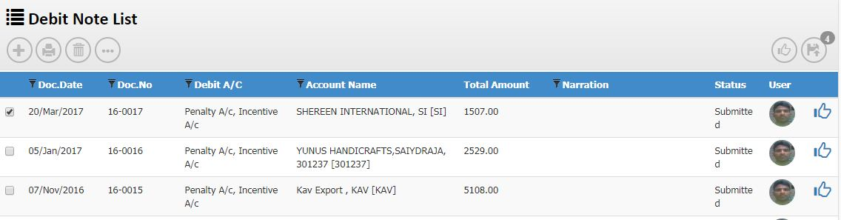
screenshotNo-20
Business Logic:

1)-Controller Name-> LedgerHeaderController: This controller has three Services for display Debit Note List.

a) ILedgerHeaderService
b) IUnitOfWork
c) IExceptionHandlingService
2)-Action Method:
Action Method Name :-> Index: In this Action we get Debit Note list using GetLedgerHeaderList () method of LedgerHeaderController
3)-Entity Framework/Services->
Services Name: LedgerHeaderService →In this services we define GetLedgerHeaderList ().
DataLogic-
View Model Name/Model - LedgerHeader
Dependencies:
Data Access Layer
(LedgerHeaderService)

Business Logic
(LedgerHeaderController)

Presentation Layer (View layer)
(Index.chtml)

Work Flow: View → Controller →Model
View: Index.chtml -> clearly us can see design of page 19
Controller: LedgerHeaderController
Model: LedgerHeader

Note: In Screen shot no.20, Double Click on “ gridview Debit note list” Hyperlink →Open below Screen
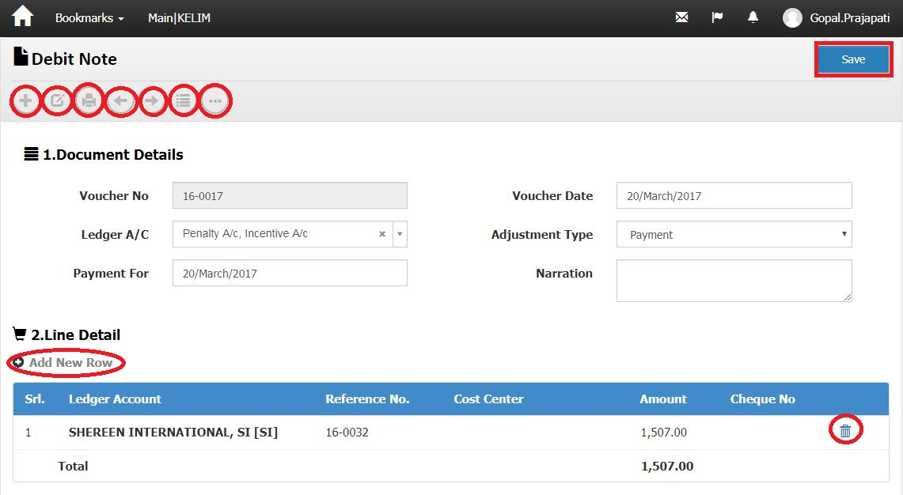
ScreenShotNo-21
Business Logic:
Controller Name->
1)- LedgerHeaderController: This controller has three Services for display Debit Note
a) ILedgerHeaderService
b) IUnitOfWork
c) IExceptionHandlingService
2)- LedgerLineController: This controller has three services for display Debit Note
a) ILedgerService
b) IUnitOfWork
c) IExceptionHandlingService

Action Method: ModifyAfter_Submit (Edit) (for header) and Index (for Line )on event:In this Action we get DEBIT NOTE. and Products use method Find ()(for header) and GetLineListForReceiptVoucher ()(for Line )
Entity Framework/Services->
Services Name: LedgerHeaderService (for header) and LedgerService (for Line) → In this services we define method Find ()(for header) and GetLineListForReceiptVoucher ()(for Line )
DataLogic-
View Model Name/Model – LedgerHeader (FOR HEADER) and LedgersViewModel (FOR LINE)

.Action Method for headers:
    - NextPage () ' For Next page
    - PrevPage ()' For Previous page
    - Report () ' For Report
    - GeneratePrints () ' For Generate print.
    - Save () ' for save record of header.
    - Edit () for modify record
    - List () for index
    - Add new () Create a new header row

Dependencies:
Data Access Layer
( LedgerHeaderService & LedgerService)

Business Logic
(LedgerHeaderController & LedgerLineController)

Presentation Layer (View layer)
(ModifyAfter_Submit. cstml & Index.cshtml)

Work Flow: View → Controller →Model
View: ModifyAfter_Submit. Chtml & index.cshtml -> clearly us can see design of page Screenshot-05
Controller: LedgerHeaderController and LedgerLineController
Model : LedgerHeader (FOR HEADER) and LedgersViewModel (FOR LINE)
Code Flow: HTML/Java Script:
For Line' we use Java Script function on Create.chtml page-> LedgerHeaderController.cs
Syntax' var link="/LedgerLine/Index/"+groupId;
Action Method for Line:
For LINE
Action Method:'
- Create ()
- ModifyLine()
- ModifyLineAfterSubmit()
- ModifyLineAfterApprove()
- Delete()

For Post '
  - FilterPost ()
  - ResultsPost ()
  - CreatePost ()

Database (Table/Stored procedure/View)
Web.Ledgerheaders
ColumnName | Datatype | ReferencedTable | ReferencedColumn
LedgerHeaderId | int |  | PRIMARY KEY
DocHeaderId | int
DocTypeId | int | Web.DocumentTypes | DocumentTypeId (FK)
DocDate | datetime
DocNo | nvarchar
DivisionId | int | Web.Divisions | DivisionId (FK)
SiteId | int | Web.Sites | SiteId (FK)
LedgerAccountId | int | Web.LedgerAccounts | LedgerAccountId (FK)
CreditDays | int
Narration | nvarchar
Remark | nvarchar
Status | int
CreatedBy | nvarchar
CreatedDate | datetime
ModifiedBy | nvarchar
ModifiedDate | datetime
OMSId | nvarchar
ProcessId | int | Web.Processes | ProcessId (FK)
CostCenterId | int | Web.CostCenters | CostCenterId (FK)
AdjustmentType | nvarchar
ReviewCount | int
ReviewBy | nvarchar
PaymentFor | datetime
LockReason | nvarchar
GodownId | int | Web.Godowns | GodownId (FK)
ReferenceDocTypeId | int | Web.DocumentTypes | DocumentTypeId (FK)
ReferenceDocId | int
DrCr | nvarchar
PartyDocNo | nvarchar
PartyDocDate | datetime
CnacelLedgerHeaderId | int | Web.LedgerHeaders | LedgerHeaderId (FK)
ForLedgerHeaderId | int | Web.LedgerHeaders | LedgerHeaderId (FK)

Web.LedgerLines
ColumnName | Datatype | ReferencedTable | ReferencedColumn
LedgerLineId | int |  | PRIMARY KEY
LedgerHeaderId | int | Web.LedgerHeaders | LedgerHeaderId (FK)
LedgerAccountId | int | Web.LedgerAccounts | LedgerAccountId (FK)
ReferenceId | int | Web.Ledgers | LedgerId (FK)
ChqNo | nvarchar
ChqDate | smalldatetime
CostCenterId | int | Web.CostCenters | CostCenterId (FK)
Amount | decimal
Remark | nvarchar
CreatedBy | nvarchar
ModifiedBy | nvarchar
CreatedDate | datetime
ModifiedDate | datetime
OMSId | nvarchar
ReferenceDocTypeId | int
ReferenceDocId | int
ReferenceDocLineId | int
BaseValue | decimal
BaseRate | decimal
LockReason | nvarchar
DeveloperNotes | nvarchar
ProductUidId | int | Web.ProductUids | ProductUIDId (FK)
DrCr | nvarchar

Debit note voucher (GST:->
Note: In Screen shot no. 4, Double Click on “ Debit note voucher (GST) ” Hyperlink →Open below Screen Shot.
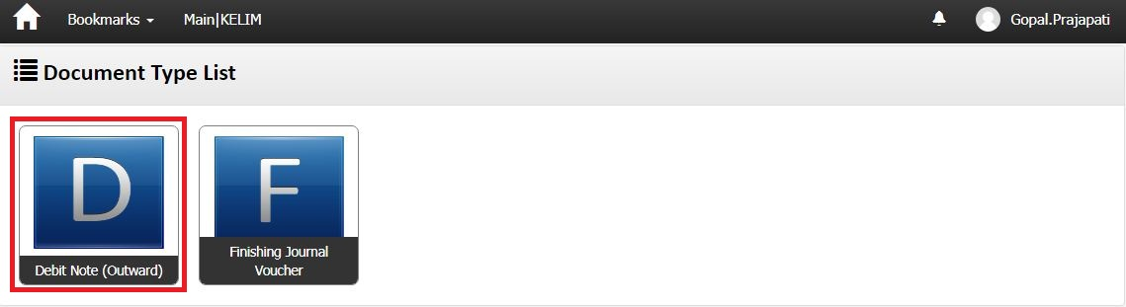

Screenshot no-22
Business Logic:
- Controller Name-> JobInvoiceReturnHeaderController: This controller has three services for display document type List
a) IJobInvoiceReturnHeaderService
b) IUnitOfWork
c) IExceptionHandlingService

Action Method:-

Action Method Name :-> DocumentTypeIndex: In this Action we get document type
list using GetJobInvoiceReturnHeaderList () method
Entity Framework/Services->Services Name: JobInvoiceReturnHeaderService → In this services we define GetJobInvoiceReturnHeaderList ().
DataLogic-
View Model Name/Model – JobInvoiceReturnHeader
Dependencies:

Data Access Layer
(JobInvoiceReturnHeaderService)

Business Logic
(JobInvoiceReturnHeaderController )

Presentation Layer (View layer)
(DocumentTypeIndex.chtml)

Work Flow: View → Controller →Model
View: DocumentTypeIndex.chtml -> clearly us can see design of page 21
Controller: JobInvoiceReturnHeaderController
Model : JobInvoiceReturnHeader
Note: In Screen shot no. 21, DoubleClick on “Debit Note (outward)” Hyperlink →Open below Screen Shot.
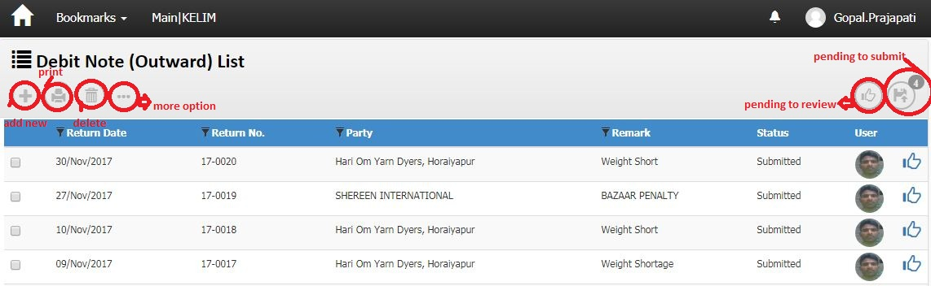
ScreenShot-23
Business Logic:
- Controller Name-> JobInvoiceReturnHeaderController: This controller has three services for display Debit note (outward) list
a) IJobInvoiceReturnHeaderService
b) IUnitOfWork
c) IExceptionHandlingService
Action Method:-
Action Method Name :->Index: In this Action we get debit note (outward) list using GetJobInvoiceReturnHeaderList () method
Entity Framework/Services->Services Name: JobInvoiceReturnHeaderService → In this services we define GetJobInvoiceReturnHeaderList ().
DataLogic-
View Model Name/Model – JobInvoiceReturnHeader
Action Method:
A) Index_PendingToSubmit () ‘For Pending submit record.
B) Index_PendingToReview () ’ For Pending Review Record.
c) Delete () ‘for delete a row from list
d) GeneratePrints () ' For Generate print.
e) addnew ()’create new row
d) delete () ‘for delete.

Dependencies:
Data Access Layer
(JobInvoiceReturnHeaderService)

Business Logic
(JobInvoiceReturnHeaderController)

Presentation Layer (View layer)
(Index.chtml)

Work Flow: View → Controller →Model
View: Index.chtml -> clearly us can see design of page screenshotno-23
Controller: JobInvoiceReturnHeader Controller
Model : JobInvoiceReturnHeader

Note: In Screen shot no. 23, Double Click on “gridviewrow of debit note (outward) list row” Hyperlink →Open below Screen
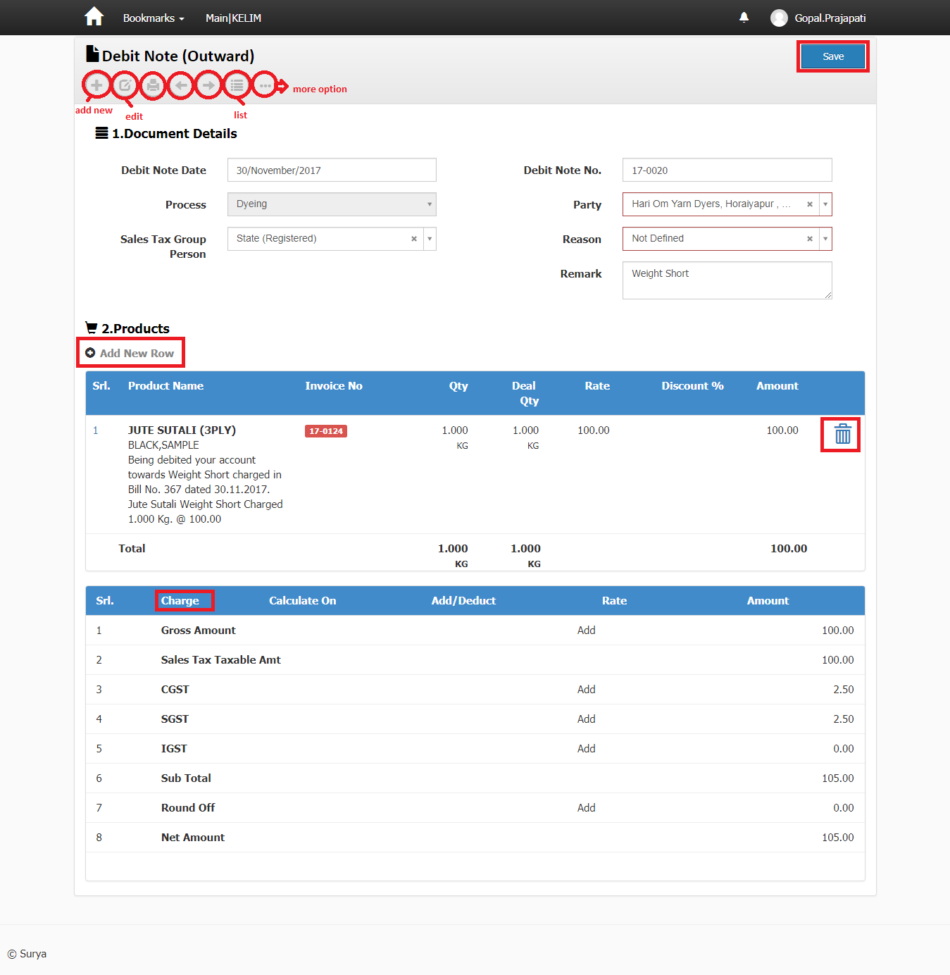

Screenshotno-24

Business Logic:

Controller Name->
1)- JobInvoiceReturnHeaderController: This controller has three Services for display Debit note (outward)
a) IJobInvoiceReturnHeaderService
b) IUnitOfWork
c) IExceptionHandlingService

2)- JobInvoiceReturnLineController: This controller has three services for display Debit Note(outward)
a) IJobInvoiceReturnLineService
b) IUnitOfWork
c) IExceptionHandlingService

Action Method: Modify after_submit (edit) (for header) and Index (for Line ) on event:In this Action we get debit note (outward) and Products use method GetJobInvoiceReturnHeader ()(for header) and GetLineListForIndex ()(for Line )
Entity Framework/Services->
Services Name: JobInvoiceReturnHeaderService and JobInvoiceReturnLineService → In this services we define GetJobInvoiceReturnHeader ()(for header) and GetLineListForIndex ()(for Line )
DataLogic-
View Model Name/Model – JobInvoiceReturnHeaderViewModel / db. JobInvoiceReturnHeader (FORHEADER) and JobInvoiceReturnLineViewModel / db.JobInvoiceReturnLine (FOR LINE)

Charge:-> in this figure(JobInvoicereturnCharges) we show it IS RELETED TO JobinvoicereturnHeaderchargesTable.

.Action Method for headers:
A) NextPage () ' For Next page
B) PrevPage ()' For Previous page
C) Report () ' For Report
D) GeneratePrints () ' For Generate print.
E) save () ' for save record of header.
F) Edit () for modify record
G) list () FOR for index
I) CREATE () CREATE A NEW HEADER ROW

DataLogic-
Data Access Layer
( JobInvoiceReturnHeaderService & JobInvoiceReturnLineService)

Dependencies:

Business Logic
(JobInvoiceReturnHeaderController & JobInvoiceReturnLineController

Presentation Layer (View layer)
(ModifyAfter_Submit(edit). cstml & Index.cshtml)

Work Flow: View → Controller →Model
View: ModifyAfter_Submit (Edit).. Chtml & index.cshtml -> clearly us can see design of page Screenshot-24
Controller: JobInvoiceReturnHeaderController and JobInvoiceReturnLineService
Model : JobInvoiceReturnHeaderViewModel / db. JobInvoiceReturnHeader (FORHEADER) and JobInvoiceReturnLineViewModel / db.JobInvoiceReturnLine (FOR LINE)
Code Flow: HTML/Java Script:
For Line' we use Java Script function on Create.chtml page ' JobInvoiceReturnHeaderController.cs
Syntax' var link="/JobInvoiceReturnLine/Index/"+groupId;

Action Method for Line:
For Get'
Action Method:'
- Create ()
- ModifyLine()
- ModifyLineAfterSubmit()
- ModifyLineAfterApprove()
- Delete()
For Post'
a) FilterPost ()
b) ResultsPost ()
c) CreatePost ()

Database (Table/Stored procedure/View):-
Web.jobinvoicereturnheaders
ColumnName | Datatype | ReferencedTable | ReferencedColumn
JobInvoiceReturnHeaderId | int |  | PRIMARY KEY
DocTypeId | int | Web.DocumentTypes | DocumentTypeId (FK)
DocDate | datetime
DocNo | nvarchar
ReasonId | int | Web.Reasons | ReasonId (FK)
DivisionId | int | Web.Divisions | DivisionId (FK)
SiteId | int | Web.Sites | SiteId (FK)
LedgerHeaderId | int | Web.LedgerHeaders | LedgerHeaderId (FK)
ExchangeRate | decimal
JobWorkerId | int | Web.People | PersonID (FK)
ProcessId | int | Web.Processes | ProcessId (FK)
JobReturnHeaderId | int | Web.JobReturnHeaders | JobReturnHeaderId (FK)
Remark | nvarchar
Status | int
ReviewCount | int
ReviewBy | nvarchar
LockReason | nvarchar
CreatedBy | nvarchar
ModifiedBy | nvarchar
CreatedDate | datetime
ModifiedDate | datetime
OMSId | nvarchar
Nature | nvarchar
ReferenceDocTypeId | int | Web.DocumentTypes | DocumentTypeId (FK)
ReferenceDocId | int
SalesTaxGroupPersonId | int | Web.ChargeGroupPersons | ChargeGroupPersonId (FK)

Web.jobinvoicereturnLines
ColumnName | Datatype | ReferencedTable | ReferencedColumn
JobInvoiceReturnLineId | int |  | PRIMARY KEY
JobInvoiceReturnHeaderId | int | Web.JobInvoiceReturnHeaders | JobInvoiceReturnHeaderId (FK)
JobInvoiceLineId | int | Web.JobInvoiceLines | JobInvoiceLineId (FK)
JobReturnLineId | int | Web.JobReturnLines | JobReturnLineId (FK)
Qty | decimal
UnitConversionMultiplier | decimal
DealUnitId | nvarchar | Web.Units | UnitId (FK)
DealQty | decimal
Rate | decimal
Amount | decimal
Remark | nvarchar
Sr | int
LockReason | nvarchar
CreatedBy | nvarchar
ModifiedBy | nvarchar
CreatedDate | datetime
ModifiedDate | datetime
OMSId | nvarchar
ReferenceDocTypeId | int | Web.DocumentTypes | DocumentTypeId (FK)
ReferenceDocLineId | int
SalesTaxGroupProductId | int | Web.ChargeGroupProducts | ChargeGroupProductId (FK)
CostCenterId | int | Web.CostCenters | CostCenterId (FK)

Credit note (outward):->

Note: In Screen shot no. 14, DoubleClick on “Credit note (outward) ” Hyperlink →Open below Screen Shot.
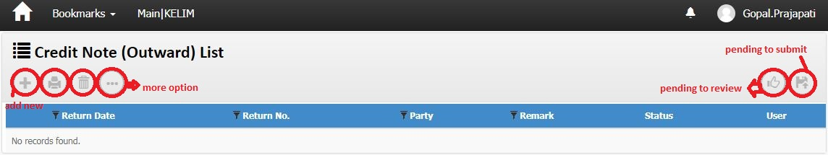
screenshotNo-25
Business Logic:
- Controller Name-> JobInvoiceReturnHeaderController: This controller has three services for display credit note (outward) list
a) IJobInvoiceReturnHeaderService
b) IUnitOfWork
c) IExceptionHandlingService
Action Method:-
Action Method Name :->Index: In this Action we get credit note (outward) list using GetJobInvoiceReturnHeaderList () method
Entity Framework/Services->Services Name: JobInvoiceReturnHeaderService → In this services we define GetJobInvoiceReturnHeaderList ().
DataLogic-
View Model Name/Model – JobInvoiceReturnHeader
Action Method:
A) Index_PendingToSubmit () ‘For Pending submit record.
B) Index_PendingToReview () ’ For Pending Review Record.
c) Delete () ‘for delete a row from list
d) GeneratePrints () ' For Generate print.
e) addnew ()’create new row
d) delete () ‘for delete.

Dependencies:
Data Access Layer
(JobInvoiceReturnHeaderService)

Business Logic
(JobInvoiceReturnHeaderController)

Presentation Layer (View layer)
(Index.chtml)

Work Flow: View → Controller →Model
View: Index.chtml -> clearly us can see design of page screenshotno-25
Controller: JobInvoiceReturnHeader Controller
Model : JobInvoiceReturnHeader
Database (Table/Stored procedure/View):-
Web.jobinvoicereturnheaders
ColumnName | Datatype | ReferencedTable | ReferencedColumn
JobInvoiceReturnHeaderId | int |  | PRIMARY KEY
DocTypeId | int | Web.DocumentTypes | DocumentTypeId (FK)
DocDate | datetime
DocNo | nvarchar
ReasonId | int | Web.Reasons | ReasonId (FK)
DivisionId | int | Web.Divisions | DivisionId (FK)
SiteId | int | Web.Sites | SiteId (FK)
LedgerHeaderId | int | Web.LedgerHeaders | LedgerHeaderId (FK)
ExchangeRate | decimal
JobWorkerId | int | Web.People | PersonID (FK)
ProcessId | int | Web.Processes | ProcessId (FK)
JobReturnHeaderId | int | Web.JobReturnHeaders | JobReturnHeaderId (FK)
Remark | nvarchar
Status | int
ReviewCount | int
ReviewBy | nvarchar
LockReason | nvarchar
CreatedBy | nvarchar
ModifiedBy | nvarchar
CreatedDate | datetime
ModifiedDate | datetime
OMSId | nvarchar
Nature | nvarchar
ReferenceDocTypeId | int | Web.DocumentTypes | DocumentTypeId (FK)
ReferenceDocId | int
SalesTaxGroupPersonId | int | Web.ChargeGroupPersons | ChargeGroupPersonId (FK)

Journal voucher:->

Note: In Screen shot no. 14, DoubleClick on journal voucher ” Hyperlink →Open below Screen Shot.
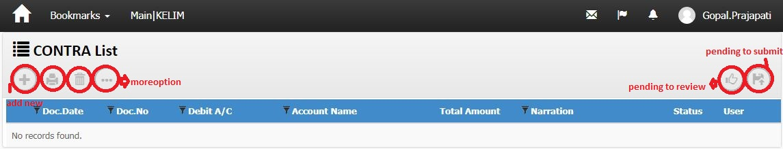
screenshotNo-26
Business Logic:

1)-Controller Name-> LedgerHeaderController: This controller has three Services for display Contra List.

a) ILedgerHeaderService
b) IUnitOfWork
c) IExceptionHandlingService
2)-Action Method:
Action Method Name :-> Index: In this Action we get contra list using GetLedgerHeaderList () method of LedgerHeaderController
3)-Entity Framework/Services->
Services Name: LedgerHeaderService →In this services we define GetLedgerHeaderList ().
DataLogic-
View Model Name/Model - LedgerHeader
Dependencies:
Data Access Layer
(LedgerHeaderService)

Business Logic
(LedgerHeaderController)

Presentation Layer (View layer)
(Index.chtml)

Work Flow: View → Controller →Model
View: Index.chtml -> clearly us can see design of page 26
Controller: LedgerHeaderController
Model: LedgerHeader
Database (Table/Stored procedure/View)
Web.Ledgerheaders
ColumnName | Datatype | ReferencedTable | ReferencedColumn
LedgerHeaderId | int |  | PRIMARY KEY
DocHeaderId | int
DocTypeId | int | Web.DocumentTypes | DocumentTypeId (FK)
DocDate | datetime
DocNo | nvarchar
DivisionId | int | Web.Divisions | DivisionId (FK)
SiteId | int | Web.Sites | SiteId (FK)
LedgerAccountId | int | Web.LedgerAccounts | LedgerAccountId (FK)
CreditDays | int
Narration | nvarchar
Remark | nvarchar
Status | int
CreatedBy | nvarchar
CreatedDate | datetime
ModifiedBy | nvarchar
ModifiedDate | datetime
OMSId | nvarchar
ProcessId | int | Web.Processes | ProcessId (FK)
CostCenterId | int | Web.CostCenters | CostCenterId (FK)
AdjustmentType | nvarchar
ReviewCount | int
ReviewBy | nvarchar
PaymentFor | datetime
LockReason | nvarchar
GodownId | int | Web.Godowns | GodownId (FK)
ReferenceDocTypeId | int | Web.DocumentTypes | DocumentTypeId (FK)
ReferenceDocId | int
DrCr | nvarchar
PartyDocNo | nvarchar
PartyDocDate | datetime
CnacelLedgerHeaderId | int | Web.LedgerHeaders | LedgerHeaderId (FK)
ForLedgerHeaderId | int | Web.LedgerHeaders | LedgerHeaderId (FK)

Credit Note Voucher:->
Note: In Screen shot no. 14, DoubleClick on credit note voucher ” Hyperlink →Open below Screen Shot.
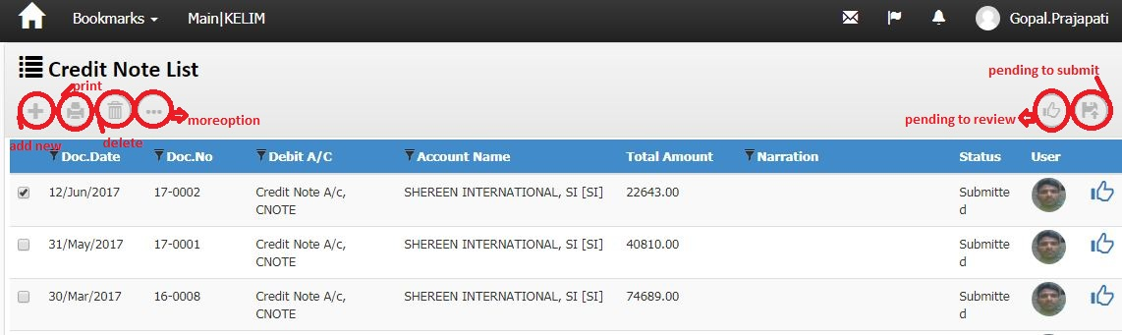
screenshotNo-27
Business Logic:

1)-Controller Name-> LedgerHeaderController: This controller has three Services for display Debit Note List.

a) ILedgerHeaderService
b) IUnitOfWork
c) IExceptionHandlingService
2)-Action Method:
Action Method Name :-> Index: In this Action we get Credit Note list using GetLedgerHeaderList () method of LedgerHeaderController
3)-Entity Framework/Services->
Services Name: LedgerHeaderService →In this services we define GetLedgerHeaderList ().
DataLogic-
View Model Name/Model - LedgerHeader
Dependencies:
Data Access Layer
(LedgerHeaderService)

Business Logic
(LedgerHeaderController)

Presentation Layer (View layer)
(Index.chtml)

Work Flow: View → Controller →Model
View: Index.chtml -> clearly us can see design of page 27
Controller: LedgerHeaderController
Model: LedgerHeader

Note: In Screen shot no.27, Double Click on “ gridview Credit note list” Hyperlink →Open below Screen
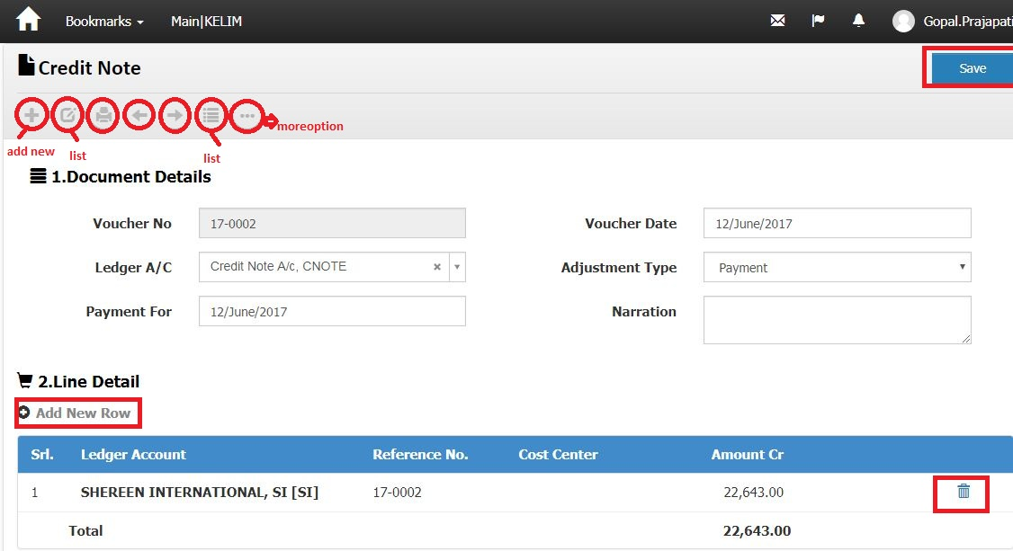
ScreenShotNo-28
Business Logic:
Controller Name->
1)- LedgerHeaderController: This controller has three Services for display credit Note
a) ILedgerHeaderService
b) IUnitOfWork
c) IExceptionHandlingService
2)- LedgerLineController: This controller has three services for display Credit Note
a) ILedgerService
b) IUnitOfWork
c) IExceptionHandlingService

Action Method: ModifyAfter_Submit (Edit) (for header) and Index (for Line )on event:In this Action we get Credit NOTE. and Products use method Find ()(for header) and GetLineListForReceiptVoucher ()(for Line )
Entity Framework/Services->
Services Name: LedgerHeaderService (for header) and LedgerService (for Line) → In this services we define method Find ()(for header) and GetLineListForReceiptVoucher ()(for Line )
DataLogic-
View Model Name/Model – LedgerHeader (FOR HEADER) and LedgersViewModel (FOR LINE)

.Action Method for headers:
    - NextPage () ' For Next page
    - PrevPage ()' For Previous page
    - Report () ' For Report
    - GeneratePrints () ' For Generate print.
    - Save () ' for save record of header.
    - Edit () for modify record
    - List () for index
    - Add new () Create a new header row

Dependencies:
Data Access Layer
( LedgerHeaderService & LedgerService)

Business Logic
(LedgerHeaderController & LedgerLineController)

Presentation Layer (View layer)
(ModifyAfter_Submit. cstml & Index.cshtml)

Work Flow: View → Controller →Model
View: ModifyAfter_Submit. Chtml & index.cshtml -> clearly us can see design of page Screenshot-028
Controller: LedgerHeaderController and LedgerLineController
Model : LedgerHeader (FOR HEADER) and LedgersViewModel (FOR LINE)
Code Flow: HTML/Java Script:
For Line' we use Java Script function on Create.chtml page-> LedgerHeaderController.cs
Syntax' var link="/LedgerLine/Index/"+groupId;
Action Method for Line:
For LINE
Action Method:'
- Create ()
- ModifyLine()
- ModifyLineAfterSubmit()
- ModifyLineAfterApprove()
- Delete()

For Post '
  - FilterPost ()
  - ResultsPost ()
  - CreatePost ()

Database (Table/Stored procedure/View)
Web.Ledgerheaders
ColumnName | Datatype | ReferencedTable | ReferencedColumn
LedgerHeaderId | int |  | PRIMARY KEY
DocHeaderId | int
DocTypeId | int | Web.DocumentTypes | DocumentTypeId (FK)
DocDate | datetime
DocNo | nvarchar
DivisionId | int | Web.Divisions | DivisionId (FK)
SiteId | int | Web.Sites | SiteId (FK)
LedgerAccountId | int | Web.LedgerAccounts | LedgerAccountId (FK)
CreditDays | int
Narration | nvarchar
Remark | nvarchar
Status | int
CreatedBy | nvarchar
CreatedDate | datetime
ModifiedBy | nvarchar
ModifiedDate | datetime
OMSId | nvarchar
ProcessId | int | Web.Processes | ProcessId (FK)
CostCenterId | int | Web.CostCenters | CostCenterId (FK)
AdjustmentType | nvarchar
ReviewCount | int
ReviewBy | nvarchar
PaymentFor | datetime
LockReason | nvarchar
GodownId | int | Web.Godowns | GodownId (FK)
ReferenceDocTypeId | int | Web.DocumentTypes | DocumentTypeId (FK)
ReferenceDocId | int
DrCr | nvarchar
PartyDocNo | nvarchar
PartyDocDate | datetime
CnacelLedgerHeaderId | int | Web.LedgerHeaders | LedgerHeaderId (FK)
ForLedgerHeaderId | int | Web.LedgerHeaders | LedgerHeaderId (FK)

Web.LedgerLines
ColumnName | Datatype | ReferencedTable | ReferencedColumn
LedgerLineId | int |  | PRIMARY KEY
LedgerHeaderId | int | Web.LedgerHeaders | LedgerHeaderId (FK)
LedgerAccountId | int | Web.LedgerAccounts | LedgerAccountId (FK)
ReferenceId | int | Web.Ledgers | LedgerId (FK)
ChqNo | nvarchar
ChqDate | smalldatetime
CostCenterId | int | Web.CostCenters | CostCenterId (FK)
Amount | decimal
Remark | nvarchar
CreatedBy | nvarchar
ModifiedBy | nvarchar
CreatedDate | datetime
ModifiedDate | datetime
OMSId | nvarchar
ReferenceDocTypeId | int
ReferenceDocId | int
ReferenceDocLineId | int
BaseValue | decimal
BaseRate | decimal
LockReason | nvarchar
DeveloperNotes | nvarchar
ProductUidId | int | Web.ProductUids | ProductUIDId (FK)
DrCr | nvarchar

Expense Voucher:->
Note: In Screen shot no. 14, DoubleClick on “Expense voucher ” Hyperlink →Open below Screen Shot.
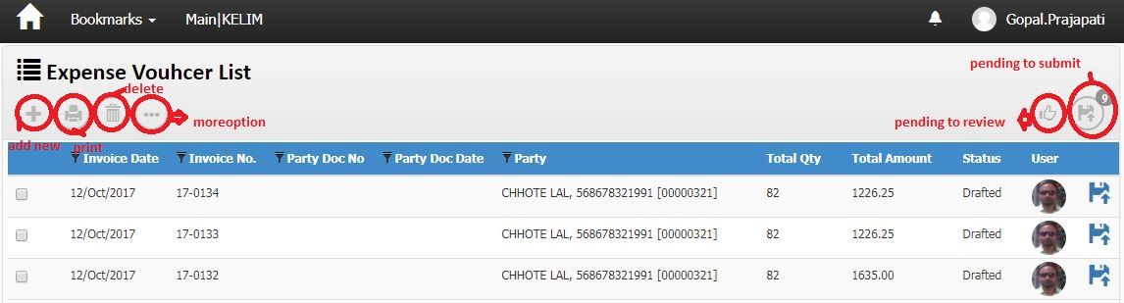
screenshotNo-29
Business Logic:

1)-Controller Name-> JobInvoiceReceiveHeaderController: This controller has three Services for display Expense voucher List.

a) IJobReceiveHeaderService
b) IJobInvoiceHeaderService
c) IUnitOfWork
d) IExceptionHandlingService
2)-Action Method:
Action Method Name :-> Index: In this Action we get Expanse voucher list using GetJobInvoiceHeaderList () method of JobInvoiceReceiveHeaderController
3)-Entity Framework/Services->

Services Name: _JobInvoiceHeaderService →In this services we define GetJobInvoiceHeaderList ().
DataLogic-
View Model Name/Model – JobInvoiceHeaderViewModel / db.JobInvoiceHeader

Dependencies:
Data Access Layer
(JobInvoiceHeaderService)

Business Logic
(JobInvoiceReceiveHeaderController)

Presentation Layer (View layer)
(Index.chtml)

Work Flow: View → Controller →Model
View: Index.chtml -> clearly us can see design of page 27
Controller: JobInvoiceReceiveHeaderController
Model: JobInvoiceHeaderViewModel / db.JobInvoiceHeader

Note: In Screen shot no.29, Double Click on “ gridview row of expanse voucher list” Hyperlink →Open below Screen
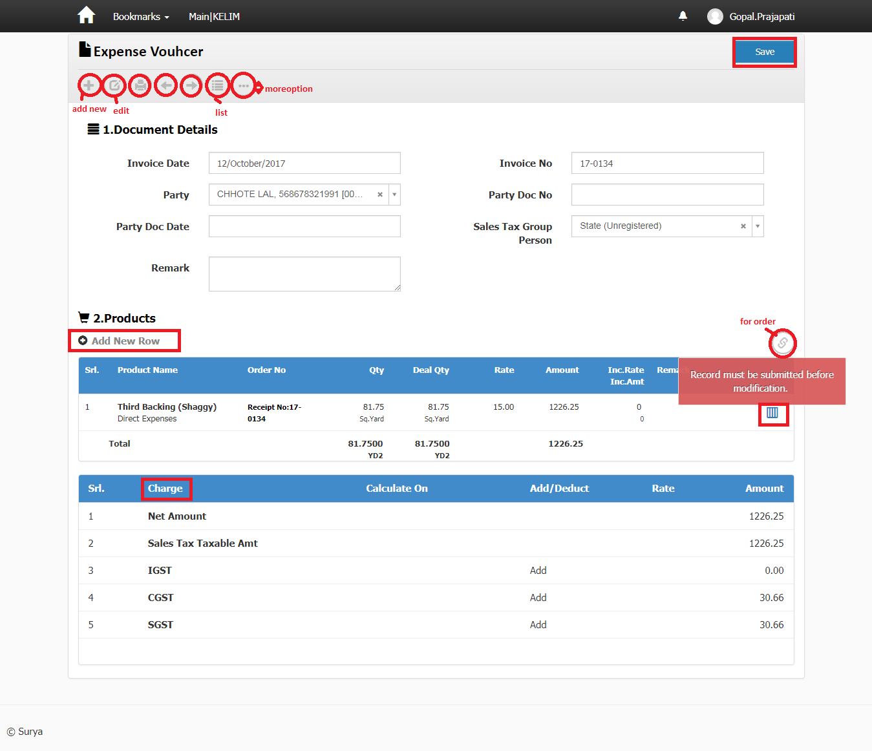
ScreenShotNo-28
Business Logic:
Controller Name->
1)- JobInvoiceReceiveHeaderController: This controller has three Services for display expanse voucher
a) IJobReceiveHeaderService
b) IJobInvoiceHeaderService
c) IUnitOfWork
d) IExceptionHandlingService
2)- JobInvoiceReceiveLineController: This controller has three services for display expanse voucher
a) IJobReceiveLineService
b) IJobInvoiceLineService
c) IUnitOfWork
d) IExceptionHandlingService

Action Method: Modify (Edit) (for header) and Index (for Line )on event:In this Action we get expanse voucher and Products use method GetJobInvoiceHeader ()(for header) and GetLineListForIndex ()(for Line )
Entity Framework/Services->
Services Name: _JobInvoiceHeaderService (for header) and _JobInvoiceLineService (for Line) → In this services we define method GetJobInvoiceHeader ()(for header) and GetLineListForIndex ()(for Line )
DataLogic-
View Model Name/Model – JobInvoiceHeaderViewModel (FOR HEADER) and JobInvoiceLineIndexViewModel (FOR LINE)

Charge:-> in this figure(JobInvoicereturnCharges) we show it IS RELETED TO JobinvoicereceiveHeaderchargesTable.

.Action Method for headers:
    - NextPage () ' For Next page
    - PrevPage ()' For Previous page
    - GeneratePrints () ' For Generate print.
    - Save () ' for save record of header.
    - Edit () for modify record
    - List () for index
    - Add new () Create a new header row
    - More option () for report

Dependencies:
Data Access Layer
( JobInvoiceHeaderService & JobInvoiceLineService)

Business Logic
(JobInvoiceReceiveHeaderController & JobInvoiceReceiveLineController)

Presentation Layer (View layer)
(Modify. cstml & Index.cshtml)

Work Flow: View → Controller →Model
View: Modify(edit). Chtml & index.cshtml -> clearly us can see design of page Screenshot-028
Controller: JobInvoiceReceiveHeaderController and JobInvoiceReceiveLineController
Model : JobInvoiceHeaderViewModel (FOR HEADER) and JobInvoiceLineIndexViewModel (FOR LINE)
Code Flow: HTML/Java Script:
For Line' we use Java Script function on Create.chtml page->
JobInvoiceReceiveHeaderController.cs
Syntax' var link="/JobInvoiceReceiveLine/Index/"+groupId;
Action Method for Line:
For LINE
Action Method:'
- Create ()
- ModifyLine()
- ModifyLineAfterSubmit()
- ModifyLineAfterApprove()
- Delete()

For Post '
  - FilterPost ()
  - ResultsPost ()
  - CreatePost ()

Database (Table/Stored procedure/View):->
Web.JobInvoiceHeaders
ColumnName | Datatype | ReferencedTable | ReferencedColumn
JobInvoiceHeaderId | int |  | PRIMARY KEY
DocTypeId | int | Web.DocumentTypes | DocumentTypeId (FK)
DocDate | datetime
DocNo | nvarchar
DivisionId | int | Web.Divisions | DivisionId (FK)
SiteId | int | Web.Sites | SiteId (FK)
Status | int
Remark | nvarchar
CreatedBy | nvarchar
ModifiedBy | nvarchar
CreatedDate | datetime
ModifiedDate | datetime
OMSId | nvarchar
ProcessId | int
CreditDays | int
JobWorkerDocNo | nvarchar
JobWorkerDocDate | smalldatetime
LedgerHeaderId | int | Web.LedgerHeaders | LedgerHeaderId (FK)
JobWorkerId | int | Web.People | PersonID (FK)
JobReceiveHeaderId | int | Web.JobReceiveHeaders | JobReceiveHeaderId (FK)
JobReceiveDocTypeId | int | Web.DocumentTypes | DocumentTypeId (FK)
LockReason | nvarchar
CreatedMode | nvarchar
ReviewCount | int
ReviewBy | nvarchar
FinancierId | int
SalesTaxGroupPersonId | int | Web.ChargeGroupPersons | ChargeGroupPersonId (FK)
CurrencyId | int | Web.Currencies | ID (FK)
ReferenceDocTypeId | int | Web.DocumentTypes | DocumentTypeId (FK)
ReferenceDocId | int
GovtInvoiceNo | nvarchar

Web.jobinvoiceLines
ColumnName | Datatype | ReferencedTable | ReferencedColumn
JobInvoiceLineId | int |  | PRIMARY KEY
JobInvoiceHeaderId | int | Web.JobInvoiceHeaders | JobInvoiceHeaderId (FK)
JobReceiveLineId | int | Web.JobReceiveLines | JobReceiveLineId (FK)
DealUnitId | nvarchar | Web.Units | UnitId (FK)
DealQty | decimal
Rate | decimal
Amount | decimal
CreatedBy | nvarchar
ModifiedBy | nvarchar
CreatedDate | datetime
ModifiedDate | datetime
OMSId | nvarchar
Remark | nvarchar
JobWorkerId | int | Web.People | PersonID (FK)
UnitConversionMultiplier | decimal
JobOrderLineId | int | Web.JobOrderLines | JobOrderLineId (FK)
Sr | int
LockReason | nvarchar
CostCenterId | int | Web.CostCenters | CostCenterId (FK)
CreatedMode | nvarchar
Qty | decimal
DeveloperNotes | nvarchar
IncentiveAmt | decimal
IncentiveRate | decimal
RateDiscountPer | decimal
RateDiscountAmt | decimal
SalesTaxGroupProductId | int | Web.ChargeGroupProducts | ChargeGroupProductId (FK)
DiscountPer | decimal
DiscountAmt | decimal
ReferenceDocTypeId | int | Web.DocumentTypes | DocumentTypeId (FK)
ReferenceDocLineId | int

