Design Flow:
- UI
- Business Logic
- Data Logic
- Custom Controls
- Dependencies
- WORK FLOW ( View -> Controller -> Model -> Entity )
Code Flow:
- UI design pattern – (HTML, Scripts)
- Coding standard and guidelines (Controller, business logic and data access)
Database objects & Schema:
- Database
- Table – Purpose, ER diagram, Model class
- Procedure, Functions, view , custom type
Backlog:
Sort Description | Detailed Description | Effort | Type (Functional/Technical) | Requested By

Created Date | Created by | Review Date | Review by

Login UI:
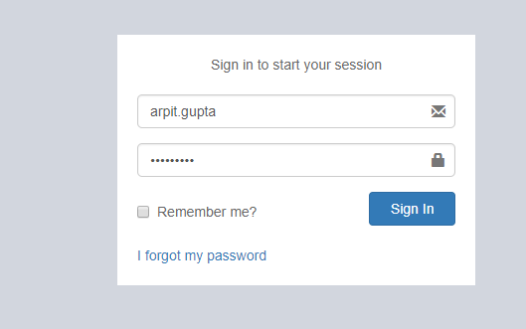

Business Logic and Module: We use Microsoft Asp.net Identity 2.0 Feature for Login Credential.
Click on Sign in Button → Open below Screen shot (SiteSelection Page).
Dependencies: Microsoft Asp.net Identity 2.0 (Only for login)

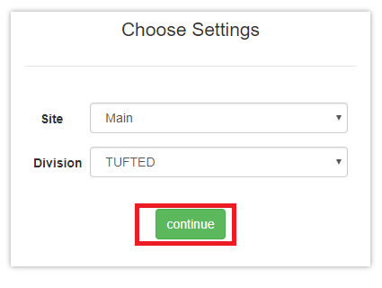Screen Shot no.1

Business Logic:
1: Controller Name -> SiteSelectionController: SiteSelection controller has seven services for use.
- ISiteSelectionService
- IUserRolesService
- ImoduleService
- IUserBookMarkService
- ICompanySettingsService
- ICompanyService
- IRolesControllerActionService
Action Method -> SiteSelection: To display site selection screen we use GetUserId method of SiteSelection controller and after that we identify for particular Roles.
Below Methods are given for User Role and Roles list.
- GetUserRolesList()
- GetRolesList()
To bind dropdown list we use below method.
- GetSiteList()
- GetDivisionList()
Data Logic→ 1: For Roles.
View Model Name/Model: UserRoleViewModel, UserRole, UserProfile, UserReferral:
In this View Model and Model we declare all property related to roles.
2: For Site & Division.
View Model Name/Model: Site/ Division
In this view model and model we declare all property related site and Division.
Entity Framework/Services->1: for Roles
Services Name: UserService: In this service has GetUserRolesList ()
In which is define in UserReferralService interface.
2: For Site & Division
Service Name: SiteService: In this service has GetSiteList () in which is define in SiteService interface.
DivisionService: In this service has GetDivisionList () in which is define in
DivisionService interface.
Dependencies:
Data Access Layer
(UserService & SiteService & DivisionService)

Business Logic
(SiteSelection Controller)

Presentation Layer (View layer)
(SiteSelection.chtml)

Work Flow: View → Controller →Model
View: SiteSelection.chtml -> clearly we can see design of page in screen shot no .1
Controller: SiteSelectionController
Model: UserRoleViewModel, UserRole, UserProfile and UserReferral

Database (Table/Stored procedure /View):
1. | Web.Menus
MenuId | INT IDENTITY NOT NULL, | PRIMARY KEY
MenuName | NVARCHAR (50) NOT NULL,
Srl | NVARCHAR (5) NOT NULL,
IconName | NVARCHAR (100) NOT NULL,
Description | NVARCHAR (100) NOT NULL,
ModuleId | INT NOT NULL,
SubModuleId | INT NOT NULL,
ControllerActionId | INT NOT NULL,
RouteId | NVARCHAR (max),
IsActive | BIT DEFAULT ((1)) NOT NULL,
CreatedBy | NVARCHAR (max),
ModifiedBy | NVARCHAR (max),
CreatedDate | DATETIME NOT NULL,
ModifiedDate | DATETIME NOT NULL,
URL | NVARCHAR (100),
IsVisible | BIT,
isDivisionBased | BIT DEFAULT ((0)),
isSiteBased | BIT DEFAULT ((0)),
AreaName | NVARCHAR (50),
ControllerName | NVARCHAR (100),
ActionName | NVARCHAR (100),

2. | Web.RolesMenus
RolesMenuId | INT IDENTITY NOT NULL, | PRIMARY KEY
RoleId | NVARCHAR (128),
MenuId | INT NOT NULL,
CreatedBy | NVARCHAR (max),
ModifiedBy | NVARCHAR (max),
CreatedDate | DATETIME NOT NULL,
ModifiedDate | DATETIME NOT NULL,
FullHeaderPermission | BIT DEFAULT ((0)) NOT NULL,
FullLinePermission | BIT DEFAULT ((0)) NOT NULL,
DivisionId | INT DEFAULT ((1)) NOT NULL,
SiteId | INT DEFAULT ((17)) NOT NULL,

3. | Web.Sites
SiteId | INT IDENTITY NOT NULL, | PRIMARY KEY
SiteName | NVARCHAR (50) NOT NULL,
Address | NVARCHAR (250),
PhoneNo | NVARCHAR (50),
CityId | INT,
IsActive | BIT DEFAULT ((1)) NOT NULL,
IsSystemDefine | BIT DEFAULT ((0)) NOT NULL,
CreatedBy | NVARCHAR (max),
ModifiedBy | NVARCHAR (max),
CreatedDate | DATETIME NOT NULL,
ModifiedDate | DATETIME NOT NULL,
OMSId | NVARCHAR (50),
SiteCode | NVARCHAR (20),
DefaultDivisionId | INT,
ThemeColour | NVARCHAR (25),
PersonId | INT,
DefaultGodownId | INT,
DocTypeId | INT,
SiteShortCode | NVARCHAR (2),

4. | Web.RolesSites
RolesSiteId | INT IDENTITY NOT NULL, | PRIMARY KEY
RoleId | NVARCHAR (128),
SiteId | INT NOT NULL,
CreatedBy | NVARCHAR (max),
ModifiedBy | NVARCHAR (max),
CreatedDate | DATETIME NOT NULL,
ModifiedDate | DATETIME NOT NULL,

5. | Web.Divisions
DivisionId | INT IDENTITY NOT NULL, | PRIMARY KEY
DivisionName | NVARCHAR (50) NOT NULL,
Address | NVARCHAR (250),
LstNo | NVARCHAR (20),
CstNo | NVARCHAR (20),
IsActive | BIT DEFAULT ((1)) NOT NULL,
IsSystemDefine | BIT DEFAULT ((0)) NOT NULL,
CreatedBy | NVARCHAR (max),
ModifiedBy | NVARCHAR (max),
CreatedDate | DATETIME NOT NULL,
ModifiedDate | DATETIME NOT NULL,
OMSId | NVARCHAR (50),
CompanyId | INT,
ThemeColour | NVARCHAR (25),
ReportHeaderTextRight1 | NVARCHAR (max),
ReportHeaderTextRight2 | NVARCHAR (max),
ReportHeaderTextRight3 | NVARCHAR (max),
ReportHeaderTextRight4 | NVARCHAR (max),
DivisionShortCode | NVARCHAR (2),
LogoBlob | NVARCHAR (max),

6 | Web.RolesDivisions
RolesDivisionId | INT IDENTITY NOT NULL, | PRIMARY KEY
RoleId | NVARCHAR (128),
DivisionId | INT NOT NULL,
CreatedBy | NVARCHAR (max),
ModifiedBy | NVARCHAR (max),
CreatedDate | DATETIME NOT NULL,
ModifiedDate | DATETIME NOT NULL,

Selection of Godown-> In Screen shot no.1, click on →Continue Button →open Below Screen.
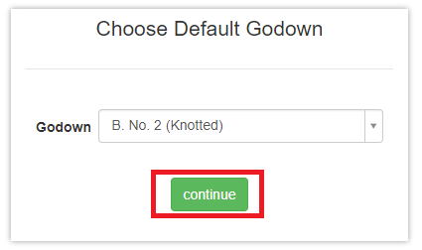
(Screen Shot no.2)
Business logic -> Controller Name: SiteSelectionController
Action Method: DefaultGodownSelection: To display Godown screen we use GetGodownList () function of SiteSelectionController.
To bind the Godown dropdown list using below method.
GetGodownList (): This function is define in IGodownService services.
Data Logic->
View Model Name/Model: Godown.cs
Entity Formwork / Services→
Service Name: ISiteSelectionService, ICompanySettingsService, IGodownService.
Dependencies:
Data Access Layer
(IGodownService, ICompanySettingsService, ISiteSelectionService)

Business Logic
(SiteSelection Controller)

Presentation Layer (View layer)
(DefaultGodownSelection)

Work Flow: View → Controller →Model
View: DefaultGodownSelection.chtml
Controller Name: SiteSelectionController
Model Name: Godown.cs
Database (Table/Stored procedure /View):
 | Web.Godowns
GodownId | INT IDENTITY NOT NULL, | PRIMARY KEY
GodownName | NVARCHAR (50) NOT NULL,
SiteId | INT NOT NULL,
IsActive | BIT DEFAULT ((1)) NOT NULL,
CreatedBy | NVARCHAR (max),
ModifiedBy | NVARCHAR (max),
CreatedDate | DATETIME NOT NULL,
ModifiedDate | DATETIME NOT NULL,
OMSId | NVARCHAR (50),
Site_SiteId | INT,
GateId | INT,
DocTypeId | INT,
GodownCode | NVARCHAR (10),
PersonId | INT,

IMPORT UI:
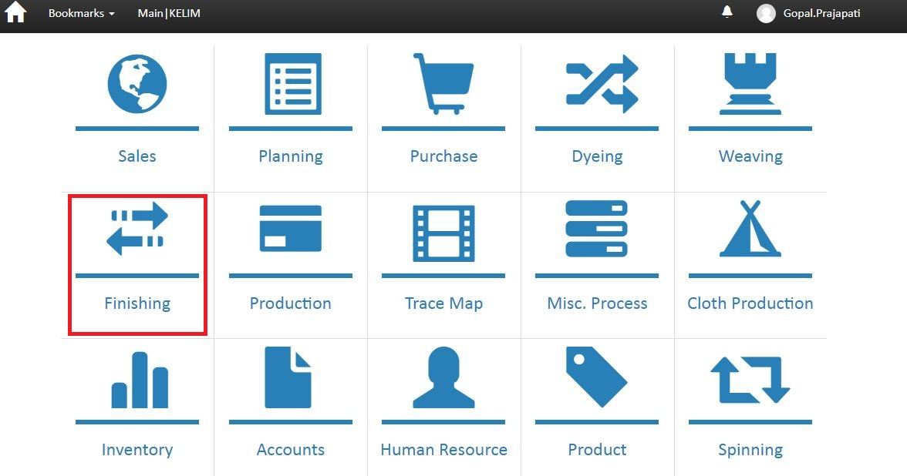
(Screenshot no -03)
Business Logic:
Controller Name-> MenuController : Menu controller has three services for display menu
a)-IModuleService
b)-ISubModuleService
c)- IUnitOfWork
- Action Method-> Module: To display menu we use GetModules function of ImoduleService interface. In Module Action we stored all menu in Moduleslist variable and check condition if Moduleslist == 1 then open SubModule otherwise Module
Data Logic:
Model Name: MenuModouleViewModel.cs
Entity Framework/ Services: ImoduleService.cs ' In this Service we define
GetModules() .

Dependencies:
Data Access Layer
(Module services)

Business Logic
(menu Controller)
Presentation Layer (View layer)
(module.chtml)

 | web.menu module
Fields | DataType | Constrain | Remark
ModuleId | INT IDENTITY NOT NULL, | PRIMARY KEY
ModuleName | NVARCHAR (50) NOT NULL,
Srl | INT NOT NULL,
IconName | NVARCHAR (100) NOT NULL,
IsActive | BIT DEFAULT ((1)) NOT NULL,
CreatedBy | NVARCHAR (max),
ModifiedBy | NVARCHAR (max),
CreatedDate | DATETIME NOT NULL,
ModifiedDate | DATETIME NOT NULL,
URL | NVARCHAR (100),

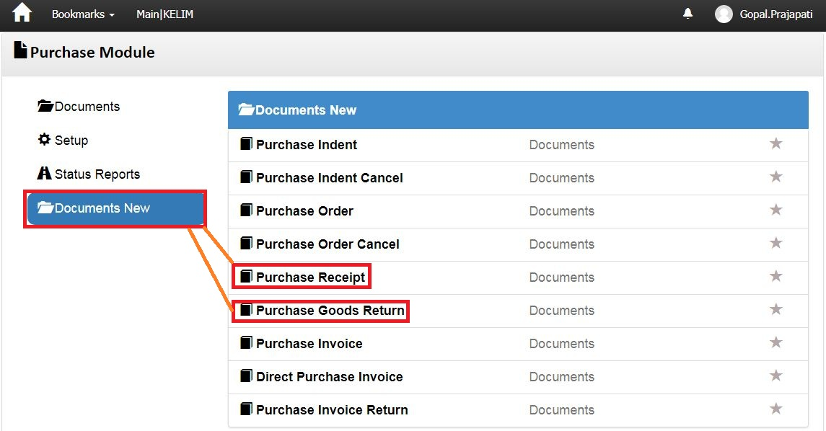
Screenshot No-4
Screen shot no-4
Business Logic:
- Controller Name-> MenuController : Menu controller has three services for display menu
a)- IModuleService
b)-ISubModuleService
c)- IUnitOfWork
Action Method: Module: In this Action method we identify particular user Role and then execute GetModuleList () and GetModuleListForUser ().
Finally Return Module and SubModule View based on condition.
DataLogic-
ModelName- SubModuleViewModel.cs

Dependencies:
Data Access Layer
(SubModuleService)

Business Logic
(Menu Controller)

Presentation Layer (View layer)
(Submodule.chtml)

Work Flow: View → Controller →Model
View: Submodule.chtml -> clearly us can see design of page
Controller: Menu Controller
Model: MenuViewModel / SubModuleViewModel

Database (Table/Stored procedure/View)
 | web.MenuSubModules
Fields | DataType | Constrain | Remark
SubModuleId | INT IDENTITY NOT NULL, | PRIMARY KEY
SubModuleName | NVARCHAR (50) NOT NULL,
IconName | NVARCHAR (100) NOT NULL,
IsActive | BIT DEFAULT ((1)) NOT NULL,
CreatedBy | NVARCHAR (max),
ModifiedBy | NVARCHAR (max),
CreatedDate | DATETIME NOT NULL,
ModifiedDate | DATETIME NOT NULL,
OMSId | NVARCHAR (50),

Purchase Receipt:-
Note: In Screen shot no. 04, DoubleClick on “Purchase Receipt” Hyperlink →Open below Screen Shot.
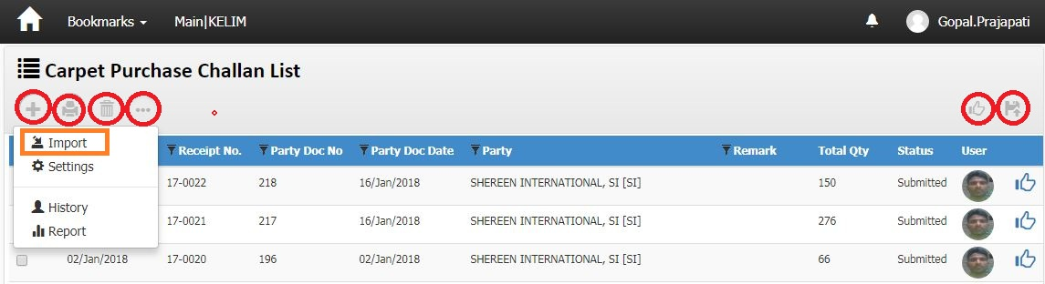
Screenshot No-05
Note: In Screen shot no. 05, Double Click on “ Click ON MORE OPTION AND Click ON IMPORT ” Hyperlink →Open below Screen
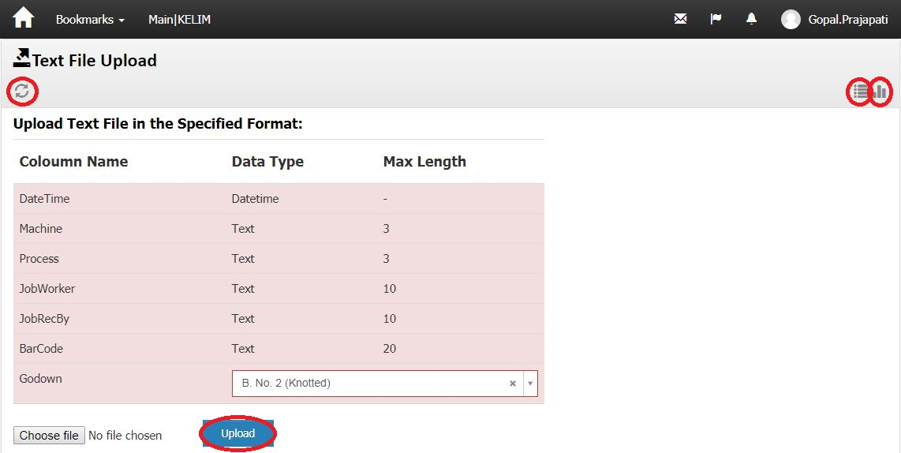
Screenshotno-06
Business Logic:
1)-Controller Name-> PurchaseGoodsReceiptTextImportController: This controller has three Services for display text file upload.
a) IProductService
b) IPersonService
c) ISaleOrderHeaderService
d) ISaleOrderLineService
e) IUnitOfWork
f) IBuyerService
g) ICurrencyService
h) IShipMethodService
i) IDeliveryTermsService
2)-Action Method:
Action Method Name :-> Index: In this Action we get text file upload using
SQLProcedures:” PurchaseGoodsReceiptHeaders ",
Note :-> Sql procedures call with controller and text file upload and save record in data base

Purchase Goods Return Import:-
Note: In Screen shot no. 04, DoubleClick on “Purchase Goods return” Hyperlink →Open below Screen Shot.
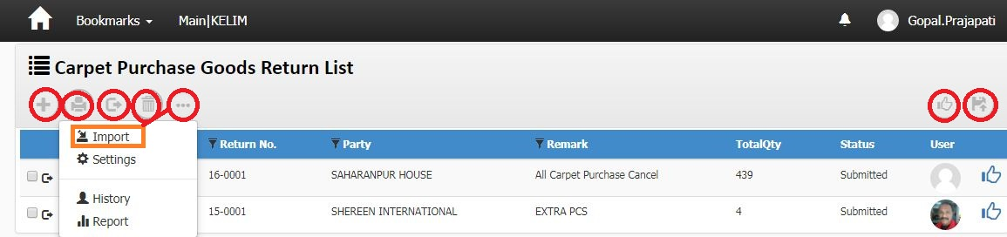
Screenshot No-07

Note: In Screen shot no. 07, Double Click on “ Click ON MORE OPTION AND Click ON IMPORT ” Hyperlink →Open below Screen
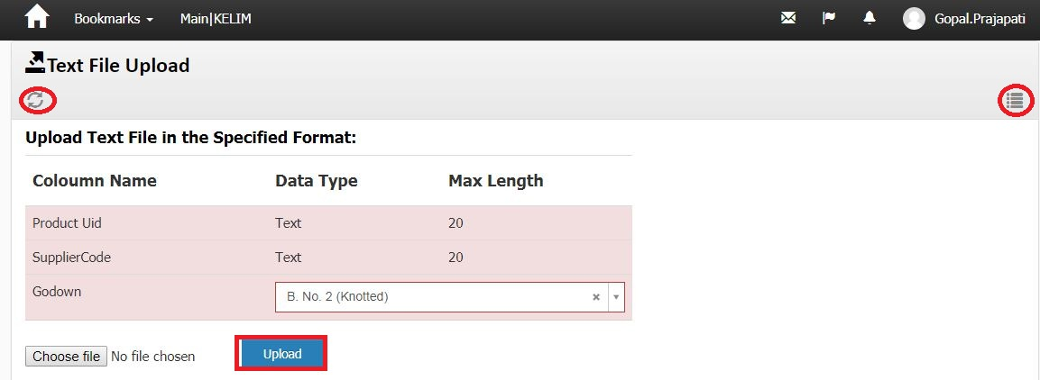
Screenshotno-08
Business Logic:
1)-Controller Name-> PurchaseGoodsReturnTextImportController: This controller has one Services for display text file upload.
a) IUnitOfWork
2)-Action Method:
Action Method Name :-> Index: In this Action we get text file upload using
SQLProcedures:” PurchaseGoodsReturnHeader",
Note :-> Sql procedures call with controller and text file upload and save record in data base.

DYEING RECEIVEIMPORT:-
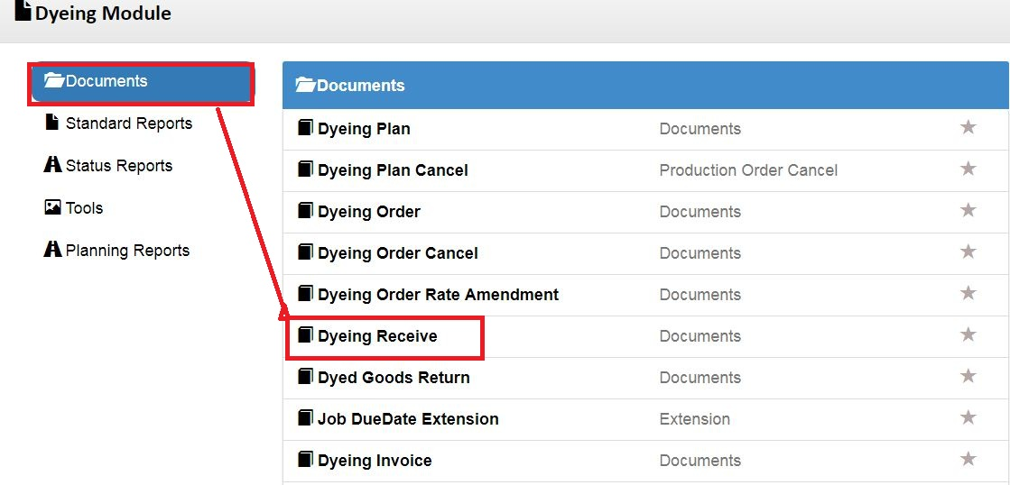
Screenshot No-4
Screen shot no-4
Business Logic:
- Controller Name-> MenuController : Menu controller has three services for display menu
a)- IModuleService
b)-ISubModuleService
c)- IUnitOfWork
Action Method: Module: In this Action method we identify particular user Role and then execute GetModuleList () and GetModuleListForUser ().
Finally Return Module and SubModule View based on condition.
DataLogic-
ModelName- SubModuleViewModel.cs

Dependencies:
Data Access Layer
(SubModuleService)

Business Logic
(Menu Controller)

Presentation Layer (View layer)
(Submodule.chtml)

Work Flow: View → Controller →Model
View: Submodule.chtml -> clearly us can see design of page
Controller: Menu Controller
Model: MenuViewModel / SubModuleViewModel

Database (Table/Stored procedure/View)
 | web.MenuSubModules
Fields | DataType | Constrain | Remark
SubModuleId | INT IDENTITY NOT NULL, | PRIMARY KEY
SubModuleName | NVARCHAR (50) NOT NULL,
IconName | NVARCHAR (100) NOT NULL,
IsActive | BIT DEFAULT ((1)) NOT NULL,
CreatedBy | NVARCHAR (max),
ModifiedBy | NVARCHAR (max),
CreatedDate | DATETIME NOT NULL,
ModifiedDate | DATETIME NOT NULL,
OMSId | NVARCHAR (50),

Dyeing Receive:-
Note: In Screen shot no. 04, DoubleClick on “Dyeing Receive” Hyperlink →Open below Screen Shot.
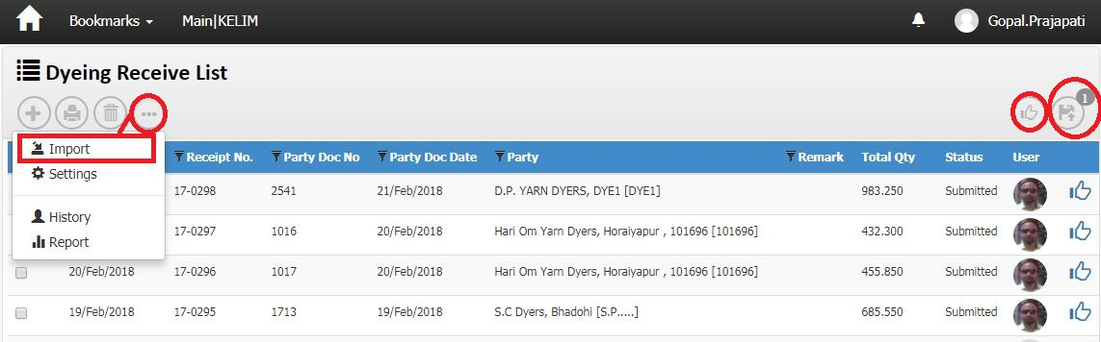
Screenshot No-05
Note: In Screen shot no. 05, Double Click on “ Click ON MORE OPTION AND Click ON IMPORT ” Hyperlink →Open below Screen
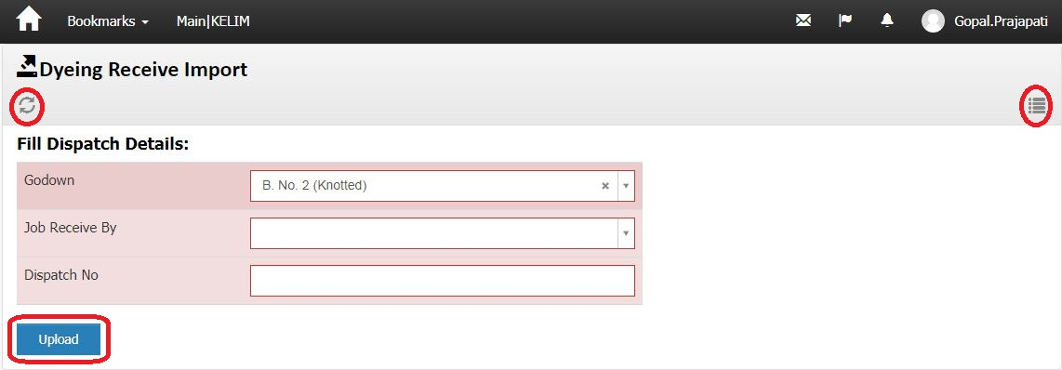
Screenshotno-06
Business Logic:
1)-Controller Name-> DyeingReceiveExcelImportController: This controller has three Services for display text file upload.
a) IUnitOfWork

2)-Action Method:
Action Method Name :-> Index: In this Action we get text file upload using
SQLProcedures:” DyeingReceiveExcelImport",
Note :-> Sql procedures call with controller and text file upload and save record in data base

Dyeing Invoice:-
Note: In Screen shot no. 04, DoubleClick on “Dyeing invoice” Hyperlink →Open below Screen Shot.
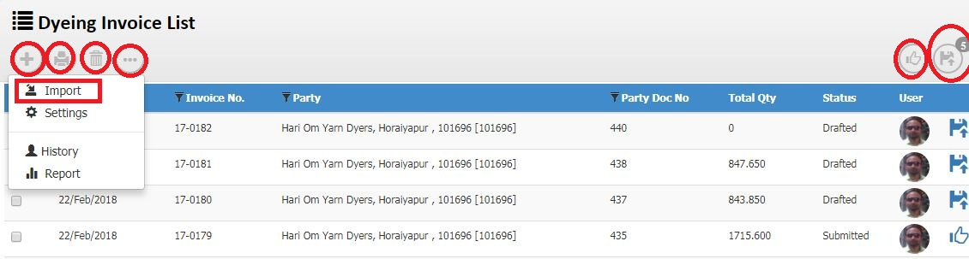
Screenshot No-05
Note: In Screen shot no. 05, Double Click on “ Click ON MORE OPTION AND Click ON IMPORT ” Hyperlink →Open below Screen
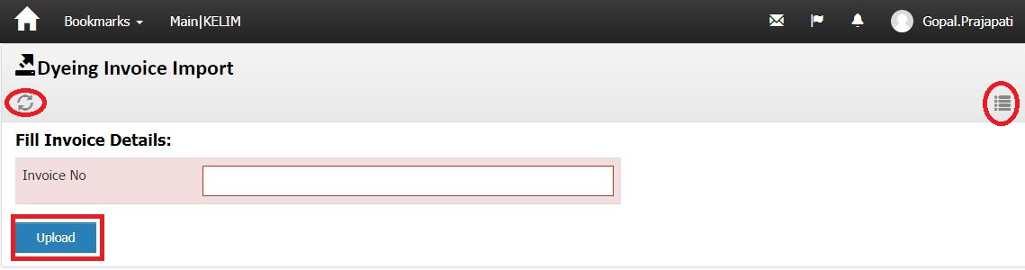
Screenshotno-06
Business Logic:
1)-Controller Name-> DyeingInvoiceExcelImportController: This controller has three Services for display text file upload.
a) IExceptionHandlingService
b) IUnitOfWork

2)-Action Method:
Action Method Name :-> Index: In this Action we get text file upload using
SQLProcedures:” DyeingInvoiceExcelImport",
Note :-> Sql procedures call with controller and text file upload and save record in data base

Finishing Invoice Return Import:-
Note: In Screen shot no. 04, DoubleClick on “finishing invoice return” Hyperlink →Open below Screen Shot.
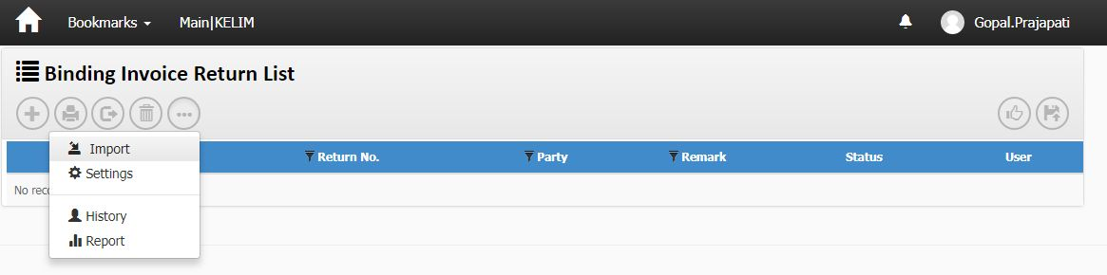
Screenshot No-07

Note: In Screen shot no. 07, Double Click on “ Click ON MORE OPTION AND Click ON IMPORT ” Hyperlink →Open below Screen
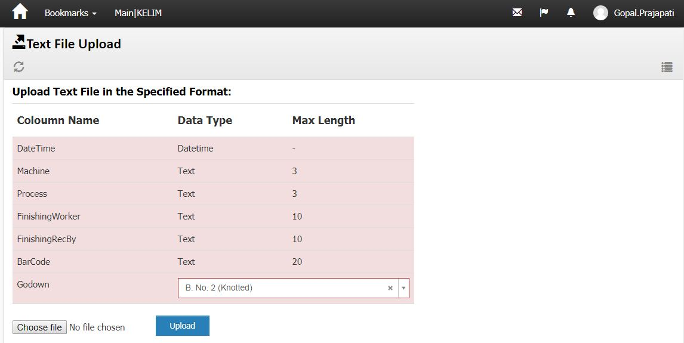
Screenshotno-08
Business Logic:
1)-Controller Name-> FinishingInvoiceReturnTextImportController: This controller has one Services for display text file upload.
a) IUnitOfWork

2)-Action Method:
Action Method Name :-> Index: In this Action we get text file upload using
SQLProcedures:” FinishingInvoiceReturnTextImport",
Note :-> Sql procedures call with controller and text file upload and save record in data base.

