**[Documentation to Restored Database]**

Step-1(How to Drop Database?): Occurred Error as below Screen shot

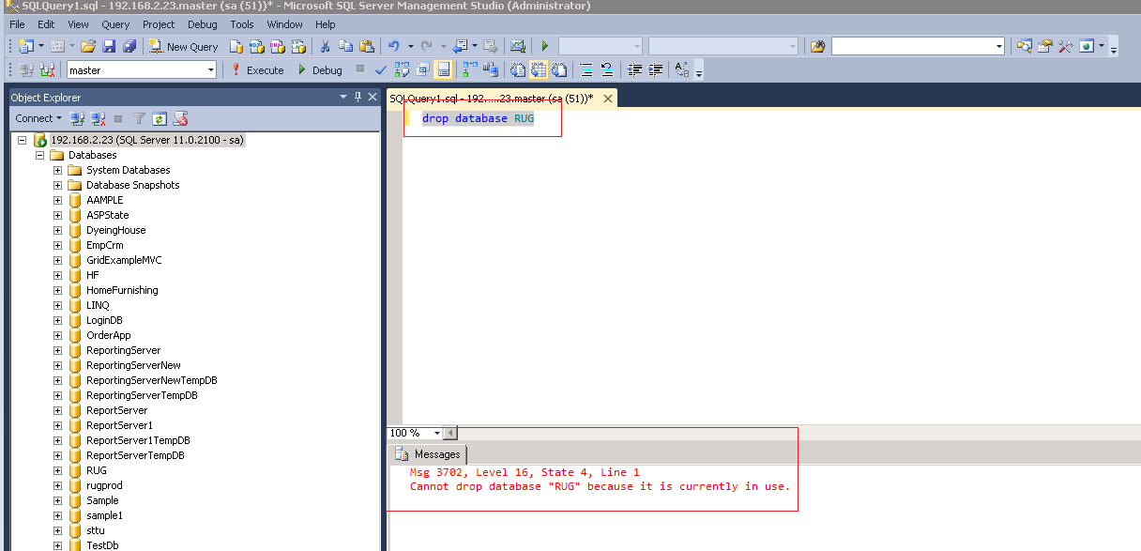

**Step-2(How to resolved Above Screen shot Issues)**

1. **Go to -> Run Command and write “services. MSc” and then click “Ok” button as given below screen shot.**

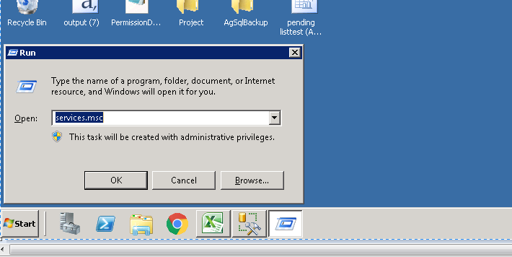

1. **In Below Screen , Stop/Start to highlighted service**

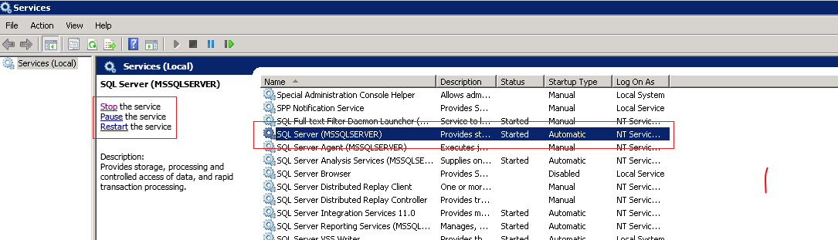

1. **Finally again fire the drop query 🡪 find as below window.**

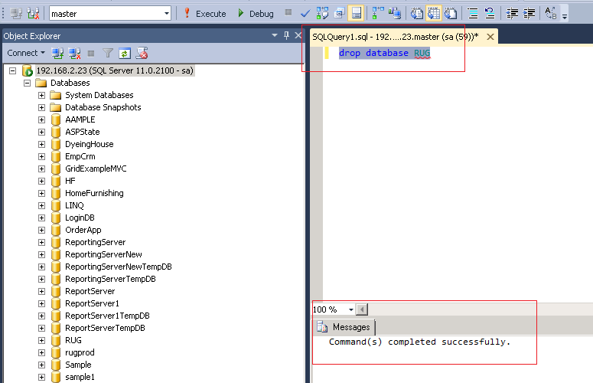

**Step-2(Right click on Database And select “Restore Database” ->click on it)**

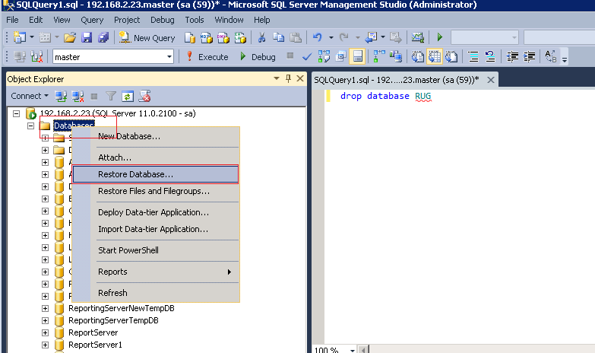

**Step-3(In below screen shot we select the file of database which we want to restored)**

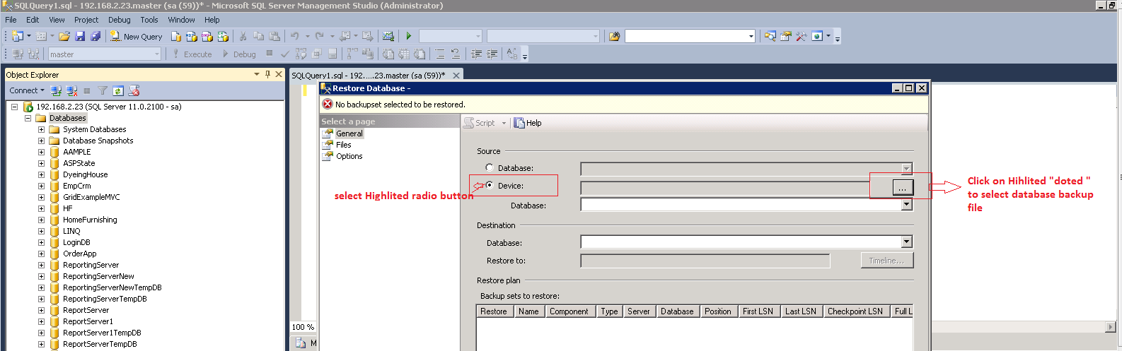

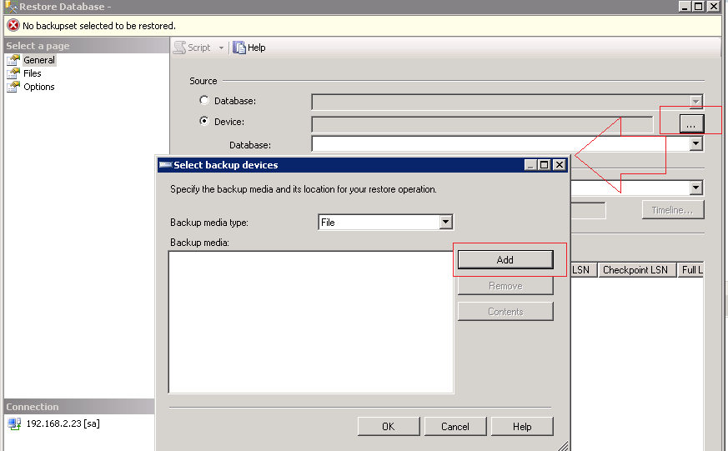

**Step-4(when we add file see as below screen shot)**

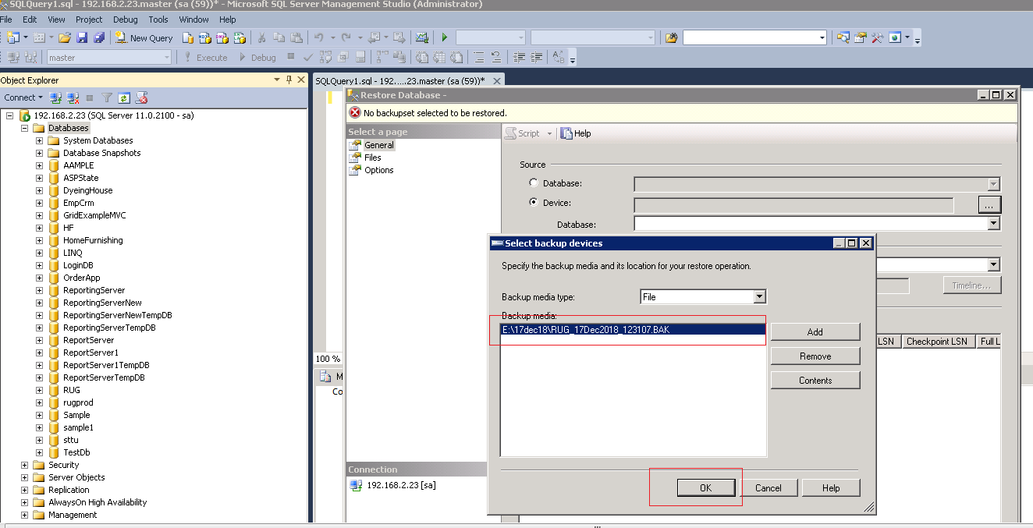

**Step-5 (In above Screen shot we click “Ok” button -> open as below screen shot)**

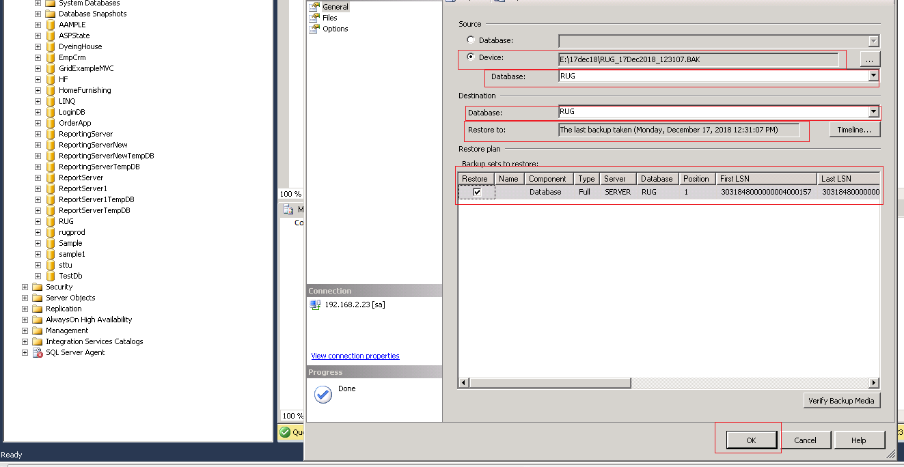

**Step-6(Finally we click “Ok” button -> Restoring Process Will be Start -----) below**

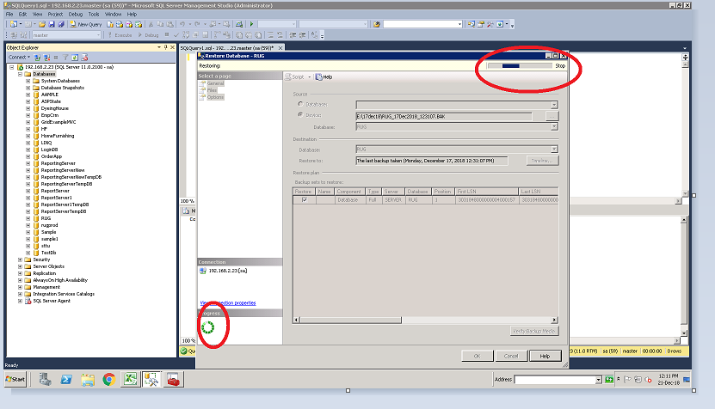

**Documentation of Database Back up**

**--------------------------------------------------------------------------------------------------------------------------------**

1. **Below given query will be fire 🡪 Database back up process Start –**

DECLARE @DatabaseName NVARCHAR(50)

DECLARE @DateTime NVARCHAR(50)

DECLARE @BackupPath NVARCHAR(100)

SET @DatabaseName = (select db_name())

SET @DateTime = (SELECT convert(NVARCHAR(50), replace(convert(NVARCHAR,getdate(),106),' ','') +'_' + replace(convert(NVARCHAR,getdate(),108),':','')) )

SET @BackupPath = (SELECT 'E:\17dec18\' + @DatabaseName +'_'+ @DateTime + '.BAK')

BACKUP DATABASE @DatabaseName

TO DISK = @BackupPath

**Documentation of Database Shrink Up**

**Note1: How to check database initial size and log space as given screen shot through Query.**

select name,recovery_model_desc, log_reuse_wait_desc from sys.databases

dbcc sqlperf(logspace)

**Execute this query see as below screen shot.**

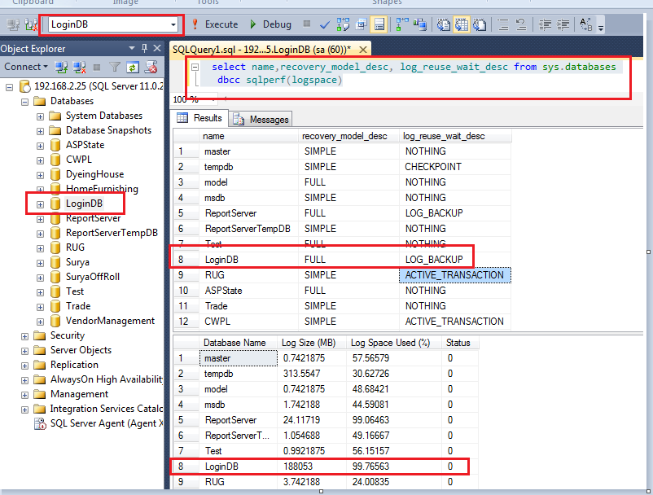

**Note2: How to check database initial size as given screen shot through wizard.**

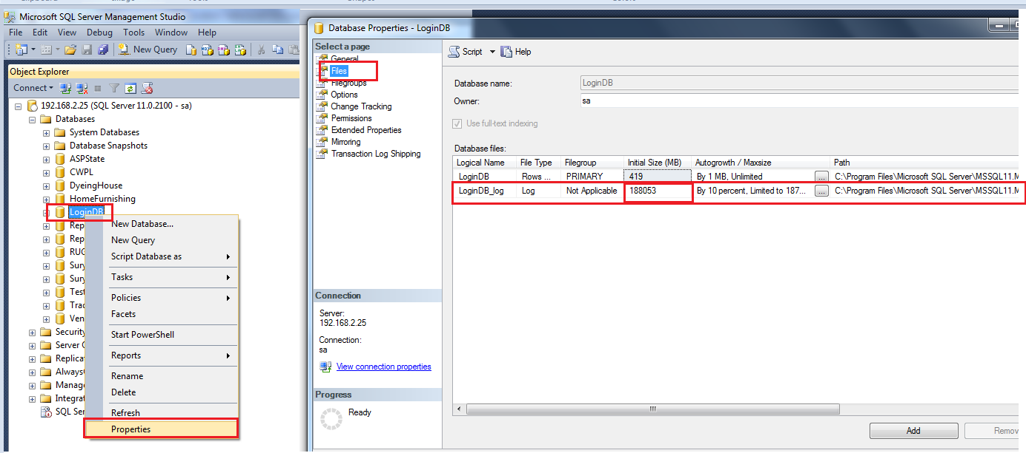

**Basically Shrink up is Process of customized the database back up file. Follow below step to perform shrinking database.**

**Step-1 Take the Back up of Data base [Full and Transaction Log] through Wizard.**

**1-Full back up && Transaction Log: -as below Screen shot.**

1. **Firstly we select backup type “full” in dropdown list and we take transaction log similar as full backup.**

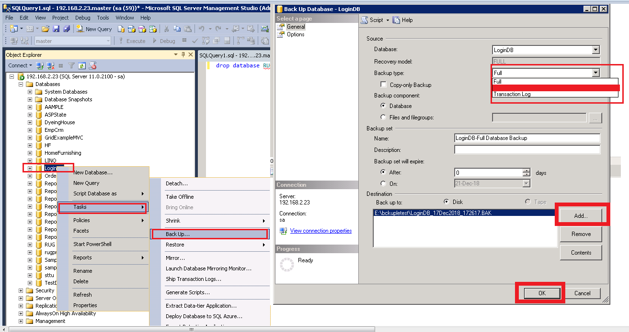

**In Above screen shot click “Add” button to save back up file location with”.bak” extension.**

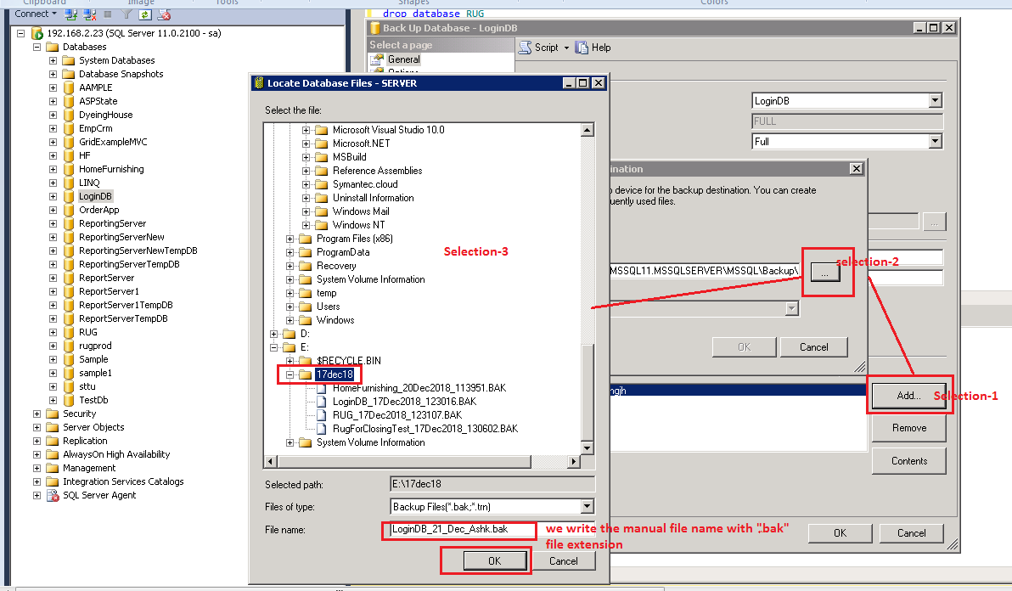

**Finally we click “OK” button 🡪 Back up process start continue---**

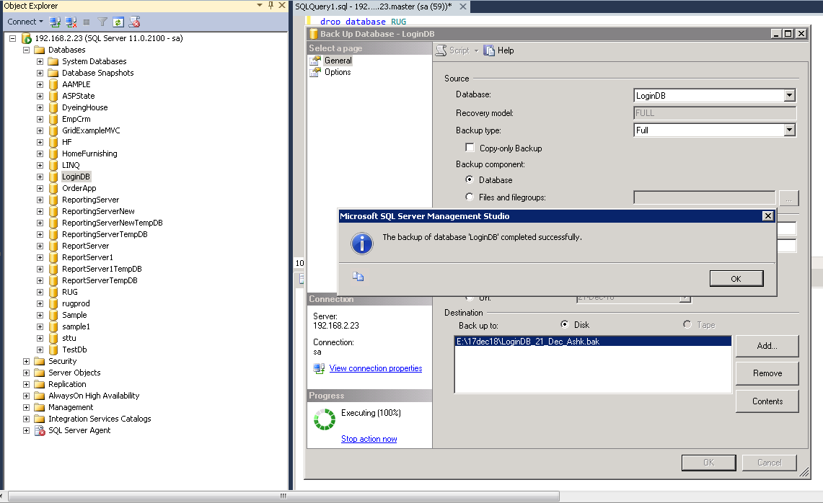

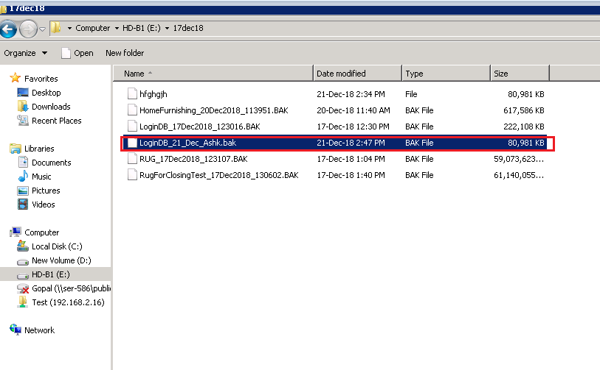

**Step-2: Start process for Shrink up.**

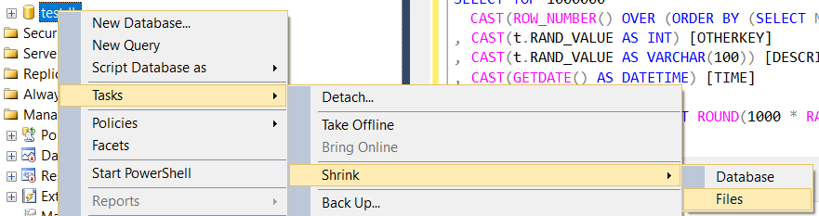

**Step-3 In below screen shot firstly select file type “data” and click “Ok” button and after that select file type “Log” as we see in screen shot.**

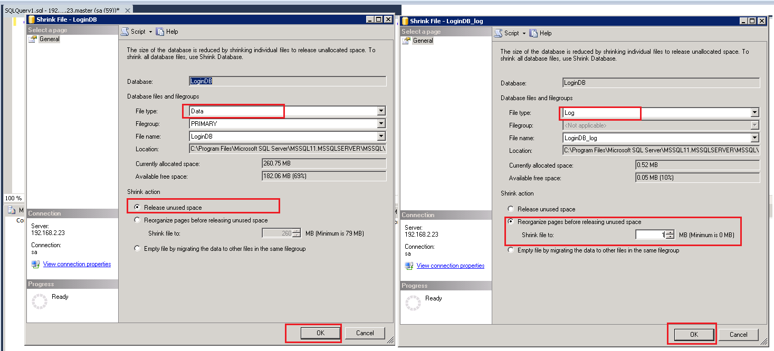

**Here we check after execute shrink up command process as below screen shot.**

