Documentation To Process for FTP WITH HELP OF FILEZILA
Host:-13.71.5.33
UserName:-deployer
Password:-Passw0rd$321
port-:990

SCREENSHOT 1:-

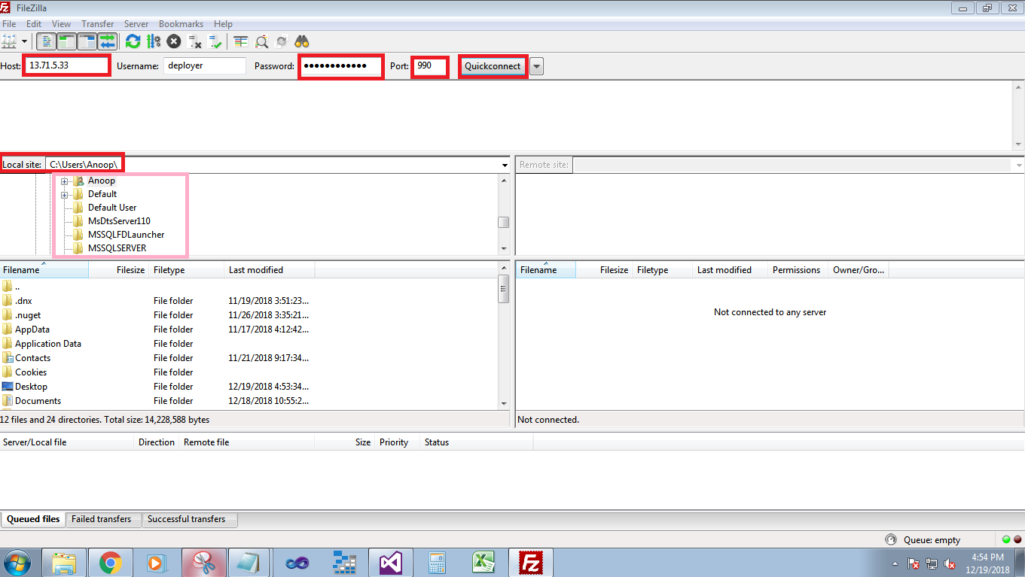

ScreenShot:2-

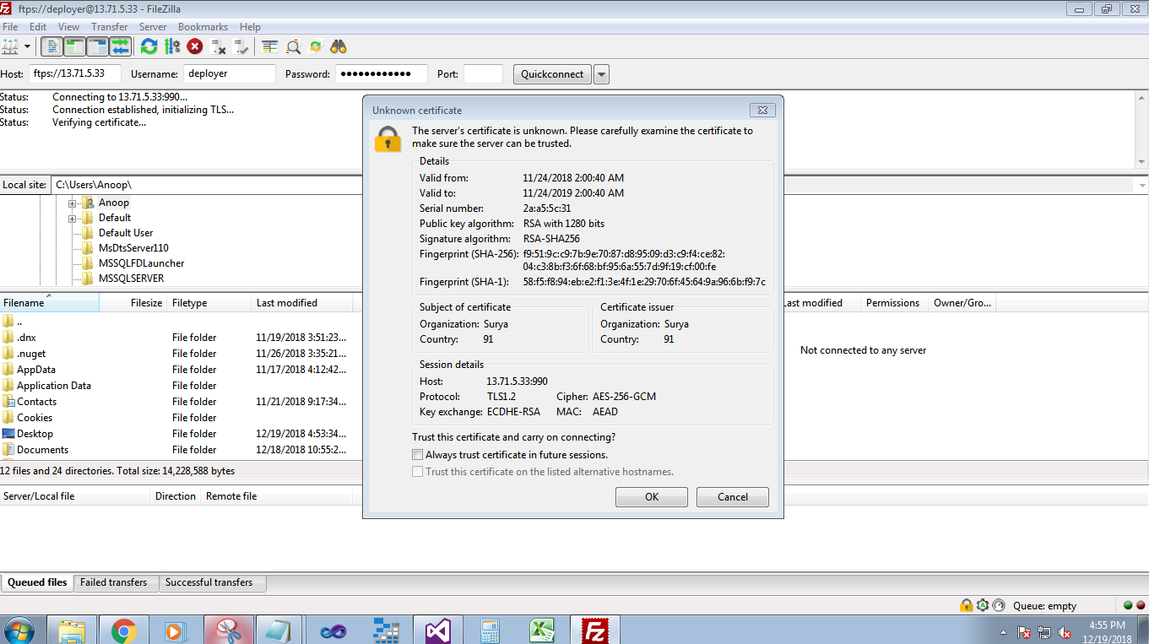

Screenshot:3-

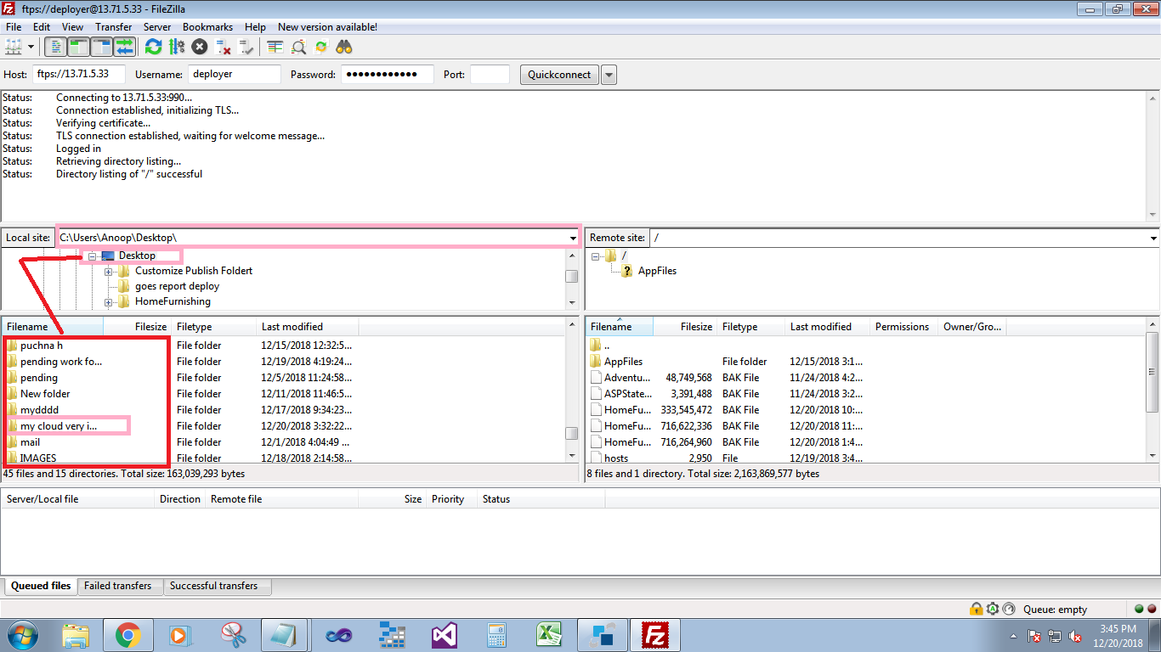

ScreenShot:4-

