Back and restore

Using Azure Recovery services

# Configuring backup

As we know data is very critical to any system and restoring the system at the time of disaster with the required data in minimum down time would be the top priority of any IT department.

Azure provides Recovery Services Vault for backing up and restoring data using Azure portal. Using this service, we can back up and restore SQL instance running on a VM and also entire VM can be restored in case of disaster.

## configuring Recovery Service Vault

First, add Recovery Services Vault services by searching it in Azure Portal.

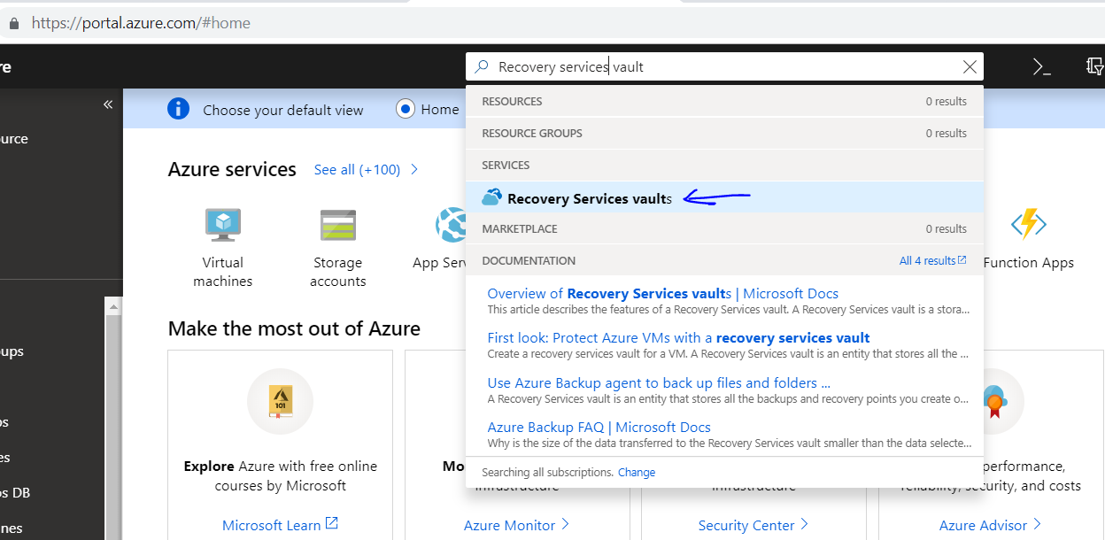

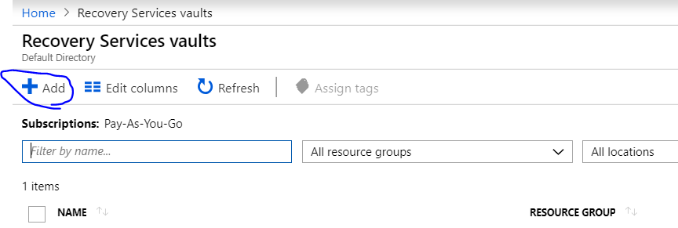

|  |  |
| --- | --- |
|  | Enter name, Resource group under which this service to be tracked and location.  Note: Make sure location is same as location from which data need to be backed up. |

## Configuring SQL instance backup

Once Recovery Services Vault is added, select the service from the vaults blade and click on Backup items.

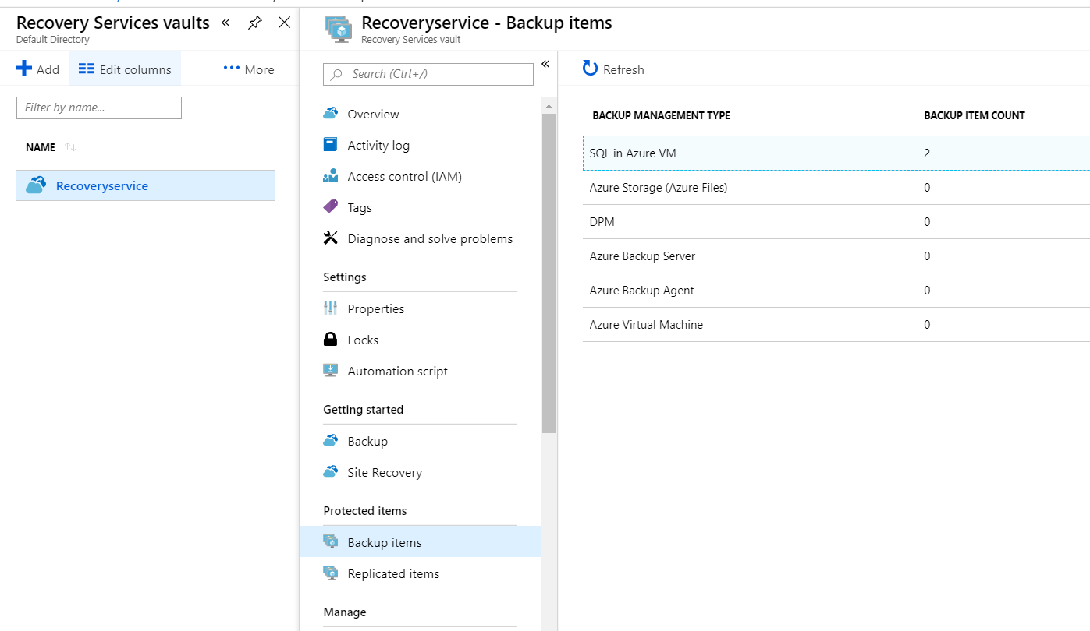

If we have backup SQL instance running in a VM then select SQL in Azure VM. For backing up VM select Azure Virtual machine.

After selecting SQL in Azure VM, Click on Add button.

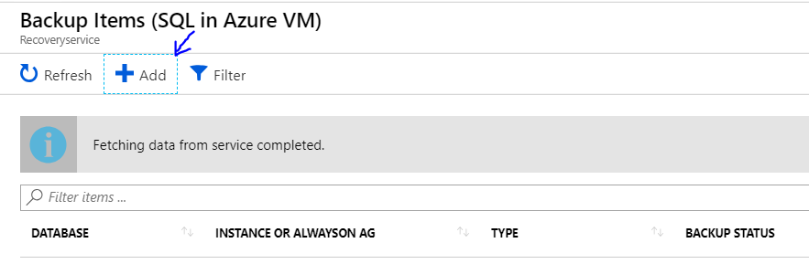

. In the next screen select DB and backup policy appropriately.

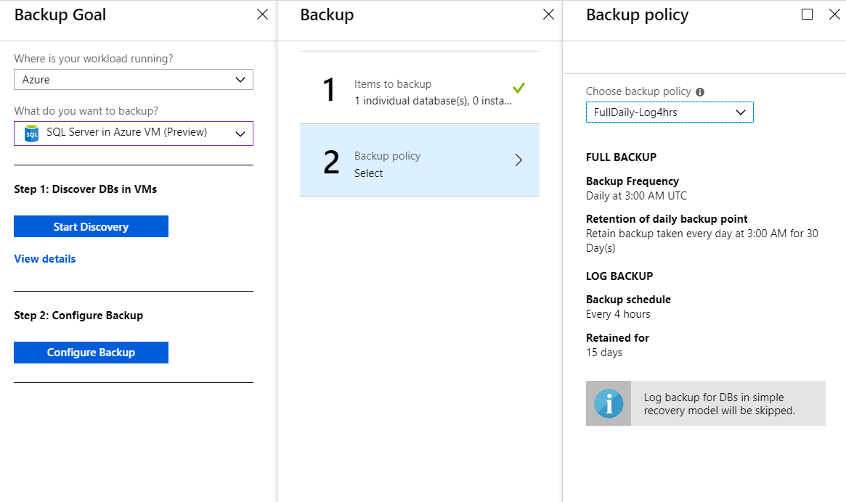

Once the configuration is done, backup items are listed as shown below.

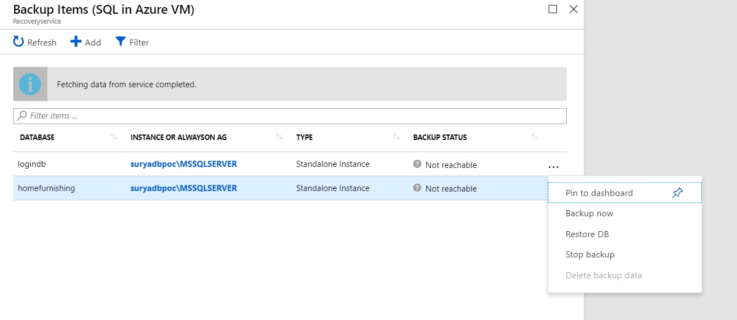

By clicking on ellipsis menu we can select appropriate actions.

|  |  |
| --- | --- |
|  | Once we trigger the action (backup now\Restore DB) the status of the job can be monitored in Back Jobs section. |

## Configuring VM backup

For configuring VM back steps are same as mentioned for DB instance, just select “What do you want to back” option as Virtual machine, create appropriate backup policy(1) and VMs to back up in “Items to backup” (2) blade.

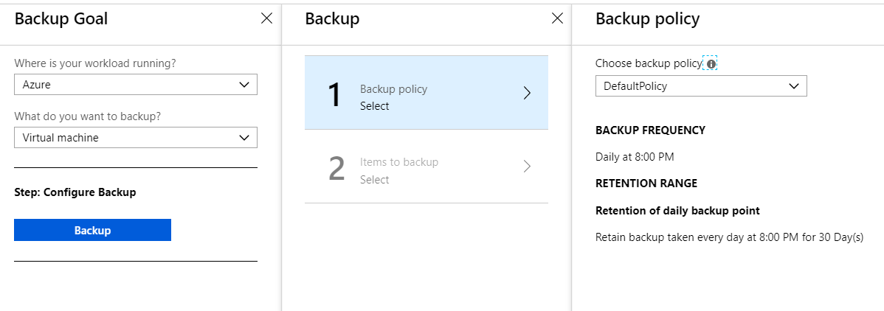

# Restoring data

Disaster can strike us at any point in time in the form of natural calamities or virus attack. By configuring backup of the systems, we are in a safe situation since we can restore the system to specific point in time.

Select Backup Items🡪 Select SQL in Azure VM/ Azure Virtual Machine 🡪 Back up items🡪 Restore (ellipses menu)

## Restoring DB

Select the destination server and DB detail appropriately.

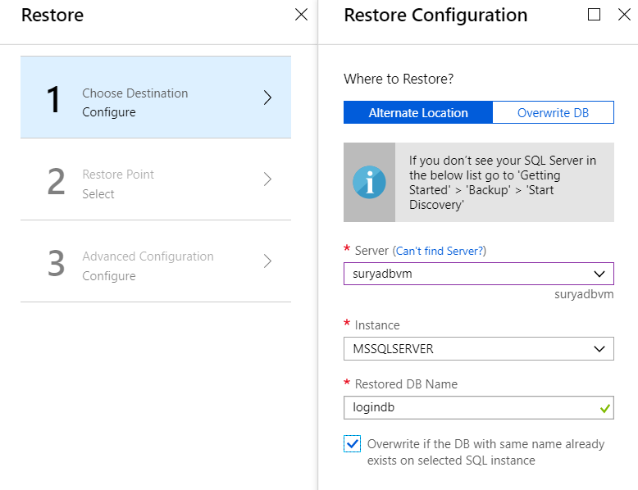

Based on the backup available, select the restore point.

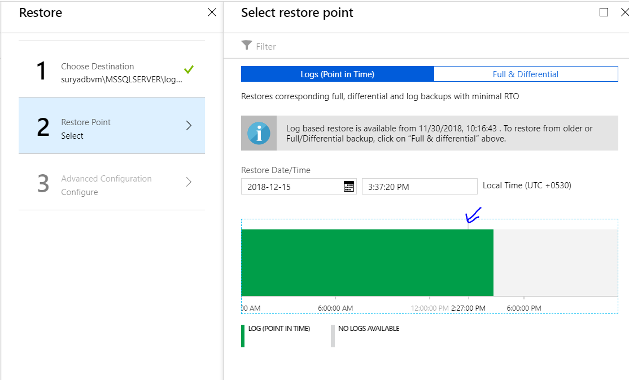

You can also select Full & Differential backup if you are not interested in restoring DB to specific point in time.

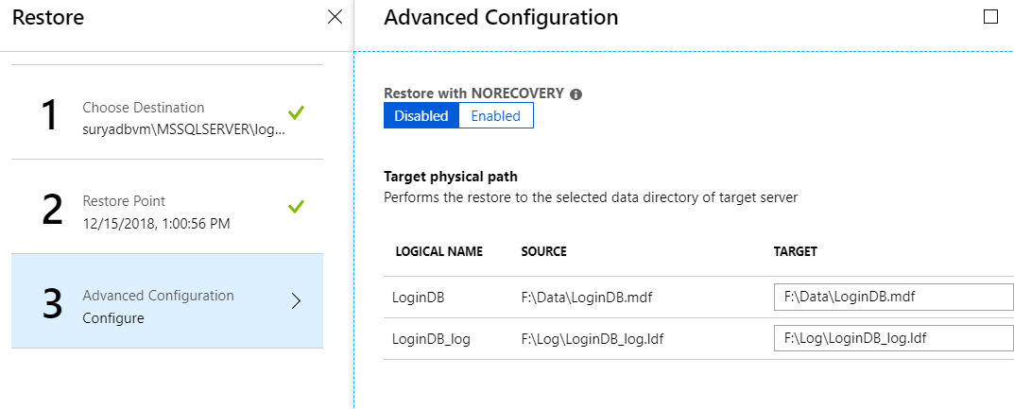

Click OK to start the restoration process.

Note: For monitoring restoration status, go to Recovery Services 🡪 Backup jobs.

# Reference

https://docs.microsoft.com/en-us/azure/backup/backup-azure-manage-windows-server