# Easy Remote Manual

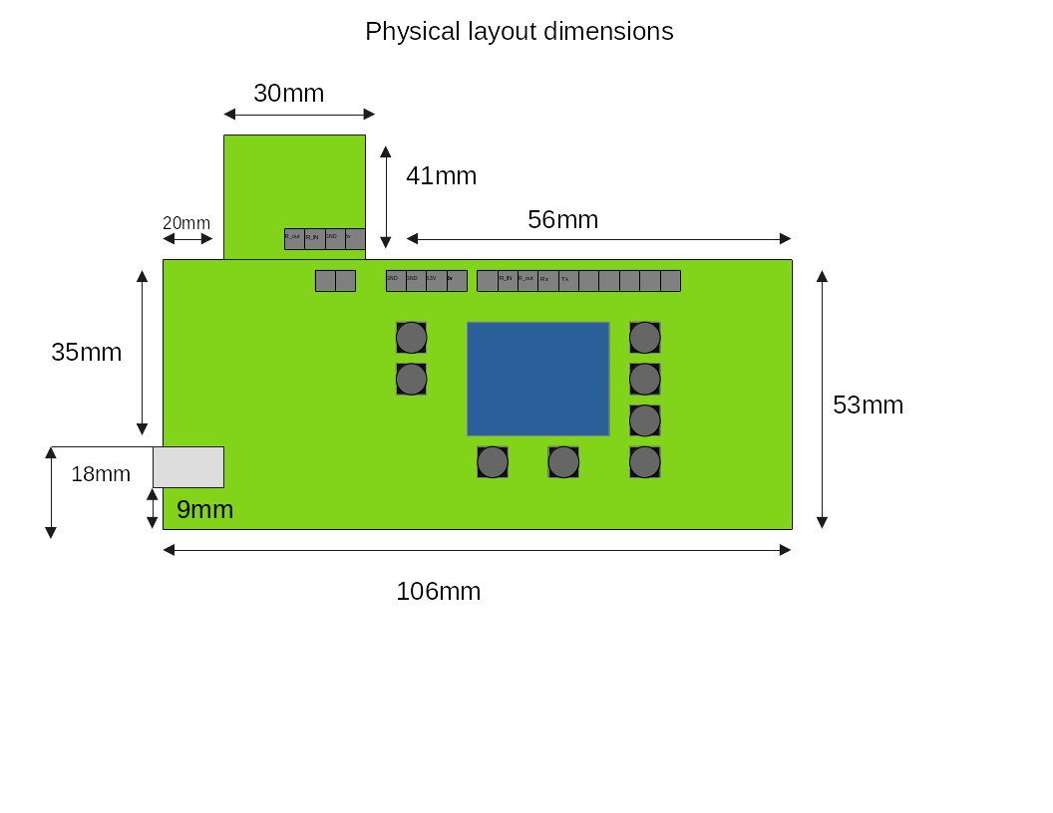 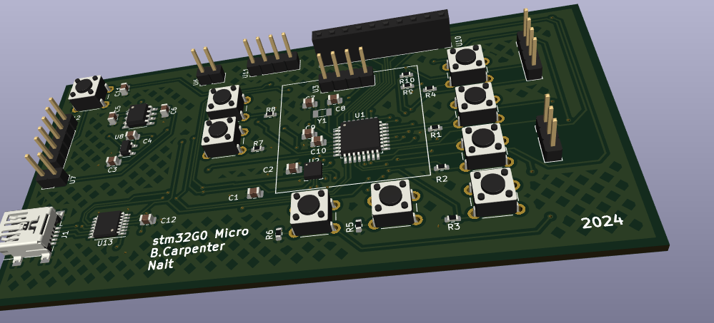Designed by Brandon Carpenter

**Introduction:**

The Easy remote is a universal remote and receiver that can do the following:

* Send and Store infrared macros into different buttons
* Store those macros in the cloud
* Back up those macros from a esp32
* Activate Macros based off a scheduled

This device is currently meant as a prototype and future revision will occur.

**Equipment and Materials:**

* 1x Esp32
* 1x Easy remote development board
* 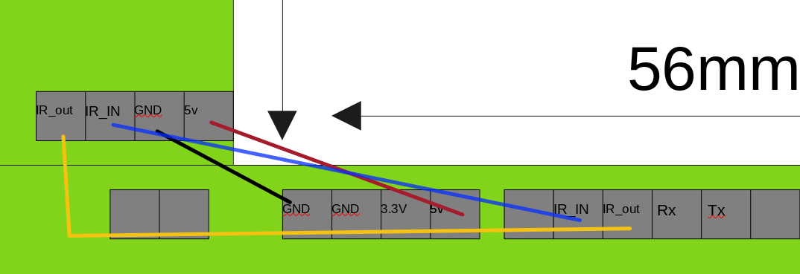5x Female to female Jumper cables
* 1x IR Module

# insert image here

**Set Up:**

1. Connect the according to Diagram
2. Connect :
   1. Rx -> esp32 Tx
   2. Tx -> esp32 Rx
3. Connect easy remote board to power
4. Connect esp32 to power(“only necessary for the first time if internet is not required”)
5. After 10 seconds all macros will be synced

**Sending a Macro:**

1. after the device is plugged in press any button to activate the macro

**Programming a Macro:**

1. Hold a button for at least 5 seconds To activate programming mode
2. While in programming mode, present remote to IR sensor and press command you would like to store. ( the easy remote can store up to 4 different commands in one macro, to store less than one command press the original button that was held to program it.)
3. now the command is stored and will update the database.

**Scheduler:**

1. To use the scheduler (requires esp32) once signed into the website, enter your scheduled into the site and after saving; reset the esp32 and all macros and schedules will be updated

**Notes:**

if there is concern or questions, email, help@brancoindustires.ca