Embedded CMPE2750
Project Proposal
Project Description
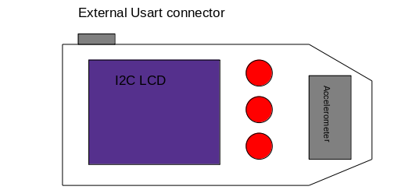
My project is a Stm32 based based Dice roller and Character sheet interface for Dungeons and Dragons. The device is vague enough that it can be reprogrammed for general use.

Features
- Stm32GX31 Micro-Controller
- easily accessible Usart Pins
- 3 tactile push buttons
- I2C LCD
- I2C accelerometer
- simple speaker controlled by PWM
- Accessible programming port
- Room for rear side Battery bank to be attacked in the future

Research Required
- I2C accelerometer Functionality
- I2C Screen interaction
Libraries still left to write
- I2C for STM32
- I2C for Accelerometer
- Usart Library

Critical Components
- STM32G0X1 Micro-Controller
- SSD1306 B/W LCD
- LIS3DH nano accelerometer
- Three tactile push buttons
- Power supply Circuit parts. 5V in 3.3v to the board

Software Considerations
This Project will require the use:
- Segger IDE,
- a Jlink programmer
- Terminal interface for Usart com

