**Human Resource Manager Functionalities (ROLE_HR):**

**Visibility of tabs:**

|  |  |  |  |  |  |  |  |  |  |  |
| --- | --- | --- | --- | --- | --- | --- | --- | --- | --- | --- |
| **Main Tabs** | | **Sub Tabs** | | | | | | | | |
| **Dashboard** | |  | |  | | |  | | |  |
| **Recruitment** | | **PROFILE** | | **POSITION** | | **INTERVIEW** | | |
| **Offer** | |  | |  | | |  | | |  |
| **Open Positions** | | **PROFILE** | | **POSITION** | | |  | | |  |
|  |  | |  | |  | | |
|  |  | |  | |  | | |

**Main Activities of HR**

* Create profiles.
* Update Job Positions.
* Schedule interviews and submit the feedback.
* Creation of offer and Send for Approval.

**Dashboard**

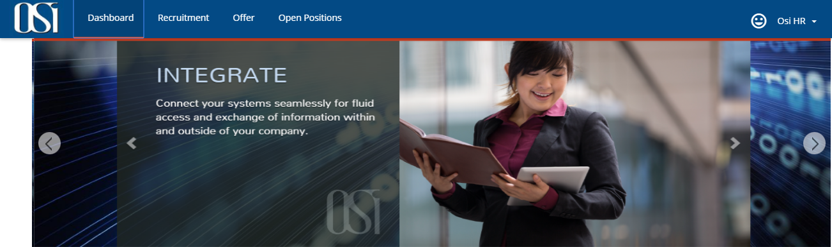

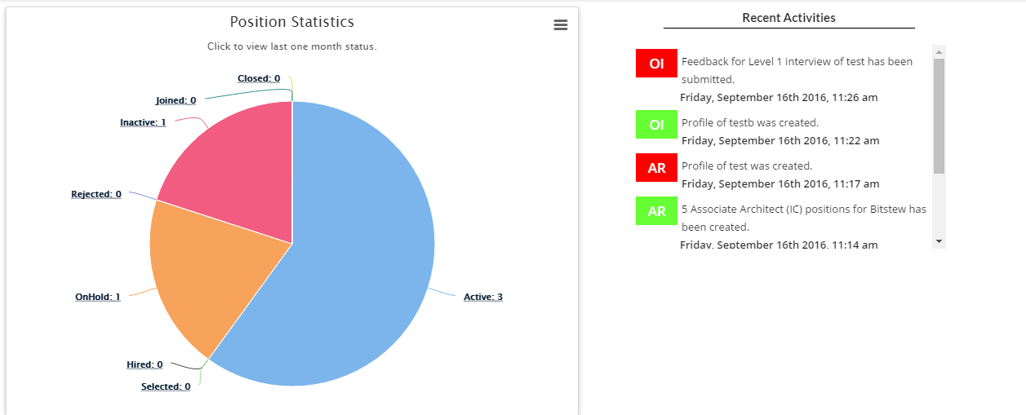

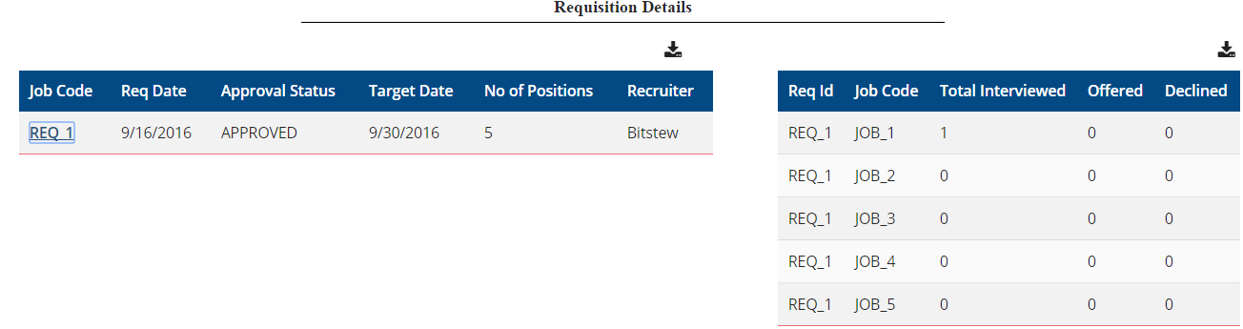

**Create profiles:**

The profile sub tab can be seen under two main tabs i.e. Recruitment > PROFILE and Referral > REFER. Under Recruitment > PROFILE, HR shall upload the profiles of only those candidates that are coming through consultancy and job sites. While under Referral > REFER, he can upload the profiles of his personal contacts.

Once job positions are created, HR will traverse through candidate profiles for screening and schedule an interview.

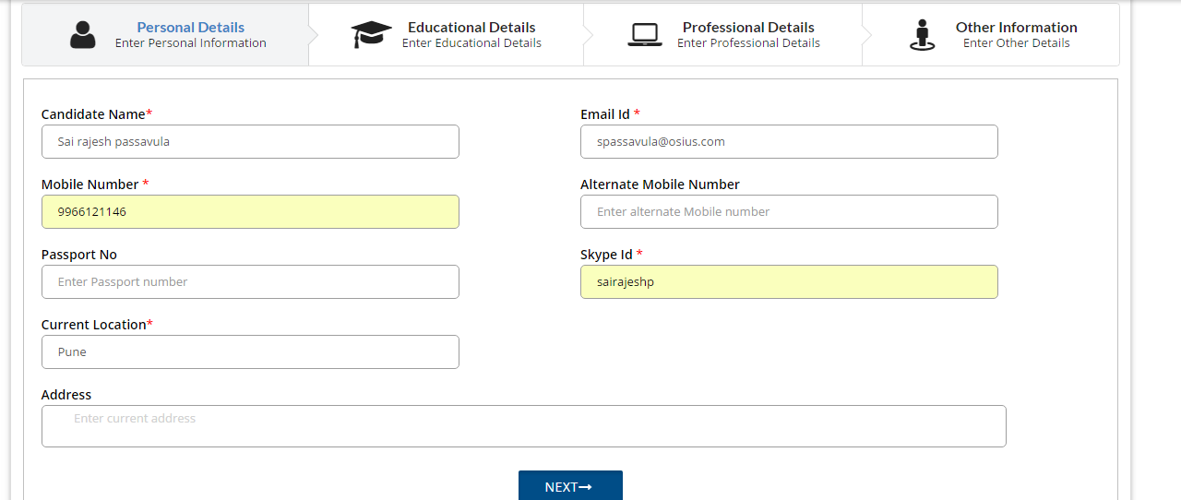

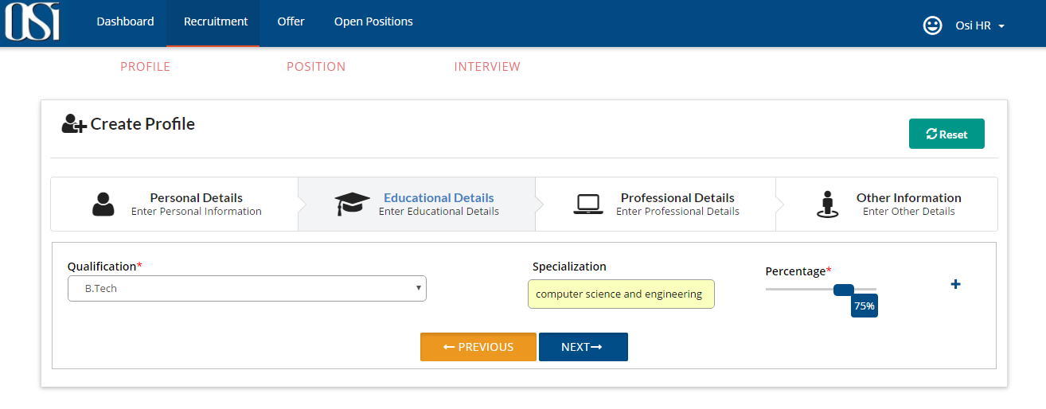 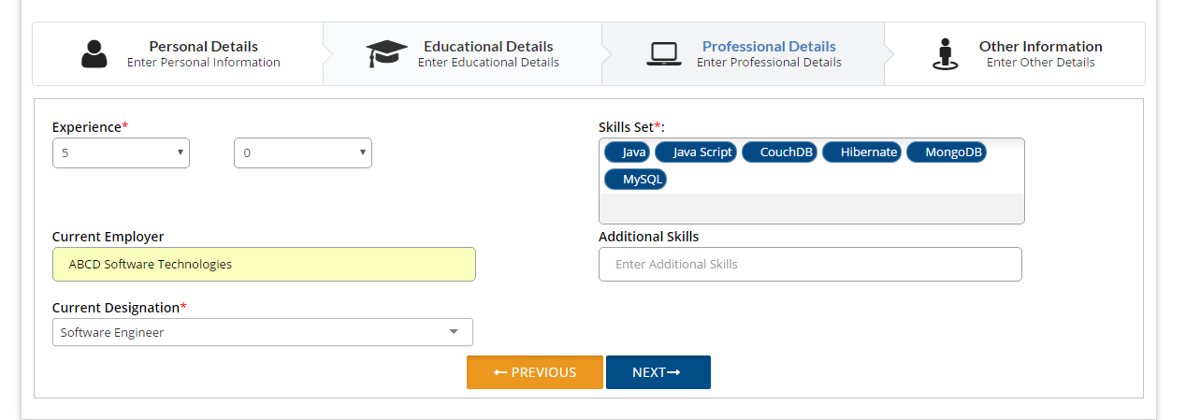 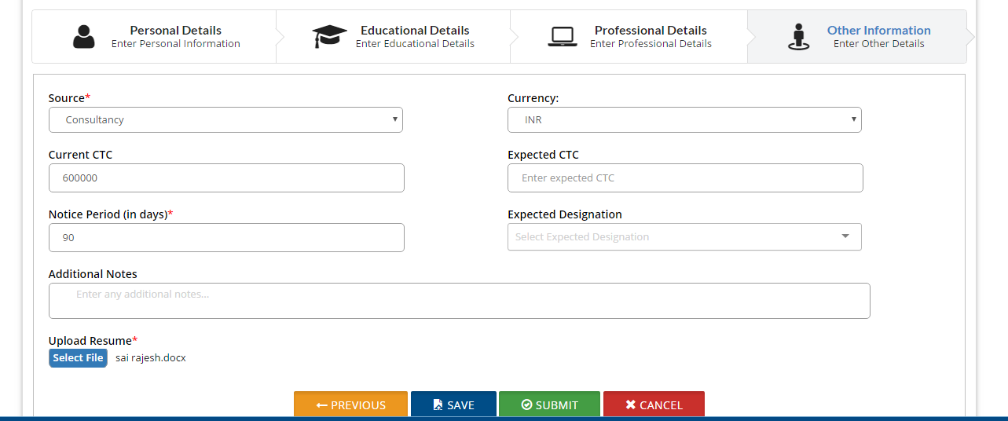

Description of buttons operation in PROFILE– creation page under RECRUITMENT tab.

**SAVE**: After entering the details of interviewee candidate, HR can able to save that profile.

**UPDATE**: HR can update the interviewee candidate profile until and unless HR submits the profile.

**SUBMIT**: Once HR submits the candidate profile, then only profile will be visible in INTERVIEW tab.

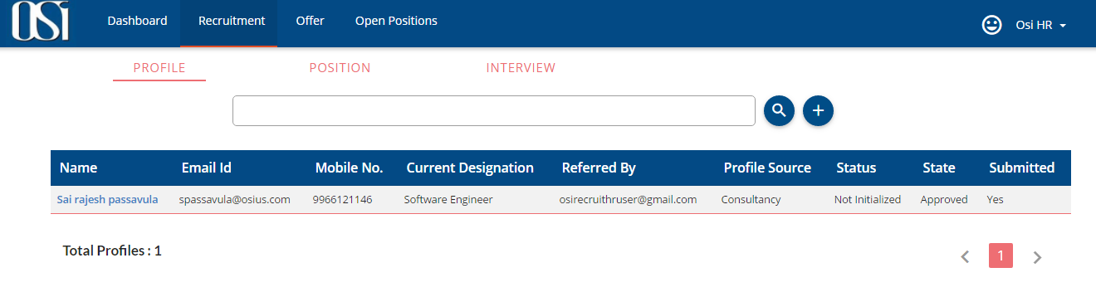

**Update Job Positions:**

HR can update the JOB_POSITIONS under RECRUITMENT tab.

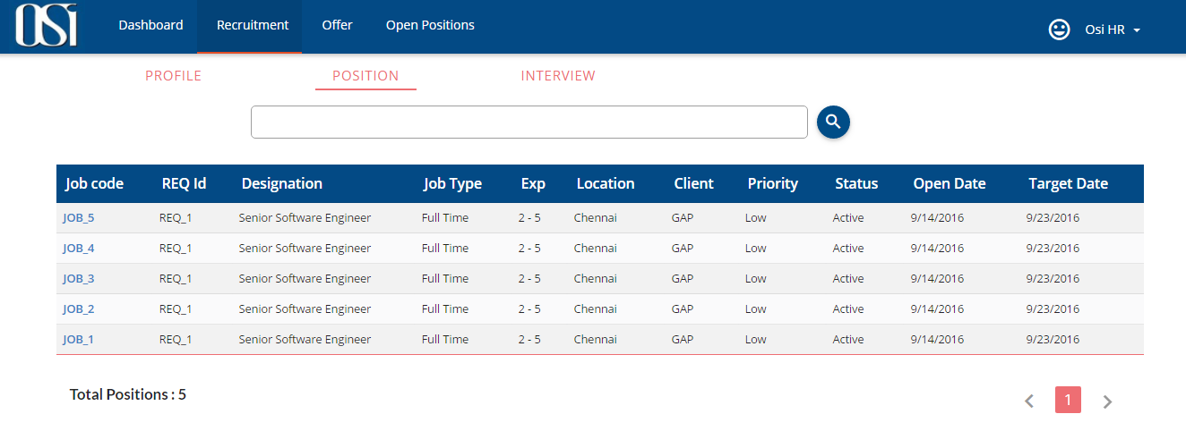

To update JOB_POSITION, click on the corresponding JOB Code link and it will open position page which has respective details to update.

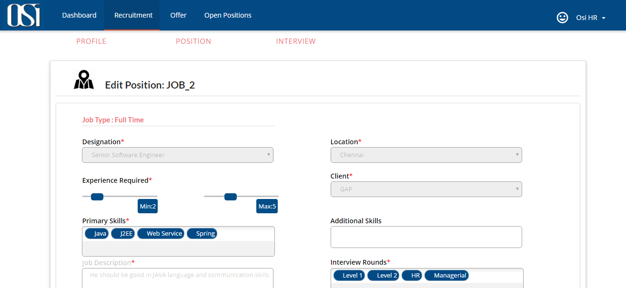 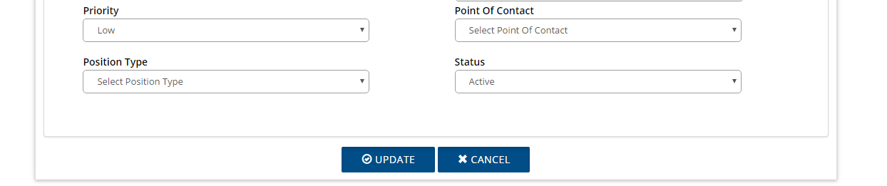

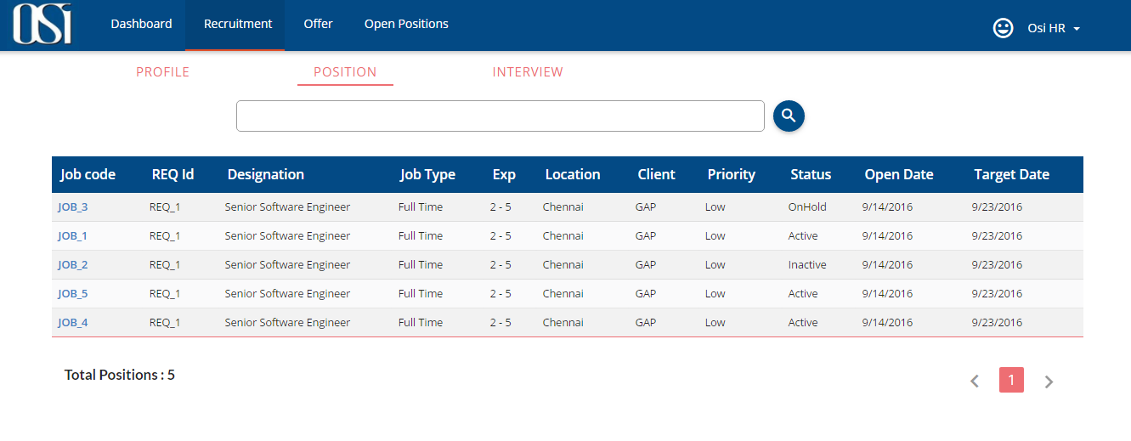

Positions in “Open Positions” tab.

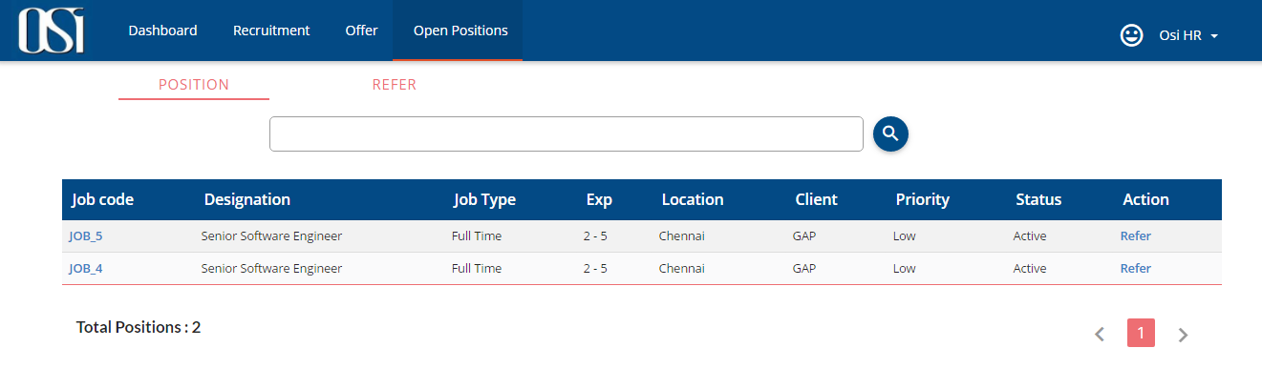

**Note**: This “Open Position” is visible to every employee in the organization.

Dashboard page gives you the statistics for all the positions available in the organization.

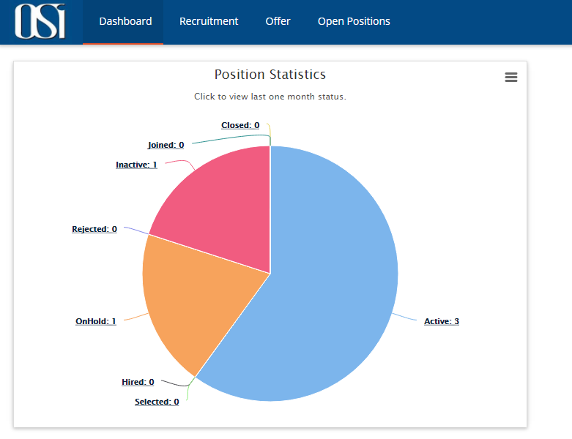

**Schedule interviews and submit the feedback.**

After screening profiles, HR shall schedule an interview for shortlisted candidates. He would select Requisition, job position, type of round, interviewer, date and time etc. for the interview and click schedule. HR can also schedule multiple rounds for the same candidate by checking the ‘Allow multiple rounds’ box. Once scheduled, Candidate and corresponding interviewer would get an email notification for the same. This scheduled will also be visible on Dashboard.

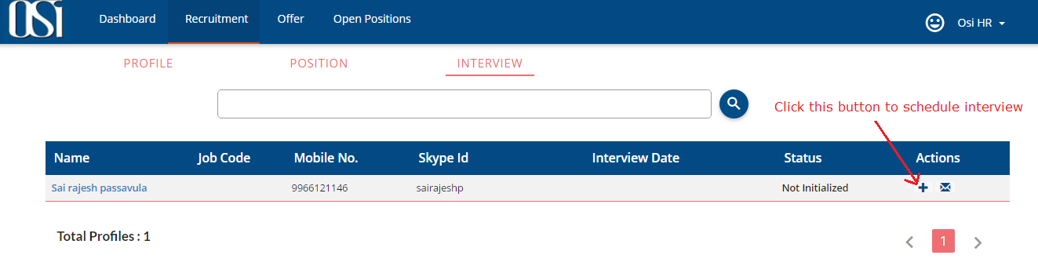

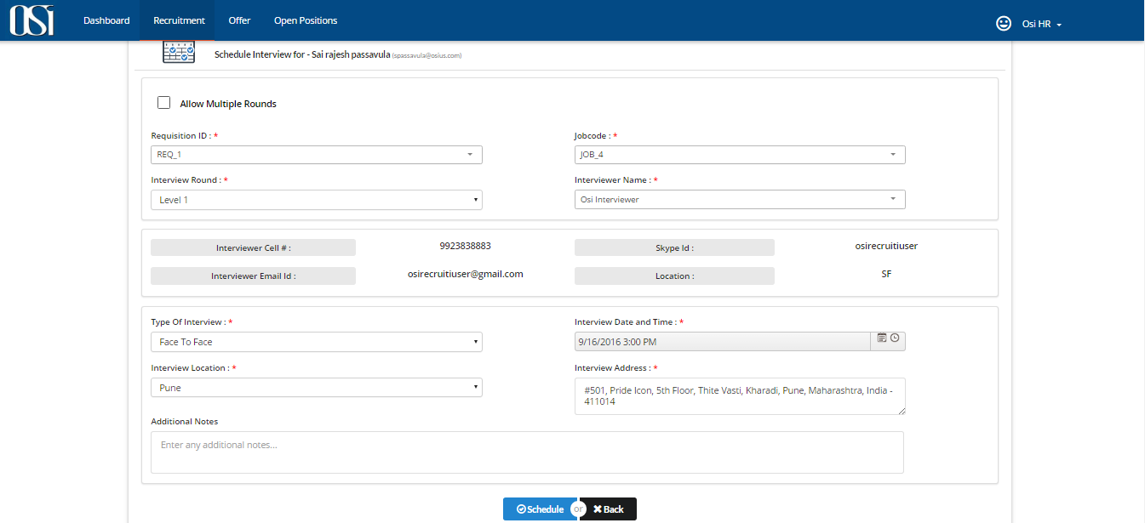

After candidate is been interviewed by Interviewer, he will submit the feedback of the interview and will also state if the candidate is selected, on Hold or Rejected. HR will be notified about the same via email.

**How to Submit the Feedback:**

Click on submit button, it will open feedback page. See in the below picture.

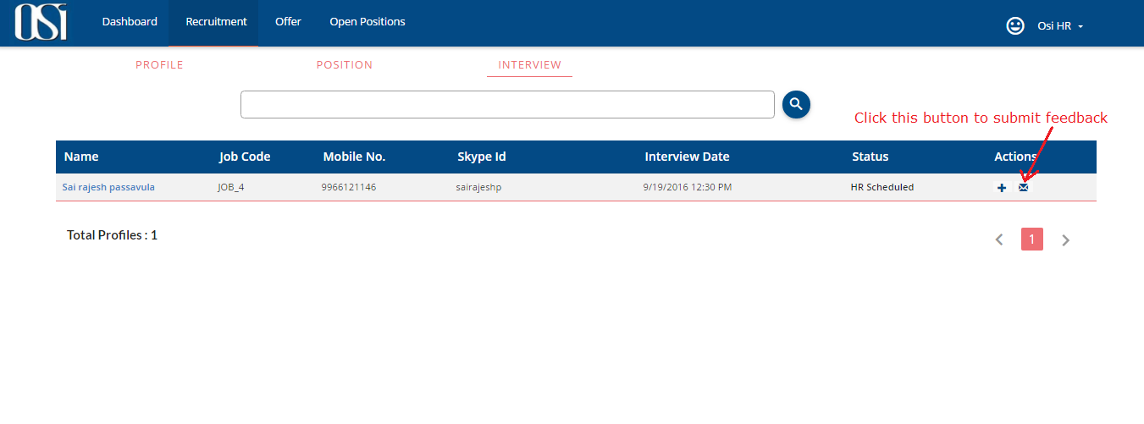

In the feedback page contains Functional, Soft skills, Management skills, and Comments tabs. Once HR enters all the corresponding details in the feedback page then “Submit” button is enabled.

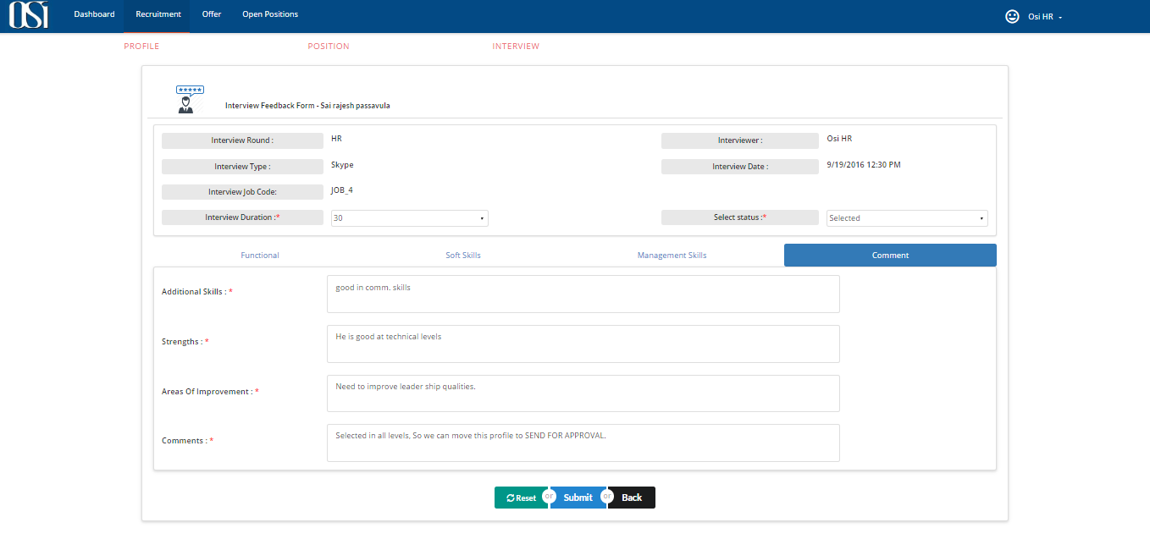

After click on “Submit” button the system displays confirmation message “Feedback submitted successfully” and HR will get an email with status and feedback of the candidate.

HR can able to see the feedback of each round in the “Interview Details” Page. By clicking on the candidate name in the Interviews page (see below figure), it will open “Interview Details” page.

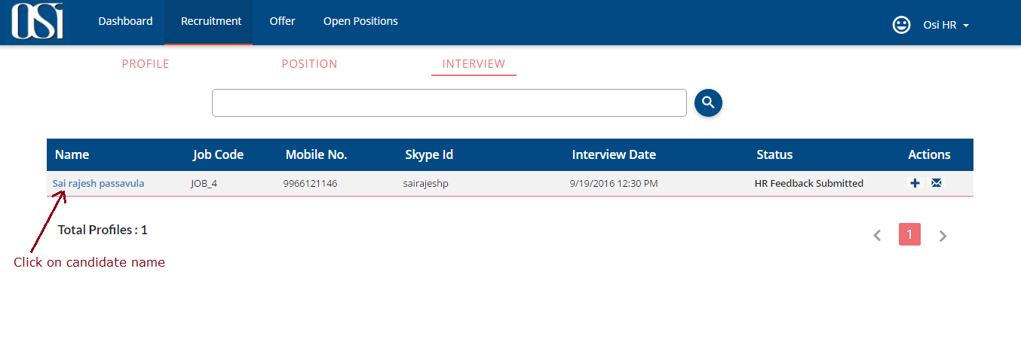 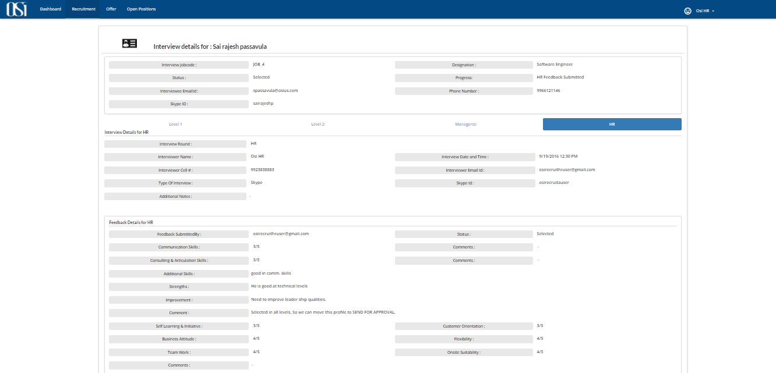

Note: Once the HR submits candidate feedback of HR round then system will not allow to schedule the interview.

**How to cancel the interview:**

Interviewer can also cancel the interview scheduled upon his name. In this case HR will be notified about the same via email. HR then would have to again reschedule the interview with different interviewer name.

By clicking on the candidate name in the interviews page (see below figure), it will open “Interview Details” page.

s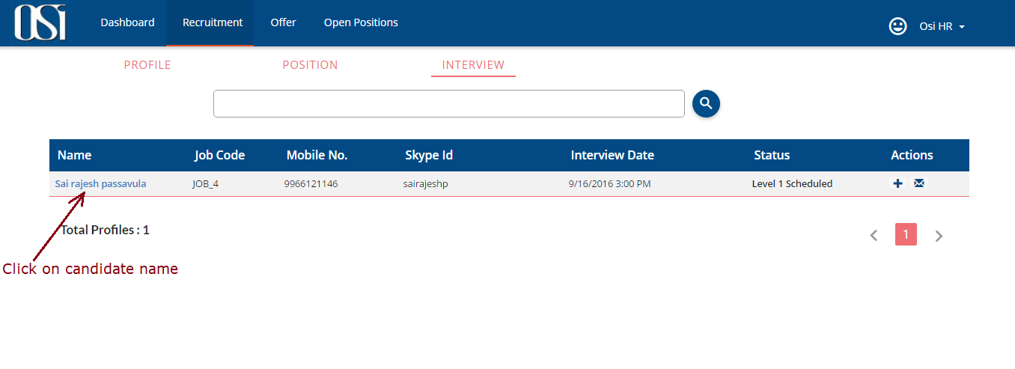

In the “Interview Details” page, go to corresponding interview round tab and there is button “Cancel Interview” by click on this button we can cancel the interview round.

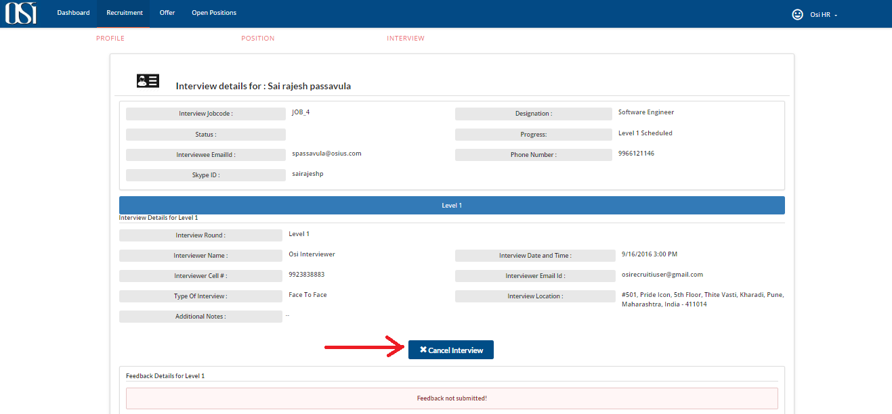

**Note**: HR can submit the feedback on behalf of Interviewer and cancel the interview on behalf of Interviewer.

**Creation of offer and Send for Approval:**

Once the profile is shortlisted (after selection of HR round) then that profile is visible in OFFER module.

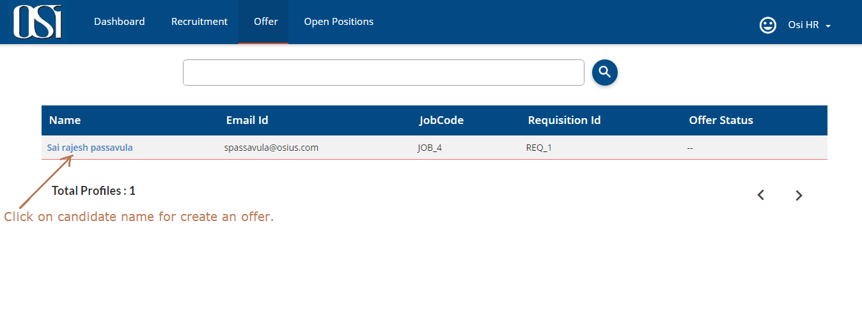

To create an offer, click on candidate name in the offer module it will open the offer page of the candidate. Here HR should enter corresponding details and he sends this profile to Approval. By clicking on “SEND FOR APPROVAL” button. Corresponding Approver would get an email notification for the same.

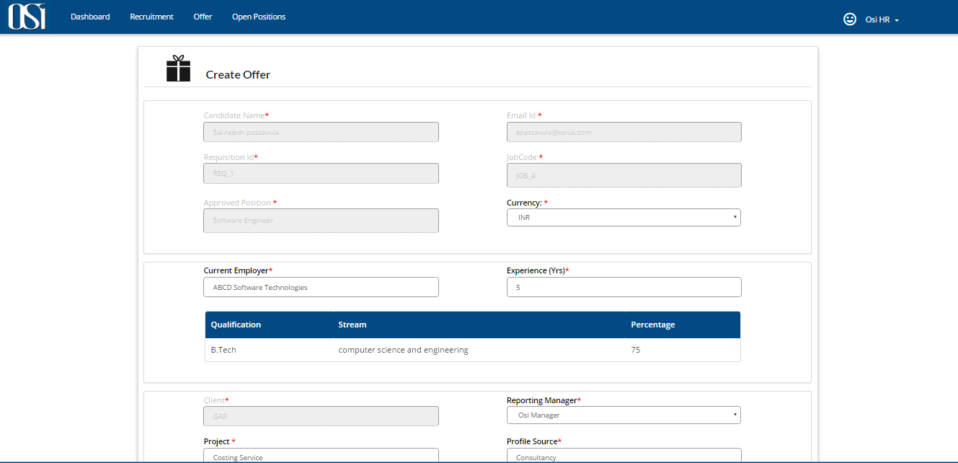

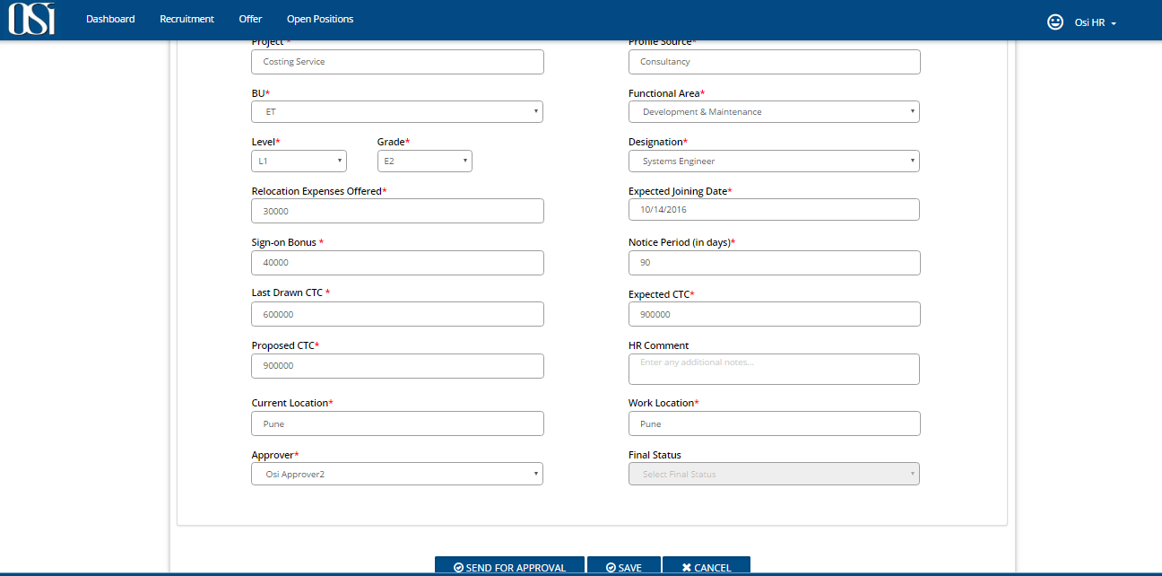

Corresponding Approver verifies the candidate feedback of each interview rounds and he can comments and set the status as APPROVE/NEGOTIATE/REJECT. Once the approver(s) submits the status then HR would get an email notification. Now HR can able to select FINAL STATUS (Offered/Rejected/Declined).