**Interviewer Functionalities (ROLE_INTERVIEWER):**

**Visibility of tabs:**

|  |  |  |  |  |  |  |  |  |  |  |
| --- | --- | --- | --- | --- | --- | --- | --- | --- | --- | --- |
| **Main Tabs** | | **Sub Tabs** | | | | | | | | |
| **Dashboard** | |  | |  | | |  | | |  |
| **Recruitment** | | **INTERVIEW** | |  | |  | | |
| **Open Positions** | | **PROFILE** | | **POSITION** | | |  | | |  |
|  |  | |  | |  | | |
|  |  | |  | |  | | |

**Main Activities of Interviewer**

* Refer candidates.
* Take interview and submit the feedback.

Any user with role “Interviewer” will be populated under Interviewer’s dropdown in schedule interview page. Interview will be notified by an email about the scheduled interview and its details.

**Dashboard**:

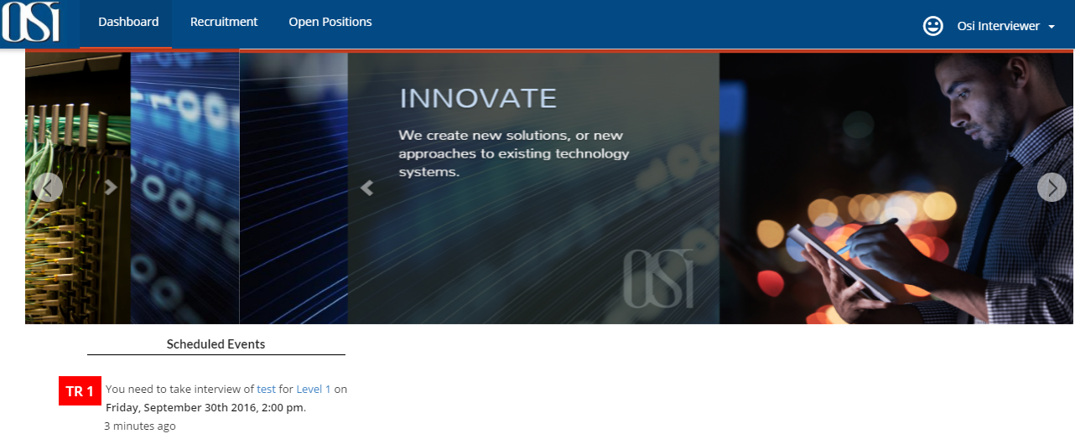

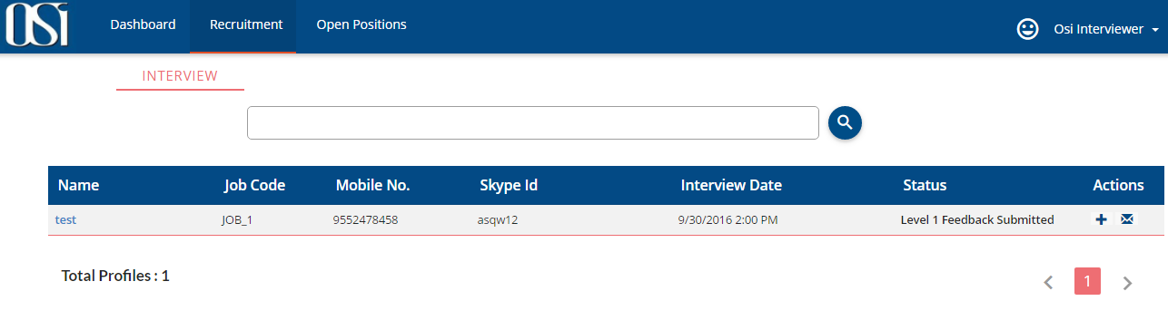

After candidate is been interviewed, he will submit the feedback of the interview and will also state if the candidate is selected, on Hold or Rejected. HR will be notified about the same via email.

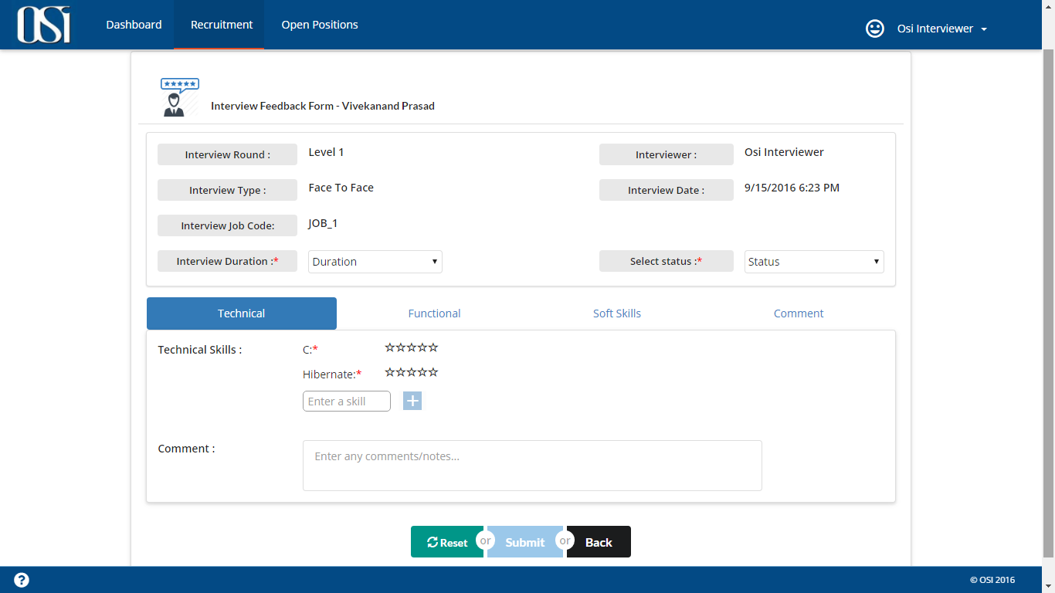

Interviewer can also view the feedback submitted by him by clicking on the candidate’s name link in search Interview page.

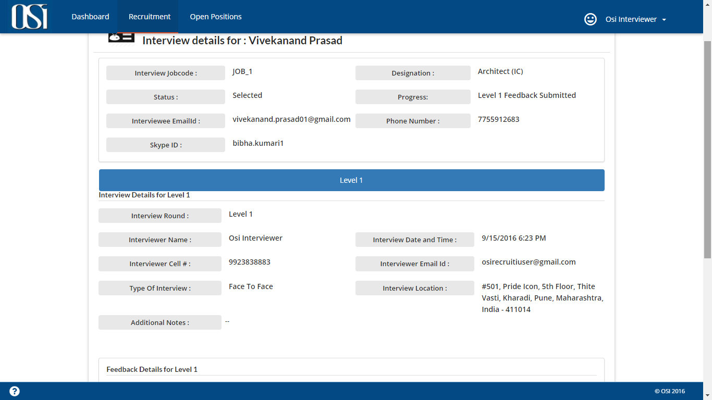

Interviewer can also cancel the interview scheduled upon his name. In this case HR will be notified about the same via email. HR then can reschedule the interview with different interviewer name.

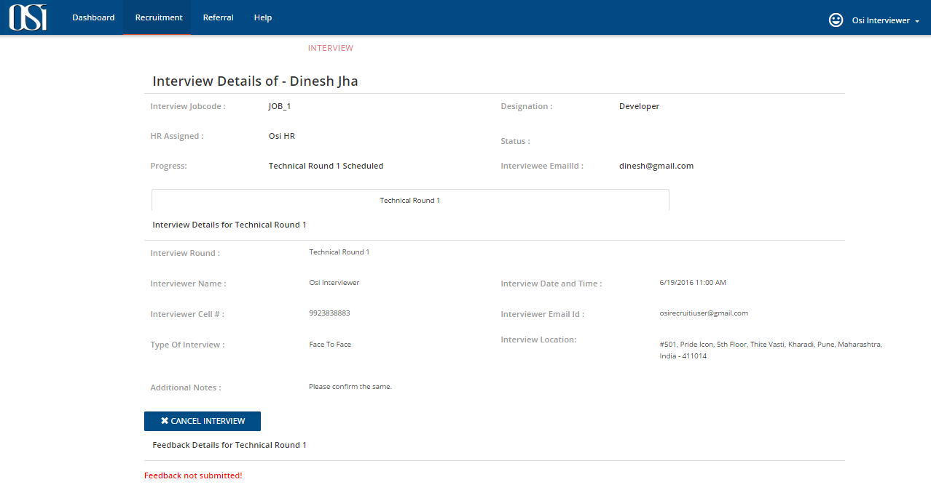

*Figure: Interviewer’s page of scheduled interview*

HR can also monitor the interview status.

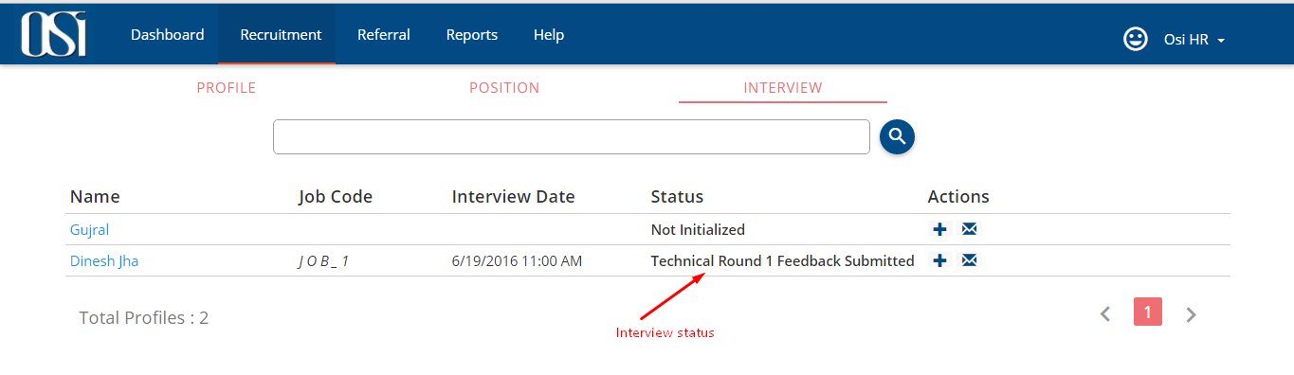

*Figure: Interview status for HR*

HR also has the privilege to submit the feedback on behalf of the interviewer.