**Manager Functionalities (ROLE_MANAGER)**

**Visibility of tabs for ROLE_MANAGER:**

|  |  |  |  |  |  |  |  |  |
| --- | --- | --- | --- | --- | --- | --- | --- | --- |
| **Main Tabs** | | **Sub Tabs** | | | | | | |
| **Dashboard** | |  | |  | |  | |  |
| **Recruitment** | | **PROFILE** | | **INTERVIEW** | |
| **Open Positions** | | **POSITION** | | **REFER** | |  | |  |
| **Help** | |  | |  | |  | |  |
|  |  | |  | |  | |

**Dashboard for Manager**

On login to the application, Manager will be redirected to the Dashboard page where he can view

1. **Scheduled Events**: Interviews scheduled under his name

2. **Recent Activities:** Notifications of Profile Creation details created by him and Interview Feedback submission.

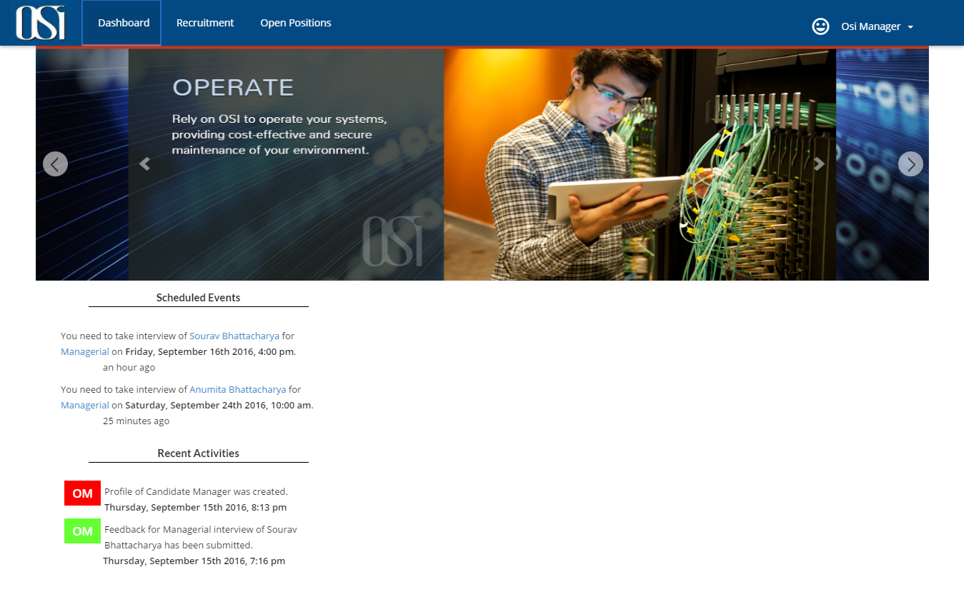

Fig 1. Dashboard for Manager

**Main Activities of Manager**

* **Submit Interview feedback** from Interview subtab
* **Cancel Interview**
* **Create profile** from Refer subtab under Open Positions

**Submit Interview feedback**

Any user with role “ROLE_MANAGER” will be populated under Interviewer Name dropdown in schedule interview page. Interviewer will be notified by an email about the scheduled interview and its whereabouts. Once scheduled, it will be displayed in manager’s Interview page.

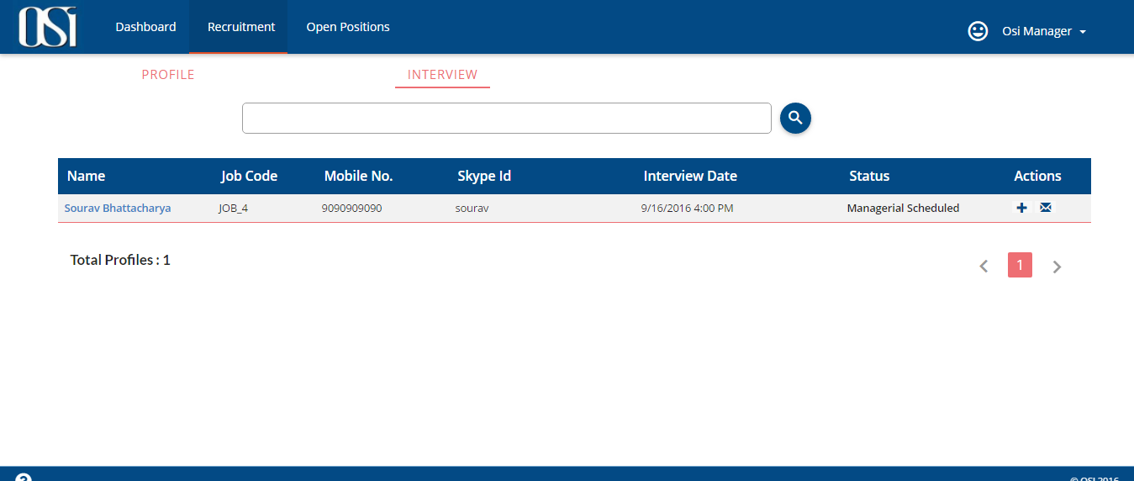

*Fig. 2 Managerial Round of Interview is scheduled and is visible under Interview subtab*

After candidate has been interviewed, manager can submit the feedback of the interview (by clicking on envelope icon under Actions) and will also state if the candidate is selected, on Hold or Rejected. HR will be notified about the same via email.

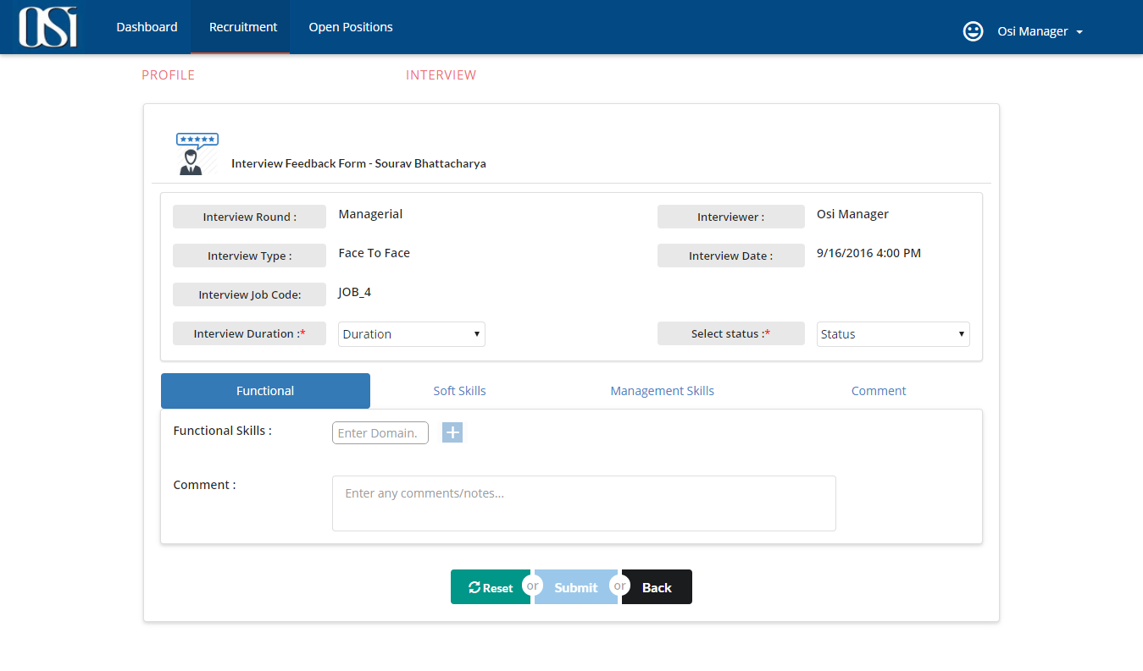

*Fig. 3 Feedback form for Manager*

Manager can also view the feedback submitted by him by clicking on the candidate’s name link in search Interview page (in Interview subtab).

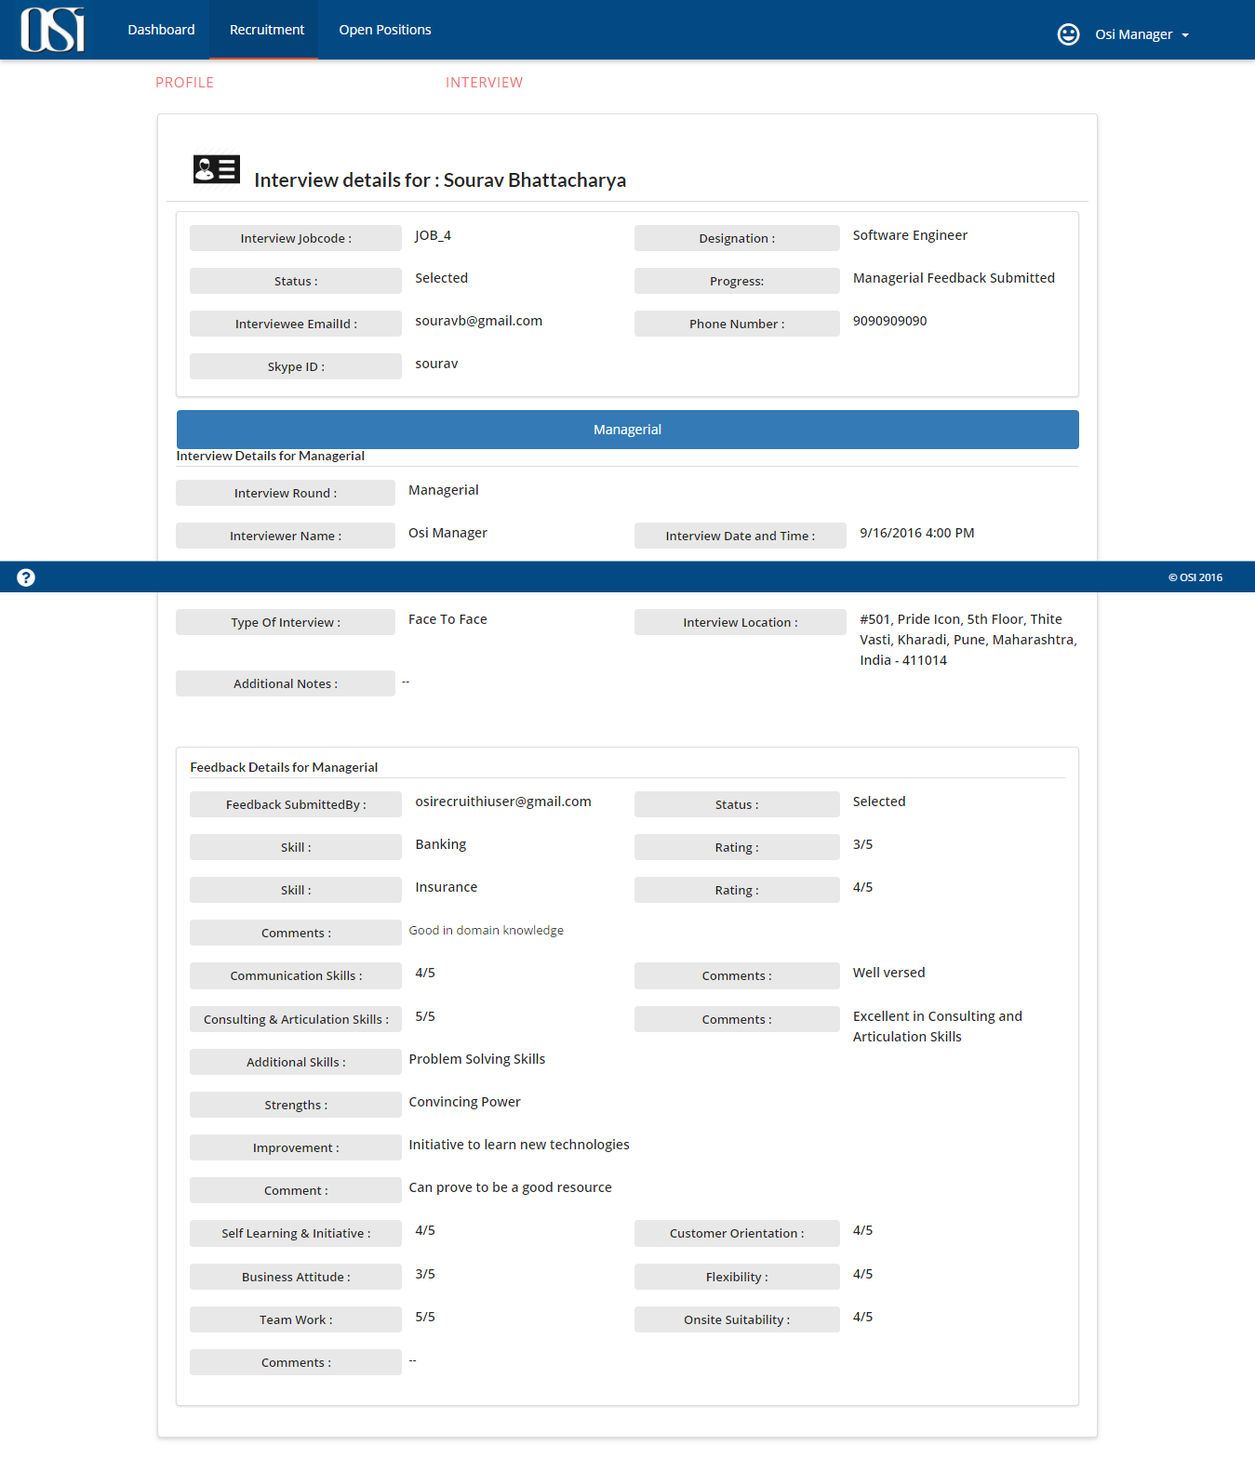

*Fig 4. Feedback Details for Manager*

Manager can also cancel the interview scheduled upon his name. In this case HR will be notified about the same via email. HR then would have to reschedule the interview with different interviewer name.

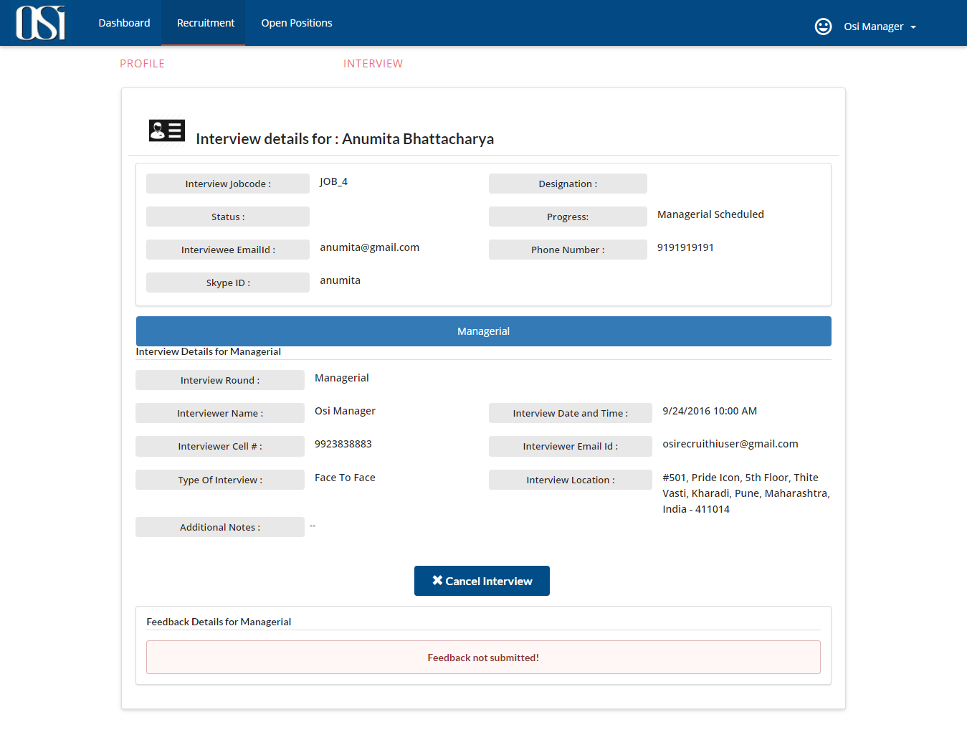

*Fig 5. Cancel Interview for Manager*

HR can also monitor the interview status. HR also has the privilege to submit the feedback on behalf of the interviewer.

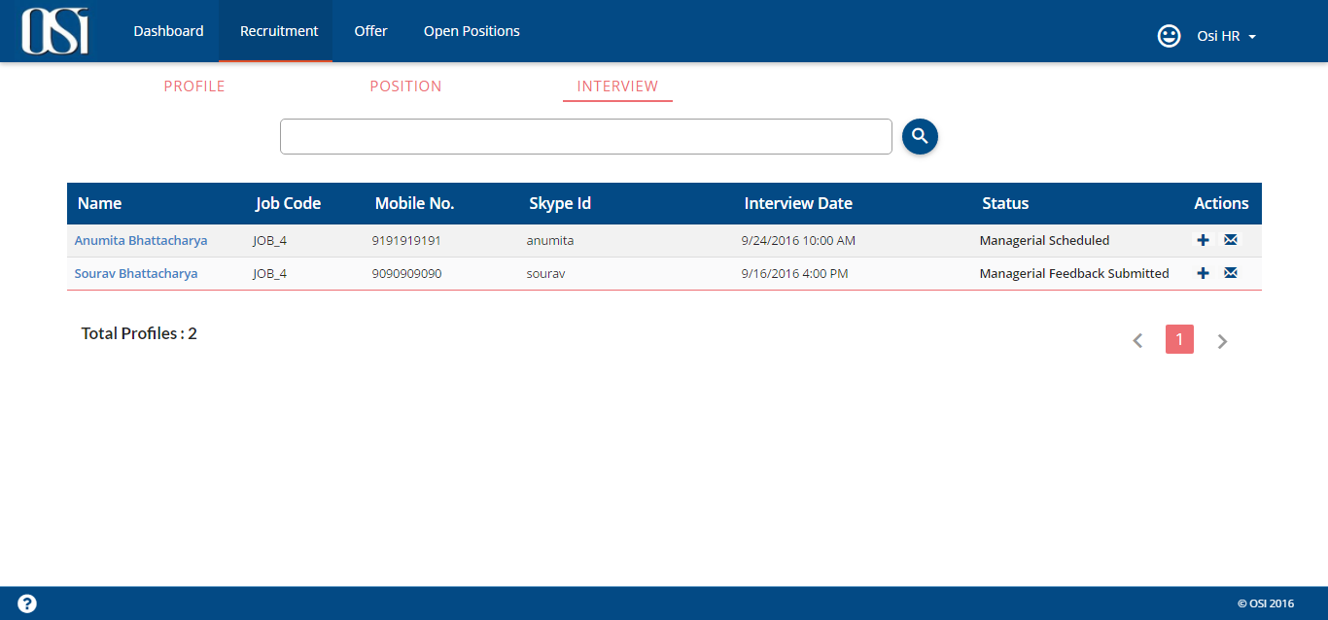

*Fig 6. HR view for Interviews scheduled to Manager*