**Requisition Approver Functionalities (ROLE_REQUISITION_APPROVER):**

**Visibility of tabs:**

|  |  |  |  |  |  |  |  |  |  |  |  |  |  |  |
| --- | --- | --- | --- | --- | --- | --- | --- | --- | --- | --- | --- | --- | --- | --- |
| **Main Tabs** | |  | | | **Sub Tabs** | | | | | | | | | |
| **Dashboard** | |  | |  | | | |  | | |  | | |  |
| **Recruitment** | | **PROFILE** | | **REQUISITION** | | | **POSITION** | | | **INTERVIEW** | | |
| **Open Positions** | | **PROFILE** | | **POSITION** | | | |  | | |  | | |  |
| **OFFER** | |  | |  | | | |  | | |  | | |  |
|  |  | |  | | |  | | |  | | |
|  |  | |  | | |  | | |  | | |

**Main Activities of Requisition Approver**

* Create, update and approve requisition.
* Approve offer.

**Dashboard**

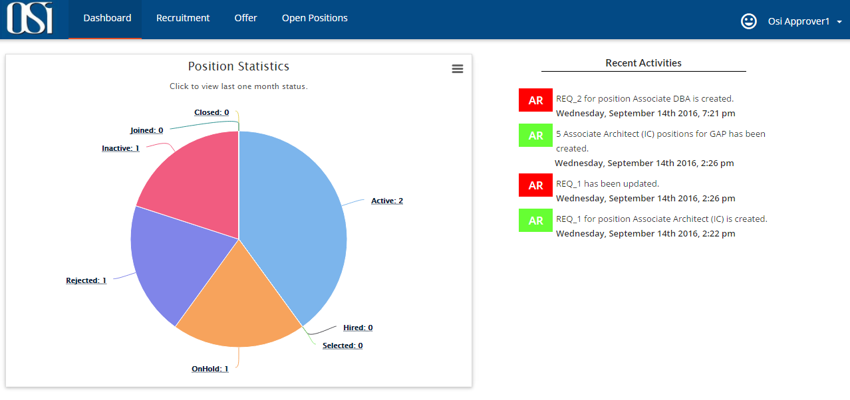

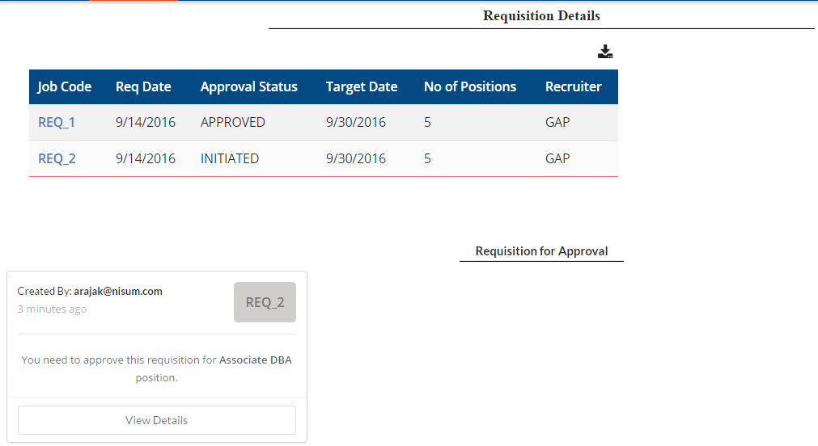

**Sub tabs visible**:

Under Recruitment main tab below sub tabs will be seen,

PROFILE, REQUISITION, POSITION, INTERVIEW

Under Open Positions main tab below sub tabs will be seen,

POSITION, REFER

**Steps to create a requisition.**

1. **Navigate to Recruitment > REQUISITION** and click on add button; Create Requisition page will be displayed.
2. Fill in all the mandatory data and hit create button.

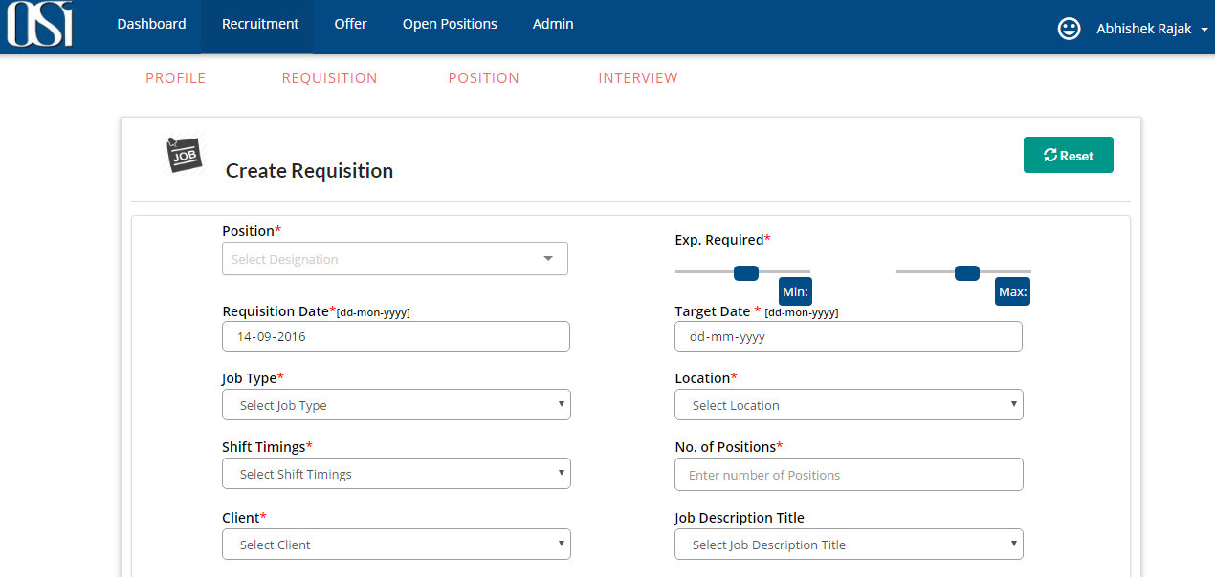

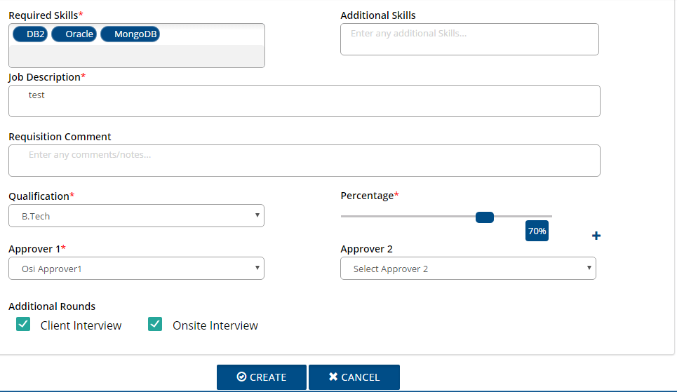

*Job description title field will be populated only if it is configured by Admin on Job description page.

1. Newly created requisition can be seen on Recruitment search page.

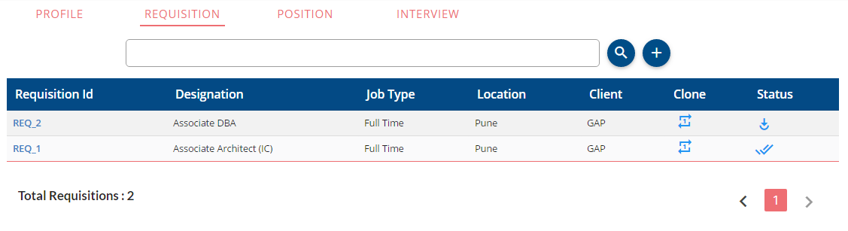

1. An email will be sent to the Approver_1 requesting for approval. Approver_2 will get email notification only after requisition is approved by Approver_1 and the same will be visible on dashboard of Approvers.

*Approver_2 is optional.

1. Requisition Approver can create, update, reject and approve requisitions.

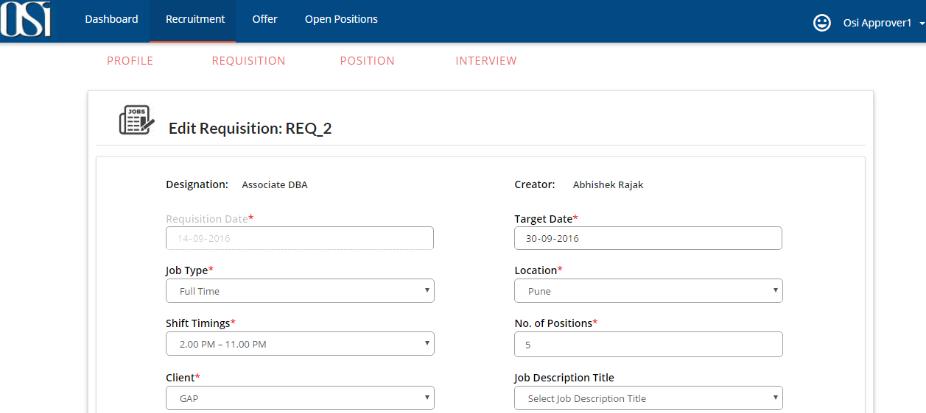

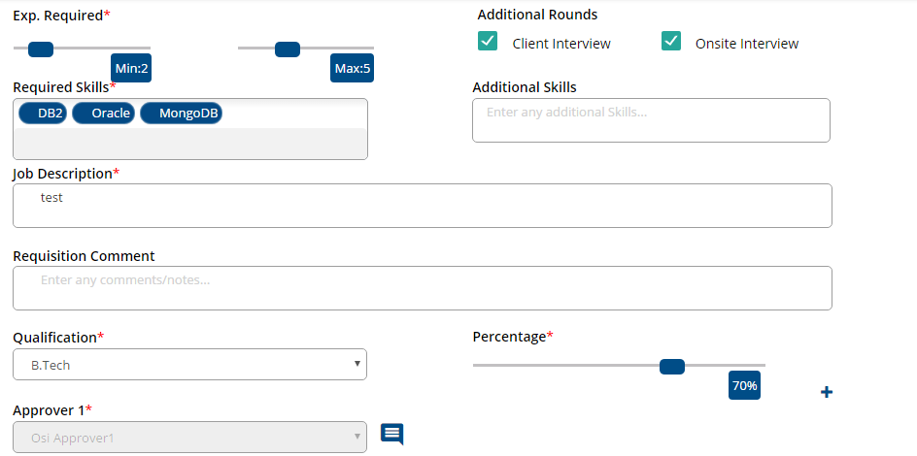



1. When requisition is approved by Approver, Requisition creator and HR will receive the email notification regarding the same and mentioned number of positions will be created which can be seen under Recruitment > POSITION sub tab and by default all the positions will be active and visible to all the users under Open Positions > POSITION tab.
2. When requisition is updated by Approver, only Requisition creator will receive the email notification regarding the same.
3. When requisition is rejected by Approver, only Requisition creator will receive the email notification regarding the same.
4. Approver can also update each job position.
5. User with Requisition Approver role can approve the offer as well.

**Offer Module**

1. HR will send an offer to Approver. The offer would be seen on Offer page and also on Dashboard under ‘Offer to be approved’ table to Approver.

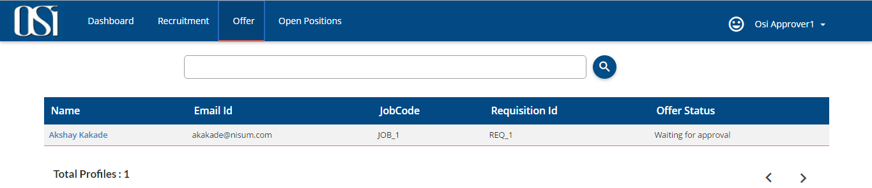

Fig. (1)

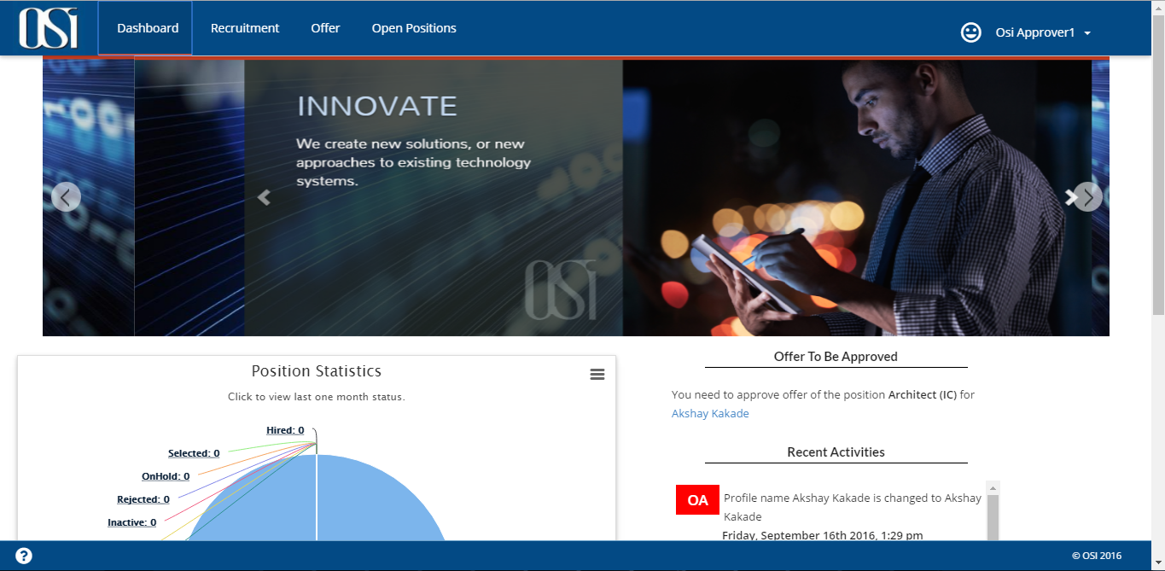

Fig. (2)

1. Approver can either Reject, Approve or Negotiate the offer.

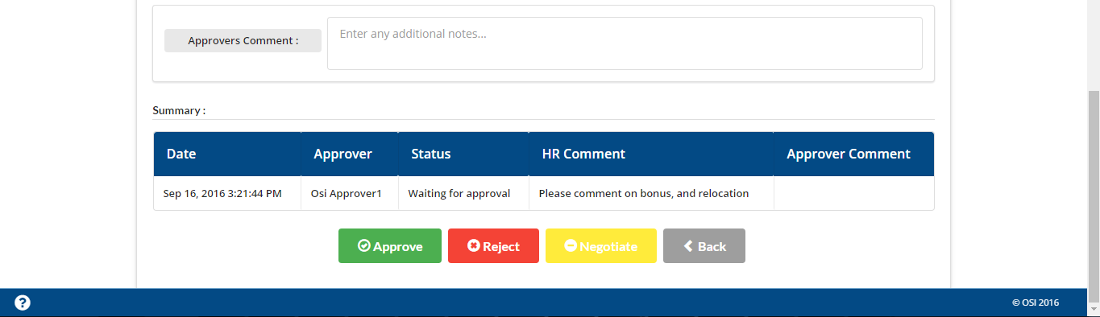

1. For either of the above actions taken by Approver, HR will get an email notification.
2. Approver can add his comments in ‘Approver’s comment’ section which can be viewed by HR as well in Summary section of the offer.

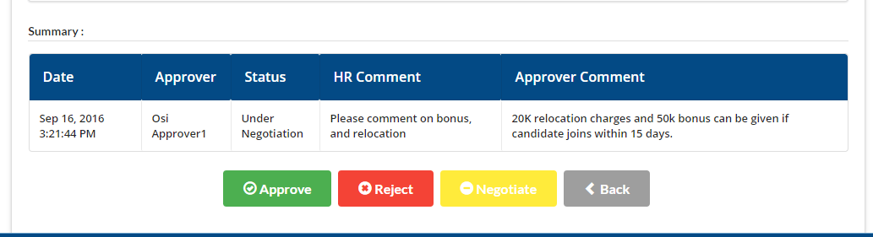

1. If offer is under negotiation then the Offer Status on Offer search page will be ‘under negotiation.’ And similarly will be for Approved and reject action.

