**User Functionalities (ROLE_USER):**

**Visibility of tabs:**

|  |  |  |  |  |  |  |  |  |
| --- | --- | --- | --- | --- | --- | --- | --- | --- |
| **Main Tabs** | | **Sub Tabs** | | | | | | |
| **Dashboard** | |  | |  | |  | |  |
| **Open Positions** | | **POSITION** | | **REFER** | |  | |  |
|  |  | |  | |  | |
|  |  | |  | |  | |

**Main Activities of User**

* View all open positions in the organization
* Refer candidates.

**User:**

User can view all open job positions under **Position** sub tab and also refer his acquaintance by uploading his/her profile by clicking on **Refer link** of respective position or by uploading profile under **Refer** sub tab.

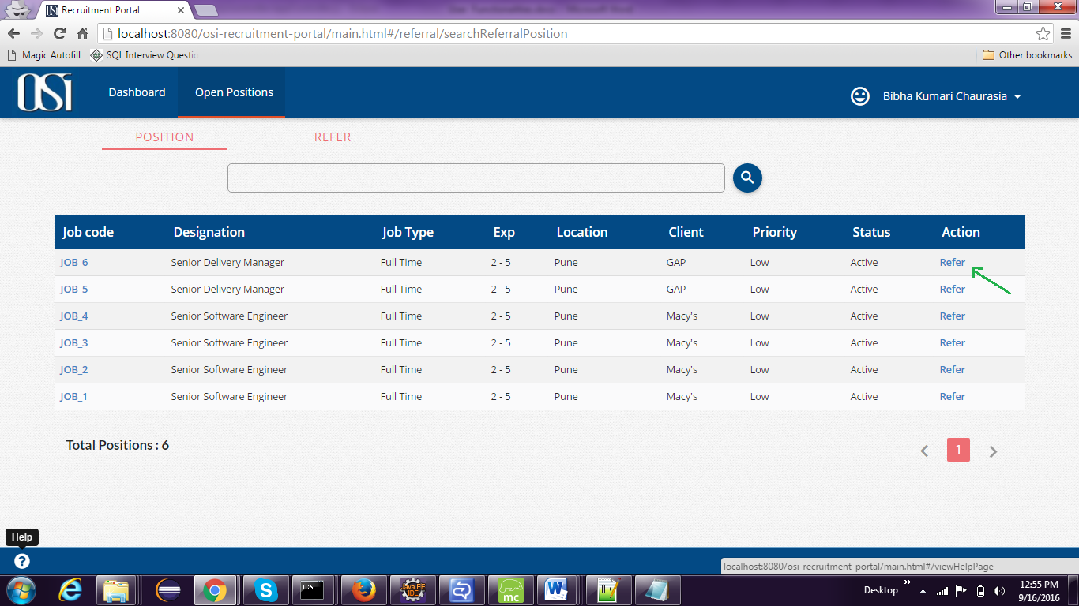

*Figure: Open Positions*

User can create Profile and upload his/her resume.

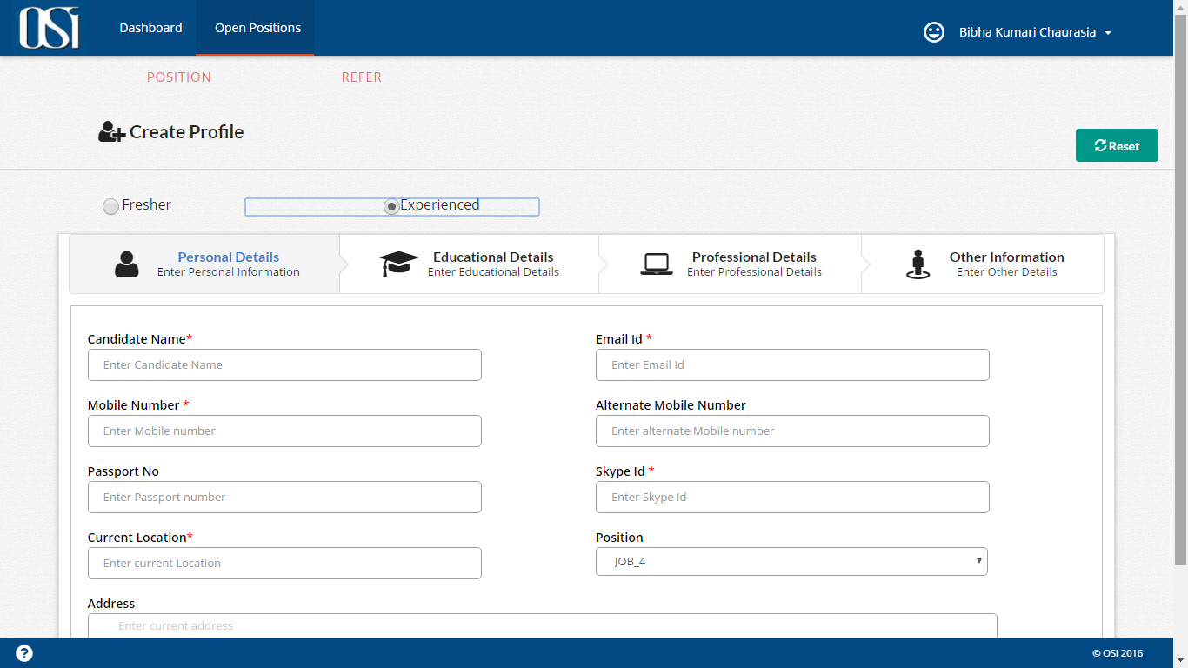

Once the profile is created successfully, User can track the status of the referred candidate by navigating to **Refer** sub tab.

