**Section 1: Install Required Tools on Development Server (Java, Jenkins)**

1. Login to Jenkins
2. Install SSH Plugin

Navigate to:

Manage Jenkins > Manage Plugins > Available Plugins

Search for SSH Plugin, click Install, then Restart Jenkins.

1. Add SSH Credentials

Navigate to:

Manage Jenkins > Credentials > System > Global Credentials

Add new credential of type SSH Username with Private Key with your username and private key. Save.

1. Add SSH Host

Navigate to:

Manage Jenkins > Configure System

Under SSH Servers, add a new host with:

Hostname: <Live server IP>

Port: 22

Username: <your-username>

Save the configuration.

Create Jenkins FreeStyle Projects

Create the following projects:

1. Flask-Build > Execute shell script on remote host using ssh > (python3 -m venv venv, source venv/bin/activate, pip install --upgrade pip, pip install -r requirements.txt)
2. Flask-Test > Execute shell script on remote host using ssh > (cd ~/dir, source venv/bin/activate, python -m py_compile app.py) #This checks for Python syntax errors in app.py
3. Flask-Deploy > Execute shell script on remote host using ssh > (cd ~/dir, pip install Flask==2.3.2, pip install Flask==2.3.2 mysql-connector-python, python3 -m venv venv, source venv/bin/activate, python app.py)

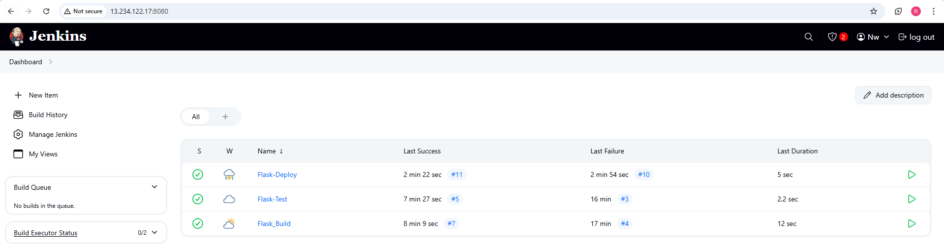

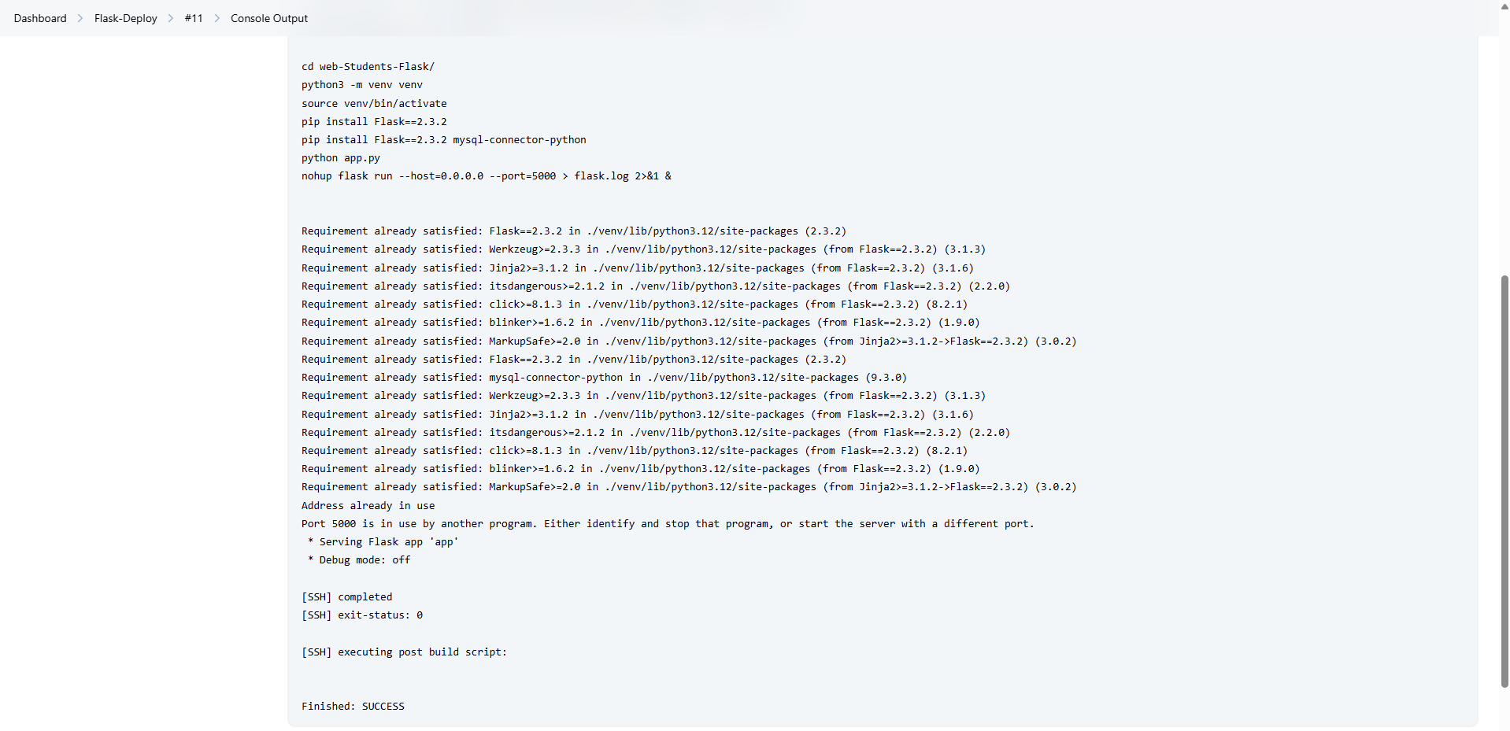

**Section 2: Clone the Repository and Set Up GitHub**

1. Create a repository on GitHub.
2. Set up a webhook on GitHub to notify Jenkins of code pushes.

3.. In your local project directory, run:

git init

git add .

git commit -m "Initial commit"

git remote add origin <repository-url>

git push origin master

**Section 3: Deployment Steps on AWS EC2**

1. Install Required System Tools

Run the following commands on your EC2 instance to install Python and MySQL:

sudo apt update

sudo apt install python3-pip python3-venv -y

sudo apt install mysql-server -y

1. Configure MySQL Database

Login to MySQL:

mysql -u root -p

1. Create a database:

CREATE DATABASE student_db;

1. Update the database credentials in app.py:

app.config['MYSQL_HOST'] = 'localhost'

app.config['MYSQL_USER'] = 'your_mysql_username'

app.config['MYSQL_PASSWORD'] = 'your_mysql_password'

app.config['MYSQL_DB'] = 'student_db'

1. python3 app.py

6. http://your-live-server-ip:5000

