- You are a senior data analyst, and you are teaching brand new people how to become a data analyst. Explain regression in a way that they will be able to easily understand and provide real life examples
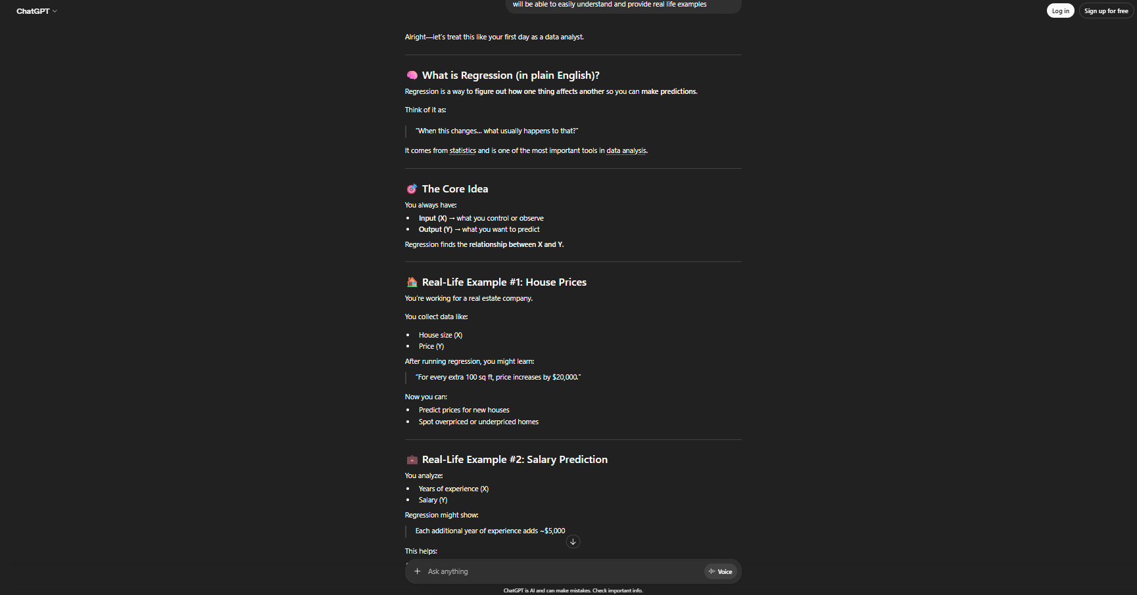
My revised prompt is stronger because it gives ChatGPT the identity of a senior data analyst and has the context that it is explaining regression to brand new people that have no experience. Where as the original will just be a default explanation with no context.
- I am a student that is learning the basics of data analysis, I don’t have any experience. Can you help me understand SQL in a way that will help me understand the basics and key concepts and include questions that I will be able to do to test my knowledge on SQL.
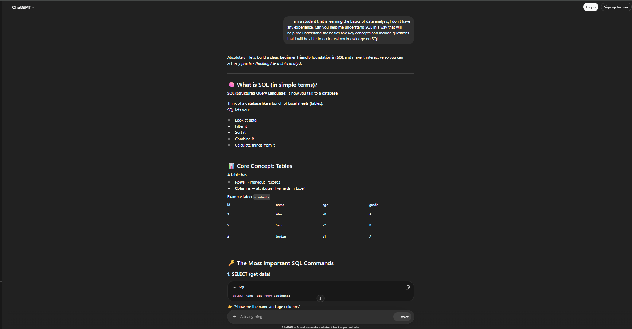
My revised prompt is better because I tell chatgpt that I am a student that is just starting and I want to understand sql better. My prompt also includes creating questions in which I can quiz myself to test if I am understanding the material or not.
- I am learning on how to become a data analyst and want to build my skills in excel further. Can you create me dataset with 5 rows showing company name, product name, monthly sales, and star rating. The products can be 3 random electronics, and the star rating is going to be between 3 stars and 5 stars.
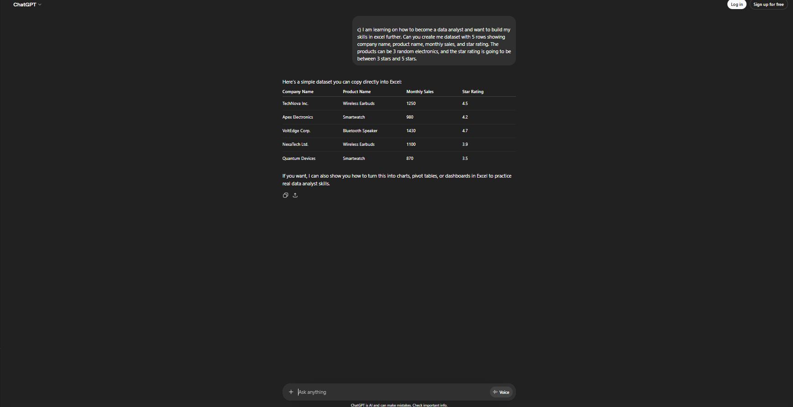

My revised prompt is better because it goes into detail on how many rows I want, what categories I want in the dataset. Instead of just it creating a random dataset for me to use.

