Consequences of legalizing prostitution

Bohdan Darmits

UCU Research

[darmits@ucu.edu.ua](mailto:darmits@ucu.edu.ua)

**Abstract**

Beginning from times that nobody remembers, the sex workers was generating billions of positive and negative thoughts. Because of the prevailing negative attitude towards this question, the industry is mainly and well explored only from this point of view. The research has both scientific and ethical goals. The scientific goals underscore the existence of an important other side of the coin, they are including the main idea of investigation, which is the identifying of the main aspects of quality of life and finding correlations between these aspects and prostitution level and type. And, last but not the least, part of scientific goal is to find some connections with Ukraine, where this topic is one of the most popular, to try to answer a question “Should Ukraine make prostitution legal?” and if Yes, “On what terms?”. Ethically, however, the project raises serious questions about the morality of these actions, but lefts the food for thoughts and lets everyone who reads it make his or her own conclusions based on given information. The data, used in the analysis was gathered by parts from different sources, what proves the rarity and possibly the uniqueness of such studies.

**Introduction**

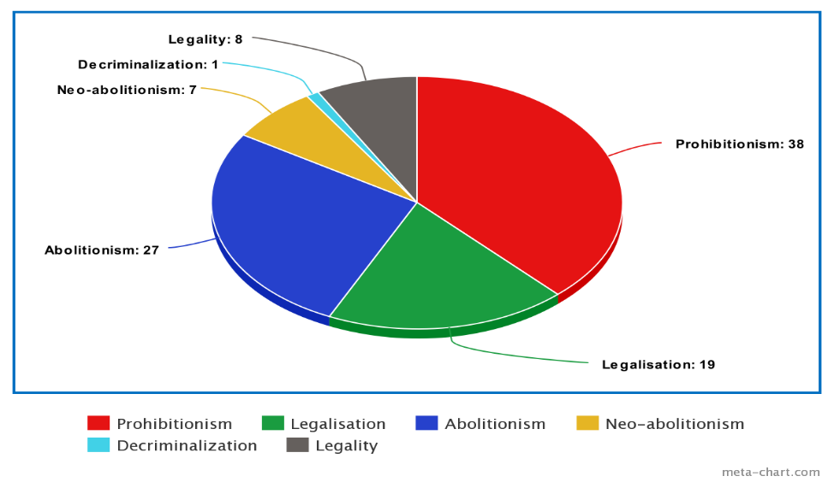Most people, based on the information they hear from mass media and surrounding know tones of negativity about the prostitution. But, what if I will say that, it not only can be, but also is a great part of economic and everyday life of many big, small, well known and unknown countries.

Figure 1. 100 investigated countries divided by the type of legalization.

As it can be seen on Figure 1, only 38 countries, out of 100 fully banned prostitution on their territory. This fact cannot be just a coincidence. In my work I will analyze and describe a huge block of data, but still it is only a small piece of different elements that influence on or are influenced by prostitution industry. I will investigate six main models of law about prostitution, compare them, in search of the bet suitable one for Ukraine and for the whole world. I conclusion I will also try to map my results on Ukraine and on data I have about this country, to find best suitable model in this particular situation.

To make all the further text more readable, below is short information about each model of sex job law:

1. Prohibitionism - all aspects of prostitution are criminalized

2. Legalization – prostitution is legal and regulated.

3.Abolitionism - prostitution is legal, while third-party involvement (bordels, etc) is usually prohibited

4. Neo-abolitionism – a so-called Swedish model. Prostitutes are legal but the buying of sex is illegal

5. Decriminalization - no criminal penalties for prostitution

6. Legality – means, that there are some local laws, which are very unusual.

(to make it easier, all visual part will use numbers of types, instead of full names)

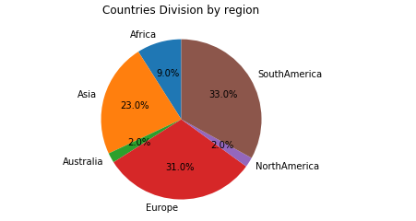Among the countries taken for this analysis there is very small percentage of nations with last two models. Despite the fact, I decided to investigate them separately. In some cases it will be suitable, in others I will artificially remove these results, In order to ensure better validity of the final conclusions. Same thing for regions. North America, for example, has only 2% of all countries in the research (Figure 2), but these countries are big and in some cases they are worth a separate study.

The main elements for the studies are the following:

1.Prostitution type – six types, as it was said earlier.

2.Population – quontity of citizens. Figure 2. Number of countries groupped by regions.

3. Region

4.Quontity of prostitutes per 10000 of population.

5.GDP (per capital) – measure of market value af all servises and products produced by country in a specific time (usually year)

6.Literacy level – percentage of people who can both read and write with understanding a short simple statement on their everyday life.

7.People growth rate - shows how much the country's population is growing in number or decreasing over time (usually year)

8.Agriculture – shows the percentage of agrarian industry in local economics.

9.HPI – Happy Planet Index - It tells how well nations are doing at achieving long, happy, sustainable lives.

Data used in analysis is varicoloured. In main investigation, where different data processing methods were used were involved datasets of the prostitutes rates and legalization types collected by US independent organization World Population Review based on World Factbook made by organization ProCon in 2019. In addition to that Data about regions, GDP, literacy, population growth, agriculture part in GDP of the country was found on open datasets resources. It is public domain from US government. Data about HPI level was taken from official website of the organization counting this index for world statistics. Exept this, in conclusions and assumptions making I was helped by New York Police Department crimes dataset, Seattle Crimes dataset and by internet resource Havoscope, which provides users with information about global sex market. Havoscope gave one of the most reliable information about Ukraine prostitution industry, and about industries in other countries. Also, a huge amount of additional information was gathered from different sources to improve research and analysis.

The Importance of this research us justified by the facts that hundreds of thousands people are suffering by being forcibly drawn into, endure violence against the body and psyche against their will. They are not properly protected by law and cannot be protected from infections. On the other hand, the moral component of the issue adds importance, since it is very difficult for humanity to perceive prostitution. It is caused by personal principles, religious principles, etc. This applies to all countries with all types of legalization, as most of the industry operates in the shadows and most of the people do not want to accept sex industry.

**Related Work**

**The “German Model”, 17 years after the liberalization of prostitution.**

This work is from speech of Dr. Ingeborg Kraus. She was criticizing the German law about prostitution. Here are some main quotes and facts from it:

“It is the German state, by normalising prostitution and by guaranteeing a total decriminalisation of the sex buyers, that has contributed to an enormous increase in demand.”

“A study by the German ministry for family affairs in 2004[9] demonstrated that 87% of the women in prostitution reported having been exposed to physical violence, 82% to emotional violence, 92% to sexual harassment, 59% to sexual violence.”

“And what are those women sacrificed for? For what are they sent into a situation similar to war? Is it to protect the country against invasions or terrorism? No, those women are being sacrificed so that some men can have sex whenever they want, the way they want and with whom they want.”

“The “German model“ of legalising prostitution has shown itself to be a law obliging the criminal world and has turned Germany into traffickers”

“This economical model of the sexual exploitation of the women has also led to an economical exploitation of those women[4]: they earn 30 Euros for sexual intercourse, while they must pay around 160 Euros for a room and 25,– Euro taxes per day; So they have to serve 6 men before starting earning money.”

“The behaviour of the sex buyers became perverted overnight with a law normalising prostitution, whose message to men is clear: There is “a right“ to buy sexual acts and there is no need to feel guilty about that anymore.”

**Шведська модель боротьби з проституцією: протидія, а не комфортизація.**

Ukrainian journalist and researcher on gender problem Олена Зайцева is proving that there is no dramatic difference between legalization and decriminalization. Here you can see some main quotes and facts from it:

“У дослідженні Європарламенту про сексуальну експлуатацію, проституцію та їх вплив на гендерну рівність сказано, що проституцію не може бути визнано легітимним бізнесом хоча б тому, що вона суперечить фундаментальним правам людини і принципу гендерної рівності, а нормалізація проституції чи торгівлі людьми або будь-яка їх легалізація це легалізація сексуального рабства і гендерної нерівності для жінок&raquo.”

“Із 1999 року, тобто за майже років, жодну проституйовану жінку у Швеції не вбив клієнт чи сутенер, тоді як за 30років у Нідерландах, де проституцію легалізовано, вбито 127жінок у проституції, у Німеччині 69 жінок убито і 28 ;зазнали замаху на вбивство лише за 13 років з 2002-го до 2015-го.”

“Було виявлено, що 45% - 50% проституйованих осіб основною своєю проблемою вважають насильство, 68 страждають від посттравматичного стресового розладу (ПТСР, як у учасників бойових дій) і психологічної дисоціації, від 43 % до 69 осіб у проституції зазнали сексуального насильства в дитинстві, майже 94% вживають наркотики[, а світові прибутки від проституції становлять приблизно $186мільярдів на рік.”

**Solution approach**

To find the results and evaluate them, was done a number of data processing methods. The data was found, cleaned, transformed and normalized. Different data frames were combined in one unique table with all elements for researches. The mean imputation method was used, to show mean results by different groups. The mean Imputation was used because it if uses mean value to input in cells. As we need mean values for displaying, this method was the best. Different approaches to missing data were considered, but, where it was need, rows with missing data were removed because in my opinion this way gave as better results. The correlation between data was performed.

**Results**

Here are all investigation result presented:

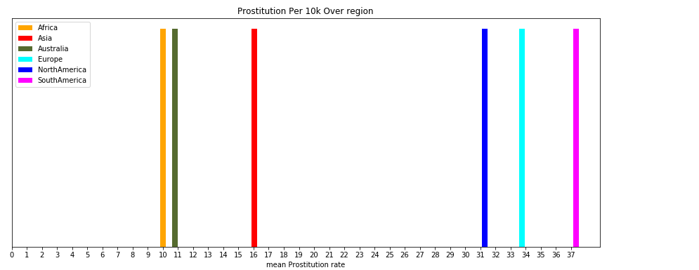

Figure 3 shows the mean quantity of sex workers per 10000 residents of country in Region.

Here results tell us that the countries of South America and Caribbean have the biggest prostitution rate what is quite interesting and not predictable result. Obvious was, that Europe and north America will take high places.

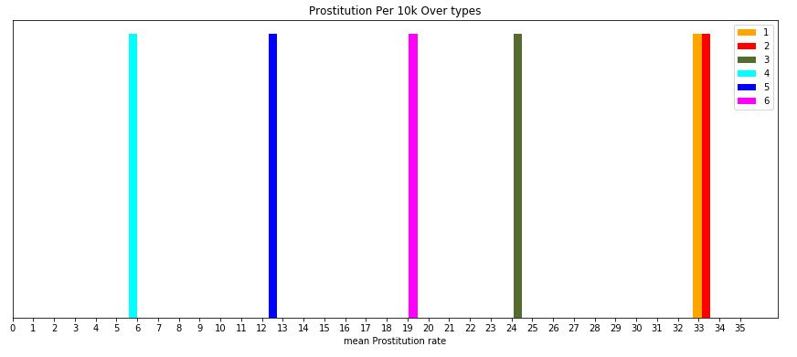

Figure 4 shows connection between type of prostitution legalization and mean number of prostitutes

All parts are on predictable places, except yellow one. It represents countries where prostitution is Illegal. Number of sex workers is higher than all, and almost the same as red element which represents legality. All others are different types of legality, they are on lower than full legality places. They are on more or less predictable places. Except decriminalization, it is the only type that gives bigger freedom in investigated area then legality but still has the lowest sex workers rate.

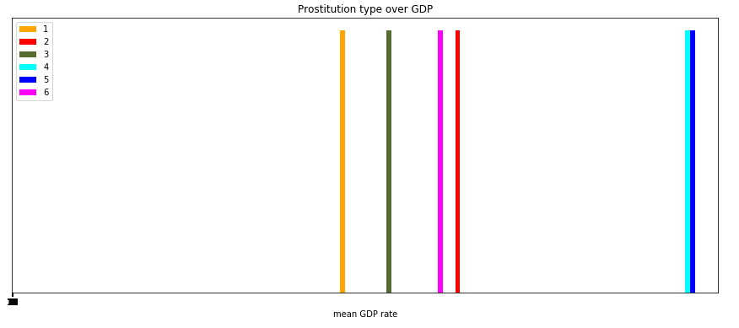

Figure 5 shows connection between type of prostitution legalization and mean GDP

Figure shows that countries that ban prostitution, have the lowest gdp. Abolutionism is on the 5th place between Prohibitionism and Legalization.

Countries from 3 other groups are not counted here because they have too much side influence on the result, and small amount of countries in groups

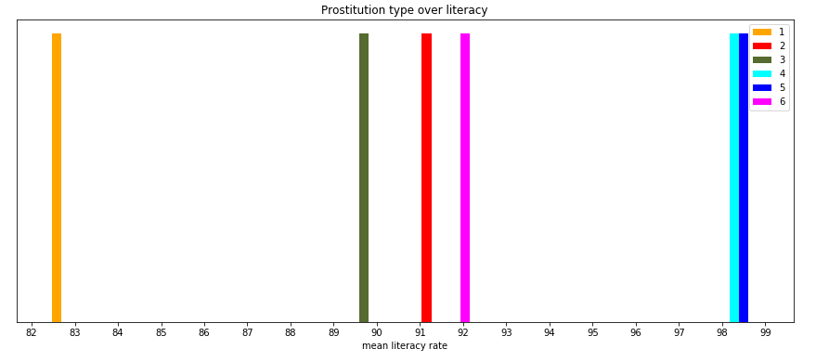

Figure 6 shows connection between type of prostitution legalization and mean Literacy

This result saves previous tendention. People with banned prostitution are less educated than all others. Also is interesting o see that the most educated counties chose the models of decriminalization and Neo – abolitionism.

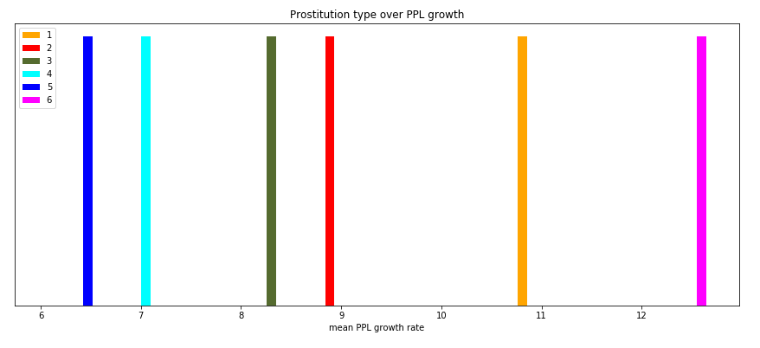

Figure 7 shows connection between type of prostitution legalization and mean population growth

Not obvious result shows that population growth is higher in counties where sex work is banned.

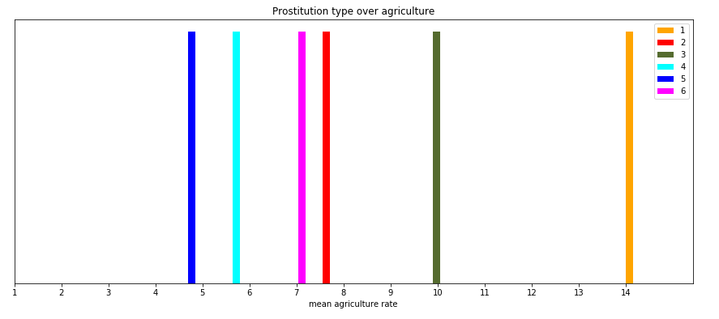

Figure 8 shows connection between type of prostitution legalization and mean agriculture part in economy

Countries where prostitution is banned are mostly agrarian.

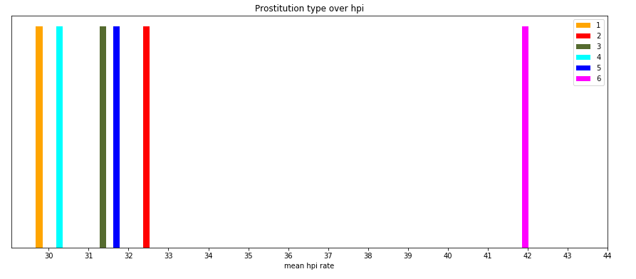

Figure 9 shows connection between type of prostitution legalization and mean HPI level

This Figure tells that countries where prostitution is banned have the lowest happiness index. At the same time it is quite strange that neo-absolutism is on the pre- last position.

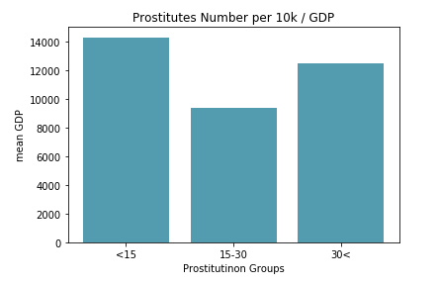 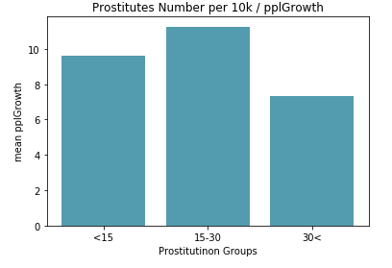

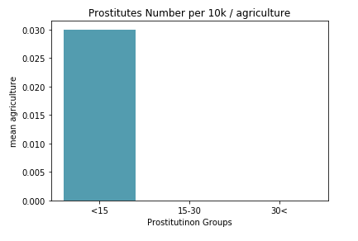 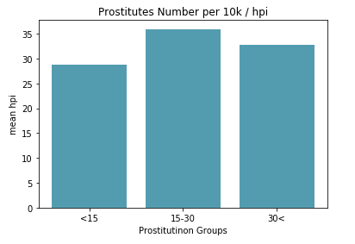

Here all countries were divided on 3 groups by the number of prostitutes: 1 – less than 15 per 10k, 2 – more than 15 less than 30 per 10k, more than 30 per 10k. These Histograms show results of comparing these groups by different criterias.

**Conclusion**

In conclusion I want to talk about all legalization types in a detail.

First one – model that bans prostitution. It showed the most interesting results. Number of prostitutes is extremely high, higher than all others, same with full legalization model. This means that banning doesn’t solve the problem, there are still huge amount of men and women who work in the industry without any control and that is the worst thing. At the same time it has quite good population growth rate. I think its because people have lower access level to the industry, and the industry workers are not protected and controlled. That’s why level is higher. GDP, Literacy and HPI levels are the lowest, agriculture level is the highest. That’s why it can be said that countries with banned prostitution are the most unhappy, agrarian, with the low level of GBD and literacy.

Countries where prostitution is legal: very high prostitutes number, good level of GDP and top2 in HPI.

Countries that use Abolitionism model: 2nd in agriculture, 3rd in prostitution rate, 5th by GDP.

Countries that use Swedish model: all results are very low, except literacy and GDP, but these two areas have too big influence from other areas.

Full decriminalization shows the lowest level of people growth rate and the lowest level of agriculture. Good results were shown by literacy and GDP, but these two areas have too big influence from other areas.

Countries with local special laws – typical average result, two areas with top1 results may have a big influence from side, that’s why this result is dropped.

Here is the main characteristic of each model. They are full of unexpected results. They show that the banning of sex industry is the worst idea. Countries should find their best models. Decriminalization is also one of the losers in competition alongside with Swedish model. Average best results are shown by legalization. I must say, that this investigation, gave a short characteristic of each model, the only thing left for each country, what they think is the best for them. But still we shouldn’t forget about thousands of other factors that have influence on and are influenced by prostitution topic in country. And, also, it’s important to remember that all countries are unique, and the same parameters and models will not always work in two different places.

As for Ukraine, we are in a very bad position considering this analysis. Based on these results, we definitely should push our model towards legalization. But it is better to proceed with further analysis and wait until more data available. To collect bigger dataset and investigate deeper.

**References**

<http://happyplanetindex.org>

<https://genderindetail.org.ua/season-topic/seksualnist/shvedska-model-borotbi-z-prostitutsieyu-protidiya-a-ne-komfortizatsiya-134359.html?fbclid=IwAR1He5bMyJT00XHN02wzSYoDyLSBp2KJsaUirP2PbGCMwXAFUl_awcCcTbU>

<https://www.trauma-and-prostitution.eu/en/2018/06/19/the-german-model-17-years-after-the-legalization-of-prostitution/?fbclid=IwAR3b6ywPNiEJWaYfh5aweObakzZ1WyZ8tgx5MTN1NPAf_wiyhWc4GLDZrXA>

<https://www.havocscope.com/ukraine-sex/>

<https://en.wikipedia.org/wiki/Decriminalizing_sex_work>

<https://www.criminaldefenselawyer.com/resources/prostitution-laws-new-york.htm>

<http://worldpopulationreview.com/countries/countries-where-prostitution-is-legal/>

<https://www.bbc.com/worklife/article/20190419-should-prostitution-be-a-normal-profession>

<https://www.google.com.ua/url?sa=t&rct=j&q=&esrc=s&source=web&cd=7&cad=rja&uact=8&ved=2ahUKEwiSnfWTmJvmAhUJsKQKHd8RC8kQFjAGegQIAxAC&url=http%3A%2F%2Fwww.europarl.europa.eu%2FRegData%2Fetudes%2Fetudes%2Fjoin%2F2014%2F493040%2FIPOL-FEMM_ET(2014)493040_EN.pdf&usg=AOvVaw0U8pTfqXN7NdeaNm-GHiVA>

<https://nij.ojp.gov/topics/articles/understanding-and-applying-research-prostitution>

<https://www.bazarmedia.info/novini/vidpochinok/8045-lehalizatsiia-prostytutsii-navishcho-tse-potribno>

<https://www.bbc.com/ukrainian/features-48077355>

<https://www.researchgate.net/publication/328282081_Prostitution>

<http://www.isca.in/IJSS/Archive/v2/i3/6.ISCA-IRJSS-2013-027.pdf>