**What is Bdcash Protocol (BDCASH)?**



It's a peer-to-peer project based and forked from **PIVX** code with **proof-of-stake** consensus and **masternode**, but with major changes to its protocol, we've made our code unique, allowing for faster transactions and relatively low rates.

Using bdcash protocol, the user will be able to create his token directly on our network thanks to our ecosystem created especially for our code (Inspired by the Scrypta project, but with the necessary modifications that make it unique.), in addition to Tokens, NFTs, Dapps can be created like Games, Farms, Marketplace and more, the possibilities are endless for using our ecosystem

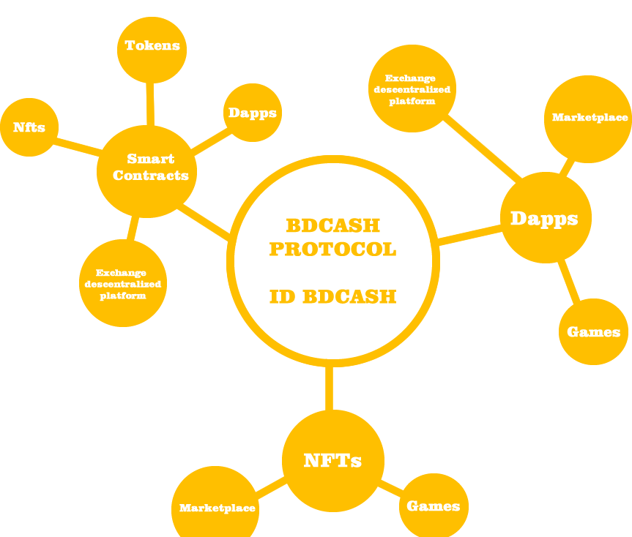

**Bdcash Protocol Ecosystem(BDCASH)**

| **IDbdcash (BDCASH Digital Identity).**  **NodeSH (Node Secure HyperConnection).**  **Chain BDCASH Platform.**  **NFT BDCASH platform.**  **BDCASH Hub.** |
| --- |

**IDBDCASH ( Digital Identify BDCASH)**



Use our IDBDCASH app to store your coins, or manage your tokens all in a simple and super secure way.

When creating your account, you will save your private key and export mnemonic (secure words) and then you can access our Android wallet, Web, extension for Chrome or Firefox.

For login the same process is used, use your safe words or private key, if you are logged in or forget to login.

Your IDBDCASH is your secure wallet that can connect to any web platform that supports the BDCASH network

**NodeSH (Node Secure HyperConnection)**



NodeSH (Node Secure HyperConnection) is certainly the most important technology. It is the heart of all data read and write operations, as well as the main data source for dApps across the entire network.

NodeSH is a NodeJS application written in TypeScript with a multitude of features:

1. **Blockchain explorer**: keeps track of all transactions and all blocks, can be used as a visual block explorer.
2. **Relay**: used by clients (bdcash-core) to send transactions to the network.
3. **Data explorer**: serves as an interface for reading information written in the blockchain; this is one of the most important features for dApp development.
4. **IPFS**: serves as an interface to the distributed file system (InterPlanetary File System), useful for uploading and downloading data.
5. **Replica**: NodeSH is the main replica of all the information and files loaded in the BDCASH Blockchain.
6. **Wallet** : it can also function as a "client", it can perform the same operations as bdcash-core clients, just call APIs and pass the necessary information.
7. **Trusted Links**: Trusted Links operations are managed internally by NodeSh, including the creation and recording of information by a Trusted Links.
8. **Smart Contracts**: Allows the execution of external code thanks to the internal virtual machine.
9. **P2P network**: allows instant communication between the different connected clients

**Chain BDCASH Platform**



Create your token on the **BDCASH** network in a simple way in just a few clicks, minimum requirements for creation to be accepted on the network:

1. Definition of genesis fields
2. Creating a new address by **NodeSH**
3. Trusted Link Creation **(IDBCASH)**
4. Submission of at least **1 BDCASH** by owner to trusted link
5. Genesis transaction written on blockchain
6. Sending the entire supply via the trusted link **(IDBCASH)** to the owner of the Sidechain

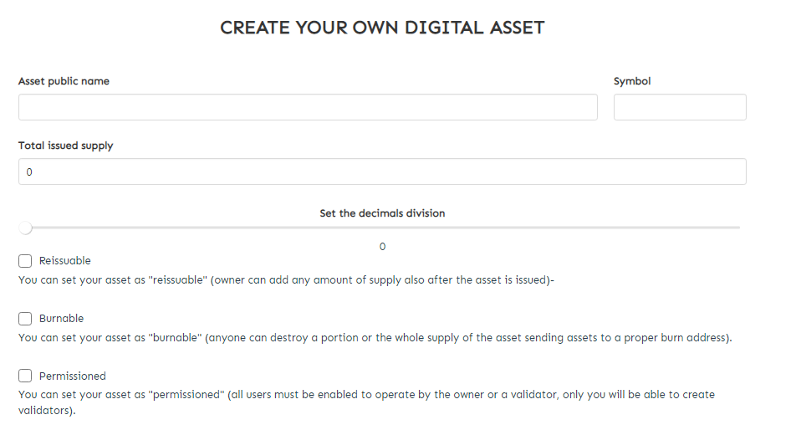

From the moment the trusted link **(IDBCASH)** transfers all the supply to the owner, it is possible to start making transactions using as **USXO (Utxo related to the sidechain**) this first transaction.

Transactions are done almost instantly due to reading the mempool in **NodeSH**, it is also responsible for guaranteeing uniqueness and guaranteeing the transaction even if it has not yet been committed in the next block.

**NFT BDCASH Platform**



**Non-Fungible Tokens** or **NFT** is coming at a big rally in the market and we will enter this market head on, for that we will launch our platform for creating, selling and buying **NFTs** in the **BDCASH** network.

The creation process will be simple, like creating tokens, and relatively cheaper than other available blockchains.

Due to our protocol and **NODESH** technology the creation will be almost instantaneous, thanks to the **BDCASH** network validators.

**BDCASH HUB (Dapps Management System)**



Bdcash Hub is a platform where all Dapps created on the BDCASH network can be found.

Among them the official Dapps of the project:

1. ***BDCASH Digital Identify (IDBDCASH)***
2. ***NodeSH (Node Secure HyperConnection).***
3. ***Chain BDCASH Platform.***

Users will also be able to find their favorite Dapps or add their own, bringing views to their applications, it can be added, Marketplace, Decentralized Games, any Dapp created within the BDCASH network

**Road Map**

**October - December 2021**

* ~~Restructure Project.~~
* ~~Rename Project.~~
* ~~update social media and listed platforms.~~
* ~~Update website, white paper and Road Map.~~
* ~~Start Update.~~
* Update code and add new nodes
* Create BCASH ID.
* Create NODESH.
* Create New PC Wallets.
* Create new Android Wallet.
* Publish extension wallet for Firefox and Chrome.
* Make the creation of smart contracts available on the BDCASH network.
* Launch Tokenization Platform.

**January- April 2022**

* Search partnerships with Exchange for acceptance of BDCASH tokens in the market.
* Expand partnerships with exchanges.
* Start construction of the NFT BDCASH platform.
* Start building the BDCASH Hub.
* Start marketing to expand the community.
* Launch NFT BDCASH platform.
* Launch BDCASH Hub.
* Review code and update protocol.
* Update Road Map with new goals and improvements.

**Team Bdcash Protocol (BDCASH)**

Our team currently has 4 official members and some collaborators helping the discord and Telegram community.

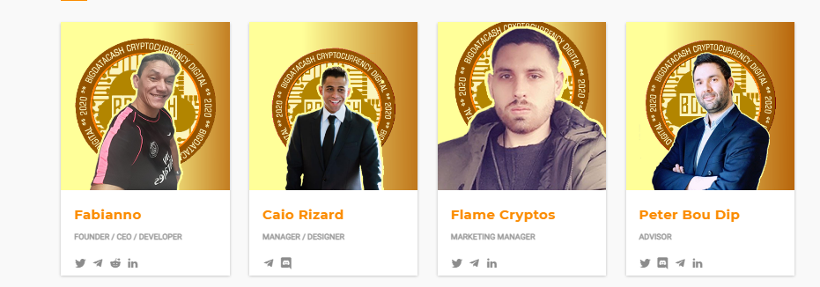

**Contributors**

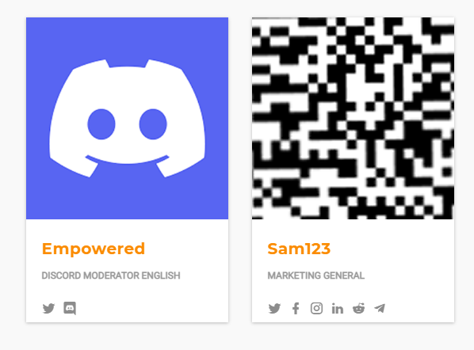

**Specs Bigdatacash (BDCASH)**

======================================

TYPE = **POS/MN**

RPC/P2P MAIN PORT= **36264 / 36263**

RPC/P2P TESTNET PORT = **37264 / 37263**

SUPPLY TOTAL = **15M**

LASTPOW BLOCO = **10000**

COLATERAL = **5000 BDCASH**

========== **REWARDS SCHEME**==============

== 0000 - 00001 = 6,6% Premine **(SWAP)**

== 0002 - 10000 = 1 .00BDCASH N/A | N/A

== 10001 - 19999 = 2.00 BDCASH | 25% POS | 75% MN

== 20000 - 29999 = 3.00 BDCASH | 25% POS | 75% MN

== 30000 - 39999 = 1.00 BDCASH | 25% POS | 75% MN

== 40000 - 59999 = 4.00 BDCASH | 25% POS | 75% MN

== 60000 - 79999 = 3.00 BDCASH | 25% POS | 75% MN

== 80000 - 99999 = 2.00 BDCASH | 25% POS | 75% MN

== 100000-149999 = 1.00 BDCASH | 25% POS | 75% MN

== 150000 -199999 = 0.75 BDCASH | 20% POS | 80% MN

== 200000 -299999 = 0.50 BDCASH | 10% POS | 90% MN

== 300000 - to end = 0.25 BDCASH | 30% POS | 70% MN

================================================

**Links**

<https://bdcashprotocol.com>

<https://bdcashprotocol.com/blog>

<https://inside.bdcashprotocol.com>

<https://blocks.bdcashprotocol.com>

<https://bdcash.ccore.online>

<https://twitter.com/bdcashprotocol>

<https://bitcointalk.org/index.php?topic=5244522>

<https://discord.gg/rrr8vFS>

<https://www.reddit.com/r/cryptocurrency_bdcash/>

<https://t.me/bdcashprotocol_official>