

Software Development Project -A

SAQAB



March 15, 2019

SAQAB

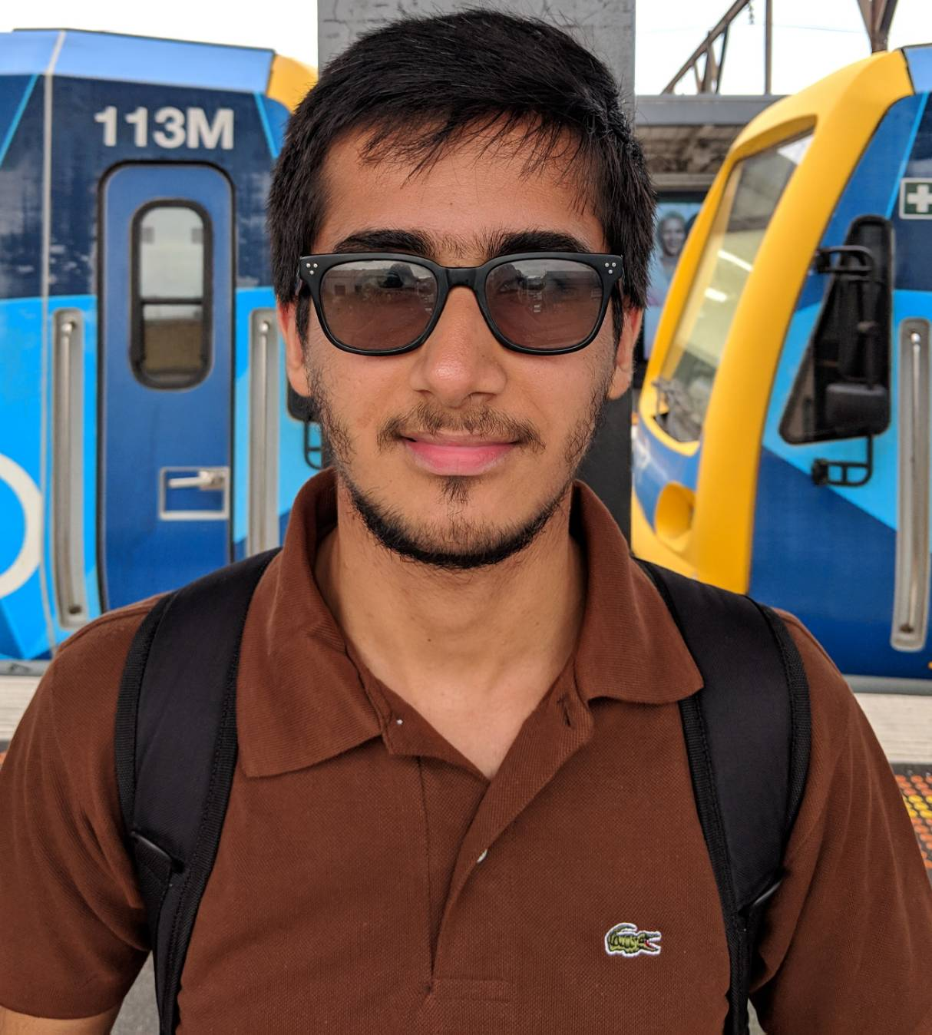

**SANEE REIMOO**

*Software Developer and Project Engineer*

*(100074144)*



**BINAY** **DHAWA**

*Team Leader & Software Developer*

*(101187399)*



**ANDRES ALVAREZ**

*Research Analyst & Software Developer*

*(101742154)*



**AYLWIN SIM**

*Software Developer and Data Analyst*

*(100074144)*

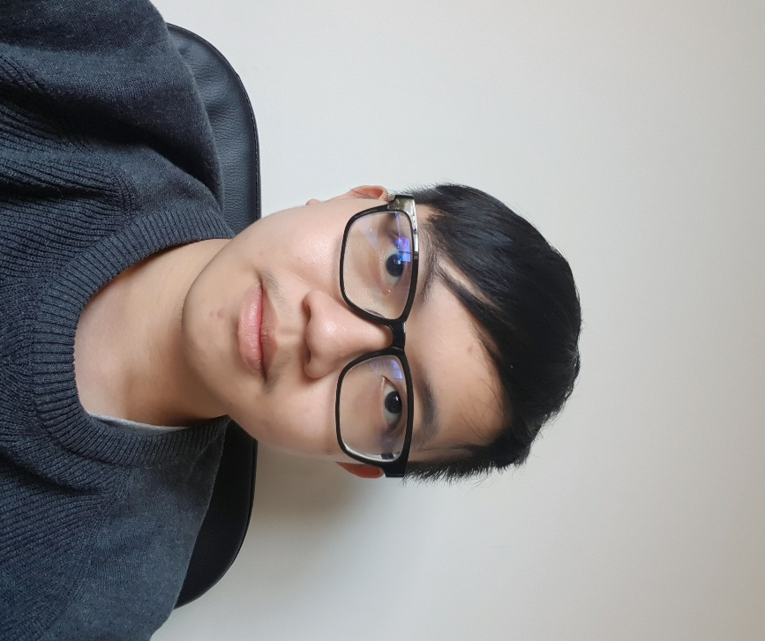

**QUAN CHONG**

*Software Developer and Data Scientist*

*(100076483)*