Benjamin Kelly

GEOG 498G

**Soccer Match Tracking Project**

1. Project Goals:

My project to be able to be able to transform broadcast soccer match video into a two-dimensional representation of the same footage from a bird’s eye view perspective. Achieving this project goal would allow soccer apps, as well as other platform to show real time match events to an audience is unable to watch the broadcast of match. This project was inspired by the work done on the paper ***“A computer vision-based web application for tracking soccer players”*** by the authors:

J.M.F. Rodrigues, P.J.S. Cardoso, T. Vilas, S. Bruno, P. Rodrigues, A.

Belguinha, and C. Gomes

In their paper they created what I hope to recreate in my project (Image Below)

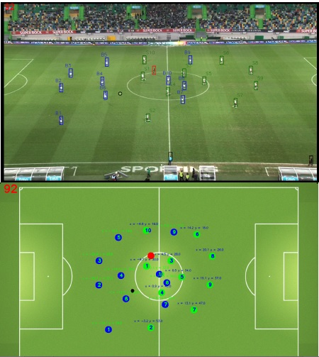

1. Objectives & Roadmap:

To achieve the goals of this project I will be working with python libraries of NumPy, and OpenCV. In this case NumPy will be used for the mathematic computations of the project, while OpenCV will be used to translate, and transform the incoming video into a two-Dimensional projection. After reading over the paper listed in the Project Goals section above, I have identified some of the targets that I need to be able to reach in order to have a functioning application by the end the semester:

Field Identification:

To identify the field of play I will need to implement an HSV Threshold Interval Field. Doing this would allow my program to remove parts of the video that I do not need like fans, and the individual pieces of grass making the dataset much easier to work with. Then I plan on using the Hough Transform method to detect straight lines that are with in the video. These lines would make up the edges of the field, as well as the different lines within.

Player & Ball Identification:

To identify the players, and ball during the match we will use the HSV output from the field identification. This with allow use to tell a part what is the field, what is the ball, and what is a player. I will then use a variety of filters like: Morphological filter, Dilation filter, and erosion filter to only return areas with players inside.

Field Position Calculation:

The bulk of the work with regards to the player position on the field will be done with Perspective transformation, or homograph the results of which will be normalized. After normalization the resulting data should give should give us the desired outcome that being the birds eye view projection of the soccer video that the program is given.

1. Possible Roadblocks & Mitigations

Road Blocks

There are main possible road blocks to this project. One block that could occur is a result of how massive the OpenCV library is. I could spend the who semester just working on understanding, and becoming familiar with it alone. Another potential block is the is the lack of uses able real game footage, as a result of most footage being copyrighted.

Mitigations

One way I might decrease the complexity of the OpenCV library is staying with the “path” my main reference paper has laid out. I should be looking for potential ways my project to other goals if I find block that is to large for a semester project. For the problem with using game footage I believe that I will use FIFA 20 footage that I have collected from playing it myself.

1. Current State of Project

Currently I have been able to track player movements using OpenCV. I have to manual outline the players at the beginning of the clip. I would like for my project to be able to find these players on its own. I have also been able to implement the HSV Thresholding intervals from my main reference paper. I will display an example of each of these first steps in my project.

HSV Threshold Example:

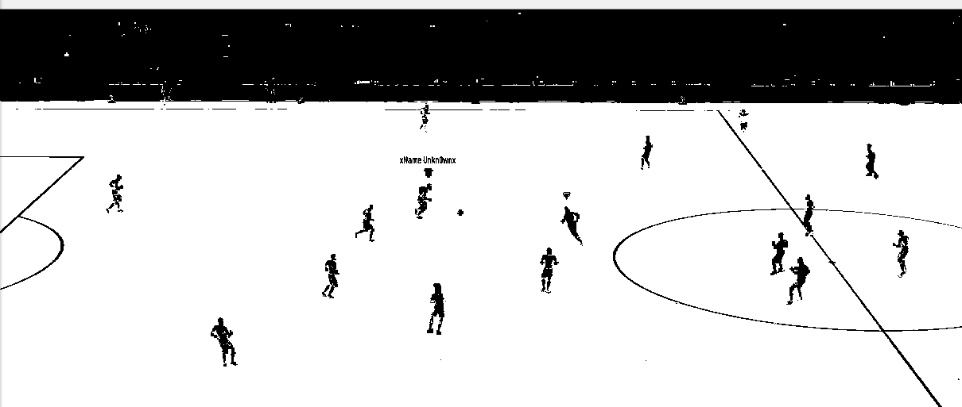

Tracking Example:

