**Data Sources & Transformations Documentation**

**1. Data Sources**

The dataset in this Power BI dashboard was sourced from the following locations:

* **Primary Source:** [Excel file>Files for project]
* **Source Connection Method:** [Direct Query / Import Mode]
* **Tables Used:** [dataset>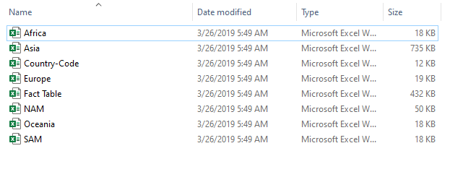]

**2. Data Transformations**

Several data preparation steps were applied using Power Query to clean and structure the data for analysis. These include:

✅ **Data Cleaning:**

* Removed null or duplicate values to ensure data integrity.
* Standardized column names for consistency.
* Fixed data type issues (e.g., converting text to date formats).

✅ **Filtering & Deduplication:**

* Applied filters to remove unnecessary records.
* Deduplicated records where applicable.

✅ **Merging & Joining Tables:**

* Combined data from multiple sources using **merge queries** (e.g., inner/left joins).
* ✅ **Data Formatting & Structuring:**
* Renamed columns for clarity.
* Rearranged tables to optimize performance.
* Created **hierarchies** (e.g., Year → Month → Day) for better drill-down analysis.

✅ **Data Modeling:**

* Established **relationships** between tables using primary and foreign keys.
* Defined the **data model structure** to ensure smooth interaction in reports.
* Optimized table connections using **one-to-many** and **many-to-one** relationships.

✅ **Report Design & Visualization:**

* Designed **interactive dashboards** using visuals like bar charts, pie charts, and tables.
* Applied **slicers and filters** to allow dynamic data exploration.
* Configured **tooltips** and **drill-through pages** for deeper insights.