@porrtal-components Quick-start-demo Features

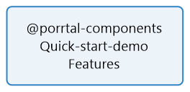

**No table of contents entries found.**