@porrtal-components Test-component-lib Features

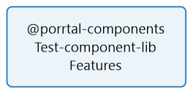

**No table of contents entries found.**