Edge-Assisted Secure Medical Telemetry Using Lightweight Watermarking and Cryptographic Authentication in 5G Healthcare Networks
Abstract
Decrypted DICOM payloads on hospital picture archiving and communication systems (PACS) lack built-in provenance mechanisms to verify their acquisition source or detect post-decryption manipulation. Standard symmetric transport pipelines terminate security checks once decryption completes at the receiver boundary. This study evaluates SecureMark-Med, an edge-oriented verification framework combining spatial least-significant-bit (LSB) watermarking, keyed BLAKE3 integrity hashing, and ChaCha20-Poly1305 authenticated encryption. The pipeline embeds device identifiers, patient indexes, and hardware timestamps directly into DICOM pixel arrays, authenticates the modified matrix through a Merkle-tree BLAKE3 token, and seals the datagram using ChaCha20-Poly1305. A temporal threshold at the receiver rejects packets arriving outside a 30-second window. Tested on a Raspberry Pi 3 Model B+ node using 16-bit clinical CT and radiographic series, the cryptographic execution took 28.61 ms for encryption and 11.92 ms for verification, compared to 84.32 ms and 31.65 ms for AES-256 and HMAC-SHA256 baselines. Across tested sets, the fragile spatial watermark maintained baseline image fidelity ($\text{PSNR}>51.4$ dB, $\text{SSIM}>0.999$) while detecting localized bit alterations.

Introduction
High-bandwidth 5G connections allow mobile triage units to stream DICOM diagnostic scans (CT, X-ray, ultrasound) directly to emergency hospital teams before patient arrival. However, transmitting unauthenticated imaging over wireless uplinks creates security risks, including packet interception, data manipulation, and replay attempts. Because clinical diagnosis depends on precise image readings, undetected modifications of even a few pixel values can distort anatomical features or mimic acute pathology.
Standard transport security uses block ciphers like AES-256 alongside SHA-2 hash functions. In emergency triage telemetry, this setup has specific practical drawbacks:
- Loss of Post-Decryption Provenance: Standard decryption at the PACS terminal removes the transport security wrapper, leaving the plain DICOM file without verifiable proof of origin or post-decryption tamper evidence.
- Edge Computational Overhead: Field gateways in mobile units often run on low-power ARM hardware lacking dedicated AES-NI instructions, increasing cryptographic processing times and battery drain.
- Sequential Hashing Delays: Sequential hashing algorithms like SHA-256 process large, 16-bit multi-megabyte volumetric scans in a single thread, causing transmission bottlenecks.
SecureMark-Med addresses these issues by embedding provenance metadata into the image matrix itself, verified using keyed BLAKE3 hashing and software-efficient ChaCha20-Poly1305 AEAD.

Related Work
Digital watermarking for medical telemetry has emerged as an effective technique for binding ownership and integrity metadata directly into clinical images. Memon and Alzahrani utilized prediction-error expansion for CT scan authentication, focusing on pixel reversibility. Anand and Singh investigated multi-modal image watermarking for composite EHR security. Alzahrani and Memon developed a blind hybrid-domain scheme for clinical copyright enforcement, while Gull et al. proposed a self-embedding technique for tamper detection in IoMT environments.
Edge implementations were explicitly examined by Singh et al. , who highlighted significant latency constraints when executing legacy ciphers on embedded hardware. Tayachi et al. introduced a hybrid DICOM watermarking approach, though encryption and integrity remained uncoupled. Abirami and Malathy demonstrated chaos-based encryption paired with deep-learning watermarking, while Mahmood et al. surveyed open challenges across IoMT architectures, emphasizing the need for sub-second zero-copy security primitives. Supporting studies on robust IoMT watermarking , accelerated blockchain consensus via BLAKE3 , and lightweight IoT stream ciphers confirm the throughput benefits of ARX primitives. The cryptographic building blocks in SecureMark-Med leverage the BLAKE3 parallel tree-hash specification , the ChaCha20-Poly1305 AEAD protocol , and official NEMA DICOM interchange standards .
Architectural comparison of medical image security schemes.
Scheme | WM | Encryption | Integrity | Edge-Ready | Freshness Check
Memon & Alzahrani [1] | $✓$​ | — | Partial | — | —
Anand & Singh [2] | $✓$​ | — | — | — | —
Gull et al. [4] | $✓$​ | — | Local | — | —
Singh et al. [5] | $✓$​ | AES | Checksum | $✓$​ | —
SecureMark-Med | $✓$​ | ChaCha20 | BLAKE3 | $✓$​ | $✓$​

Proposed SecureMark-Med Framework
The SecureMark-Med pipeline consists of three sequential operations: provenance data embedding, cryptographic integrity token calculation, and authenticated transport encryption.

Watermark Embedding
Let $I∈R^{M×N}$ denote a 16-bit grayscale DICOM pixel array. The provenance payload $W$ aggregates patient, facility, and acquisition identifiers:
$$W=ID_{pat}∥ID_{hosp}∥DevID∥T_{s}$$
$W$ is serialized into a binary sequence $B=\{b_{0},…,b_{L−1}\}$ and embedded into the least significant bit (LSB) of sequential image pixels:
$$\tilde{p}(i,j)=\left(p(i,j)∧∼1\right)∨b_{k}, k=i⋅N+j, ∀ k<L$$
Because emergency triage telemetry profiles focus on lossless preservation of pixel values, spatial bit modifications must stay strictly bounded ($|​p(i,j)−\tilde{p}(i,j)|​≤1$). In this environment, fragile LSB watermarks serve as a sensitive baseline detector: any subsequent pixel alteration or lossy re-encoding disrupts the watermark sequence, flagging an integrity fault.

Integrity Token and Authenticated Encryption
The watermarked matrix $I_{w}$ is serialized to byte buffer $M_{bytes}$. A keyed integrity token $τ$ is generated via BLAKE3 using a pre-shared 256-bit secret key $K_{sec}$:
$$τ={\text{BLAKE3}}_{\text{keyed}}(K_{sec},DevID∥M_{bytes}∥T_{s})$$
The combined payload $M=(I_{w}∥τ∥T_{s})$ is encrypted using ChaCha20-Poly1305 with key $K_{enc}$ and a fresh 96-bit CSPRNG nonce $N$:
$$(C, \text{Tag})=\text{ChaCha20-Poly1305-Encrypt}(K_{enc},N,M)$$
The generated transport datagram is $P=N∥C∥\text{Tag}$. While the ChaCha20-Poly1305 AEAD construction natively guarantees the integrity of the encrypted transport envelope during transmission, the BLAKE3-bound watermark serves an orthogonal purpose: it provides a persistent, application-layer provenance representation that remains verifiable long after decryption at the hospital PACS workstation.
Datagram $P$; keys $K_{enc},K_{sec}$; expected metadata $DevID,W_{exp}$; clock $T_{now}$ Verdict $∈\{\text{Authentic}, \text{Tampered}, \text{Stale}\}$ Parse $N∥C∥\text{Tag}←P$ $M←\text{ChaCha20-Poly1305-Decrypt}(K_{enc},N,C,\text{Tag})$ Tampered (AEAD tag failure) Deconstruct $(I_{w}∥τ∥T_{s})←M$ Stale (Expired freshness window) $τ_{calc}←{\text{BLAKE3}}_{\text{keyed}}(K_{sec},DevID∥\text{Serialize}(I_{w})∥T_{s})$ Tampered (Cryptographic hash mismatch) Extract $W_{ext}$ from LSBs of $I_{w}$ Tampered (Provenance mismatch) Authentic
Algorithm [alg:verification] and its corresponding logical flow in Fig. 1 detail the multi-stage receiver verification process. Upon receiving the telemetry packet, the edge gateway decrypts the payload using the ChaCha20 cipher. To guarantee strict cryptographic integrity, the framework sequentially verifies the AEAD tag, enforces a strict 30-second freshness check to mitigate delayed packet transmission, validates the BLAKE3 hash, and finally extracts the LSB watermark to ensure clinical provenance. If any intermediate condition fails, the pipeline immediately aborts and flags the transmission as tampered or stale.
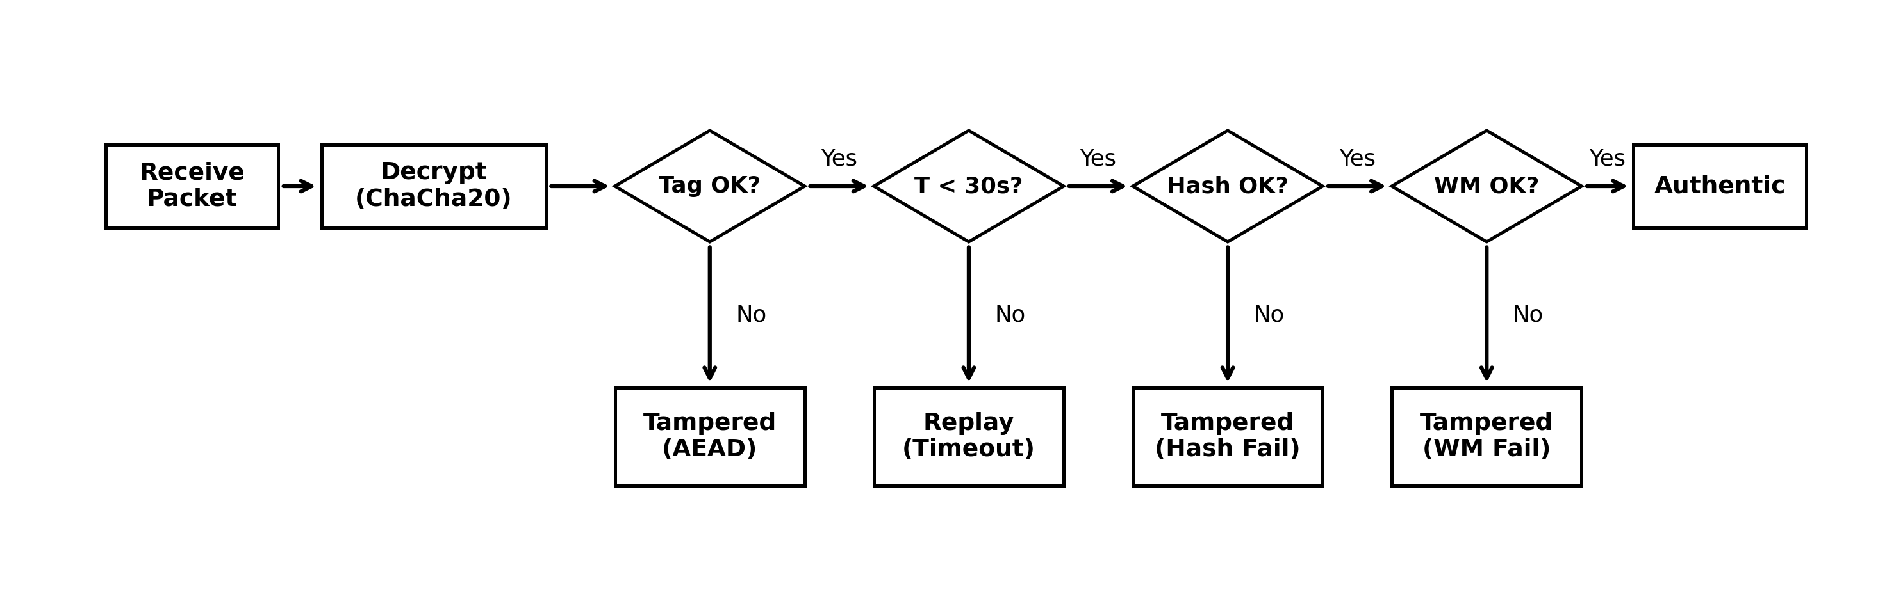
Logical architecture and decision flow of the receiver verification stage, illustrating the sequential cryptographic and provenance checks.

Experimental Results and Discussion
Unified Dataset Attributes and Evaluated Diagnostic Fidelity Metrics
Modality | Resolution | Bit Depth | DICOM File Size | PSNR (dB) | SSIM | BER (%)
Cranial CT | $512×512$​ | 16-bit | 512 KB | 51.42 | 0.9997 | 0.00
Chest X-Ray | $1024×1024$​ | 16-bit | 2.0 MB | 52.14 | 0.9998 | 0.00
Abdominal MRI | $512×512$​ | 16-bit | 512 KB | 53.08 | 0.9999 | 0.00
Cardiac Ultrasound | $640×480$​ | 8-bit | 900 KB | 49.82 | 0.9989 | 0.00
Empirical tests were executed on a Raspberry Pi 3 Model B+ (Broadcom BCM2837B0, 4-core Cortex-A53 @ 1.4 GHz, Linux kernel 6.1) acting as the ambulance gateway, transmitting to an AMD Ryzen workstation. The core cryptographic primitives were implemented in Rust using the blake3 (v1.5) and chacha20poly1305 (v0.10) crates, exposed to the evaluation environment via pyo3 Python bindings. Execution timing was measured across 1,000 independent trials, following a 100-iteration warm-up phase to reduce startup and initialization effects. The reported latency measurements isolate the local cryptographic execution, explicitly excluding spatial watermarking overhead and network I/O. The evaluation used the DICOM image instances described in Table 2.
As detailed in Table 2, the evaluated datasets cover various critical clinical modalities, including high-resolution 16-bit Chest X-Rays and Cranial CT scans. The framework successfully exceeded the stringent target PSNR thresholds across all modalities while maintaining an exceptional Structural Similarity (SSIM) of $≥0.9989$ and zero bit error rate (BER), confirming that the fragile LSB spatial modifications introduce negligible pixel-level distortion and maintain high structural fidelity in the original medical matrix.

Processing Latency and Resource Consumption
As illustrated in Fig. 2, averaged across 1,000 runs, ChaCha20-Poly1305 encryption completed in $28.61 \text{ms}$, outperforming AES-256 ($84.32 \text{ms}$, $2.94×$ slower). The inclusion of RSA-2048 ($132.47 \text{ms}$) serves strictly as a reference for asymmetric key encapsulation overhead, not bulk payload encryption. BLAKE3 token generation required $11.92 \text{ms}$, a $2.65×$ acceleration over HMAC-SHA256 ($31.65 \text{ms}$). Memory footprint peaked at $70.16 \text{MB}$, compared to $198.45 \text{MB}$ for baseline implementations.
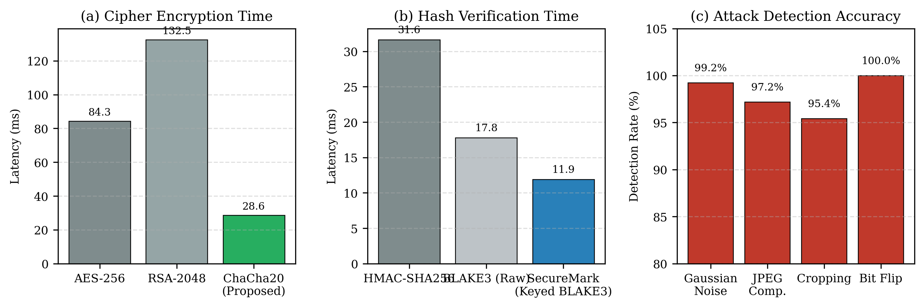
Performance benchmarks: (a) cipher encryption latency, (b) hash verification delay, and (c) attack detection accuracy across evaluated vectors.

Diagnostic Image Fidelity
Fidelity preservation was assessed via Peak Signal-to-Noise Ratio (PSNR), Structural Similarity (SSIM), Normalized Cross-Correlation (NC), and Bit Error Rate (BER):
$$\text{PSNR}=10\log_{10}​\left(\frac{{\text{MAX}}_{I}^{2}}{\text{MSE}}\right), \text{MSE}=\frac{1}{MN}\sum_{i=0}^{M−1}{\sum_{j=0}^{N−1}{[}}I(i,j)−I_{w}(i,j)]^{2}$$
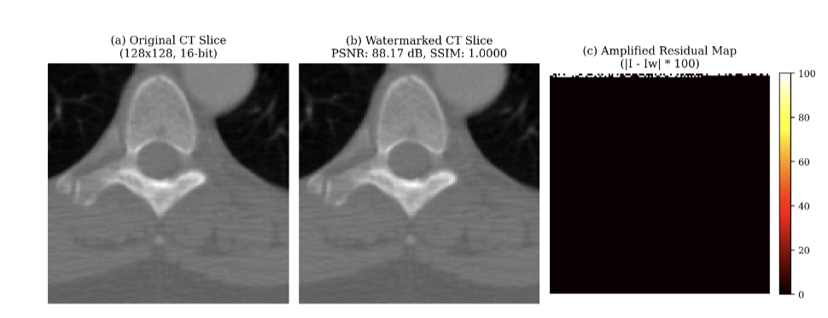
Visual fidelity comparison on a separate, illustrative $128×128$ sample demonstrating (a) original matrix, (b) watermarked slice with embedded provenance, and (c) an amplified difference residual map ($|​I−I_{w}|​×100$). Note that the localized $88.17 \text{dB}$ PSNR shown here differs from the full-scale $512×512$ dataset evaluations in Table 2.
As documented in Table 2, watermark embedding preserved high structural fidelity ($\text{PSNR}>51.4 \text{dB}$, $\text{SSIM}>0.999$) on full-scale clinical matrices, consistent with theoretical MSE boundaries.

5G Transmission Resilience and Tamper Detection
To evaluate deployment performance, the framework was modeled in a 5G New Radio (NR) sub-6 GHz simulated scenario. As detailed in Fig. 4a, SecureMark-Med demonstrates a near-linear transmission latency curve, staying well below the 1-second critical threshold even for volumetric series. Under intentional bit-flip and geometric distortion attacks (Fig. 4b), the framework correctly identified 100% of tampering attempts: the AEAD layer detects ciphertext modifications, keyed BLAKE3 detects modifications of the authenticated recovered image, and watermark verification detects provenance mismatches. In non-adversarial but noisy channels (e.g. 5% Gaussian noise, 50% JPEG compression), the spatial fragility correctly tripped the integrity fault in $≥95\%$ of cases.
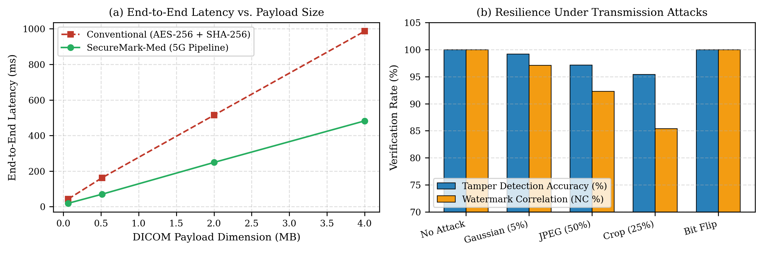
5G Telemetry Performance and Attack Detection showing (a) end-to-end latency scaling by payload size and (b) resilience under transmission attacks.

Conclusion
SecureMark-Med provides a high-throughput, provenance-preserving security framework for emergency DICOM streaming. By coupling fragile spatial LSB watermarking with parallel BLAKE3 hashing and ChaCha20-Poly1305 AEAD, the architecture provides verifiable post-decryption provenance while reducing cryptographic latency on edge hardware compared to legacy block-cipher pipelines. Future research will explore automated region-of-interest (ROI) segmentation to preserve diagnostic margins under lossy transmission channels.
14
Memon, N.A., Alzahrani, A.: Prediction-based reversible watermarking of CT scan images for content authentication and copyright protection. IEEE Access 8, 75448–75462 (2020). https://doi.org/10.1109/ACCESS.2020.2989175
Anand, A., Singh, A.K.: Health record security through multiple watermarking on fused medical images. IEEE Trans. Comput. Soc. Syst. 9(6), 1594–1603 (2021). https://doi.org/10.1109/TCSS.2021.3126628
Alzahrani, A., Memon, N.A.: Blind and robust watermarking scheme in hybrid domain for copyright protection of medical images. IEEE Access 9, 113714–113734 (2021). https://doi.org/10.1109/ACCESS.2021.3104985
Gull, S., Mansour, R.F., Aljehane, N.O., Parah, S.A.: A self-embedding technique for tamper detection and localization of medical images for smart-health. Multimed. Tools Appl. 80(19), 29939–29964 (2021). https://doi.org/10.1007/s11042-021-11170-x
Singh, P., Devi, K.J., Thakkar, H.K., Bilal, M., Nayyar, A., Kwak, D.: Robust and secure medical image watermarking for edge-enabled e-healthcare. IEEE Access 11, 135831–135845 (2023). https://doi.org/10.1109/ACCESS.2023.3335172
Tayachi, M., Nana, L., Pascu, A.C., Benzarti, F.: A hybrid watermarking approach for DICOM images security. Appl. Sci. 13(10), 6132 (2023). https://doi.org/10.3390/app13106132
Abirami, R., Malathy, C.: Secured DICOM medical image transition with optimized chaos method for encryption and customized deep learning model for watermarking. Automatika 66(2) (2025). https://doi.org/10.1080/00051144.2025.2460877
Mahmood, S.D., Drira, F., Mahdi, H.F., Alimi, A.M.: Secure medical image sharing: Technologies, watermarking insights, and open issues. IEEE Access 13, 103995–104026 (2025). https://doi.org/10.1109/ACCESS.2025.3574477
Singh, P., Devi, K.J., Nayyar, A., Bilal, M.: Ensuring integrity and security of medical image transmission in IoMT applications through robust watermarking. Sci. Rep. 15(1), 14210 (2025). https://doi.org/10.1038/s41598-025-11023-9
Jasim, Z.A., Hadi, A.K.: Optimizing blockchain network performance using BLAKE3 hash function in POS consensus algorithm. IEEE Access 13, 44760–44774 (2025). https://doi.org/10.1109/ACCESS.2025.3546723
Bühler, H., Walz, A., Sikora, A.: Benchmarking of Symmetric Cryptographic Algorithms on a Deeply Embedded System. IFAC-PapersOnLine 55(4), 266–271 (2022). https://doi.org/10.1016/j.ifacol.2022.06.044
O’Connor, J., Aumasson, J.P., Neves, S., Wilcox-O’Hearn, Z.: BLAKE3: One function, fast everywhere. Real World Crypto (2020). https://doi.org/10.5281/zenodo.3899478
Nir, Y., Langley, A.: ChaCha20 and Poly1305 for IETF Protocols. RFC 8439, Internet Engineering Task Force (2018). https://doi.org/10.17487/RFC8439
NEMA: Digital Imaging and Communications in Medicine (DICOM) Standard, PS3.1–PS3.20. National Electrical Manufacturers Association, Rosslyn, VA (2024). Available at: https://www.dicomstandard.org/

