Sage 300 Web Screens SDK

Creating Payment Codes Screen - Tutorial

December 2016

The MIT License (MIT)

Copyright © 2016 The Sage Group plc or its licensors. All rights reserved.

Permission is hereby granted, free of charge, to any person obtaining a copy of this software and associated documentation files (the “Software”), to deal in the Software without restriction, including without limitation the rights to use, copy, modify, merge, publish, distribute, sublicense, and/or sell copies of the Software, and to permit persons to whom the Software is furnished to do so, subject to the following conditions:

The above copyright notice and this permission notice shall be included in all copies or substantial portions of the Software.

THE SOFTWARE IS PROVIDED “AS IS”, WITHOUT WARRANTY OF ANY KIND, EXPRESS OR IMPLIED, INCLUDING BUT NOT LIMITED TO THE WARRANTIES OF MERCHANTABILITY, FITNESS FOR A PARTICULAR PURPOSE AND NONINFRINGEMENT. IN NO EVENT SHALL THE AUTHORS OR COPYRIGHT HOLDERS BE LIABLE FOR ANY CLAIM, DAMAGES OR OTHER LIABILITY, WHETHER IN AN ACTION OF CONTRACT, TORT OR OTHERWISE, ARISING FROM, OUT OF OR IN CONNECTION WITH THE SOFTWARE OR THE USE OR OTHER DEALINGS IN THE SOFTWARE.

Contents

1. Overview 4

2. A/R Payment Codes 5

2.1 Desktop Screen 5

2.2 Web Screen 5

3. Solution Wizard 6

3.1 Solution Information 7

3.2 Kendo UI Information 8

3.3 Generate Solution 9

4. Code Generation Wizard 10

4.1 Select Code Type 11

4.2 Enter View and Credentials 11

4.3 Enter Resource Name 12

4.4 Select Options 13

4.5 Generate Code 14

4.6 Wizard Completion 15

5. Complete the Screen 17

5.1 Payment Codes Business Entity Interface 17

5.2 Payment Codes Service Interface 18

5.3 Payment Codes Entity Service 19

5.4 Payment Codes Repository 21

5.5 Payment Codes Model 26

5.6 Payment Codes View Model 29

5.7 Payment Codes Internal Controller 31

5.8 Payment Codes Controller 37

5.9 Payment Codes Partial Razor View 43

5.10 Payment Codes Repository JavaScript 46

5.11 Payment Codes Knockout Binding JavaScript 47

5.12 Payment Codes Behavior JavaScript 48

6. Review the Screen 58

1. Overview

This document is intended to serve as a tutorial for creating the AR Payment Codes web screen with the Sage 300 Web SDK Wizard.

The wizard creates the solution, the required framework files and generates as much code as possible. However, the generated code specific to the AR Payment Codes screen is only for the key field to the screen plus framework components, such as: Create New Button, Save Button, Delete Button, Options Menu, Finder, etc. Thus, there is additional manual work required to complete the screen to include the remaining required controls.

Therefore, this tutorial will:

* Use the Solution Wizard to create the Visual Studio solution for the Valued Partner Company utilizing the TU module
* Use the Code Generation Wizard to create the code files and screen for the AR Payment Codes Business View (AR0012)
* Use Visual Studio to complete the code required to have a fully functioning AR Payment Codes screen

This document’s content is derived from the following documents and these documents should be referred to for further and complete documentation:

* docs\wizards\Sage300SDK_SolutionWizard.docx
* docs\wizards\Sage300SDK_CodeGenerationWizard.docx
* docs\development\Sage300SDK_CreatingSetupWebScreen.docx

1. A/R Payment Codes
   1. Desktop Screen

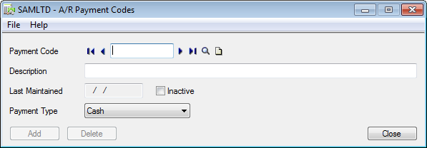

* 1. Web Screen

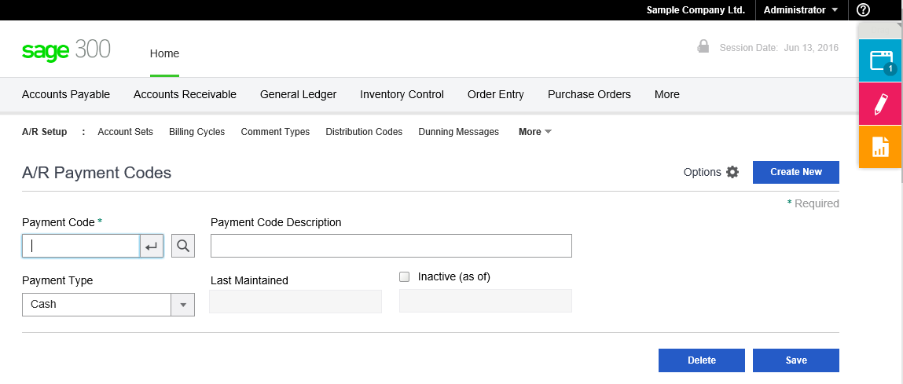

1. Solution Wizard

* Launch Visual Studio
  + Note: It is recommended to run Visual Studio with administrator permissions
* Select **New/Project** to display the following dialog:

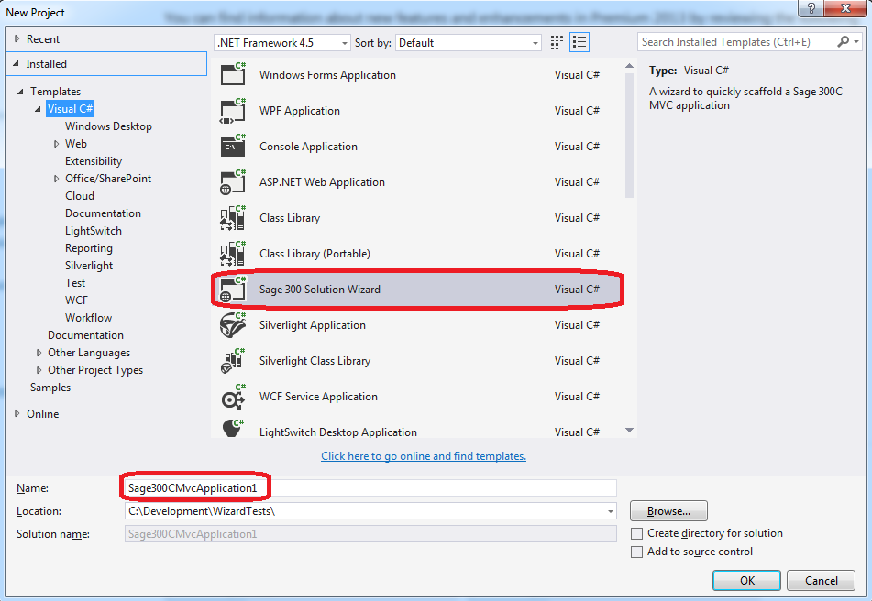

* Enter **ValuedPartner** for the solution name and change the location if needed.
* Press **OK** to create the solution and display the Sage 300 Solution Wizard
  1. Solution Information

After supplying the information required to create a new project (solution), the following dialog box appears:

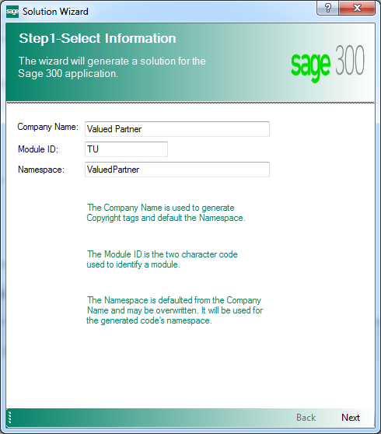

* Enter Valued Partner for the Company Name field

Used for copyright information and to provide a default value for the Namespace field.

* Enter TU for the Module ID field

Used as a Module designator that will be used to segregate the projects, and will also become part of the namespace.

* ValuedPartner is defaulted for the Namespace field

Used as the base Namespace value. The namespace will become a composite of this field and the Module ID. This field is defaulted from the Company Name field but may be overridden.

Click Next to proceed.

* 1. Kendo UI Information

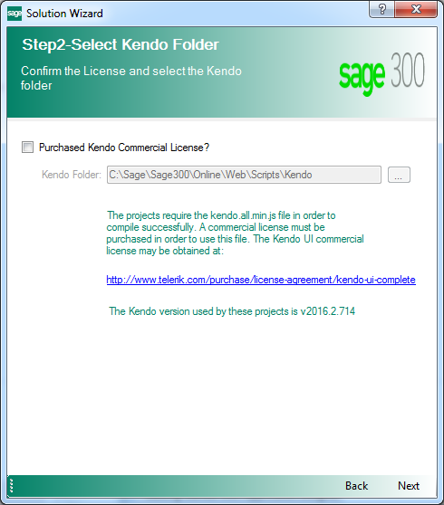

Select the Purchased Kendo Commercial License checkbox.

* Purchased Kendo Commercial License

This checkbox must be selected or the Solution Wizard will not proceed. This is the acknowledgment that the user/consumer has purchased a Kendo License since Sage does not distribute the Kendo files for development purposes.

* Kendo Folder

Defaults to the location of the Sage 300 Web installation in order to consume that version of the Kendo file. An alternate folder may be entered, but the Kendo folder must have the version specified as being compatible with Sage 300c Web Screens

Click Next to proceed.

* 1. Generate Solution

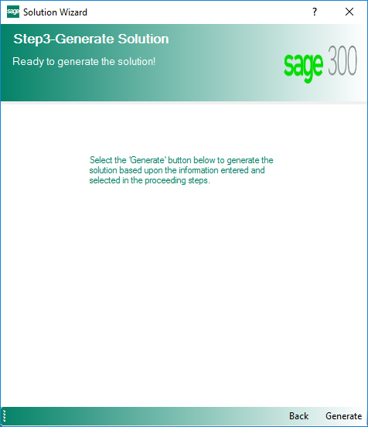

Click Generate to generate the solution.

1. Code Generation Wizard

Within Visual Studio, right-click on the **ValuedPartner** solution from the Solution Explorer to display the following context menu:

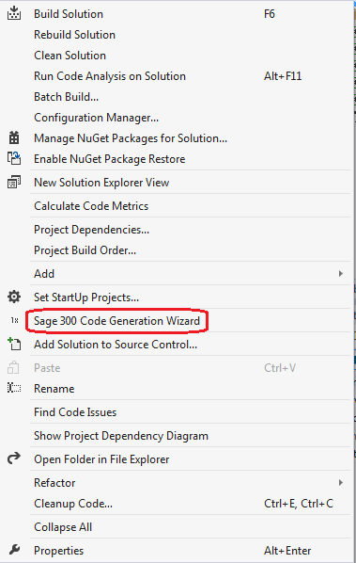

Select the **Sage 300 Code Generation Wizard** option.

* 1. Select Code Type

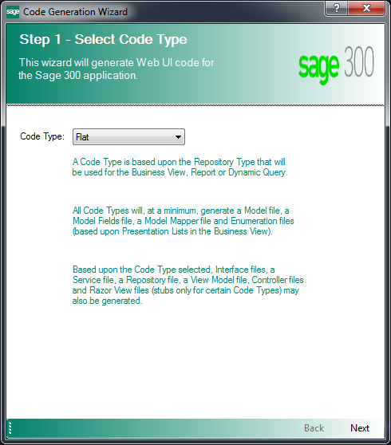

Select Flat code type because this is a simple setup screen (stateless).

Click **Next** to proceed.

* 1. Enter View and Credentials

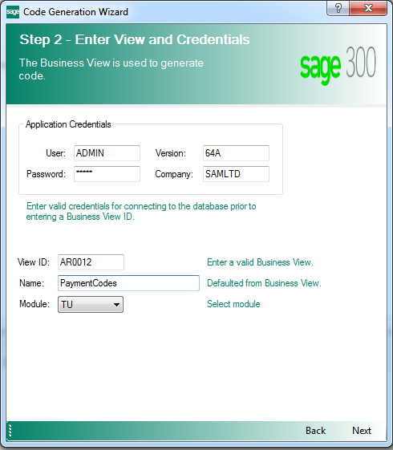

* Enter **AR0012** for the View ID field.
* After entering the Business View, the Name will default to **PaymentCode** for the Entity being created, which is generated from the Business View’s description. Change this value to **PaymentCodes**.

Click **Next** to proceed.

* 1. Enter Resource Name

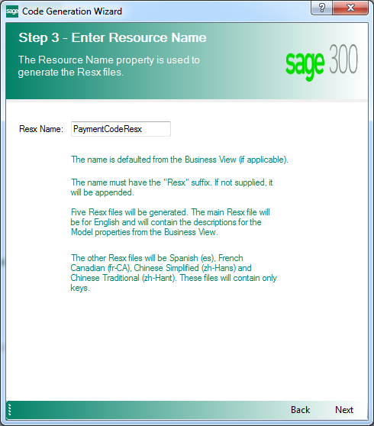

The Resource Name is defaulted from the Business View’s description and can be overridden if needed.

Click **Next** to proceed.

* 1. Select Options

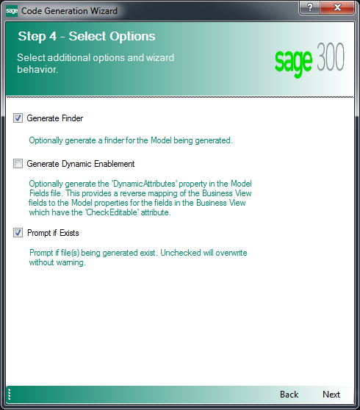

* Select the Generate Finder check box to generate the Finder’s internal controller for the view selected.
* Do not select the Generate Dynamic Enablement check box is optional and will generate the DynamicAttributes property in the Model Fields class. This provides a reverse mapping of the Server Fields (Business View) to the Model Properties (Business Entity) for those fields in the Business View that have the CheckEditable attribute.
* Select the Prompt If Exists check box to allow you to skip files that are generated in case they already exist. An example of this would be if you ran the wizard twice on the same Business View.

Click **Next** to proceed.

* 1. Generate Code

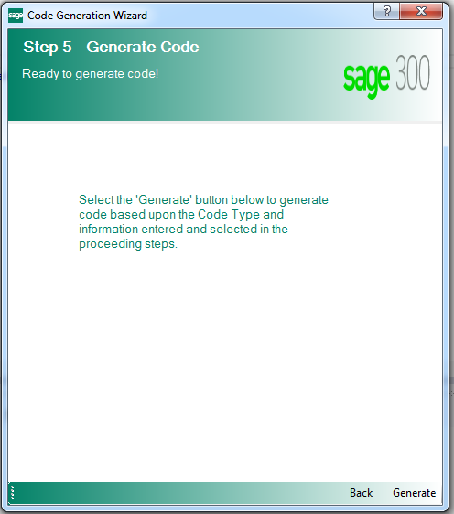

Click **Next** to proceed.

* 1. Wizard Completion

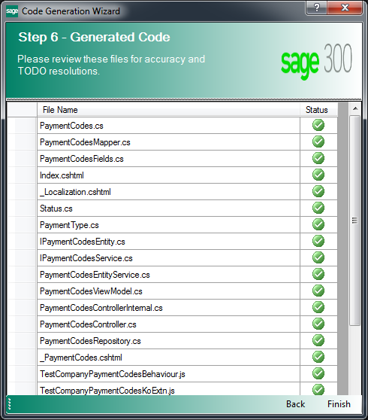

When the wizard has completed generating the code files based upon the wizard’s inputs, the list of files is displayed. These files, based upon the Prompt If Exists option, have been added to the appropriate projects within the solution.

Select the **Build\Build Solution** option to compile the solution in order to run the screen.

1. Complete the Screen

The generation activities up to this point have dealt with creating the components required for the A/R Payment Codes screen and implementing base behaviors and minimal functionality.

The screen is able to be compiled and is functional.

This section will deal with specific changes to complete the A/R Payment Codes screen.

* 1. Payment Codes Business Entity Interface

Access the **IPaymentCodesEntity.cs** class and add the **UpdateInactiveStatus** and **IsModuleActive** routines to the class (the code to be added is highlighted in yellow).

­­­­// Copyright © 2016 Valued Partner

#region Namespace

using ValuedPartner.TU.Models;

using Sage.CA.SBS.ERP.Sage300.Common.Interfaces.Repository;

#endregion

namespace ValuedPartner.TU.Interfaces.BusinessRepository

{

/// <summary>

/// Interface IPaymentCodesEntity

/// </summary>

/// <typeparam name="T">Where T is type of <see cref="PaymentCodes"/></typeparam>

public interface IPaymentCodesEntity<T> : IBusinessRepository<T>, ISecurity

where T : PaymentCodes, new()

{

/// <summary>

/// Update status

/// </summary>

/// <param name="model">Model for PaymentCodes</param>

/// <returns>Model for PaymentCodes</returns>

T UpdateInactiveStatus(T model);

/// <summary>

/// Check whether module is active or not.

/// </summary>

/// <param name="moduleId">module Id</param>

/// <returns>True if module is active else false</returns>

bool IsModuleActive(string moduleId);

}

}

* 1. Payment Codes Service Interface

Access the **IPaymentCodesService.cs** class and add the **UpdateInactiveStatus** and **IsModuleActive** routines to the class (the code to be added is highlighted in yellow).

// Copyright © 2016 Valued Partner

#region Namespace

using ValuedPartner.TU.Models;

using Sage.CA.SBS.ERP.Sage300.Common.Interfaces.Service;

#endregion

namespace ValuedPartner.TU.Interfaces.Services

{

/// <summary>

/// Interface IPaymentCodesService

/// </summary>

/// <typeparam name="T">Where T is type of <see cref="PaymentCodes"/></typeparam>

public interface IPaymentCodesService<T> : IEntityService<T>, ISecurityService

where T : PaymentCodes, new()

{

/// <summary>

/// Update status

/// </summary>

/// <param name="model">Model for PaymentCodes</param>

/// <returns>Model for PaymentCodes</returns>

T UpdateInactiveStatus(T model);

/// <summary>

/// Check whether module is active or not.

/// </summary>

/// <param name="moduleId">module Id</param>

/// <returns>True if module is active else false</returns>

bool IsModuleActive(string moduleId);

}

}

* 1. Payment Codes Entity Service

Access the **PaymentCodesEntityService.cs** class and add the UpdateInactiveStatus and IsModuleActive routines to the class (the code to be added is highlighted in yellow).

// Copyright © 2016 Valued Partner

#region Namespace

using System;

using Sage.CA.SBS.ERP.Sage300.Common.Models;

using Sage.CA.SBS.ERP.Sage300.Common.Services.Base;

using ValuedPartner.TU.Interfaces.BusinessRepository;

using ValuedPartner.TU.Interfaces.Services;

using ValuedPartner.TU.Models;

#endregion

namespace ValuedPartner.TU.Services

{

/// <summary>

/// Class for PaymentCodesEntityService

/// </summary>

/// <typeparam name="T">Where T is type of <see cref="PaymentCodes"/></typeparam>

public class PaymentCodesEntityService<T> : FlatService<T, IPaymentCodesEntity<T>>, IPaymentCodesService<T>

where T : PaymentCodes, new()

{

#region Constructor

/// <summary>

/// Constructor for PaymentCodes

/// </summary>

/// <param name="context">Request Context</param>

public PaymentCodesEntityService(Context context)

: base(context)

{

}

#endregion

/// <summary>

/// Update status

/// </summary>

/// <param name="model">Model for PaymentCodes</param>

/// <returns>Model for PaymentCodes</returns>

public virtual T UpdateInactiveStatus(T model)

{

if (model == null)

{

throw new ArgumentNullException("model");

}

using (var repository = Resolve<IPaymentCodesEntity<T>>())

{

return repository.UpdateInactiveStatus(model);

}

}

/// <summary>

/// Check whether module is active or not.

/// </summary>

/// <param name="moduleId">module Id</param>

/// <returns>True if module is active else false</returns>

public bool IsModuleActive(string moduleId)

{

using (var repository = Resolve<IPaymentCodesEntity<T>>())

{

return repository.IsModuleActive(moduleId);

}

}

}

}

* 1. Payment Codes Repository

It is important to mention at this point a concept called Benign Programming or Agnostic Programming. The more generic the class, the less amount of refactoring is to be required if a particular class is copied and pasted into another class.

What does this mean? If the screen has a single business entity, the wizard will name it _**businessEntity** instead of something specific to the entity. Parameters will be generic unless multiple entities prevents this (such as **id** vs. **paymentCode**) (the code to be added is highlighted in yellow).

Access the **PaymentCodesRepository.cs** class and add the **UpdateInactiveStatus** and **IsModuleActive** routines to the class.

// Copyright © 2016 Valued Partner

#region Namespace

using System;

using System.Linq.Expressions;

using Sage.CA.SBS.ERP.Sage300.Common.BusinessRepository;

using Sage.CA.SBS.ERP.Sage300.Common.BusinessRepository.Base;

using Sage.CA.SBS.ERP.Sage300.Common.Interfaces.Entity;

using Sage.CA.SBS.ERP.Sage300.Common.Models;

using Sage.CA.SBS.ERP.Sage300.Common.Utilities;

using Sage.CA.SBS.ERP.Sage300.Common.Models.Enums;

using ValuedPartner.TU.BusinessRepository.Mappers;

using ValuedPartner.TU.Interfaces.BusinessRepository;

using ValuedPartner.TU.Models;

#endregion

namespace ValuedPartner.TU.BusinessRepository

{

/// <summary>

/// Class PaymentCodes Repository

/// </summary>

/// <typeparam name="T">Where T is type of <see cref="PaymentCodes"/></typeparam>

public class PaymentCodesRepository<T> : FlatRepository<T>, IPaymentCodesEntity<T>

where T : PaymentCodes, new()

{

#region Variables

/// <summary>

/// Mapper

/// </summary>

private ModelMapper<T> _mapper;

/// <summary>

/// Business Entity

/// </summary>

private IBusinessEntity _businessEntity;

#endregion

#region Constructor

/// <summary>

/// Constructor for PaymentCodes

/// </summary>

/// <param name="context">Context</param>

public PaymentCodesRepository(Context context)

: base(context, new PaymentCodesMapper<T>(context), ActiveFilter)

{

SetFilter(context);

}

/// <summary>

/// Constructor for PaymentCodes

/// </summary>

/// <param name="context">Context</param>

/// <param name="session">Business Entity Session</param>

public PaymentCodesRepository(Context context, IBusinessEntitySession session)

: base(context, new PaymentCodesMapper<T>(context), ActiveFilter, session)

{

SetFilter(context);

}

#endregion

#region Protected/public methods

/// <summary>

/// Additional Access Check for Export and Import

/// </summary>

/// <returns>User Access</returns>

public override UserAccess GetAccessRights()

{

var userAccess = base.GetAccessRights();

if (SecurityCheck(Security.VPImport))

{

userAccess.SecurityType |= SecurityType.Import;

}

if (SecurityCheck(Security.VPExport))

{

userAccess.SecurityType |= SecurityType.Export;

}

return userAccess;

}

/// <summary>

/// Create entities for repository

/// </summary>

/// <returns>Business Entity</returns>

protected override IBusinessEntity CreateBusinessEntities()

{

CreateBusinessEntitiesInternal();

return _businessEntity;

}

/// <summary>

/// Get Update Expression

/// </summary>

/// <param name="model">Model for PaymentCodes</param>

/// <returns>Expression</returns>

protected override Expression<Func<T, bool>> GetUpdateExpression(T model)

{

return entity => entity.PaymentCode.StartsWith(model.PaymentCode);

}

/// <summary>

/// Update status

/// </summary>

/// <param name="model">Model for PaymentCodes</param>

/// <returns>Model for PaymentCodes</returns>

public virtual T UpdateInactiveStatus(T model)

{

CheckRights(GetAccessRights(), SecurityType.Modify);

var filter = GetUpdateExpression(model);

if (Search(_businessEntity, filter))

{

_mapper.Map(model, _businessEntity);

_businessEntity.SetValue(PaymentCodes.Index.Status, model.Status, true);

}

return _mapper.Map(_businessEntity);

}

/// <summary>

/// Check whether module is active or not.

/// </summary>

/// <param name="moduleId">module Id</param>

/// <returns>True if module is active else false</returns>

public bool IsModuleActive(string moduleId)

{

return IsApplicationActive(moduleId);

}

#endregion

#region Private methods

/// <summary>

/// ActiveFilter Condition

/// </summary>

/// <value>The active filter</value>

private static Expression<Func<T, bool>> ActiveFilter

{

get { return null; }

}

/// <summary>

/// Creates the business entities

/// </summary>

private void CreateBusinessEntitiesInternal()

{

_businessEntity = OpenEntity(PaymentCodes.EntityName);

}

/// <summary>

/// Set Filter

/// </summary>

/// <param name="context">Context</param>

private void SetFilter(Context context)

{

ValidRecordFilter = null;

ValidRecordFilter = model => !string.IsNullOrEmpty(model.PaymentCode);

_mapper = new PaymentCodesMapper<T>(context);

}

#endregion

}

}

* 1. Payment Codes Model

Access the **PaymentCodes.cs** class

* Evaluate the attributes that have been added to the generated properties.
* Evaluate the property names that have been generated by the wizard.
* These generated names are not set in stone.
* These names have been generated from the description of the field/property in the business view. If it does not make sense, is not properly cased or whatever, it is the developer’s responsibility to change it.
* Additional attributes may be added later in the development process.

Add the **RegularExpression** annotation to the **PaymentCode** property (the code to be added is highlighted in yellow).

// Copyright © 2016 Valued Partner

#region Namespace

using System;

using System.ComponentModel.DataAnnotations;

using Sage.CA.SBS.ERP.Sage300.Common.Models;

using Sage.CA.SBS.ERP.Sage300.Common.Models.Attributes;

using Sage.CA.SBS.ERP.Sage300.Common.Resources;

using ValuedPartner.TU.Models.Enums;

using ValuedPartner.TU.Resources.Forms;

#endregion

namespace ValuedPartner.TU.Models

{

/// <summary>

/// Partial class for PaymentCodes

/// </summary>

public partial class PaymentCodes : ModelBase

{

/// <summary>

/// Gets or sets PaymentCode

/// </summary>

[Key]

[Required(ErrorMessageResourceName = "Required", ErrorMessageResourceType = typeof(AnnotationsResx))]

[StringLength(12, ErrorMessageResourceName = "MaxLength",ErrorMessageResourceType = typeof(AnnotationsResx))]

[Display(Name = "PaymentCode", ResourceType = typeof (PaymentCodesResx))]

[RegularExpression(@"^[a-zA-Z0-9]+$", ErrorMessageResourceName = "AlphaNumeric",

ErrorMessageResourceType = typeof(AnnotationsResx))]

public string PaymentCode { get; set; }

/// <summary>

/// Gets or sets Description

/// </summary>

[StringLength(60, ErrorMessageResourceName = "MaxLength",ErrorMessageResourceType = typeof(AnnotationsResx))]

[Display(Name = "Description", ResourceType = typeof (PaymentCodesResx))]

public string Description { get; set; }

/// <summary>

/// Gets or sets Status

/// </summary>

[Display(Name = "Status", ResourceType = typeof (PaymentCodesResx))]

public Status Status { get; set; }

/// <summary>

/// Gets or sets InactiveDate

/// </summary>

[ValidateDateFormat(ErrorMessageResourceName="DateFormat", ErrorMessageResourceType = typeof(AnnotationsResx))]

[Display(Name = "InactiveDate", ResourceType = typeof (PaymentCodesResx))]

public DateTime InactiveDate { get; set; }

/// <summary>

/// Gets or sets DateLastMaintained

/// </summary>

[ValidateDateFormat(ErrorMessageResourceName="DateFormat", ErrorMessageResourceType = typeof(AnnotationsResx))]

[Display(Name = "DateLastMaintained", ResourceType = typeof (PaymentCodesResx))]

public DateTime DateLastMaintained { get; set; }

/// <summary>

/// Gets or sets PaymentType

/// </summary>

[Display(Name = "PaymentType", ResourceType = typeof (PaymentCodesResx))]

public PaymentType PaymentType { get; set; }

#region UI Strings

/// <summary>

/// Gets Status string value

/// </summary>

public string StatusString

{

get { return EnumUtility.GetStringValue(Status); }

}

/// <summary>

/// Gets PaymentType string value

/// </summary>

public string PaymentTypeString

{

get { return EnumUtility.GetStringValue(PaymentType); }

}

#endregion

}

}

* 1. Payment Codes View Model

Access the **PaymentCodesViewModel.cs** class and add the **FormattedInactiveDate** property and modify the **PaymentTypes** property as this will now be set by the controller, since it will have a filter applied (the code to be added is highlighted in yellow).

// Copyright © 2016 Valued Partner

#region Namespace

using System;

using System.Collections;

using Sage.CA.SBS.ERP.Sage300.Common.Web;

using Sage.CA.SBS.ERP.Sage300.Common.Models;

using Sage.CA.SBS.ERP.Sage300.Common.Utilities;

using ValuedPartner.TU.Models;

using ValuedPartner.TU.Models.Enums;

#endregion

namespace ValuedPartner.Web.Areas.TU.Models

{

/// <summary>

/// Class for PaymentCodesViewModel

/// </summary>

/// <typeparam name="T">Where T is type of <see cref="PaymentCodes"/></typeparam>

public class PaymentCodesViewModel<T> : ViewModelBase<T>

where T : PaymentCodes, new()

{

/// <summary>

/// Status list

/// </summary>

public IEnumerable Status

{

get { return EnumUtility.GetItems<Status>(); }

}

/// <summary>

/// PaymentType list

/// </summary>

public IEnumerable PaymentTypes { get; set; }

/// <summary>

/// Gets FormattedInactiveDate

/// </summary>

public string FormattedInactiveDate

{

get

{

return DateUtil.GetShortDate((Data != null &&

Data.Status == ValuedPartner.TU.Models.Enums.Status.Inactive ?

Data.InactiveDate :

DateUtil.GetNowDate()), string.Empty);

}

}

}

}

* 1. Payment Codes Internal Controller

Internal methods are only used by the public controller and the complexities are placed here as opposed to the public controller.

Access the **PaymentCodesControllerInternal.cs** class and add the private constants **PaymentAndProcessingModuleId** and **PaymentProcessing** (the code to be added is highlighted in yellow).

Add the **UpdateInactiveStatus** routine to the class (the code to be added is highlighted in yellow).

Modify the **GetViewInfo** routine and add the **FilteredPaymentTypes** routine to the class (the code to be added is highlighted in yellow).

// Copyright © 2016 Valued Partner

#region Namespace

using System;

using System.Linq;

using System.Linq.Expressions;

using System.Collections.Generic;

using Sage.CA.SBS.ERP.Sage300.Common.Models;

using Sage.CA.SBS.ERP.Sage300.Common.Resources;

using Sage.CA.SBS.ERP.Sage300.Common.Web;

using Sage.CA.SBS.ERP.Sage300.Common.Web.Controllers.ExportImport;

using ValuedPartner.TU.Interfaces.Services;

using ValuedPartner.TU.Models;

using ValuedPartner.TU.Models.Enums;

using ValuedPartner.TU.Resources.Forms;

using ValuedPartner.Web.Areas.TU.Models;

#endregion

namespace ValuedPartner.Web.Areas.TU.Controllers

{

/// <summary>

/// PaymentCodes Internal Controller

/// </summary>

/// <typeparam name="T">Where T is type of <see cref="PaymentCodes"/></typeparam>

public class PaymentCodesControllerInternal<T> : BaseExportImportControllerInternal<T, IPaymentCodesService<T>>

where T : PaymentCodes, new()

{

#region Private variables

private const string PaymentAndProcessingModuleId = "YP";

private const int PaymentProcessing = 5;

#endregion

#region Constructor

/// <summary>

/// New instance of <see cref="PaymentCodesControllerInternal{T}"/>

/// </summary>

/// <param name="context">Context</param>

public PaymentCodesControllerInternal(Context context)

: base(context)

{

}

#endregion

#region Internal methods

/// <summary>

/// Create a PaymentCodes

/// </summary>

/// <returns>JSON object for PaymentCodes</returns>

internal PaymentCodesViewModel<T> Create()

{

var viewModel = GetViewModel(new T(), null);

viewModel.UserAccess = GetAccessRights();

return viewModel;

}

/// <summary>

/// Get a PaymentCodes

/// </summary>

/// <param name="id">Id for PaymentCodes</param>

/// <returns>JSON object for PaymentCodes</returns>

internal PaymentCodesViewModel<T> GetById(string id)

{

var data = Service.GetById(id);

var userMessage = new UserMessage(data);

return GetViewModel(data, userMessage);

}

/// <summary>

/// Add a PaymentCodes

/// </summary>

/// <param name="model">Model for PaymentCodes</param>

/// <returns>JSON object for PaymentCodes</returns>

internal PaymentCodesViewModel<T> Add(T model)

{

var data = Service.Add(model);

var userMessage = new UserMessage(data,

string.Format(CommonResx.AddSuccessMessage, PaymentCodesResx.PaymentCode, data.PaymentCode));

return GetViewModel(data, userMessage);

}

/// <summary>

/// Update a PaymentCodes

/// </summary>

/// <param name="model">Model for PaymentCodes</param>

/// <returns>JSON object for PaymentCodes</returns>

internal PaymentCodesViewModel<T> Save(T model)

{

var data = Service.Save(model);

var userMessage = new UserMessage(data, CommonResx.SaveSuccessMessage);

return GetViewModel(data, userMessage);

}

/// <summary>

/// Delete a PaymentCodes

/// </summary>

/// <param name="id">Id for PaymentCodes</param>

/// <returns>JSON object for PaymentCodes</returns>

internal PaymentCodesViewModel<T> Delete(string id)

{

Expression<Func<T, bool>> filter = param => param.PaymentCode == id;

var data = Service.Delete(filter);

var userMessage = new UserMessage(data,

string.Format(CommonResx.DeleteSuccessMessage, PaymentCodesResx.PaymentCode, data.PaymentCode));

return GetViewModel(data, userMessage);

}

/// <summary>

/// Update status

/// </summary>

/// <param name="model">Model for PaymentCodes</param>

/// <returns>Model for PaymentCodes</returns>

internal PaymentCodesViewModel<T> UpdateInactiveStatus(T model)

{

var data = Service.UpdateInactiveStatus(model);

var userMessage = new UserMessage(data, CommonResx.SaveSuccessMessage);

return GetViewModel(data, userMessage);

}

#endregion

#region Private methods

/// <summary>

/// Generic routine to return a view model for PaymentCodes

/// </summary>

/// <param name="model">Model for PaymentCodes</param>

/// <param name="userMessage">User Message for PaymentCodes</param>

/// <returns>View Model for PaymentCodes</returns>

private PaymentCodesViewModel<T> GetViewModel(T model, UserMessage userMessage)

{

return new PaymentCodesViewModel<T>

{

Data = model,

UserMessage = userMessage,

PaymentTypes = FilteredPaymentTypes()

};

}

/// <summary>

/// Filter Payment Types

/// </summary>

/// <returns>Filtered List</returns>

private IEnumerable<SelectList> FilteredPaymentTypes()

{

// Locals

var isModuleActive = Service.IsModuleActive(PaymentAndProcessingModuleId);

var paymentTypes = EnumUtility.GetItems<PaymentType>();

// Filter list if module is not active

if (paymentTypes != null && !isModuleActive)

{

paymentTypes = from selectList in paymentTypes where

Convert.ToInt16(selectList.Value) != PaymentProcessing

select selectList;

}

return paymentTypes;

}

#endregion

}

}

* 1. Payment Codes Controller

Public methods are invoked by the MVC framework and from JavaScript. The complexities of the public methods are hidden in the internal controller’s methods.

Access the **PaymentCodesController.cs** class and add the **UpdateInactiveStatus** routine to the class (the code to be added is highlighted in yellow).

// Copyright © 2016 Valued Partner

#region Namespace

using Microsoft.Practices.Unity;

using System.Web.Mvc;

using Sage.CA.SBS.ERP.Sage300.Common.Exceptions;

using Sage.CA.SBS.ERP.Sage300.Common.Models;

using Sage.CA.SBS.ERP.Sage300.Common.Models.Enums;

using Sage.CA.SBS.ERP.Sage300.Common.Resources;

using Sage.CA.SBS.ERP.Sage300.Common.Web;

using ValuedPartner.TU.Models;

using ValuedPartner.TU.Models.Enums;

using ValuedPartner.TU.Resources.Forms;

using ValuedPartner.Web.Areas.TU.Models;

#endregion

namespace ValuedPartner.Web.Areas.TU.Controllers

{

/// <summary>

/// PaymentCodes Public Controller

/// </summary>

/// <typeparam name="T">Where T is type of <see cref="PaymentCodes"/></typeparam>

public class PaymentCodesController<T> : MultitenantControllerBase<PaymentCodesViewModel<T>>

where T : PaymentCodes, new()

{

#region Public variables

/// <summary>

/// Gets or sets the internal controller

/// </summary>

public PaymentCodesControllerInternal<T> ControllerInternal { get; set; }

#endregion

#region Constructor

/// <summary>

/// Constructor for PaymentCodes

/// </summary>

/// <param name="container">Unity Container</param>

public PaymentCodesController(IUnityContainer container)

: base(container,"VPPaymentCodes")

{

}

#endregion

#region Initialize MultitenantControllerBase

/// <summary>

/// Override Initialize method

/// </summary>

/// <param name="requestContext">Request Context</param>

protected override void Initialize(System.Web.Routing.RequestContext requestContext)

{

base.Initialize(requestContext);

ControllerInternal = new PaymentCodesControllerInternal<T>(Context);

}

#endregion

#region Public methods

/// <summary>

/// Load screen

/// </summary>

/// <param name="id">Id for PaymentCodes</param>

/// <returns>JSON object for PaymentCodes</returns>

public virtual ActionResult Index(string id)

{

PaymentCodesViewModel<T> viewModel;

try

{

viewModel = !string.IsNullOrEmpty(id) ? ControllerInternal.GetById(id) : ControllerInternal.Create();

}

catch (BusinessException businessException)

{

return

JsonNet(BuildErrorModelBase(CommonResx.GetFailedMessage, businessException,

PaymentCodesResx.PaymentCode));

}

return View(viewModel);

}

/// <summary>

/// Get PaymentCodes

/// </summary>

/// <param name="id">Id for PaymentCodes</param>

/// <returns>JSON object for PaymentCodes</returns>

[HttpPost]

public virtual JsonNetResult Get(string id)

{

try

{

if (!string.IsNullOrEmpty(id))

{

return JsonNet(ControllerInternal.GetById(id));

}

}

catch (BusinessException businessException)

{

return

JsonNet(BuildErrorModelBase(CommonResx.GetFailedMessage, businessException,

PaymentCodesResx.PaymentCode));

}

return JsonNet(new PaymentCodesViewModel<T>());

}

/// <summary>

/// Add PaymentCodes

/// </summary>

/// <param name="model">Model for PaymentCodes</param>

/// <returns>JSON object for PaymentCodes</returns>

[HttpPost]

public virtual JsonNetResult Add(T model)

{

try

{

ViewModelBase<ModelBase> viewModel;

return ValidateModelState(ModelState, out viewModel)

? JsonNet(ControllerInternal.Add(model))

: JsonNet(viewModel);

}

catch (BusinessException businessException)

{

return

JsonNet(BuildErrorModelBase(CommonResx.AddFailedMessage, businessException,

PaymentCodesResx.PaymentCode));

}

}

/// <summary>

/// Create PaymentCodes

/// </summary>

/// <returns>JSON object for PaymentCodes</returns>

[HttpPost]

public virtual JsonNetResult Create()

{

return JsonNet(ControllerInternal.Create());

}

/// <summary>

/// Update PaymentCodes

/// </summary>

/// <param name="model">Model for PaymentCodes</param>

/// <returns>JSON object for PaymentCodes</returns>

[HttpPost]

public virtual JsonNetResult Save(T model)

{

try

{

ViewModelBase<ModelBase> viewModel;

return ValidateModelState(ModelState, out viewModel)

? JsonNet(ControllerInternal.Save(model))

: JsonNet(viewModel);

}

catch (BusinessException businessException)

{

return JsonNet(BuildErrorModelBase(CommonResx.SaveFailedMessage, businessException));

}

}

/// <summary>

/// Delete PaymentCodes

/// </summary>

/// <param name="id">Id for PaymentCodes</param>

/// <returns>JSON object for PaymentCodes</returns>

[HttpPost]

public virtual JsonNetResult Delete(string id)

{

try

{

return JsonNet(ControllerInternal.Delete(id));

}

catch (BusinessException businessException)

{

return

JsonNet(BuildErrorModelBase(CommonResx.DeleteFailedMessage, businessException,

PaymentCodesResx.PaymentCode));

}

}

/// <summary>

/// Update status

/// </summary>

/// <param name="model">Model for PaymentCodes</param>

/// <returns>Model for PaymentCodes</returns>

[HttpPost]

public virtual JsonNetResult UpdateInactiveStatus(T model)

{

try

{

ViewModelBase<ModelBase> viewModel;

return ValidateModelState(ModelState, out viewModel)

? JsonNet(ControllerInternal.UpdateInactiveStatus(model))

: JsonNet(viewModel);

}

catch (BusinessException businessException)

{

return JsonNet(BuildErrorModelBase(CommonResx.SaveFailedMessage, businessException));

}

}

#endregion

}

}

* 1. Payment Codes Partial Razor View

Access the _**PaymentCodes.cshtml** file and add the remaining controls to the screen (the code to be added is highlighted in green).

@* Copyright © 2016 Valued Partner *@

@model ValuedPartner.Web.Areas.TU.Models.PaymentCodesViewModel<ValuedPartner.TU.Models.PaymentCodes>

@using PaymentCodesResx = ValuedPartner.TU.Resources.Forms.PaymentCodesResx

@using Sage.CA.SBS.ERP.Sage300.Common.Web.AreaConstants

@using Sage.CA.SBS.ERP.Sage300.Common.Resources

@using Sage.CA.SBS.ERP.Sage300.Common.Web.HtmlHelperExtension

@using Sage.CA.SBS.ERP.Sage300.Common.Models.Enums

@using AnnotationsResx = Sage.CA.SBS.ERP.Sage300.Common.Resources.AnnotationsResx

<script type="text/javascript">

@Html.ConvertToJsVariableUsingNewtonSoft("PaymentCodesViewModel", Model)

</script>

@Html.Partial("~/Areas/VP/Views/PaymentCodes/Partials/_Localization.cshtml")

<div id="success" class="message"></div>

<div class="form-screen">

<div id="message"></div>

<header>

<section class="header-group-1">

<div class="header-wrapper">

<div class="header-headline">

@Html.SageHeader1Label("PaymentCodesHeader", PaymentCodesResx.Entity)

</div>

@Html.Partial(Core.OptionsMenu, Model.UserAccess, new ViewDataDictionary { { OptionsMenu.UseLessCss, true } })

<div class="header-options">

@if (Model.UserAccess.SecurityType.HasFlag(SecurityType.Modify))

{

@Html.KoSageButton("btnNew", null, new { @value = CommonResx.CreateNew, @id = "btnNew", @class = "btn btn-primary" })

}

</div>

</div>

<div class="flag-required">

<span class="req-option">@CommonResx.RequiredLegend</span>

</div>

</section>

</header>

<div class="form-group">

<div class="search-group">

@Html.SageLabel("PaymentCode", PaymentCodesResx.PaymentCode, new { @class = "required" })

@Html.KoSageTextBoxFor(model => model.Data.PaymentCode, new { @sagevalue = "Data.PaymentCode", @valueUpdate = "'input'" }, new { @id = "txtPaymentCode", @class = "default txt-upper", @formatTextbox = "alphaNumeric" })

@Html.KoSageButton("btnLoadPaymentCode", null, new { @id = "btnLoad", @class = "icon btn-go", @tabindex = "-1" })

@Html.KoSageButton("btnFinderPaymentCode", null, new { @class = "icon btn-search", @id = "btnFinderPaymentCode", @tabindex = "-1" })

@Html.ValidationMessageFor(model => model.Data.PaymentCode)

</div>

<div class="input-group">

@*@Html.ValidationMessageFor(m => m.Data.PaymentCode)*@

@Html.SageLabelFor(model => model.Data.Description)

@Html.KoSageTextBoxFor(model => model.Data.Description, new { @value = "Data.Description", @valueUpdate = "'input'" }, new { @id = "tbDescription", @class = "large" })

@Html.ValidationMessageFor(model => model.Data.Description, null, new { @class = "" })

</div>

</div>

<div class="form-group">

<div class="dropdown-group">

@Html.SageLabelFor(model => model.Data.PaymentType)

@Html.KoSageDropDownList("ddlPaymentType", new { @options = "PaymentTypes", @value = "Data.PaymentType", @optionsText = "'Text'", @optionsValue = "'Value'" }, new { @id = "ddlPaymentType", @class = "default" })

</div>

<div class="input-group">

@Html.SageLabelFor(model => model.Data.DateLastMaintained)

@Html.KoSageTextBox("txLastDateMaintained", new { @value = "Data.ComputedLastMaintainedDate" }, new { @disabled = "true", @class = "default" })

</div>

<div class="input-group with-checkbox">

<div class="child">

@Html.KoSageCheckBox("chkStatus", false, new { @sagechecked = "Data.Inactive" }, new { @id = "chkStatus" })

@Html.SageLabel(CommonResx.InactiveAsOfDate, null, new { @for = "chkStatus", @class = "" })

</div>

@Html.KoSageTextBox("txInactiveDate", new { @value = "Data.ComputedInactiveDate" }, new { @disabled = true, @class = "default" })

</div>

</div>

<section class="footer-group-1">

@if (Model.UserAccess.SecurityType.HasFlag(SecurityType.Modify))

{

@Html.KoSageButton("btnSave", new { }, new { @value = CommonResx.Save, @id = "btnSave", @class = "btn btn-primary" })

@Html.KoSageButton("btnDelete", new { }, new { @value = CommonResx.Delete, @id = "btnDelete", @class = "btn btn-primary" })

}

</section>

</div>

* 1. Payment Codes Repository JavaScript

Access the **…PaymentCodesRepository.js** file and add the **updateInactiveStatus** method (the code to be added is highlighted in yellow).

/* Copyright © 2016 Valued Partner */

"use strict";

// Ajax call to controller

var paymentCodesAjax = {

call: function (method, data, callbackMethod) {

var url = sg.utls.url.buildUrl("VP", "PaymentCodes", method);

sg.utls.ajaxPost(url, data, callbackMethod);

}

};

var paymentCodesRepository = {

// Get

get: function(id, callbackMethod) {

var data = { 'id': id };

paymentCodesAjax.call("Get", data, callbackMethod);

},

// Create

create: function(callbackMethod) {

var data = {};

paymentCodesAjax.call("Create", data, callbackMethod);

},

// Delete

delete: function(id, callbackMethod) {

var data = { 'id': id };

paymentCodesAjax.call("Delete", data, callbackMethod);

},

// Add

add: function(data, callbackMethod) {

paymentCodesAjax.call("Add", data, callbackMethod);

},

// Update

update: function(data, callbackMethod) {

paymentCodesAjax.call("Save", data, callbackMethod);

},

updateInactiveStatus: function (data, callbackMethod) {

paymentCodesAjax.call("UpdateInactiveStatus", data, callbackMethod);

}

};

* 1. Payment Codes Knockout Binding JavaScript

Access the …**PaymentCodesKoExtn.js** file and add the new computed properties for **Status**, **InactiveDate**, and **DateLastMaintained** (the code to be added is highlighted in yellow).

/* Copyright © 2016 Valued Partner */

"use strict";

function paymentCodesObservableExtension(viewModel, uiMode) {

var model = viewModel.Data;

model.UIMode = ko.observable(uiMode);

// Computed Fields go here

model.Inactive = ko.computed({

read: function () {

return (model.Status() === paymentCodesUI.status.InActive);

},

write: function (value) {

if (value) {

model.Status(paymentCodesUI.status.InActive);

} else {

model.Status(paymentCodesUI.status.Active);

}

}

});

model.ComputedInactiveDate = ko.computed(function () {

if (model.Status() === paymentCodesUI.status.Active) {

return null;

} else {

return sg.utls.kndoUI.getFormattedDate(model.InactiveDate()) ?

sg.utls.kndoUI.getFormattedDate(model.InactiveDate()) :

viewModel.FormattedInactiveDate();

}

});

model.ComputedLastMaintainedDate = ko.computed(function () {

return sg.utls.kndoUI.getFormattedDate(model.DateLastMaintained());

});

};

* 1. Payment Codes Behavior JavaScript

Access the **…PaymentCodesBehaviour.js** file and add the business logic for the new screen controls (the code to be added is highlighted in yellow).

/* Copyright © 2016 Valued Partner */

"use strict";

var modelData;

var paymentCodesUI = paymentCodesUI || {};

paymentCodesUI = {

paymentCodesModel: {},

status: { InActive: 0, Active: 1 },

ignoreIsDirtyProperties: ["PaymentCode"],

computedProperties: ["UIMode", "Inactive", "ComputedInactiveDate", "ComputedLastMaintainedDate"],

hasKoBindingApplied: false,

isKendoControlNotInitialised: false,

paymentCode: null,

checkStatus: true,

// Init

init: function () {

paymentCodesUI.initButtons();

paymentCodesUI.initFinders();

paymentCodesUISuccess.initialLoad(PaymentCodesViewModel);

paymentCodesUISuccess.setkey();

},

// Save

savePaymentCodes: function () {

if ($("#frmPaymentCodes").valid()) {

var data = sg.utls.ko.toJS(modelData, paymentCodesUI.computedProperties);

if (modelData.UIMode() === sg.utls.OperationMode.SAVE) {

paymentCodesRepository.update(data, paymentCodesUISuccess.update);

} else {

paymentCodesRepository.add(data, paymentCodesUISuccess.update);

}

}

},

// Init Buttons

initButtons: function () {

// Import/Export Buttons

sg.exportHelper.setExportEvent("btnOptionExport", "vppaymentcodes", false, $.noop);

sg.importHelper.setImportEvent("btnOptionImport", "vppaymentcodes", false, $.noop);

// Key field with Finder

$("#txtPaymentCode").bind('blur', function (e) {

modelData.PaymentCode($("#txtPaymentCode").val());

sg.delayOnBlur("btnFinderPaymentCode", function () {

if (sg.controls.GetString(modelData.PaymentCode() != "")) {

if (sg.controls.GetString(paymentCodesUI.paymentCode) != sg.controls.GetString(modelData.PaymentCode())) {

paymentCodesUI.checkIsDirty(paymentCodesUI.get, paymentCodesUI.paymentCode);

}

}

});

});

// Create New Button

$("#btnNew").bind('click', function () {

paymentCodesUI.checkIsDirty(paymentCodesUI.create, paymentCodesUI.paymentCode);

});

// Save Button

$("#btnSave").bind('click', function () {

sg.utls.SyncExecute(paymentCodesUI.savePaymentCodes);

});

// Delete Button

$("#btnDelete").bind('click', function () {

if ($("#frmPaymentCodes").valid()) {

var message = jQuery.validator.format(paymentCodesResources.DeleteConfirmMessage, paymentCodesResources.PaymentCodeTitle, modelData.PaymentCode());

sg.utls.showKendoConfirmationDialog(function () {

sg.utls.clearValidations("frmPaymentCodes");

paymentCodesRepository.delete(modelData.PaymentCode(), paymentCodesUISuccess.delete);

}, null, message, paymentCodesResources.DeleteTitle);

}

});

},

// Init Dropdowns here

initDropDownList: function () {

$("#ddlPaymentType").kendoDropDownList();

},

// Init Finders, if any

initFinders: function () {

var title = jQuery.validator.format(paymentCodesResources.FinderTitle, paymentCodesResources.PaymentCodeTitle);

sg.finderHelper.setFinder("btnFinderPaymentCode", "vppaymentcodes", paymentCodesUISuccess.finderSuccess, $.noop, title, paymentCodesFilter.getFilter);

},

// Get

get: function () {

paymentCodesRepository.get(modelData.PaymentCode(), paymentCodesUISuccess.get);

},

// Create

create: function () {

sg.utls.clearValidations("frmPaymentCodes");

paymentCodesRepository.create(paymentCodesUISuccess.create);

},

// Is Dirty check

checkIsDirty: function (funcionToCall, paymentCode) {

if (paymentCodesUI.paymentCodesModel.isModelDirty.isDirty() && paymentCode != null && paymentCode != "") {

sg.utls.showKendoConfirmationDialog(

function () { // Yes

sg.utls.clearValidations("frmPaymentCodes");

funcionToCall.call();

},

function () { // No

if (sg.controls.GetString(paymentCode) != sg.controls.GetString(modelData.PaymentCode())) {

modelData.PaymentCode(paymentCode);

}

return;

},

jQuery.validator.format(globalResource.SaveConfirm, paymentCodesResources.PaymentCodeTitle, paymentCode));

} else {

funcionToCall.call();

}

},

statusChange: function (value) {

if (value && sg.controls.GetString(modelData.PaymentCode() != "")) {

if ($("#frmPaymentCodes").valid()

&& modelData.UIMode() === sg.utls.OperationMode.SAVE) {

if (paymentCodesUI.checkStatus) {

var data = sg.utls.ko.toJS(modelData, paymentCodesUI.computedProperties);

paymentCodesRepository.updateInactiveStatus(data, paymentCodesUISuccess.updateStatus);

}

paymentCodesUI.checkStatus = true;

}

}

}

};

// Callbacks

var paymentCodesUISuccess = {

// Setkey

setkey: function () {

paymentCodesUI.paymentCode = modelData.PaymentCode();

},

// Get

get: function (jsonResult) {

if (jsonResult.UserMessage && jsonResult.UserMessage.IsSuccess) {

if (jsonResult.Data != null) {

paymentCodesUI.checkStatus = (jsonResult.Data.Status === paymentCodesUI.status.Active);

paymentCodesUISuccess.displayResult(jsonResult, sg.utls.OperationMode.SAVE);

} else {

modelData.UIMode(sg.utls.OperationMode.NEW);

}

paymentCodesUISuccess.setkey();

}

},

// Update

update: function (jsonResult) {

if (jsonResult.UserMessage.IsSuccess) {

paymentCodesUISuccess.displayResult(jsonResult, sg.utls.OperationMode.SAVE);

paymentCodesUISuccess.setkey();

}

sg.utls.showMessage(jsonResult);

},

updateStatus: function (jsonResult) {

if (!jsonResult.UserMessage.IsSuccess) {

modelData.Status(paymentCodesUI.status.Active);

sg.utls.showMessage(jsonResult);

}

},

// Create

create: function (jsonResult) {

paymentCodesUISuccess.displayResult(jsonResult, sg.utls.OperationMode.NEW);

paymentCodesUI.paymentCodesModel.isModelDirty.reset();

paymentCodesUISuccess.setkey();

sg.controls.Focus($("#txtPaymentCode"));

},

// Delete

delete: function (jsonResult) {

if (jsonResult.UserMessage.IsSuccess) {

paymentCodesUISuccess.displayResult(jsonResult, sg.utls.OperationMode.NEW);

paymentCodesUI.paymentCodesModel.isModelDirty.reset();

paymentCodesUISuccess.setkey();

}

sg.utls.showMessage(jsonResult);

},

// Display Result

displayResult: function (jsonResult, uiMode) {

if (jsonResult != null) {

if (!paymentCodesUI.hasKoBindingApplied) {

paymentCodesUI.paymentCodesModel = ko.mapping.fromJS(jsonResult);

paymentCodesUI.hasKoBindingApplied = true;

modelData = paymentCodesUI.paymentCodesModel.Data;

paymentCodesObservableExtension(paymentCodesUI.paymentCodesModel, uiMode);

modelData.Inactive.subscribe(paymentCodesUI.statusChange);

paymentCodesUI.paymentCodesModel.isModelDirty = new ko.dirtyFlag(modelData, paymentCodesUI.ignoreIsDirtyProperties);

ko.applyBindings(paymentCodesUI.paymentCodesModel);

} else {

ko.mapping.fromJS(jsonResult, paymentCodesUI.paymentCodesModel);

modelData.UIMode(uiMode);

if (uiMode != sg.utls.OperationMode.NEW) {

paymentCodesUI.paymentCodesModel.isModelDirty.reset();

}

}

if (!paymentCodesUI.isKendoControlNotInitialised) {

paymentCodesUI.isKendoControlNotInitialised = true;

paymentCodesUI.initDropDownList();

$("#ddlPaymentType").data("kendoDropDownList").value(modelData.PaymentType(jsonResult.Data.PaymentType));

} else {

$("#ddlPaymentType").data("kendoDropDownList").value(modelData.PaymentType());

}

}

},

// Initial Load

initialLoad: function (result) {

if (result) {

paymentCodesUISuccess.displayResult(result, sg.utls.OperationMode.NEW);

} else {

sg.utls.showMessageInfo(sg.utls.msgType.ERROR, paymentCodesResources.ProcessFailedMessage);

}

sg.controls.Focus($("#txtPaymentCode"));

},

// Finder Success

finderSuccess: function (data) {

if (data != null) {

paymentCodesUI.finderData = data;

paymentCodesUI.checkIsDirty(paymentCodesUISuccess.setFinderData, paymentCodesUI.paymentCode);

}

},

// Set Finder

setFinderData: function () {

var data = paymentCodesUI.finderData;

sg.utls.clearValidations("frmPaymentCodes");

paymentCodesUI.checkStatus = (data.Status === paymentCodesUI.status.Active);

ko.mapping.fromJS(data, {}, modelData);

paymentCodesUI.finderData = null;

modelData.UIMode(sg.utls.OperationMode.SAVE);

$("#ddlPaymentType").data("kendoDropDownList").value(modelData.PaymentType());

paymentCodesUI.paymentCodesModel.isModelDirty.reset();

paymentCodesUISuccess.setkey();

},

// Is New

isNew: function (model) {

if (model.PaymentCode() === null) {

return true;

}

return false;

}

};

// Finder Filter

var paymentCodesFilter = {

getFilter: function () {

var filters = [[]];

var paymentCodesName = $("#txtPaymentCode").val();

filters[0][0] = sg.finderHelper.createFilter("PaymentCode", sg.finderOperator.StartsWith, paymentCodesName);

return filters;

}

};

// Initial Entry

$(function () {

paymentCodesUI.init();

$(window).bind('beforeunload', function () {

if (globalResource.AllowPageUnloadEvent && paymentCodesUI.paymentCodesModel.isModelDirty.isDirty()) {

return jQuery('<div />').html(jQuery.validator.format(globalResource.SaveConfirm2, paymentCodesResources.PaymentCodeTitle)).text();

}

});

});

1. Review the Screen

At this point, the screen should be complete and functioning as expected.

