Sage 300

Web Screens SDK 2016

Upgrade Guide

August 2016

The MIT License (MIT)

Copyright © 2016 The Sage Group plc or its licensors. All rights reserved.

Permission is hereby granted, free of charge, to any person obtaining a copy of this software and associated documentation files (the “Software”), to deal in the Software without restriction, including without limitation the rights to use, copy, modify, merge, publish, distribute, sublicense, and/or sell copies of the Software, and to permit persons to whom the Software is furnished to do so, subject to the following conditions:

The above copyright notice and this permission notice shall be included in all copies or substantial portions of the Software.

THE SOFTWARE IS PROVIDED “AS IS”, WITHOUT WARRANTY OF ANY KIND, EXPRESS OR IMPLIED, INCLUDING BUT NOT LIMITED TO THE WARRANTIES OF MERCHANTABILITY, FITNESS FOR A PARTICULAR PURPOSE AND NONINFRINGEMENT. IN NO EVENT SHALL THE AUTHORS OR COPYRIGHT HOLDERS BE LIABLE FOR ANY CLAIM, DAMAGES OR OTHER LIABILITY, WHETHER IN AN ACTION OF CONTRACT, TORT OR OTHERWISE, ARISING FROM, OUT OF OR IN CONNECTION WITH THE SOFTWARE OR THE USE OR OTHER DEALINGS IN THE SOFTWARE.

Contents

1. Overview 4

1.1 Required Version of Sage 300 4

2. Updating Sage 300 SDK Wizards 5

3 Updating References to ACCPAC.Advantage 6

4 Updating Binary and Text Files 7

4.1 Updating Files 7

4.2 Confirming the Updates 7

4.3 Deleting the Temporary Visual Studio Solution 10

5 Setting Up the Sage300WebDir Environment Variable 11

6 PDX Guidelines 12

2.1 2016 Example 12

2.2 2017 Example 12

7 Recompiling the Solution 14

1. Overview

This Upgrade Guide provides instructions for upgrading Visual Studio solutions and projects that were generated with Web Screens SDK 2016.

Since Web Screens SDK 2016 was released, code changes were made to CSS, HTML, JavaScript, and other source files. To build with Sage 300 2017, some folders and files require updates.

**Note:** The steps in this document are required only for solutions and projects generated with Web Screens SDK 2016. The Solution Wizard and Code Generation Wizard have the updated code files and libraries, so solutions and projects that were generated recently will have the latest files and libraries.

* 1. Required Version of Sage 300

This guide is for Sage 300 2017.

To get started, install Sage 300 2017 with the Web Screens option selected.

1. Updating Sage 300 SDK Wizards

The Sage 300 SDK wizards have been updated. You must uninstall any existing wizards, and then install the new wizards.

To uninstall existing wizards:

1. In Visual Studio, select Tools\Extensions and Updates.
2. In the Installed section, search for Sage 300 UI Wizard Package.
3. Select the Uninstall option.
4. Select Visual Studio to Restart.
5. Exit Visual Studio.

To install the new wizards:

1. Run Sage300WizardPackage.vsix.
2. Select the Install the Wizard Package option.
3. Updating References to ACCPAC.Advantage

You must make the following change in all project files (*.csproj) that reference ACCPAC.Advantage:

From  
 processorArchitecture=MSIL

To  
 processorArchitecture=x86

**Note:** At a minimum, the *.BusinessRepository.csproj project file will require this change.

1. Updating Binary and Text Files

Some binary and text files must be updated. To update these files, you generate a temporary Visual Studio solution and then copy files from the temporary solution to your solution. After confirming that your solution is updated correctly, you can delete the temporary solution.

* 1. Updating Files

To generate a temporary solution:

1. Use the Sage 300 Solution Wizard to generate a solution. For more information, see Sage300SDK_SolutionWizard.docx in the **docs\wizards** folder.
2. Copy the following batch files to the root directory of the temporary solution’s Web project:

* Sage300SDK_2016Upgrade-bin.bat
* Sage200SDK_2016Upgrade-text.bat

To update files in your solution:

**Important!** When running the batch files mentioned below, you must use a parameter to specify the path to the Web folder of your solution. For example:

Sage300SDK_2016Upgrade-bin.bat ..\{2016solution}\{company}.web

1. Update binary files by running Sage300SDK_2016Upgrade-bin.bat.
2. Update text files in one of the following ways:

* Copy Sage300SDK_2016Upgrade.patch to the root directory of your solution’s Web project folder, and then apply the patch to the folder.

**Note:** To use this patch file, your project must be source controlled using GIT.

* Overwrite text files in your solution with files from the temporary solution, by running Sage300SDK_2016Upgrade-text.bat.

1. Manually merge the Web.csproj file from the temporary solution to your solution.
   1. Confirming the Updates

To confirm that files have been updated correctly:

1. Open AccpacDotNetVersion.props (in the **Web** project folder), and check that the version is **6.4.0.0**.
2. Check that the following files have been updated (74 changed, 23 added, 1 deleted):

|  |
| --- |
| **Binary files copied to Web folder**  Assets\fonts\sagearmonyeicons.eot  Content\fonts\sagearmonyeicons.eot  Content\Images\loading_new.gif  Content\Images\ItemWizardWelcome.jpg  Content\Images\nav\bg_menu_1.jpg  Content\Images\nav\bg_menu_10.jpg  Content\Images\nav\bg_menu_11.jpg  Content\Images\nav\bg_menu_2.jpg  Content\Images\nav\bg_menu_3.jpg  Content\Images\nav\bg_menu_4.jpg  Content\Images\nav\bg_menu_5.jpg  Content\Images\nav\bg_menu_6.jpg  Content\Images\nav\bg_menu_7.jpg  Content\Images\nav\bg_menu_8.jpg  Content\Images\nav\bg_menu_9.jpg  Assets\images\ui\sprite_icons.png  Content\Images\arrow.png  Content\Images\bar_left.png  Content\Images\bar_middle.png  Content\Images\bar_right.png  Content\Images\editor.png  Content\Images\logo-img-holder.png  Content\Images\sage_300_logo.png  Content\Images\sprite.png  Content\Images\tick.png  Content\Images\toolBar_icons.png  Content\Images\toolBar_icons_disabled.png  Content\Images\tour_icon_sprite.png  Content\Images\vpf-logo.png  Content\Images\white-left-arrow-t.png  Content\Images\white-right-arrow-t.png  Content\jasmine\jasmine_favicon.png  Assets\fonts\sagearmonyeicons.ttf  Content\fonts\sagearmonyeicons.ttf  Assets\fonts\sagearmonyeicons.woff  Content\fonts\sagearmonyeicons.woff |

|  |
| --- |
| **Text files added/modified/deleted**  Web.config  ValuedPartner.Web.csproj (merge Web project file)  AccpacDotNetVersion.props  Enums\UserInterfaceMode.cs  Areas\Core\Views\Error\ICTNotAvailable.cshtml  Areas\Core\Views\Find\Find.cshtml  Areas\Core\Views\Shared\_OptionsMenu.cshtml  Areas\Core\Views\Shared\_OptionsMenuDisableCheck.cshtml  Areas\Core\Views\Shared\LabelMenuPopup.cshtml  Areas\Shared\Views\DocumentHistory\_Localization.cshtml  Areas\Shared\Views\Shared\_Localization.cshtml  Areas\Shared\Views\Shared\_LocalizedLayout.cshtml  Views\Partials\_FeatureTour.cshtml  Views\Partials\_Footer.cshtml  Views\Partials\_MenuUrl.cshtml  Views\Partials\_QuickMenu.cshtml  Views\Portal.cshtml  Views\Shared\_GenericLayout.cshtml  Views\Shared\_Layout.cshtml  Views\UnsupportedBrowser\Error.cshtml  Assets\styles\css\default.min.css  Content\jasmine\jasmine.css  Content\Styles\base.css  Content\Styles\custom.css  Content\Styles\default.css  Content\Styles\Sage.CA.SBS.ERP.Sage300.Core.Portal.css  Content\Styles\Sage.CA.SBS.ERP.Sage300.StandAlone.css  Content\Styles\Sage.CA.SBS.ERP.Sage300.Vpf.css  Content\Styles\Sage.CA.SBS.ERP.Sage300.Widget.css  Areas\Core\Scripts\ExportImport\Sage.CA.SBS.ERP.Sage300.Common.Plugin.Export.js  Areas\Core\Scripts\Process\Sage.CA.SBS.Sage300.Common.Process.js  Areas\Core\Scripts\Sage.CA.SBS.ERP.Sage300.Common.BatchGridHelper.js  Areas\Core\Scripts\Sage.CA.SBS.ERP.Sage300.Common.FinderGrid.js  Areas\Core\Scripts\Sage.CA.SBS.ERP.Sage300.Common.OptionalFields.js  Areas\Core\Scripts\Sage.CA.SBS.ERP.Sage300.Common.Plugin.Finder.js  Areas\Shared\Scripts\Sage.CA.SBS.ERP.Sage300.Common.Customization.js  Areas\Shared\Scripts\Sage.CA.SBS.ERP.Sage300.Common.Global.js  Areas\Shared\Scripts\Sage.CA.SBS.ERP.Sage300.Common.iFrameHelper.js  Areas\Shared\Scripts\Sage.CA.SBS.ERP.Sage300.Common.InquiryGrid.js  Areas\Shared\Scripts\Sage.CA.SBS.ERP.Sage300.Common.KendoHelpers.js  Areas\Shared\Scripts\Sage.CA.SBS.ERP.Sage300.Common.LabelMenuHelper.js  Areas\Shared\Scripts\Sage.CA.SBS.ERP.Sage300.Common.SessionTimeOut.js  ~~Areas\Shared\Scripts\Sage.CA.SBS.Sage300.Common.SessionTimeOut.js~~ (deleted file)  Scripts\Help\Help.js  Scripts\jasmine\boot.js  Scripts\jasmine\console.js  Scripts\jasmine\jasmine-html.js  Scripts\jasmine\jasmine.js  Scripts\Portal\TaskDock-Menu-BreadCrumb.js  Assets\styles\less\framework\buttons.less  Assets\styles\less\framework\form-header.less  Assets\styles\less\framework\forms.less  Assets\styles\less\framework\popovers.less  Assets\styles\less\framework\summary.less  Assets\styles\less\framework\tables.less  Assets\styles\less\framework\tabs.less  Assets\styles\less\framework\totals.less  Assets\styles\less\framework\type.less  Assets\styles\less\layouts\blank.less  Assets\styles\less\libs\glyphicons.less  Assets\fonts\sagearmonyeicons.svg  Content\fonts\sagearmonyeicons.svg |

* 1. Deleting the Temporary Visual Studio Solution

After confirming that files in your solution have been updated correctly, you can delete the temporary solution.

1. Setting Up the Sage300WebDir Environment Variable

The Sage300WebDir environment variable is used in the projects to provide the path to your Sage 300 Online folder. Set up this variable so the solution properly references the location of the Sage 300 Online folder.

**Note:** The following instructions can also be found in the README file in the **samples** folder.

|  |
| --- |
| Environment setup for compilation.  ----------------------------------  For successful compilation, the environment variable, Sage300WebDir, must  be set to the install location of the Sage300 "Online\Web" folder.  By default, the SDK Samples Sage300WebDir variable is set to the Sage 300 Online\Web  install path of the workstation that ran the Sage 300 code generation wizard.  This variable must be overridden before building locally on other workstations.  This can be accomplished in the following ways:  1) Set the system variable Sage300WebDir on the machine to the Sage300 Online\Web  folder.  Using Powershell Command Window:  ps> [Environment]::SetEnvironmentVariable("Sage300WebDir", "{Online\Web path}", "Machine")  Using Windows System Environment Variables window:  a) Control Panel -> System -> Advanced system settings: System Properties window  b) System Properties --> Advanced tab --> Environment Variables...: Environment Variables window  c) Environment Variables --> System Variables --> New...: New System Variables  d) New System Variables:  i) Variable name: Sage300WebDir  ii) Variable value: {Online\Web path} |

1. PDX Guidelines

Sage 300 2017 makes better use of the screen real estate than did the 2016 release.

The has in part been achieved with a more horizontal layout of the screen widgets.

If you want to achieve the same look with better real estate management in any of your screens, the following sections will illustrate the manual steps required to achieve this.

* 1. 2016 Example

The following example is from a 2016 screen and shows a more vertical approach:

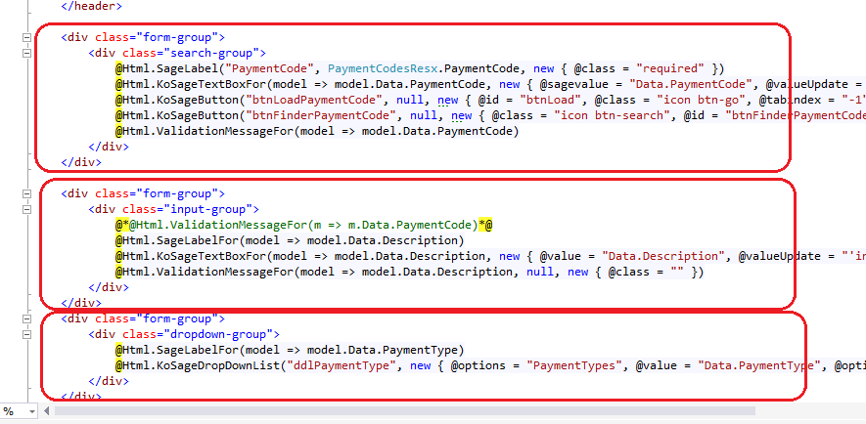

* 1. 2017 Example

The following example is from the same screen in the 2017 release and shows a more horizontal approach (the form group divs encapsulate the widgets for a horizontal presentation):

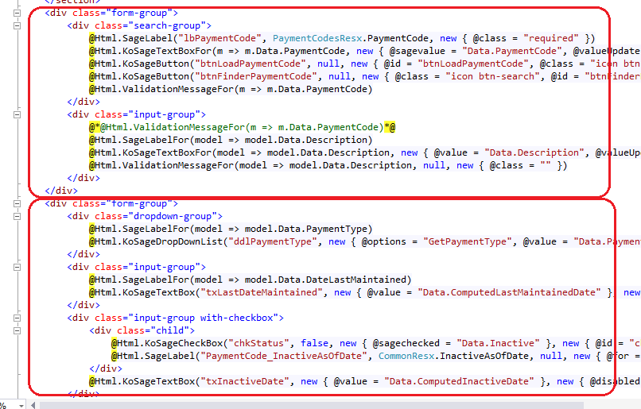

1. Recompiling the Solution

The solution that was generated by the 2016 version of the SDK has now been manually upgraded.

Recompile the solution.

**Note:** Before running the new solution, clear the browser cache to replace cached JavaScript and CSS files.