Sage 300 Web Screens SDK

Global Layout Refactoring Guide

March 2017

The MIT License (MIT)

Copyright © 2017 The Sage Group plc or its licensors. All rights reserved.

Permission is hereby granted, free of charge, to any person obtaining a copy of this software and associated documentation files (the “Software”), to deal in the Software without restriction, including without limitation the rights to use, copy, modify, merge, publish, distribute, sublicense, and/or sell copies of the Software, and to permit persons to whom the Software is furnished to do so, subject to the following conditions:

The above copyright notice and this permission notice shall be included in all copies or substantial portions of the Software.

THE SOFTWARE IS PROVIDED “AS IS”, WITHOUT WARRANTY OF ANY KIND, EXPRESS OR IMPLIED, INCLUDING BUT NOT LIMITED TO THE WARRANTIES OF MERCHANTABILITY, FITNESS FOR A PARTICULAR PURPOSE AND NONINFRINGEMENT. IN NO EVENT SHALL THE AUTHORS OR COPYRIGHT HOLDERS BE LIABLE FOR ANY CLAIM, DAMAGES OR OTHER LIABILITY, WHETHER IN AN ACTION OF CONTRACT, TORT OR OTHERWISE, ARISING FROM, OUT OF OR IN CONNECTION WITH THE SOFTWARE OR THE USE OR OTHER DEALINGS IN THE SOFTWARE.

Contents

1. Overview 4

2. Automatic Refactoring Steps 5

2.1 Referenced Layout 5

2.2 Form Container Class 6

2.3 Grid Button Helpers 7

2.4 Checkbox Container 8

2.5 Button Class 9

2.6 Input-box Class (numeric alignment) 10

3. Manual Refactoring Steps 12

3.1 Label Menu (not data bound) 12

3.2 Label Menu (data bound) 13

3.3 Grid Class 14

3.4 Multi-List Buttons 15

1. Overview

Prior to Web Screens SDK 2017.2, a combination of layouts were used ('LocalizedLayoutR2' and 'LocalizedLayoutR3') in the razor views. This document serves as a guide to illustrating the steps required to convert all the razor views to use the new Global Layout (Global Layout) and supporting changes required by the Global Layout.

The new global layout is located at **Areas\Shared\Views\Shared**\**_GlobalLayout.cshtml**. Any razor views in the **Areas\{module}\Views** folder will potentially need refactoring for any changes required by the new layout.

**Important:** The Sage 300 Upgrade Wizard will automatically perform most of the changes required for the refactoring of razor views, but some areas require manual work. It’s recommended to examine razor views following the steps detailed below.

1. Automatic Refactoring Steps

The steps listed in this section will be performed automatically by the Sage 300 Upgrade Wizard when it is run against Sage 300 2017.1 projects.

* 1. Referenced Layout
* **Files affected**

Areas\{module}\Views\{screen}\Index.cshtml

* **Description**

Apply the GlobalLayout by changing ***LocalizedLayout*, *LocalizedLayoutR2*** or ***LocalizedLayoutR3*** to ***GlobalLayout***

* **Before Change**



* **After Change**



* 1. Form Container Class
* **Files affected**

Partial files under Areas\{module}\Views\{screen}\partials\

* **Description**

Change ***.container_16*** to ***.form-screen*** in the wrapper div of each partial files

* **Before Change**



* **After Change**



* 1. Grid Button Helpers
* **Files affected**

Grid files under Areas\{module}\Views\{screen}\partials\

* **Description**

Apply ***@Html.*** ***KoSageButtonNoName*** for buttons belonging to a grid

* **Before Change**



* **After Change**



* **Example**

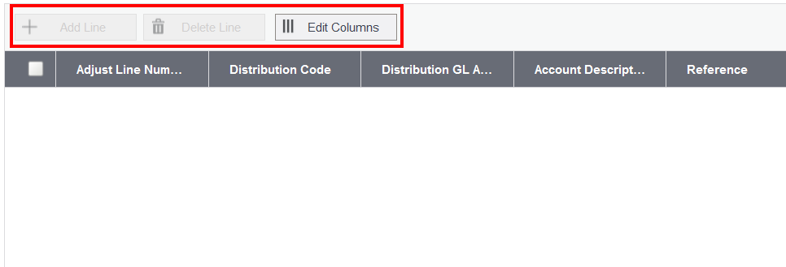

* 1. Checkbox Container
* **Files affected**

Partial files under Areas\{module}\Views\{screen}\partials\

* **Description**

For checkbox container, replace ***<div class="controls-group”> or <div class="ctrl-group no-label”>*** with ***<div class="ctrl-group”>***

* **Before Change**



* **After Change**



* **Example**

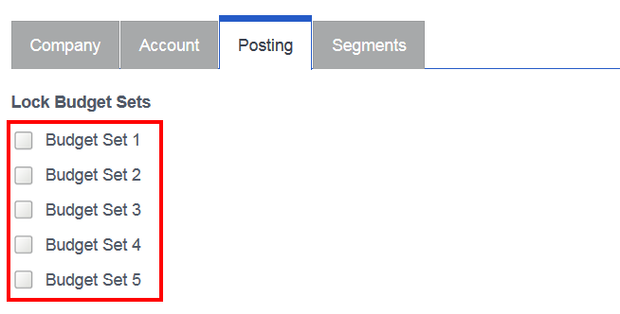

* 1. Button Class
* **Files affected**

Partial files under Areas\{module}\Views\{screen}\partials\

* **Description**

For button, replace ***<class="btn-primary”>*** with ***<class="btn btn-primary”>***

* **Before Change**



* **After Change**



* **Example**

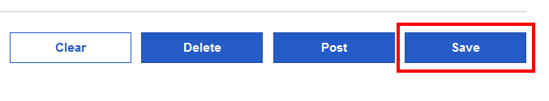

* 1. Input-box Class (numeric alignment)
* **Files affected**

Partial files under Areas\{module}\Views\{screen}\partials\

* **Description**

For numeric textboxes, replace ***.align-right*** with ***.numeric***

* **Before Change**



* **After Change**



* **Example**

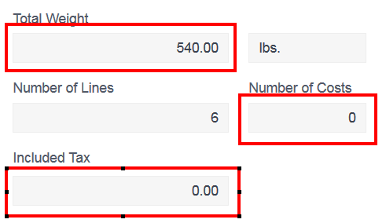

1. Manual Refactoring Steps

The steps listed in this section must be performed manually as the Sage 300 Upgrade Wizard is unable to properly detect the code requiring modification.

* 1. Label Menu (not data bound)
* **Files affected**

Partial files under Areas\{module}\Views\{screen}\partials\

* **Description**

Add ***<div class="label-with-menu"> … </div>*** for a label that is not data bound with a hamburger menu

* **Before Change**



* **After Change**



* **Example**



* 1. Label Menu (data bound)
* **Files affected**

Partial files under Areas\{module}\Views\{screen}\partials\

* **Description**

Convert multiple HTML Helpers to ***@Html.SageLabelForWithHamburger*** for labels that are data bound with a hamburger menu

* **Before Change**



* **After Change**



* **Example**

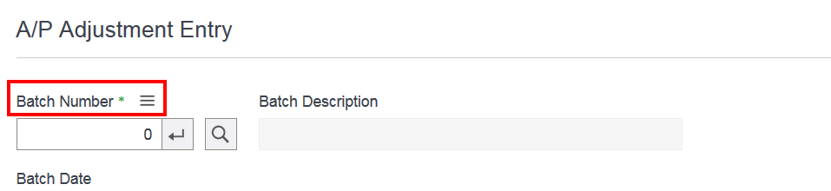

* 1. Grid Class
* **Files affected**

Partial files under Areas\{module}\Views\{screen}\partials\

* **Description**

For grid section, replace ***<section class="gridcontrols-group clearfix"></section>*** with ***<div class="gridcontrols-group clearfix"></div>***

* **Before Change**



* **After Change**



* **Example**

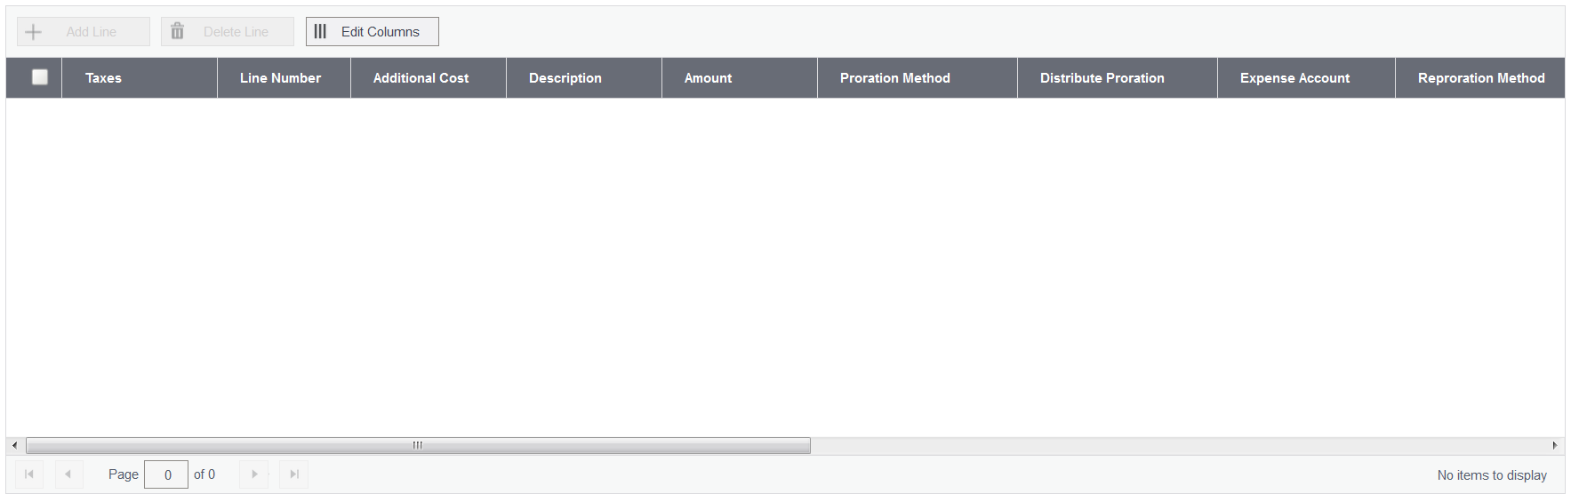

* 1. Multi-List Buttons
* **Files affected**

Partial files under Areas\{module}\Views\{screen}\partials\

* **Description**

For multi-list buttons, replace ***@Html.KoSageButton*** with ***@Html.SageButtonNoName***

* **Before Change**



* **After Change**



* **Example**

