**Sage 300 Web API – WCF Data Services**

In this exercise, you will discover how simple it is to call Sage 300 Web API using the Windows Communication Foundation (WCF) Data Services. By adding Service References, making Sage 300 Web API request becomes as trivial as making LINQ queries on collections.

1. Start Visual Studio and from the **File** menu, select **New** and then **Project.**
2. In the **New Project** dialog, select **Installed**, then **Templates** and expand the **Visual C#** node. Next select **Windows Desktop**. In the list of project templates, select **Console Application**. Name the project **WebApi_WcfDataServices** and click **OK**.

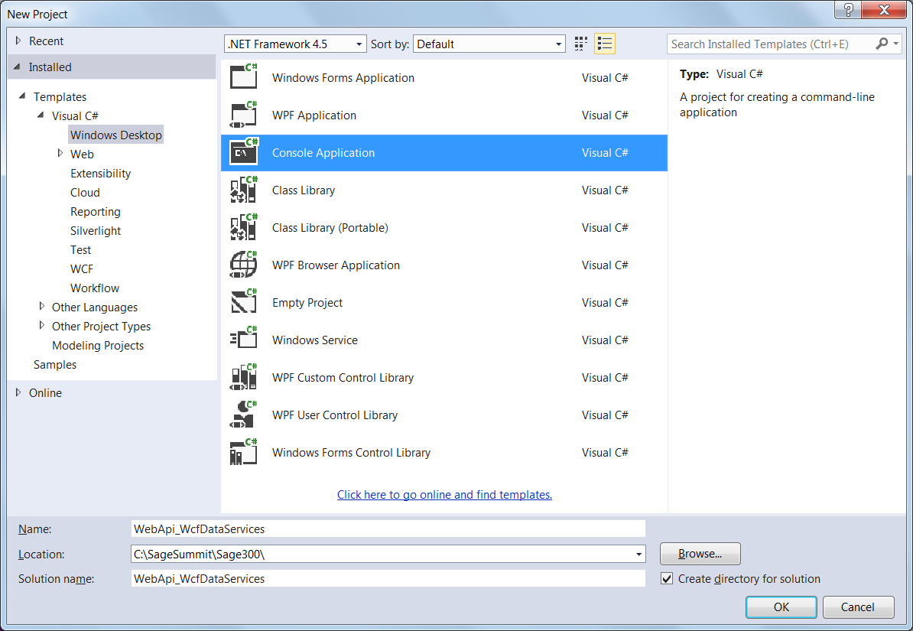

1. In Solution Explorer, right-click **References** and select **Add Service Reference**…
2. In the **Add Service Reference** dialog:
   * For Address, enter **http://localhost/Sage300WebApi/-/SAMLTD/AR**
   * For Namespace, enter **Sage300AR**

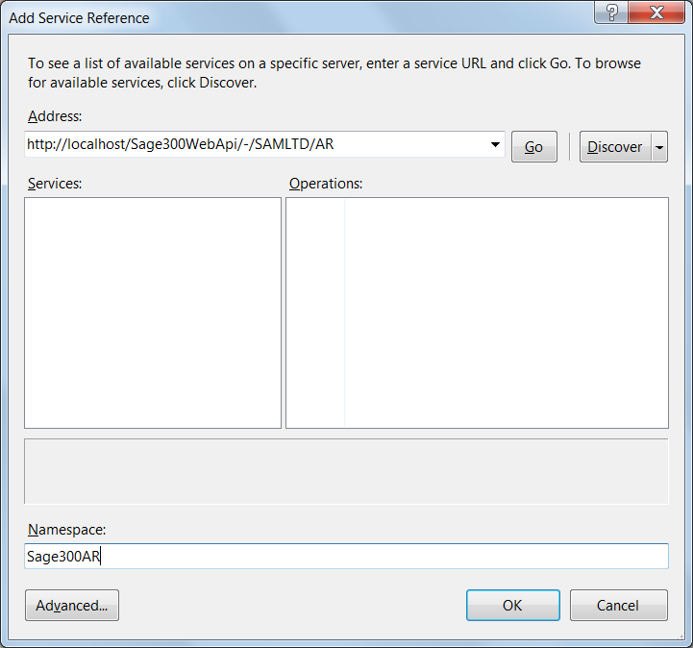

1. Click **Go** then **Yes** in the Web Discovery Service Dialog.

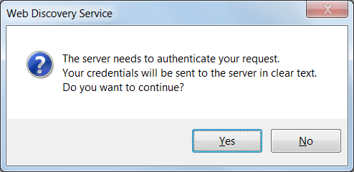

1. Enter **ADMIN** for the user name and **ADMIN** for the Password.
2. Click **OK** to add the data service. You should be able to see the **Sage300AR** data service in the **Service References** folder.

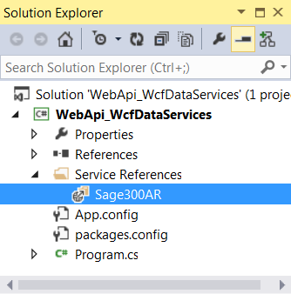

1. Inside **Program.cs** replace the import section at the top of the class with the following:



1. Add a method in the **Program** class to display a customer record:



1. Add a method to create your first request as follows:



1. Change the **Main** method by creating a new instance of the **Sage300AR** proxy then calling **GetCustomers** as follows:



1. Run the program by pressing **F5.**

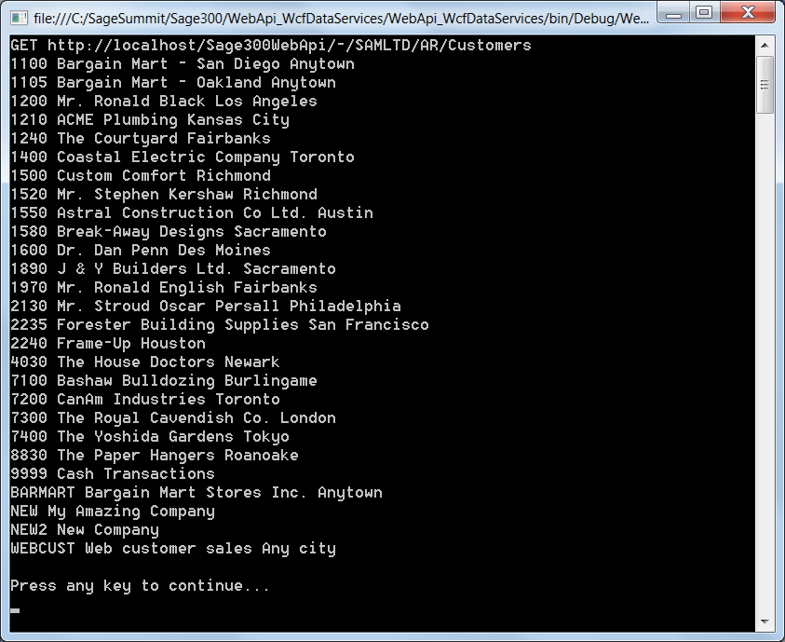

1. Add methods to retrieve customers in a variety of ways as follows:



1. Call the new methods inside the **Main** method:



1. Run the program by pressing **F5.**
2. Add methods to manipulate customers:



1. Call these methods within **Main** as follows:



1. Run the final program by pressing **F5.**