Terentyev Alexander

Dynamic difficulty adjustment

Supervisor: Fries Boury

Coach: Kasper Geeroms

Graduation Work 2023-2024

Digital Arts and Entertainment

Howest.be

Contents

Abstract & Key words 3

Preface 4

List of Figures 5

Introduction 6

Background 6

Purpose of this paper 7

Observation and Inpiration on this work 7

Relevancy 8

Literature Study / Theoretical Framework 9

Dynamic difficulty adjustment 9

Dynamic difficulty adjustment 9

Flow Theory 9

The start and evolution of dynamic difficulty adjustments 11

Player-Centric Difficulty Adjustment (PCDA) 12

Player-Centric Difficulty Adjustment (PCDA) 12

Space combat arena 14

Space combat arena 14

Creating FOUNDATION 15

Research 17

Overview 17

1. Experimental Design 17

1.1. Objects of Testing 17

1.1.1. Prototype Game 17

1.1.2. DDA Systems tested 17

1.2. Subjects of testing 17

1.2.1.1. Participants 17

2. Data collection and analysis 18

2.1. Data Gathering 18

2.2. Data Cleaning 18

2.3. Measurements 18

3. Experimental procedure 18

3.1. Pre-Experiment Setup 18

3.2. Gameplay session 18

3.3. Post-Experiment feedback 19

4. Results 19

4.1. Quantitative Results 19

4.2. Qualitative results 23

4.3. Observational insights 28

Discussion 29

Conclusion 30

Future work 31

Critical Reflection 32

References 33

Acknowledgements 35

Appendices 36

# Abstract & Key words

Abstract (English)

This research explores the application of Dynamic Difficulty Adjustment (DDA) system to improve player experience (PX or UX -> user experience) in video games. By dynamically adapting game difficulty to individual player skills and performance, DDA systems aim to maintain player engagement and satisfaction. This study focuses on designing and testing a combat arena prototype with DDA configurations, including continuous adjustments.

Using a controlled experiment, player performance metrics (like enemies killed, pickups used) and qualitative feedback (surveys) were gathered to evaluate the impact of each DDA system. Results indicate that periodic difficulty adjustments effectively maintain a flow state for players, while player-controlled adjustments might provide a stronger sense of control but may disrupt immersion. Continuous adjustments, while seamless, occasionally led to unpredictability in gameplay.

The findings show best practices for implementing DDA system that balance challenge and engagement without breaking the factor of fairness or immersion. This research contributes to understanding how adaptive systems can enhance player satisfaction and provides insights for developers to create more personalized gaming experiences.

***Keywords: Dynamic Difficulty Adjustment, Player Experience, Adaptive Gameplay, Game Development, Flow State, Player Engagement***

Abstract (Nederlands)

Dit onderzoek richt zich op de toepassing van Dynamische moeilijkheidsaanpassing in videogames om de spelervaring van spelers te verbeteren. Door de moeilijkheidsgraad van het spel dynamisch aan te passen aan de vaardigheden en prestaties van individuele spelers, streven DDA-systemen ernaar om betrokkenheid en tevredenheid van de spelers te behouden. Deze studie richt zich op het ontwerpen en testen van een gevechtsarena-prototype met een DDA-configuratie, waaronder continue aanpassingen.

Met behulp van een gecontroleerd experiment zijn prestatiegegevens van spelers (bijv. aantal vijanden vernietigd, aantal pickups gebruikt) en kwalitatieve feedback (enquêtes) verzameld om de impact van het DDA-systeem te evalueren. De resultaten tonen aan dat periodieke aanpassingen effectief een flowtoestand behouden voor spelers, terwijl door spelers aangestuurde aanpassingen een sterker gevoel van controle kunnen bieden maar de immersie kunnen verstoren. Continue aanpassingen, hoewel naadloos, leidden af en toe tot onvoorspelbaarheid in het spel.

De bevindingen benadrukken de beste praktijken voor het implementeren van het DDA-systeem die uitdaging en betrokkenheid in balans houdt zonder afbreuk te doen aan eerlijkheid of immersie. Dit onderzoek draagt bij aan het begrijpen van hoe adaptieve systemen de tevredenheid van spelers kunnen verbeteren en biedt inzichten voor ontwikkelaars om meer gepersonaliseerde spelervaringen te creëren.

***Trefwoorden: Dynamische Moeilijkheidsaanpassing, Spelervaring, Adaptieve Gameplay, Spelontwikkeling, Flowtoestand, Spelersbetrokkenheid***

# Preface

*The motivation or interest for taking this research comes just from my interest in understanding how games can adapt to the diverse skills and playstyles of players and make sure that games remain engaging, challenging, and enjoyable for everyone. As someone interested in becoming a gameplay programmer or a game systems programmer, I am pretty much interested in the technology and design that makes such experiences possible. Dynamic Difficulty Adjustment (DDA) systems represent a pivotal aspect of this, as they showcase how artificial intelligence and player-centric design principles can enhance gameplay experiences.*

*I also want to acknowledge the influence of my prior experiences working on Shiver Thy Timbers (Group Projects) and exploring artificial intelligence in games. These experiences gave me the foundation and confidence to tackle this research topic. They taught me the importance of iteration and feedback, all of which I then applied during the course of this project (Grad work).*

# List of Figures

*Figure 1 Player-Engagement graph* 6

Figure 2 Ranking system in Counterstrike 6

Figure 3 Left 4 dead 2 developer commentary on how AI director works 7

*Figure 4 Flow zone* 9

Figure 5 The eight channels of flow theory 10

*Figure 6 Screenshot of the prototype* 14

Figure 7 Enemy fighter with the default properties 15

Figure 8 Difficulty settings system 16

*Figure 9 Graph difficulty statistics* 22

Figure 10 Amount of experienced arcade players 23

Figure 11 How often do people play games? 23

Figure 12 Amount of skilled players 24

Figure 13 Amount of people that found it challenging 24

Figure 14 Amount of people satisfied 25

Figure 15 Amount of people that felt the game adapted 25

Figure 16 How fair were the adjustments 26

Figure 17 Amount of people that found it engaging 26

Figure 18 Amount of people that found it frustrating or to easy 27

Figure 19 Manual adjustment or System adjustment? 27

Figure 20 Did the DDA enhance the UX? 27

*Figure 21 General difficulty settings* 36

*Figure 22 Code AdjustPickupSpawnChance* 37

*Figure 23 EnemyFighter that changes properties based on difficultySettings* 37

# Introduction

## Background

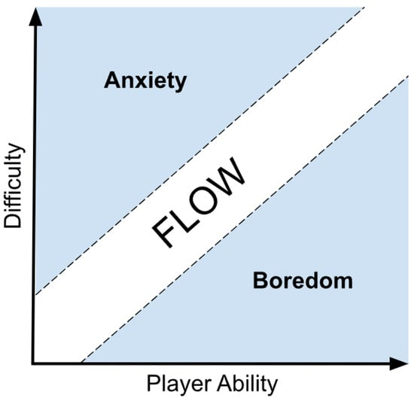Video games have become one of the most influential and widely consumed forms of entertainment, giving players that play those games diverse experiences across different genres. However, a persistent challenge in game design is addressing the wide range of player skill levels and preferences. A game that is too difficult risks frustrating the player, while one that is too easy can quickly lead to boredom (*Figure 1*). Traditionally, developers have relied on static or player-controlled difficulty settings such as “Easy,” “Medium,” or “Hard”, to cater to different players. While this approach offers some customization, it often falls short in adapting to a player's evolving performance and engagement during gameplay.

*Figure 1 Player-Engagement graph*

Dynamic Difficulty Adjustment (DDA) systems present a solution to this challenge by making the game’s difficulty in real time based on player performance, behavior, or other measurable metrics. These systems can maintain a balance between challenge and enjoyment, ensuring players remain engaged regardless of their skill level. By responding dynamically to player’s needs, DDA systems can preserve the so-called “flow state,” a psychological condition in which players are fully immersed and motivated to overcome challenges.

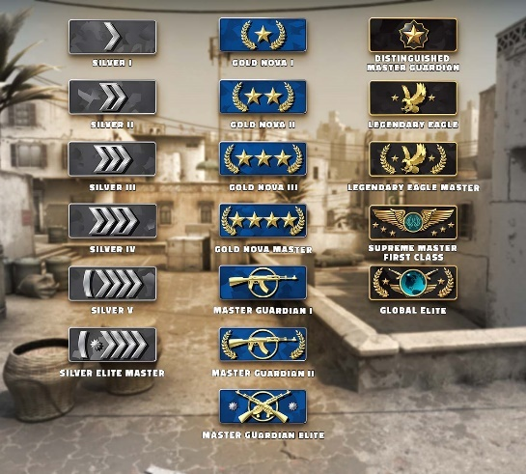My interest in DDA systems was sparked by observing how players react to difficulty in games. In competitive multiplayer games like *Counter-Strike Global offensive*, skill-based matchmaking adjusts the challenge level by pairing players of similar skill by having a rank system (*Figure 2*), creating more engaging matches. The last thing that sparked my interest was the *Left 4 Dead* genre because they utilize the “AI Director” to dynamically adjust enemy spawns and events based on team performance. These examples highlight the potential of DDA to create personalized and rewarding experiences. However, many games still rely on static difficulty settings, and the design and implementation of effective DDA systems remain underexplored.

Figure Ranking system in Counterstrike

## Purpose of this paper

The purpose of this research is to research how DDA systems can effectively make gameplay difficulty to individual player skill while maintaining player engagement and satisfaction. By exploring the technical aspects of DDA, I aim to try and seek the best practices for implementing adaptive systems that enhance the gaming experience. This research aims to provide actionable insights for developers looking to design systems that balance fairness, immersion, and engagement.

To achieve this, I made a combat arena prototype with multiple DDA configurations, including continuous adjustments, and player-controlled difficulty. The prototype captures performance metrics such as retries, completion times, and success rates, as well as qualitative feedback from players. By analyzing the results, this research evaluates which DDA systems are most effective at delivering a personalized and satisfying gaming experience.

## Observation and Inpiration on this work

My inspiration for this project came from my own experiences as I played games. I noticed that games with well-implemented difficulty systems such as Left 4 dead 2, which made the game adjust based on how well the 4 players were surviving without making it too obvious and later only in developer commentary I only realized that that system was in place.

Figure Left 4 dead 2 developer commentary on how AI director works

or Resident Evil 4, which adjusts enemy aggressiveness that often led to a more fulfilling experience.

*Conversely, games with poorly balanced difficulty can feel punishing or unengaging, leading players to abandon them entirely.*

What stood out to me is the potential of DDA systems to create a middle ground: one that adapts seamlessly to the player's skill while preserving the intended challenge and enjoyment of the game. This observation motivated me to explore how DDA could be applied more broadly, particularly in single-player experiences where real-time adaptation has the most potential to shine.

Based on that explanation,

The following research question was born:

***How can dynamic difficulty adjustment systems effectively create gameplay difficulty tailored to individual player skill while maintaining player engagement and satisfaction?***

This question reflects the dual challenge of designing DDA systems that not only balance difficulty but also preserve the player's emotional connection to the game.

And to address the research question, the following hypotheses were formulated:

* Continuous Adaptation: Dynamic difficulty adjustment systems that continuously adapt to individual player performance will result in higher player engagement and satisfaction compared to static difficulty settings.
* Periodic Adjustments and Flow: DDA systems that adjust difficulty periodically based on a player's progress and performance are more effective at maintaining players in a flow state compared to constant or one-time adjustments.
* Comprehensive Metrics: Combining player performance metrics, such as success rate, time to complete tasks, will allow for more accurate real-time difficulty adjustments.
* Perception of Fairness: Players will perceive DDA systems that seamlessly integrate difficulty changes into gameplay (like through in-game mechanics rather than explicit player prompts) as fairer and less intrusive, leading to a more positive player experience.
* Preserving Immersion: DDA systems that utilize indirect difficulty changes (such as modifying enemy behavior or resource availability) will maintain player immersion better than systems that require players to manually adjust difficulty settings.

## Relevancy

This research aims to increase player satisfaction and engagement by understanding how different approaches to DDA influence player satisfaction and engagement. The results of this study have the potential to guide developers in creating more accessible, enjoyable, and personalized gaming experiences, bridging the gap between technical implementation and player-centric design principles.

# Literature Study / Theoretical Framework

## Dynamic difficulty adjustment

### Dynamic difficulty adjustment

Dynamic Difficulty Adjustment refers to a design philosophy and implementation strategy in video games that aim to dynamically alter the difficulty level of a game based on the player's ability, ensuring an optimal level of challenge and engagement. This concept is crucial for maintaining player interest and promoting an inclusive gaming experience by adapting to different skill levels. Several studies, such as those by David Kristan and Ricardo Costa, have highlighted how DDA can enhance player satisfaction and retention by maintaining the flow state, as theorized by Mihaly Csikszentmihalyi. [4]

### Flow Theory

Flow theory, introduced by Mihaly Csikszentmihalyi, describes an optimal psychological state that occurs when a person engages in activities that are both challenging and commensurate with their skill level. In the context of video games, ensuring a player remains in this state can significantly affect their enjoyment and engagement. The relevance of flow theory to DDA systems lies in its ability to inform the adjustment algorithms, ensuring that players are not overwhelmed or bored, but are consistently engaged in the challenge presented by the game. This is supported by the findings of Daniel J. Acland (2020), who explored the application of flow theory in video game design and explains the flow theory in detail (see figure 5).[1] [23]

*Figure 4 Flow zone*

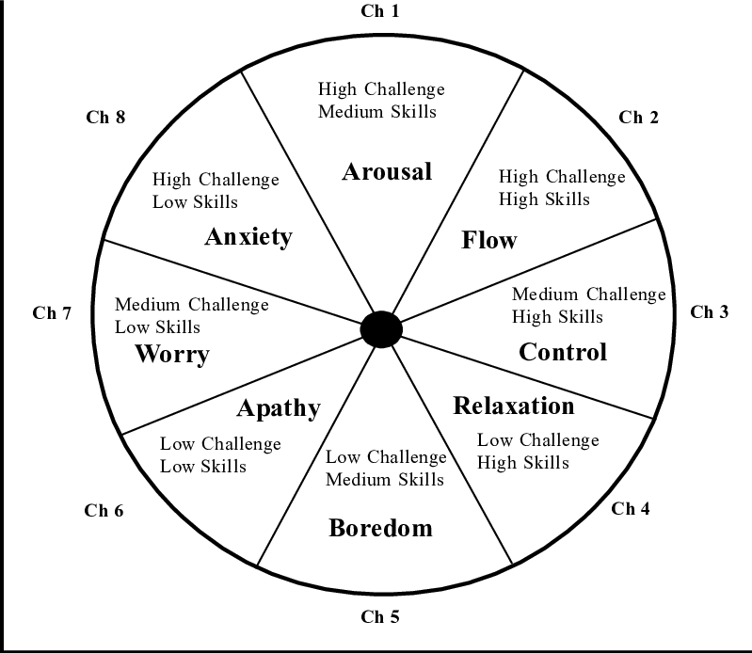

Figure The eight channels of flow theory

Empirical research has demonstrated various methodologies and outcomes of implementing DDA systems in games. For example, Rhio Sutoyo (2015) implemented DDA techniques in a Tower Defense and observed notable improvements in player engagement metrics. Such studies provide a foundational proof for the effectiveness of DDA systems and offer a benchmark for comparing different implementation strategies. [12]

The integration of Dynamic Difficulty Adjustment within games involves various techniques ranging from changing game parameters like enemy health and attack power to more sophisticated methods such as altering game storylines dynamically. The literature reveals a trend towards more adaptive systems that use real-time data analytics to modify difficulty levels. For instance, Rhio Sutoyo discusses a model that uses player performance data to predict and implement difficulty adjustments dynamically, which has been tested in real-world scenarios with positive outcomes. [12]

*“To create the dynamic difficulty adjustment for our tower defence game, we use multipliers that affect the objects in our games. These multipliers are changed in the end of every level where the change points depend on the performance gameplay of the players. For instance, if the players use good strategy and did not lost any lives in the certain levels, the multiplier points will be increased and the next levels will be harder. There are four type of multipliers in our game, which are: status multiplier, spawn multiplier, gold multiplier, and difficulties point global. These multipliers will affect the number on the variables. The variables are status point, spawn point, and gold point. The status point affect the enemies’ power, the spawn point affect the number of enemies that will be spawned at that current level, and the gold point affect the number of gold received in every cleared level.”*

Understanding these foundational concepts and their interrelations is essential for my project because it allows me to build upon proven methodologies **while innovating in my application context**. The literature not only supports the viability of DDA but also enriches the theoretical framework for my experimentation with a combat platformer space game. By aligning my research with established theories and practices, I aim to contribute to the field by offering new insights and potentially new applications of these principles.

### The start and evolution of dynamic difficulty adjustments

Dynamic Difficulty Adjustment (DDA) has a rich history that extends back over three decades, marking its initial start as a groundbreaking concept in game design. The roots of DDA can be traced to 1987 with the release of *Zanac*, a shoot 'em up video game developed by Compile for the MSX Computer and the Famicom/NES. (<https://en.wikipedia.org/wiki/Dynamic_game_difficulty_balancing>)

*Zanac* was one of the first games to feature the "Automatic Level of Difficulty Control" (ALC) system, a sophisticated mechanism that dynamically adjusted the game’s challenge based on the player's performance. The ALC system responded to various player actions, such as the frequency of main cannon use, power-up collection, and outcomes of boss battles. Conversely, actions like losing a life or starting a new level could trigger a reduction in difficulty, making *Zanac* a pioneering example of adaptive gameplay. [27]

As video games evolved, the concept of DDA expanded into various genres, becoming more sophisticated and integrated. In the realm of racing games, techniques such as "rubberbanding" were introduced. This form of DDA allows AI opponents to adjust their speed dynamically, ensuring that races remain competitive regardless of the player’s skill level. Notably, popular games like *Mario Kart* leverage DDA not just through AI adjustments but also through strategic item distributions, which are influenced by the player's current position in the race.

*(Last player has more chance of getting a rocket powerup that targets the first player for balancing)*

Platforming games also embraced DDA to enhance player engagement and reduce frustration. For instance, *Crash Bandicoot 2: Cortex Strikes Back* implemented DDA by adjusting the speed of pursuing threats and placing checkpoints strategically within particularly challenging segments. The game also offered aids like the "Aku Aku Mask" to grant temporary invincibility after repeated failures, thus helping players advance through difficult sections. (<https://crashbandicoot.fandom.com/wiki/Dynamic_Difficulty_Adjustment>)

Moreover, iconic franchises such as *Super Mario Bros.* have experimented with DDA to varying degrees. *New Super Mario Bros. Wii* introduced the Super Guide feature, which allowed the game to demonstrate successful level completion if a player struggled excessively. This feature has since become a staple in later installments of the series, illustrating the enduring influence of DDA in mainstream gaming.

Beyond these examples, a wide array of titles across different genres, including *Fallout 3*, *Resident Evil 4*, and *Left 4 Dead*, have integrated DDA techniques to subtly enhance the gaming experience. These implementations often remain imperceptible to players, yet they play a crucial role in balancing challenge and accessibility, thereby enriching the player's engagement and satisfaction. [3]

In essence, Dynamic Difficulty Adjustment has evolved from a novel feature in early video games to a fundamental aspect of modern game design. Its continued development and application reflect its significance in creating adaptable and enjoyable gaming experiences that cater to diverse player skills and preferences.

## Player-Centric Difficulty Adjustment (PCDA)

### Player-Centric Difficulty Adjustment (PCDA)

Player-Centric Difficulty Adjustment (PCDA) finds its application in enhancing player engagement and challenge in video games by dynamically adjusting game parameters. Unlike static difficulty settings, PCDA adapts in real-time to the player's skill level and performance, ensuring an optimal challenge that keeps games accessible and enjoyable for players of all skill levels. [25]

The concept of Dynamic Difficulty Adjustment has been evolving since the late 1980s, but PCDA specifically focuses on tailoring difficulty through direct manipulation of game parameters such as enemy speed, spawn rates, and health systems. This approach not only maintains game balance but also enhances player satisfaction by avoiding frustration and boredom. [19]

PCDA operates through a seamless, multi-phase process that enhances player engagement by dynamically tuning game challenges in real time. Initially, PCDA systems monitor the player’s interactions within the game, capturing performance metrics like hit rates, movement patterns, and outcomes of various game segments. This continuous monitoring helps in building a comprehensive profile of the player's abilities and gameplay style. [3]

Following the collection of gameplay data, the system analyzes this information to determine the appropriateness of the game’s current difficulty level. This analysis relies on predefined metrics that gauge whether the player is finding the game too easy or too difficult, ensuring that adjustments are both necessary and timely.

*“The difficulty measure of the game is based on the player’s feelings. The specific feelings of a player are correlated with the various difficulty settings of the game. When a measuring tool recognizes that the game is too hard for the player (or too easy), the DDA system adjusts the difficulty.”* [5]

Based on this analytical insight, PCDA actively modifies game parameters to better suit the player’s skill level. For instance, if a player is repeatedly failing at a particular challenge, the system might decrease the speed or attack frequency of enemies. Conversely, if the player is excelling, it might introduce more complex challenges or enhance enemy capabilities to maintain a consistent level of engagement. [5]

The final phase of PCDA involves integrating feedback from these adjustments to refine the system's future responses. This feedback loop allows PCDA to learn from each player's unique responses to difficulty adjustments, progressively tailoring the gaming experience to individual preferences and skills over time.

*“Looking at the FPS environment, we can abstract gameplay with a relatively simple state transition diagram. Players engage in loops of searching, retrieving, solving and fighting. With each new level, new enemies and obstacles are introduced. Overall, difficulty increases with time, as does skill acquisition.”* [2]

The primary benefit of implementing PCDA is its ability to provide tailored gaming experience that can significantly enhance player satisfaction and retention. By dynamically adjusting game difficulty, developers can cater to a broad spectrum of players, from beginners to experts, without the need to manually create diverse difficulty settings. This not only enhances accessibility but also reduces development costs.

“*A well-designed Dynamic Difficulty Adjustment system provides a consistent, perfectly paced game, which brings a greater sense of accomplishment for the player. To create a flexible interactive experience, which adjusts automatically to the player, different DDA systems can be used,* ***while always bearing in mind the importance of decreasing the costs related to the development of adaptive games*** *by using the most effective system for a specific game.*” [4]

Looking ahead, the potential integration of advanced AI and machine learning techniques with PCDA promises even more refined control over game difficulty. Such technologies could predict player behavior and make preemptive adjustments to the game environment, thereby preventing player frustration or boredom before it even arises. This proactive approach to game design could revolutionize player experiences, making games more immersive and enjoyable than ever before. [26]

## Space combat arena

### Space combat arena

For this research project, I developed a prototype of a space combat arena game that incorporates Dynamic Difficulty Adjustment (DDA) to tailor gameplay experiences to individual player performance. This game, designed as a top-down shooter, sets players during space battles where they must navigate their spacecraft, avoid incoming fire, and eliminate enemy ships.

The core of the game revolves around a combat system where players engage with both AI-controlled enemy ships and environmental challenges. Players can collect different power-ups, adding a strategic layer to the gameplay as they choose different methods to handle the challenges presented.

A key component of the game is the implementation of the Player-Centric Difficulty Adjustment System (PCDA), which dynamically adjusts various game parameters based on real-time analysis of player performance. This system tracks a range of metrics, such as the player’s hit and miss ratios, enemies killed, pickups used, damage taken, and rate of progression through levels. Depending on these metrics, the PCDA adjusts enemy behavior, spawn rates, and the types of challenges introduced, aiming to keep the game engaging and appropriately challenging for each player.

The PCDA's effectiveness was tested through user sessions, where data on player performance and system adjustments were meticulously recorded and analyzed. This provided valuable insights into the system’s responsiveness to changing player skills and strategies, demonstrating its potential to enhance player engagement and satisfaction.

This space combat arena game serves as both a platform for testing the practical application of DDA and a step forward in understanding how such systems can be optimized to improve game design. The development process highlighted the importance of balancing algorithmic efficiency with user-centric design principles to create compelling, adaptive gameplay experiences.

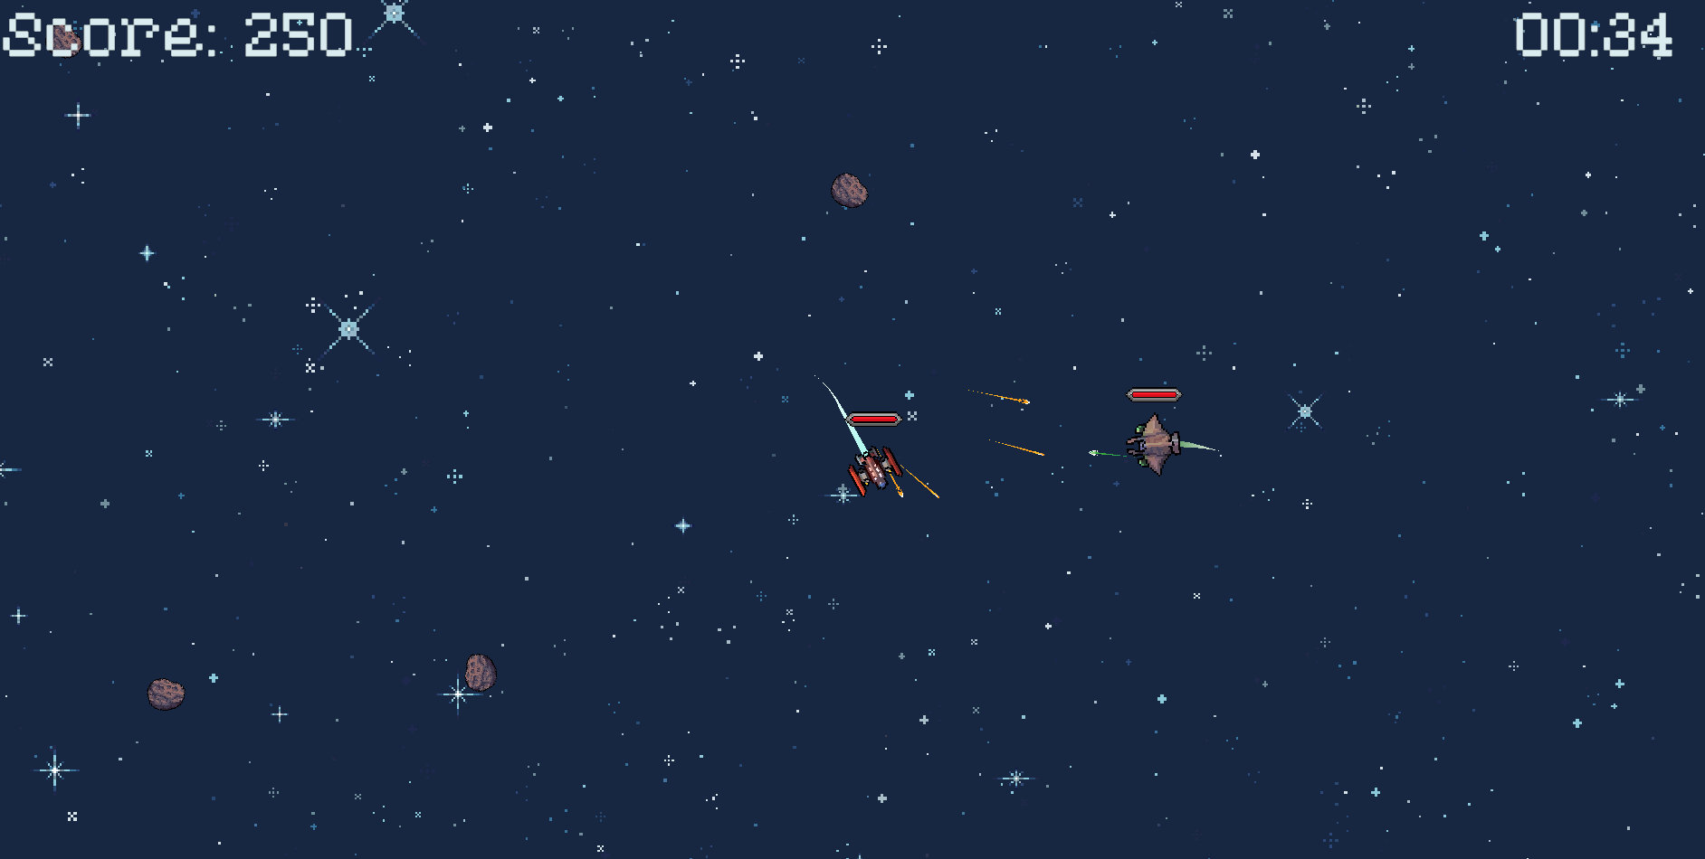

*Figure 6 Screenshot of the prototype*

### Creating FOUNDATION

The foundation of our space combat arena game was built using Unity, an engine ideal for rapid prototyping and sophisticated game development. Initially, the game was designed with a static difficulty level at first to establish a baseline for gameplay mechanics and to ensure the core functionalities such as ship control, enemy behavior, and collision detection were properly implemented.

In the early stages, various game objects including enemy ships, asteroids, and power-ups were integrated with fixed properties. This setup allowed for a straightforward gameplay experience where the difficulty remained constant, regardless of the player's skill level. This phase was crucial for testing the fundamental interactions and mechanics, such as shooting, navigating, and enemy AI behaviors, which are integral to the game's overall flow.

Once the basic structure was confirmed to be stable and functional, the next phase involved the integration of the Dynamic Difficulty Adjustment (DDA) system. The implementation of DDA required an overhaul of how game objects' properties were managed. Instead of static attributes, these properties were made dynamic and responsive to changes dictated by the DDAManager inside the project which acts as a player-centric difficulty adjustment system.

The PCDA was programmed to monitor various player performance metrics, such as accuracy, frequency of damage taken, and overall speed of progression through levels. Based on this data, the system dynamically adjusted the properties of game objects. For instance, if the player was found to be losing too quickly without any enemies killed, the game could reduce the attack frequency of enemies or lower their speed, thereby decreasing the game’s difficulty in real time. Conversely, if the game was progressing too easily, the PCDA would increase the challenges by enhancing enemy aggressiveness or reducing the availability of power-ups.

This dynamic adjustment not only made the game more engaging by adapting to the player's skill level but also served as a core research tool in the study of DDA's impact on player experience. The flexibility of Unity was instrumental in allowing these complex systems to be implemented and refined, providing a robust platform for both game development and academic research.

Figure Enemy fighter with the default properties

Figure Difficulty settings system

Based on the properties inside this, the game objects used to create gameplay will change their default properties to these ones, because this systems is monitoring how good the player is performing per session so that the changes can then be made to the players skill.

# Research

## Overview

This section describes the methodology, objects, subjects, tests, and data handling processes for the research experiment. The primary goal of this research is to evaluate how Dynamic Difficulty Adjustment (DDA) systems can effectively create gameplay difficulty made to individual player skill while maintaining engagement and satisfaction. A Unity-based combat arena prototype was developed to facilitate the experiment.

## Experimental Design

To fall back on the research question: “*How can dynamic difficulty adjustment systems effectively create gameplay difficulty tailored to individual player skill while maintaining player engagement and satisfaction?*”

I try and create an experiment with the purpose of comparing a DDA system to assess the impact on player performance, engagement, and satisfaction. This will help understand the effectiveness of dynamic difficulty adjustments in real-time gaming scenarios.

The experiment focuses on comparing different statistics of the player for the DDA system to adapt the difficulty based on player performance, engagement, and satisfaction.

### Objects of Testing

### Prototype Game

A Unity-based combat arena where players must survive against waves of enemies. Key mechanics include dynamic adjustments to enemy attributes like speed, damage, and fire rate based on player performance. Player abilities and resources, such as health and shield pickup, are also influenced by the DDA system.

### DDA System tested

This experiment will evaluate one DDA configuration: A continuous adjustment. Continuous adjustment dynamically adapts difficulty based on performance metrics like enemies killed rate. This system is tested to determine their impact on engagement and immersion.

### Subjects of testing

### Participants

Participants will include 10 individuals aged 18–35 with prior experience in platform games. The sample represents diverse skill levels to assess the effectiveness of DDA systems across a broad player base. Participants are recruited via personal contacts and online communities, ensuring a mix of casual and experienced gamers.

## Data collection and analysis

This section details the process of gathering, cleaning, and analyzing data from gameplay sessions. The collected data will measure player performance, engagement, and satisfaction with the DDA system.

### Data Gathering

Quantitative metrics include performance data such as number of enemies defeated, and retries. Additional data includes game progression metrics like missed/hit shots and resource utilization like pickups used. Qualitative feedback is collected through surveys, capturing player perceptions of engagement, fairness, and overall satisfaction. Observational data, such as player behavior during gameplay, complements the metrics if applicable.

### Data Cleaning

Data cleaning involves removing incomplete or inconsistent data, such as sessions where participants quit prematurely or the first 1-2 games due to the lack of understanding the controls etc… . Feature extraction focuses on processing raw data to calculate relevant metrics, such as average time survived per wave (1 minute is given each session), enemy defeat ratios (EnemiesKilled), and resource usage efficiency (PickupsUsed).

### Measurements

Measurements are categorized into engagement, performance, and satisfaction metrics. Engagement is evaluated through session length and retry rates. Performance is measured by success rates and adaptation responses. Satisfaction is gauged using survey responses on enjoyment and perceived fairness. These metrics provide a comprehensive view of player experiences with the tested DDA system.

## Experimental procedure

The experimental procedure outlines the steps taken to prepare and conduct gameplay sessions, ensuring consistent data collection and participant feedback.

### Pre-Experiment Setup

Participants are briefed on the game mechanics and the purpose of the study. The setup ensured participants understand how the system works without influencing their perception of difficulty.

### Gameplay session

Each participant engages in gameplay across seven different sessions, each distinctly measuring the impact of continuous dynamic difficulty adjustments:

**Session 1 to 7:** Continuous adjustments are applied throughout these sessions, where the game's difficulty is dynamically adapted based on the player’s performance metrics such as enemies killed. This adaptive mechanism is designed to seamlessly scale the challenge in real-time, ensuring that the gameplay remains engaging and appropriately challenging, avoiding frustration from excessive difficulty or boredom from insufficient challenge.

These sessions help in assessing how well the continuous adjustment mechanism maintains a balanced difficulty level that aligns with each player’s evolving skill set and gameplay style.

### Post-Experiment feedback

After completing all sessions, participants completed a survey rating their experience with each DDA system. These questions allowed players to provide qualitative insights into engagement, satisfaction, and fairness of the adjustments.

## Results

The results present the data gathered during the gameplay sessions, including performance metrics, engagement ratings, and qualitative feedback.

### Quantitative Results

{

    "Sessions": [

        {

            "Session": 1,

            "CurrentScore": 550,

            "EnemiesKilled": 1,

            "AsteroidsDestroyed": 6,

            "PickupsUsed": 0,

            "ShotsHit": 4,

            "ShotsMissed": 6,

            "DamageTaken": 120,

            "PickUpChance": 25,

            "EnemySpeed": 1.0,

            "EnemyStopDistance": 3.0,

            "EnemyFireRate": 1.0,

            "EnemyRotationSpeed": 50.0

        },

        {

            "Session": 2,

            "CurrentScore": 2000,

            "EnemiesKilled": 3,

            "AsteroidsDestroyed": 25,

            "PickupsUsed": 4,

            "ShotsHit": 11,

            "ShotsMissed": 97,

            "DamageTaken": 105,

            "PickUpChance": 35,

            "EnemySpeed": 1.0,

            "EnemyStopDistance": 3.0,

            "EnemyFireRate": 1.0,

            "EnemyRotationSpeed": 50.0

        },

        {

            "Session": 3,

            "CurrentScore": 3000,

            "EnemiesKilled": 6,

            "AsteroidsDestroyed": 30,

            "PickupsUsed": 4,

            "ShotsHit": 22,

            "ShotsMissed": 134,

            "DamageTaken": 135,

            "PickUpChance": 40,

            "EnemySpeed": 1.0,

            "EnemyStopDistance": 3.0,

            "EnemyFireRate": 1.0,

            "EnemyRotationSpeed": 50.0

        },

        {

            "Session": 4,

            "CurrentScore": 3200,

            "EnemiesKilled": 7,

            "AsteroidsDestroyed": 29,

            "PickupsUsed": 6,

            "ShotsHit": 30,

            "ShotsMissed": 98,

            "DamageTaken": 255,

            "PickUpChance": 45,

            "EnemySpeed": 1.0,

            "EnemyStopDistance": 3.0,

            "EnemyFireRate": 1.0,

            "EnemyRotationSpeed": 55.0

        },

        {

            "Session": 5,

            "CurrentScore": 1650,

            "EnemiesKilled": 4,

            "AsteroidsDestroyed": 13,

            "PickupsUsed": 2,

            "ShotsHit": 18,

            "ShotsMissed": 62,

            "DamageTaken": 330,

            "PickUpChance": 45,

            "EnemySpeed": 1.399999976158142,

            "EnemyStopDistance": 3.0,

            "EnemyFireRate": 1.2000000476837159,

            "EnemyRotationSpeed": 63.0

        },

        {

            "Session": 6,

            "CurrentScore": 500,

            "EnemiesKilled": 1,

            "AsteroidsDestroyed": 5,

            "PickupsUsed": 1,

            "ShotsHit": 10,

            "ShotsMissed": 18,

            "DamageTaken": 525,

            "PickUpChance": 60,

            "EnemySpeed": 1.399999976158142,

            "EnemyStopDistance": 3.0,

            "EnemyFireRate": 1.2000000476837159,

            "EnemyRotationSpeed": 63.0

        },

        {

            "Session": 7,

            "CurrentScore": 1050,

            "EnemiesKilled": 3,

            "AsteroidsDestroyed": 6,

            "PickupsUsed": 2,

            "ShotsHit": 7,

            "ShotsMissed": 13,

            "DamageTaken": 135,

            "PickUpChance": 55,

            "EnemySpeed": 1.2000000476837159,

            "EnemyStopDistance": 3.0,

            "EnemyFireRate": 1.100000023841858,

            "EnemyRotationSpeed": 55.0

        }

    ]

}

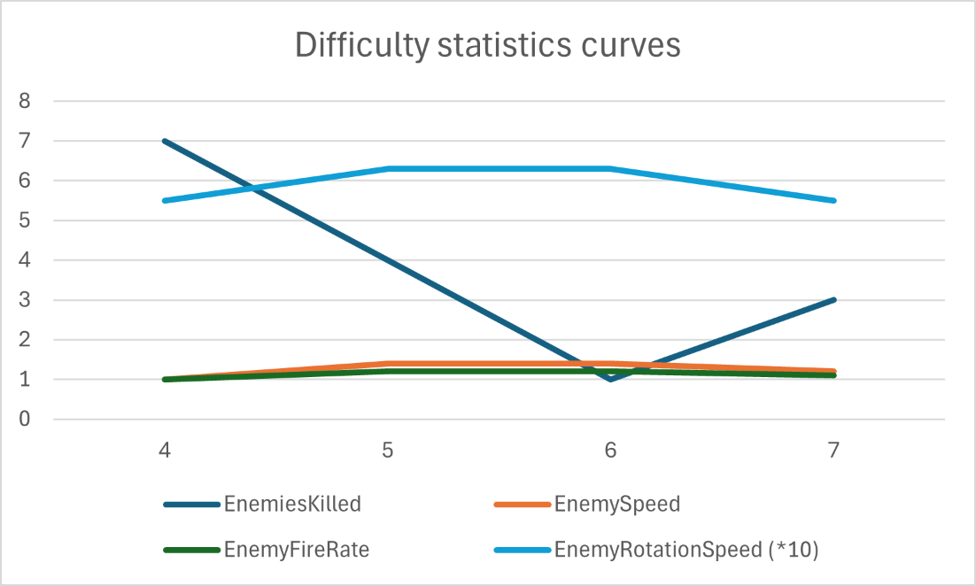

*Figure 9 Graph difficulty statistics*

Based on the graph above that is created with the quantitative results, depicting the difficulty statistics, it is evident that adjustments in gameplay mechanics directly influence the player's experience and performance. The graph highlights the relationship between different elements such as enemies killed and various enemy attributes like speed, fire rate, and rotation speed across multiple sessions.

As the sessions progress, the number of enemies killed fluctuates, indicating variations in game difficulty. For instance, a noticeable decrease in enemy kills correlates with increases in enemy speed and other attributes, suggesting that these enhancements pose greater challenges to the player. Conversely, sessions with higher enemy kills might correspond to periods when the game's difficulty parameters were lower and thus more favorable or easier for the player.

This dynamic adjustment of difficulty settings is aimed at maintaining a balanced challenge, keeping the game engaging and responsive to the player's skill level. The intention is to avoid player frustration from a static difficulty level while also preventing the game from becoming too easy, which could lead to disinterest.

Such a graph is crucial for illustrating the effectiveness of dynamic difficulty adjustment systems in games. It provides clear, quantifiable evidence that careful calibration of difficulty parameters can significantly impact player engagement and success. This insight is valuable for developers aiming to refine game design and enhance player satisfaction through adaptive challenge levels.

Based on the provided survey results, a comprehensive understanding of player experience and satisfaction with the game's difficulty adjustments can be developed. The survey results are visually represented through various charts, which clearly depict the players' interaction and reaction to the game dynamics. [22]

### Qualitative results

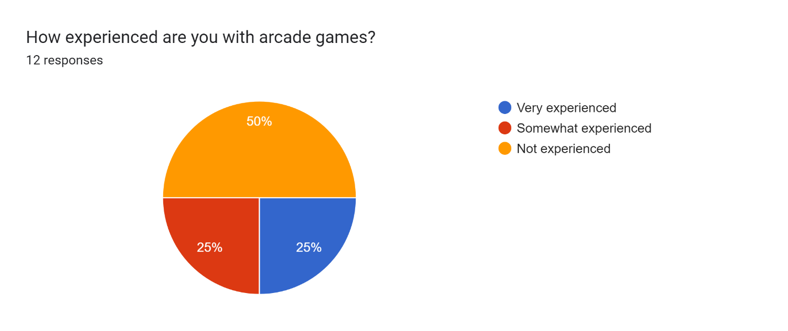

Figure Amount of experienced arcade players

Player Experience with Arcade Games (Figure 10): Most participants have substantial experience with arcade games, with 50% (25-25) identifying them as experienced. This demographic foundation suggests that feedback and difficulty perceptions are informed by a seasoned understanding of similar game mechanics.

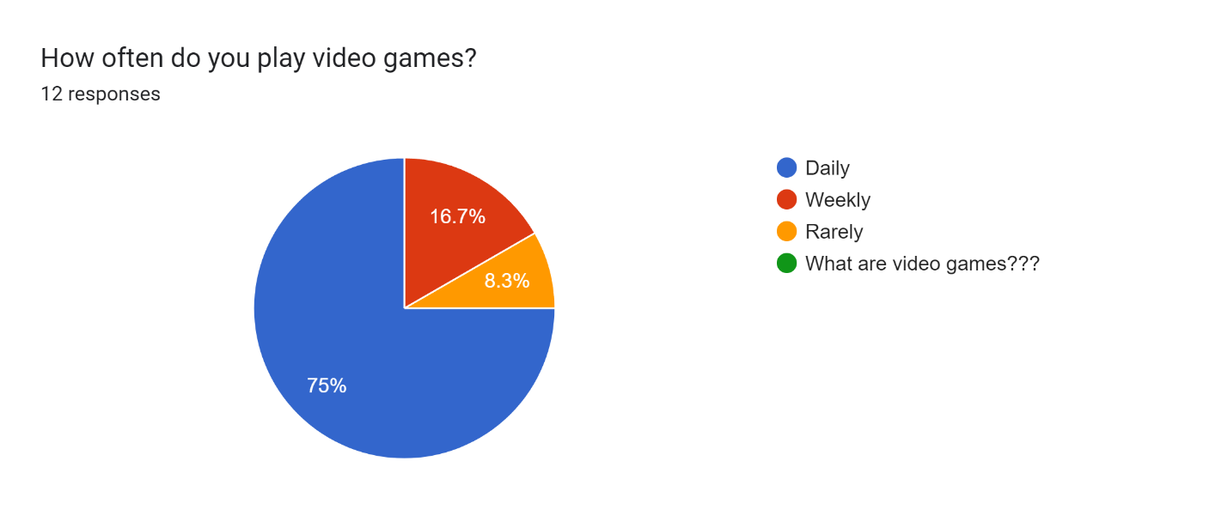

Figure How often do people play games?

Frequency of Gameplay (Figure 11): A significant 75% of respondents play video games daily, which indicates a high level of familiarity and comfort with gaming interfaces and challenges. This regular interaction with games could influence their expectations and perceptions of difficulty levels.

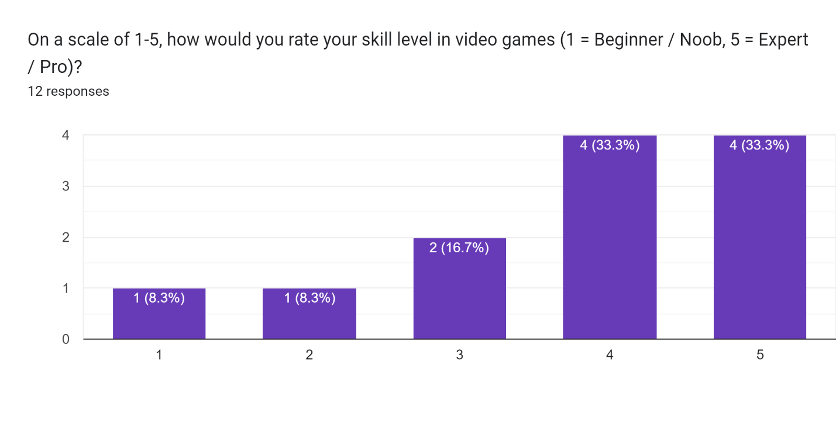

Figure Amount of skilled players

Skill Level Self-Assessment (Figure 12): The players' self-rated skill levels show a bell-curve distribution with the majority considering themselves intermediate to expert. This distribution supports the notion that the game was tested by a competent group of players capable of providing reliable feedback on its difficulty settings.

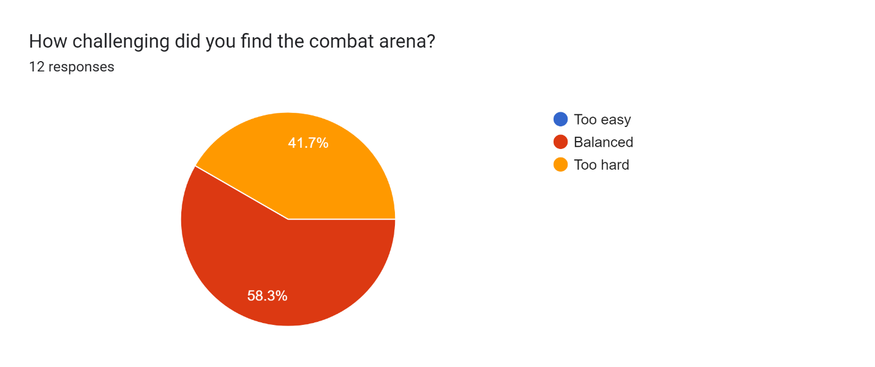

Figure Amount of people that found it challenging

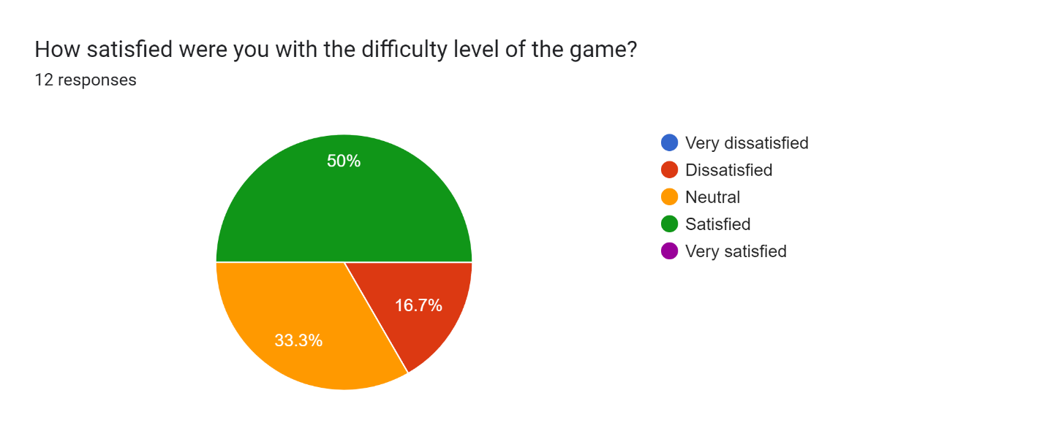

Figure Amount of people satisfied

Perceived Challenge and Satisfaction (Figure 13): A substantial 58.3% found the combat arena balanced, which aligns with the game's aim to provide a challenging yet manageable experience. The satisfaction levels with the difficulty level also reflect a positive reception, with 83.3% of participants reporting that they were satisfied/neutral, suggesting that the game meets the difficulty preferences for most players. (Figure 14)

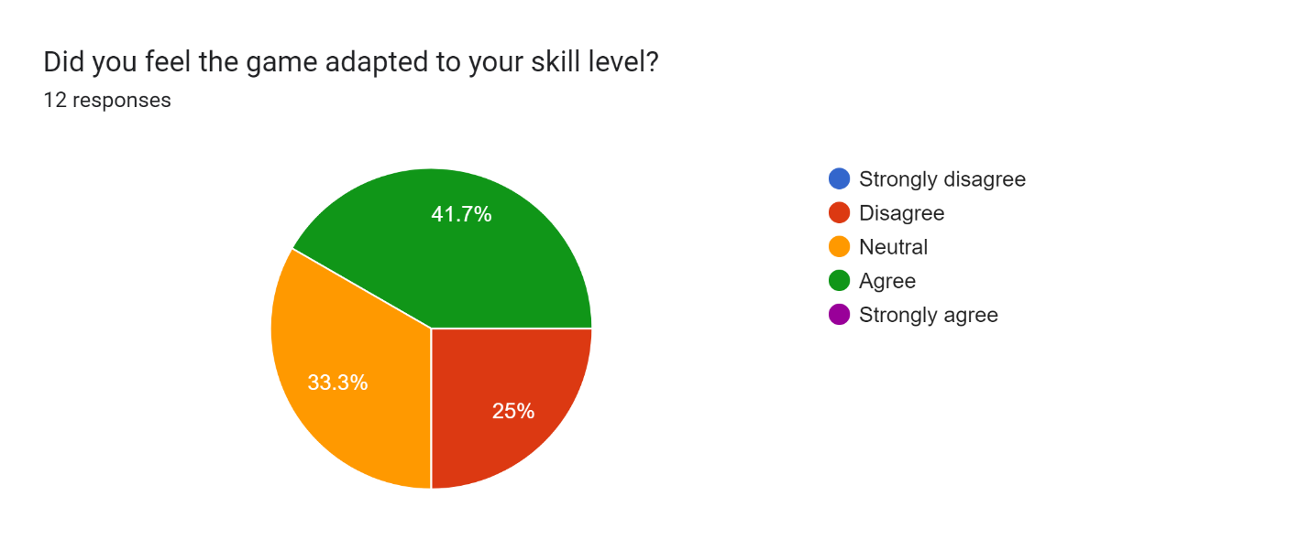

Figure Amount of people that felt the game adapted

Adaptation to Skill Level (Figure 15): Regarding the game’s adaptive difficulty, opinions are mixed. While 41.7% agree that the game adjusted well to their skill level, a notable 33.3% were neutral, and 25% disagreed, indicating potential areas for improvement in how the game scales its challenges based on player performance.

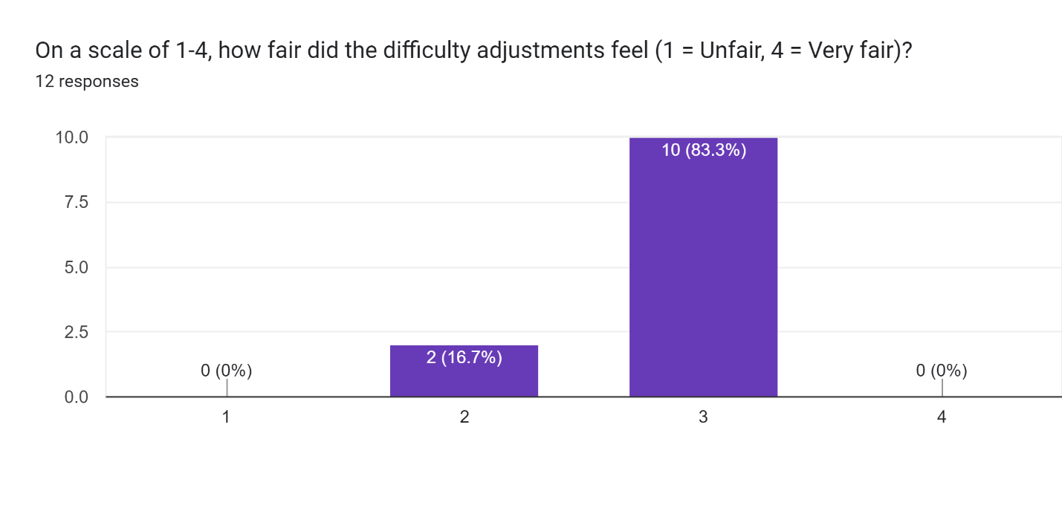

Figure How fair were the adjustments

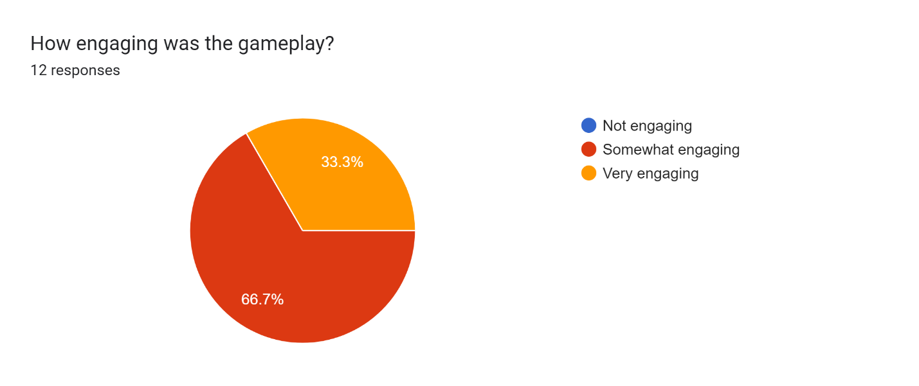

Figure Amount of people that found it engaging

Gameplay Engagement and Fairness (Figure 17): The gameplay engagement is predominantly viewed positively, with 66.7% finding it engaging. Moreover, the fairness of the difficulty adjustments received high marks, with most players feeling that the changes were very fair, suggesting that the dynamic difficulty adjustment system is effective and enhances the gameplay experience. (Figure 16)

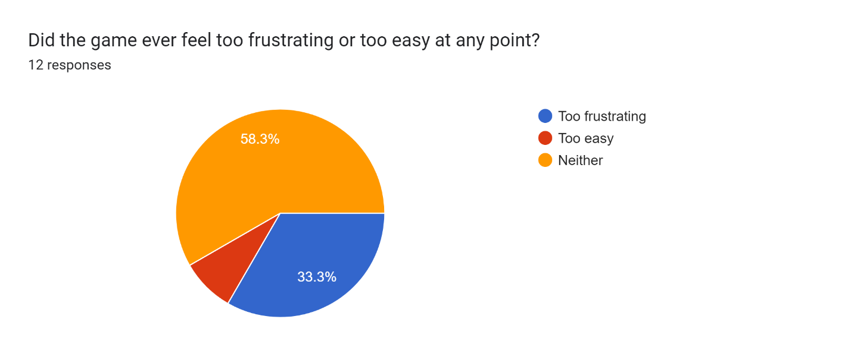

Figure Amount of people that found it frustrating or to easy

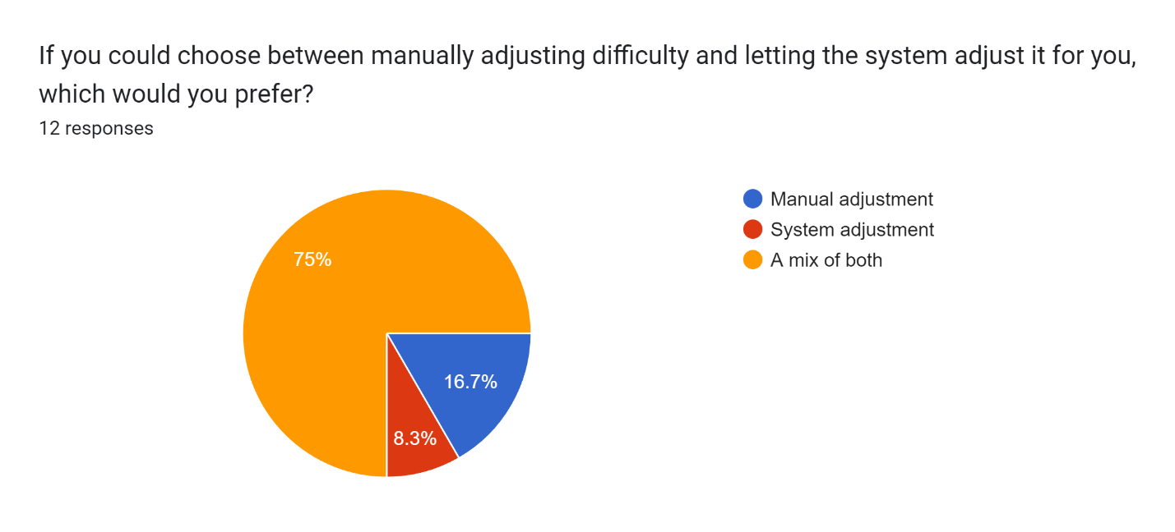

Figure Manual adjustment or System adjustment?

Preference for Difficulty Adjustment (Figure 19): Interestingly, when asked about their preference for manual versus automated difficulty adjustment, a majority (75%) preferred a system that either automatically adjusts or a mix of both, highlighting a trend towards favoring systems that change challenges in real-time.

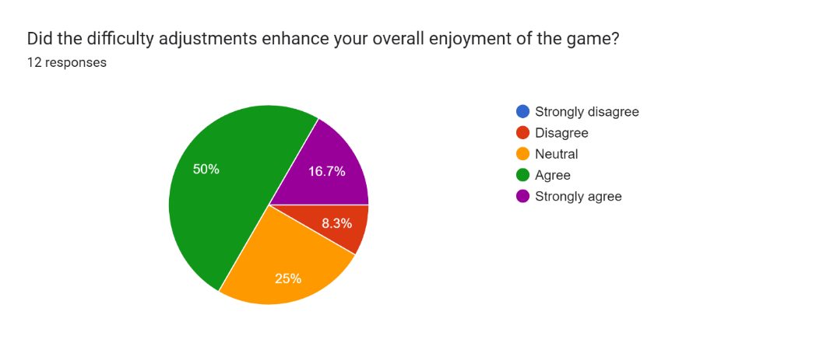

Figure Did the DDA enhance the UX?

### Observational insights

From these insights, it is evident that the game's difficulty adjustment mechanisms are generally well-received, aligning challenges appropriately with varied player skills and preferences. However, the mixed responses on adaptation suggest that further refinement could enhance the perception of the game's responsiveness to individual player progress and abilities.

# Discussion

The evaluation of survey results and difficulty adjustment data from the game sessions suggests a complex interaction between player experience and the effectiveness of dynamic difficulty adjustments. The results provide practical support for the theoretical framework underlying adaptive game design, wherein adjustments are made in real-time to adapt to individual player skills and preferences to enhance engagement and satisfaction.

The theoretical underpinnings of dynamic difficulty adjustments involve concepts from adaptive systems and user-centric design, suggesting that games should dynamically align challenges according to real-time player performance metrics. In our case, the data shows a notable alignment between increased difficulty settings (like enemy speed and fire rate) and a reduction in enemies killed, which is indicative of the DDA system successfully increasing game difficulty in response to player skill levels. This is supported by the players positive response to the fairness and engagement of the game, as seen in the survey results, where a significant majority found the difficulty adjustments to be fair and the gameplay engaging.

The findings show that while the difficulty adjustments were generally well-received, there is a nuanced response regarding the game's adaptability to individual skill levels. Despite the majority appreciating the adaptive difficulty, a quarter of the players did not feel the game adapted well to their skill level, indicating potential areas for refinement in the DDA algorithm or it was too subtle. This might be attributed to the specific metrics used to measure player performance, suggesting that a finer approach could be developed.

Additionally, the engagement levels and how often players encountered a level of difficulty that was either too easy or too frustrating suggest that while the DDA system generally maintains a balanced challenge, there are moments where the balance could tip too far, impacting player satisfaction. This aspect ties back to the theoretical concept that overly frequent or drastic changes can disrupt the player's flow state, potentially leading to frustration or disengagement that led the player to leave the game and never finish the 7 sessions.

From a theoretical standpoint, the application of DDA aligns with concepts of flow and motivation as outlined by Csikszentmihalyi, where the goal is to keep players in a state where the challenge matches their skill level to maintain engagement. The survey responses indicate that the game partially achieves this, especially in terms of maintaining a challenging environment as endorsed by the balance in difficulty levels perceived by players. However, the data also suggests that the precision of the difficulty adaptation could be enhanced to accommodate a wider range of player sensitivities to challenge adjustments.

# Conclusion

This study on DDA within a gaming context provides insights into the adaptive mechanisms of modern game design and their impact on player engagement and satisfaction. The implementation of DDA, as explored through quantitative game session data and qualitative survey responses, affirms the potential of adaptive game systems to enhance player experience by aligning game challenges with player skill levels in real-time.

The primary outcome of this study reveals that dynamic difficulty adjustments can significantly change the gaming experience in ways that align with theoretical frameworks of player engagement and motivation. The data derived from game sessions clearly illustrates a correlation between adjusted difficulty parameters and player performance metrics, demonstrating the effectiveness of DDA systems in maintaining a balance between challenge and player ability. This balance is crucial for sustaining player interest and promoting a rewarding game experience.

Moreover, the survey results further substantiate the quantitative findings, with most participants recognizing the fairness and engagement of the difficulty adjustments. This dual-faceted approach, integrating both gameplay metrics and player feedback, highlights the impact of DDA systems in diverse gaming scenarios and offers a robust model for evaluating player-centric game design strategies.

# Future work

The implementation of Dynamic Difficulty Adjustment (DDA) has proven effective in creating a responsive game environment, yet there is notable potential for enhancement in how difficulty adjustments are perceived and experienced by players. Future work should focus on developing refined player metrics that can facilitate more precise difficulty adjustments, as well as experimenting with hybrid models that integrate player choices with automated scaling. By expanding upon these strategies, it is possible to address the discrepancies in player satisfaction and adaptability, ultimately enhancing player engagement and retention in adaptive games. This continued evolution will not only improve the effectiveness of DDA systems but also ensure that the adjustments are seamlessly integrated into gameplay, providing a uniformly positive gaming experience that is substantiated by both practical data and established theoretical frameworks.

# Critical Reflection

In reflection, this project has been a profound learning experience that has not only enhanced my technical skills, such as working in Unity and programming a DDA system within a combat platformer space game but has also underscored the importance of effective project management and communication strategies. As I continue to grow in my career, I am committed to refining these skills and addressing the identified areas for improvement. This experience has highlighted the need for me to manage communications with greater diligence (opening outlook more often), ensuring that my future projects are managed more effectively and are more aligned with expectations and industry standards. Additionally, also keep an eye out for task management to make room for unexpected bugs and more testing.

# References

1. Daniel J. Acland (2020) | An Investigation of Flow Theory in an Online Game (<https://gspp.berkeley.edu/assets/uploads/research/pdf/Acland_%282020%29_An_investigation_of_flow_theory_in_an_online_game.pdf>)
2. Robin Hunicke, Vernell Chapman | AI for Dynamic Difficulty Adjustment in Games
3. Robin Lievrouw (2019) | Deep Reinforcement Learning Applying Dynamic Game Difficulty Adjustment Using (
4. David Kristan, Pedro Bessa, Ricardo Costa and Carlos Vaz de Carvalho (2020) | Creating Competitive Opponents for Serious Games through Dynamic Difficulty Adjustment (<https://www.mdpi.com/2078-2489/11/3/156>)
5. Dagmara Dziedzic & Wojciech Włodarczyk (2018) | Approaches to Measuring the Difficulty of Games in Dynamic Difficulty Adjustment Systems (<https://doi.org/10.1080/10447318.2018.1461764>)
6. Juzeleniene, S., Mikelioniene, P., Escudeiro, P., Vaz de Carvalho, C. Gaball Project (2014) | Serious games based language learning
7. Aurelie Le Chevalier (2019) | Data-Driven Dynamic Gameplay Effects on For Honor (<https://www.youtube.com/watch?v=JgSvuSaXs3E>)
8. AI and Games (2020) | Director AI for Balancing In-Game Experiences | AI 101 (<https://www.youtube.com/watch?v=Mnt5zxb8W0Y&t=274s>)
9. Upper Echelon (2019) | Dynamic Difficulty Adjustment - A Whole New Breed of Pay to Win (<https://www.youtube.com/watch?v=vYAyCHvhYOQ&t=359s>)
10. Mohammad Zohaib | Dynamic Difficulty Adjustment (DDA) in Computer Games: A Review (<https://onlinelibrary.wiley.com/doi/10.1155/2018/5681652>)
11. Changchun Liu, Pramila Agrawal, Nilanjan Sarkar & Shuo Chen (2009) | Dynamic Difficulty Adjustment in Computer Games Through Real-Time Anxiety-Based Affective Feedback (<http://dx.doi.org/10.1080/10447310902963944>)
12. Rhio Sutoyo, Davies Winata, Katherine Oliviani, Dedy Martadinata Supriyadi (2015) | Dynamic Difficulty Adjustment in Tower Defence (<http://www.sciencedirect.com>)
13. Mirna Paula, Victor do Nascimento Silva, Luiz Chaimowicz (2016) | Dynamic difficulty adjustment on MOBA games (<https://www.sciencedirect.com/science/article/abs/pii/S1875952116300350?via%3Dihub>)
14. Mariia Shakhova, Aleksandr Zagarskikh (2019) | Dynamic Difficulty Adjustment with a simplification ability using neuroevolution (<https://www.sciencedirect.com/science/article/pii/S187705091931138X>)
15. Adi Stein, Yair Yotam, Rami Puzis, Guy Shani, Meirav Taieb-Maimon (2017) | EEG-triggered dynamic difficulty adjustment for multiplayer games (<https://www.sciencedirect.com/science/article/abs/pii/S1875952117301325?via%3Dihub>)
16. Ewa Lach (2017) | EuroGP (European Conference on Genetic Programming) (<https://www.researchgate.net/publication/318134355_Dynamic_Difficulty_Adjustment_for_Serious_Game_Using_Modified_Evolutionary_Algorithm>)
17. Edwin A. Romero-Mendez, Pedro C. Santana-Mancilla, Miguel Garcia-Ruiz, Osval A. Montesinos-López, Luis E. Anido-Rifón (2023) | IEEE Conference on Computational Intelligence and Games (CIG) (<https://www.mdpi.com/2076-3417/13/14/8249>)
18. Peizhi Shi, Ke Chen (2017) | Learning Constructive Primitives for Real-Time Dynamic Difficulty Adjustment in Super Mario Bros (<https://ieeexplore.ieee.org/document/8010833>)
19. Dennis Ang, Alex Mitchell (2019) | Representation and Frequency of Player Choice in Player-Oriented Dynamic Difficulty Adjustment (<https://www.youtube.com/watch?v=CNgKQnW5T5g>)
20. Robin Hunicke (2005) | The case for dynamic difficulty adjustment in games (<https://www.researchgate.net/publication/220982524>)
21. Top 10 You Should Know (2024) | Top 10 Games That Use Machine Learning for Dynamic Difficulty Adjustment (<https://www.youtube.com/watch?v=Q4w8SXAke_8>)
22. Susan A.Jackson, Herbert W.Marsh (1996) | Development and Validation of a Scale to Measure Optimal Experience: The Flow State Scale (<https://ess22012.wordpress.com/wp-content/uploads/2012/09/flow-state-scale004.pdf>)
23. Csikszentmihalyi (1990) | M. Flow: The Psychology of Optimal Experience (<https://blogs.baruch.cuny.edu/authenticityandastonishment2/files/2013/04/Mihaly-Csikszentmihalyi-Flow1.pdf>)
24. Csikszentmihalyi (1975) | Beyond boredom and anxiety (<https://www.researchgate.net/publication/232463581_Beyond_Boredom_and_Anxiety>)
25. HitBerry Games (2024) | Player-Centric approach to gameplay mechanics (<https://www.linkedin.com/pulse/gameplay-mechanics-player-centric-approach-hitberry-games-frckf>)
26. BusinessWire (2025) | Wemade Next to Develop an AI Boss in MIR5 in Collaboration with NVIDIA (<https://www.youtube.com/watch?v=vArUDtpQY7o>) (<https://www.businesswire.com/news/home/20250106300797/en/Wemade-Next-to-Develop-an-AI-Boss-in-MIR5-in-Collaboration-with-NVIDIA>)
27. Olana Missura (2015) | Dynamic difficulty adjustment (<https://d-nb.info/1079273344/34>)

# Acknowledgements

I want to thank Fries Boury and Kasper Geeroms for their guidance and support throughout the duration of this research. Their support and encouragement were crucial in understanding and navigating the challenges encountered during the development and testing phases.

Additionally, I extend my thanks to all the testers who participated in evaluating my prototype. Their feedback has been very instrumental in refining the gameplay mechanics and enhancing the overall user experience, making the project not just a theoretical exercise but a practical exploration into this research.

All your collective expertise and dedication have greatly contributed to my professional growth and the success of this project. Thank you all for your support and commitment.

*Alexander T.*

# Appendices

Here you can find code snippets and links to the tools and programs I used and a link to Github that has the prototype used by the testers for the survey data (link will also be provided to the forum questions).

**Prototype:**

<https://github.com/BeHaVeZ/BeHaVeZ-DDA_GW2024-25>

**Tools and programs:**

1. Unity engine for the framework (<https://unity.com>)
2. Visual studio for the coding behind the system (<https://visualstudio.microsoft.com>)
3. Google forms for the qualitative feedback (<https://forms.gle/DKkis7oUa2DLKLBx7>)

*Figure 21 General difficulty settings*

*Figure 22 Code AdjustPickupSpawnChance*

*Figure 23 EnemyFighter that changes properties based on difficultySettings*