Pose estimation SOP

SOP for generating the .csv file with 3D coordinates of body keypoints from videos recorded during the experimental session and integration into the pyal data.

Quick use: once the bnp environment is set up and activated, run the command line:

bnp pose session_name

Overview:
- Overall workflow
- Setting up the environment
- Running the pipeline on a full session
- Running a test on a session
- Evaluation
- Manual annotation for training
- Training
- Paths in config file

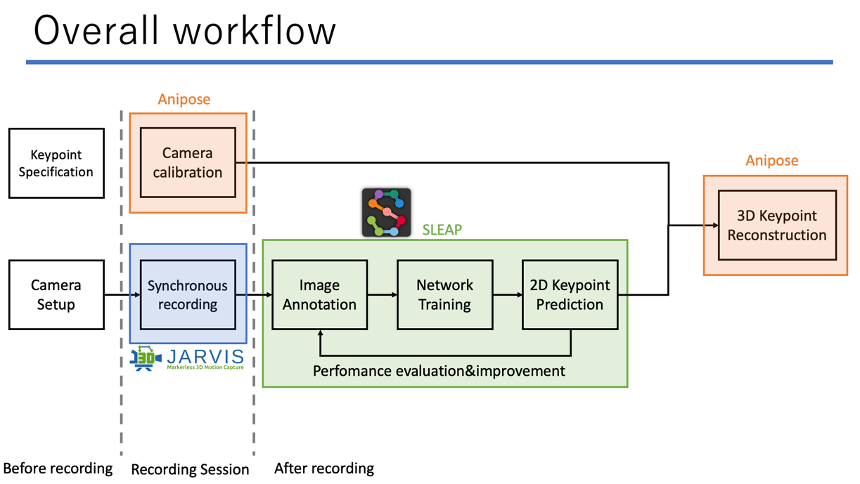

1. Setting up the environment:
What you will need:
- LOCAL_PATH: path to the folder on the local machine (brain or personal computer) that contains a folder called “raw
- REMOTE_PATH: path to rds: “…/live” (parent of “raw” folder on RDS)
- https://github.com/BeNeuroLab/beneuro_pose_estimation Follow the instructions in the README file. Make sure you have the right versions for: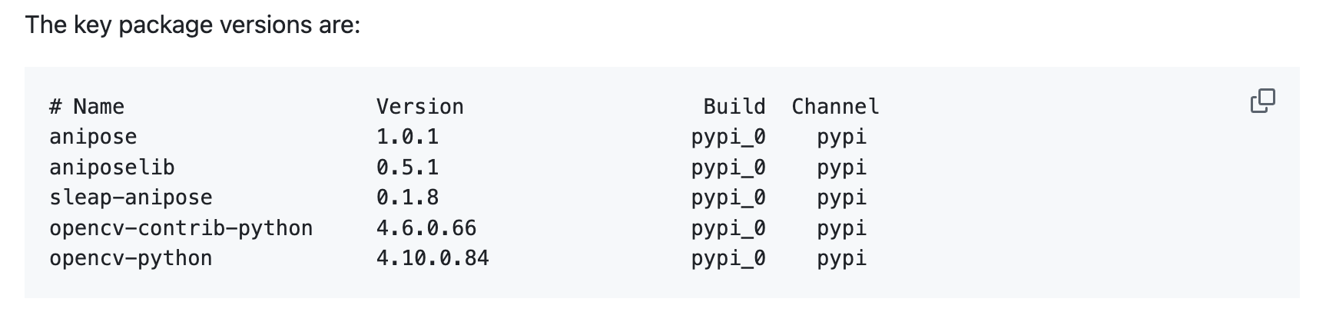
- conda install typer 🙂
- pip install plotly 🙂
- bnp init
  - will ask you for the REMOTE_PATH (path to rds: “…/live”) and LOCAL_PATH (any folder on your local machine that contains a “raw” folder: “…/live”).

2. Running the pipeline on a full session:
===================================================
- Download the session videos locally with bnd
conda activate bnd
bnd dl session_name -v
====================================================

conda activate bnp
bnp pose session_name

e.g: bnp pose M062_2025_03_21_14_00
*can also pass a list of sessions:
bnp pose M062_2025_03_21_14_00 M062_2025_03_20_14_00

Output:
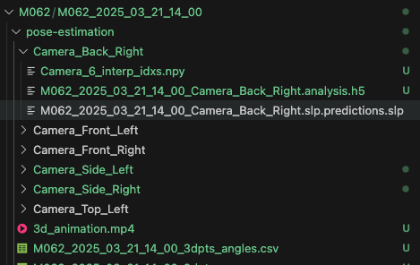

- Intermediate triangulation and csv files are deleted at the end as part of the pose command.
If you have test folders that you want to get rid of before uploading to rds with bnd:
bnp cleanup session_name

which will check for any intermediate triangulation files and test folders and will ask whether you want to delete the test folders

- Add it to the pyal data .mat file:
If the .nwb file for the session already exists, delete it. The g0 files will have to be downloaded locally to recreate it.

conda activate bnd
bnd dl session_name
bnd to-pyal session_name

If .mat files already exist, it will ask whether you want to rewrite them, say yes.

To upload to rds:
bnd up session_name

3. Running a test on a session:
Run the full pipeline on a short video extracted from the session (from each camera) to evaluate the results.

bnp pose-test session_name
e.g. bnp pose-test M062_2025_03_21_14_00

Optional – can specify test name
bnp pose-test session_name --test-name test_name
e.g. bnp pose-test M062_2025_03_21_14_00_ test _soft_l1

Other optional arguments:
force_new: bool = typer.Option(
False,
"--force-new", "-f",
help="Force creation of new test videos even if they exist."
),
start_frame: Optional[int] = typer.Option(
None,
"--start-frame", "-s",
help="Frame number to start from. If not specified, uses frame 0 (I think)."
),
duration: Optional[int] = typer.Option(
10,
"--duration", "-d",
help="Duration in seconds. If not specified, uses 100 frames."
)

Output: same as pose, in raw/animal/session_name/pose-estimation/tests/test_name

pose-test will also save an animation html file that you can download locally and open to visualize an interactive animation. instructions printed in terminal:
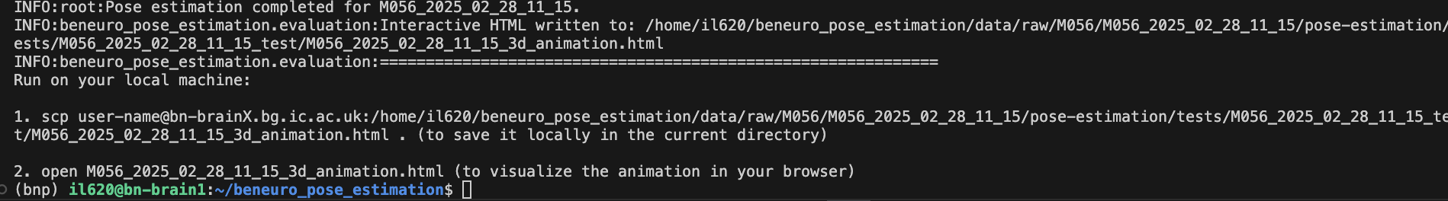
Edit user-name with your shortcode and the brain address (@brainX.bg.ic.ac.uk).

4. Evaluation:
Interactive animation – only for evaluation of a test session, not the full session. Will add it for full session too.

- Run in your local terminal the commands printed by pose-test.
- If you are happy with the animation, run the pipeline on the full session (2).

- Otherwise, check 2D predictions and triangulation:

In REPO_PATH/notebooks/evaluation_visualization_empty.ipynb

Make a copy if you want to keep it:
Save as > REPO_PATH/notebooks/evaluation_visualization_{test_name}.ipynb

- Set SESSION_NAME and TEST_NAME in Configuration
if you didn’t specify the test name when running pose-test, TEST_NAME = “{session_name}_test”
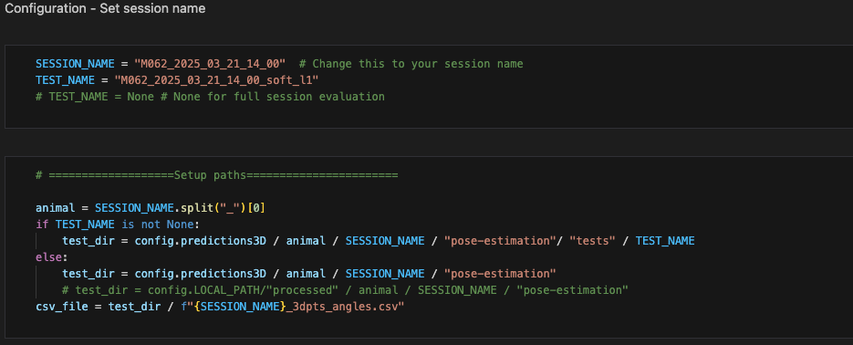
- Then, can just run the whole notebook
- Can check animation again, but not interactive
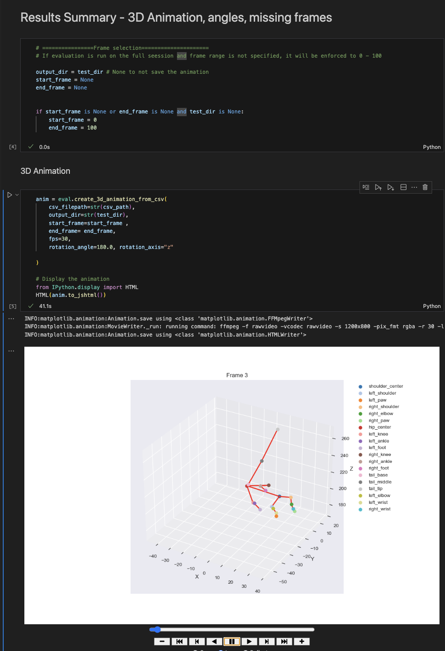
- If you are happy, run the pipeline on the full session (2).
- Else, check 2D predictions:
  - Model information – training/validation metrics, independent of test session; specify camera;
  - 2D prediction scores – predictions confidence scores on test session

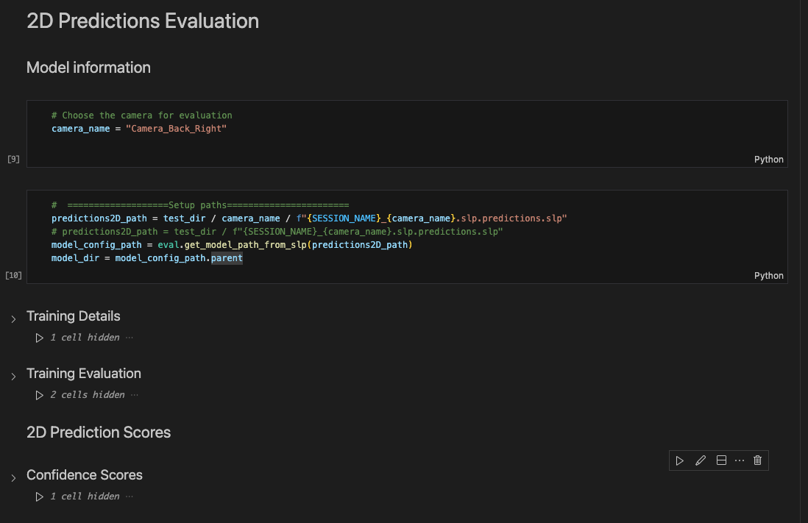
- If you are not happy and want to annotate/train more –> (5),(6).
- If you are happy, check triangulation evaluation (reprojection errors – projecting 3D estimations back on the 2D views):

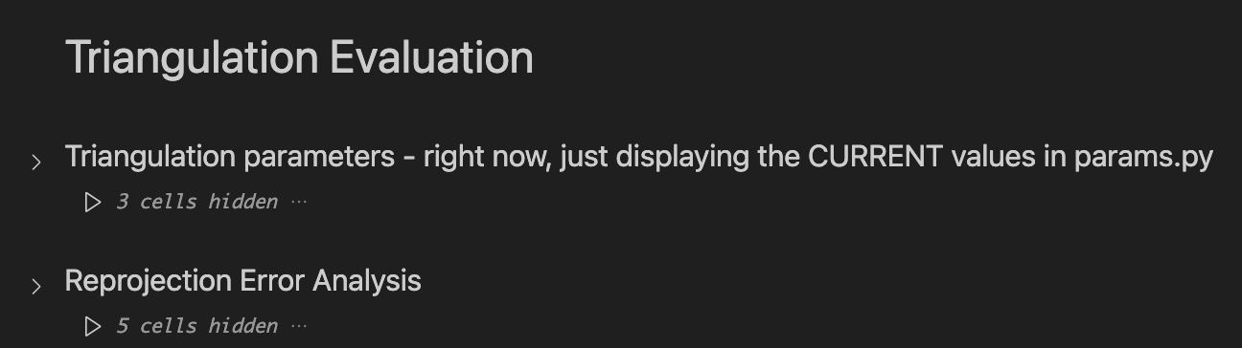

- Extra joint angle analysis
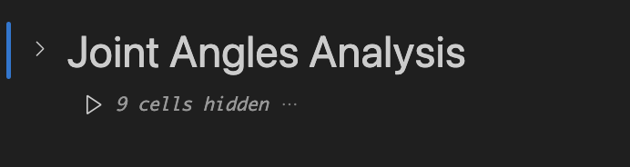

Manual annotation for training:

*better to do this on your own laptop for the GUI – otherwise you need to install something to forward the gui from the remote machine to the local one

bnp annotate session_name camera_name

Will open an existing annotation project if there is one otherwise it first creates the project.

Can also create the annotation projects beforehand:

To create annotation projects for all cameras:
bnp create-annotation-projects session_name

To create annotation projects for specific cameras:
bnp create-annotation-projects session_name --cameras camera_name

- While annotating, can save (Ctrl+S/Command+S) and close the project and resume by running the annotate command again.
- ! When you are done annotating:
Predict > Export Labels Package > Labeled frames > Save it in remote_path/processed/AnnotationParty/training/{camera_name}/{camera_name}_{session_name}.pkg.slp

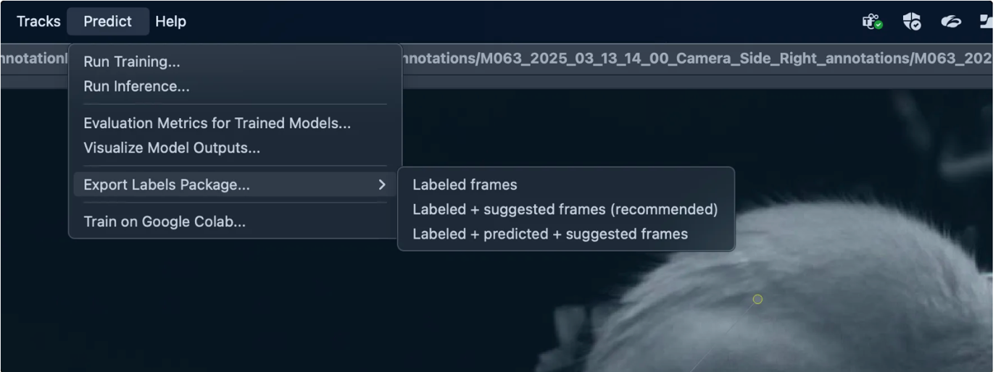
--------------

Can either use this path for the training labels, or can merge it into the file with all the annotations for that camera:

- Launch sleap GUI:
sleap-label

- Open project:
remote_path/processed/AnnotationParty/training/{camera_name}/{camera_name}.pkg.slp
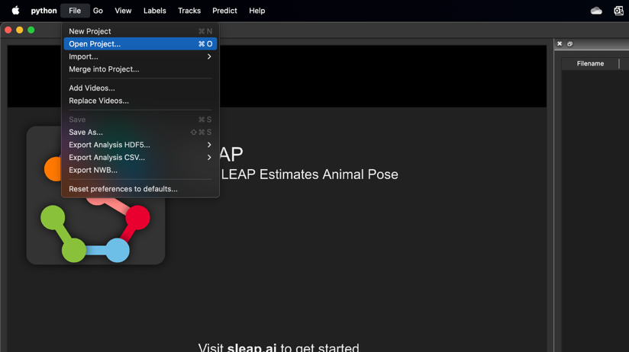

- Merge into project:
remote_path/processed/AnnotationParty/training/{camera_name}/{camera_name}_{session_name}.pkg.slp

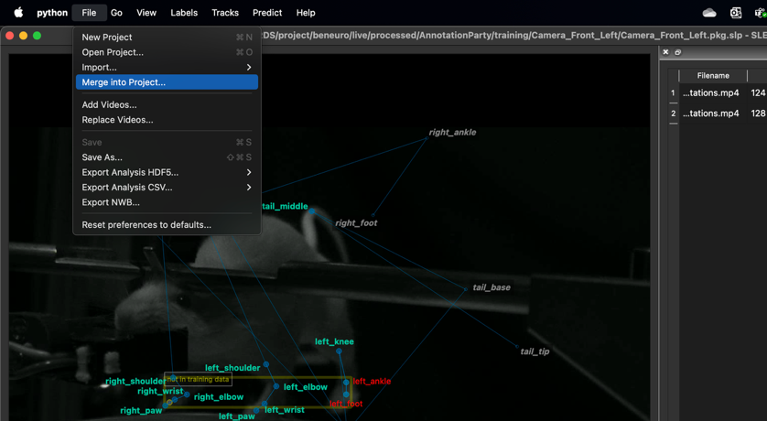
Can also create a labels package for a certain type of sessions – e.g.: bci
- Make a copy of the new labels package
Save as > remote_path/processed/AnnotationParty/training/{camera_name}/{camera_name}_bci.pkg.slp
- Merge into the project the labels from other bci sessions

Annotation tips:
- Save regularly (Ctrl+S / Command+S)
- To create a new annotation instance on a frame: Ctrl+I / Command+I
- Select instance placement method - if predictions are good, use copy predictions; if not, can use copy prior frame, and you can also do Delete All Predictions if they are annoying.
- If SLEAP suddenly closes when you click on the screen, use a mouse.
- Can also zoom in. There is a way to make it not crash on mac but need to check again.
6.Training
- Edit training config file from REPO_PATH/beneuro_pose_estimation/training_config.json

- IF you want to use a custom labels package (not the one with all the annotations for that camera), specify path:
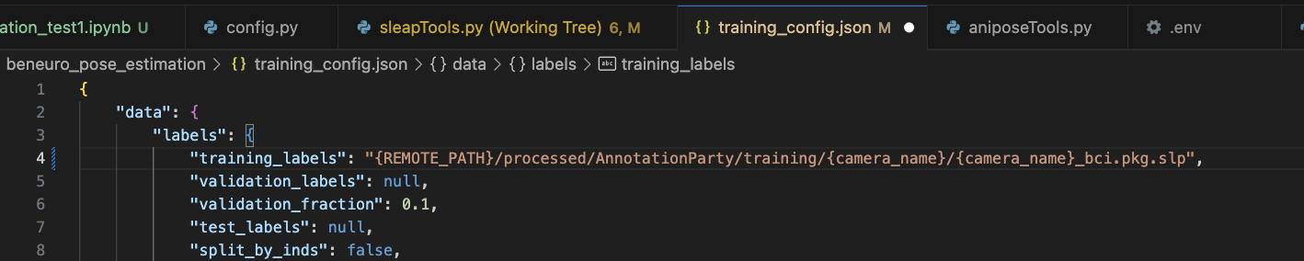

Otherwise leave it empty “”.
- Edit output paths
  - run_name = “test_name”
  - run_name_prefix = “{camera_name}_”
  - runs_folder = “LOCAL_PATH/raw/pose-estimation/models/{camera_name}”.
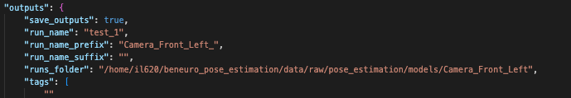
- If you want to change training details:
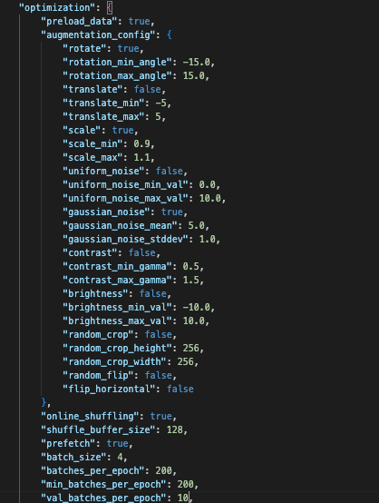
- If the annotations were done on a different computer (e.g local instead of remote), you need to check that on the computer on which you are training the paths in the labels project point to the right location -> might need to open the labels project in sleap on the computer on which you are training and it will ask to select the location of the videos used for the annotations in case it cannot find them.
- bnp train --cameras camera_name (-cl for custom labels package)

or, to train models for all cameras
bnp train
Output: in runs_folder:
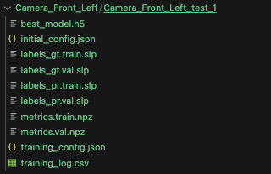

- Can run a test using the new model or run the full pipeline using this custom model by using the run_name:
bnp pose-test {session_name} --test_name {run_name}
bnp pose {session_name} --model_name {run_name}

To upload the model to RDS:
- bnp model-up {model_folder_name}
e.g. bnp model-up Camera_Front_Left_test_1
maybe rename the model with the date?

This will upload the model on RDS along with all the other models.
Then, to replace the old general model that everyone uses with the new one: copy the contents of this folder into AnnotationParty>models>camera_name>

7. Paths

