/*
College Name :- Lovely Professional University, Jalandhar
Faculty Name :- Roshan Srivastava
Name :- Ashwani Kumar
Roll No. :- B-38
Registration No. :- 11806645
Section :- K18PG
Subject :- CSE310 ( Programming To Java )
*/
/* Hotel Management System */
/* Save as Hotel.java */
/* Code */
import java.io.IOException;
import java.util.ArrayList;
import java.util.Scanner;

class Room
{
// Each time a new Room is created by Hotel, Room No is 100, but a roomCounter in the Hotel class increments it each time
protected int roomNo = 100; // This is only set for a Room object when the Room object is first is created
protected String type;
protected double dailyRent;
protected boolean hasSeaView;
protected boolean occupancyStatus;

public int setRoom(String type, double dailyRent, boolean hasSeaView)
{
this.type = type;
this.dailyRent = dailyRent;
this.hasSeaView = hasSeaView;
this.occupancyStatus = false; // By default, whenever a Room is added it is empty

return this.roomNo;
}

}

class Booking extends Room
{
protected int roomNo;
protected String guestName;
protected String guestEmail;
protected int noOfDays;
protected double guestBill;

public double bookRoom(int roomNo, String guestName, String guestEmail, int noOfDays)
{
this.roomNo = roomNo;
this.guestName = guestName;
this.guestEmail = guestEmail;
this.noOfDays = noOfDays;
return this.guestBill;
}
}

public class Hotel extends Booking
{

protected String name;
protected String city;
protected int maxRooms; // To hold max possible rooms in a hotel
protected ArrayList<Room> rooms;
public static int roomCounter = 1; // To simply increment each time a room is added
protected ArrayList<Integer> searchedRooms; // A list to just hold the searched Rooms list. It will be cleared after each search.
protected ArrayList<Booking> bookings;
// Setter for Hotel : Method to set up a Hotel
public void setHotel(String name, String city, int maxRooms)
{
this.name = name;
this.city = city;
this.maxRooms = maxRooms; //Sets maxRooms to inputed value
this.rooms= new ArrayList<Room>(maxRooms);
this.bookings= new ArrayList<Booking>(maxRooms); // Declares Array List which can maximum number of rooms
System.out.println("Congratulations on Setting Up Your New Hotel.....!!!!\n");
}
// Getter for Hotel : Method to display Details of Hotel
public void getHotel()
{
System.out.println("***************************************************************************************************************************************************\n");
System.out.println("Hotel Name: "+this.name);
System.out.println("Hotel City: "+this.city);
System.out.println("Maximum Rooms in The Hotel: "+(this.maxRooms));
System.out.println("**************************************************************************************************************************************************\n");
System.out.println("\n");
}
// Function to add new Room into Hotel (ArrayList of rooms)
public void addRoom(Room roomObj)
{
this.rooms.add(roomObj);
}
// Function to get all details of all rooms in the Hotel
public void displayAllRooms()
{
System.out.println("Maximum Number Of Rooms in The Hotel "+this.name+" are "+rooms.size()+"\n");
System.out.println("------------------------------------------------------------------------------------------------------------------------------------------------------------\n");
System.out.println("Room Number Type Daily Rent (INR) Sea View Occupancy Status "+"\n");
System.out.println("-------------------------------------------------------------------------------------------------------------------------------------------------------------\n");
// Iterates for max rooms number of times, and displays needed details of all rooms line by line
for(int i=0; i<rooms.size(); i++) {
System.out.print(" "+rooms.get(i).roomNo+" ");
System.out.print(rooms.get(i).type+" ");
System.out.print("\t"+rooms.get(i).dailyRent+" ");
System.out.print(rooms.get(i).hasSeaView+"\t\t ");
System.out.println(rooms.get(i).occupancyStatus);
System.out.println("===================================================================================================\n");
}
System.out.println("***************************************************************************************************************************************************\n");
System.out.println(" All Room Details of The Registered Hotel are Shown Above. " +"\n" );
System.out.println("***************************************************************************************************************************************************\n");
}
// Function to add a new Booking with the Booking Object
public void addBooking(Booking bookingObj)
{
this.bookings.add(bookingObj);
}
// Function to display the room numbers of all the booked rooms
public void displayAllBookedRooms()
{
System.out.println("The Rooms(Room Numbers) that have been booked are :- "+"\n");
System.out.println("==========================================================================================================\n");
for(int i=0; i<bookings.size(); i++)
{ // Iterates through the Array List: bookings
System.out.print(bookings.get(i).roomNo+" ");
}
System.out.println("\n=========================================================================================================\n");
System.out.println();
}
// Function to search for a room based on Case Study Criteria of asking for Room type and whether it has a sea View or not
public int searchRoom(String roomType,boolean hasSeaView)
{
int c=0; // Counter for rooms that are matching the criteria
this.searchedRooms = new ArrayList<Integer>(this.maxRooms);
for(int i=0; i<rooms.size(); i++)
{ // Iterating through the ArrayList: rooms
Room roomObj = rooms.get(i); // Retrieving Room Object from the ArrayList: rooms, one at a time
// If criteria matches, increment Counter
if((roomObj.type.equals(roomType)) && (roomObj.hasSeaView==hasSeaView) && (roomObj.occupancyStatus==false))
{
searchedRooms.add(roomObj.roomNo); // The room number gets appended onto the List
c++;
}
}
return c; // Returns the number of rooms that matched the criteria
}
// Function to search for room based on a maxBudget per night constraint as specified by the user
public int searchRoom(double maxBudget)
{
int c=0; //counter for rooms matching criteria
this.searchedRooms = new ArrayList<Integer>(this.maxRooms);
for(int i=0; i<rooms.size(); i++)
{ // Iterating through the ArrayList: rooms
Room roomObj = rooms.get(i); // Retrieving Room Object from the ArrayList: rooms, one at a time

// If the daily rent of a room is less than maxBudget, and room is not occupied
if((roomObj.dailyRent <= maxBudget) && (roomObj.occupancyStatus==false))
{
searchedRooms.add(roomObj.roomNo); // The room number gets appended onto the List
c++;
}
}
return c; // Returns the number of rooms that matched the criteria
}
// Function to show all the Guests who have already Booked a room
public void displayGuestDetails()
{
System.out.println("************************************************************************************************************************************\n");
System.out.println(" Room Number Guest Name Email ID Number of Days Bill (INR)"+"\n");
System.out.println("===================================================================================================================\n");
System.out.println();

for(int i=0; i<bookings.size(); i++)
{ // Iterates through the ArrayList: bookings
System.out.print("\t"+bookings.get(i).roomNo+"\t\t");
System.out.print(bookings.get(i).guestName+"\t\t");
System.out.print(bookings.get(i).guestEmail+"\t\t");
System.out.print(bookings.get(i).noOfDays+"\t\t ");
System.out.println(bookings.get(i).guestBill+"\t\t");
System.out.println("=============================================================================================================\n");

}
}

// Main Method
public static void main(String[] args) throws IOException
{
Scanner sc = new Scanner(System.in);
// I've used a simple Exception Handling mechanism where the Error message will be apt. Errors during runtime usually might be due to "bad inputs". Always follow the instructions provided
try
{
System.out.println(" ******************** SUNSHINE HOTEL MANAGEMENT SYSTEM ********************");
System.out.println(" ********************** Better Living ********************");
System.out.println(" * *");
System.out.println(" *** ****************************************** ***");
System.out.println(" ***** * **** * * * * **** * *****");
System.out.println(" ******** * * * * * * * * * * ********");
System.out.println(" ********** * * * * * * * * * **********");
System.out.println(" **** **** * **** ***** * * **** * **** ****");
System.out.println(" **** **** * * * * * * * * **** ****");
System.out.println(" **** **** * * * * * * * * **** ****");
System.out.println(" **** **** * **** * * * * **** * **** ****");
System.out.println(" ********** ****************************************** **********");
System.out.println("**************************************************************************************************************************************************************\n");
System.out.println("Welcome to Our Hotel Management System. Before We begin with Our Functionalities, Let Us Set Up Your Hotel.\n");
System.out.println("========================================================================================================================\n");
System.out.println("Note:- Please Follow Each instruction Carefully, And You won't have Any Kind of issues." +"\n"+"Thank you....!!!!\n");
System.out.println("========================================================================================================================\n");
System.out.println("Enter Hotel Name, City, Total Number of Rooms ( Maximum Number of Rooms that Your Hotel Can Hold. ) :-\n"); // Reading Hotel attributes from user
System.out.println("========================================================================================================================\n");
System.out.println("Please Note :- Input should be Like\n Hyatt\n Kolkata\n 2\n");
System.out.println("========================================================================================================================\n");
System.out.println("Enter The Hotel Name :-\n");
String name = sc.next();
System.out.println("\nEnter The City Name :-\n");
String city = sc.next();
System.out.println("\nEnter The Total Number of Rooms ( Maximum Number of Rooms that Your Hotel Can Hold. ) :-\n");
int maxRooms = sc.nextInt();
Hotel hotelObj = new Hotel(); // Hotel Object is created here
hotelObj.setHotel(name, city, maxRooms); // Hotel is SET here
hotelObj.getHotel(); // To check if all details have been set correctly
System.out.println("===================================================================================================\n");
System.out.println("Now As An Administrator, You will have to Enter Each Room Details. "
+ "(Yes, For All The "+hotelObj.maxRooms+" Rooms that You Have Mentioned Which Your Hotel Can Accomodate. "
+ "\nYour Room Numbers Will Be Auto Generated As per The Computed Logic\n");

System.out.println("Types of Room Are To Be Entered in A Certain Fashion For Better Readability. "
+ "\nS: Standard \nD: Deluxe \nL: Luxury \n");
System.out.println("Please Note :- Input should be Like\n"+ "S/D/L\n"+"5000\n"+"true/false\n");

System.out.println("====================================================================================================\n");

for(int i=1; i<=hotelObj.maxRooms; i++)
{ // Iterating up to the Max rooms

System.out.println("Room "+i);
System.out.println("Enter The Type of Room, Daily Rent, and Mention if It Has A Sea View or Not [ boolean( true/false ) ]. "+"\n");
System.out.println("Enter The Type of Room :- "+"\n");
String type = sc.next();
System.out.println("\nEnter The Daily Rent :-"+"\n");
double dailyRent = sc.nextDouble();
System.out.println("\nEnter if It Has A Sea View or Not [ boolean( true/false ) ] :- "+"\n");
boolean hasSeaView = sc.nextBoolean();
Room roomObj = new Room(); // New Room Object is created here
int roomNo = roomObj.setRoom(type, dailyRent, hasSeaView); // Room Properties are set here and 100 is always returned
roomObj.roomNo = roomNo+roomCounter; // Custom roomNo property is set here
roomCounter++; // Increments whenever a new Room is created
hotelObj.addRoom(roomObj); //Adds the Room into the ArrayList: rooms in Hotel
System.out.println("--------------------------------------------------------------------------------------------------------------------------------------------------------");
}
System.out.println("Congratulations, All Your Rooms Have Been Set. "+"\n");
System.out.println("All Your Room Details for The Registered Hotel Are Given Below :- "+"\n");
hotelObj.displayAllRooms(); //Displays all rooms
System.out.println("========================================================================================================\n");
System.out.println("Your Hotel is Set, And All Your Hotel Rooms are Defined.\n"+"\nThank You for Joining Us. "
+ "\nPlease Note :- From Here Onwards Comes The Functionalities of What Can Be Done.. "
+ "\nPlease Note :- Neither Your Hotel Details Nor Your Room Details Can Be Redefined. "
+ "\nPlease Note :- However, If You Really Want To Redefine it, Run This Program Again. "+"\n");
System.out.println("\nPlease Note :- Functionalities Provided (or Coded For Are Limited .)"
+ " \nYou Can Make Bookings, View Total Bookings, or Search for Rooms Based on Criteria [ Type of Room/Cost ].\n");
int c=-1;
System.out.println("========================================================================================================\n");
do {
System.out.println("\nWhat Are You Looikng For? \n"
+ "Press 1 : Make A Booking \nPress 2 : View All Bookings \nPress 3 : Search The Hotel Rooms \nPress 4 : Display Guest Details\n"
+ "Press Any Other Number : Exit [Positive Numeric Input Only] "+"\n");
System.out.println("========================================================================================================\n");
c = sc.nextInt();
switch(c)
{
// Case: Make a new Booking
case 1:
System.out.println("========================================================================================================\n");
System.out.println("Enter The Room Number, Guest Name, Guest Email ID and Number of Days, They Are Going To Book For :- " +"\n");
System.out.println("Please Note :- Input should be Like \n"+"101\n"+"Rohan Sharma\n"+"rohansharma@gmail.com\n"+"5\n");
System.out.println("========================================================================================================\n");
System.out.println("Enter The Room Number ( See Above Hotel Details ) :- " +"\n");
int roomNo = sc.nextInt();
System.out.println("\nEnter The Guest Name :- " +"\n");
String guestName = sc.next(); // This accepts only one name for reading the name. if we want, we can use sc.nextLine();
System.out.println("\nEnter The Guest Email ID :- " +"\n");
String guestEmail = sc.next();
System.out.println("\nEnter The Number of Days, They Are Going To Book For :- " +"\n");
int noOfDays = sc.nextInt();

Booking bookingObj = new Booking(); // New Booking Object is created

int desiredRoomLocInList = -1; // To hold the position of Object: Room in ArrayList: rooms, if found

for(int i=0; i<hotelObj.rooms.size(); i++)
{ // Iterates through the ArrayList rooms till desired Room object is found
if(roomNo == hotelObj.rooms.get(i).roomNo)
{
desiredRoomLocInList = i; // To find position of desired room in ArrayList: rooms
break;
}
}
System.out.println("===========================================================================================================\n");
if(desiredRoomLocInList == -1)
{
System.out.println("No Such Room Number Exists. Please Read The Above Instructions Carefully. \n");
System.out.println("========================================================================================================\n"); // Means user has input a wrong room Number
}
// When the Room exists
else
{
if(noOfDays<=0)
{
System.out.println("Number Of Days of Stay Can't Be Zero or Less Than Zero. Please Provide Proper Inputs for Booking The Hotel Room. \n");
System.out.println("============================================================================================================\n");
}
else if(hotelObj.rooms.get(desiredRoomLocInList).occupancyStatus)
{ // If Room is occupied
System.out.println("Sorry! That Room has Already Been Booked. "+"\n");
System.out.println("============================================================================================================\n");
}
else { // When Room is NOT occupied
double guestBill = bookingObj.bookRoom(roomNo, guestName, guestEmail, noOfDays); // Always returns a 0 as guestBill is calculated here, not in the Booking class
bookingObj.guestBill = hotelObj.rooms.get(desiredRoomLocInList).dailyRent * bookingObj.noOfDays; // Bill is calculated HERE and set
hotelObj.rooms.get(desiredRoomLocInList).occupancyStatus = true; // Set Occupancy status to true
System.out.println("Room Number "+bookingObj.roomNo+" Has Been Booked By "+bookingObj.guestName+".\n");
System.out.println("Your Stay for "+bookingObj.noOfDays+" Days With Total Cost is Rs "+bookingObj.guestBill+".\n");
hotelObj.addBooking(bookingObj); // Since the new booking is successful, add it to the list of bookings
System.out.println("========================================================================================================\n");
}
}
System.out.println("=============================================================================================================\n");
break; // Break for case 1
case 2:
if(hotelObj.bookings.size()==0)
System.out.println("Till Now, No Bookings Done.\n");
else
hotelObj.displayAllBookedRooms(); // Adding a booking
break;
case 3:
double maxBudget = -1;
int numOfRooms=0;
System.out.println("Search Based on Criteria[ Press 1] or MaxBudget[ Press 2]\n ");
System.out.println(" Please Note :- Don't Enter Any Other Choice.\n"+"Press 1 for Search Based on Room Criteria.\n"+"Press 2 for Search Based on Budget. \n ");
int ch1 = sc.nextInt();
if(ch1==1)
{
System.out.println("========================================================================================================\n");
System.out.println("\nEnter The Room Type[S/D/L], Want Sea View(true/false)\n"+"Please Note :- Yes for Sea View Type 'true' or No for Sea View Type 'false' .\n");
System.out.println("\nInput should be Like \n"+"S/D/L\n"+"true/false\n");
System.out.println("========================================================================================================\n");
System.out.println("\nEnter The Room Type [S/D/L] :-\n");
String roomType = sc.next();
System.out.println("\nPlease Note :- Yes for Sea View Type 'true' or No for Sea View Type 'false' .\n"+"\nEnter The Boolean Value (true/false) for Sea View\n");
boolean hasSeaView = sc.nextBoolean();
numOfRooms = hotelObj.searchRoom(roomType,hasSeaView);
System.out.println("========================================================================================================\n");
}
else if(ch1==2)
{
System.out.println("========================================================================================================\n");
System.out.println("Enter Maximum Budget You Can Pay For Daily Rent :- ");
maxBudget = sc.nextDouble();
numOfRooms = hotelObj.searchRoom(maxBudget);
System.out.println("========================================================================================================\n");
}
if(ch1==1 || ch1==2)
{
System.out.println("========================================================================================================\n");
System.out.println("Number of Rooms That Meet Your Needs Are "+numOfRooms+"\n");
System.out.println("Rooms Are : ");
// Gets all Room Numbers available
for(int i=0; i<hotelObj.searchedRooms.size(); i++)
{ // Iterating through ArrayList: searchedRooms
System.out.println(hotelObj.searchedRooms.get(i)+" "+"\n");
System.out.println("========================================================================================================\n");
}

hotelObj.searchedRooms.clear(); // We need to empty the ArrayList for the next Search
}
else
System.out.println(" Please Note :- No Such Option Exists....!! Please Read The Following Instructions Carefully....!!\n");
break;
case 4:
if(hotelObj.bookings.size()==0)
System.out.println("Till Now , There is No Guest in The Hotel Room.\n");
else
hotelObj.displayGuestDetails();
break;
}
}while(c>0 && c<=4);
}
catch(Exception e)
{
System.out.println("**********************************************************************************************************************************************************\n");
System.out.println("Please Note :- The Program Has Been Terminated As You Probably Didn't Stick To The Basic Instructions Provided At Each Line."+"\n");
System.out.println("You Probably Didn't Provide The Correct Datatype Inputs in The correct Order."+"\n");
System.out.println("Error: "+e+"\n");
System.out.println("============================================================================================================\n");
}
System.out.println("Thank You, Come Again !!"+"\n");
System.out.println("============================================================================================================\n");
}
}

Output of The Code :-
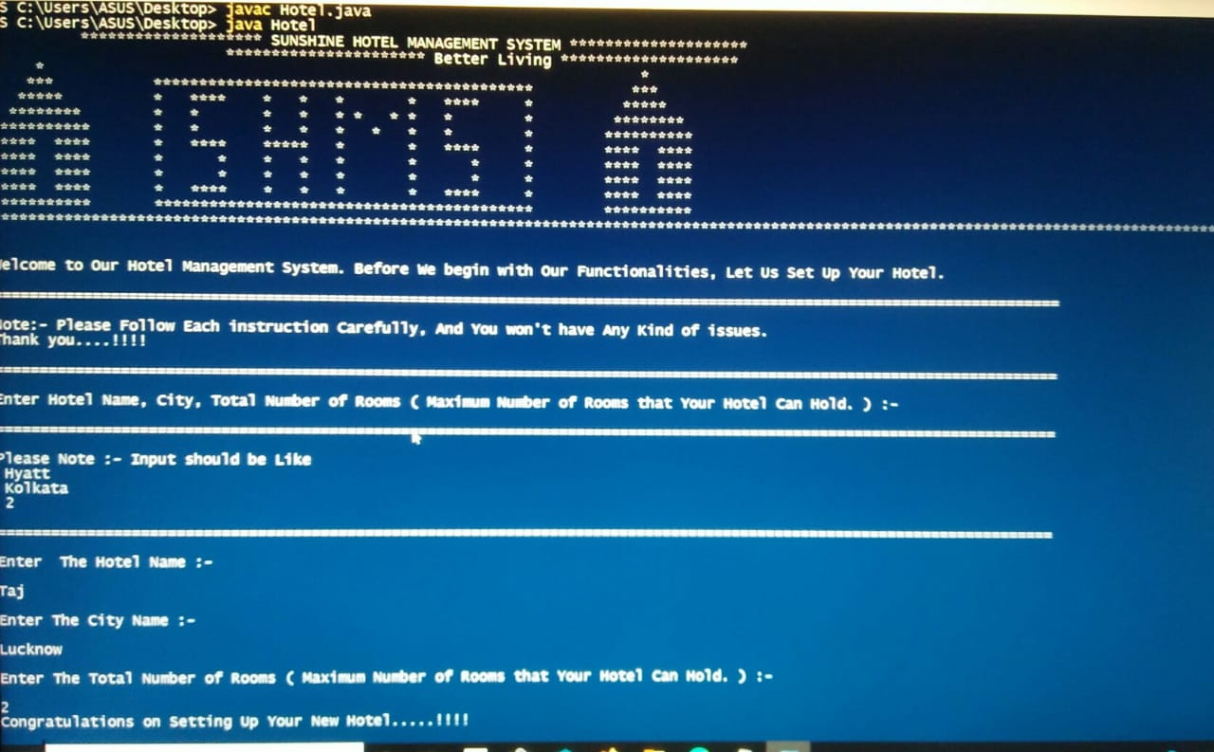
Here, We Are Taking input From Manager to Specity His Hotel Configuration.
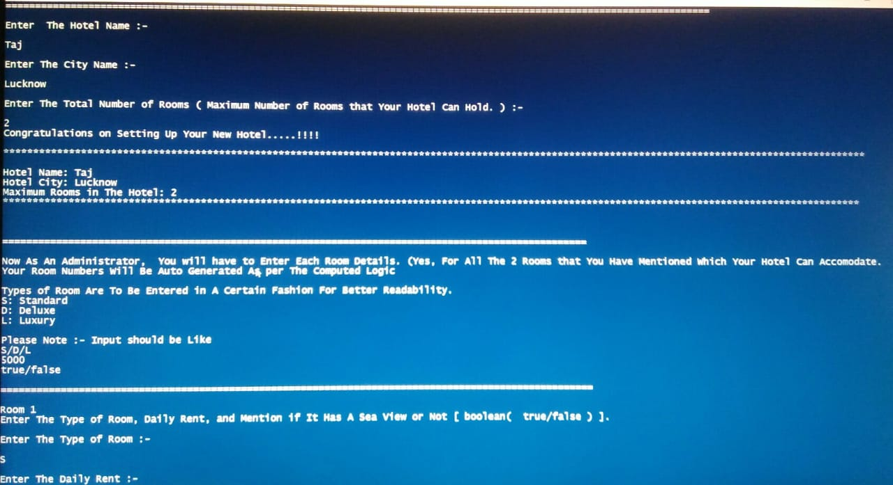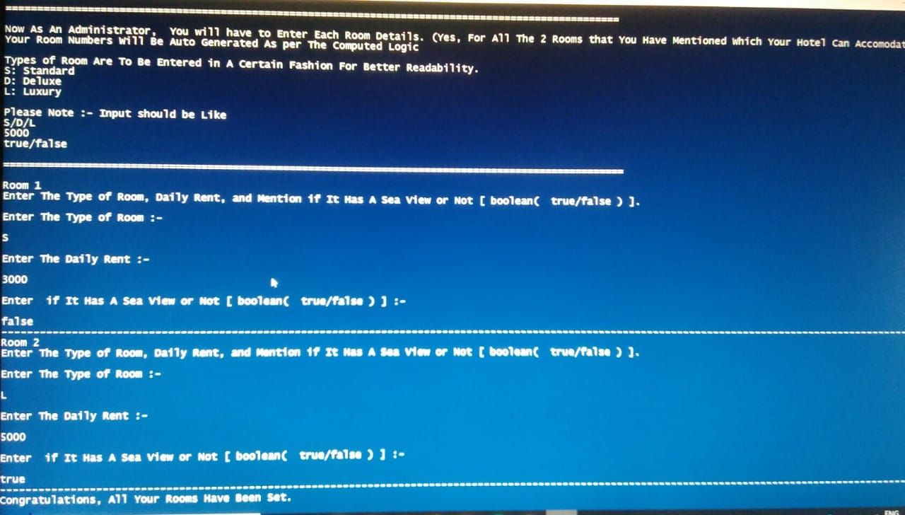
Here, We Are Displaying the Hotel Name, City, and Total Rooms Available.
Here, We Are Taking for Room Configuration of Each Room from Administrator/Manager.
Here, We Are Taking Input for Room Configuration of Each Room from Administrator/Manager.
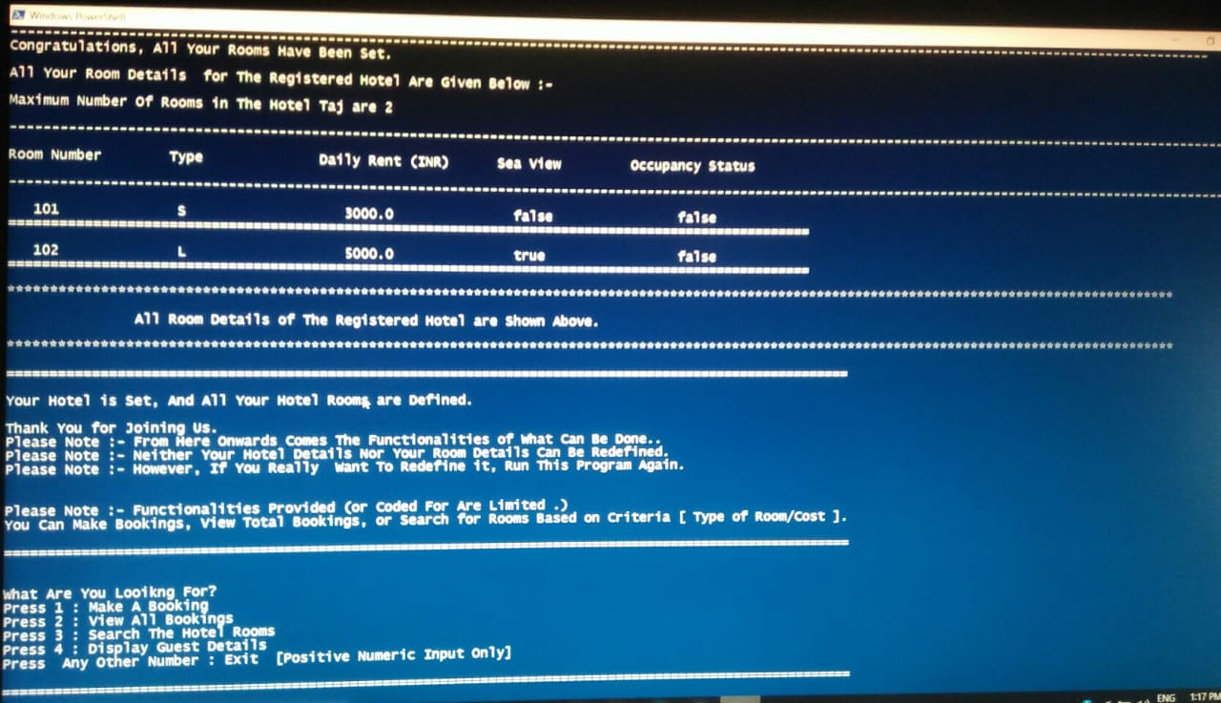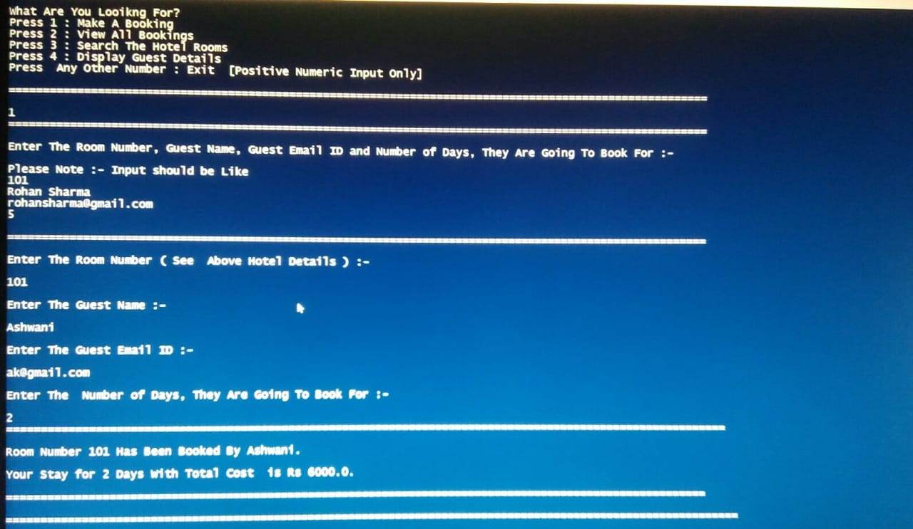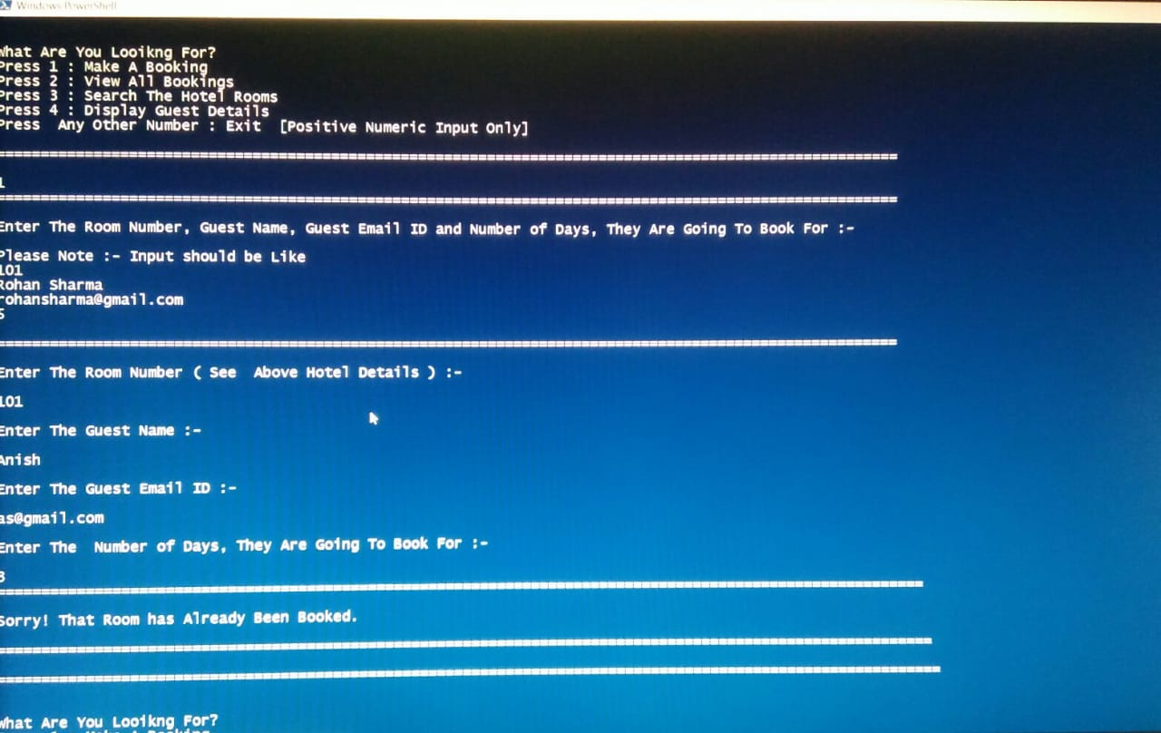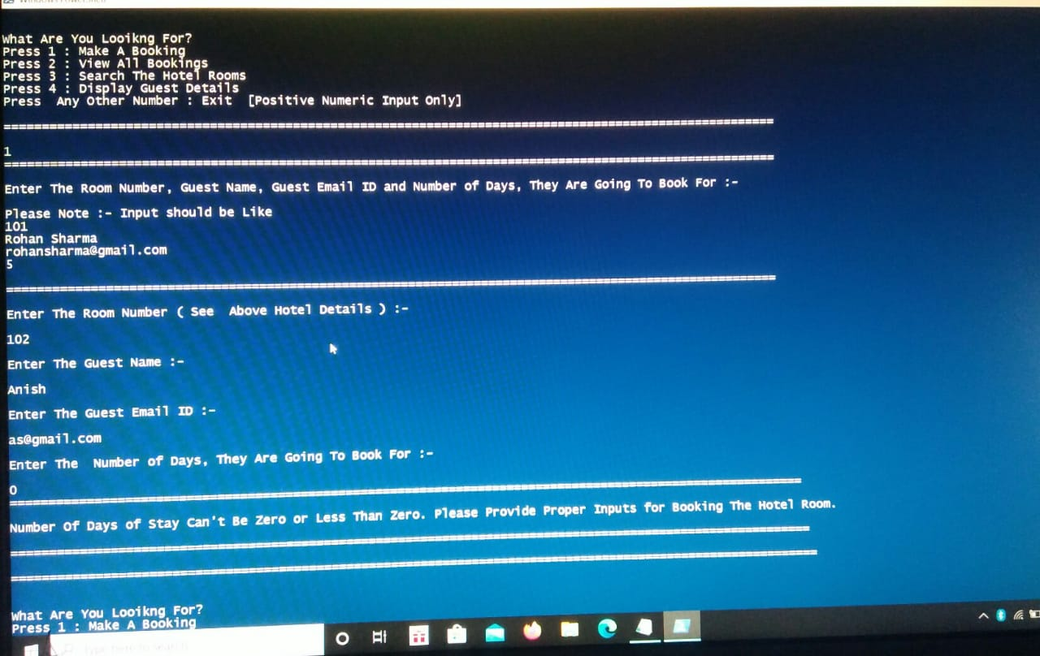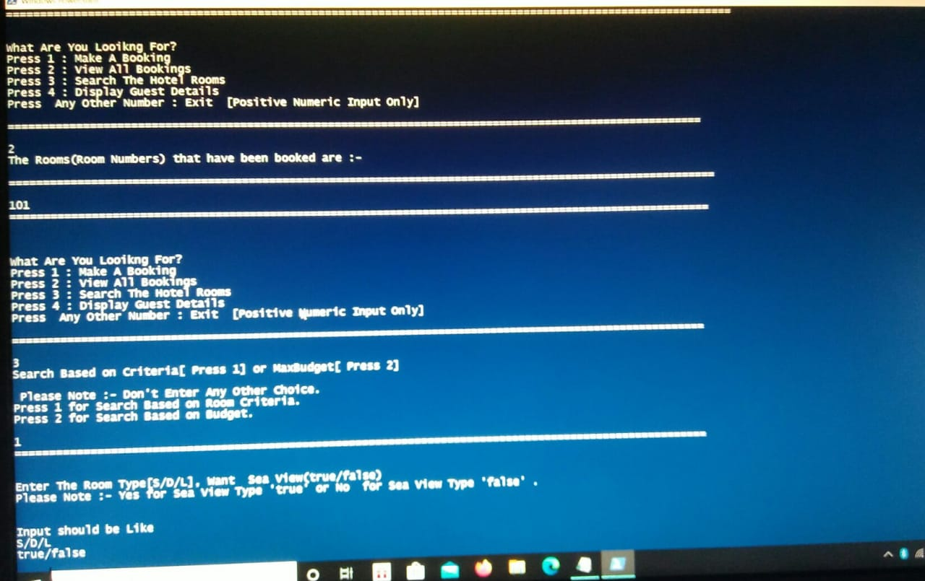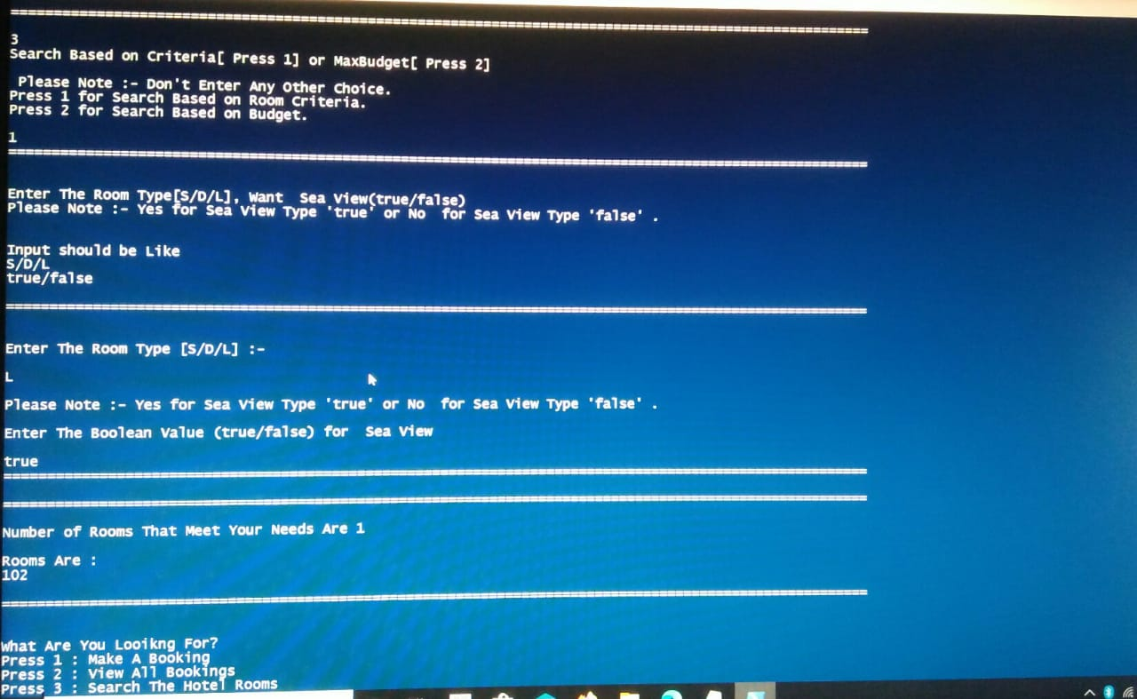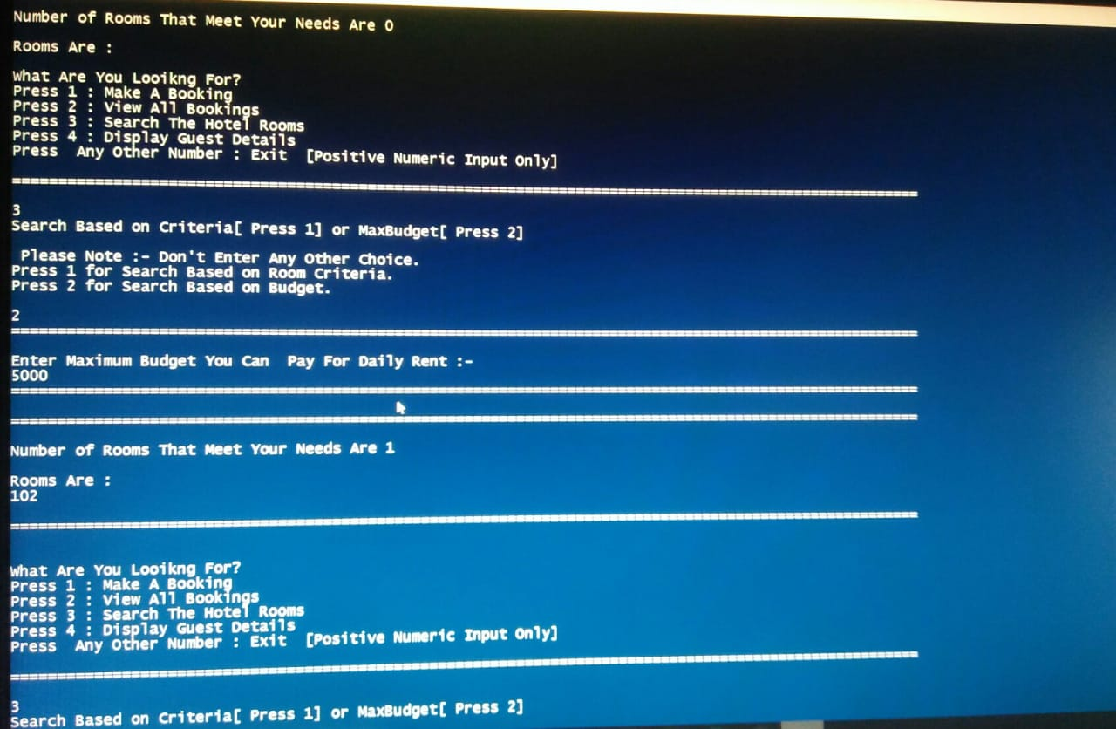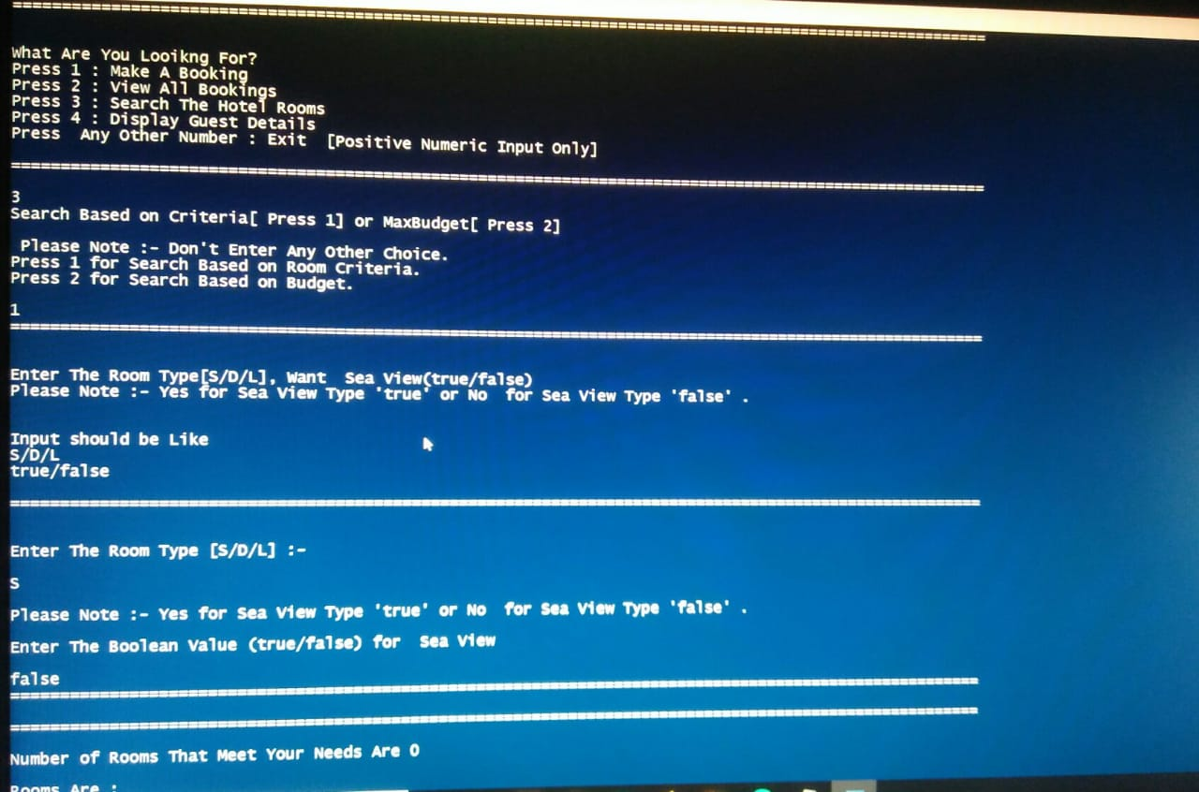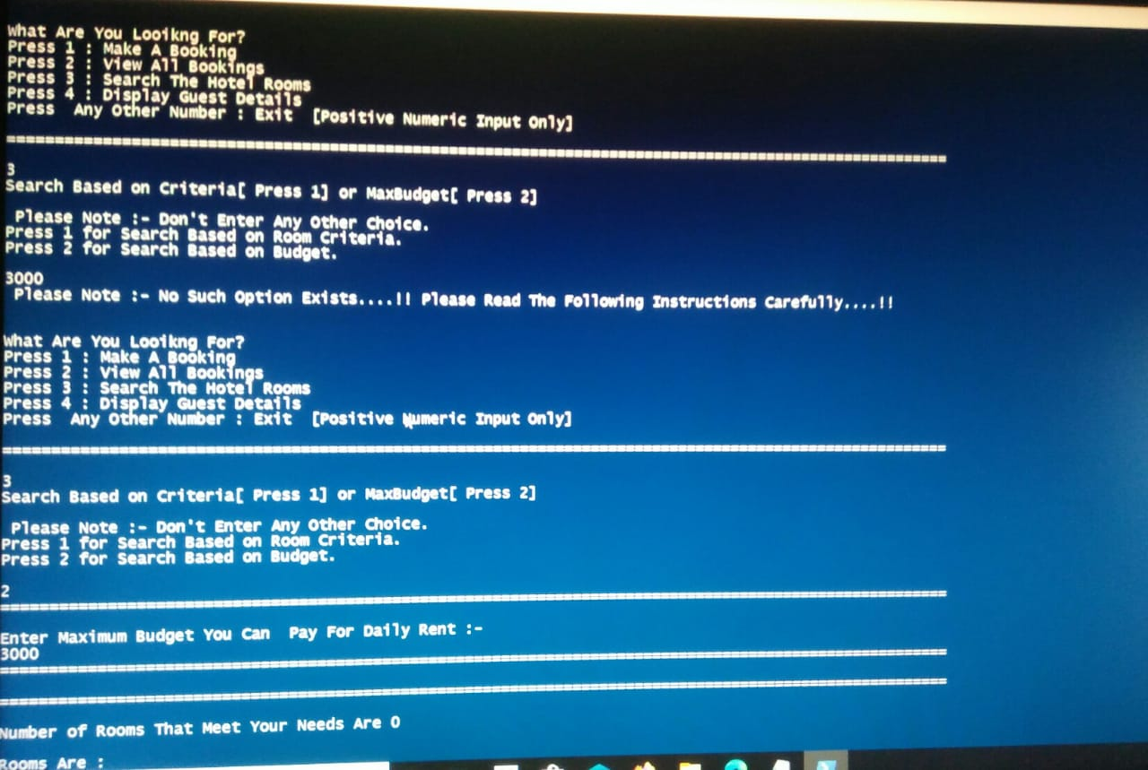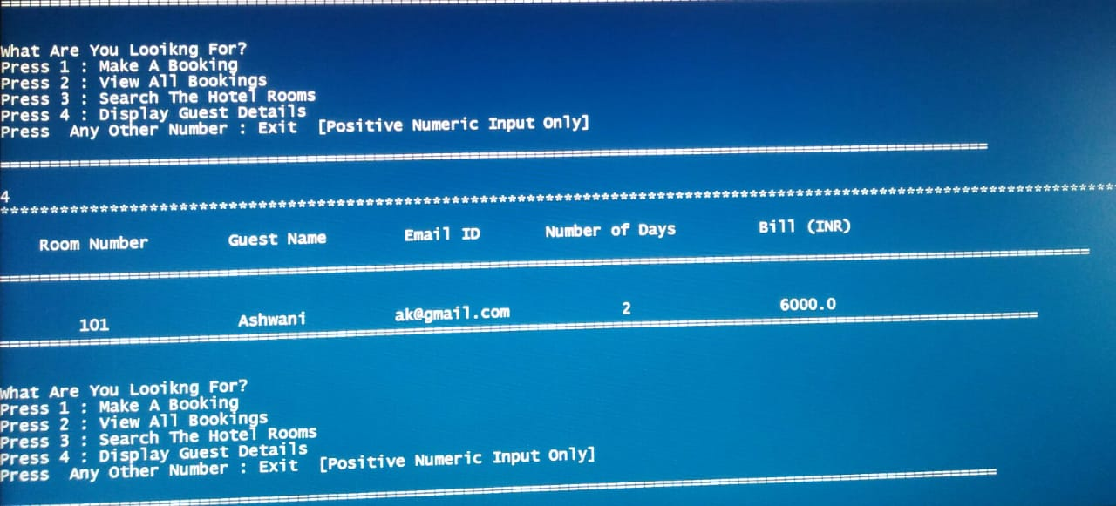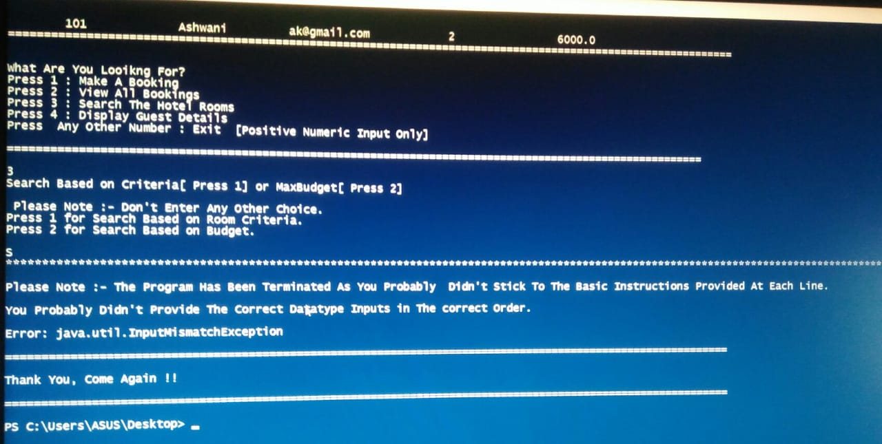
Here, We Are Displaying for Room Configuration of Each Room.
Now, As The Hotel Room Configuration Has Been Set, We Can Take Input From User As per Requirement Like Boooking A Room, View Booking, Search For Room Available, and Display The Guest Detail.
Here, We Are Displaying The Cost and Detail of Hotel Booking.
Here, We Are Displaying Input for Booking A Room in The Hotel.
If the Room is Booked, We Can’t Book it.
If Number of Days Staying is Zero, We can’t Book it.
Here, We Want to See All The Booking , So, We Are Displaying All The Booking Done.
Here, We Want to Search For The Room Either On The Basis Of Some Criteria or On Basis of Our Budget.
Here, We Are Displaying The Room On The Basis of Criteria Match and If The Room Is Available.
Here, We Are Input And Displaying The Room On The Basis of Budget Match and If The Room Is Available.
Here, We Are Displaying The Guest Details As per The Booking.
Here, Input is Not As per instruction.
So, An Input Mismatch Exception is Generated i.e., Error

