31. List the total number of products per product line where number of products > 3 (6)

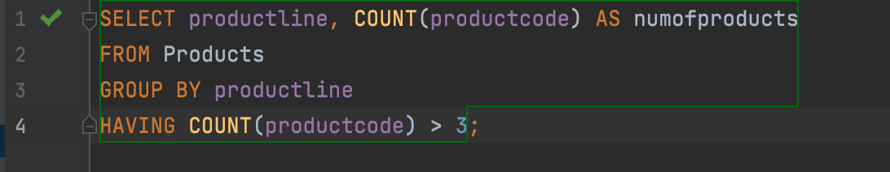

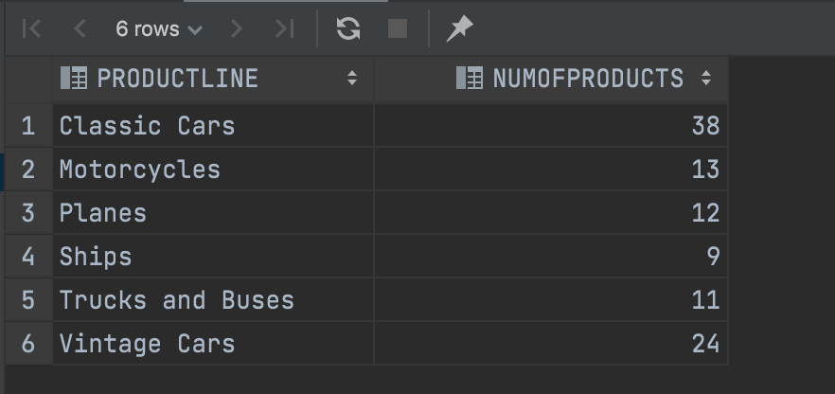

32. List the orderNumber and order total for all orders that totaled more than $60,000.00. (3)

CHECK QUERRY

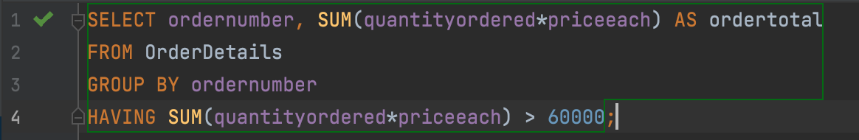

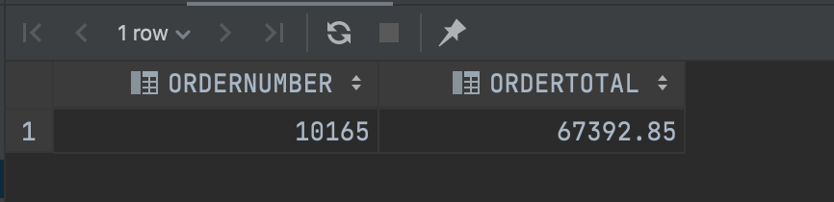

33. List the products and the profit that we have made on them. The profit in each order for a given product is (priceEach – buyPrice) \* quantityOrdered. List the product’s name and code with the total profit that we have earned selling that product. Order the rows descending by profit. Only show those products whose profit is greater than $60,000.00. (11)

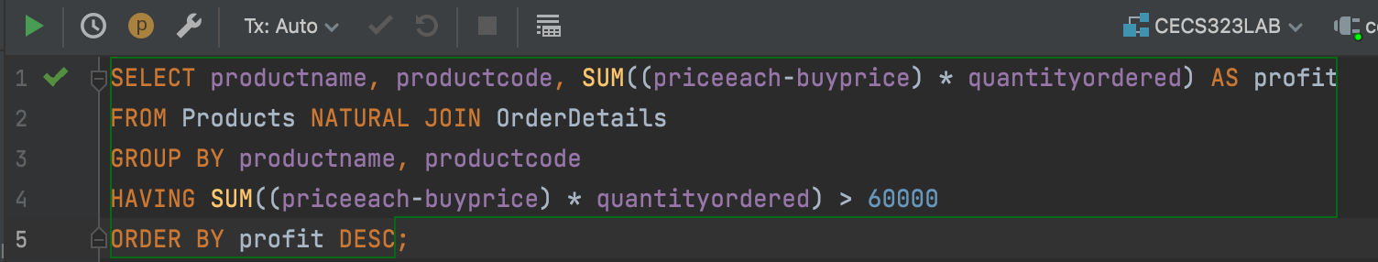

INCOMPLETE; CHECK QUERRY

34. List the average of the money spent on each product across all orders where that product appears when the customer is based in Japan. Show these products in descending order by the average expenditure (45).

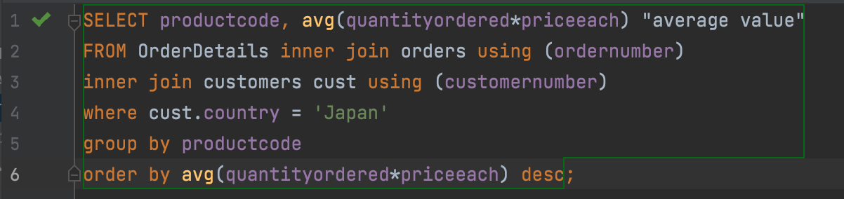

INCOMPLETE; CHECK QUERRY

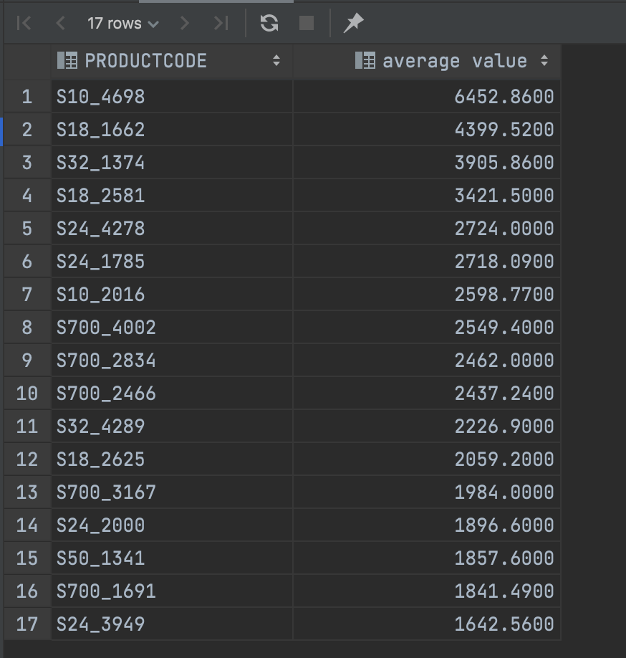

35. What is the profit per product (MSRP-buyprice). Order by productName. (110)

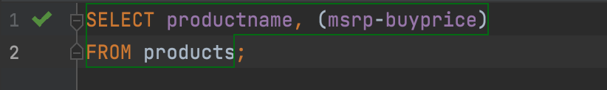

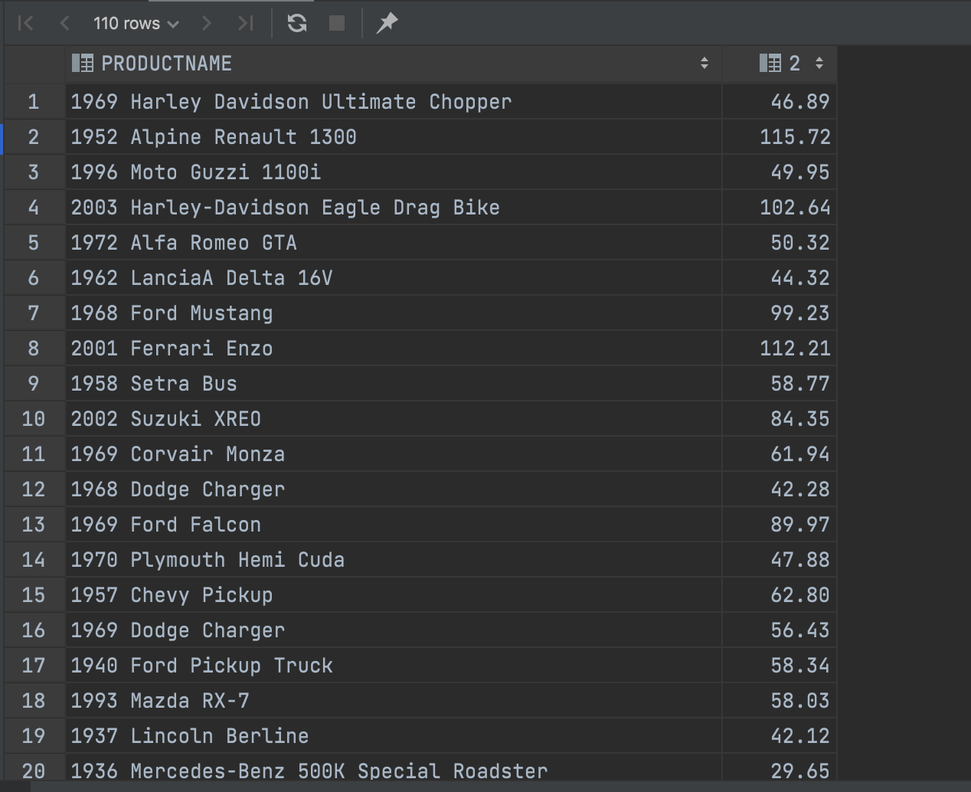

36. List the Customer Name and their total orders (quantity \* priceEach) across all orders that the customer has ever placed with us, in descending order by order total for those customers who have ordered more than $100,000.00 from us ordered by Customer total in descending order. (32)

