Currently, data is sourced from the /data folder in the directory. All files for visualisation are placed there. Data needs to be as a 2000m export from Logan:

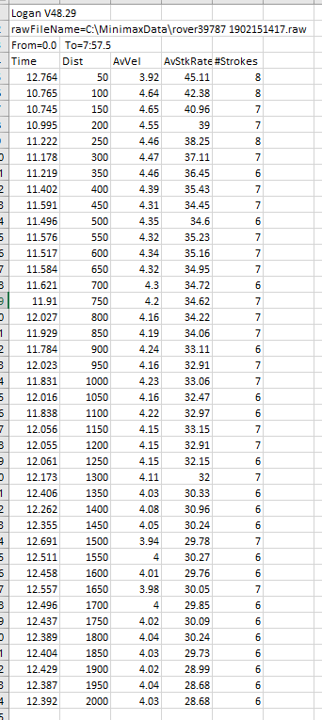

The filename needs to follow this convention:

YYYY.MM.DD_CLASS_Name_Competition_Location_Age_Phase

For example: 2019.02.15_BLW1X_Masters_NSW State Championships_SIRC_Senior_Heat

Data can be manually uploaded in the app: to do this, uncomment the lines of code in ‘UI’

# UNCOMMENT IF MANUAL UPLOAD###

#fileInput("file1", "Choose files", multiple = TRUE,

# accept = c("text/csv",

# "text/comma-separated-values,text/plain",

# ".csv")),

and in ‘server’:

#### Read data into a list if manual upload ####

## enable for manual file upload and delete code from Global

#table1 <- isolate(lapply(input$file1$datapath, fread, skip = 3, header=TRUE, stringsAsFactors=FALSE))

# identify data labels #

#dataname <- input$file1[['name']]

#dataname <- str_remove_all(dataname, ".csv")

#labels <- t(data.frame(strsplit(dataname, "_")))

#fullnames <- data.frame(dataname, labels)

And comment the lines of code in ‘global’:

filePaths <- list.files("data", full.names = TRUE)

table1 <- lapply(filePaths, fread, skip = 3, header=TRUE, stringsAsFactors=FALSE)

#### identify data labels ####

#dataname <- input$file1[['name']]

dataname <- str_remove_all(filePaths, ".csv")

dataname <- str_remove_all(dataname, "data/")

labels <- t(data.frame(strsplit(dataname, "_")))

fullnames <- data.frame(dataname, labels)