**Tammer “The Hammer”**

April 2nd, 2018: Enroute to pick up my wife Tammy Sue Lee (whom I call “Tammer the Hammer”) soup from Panera Bread, a **HammerTime** Construction panel truck turned off route 35 north onto Shrewsbury Avenue

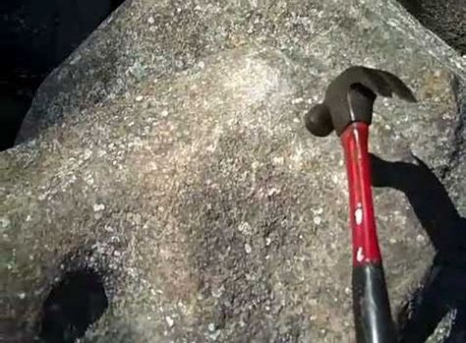

Hammering the Ringing Rocks in Bucks County Pennsyvania

Hammertime Construction Inc. Directions Address: 35 ***Ice Pond Rd****,* Levittown, PA 19057 Phone: (215) 945–1001

A few nights ago, Tammy told me her dream about us being at Ringing Rocks Park near Pottstown PA north of Washington’s Crossing [LINK https://www.youtube.com/watch?v=NBfrLoBpsIQ&t=20s](https://www.youtube.com/watch?v=NBfrLoBpsIQ&t=20s)

Tonight at 10:13, my wife who has been given the stage four cancer talk twice and is at home in hospice care said again “I’m tired” (of everything). My take on this is that Tammy will depart this world soon and fly like a kite up to go **home** (she asked for a Wendy’s ***home*** style chicken sandwich this weekend) above this low, slow, resonance, frequency and vibration (nod to Tesla and Einstein) and often mean spirited plane of existence prior to the pending [“RESET”](https://medium.com/@heart.beacon.cycle/time-for-a-universal-event-bus-8fd12b5481b1) of the economy / population before the impending massive climate change due to the earth’s farthest position from the sun in 100,000 years known as the [Milankovitch](https://youtu.be/6lbJrvtxWNE) Cycles and Ice Age <https://youtu.be/anZJZCvGoZE> [Link](https://youtu.be/anZJZCvGoZE)

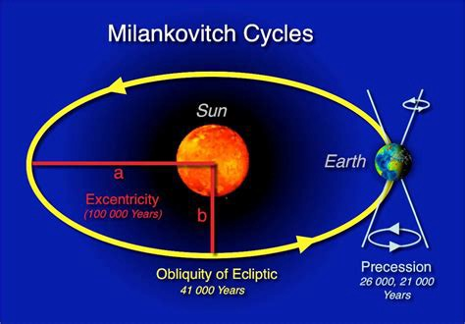

Milankovitch Cycle

Earth’s orbit approximates an [ellipse](https://en.wikipedia.org/wiki/Ellipse). [Eccentricity](https://en.wikipedia.org/wiki/Eccentricity_%28orbit%29) measures the departure of this ellipse from circularity. The shape of the Earth’s orbit varies between nearly circular (with the lowest eccentricity of 0.000055) and mildly elliptical (highest eccentricity of 0.0679)[[3]](https://en.wikipedia.org/wiki/Milankovitch_cycles#cite_note-3) Its geometric or logarithmic mean is 0.0019. The major component of these variations occurs with a period of 413,000 years (eccentricity variation of ±0.012). Other components have 95,000-year and 125,000-year cycles (with a beat period of 400,000 years). They loosely combine into a 100,000-year cycle (variation of −0.03 to +0.02). The present eccentricity is 0.017 and decreasing.

Effect on temperature: The semi-major axis is a constant. Therefore, when Earth’s orbit becomes more eccentric, the [semi-minor axis](https://en.wikipedia.org/wiki/Semi-minor_axis) shortens. This increases the magnitude of seasonal changes.[[4]](https://en.wikipedia.org/wiki/Milankovitch_cycles#cite_note-4)

<https://en.wikipedia.org/wiki/Milankovitch_cycles>

See prior posts: dog sleds headed towards poles, Casper, Caspian Sea, Stay Puff Marshmallow Man & RESET in the 2nd video:  
 <https://youtu.be/anZJZCvGoZE> Link Milankovitch Cycles Ice Age  
 [https://youtu.be/DboD8zK3Fvo](https://l.facebook.com/l.php?u=https%3A%2F%2Fyoutu.be%2FDboD8zK3Fvo&h=ATOyss4DwY8LQnCu2zbuvXyN9Xh1C0knLDZ0_8uFV8GOQLKbZ5fhnwAIDYFQSfngTHNZZrcJtYtg4HlO-XY55_nUBu9QXCqaaBkvqJo_-WdkAUyr02rBgJqJCAGkGd6GNHn2A67ba-6RhX0n71yHL4A9) LINK

[**Dog sleds, poles, Casper — Caspian Sea caves — Stay Puff Marshmallow Man / RESET**  
*see prior posts from Shaman Circle of the Sacred Earth Reiki energy balancing / counseling sessions: dog sleds headed…*medium.com](https://medium.com/@heart.beacon.cycle/dog-sleds-poles-casper-caspian-sea-caves-stay-puff-marshmallow-man-reset-80856929f011)

My take on this is that given Tammy’s astrological birth chart features a kite formation — see below, Tammy will soar up out of these mortal coils having volunteered as part her (Carolyn Myss) [Sacred](https://www.goodreads.com/book/show/190115.Sacred_Contracts) contract to be with her ancestors (I’ve been drawing the Ancestor Ancient symbol card alot)…

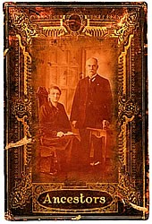

… where she will watch the chaos and confusion down below humming the MC Hammer [Song](https://youtu.be/z5X5zh00rdg) “can’t touch this”… Lyrics:

You can’t touch this  
You can’t touch this  
You can’t touch this  
You can’t touch this

My, my, my my music hits me so hard  
Makes me say, “Oh my Lord”  
Thank you for blessin’ me  
With a mind to rhyme and two hype feet  
It feels good, when you know you’re down  
A super dope homeboy from the Oaktown  
And I’m known as such  
And this is a beat, uh, you can’t touch

I told you homeboy (You can’t touch this)  
Yeah, that’s how we livin’ and ya know (You can’t touch this)  
Look in my eyes, man (You can’t touch this)  
Yo, let me bust the funky lyrics (You can’t touch this)

Fresh new kicks, and pants  
You gotta like that, now you know you wanna dance  
So move outta yo seat  
And get a fly girl and catch this beat  
While it’s rollin’, hold on!  
Pump a little bit and let ’em know it’s goin’ on  
Like that, like that  
Cold on a mission, so fall on back  
Let ’em know, that you’re too much  
And this is a beat, uh, they can’t touch

Yo, I told you (you can’t touch this)  
Why you standin’ there, man? (You can’t touch this)  
Yo, sound the bell, school’s in, sucka (You can’t touch this)

Give me a song, or rhythm  
Makin’ ’em sweat, that’s what I’m givin’ ‘em  
Now, they know  
You talkin’ ‘bout the Hammer, you’re talkin’ ‘bout a show  
That’s hyped, and tight  
Singers are sweatin’, so pass them a wipe  
Or a tape, to learn  
What’s it gonna take in the 90’s to burn  
The charts? Legit  
Either work hard or you might as well quit

That’s word because you know (You can’t touch this)  
(You can’t touch this)  
Break it down!

Stop, Hammer time!

Go with the flow, it is said  
That if you can’t groove to this then you probably are dead  
So wave yo hands in the air  
Bust a few moves, run your fingers through your hair  
This is it, for a winner  
Dance to this and you’re gonna get thinner  
Move, slide your rump  
Just for a minute let’s all do the bump  
(Bump, bump, bump)

Yeah (You can’t touch this)  
Look, man (You can’t touch this)  
You better get hype, boy, ’cause you know you can’t (You can’t touch this)  
Ring the bell, school’s back in  
Break it down!

Stop, Hammer time!

You can’t touch this  
You can’t touch this  
You can’t touch this  
Break it down!

Stop, Hammer time!

Every time you see me, the Hammer’s just so hyped  
I’m dope on the floor and I’m magic on the mic  
Now why would I ever stop doin’ this?  
With others makin’ records that just don’t hit  
I’ve toured around the world, from London to the Bay  
It’s “Hammer, go Hammer, MC Hammer, yo Hammer”  
And the rest can go and play  
You can’t touch this

You can’t touch this  
You can’t touch this  
Yeah (You can’t touch this)  
I told you (Can’t touch this)  
Too hot (Can’t touch this)  
Yo, we outta here (Can’t touch this)

Songwriters: ALONZO MILLER, RICK JAMES, STANLEY KIRK BURRELL

© Sony/ATV Music Publishing LLC

— — — — — — — — — — — — — — — — — — — — — — — — — — — —

Tammy gave me a copy of Carolyn Myss’s Book Sacred Contracts about ten years ago coincidentally. Carolyn Myss works with a woman with two PhD’s who was diagnosed to be bipolar coincidentally.

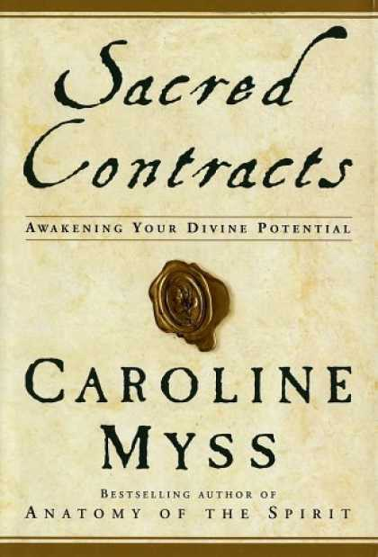

Tammy’s gift to me ten or more years ago

— — — — — — — — — — — — — — — — — — — — — — — — — —

Tammy’s favorite saying “abundance is enough for the wise” — she had this saying placed on her checks:

Animal Totem: Shrew

In Hindu mythology, the shrew is the vahana, or divine vehicle of Lord Ganesha. The shrew carries Lord Ganesha wherever he travels. It is said that the shrew represents “worldly desires that is meant to be overcome.” / One day at the beach, a stature of Ganesha washed up in front of Tammy’s Feet… coincidentally….

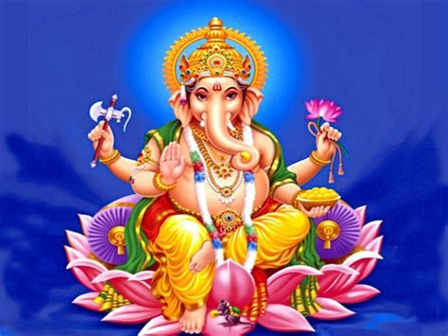

**Animal Symbolism in the Hindu Religion**  
*In Hindu mythology, the shrew is the vahana, or divine vehicle of Lord Ganesha. The shrew carries Lord Ganesha wherever…*

http://www.beliefnet.com

— — — — — — — — — — — — — — — — — — — — — — — — — — — — -

My wife Tammy who has stage IV cancer or “consumption” father was Blackfoot Native American Indian. According to a Shaman, Circle of the Sacred Earth named Reverend Kathy Graves, the energetic force behind the project we have been working on is Great Deer assisted by the Buffalo:

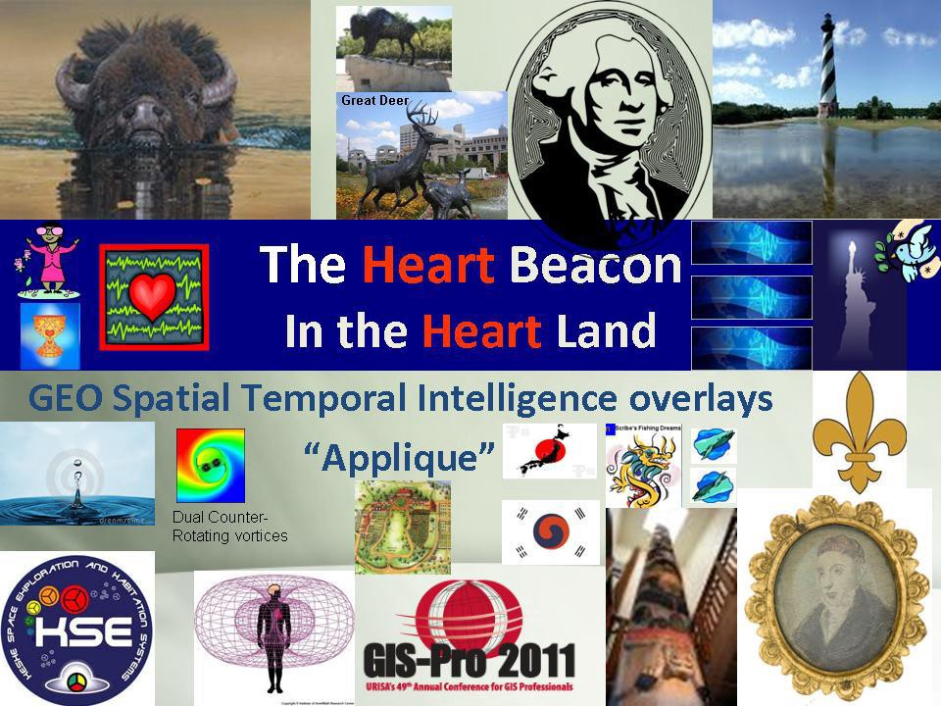

Graphic from presentation In Indianapolis Indiana GIS in the Heartland

**“You are provided for in all ways” – Buffalo Spirit Totem Animal**

The First Nations peoples used / “consumed” all of the Buffalo

[**Buffalo Bison Power Animal Symbol Of Abundance**](http://www.shamanicjourney.com/buffalobison-power-animal-symbol-of-abundance)

[http://shamanicjourney.com/**buffalobison-power-animal-symbol-of-abundance**](http://www.shamanicjourney.com/buffalobison-power-animal-symbol-of-abundance)[**LINK**](http://shamanicjourney.com/buffalobison-power-animal-symbol-of-abundance)

Buffalo/Bison’s medicine includes manifestation, protection, earth creativity, feminine courage, abundance, knowledge, generosity, hospitality, sharing work, courage, strength, challenge, survival, giving for the greater good, formulating beneficial plans. Those with buffalo as power animal must walk a sacred path, honoring every walk of life.

Speaking of consumption, my wife’s stomach has swollen to the point of her looking pregnant coincidentally. Her Sun sign is Leo. Her chart astrological birth chart shows a bowl formation (most aspects located in one location) i the 7th House of relating to others and spouse (as the contaminant).

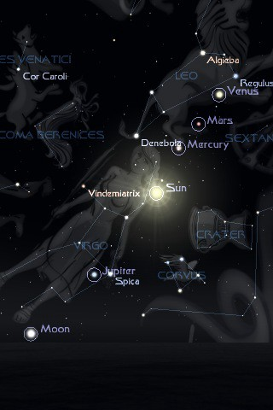

Revelations 12 Leo / Virgo start of 7 year tribulation period 2017–2024 Revelations posts 7 year window 2017–2024 [LINK](https://www.youtube.com/watch?v=O9pPhJ66pIE)

**Rune  
(Equivalent of “Tammy Sue Lee”) see http://facade.com**

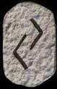

Ger Rune Stone

**Ger** is one of the runes that touches on the cycles of the year, in this case the fall harvest. These cycles are eternal, which is represented in the rune by the fact that it is unchanged by reversal. Ger can represent **pregnancy** or other forms of fruitfulness, and is especially indicative of the cycles of **providence and karma** — that which has been sown is now being reaped. This rune can also represent the cycles of wealth, for crops were frequently a sign of wealth.

Reverend Kathy Graves Shaman of the Sacred Earth clairaudience from one of many Reiki energy balancing / counseling / healing sessions: “Providence”

— — — — — — — — — — — — — — — — — — — — — — — — — — — — — -

Speaking of auric field contaminants, using Vedic / Sidereal astrology, I’m a Capricorn on the cusp of Aquarius within orb of this star:

Sinistra The left hand of Serpentarius (Ophiuchus). Immoral, mean and slovenly, depraved, lustful, wanton, infamous, scandalous, addicted to sorcery and poisoning 29° Sag 45 29° Sag 53 Unfortunate Saturn/ Venus ν (Nu) Ophiuchi K0 (orange) Mg.3.32 var.

A close up of a device

Description generated with high confidence

Tammy’s natal sun (Will, vitality) in the sixth house of nose to the grindstone as a diligent and dedicated worker. The sixth house also involves [medical issues.](https://youtu.be/8DcbdGZUUsw) Linda “The Psychic Shield” said that Tammy would have medical issues. After a long, pregnant pause, Linda said that her medical issues would be taken care of. The medical issues would have been taken care of had I figured out the Shaman, Circle of the Sacred Earth’s “Energizer Bunny” message citing the need for her / me to alkalize our diets and detox our guts — in my sake to resolve the mood swings associated with poor eating habits and chasing after windmills along with medicating myself with my own endorphins which is a blogpost in itself.

I have at least three reasons to believe this:

Reverend Kathy Graves is a medical intuitive who is a Master Reiki Practitioner. Her symbolism, for example, see the energizer bunny beating a **DRUM** below is clearly about a medical condition because she as a medical intuitive and healer, leads First Nation Indigenous type drumming circles. She believes she was indigenous or First People’s in a prior reincarnation. Energizer Bunny commercial [LINK](https://youtu.be/qiFQsxGUQOI)

After Tammy’s radiation, she was on a “chemo break” because you can’t have radiation and chemo simultaneously if memory serves. We traveled home to my parents home and went out to the Knickerbocker bar where a candle holder of very thick glass suddenly split into two pieces / divided (metastasized) right in front of us. I took a picture of this .. will insert later

Upon returning home from the hospital one night after one of Tammy’s hospitalizations, the Kleenex box downstairs had half of it’s tissues pulverized into very small pieces… they were pulverized — not torn into strips as you would expect if mice were using the material as nests. The flecks of tissue paper were so fine that I vacuumed them up. I did not have the presence of mind to photograph this phenomenon I regret to say.

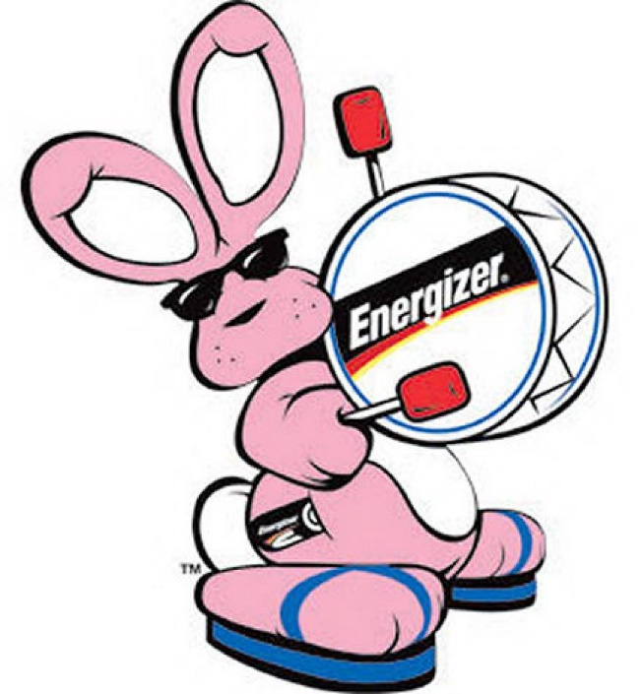

Shaman’s Energizer ALKALINE Battery image heeded too late. We could have / would have / should have detoxified, energized, and alkalized PH

See Charlotte’s Web [post](https://medium.com/@heart.beacon.cycle/charlotte-gersons-web-492a1a597993) Would the cancer happened had I figured out the signs passed on to me by a Shaman, Circle of the Sacred Earth?

Tammy’s progressed chart is interesting and coincidental if you look at Saturn’s location in context with the fixed stars. Recalling Tammy’s request to the universe tonight “It’s time” (to take her home), note that Tammy’s chart has a kite for her to deliver her beacon message, support me when no one else would have then soar up and out of this mortal coil prior to the pending “RESET” (s) economic, climate

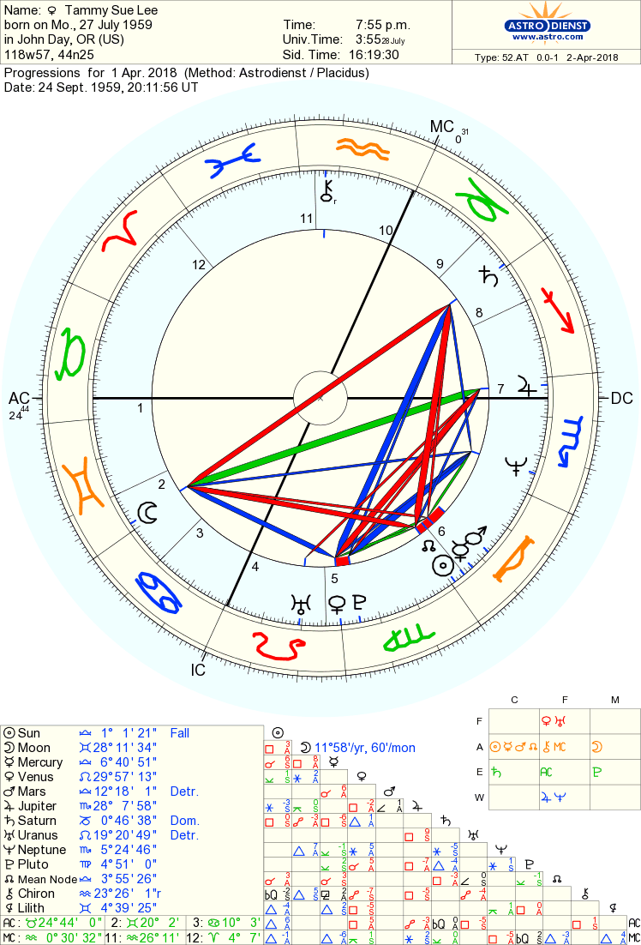

Tammy Sue Lee progressed chart

Note the location of Tammy’s Saturn (Time Lord / Lord of restriction) — Tammy’s time on earth has apparently been “restricted”. And Saturn as Chronos / Grim reaper will bring about her end (God forbid — I want her to stay here and finish out our lives together) will in all probability occur when the tumor inside the top of her spin restricts signals down to the body / lungs

Spiculum  
The Lagoon Nebula Eye trouble, blindness, depression, hopelessly doomed, morbid religious outlook, ***no concern for human life***; a nebula in the upper part of the Bow of the Archer. 1° Cap 04 1° Cap 12 Unfortunate Mars/ Moon

Note the T-Square of the Moon (deception, behind the scenes hidden actions), square Saturn and square sun (vitality). The lack of concern for human life is described in the Charlotte Gerson’s Web post on Medium [LINK](https://medium.com/@heart.beacon.cycle/charlotte-gersons-web-492a1a597993)

I’ve been watching out for the Shaman, Circle of the Sacred Earth’s imagery “I see Sagittarius the Archer and two triangles for years. Saturn the Time Lord is on the cusp of Sagittarius within orb of my fixed star using Sidereal Astrology. The T-Square is a triangle and Capricorn’s / Masonic Goat of Mendez’s head is a triangle. Right again Reverend Kathy ! :)

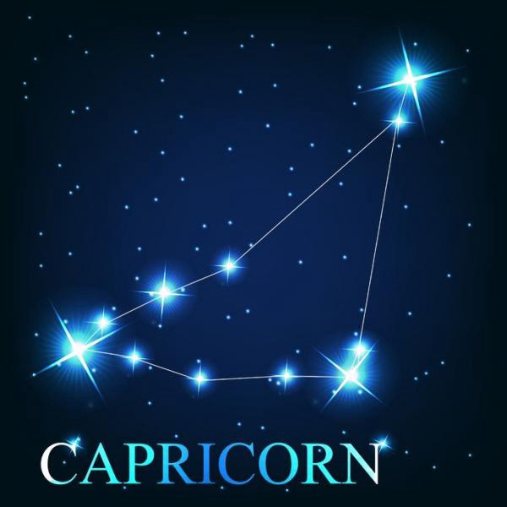

Capricorn The Sea Goat

— — — — — — — — — — — — — — — — — — — — — — — — — — — — -



Tammy Lee McGee’s Facebook banner

Toes in the sand Tammy Lee, Toes in the sands…

At 10:13 PM April 2nd 2013 My wife Tammy Sue Lee said:

“please universe, it’s time” (to take me home

At 10:34, I entered Tammy Lee’s birthday into e-tarocchi dot com’s Personal Daily Ancient symbols:

**Your Ancient Symbols for Today:**

[**LINK**](http://e-tarocchi.com/Ancient-Symbols-Daily/) **http://e-tarocchi.com/Ancient-Symbols-Daily/**

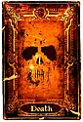<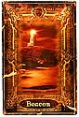

Death is not a card to shy away from. It does not foretell your impending doom. However it does suggest a period of change and the turbulence that often comes with it are on the horizon. We may not always welcome change, but invariably we must change to grow. Sometimes we have to shed some of the comfort of who we are today to embrace the adventure of who we will be tomorrow. Death is the prophecy of such times.

**The Beacon**: The Beacon symbolizes both guidance to safe harbors and a warning of dangerous waters. The Beacon is represented by a lighthouse atop jagged rocks with its powerful light cutting a path that leads to an adjacent entrance to a calm harbor on a stormy night. The Beacon suggest that if you look for it, there is a general path for you to follow to reach a place of peace and harmony. However, The Beacon itself sets upon rough ground, so you must still step carefully as you follow it to quiet waters.

Circa 2006 or so, a woman who visited us as a business development manager for the Turtle Mountain Band of Chippewa Indians visited us in our home. She said that she had zero fear of death because she herself had been pronounced dead on the operating table — twice. She said she came back because she felt she had a mission to do and she would pursue that mission fearlessly. Coincidentally, this is the second time Tammy has been given “the talk” Coincidentally, Tammy’s mother told her that that when she was born, she looked “like a Turtle”. Tammy’s father was a Coho who was / is a First Nation, Native American.



Turtle Mountain Band of Chippewa [LINK](http://tmbci.org/) <http://tmbci.org/>

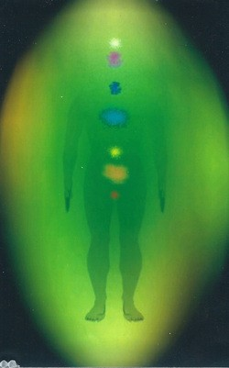

Kirlian Photograph

Tammy had her Kirlian photograph taken in New York City. The photographer remarked how her heart chakra was twice the size of everyone elses… Juan, a medical intuitive working in the Tucson Arizona area told Tammy that she needed to pull in her auric field so that other people (like me) would not contaminate her. When breast cancer was discovered in Tammy, it’s location was exactly where she would pull my hand to when “spooning” or snuggling in bed coincidentally

April 3rd Update: I entered Tammy’s birthday into e-tariocchi dot com’s web site personal symbols tab and these two symbols were returned. The Heart Beacon Cycle Time — Space meter is intended to support an Eco-Economic pulse to keep the peace and help humanity through a challenging time much the same as the Great Pyramid of Giza when it had crystals etc., operational was said to have broadcasted or magnified the earth’s heartbeat Schumann resonance in order to provide a calming influence during decending Yuga epochs. Reverend Kathy Graves saw me as a little dutch boy (I have Dutch ancestry) holding my finger in the dike.

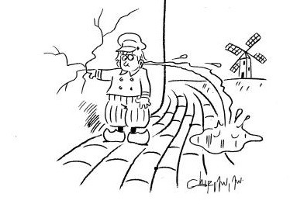

Little Dutch Boy Finger in the Dike

E-tariocchi dot com’s daily ancient symbols, the Peace Dove ancient symbol and the Believer Ancient Symbol were selected on April 3rd coincidentally.

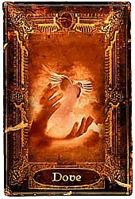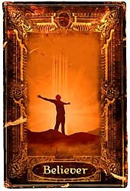

Believer card — that would be me

April 3rd update: my wife Tammy declined my offer to bring her Gerber’s baby food or Gerber breakfast cereal or yogurt etc. She wanted eggs for protein. So, she sent me to one of her standby breakfast choices Dunkin Doughnuts for two egg and cheese breakfast wraps. Being into numerology as a cousin of Astrology and foundation for sacred geometrical metaphysical musings, I noticed that the order number was #672 and the transaction sequence number was 2147672. [LINK](https://www.youtube.com/watch?v=GHyLzZ4wFNI)

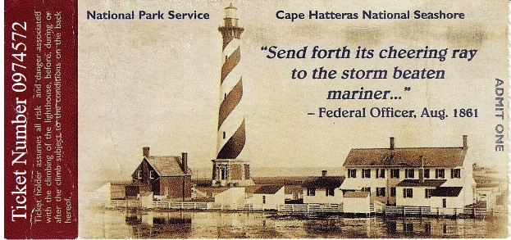

Ticket from trip to climb Cape Hatteras Light House

The corporate logo drawn by the Shaman, Circle of the Sacred Earth in the business card below is to be depicted in 3D which makes it a tetrahedron. A pyramid in 3D is a type of tetrahedron that when inverted and two placed opposite of each other fit into a cube, the foundation of all geometric shapes. The objects inside the triangle in the logo were up to me so I selected the outward and inward seeing eye of Providence given the clairaudience “Rhode Island” and the Eagles song and the [Law of Time](https://www.lawoftime.org/pdfs/ch7-intro.pdf) dot org logo given my search on heart, beacon, cycle, time — space and synchronization — and the [cube](https://youtu.be/IwXZV7Ba0HM) of course. The number [72](https://en.wikipedia.org/wiki/Tetragrammaton) is of great significance in the mystery schools as initiates and adepts well know.

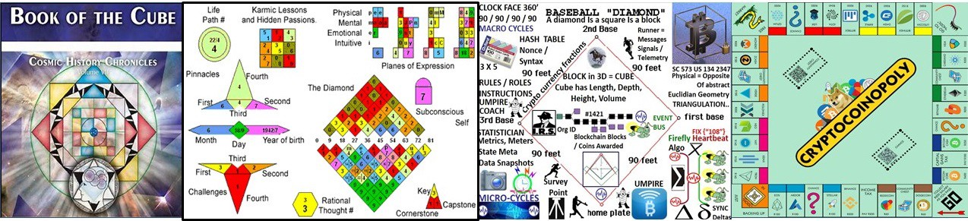

Cube Banner: Book of the Cube — Law of Time / #72 Numerology / Baseball Meme USPTO United States Patent and Trade Mark Office #13/573,002 = 21

1 + 3 + 5 + 7 + 3 + 2 = 21: The World Card

When I was in grades school at Bell Township Elementary going through the motions of playing shortstop, a line drive was hit directly at my chest. Since I was watching the girl’s play kickball instead, the act of my bringing the glove up to my chest at the sound, sight of the ball caused it to tip off the top of my glove into my throat. Minutes of gasping for air later, my adams apple popped out and I could breath again.

During a Reiki session, the Shaman said, I see you playing baseball so I related to her my elementary school tale of almost dying. About a year or two later, the patent attorney I had retained told me that he was no longer accept me as a client unless I explained to him the idea in terms of a Little League Baseball tournament using one graphic shaped like a tree. US Supreme Court’s Alice Corp Vs CLS Bank teaches that “claims may not direct towards abstract ideas”. Physical, like a [baseball diamond](http://www.sawconcepts.com/index/id4.html) is the opposite of abstract. ***Alice Corp. v. CLS Bank International*, 573 U.S. 134 S. Ct. 2347**

Tammy Sue Lee sat with me in the den / computer room the entire week I was working on the patent revision listening to my rants, raves, ruminations. No one else in the world would have had the unconditional love and patience to have done this and put up with me. Tammy Sue Lee, The Heart Beacon has done much to provide a template for the world to follow and mitigate the tough times ahead of mankind. She helped form an modern Great Pyramid of Giza Shuman Heart Beat resonance to help mankind though troubled times.

Cold Play’s [Adventure’s of a Lifetime](https://youtu.be/QtXby3twMmI) “we are diamonds taking shape”

Cape Hatteras Light House protects the Diamond Shoals. Another interesting, coincidental fact about this island is the Shackleford Horses used for DNA genetic drift studies: Video [LINK](https://youtu.be/lFbJP62MdQg) / Web page [link](http://www.wildhorse.com/2000/12/wild-horses-of-shackleford-banks/)

So Tammy’s choice of Memorial Sloan Kettering was made given she wanted to explore advanced clinical trials that she never received. The first chemo Tammy received was derived from bark from a tree. The last chemo she received was finished the year I gradated from college in 1983 and given the go ahead for use in the 1990's… not long after we returned from Europe having met each other in Able Archer 88 — a nuclear release exercise which had a logo looking very much like Woodsy Owl Give a hoot don’t pollute”. Recall Reverend Kathy Graves imagery “I see the Archer (Sagittarius) and two triangles above in the examination of Tammy’s astrological charts.

Able Archer 88 / Rev K “I see the Archer and two triangles”

Speaking of patent application USPTO 13/573,002’s single diagram given the patent attorney located at Eagle Rock New Jersey — another Reverend Kathy Grave’s images which is the reason I found and retained that particular patent attorney in the first place

God’s speed Tammy Lee. If you plan on staying here a while longer I will be overjoyed. If you decide to rejoin your ancestors for another great adventure, so be it.

We all know you will be untouchable above the clouds flying high as kites can possibly fly. Thank you from the bottom of my little heart.

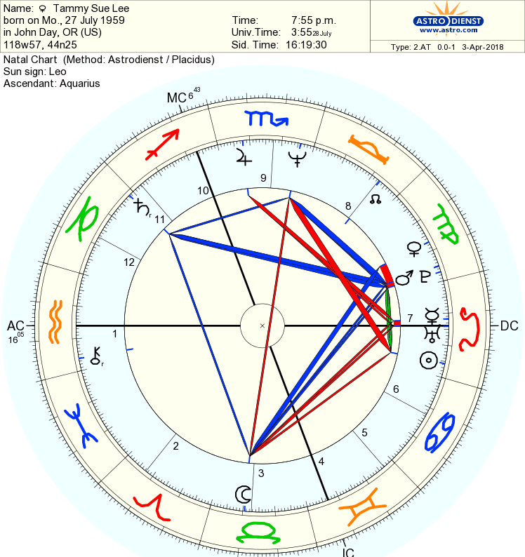

Tammy’s Kite / Shaman’s clairaudience “it’s in the stars”

Greetings Tribe of Light

On The Galactic Calendar, we now have entered the “The Planetary Moon of Manifestation” (April 4 — May 1)

“This is the time to inquire: What in my life is calling to be manifested? What visions, projects, plans or to-do lists is it time to follow through on and carry out? What in my life is ready to be shifted into a higher creative gear?”

PLEASE ENJOY THE FULL GALACTIC TIME UPDATE HERE: [LINK](https://galacticculture.wordpress.com/2018/04/05/new-galactic-cycle-april-4-may-1-planetary-moon-of-manifestation-time-to-boldly-bring-your-gifts-to-life/)

<https://galacticculture.wordpress.com/2018/04/05/new-galactic-cycle-april-4-may-1-planetary-moon-of-manifestation-time-to-boldly-bring-your-gifts-to-life/>

We Send Blessings to All to of You, From our Hearts to Yours.

May All Beings Be Guided to Serve Love and Serve Life!

In Lak’ech ~ I Am Another Yourself ~

Eden Sky of SkyTime

Activate the Magic of Every Day with The Galactic Calendar!

*Time to Raise the Frequency on Planet Earth*

<http://13moon.com>

TIME IS ART! LIFE IS ART! LOVE IS ART!

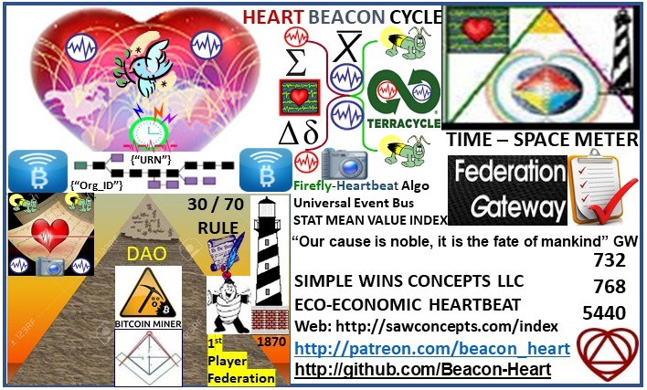

Business Card Logo doodled by Shaman, Circle of the Sacred Earth

Thank you Tammy Sue Lee. You will always be my guardian angel and my light from above. Bless your for your heart chakra that is twice the size of most people’s.. see the light shining down from above and the halo?



God’s speed Tammer the Hammer ! It’s HAMMER TIME !