API Design

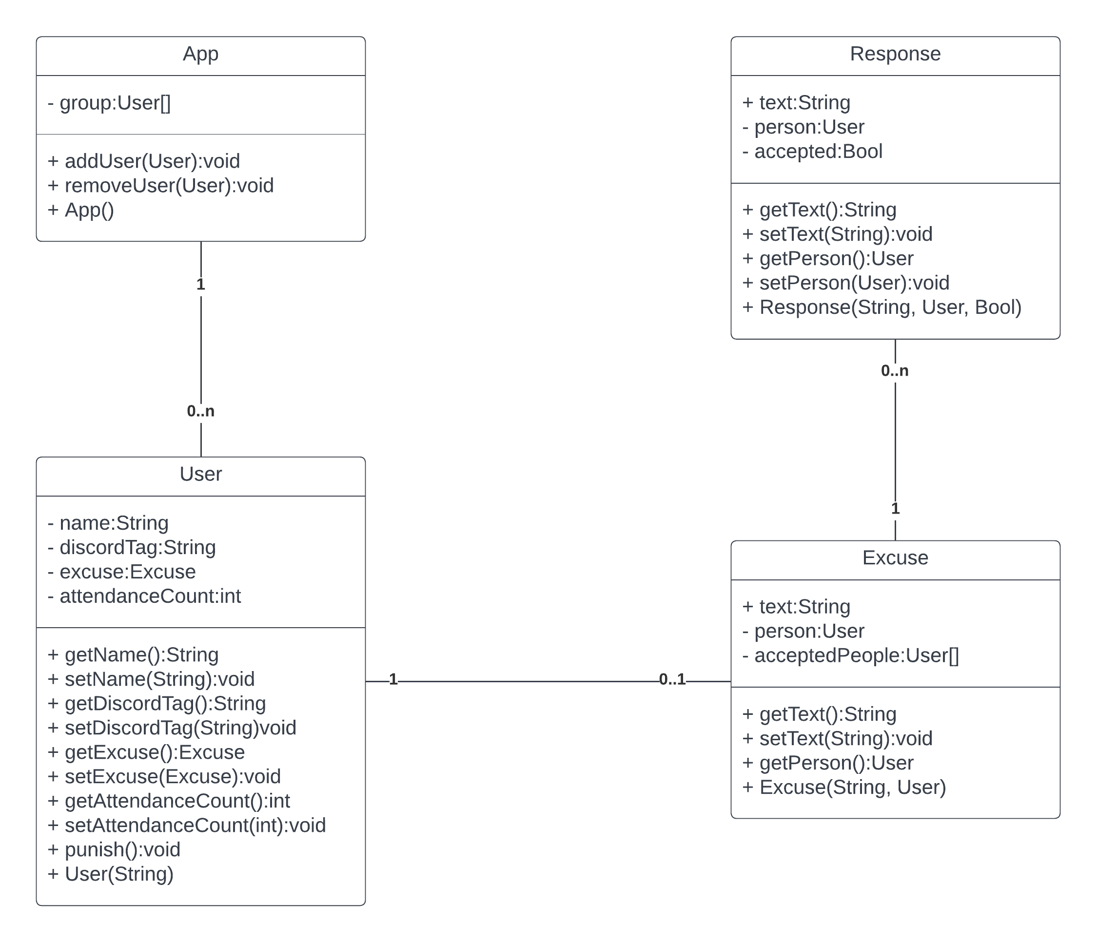
UML Klassendiagramm

App Endpoints

Muster

- Endpoint: Endpoint
- Methode: GET/POST/PUT..
- Parameter: Body… (JSON)
- Returns: Body… (JSON)
- Funktion: do_something()
- Beschreibung

addUser

- Endpoint: /users/add
- Methode: POST
- Parameter: { name(String), discordTag(String) }
- Returns: { status(int), message(String) }

removeUser

- Enpoint: /users/remove
- Methode: POST
- Parameter: { name }
- Returns: { status(int), message(String) }

