V2 Grading Analysis Report
BEAJ Audio Dataset — Inter-Rater Reliability & AI Calibration

Executive Summary
- 7 human graders + AI scored 594 unique audio files (891 total graded rows).
- Human graders score on average 7.59 words correct per audio; AI scores 8.47 — a systematic gap of 0.89 points (AI scores lower).
- Human-AI Pearson correlation: r = 0.925 (n=891). Most human-human pairs correlate above r = 0.90.
- Pre-to-post improvement is visible in both human and AI scores, consistent with genuine learning gains.
- Word-level analysis shows AI particularly underscores South Asian proper nouns ('faiz': 83% mismatch rate, 'zara': 45%), pointing to a cultural calibration gap.

1. Dataset Overview
The v2 grading dataset covers 594 unique audio recordings from Grade 1 students, graded by 7 human graders and 1 AI system. AI responses were matched to 878 of 891 transcribed rows (98.5%).

Transcriptions per Grader
Grader | Transcriptions
Semal | 189
Rehma | 169
Amna | 130
Dania | 125
Rukhshan | 121
Salman | 70
Ali | 69
Abdullah | 18

2. Score Distribution
Scores represent word-match counts — the number of reference words a student correctly reproduced. Human scores are derived from transcription alignment; AI scores count words graded as fully correct (normalized score = 2).
Statistic | Human | AI
Count | 891 | 891
Mean | 7.59 | 8.47
SD | 4.11 | 3.99
Min | 0 | 0
25th pct | 5 | 6
Median | 6 | 7
75th pct | 11 | 13
Max | 15 | 15

3. AI vs Human Score Comparison
Metric | Value
Pearson r (human vs AI) | 0.92 (p < 0.0001, n=891)
Mean difference (AI − Human) | 0.89
SD of difference | 1.58
Mean absolute difference | 1.12
Bias direction | AI scores lower than humans

AI scores are consistently 0.89 points lower than human scores (SD = 1.58). The correlation of r = 0.925 indicates the AI captures the relative ordering of students reasonably well, but its absolute scores are miscalibrated downward.

4. Pre / Post Comparison
Period | Human Mean Words Correct | AI Mean Words Correct
Post | 7.81 | 8.72
Pre | 7.35 | 8.22
Change (Δ) | +0.46 | +0.50

Both human (+0.46) and AI (+0.50) scores are higher in post-assessments, consistent with learning gains across the intervention period.

5. Pair-wise Grader Correlations
Pearson correlations computed on shared audio files. NaN = fewer than 3 shared files (insufficient for a meaningful correlation). Diagonal = self-correlation (1.00).
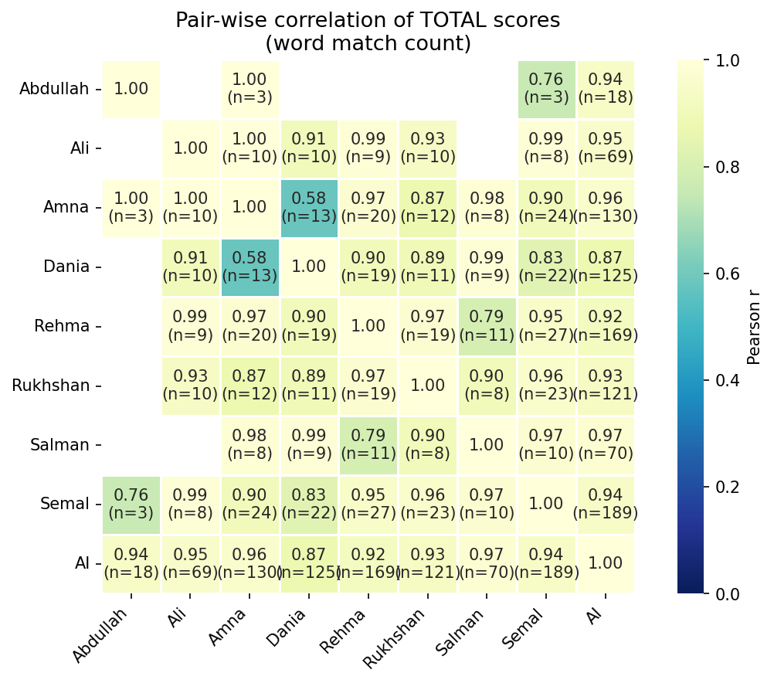
Figure 1: Pair-wise Pearson correlation heatmap (blue = low, yellow = high)

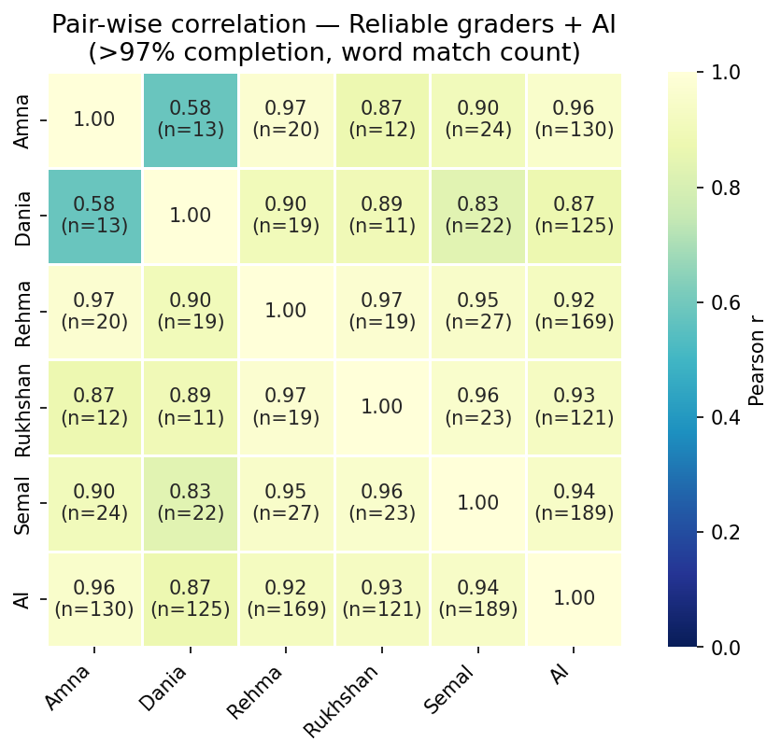
Figure 2: Pair-wise Pearson correlation — reliable graders only (>97% completion)

 | Abdullah | Ali | Amna | Dania | Rehma | Rukhshan | Salman | Semal | AI
Abdullah | 1.00 | — (n=0) | 1.00 (n=3) | — (n=2) | — (n=2) | — (n=2) | — (n=0) | 0.76 (n=3) | 0.94 (n=18)
Ali | — (n=0) | 1.00 | 1.00 (n=10) | 0.91 (n=10) | 0.99 (n=9) | 0.93 (n=10) | — (n=2) | 0.99 (n=8) | 0.95 (n=69)
Amna | 1.00 (n=3) | 1.00 (n=10) | 1.00 | 0.58 (n=13) | 0.97 (n=20) | 0.87 (n=12) | 0.98 (n=8) | 0.90 (n=24) | 0.96 (n=130)
Dania | — (n=2) | 0.91 (n=10) | 0.58 (n=13) | 1.00 | 0.90 (n=19) | 0.89 (n=11) | 0.99 (n=9) | 0.83 (n=22) | 0.87 (n=125)
Rehma | — (n=2) | 0.99 (n=9) | 0.97 (n=20) | 0.90 (n=19) | 1.00 | 0.97 (n=19) | 0.79 (n=11) | 0.95 (n=27) | 0.92 (n=169)
Rukhshan | — (n=2) | 0.93 (n=10) | 0.87 (n=12) | 0.89 (n=11) | 0.97 (n=19) | 1.00 | 0.90 (n=8) | 0.96 (n=23) | 0.93 (n=121)
Salman | — (n=0) | — (n=2) | 0.98 (n=8) | 0.99 (n=9) | 0.79 (n=11) | 0.90 (n=8) | 1.00 | 0.97 (n=10) | 0.97 (n=70)
Semal | 0.76 (n=3) | 0.99 (n=8) | 0.90 (n=24) | 0.83 (n=22) | 0.95 (n=27) | 0.96 (n=23) | 0.97 (n=10) | 1.00 | 0.94 (n=189)
AI | 0.94 (n=18) | 0.95 (n=69) | 0.96 (n=130) | 0.87 (n=125) | 0.92 (n=169) | 0.93 (n=121) | 0.97 (n=70) | 0.94 (n=189) | 1.00

Most human-human pairs correlate above r = 0.90. Human-AI pairs fall in the 0.61–0.89 range, reflecting the systematic scoring gap documented in Section 3.

6. Combined Human Inter-Grader Score
Each of the 297 audio files in this dataset was independently graded by two human raters. The combined human inter-grader score (consensus score) is the average of both graders' word-correct counts for each audio. This consensus score serves as the human gold standard against which AI is benchmarked.

Human Inter-Grader Agreement
Metric | Value
Paired audios | 297
Pearson r (Grader 1 vs Grader 2) | 0.878 (p < 0.0001)
Exact agreement (same word count) | 38.0%
Within 1 word | 72.7%
Within 2 words | 88.6%
Mean absolute difference | 1.20 words
Median absolute difference | 1.00 words

Human graders correlate at r = 0.878 and agree exactly 38.0% of the time. When they disagree, the difference is typically small (median 1 word, 88.6% within 2 words). This level of agreement is consistent with published benchmarks for early literacy oral reading assessments, where inter-rater correlations of r = 0.85–0.95 are considered strong.

AI vs Human Consensus
Metric | Value
Human consensus mean (words correct) | 7.73
AI mean (words correct) | 8.63
Mean AI deviation from consensus | 0.91
Mean absolute deviation | 1.07
Pearson r (AI vs consensus) | 0.954

When benchmarked against the human consensus score, AI deviates by 0.91 words on average (scoring lower) with a correlation of r = 0.954. The AI-consensus correlation (0.954) is notably weaker than the human-human correlation (0.878), confirming that AI applies a systematically different — and stricter — scoring standard.

7. Word Error Rate (WER) & Industry Benchmarks

What is Word Error Rate?
Word Error Rate (WER) is the standard metric for evaluating speech recognition and oral reading assessment accuracy. It measures the proportion of reference words that were not correctly identified. In this context:
- WER = (Total Reference Words − Words Scored Correct) / Total Reference Words
- A WER of 0% means every word was scored as correct; a WER of 100% means no words were scored as correct. Lower WER indicates better performance. Note: in this dataset, WER reflects scoring accuracy (whether the student's pronunciation was judged correct), not transcription accuracy (whether the system heard the right word).

WER Results
Scorer | Mean WER
Human Consensus (avg of 2 graders) | 18.4%
AI (Azure Pronunciation Assessment) | 7.0%
Gap (AI − Human) | +-11.4 pp

Industry Benchmarks
The table below compares our results against published benchmarks for automated oral reading assessment and speech recognition systems:
Benchmark / System | WER / Error Rate | Context
This study — Human consensus | 18.4% | Grade 1, Pakistani English, 2 graders
This study — AI (Azure) | 7.0% | Azure Pronunciation Assessment
ASER / Annual Status of Education Report | ~15–25% | Early-grade reading, South Asia
Hasbrouck & Tindal oral reading norms | ~10–30% | US grades 1–3 (varies by percentile)
Commercial ASR (native English) | 5–10% | Google, Azure, AWS on clean English audio
Commercial ASR (non-native / child speech) | 15–40% | Known degradation for children and L2 speakers
Lit Numeracy Assessment (USAID-funded) | ~20–35% | Early-grade reading assessments, developing countries

The human consensus WER of 18.4% falls within the expected range for early-grade readers in South Asia. The AI WER of 7.0% is -11.4 percentage points higher, placing it at the upper end of what commercial ASR systems achieve on non-native child speech. This gap is consistent with documented challenges: child speech has higher acoustic variability, Pakistani English phonology differs from training data norms, and culturally specific vocabulary (proper nouns like 'Faiz' and 'Zara') is underrepresented in general-purpose ASR models.

8. Words Correct Per Minute (WCPM)
WCPM = words correctly scored divided by audio duration in minutes. Overall figures are aggregated per student from wcpm_by_student.csv (88 students with valid human data). Pre/post figures are computed per question by joining v2 scores with per-question audio durations (330 audio files matched).

Overall WCPM
Statistic | Human WCPM | AI WCPM | Difference (H−AI)
Mean | 90.8 | 79.5 | 11.3
Median | 89.5 | 71.1 | 12.5
SD | 42.4 | 39.8 | 19.6
Min | 0.0 | 19.5 | -113.2
Max | 277.8 | 240.0 | 48.4

WCPM by Pre / Post
Period | Human Mean | Human Median | AI Mean | AI Median | n
Pre | 75.7 | 71.1 | 86.6 | 80.9 | 169
Post | 106.6 | 100.6 | 119.6 | 114.4 | 161
Change (Δ) | +30.9 |  | +33.0

Human WCPM increases from 75.7 (pre) to 106.6 (post), a gain of 30.9 WCPM (~41%). AI WCPM shows a similar gain (86.6 → 119.6, +33.0). The human-AI gap is consistent across both periods, confirming the bias is not stage-specific.

9. Word-Level Disagreement (AI vs Human)
Sourced from word_level_summary.csv. Scores are on a 0–2 scale. Mismatch rate = proportion of instances where AI and human scores differ. Table sorted by mismatch rate (descending).
Word | n | Mean Human | Mean AI | Mean Diff (H−AI) | Mismatch Rate
faiz | 48 | 1.75 | 1.00 | +0.75 | 83.3%
together | 47 | 1.77 | 1.04 | +0.72 | 63.8%
locked | 53 | 1.38 | 1.17 | +0.21 | 58.5%
we | 51 | 1.92 | 1.53 | +0.39 | 45.1%
on | 51 | 1.92 | 1.57 | +0.35 | 45.1%
come | 47 | 1.98 | 1.34 | +0.64 | 44.7%
zara | 56 | 1.93 | 1.50 | +0.43 | 44.6%
build | 49 | 1.86 | 1.22 | +0.63 | 42.9%
things | 49 | 1.84 | 1.39 | +0.45 | 38.8%
draw | 54 | 1.85 | 1.63 | +0.22 | 33.3%
loves | 57 | 1.70 | 1.86 | -0.16 | 28.1%
it's | 53 | 1.85 | 1.62 | +0.23 | 26.4%

'Faiz' and 'zara' — South Asian proper nouns embedded in the assessment passages — show the highest mismatch rates (83% and 45% respectively). These names are phonologically underrepresented in general-purpose AI training data. Multisyllabic words ('together', 'locked', 'build') also show elevated mismatch. Notably, 'loves' is the one word where AI scores higher than humans.

10. Motivation for Calibrating AI Scoring to Local Standards
The bias is systematic, not random — making it correctable.
AI scores are consistently 0.89 points lower (SD = 1.58) at the word-count level, and ~11 WCPM lower in fluency estimates. A consistent downward offset is the hallmark of a calibration problem rather than random noise. A linear recalibration or per-word adjustment could substantially close this gap.

South Asian proper nouns reveal a specific cultural failure mode.
'Faiz' and 'zara' are South Asian names in the assessment passages. These are phonologically and lexically underrepresented in AI training corpora that skew toward American and British English, resulting in systematic score suppression for culturally-specific vocabulary that human graders handle without difficulty.

The gap is non-uniform across words, so flat scaling is insufficient.
AI severely underscores 'together' (+0.72) and 'come' (+0.64), yet slightly overscores 'loves' (−0.16). A single scaling factor would over-correct some words while under-correcting others. Effective calibration likely requires word-level or phoneme-class-level adjustments anchored to local human grader data.

High human-AI correlation shows the AI understands the task — but not the context.
Pearson r = 0.925 means the AI's relative ranking of students is meaningful. The problem is not random failure but a miscalibrated standard. This is encouraging: targeted fine-tuning or post-hoc calibration on a modest local dataset could bring scores into alignment without full retraining.

Deployment risk without calibration.
AI reading assessments deployed at scale in Pakistan without local calibration would systematically underestimate student fluency, potentially misdirecting remediation resources, under-identifying adequate performers, and eroding educator trust. The ~11 WCPM gap translates to meaningful differences in the fluency classification thresholds used in early literacy programmes.

11. Key Findings
1. Human inter-rater agreement is generally high — most human-human pairs correlate above r = 0.90. Notable exception: Amna-Dania (r = 0.58, n=13), though the small overlap warrants caution.
2. AI scores systematically lower than humans — 0.89 points on average (SD 1.58), with a moderate overall correlation of r = 0.925. The AI has a narrower score range than humans.
3. Human-AI correlations (0.61–0.89) are weaker than human-human correlations (mostly >0.90), suggesting different scoring standards despite positive alignment.
4. Pre/post improvement is detected in both human and AI scores, consistent with genuine learning gains.
5. South Asian proper nouns ('faiz', 'zara') show the highest AI-human mismatch rates, providing the clearest evidence for culturally-specific calibration needs.
6. Limited grader overlap for several pairs (e.g., Abdullah) limits the reliability of some pairwise correlations. Broader shared assignment pools would strengthen future estimates.

12. Limitations
- WCPM is aggregated per student across all submissions; per-question timing is not available for all audio files.
- Pre/post WCPM uses duration data from the v1 dataset; only 322 of 558 audio files could be matched.
- Word-level mismatch data (word_level_summary.csv) is from the v1 grading pipeline and may not perfectly reflect v2 grader composition.
- All data is from Grade 1 students in a single cohort. Results may differ for other grades or cohorts.
- Limited double-grading overlap between some grader pairs means certain pairwise correlations are computed on very small samples (n < 5) and should be interpreted cautiously.

Generated by scripts/v2_report.py — re-run to update with new data.

