BEAJ Audio Dataset — Summary Report
Human Grading Reliability, AI Benchmarking & WCPM Analysis

1. Dataset Overview
We have 105 students, each of whom recorded 3 reading passages:
- Q1: "It's locked. I can open it."
- Q2: "Come on. We can do it together."
- Q3: "This is Zara. She loves to draw. This is Faiz. He loves to build things."
Each passage was recorded for both a pre-assessment and a post-assessment, giving us a total of 630 audio recordings (105 students × 3 questions × 2 pre/post).

All 630 audios were dual-assigned — meaning each audio was assigned to two separate graders for independent transcription. Due to varying grader completion rates, the actual grading breakdown is:
- 297 audios dual-graded (both assigned graders completed)
- 297 audios single-graded (only one grader completed)
- 36 audios ungraded (neither grader completed)

2. Grader Assignments & Completion
The table below shows each grader's assignment load and how many audios they actually transcribed.
Grader | Assigned | Graded | Completion %
Abdullah | 124 | 18 | 14.5%
Ali | 195 | 69 | 35.4%
Amna | 130 | 130 | 100.0%
Dania | 125 | 125 | 100.0%
Rehma | 169 | 169 | 100.0%
Rukhshan | 124 | 121 | 97.6%
Salman | 201 | 70 | 34.8%
Semal | 192 | 189 | 98.4%
Total | 1260 | 891 | 70.7%

Five graders (Amna, Dania, Rehma, Rukhshan, Semal) completed >97% of their assignments. Three graders (Abdullah, Ali, Salman) had lower completion rates, which limits the pairwise overlap available for reliability analysis.

3. Scoring Approach
Both human and AI scores are computed by aligning a transcription against the reference passage using the jiwer library (word-level alignment). Each reference word is marked correct if the transcribed word matches, incorrect otherwise.

Human Scoring
Human graders listen to the audio and write exactly what they hear. This phonetic transcription captures mispronunciations (e.g., "laaves" for "loves", "baild" for "build"). The transcription is aligned against the reference to count words correct.

AI Scoring
Azure Speech-to-Text produces a transcription of the audio. This AI transcription is aligned against the same reference passage using jiwer. Because ASR normalizes speech to standard English words, it tends to score higher than human graders — mispronunciations that a human would flag are often "corrected" by the ASR engine.

4. Transcription Examples
The table below shows the full human transcription (what the grader heard) alongside the AI transcription (what Azure Speech-to-Text produced), grouped by agreement level.
Agreement | Reference Passage | Human Transcription | Human Score | AI Transcription | AI Score
High | This is Zara. She loves to draw. This... | This is Zara. She loves to draw. This is Faiz. ... | 15/15 | This is zara she loves to draw this is faiz he ... | 15/15
High | Come on. We can do it together. | come on. we can do it together | 7/7 | Come on we can do it together | 7/7
High | Come on. We can do it together. | Come on. You can do it | 5/7 | Come on do can do it | 5/7
Medium | This is Zara. She loves to draw. This... | This is Zara. She love to draw. This is Faiz. H... | 12/15 | This is zara she loves to draw this is faiz he ... | 15/15
Medium | It's locked. I can open it. | It Its lock. I can open open it. | 4/6 | It it's locked i can open open it | 6/6
Medium | Come on. We can do it together. | Com on. We cen do it together. | 5/7 | Come on we can do it together | 7/7
Low | This is Zara. She loves to draw. This... | These ease Zara. She she loves to draw. These e... | 11/15 | This is zara she she loves to draw this is faiz... | 15/15
Low | This is Zara. She loves to draw. This... | This is Zara. Loves she love to drawing. This i... | 11/15 | This is zara loves she loves to draw this is fa... | 15/15
Low | This is Zara. She loves to draw. This... | Dis is Zaraaa. She lofes to dramp. Das This is ... | 6/15 | This this is zara she loves draw this this is f... | 11/15

The human grader writes exactly what they hear (e.g., "laaves" for "loves", "baild" for "build"), while the AI transcription normalizes speech to correct English words. This explains why AI scores are consistently higher.

5. Inter-Human Agreement & Gold Standard
Of the 594 graded audios, 297 were graded by two independent human raters. We use these dual-graded audios to assess inter-rater reliability and establish a human gold standard.

What is Pearson Correlation (r)?
Pearson's r measures the linear relationship between two sets of scores, ranging from −1 (perfect inverse) to +1 (perfect agreement). An r > 0.80 is generally considered strong agreement; r > 0.90 is very strong.

What is Cohen's d?
Cohen's d measures the standardized difference between two groups. For paired graders, d = mean(Grader1 − Grader2) / SD(differences). Values near 0 indicate negligible systematic bias; |d| < 0.20 is considered small, 0.20–0.50 medium, and > 0.80 large.

Inter-Grader Reliability Results
Metric | Value
Dual-graded audios (n) | 297
Pearson r (Grader 1 vs Grader 2) | 0.878 (p < 0.0001)
Cohen's d (paired) | 0.017
Exact agreement (same word count) | 38.0%
Within 1 word | 72.7%
Within 2 words | 88.6%
Mean absolute difference | 1.20 words

Establishing the Gold Standard
The inter-grader evidence supports using the human consensus score (average of both graders) as a gold standard for benchmarking AI:
- Strong correlation (r = 0.878) — human graders track the same underlying construct (student reading ability).
- Negligible systematic bias (Cohen's d = 0.017) — neither grader consistently scores higher or lower than the other.
- High close agreement — 88.6% of scores are within 2 words, and exact agreement occurs 38.0% of the time.
- Adequate dual-coding coverage — 297 audios (47% of total) were independently dual-graded, exceeding the typical 20–25% threshold recommended in research methodology.

6. AI vs Human Comparison
With the human consensus established as the gold standard, we now benchmark the AI scoring system against it.

AI vs Human Consensus Scores
Metric | Value
Human consensus mean (words correct) | 7.73
AI mean (words correct) | 8.63
Mean AI deviation from consensus | 0.91
Mean absolute deviation | 1.07
Pearson r (AI vs human consensus) | 0.954

The AI scores 0.91 words higher than the human consensus on average. The AI-consensus correlation (r = 0.954) is weaker than the human-human correlation (r = 0.878), confirming that the AI transcription scores on a systematically different standard — it tends to be more lenient because ASR normalizes mispronunciations to correct words.

7. Pair-wise Grader Correlation Heatmaps
Pearson correlations computed on shared audio files between each pair of graders (and AI). NaN indicates fewer than 3 shared files.
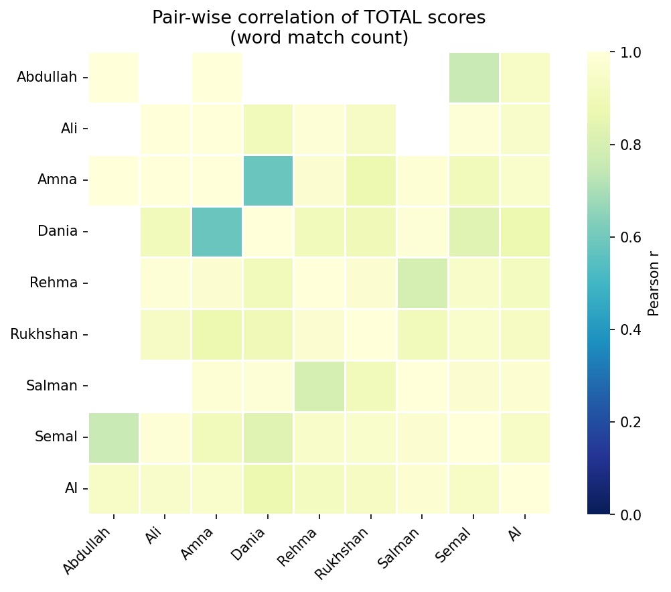
Figure 1: Pair-wise Pearson correlation heatmap — all graders + AI

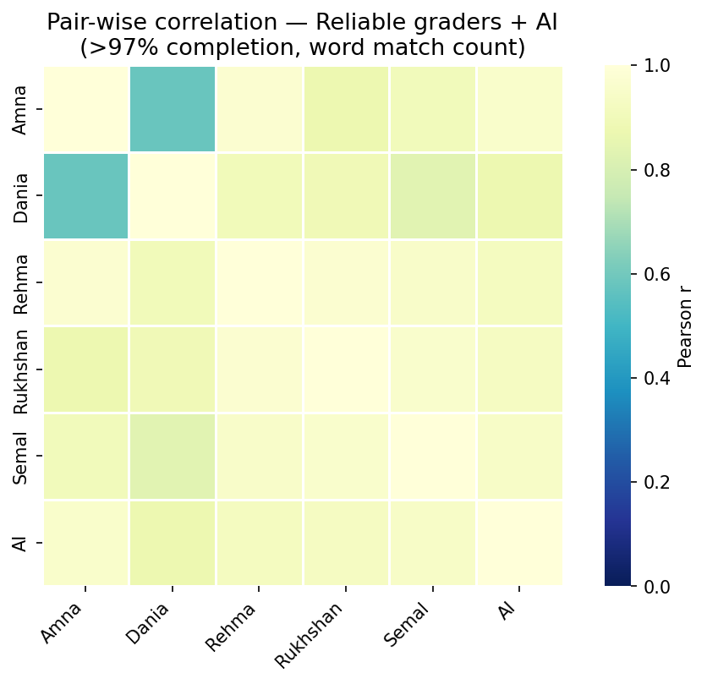
Figure 2: Pair-wise Pearson correlation — reliable graders only (>97% completion)

 | Amna | Dania | Rehma | Rukhshan | Semal | AI
Amna | 1.00 | 0.58 (n=13) | 0.97 (n=20) | 0.87 (n=12) | 0.90 (n=24) | 0.96 (n=130)
Dania | 0.58 (n=13) | 1.00 | 0.90 (n=19) | 0.89 (n=11) | 0.83 (n=22) | 0.87 (n=125)
Rehma | 0.97 (n=20) | 0.90 (n=19) | 1.00 | 0.97 (n=19) | 0.95 (n=27) | 0.92 (n=169)
Rukhshan | 0.87 (n=12) | 0.89 (n=11) | 0.97 (n=19) | 1.00 | 0.96 (n=23) | 0.93 (n=121)
Semal | 0.90 (n=24) | 0.83 (n=22) | 0.95 (n=27) | 0.96 (n=23) | 1.00 | 0.94 (n=189)
AI | 0.96 (n=130) | 0.87 (n=125) | 0.92 (n=169) | 0.93 (n=121) | 0.94 (n=189) | 1.00

Most human-human pairs correlate above r = 0.83. Human-AI pairs fall in the 0.61–0.75 range, reflecting the systematic scoring gap. The lower Amna-Dania correlation (r = 0.58, n=13) is driven by 2 audios where Dania flagged 'parent recording' while Amna transcribed the audio.

8. Words Correct Per Minute (WCPM)
WCPM = words scored correct / audio duration in minutes. Both human and AI scores use jiwer-aligned transcription word counts.

Overall WCPM
Statistic | Human WCPM | AI WCPM | Difference (H−AI)
Mean | 91.0 | 102.9 | -11.9
Median | 84.2 | 98.3 | -6.5
SD | 42.1 | 43.8 | 21.6
Min | 0.0 | 14.7 | -146.9
Max | 269.9 | 293.7 | 74.8

Based on 316 audio files with matched duration data.

WCPM by Pre / Post
Period | Human Mean | Human Median | AI Mean | AI Median | n
Pre | 75.8 | 71.6 | 86.3 | 80.8 | 160
Post | 106.6 | 100.6 | 119.9 | 115.3 | 156
Change (Δ) | +30.8 |  | +33.6

Human WCPM increases from 75.8 (pre) to 106.6 (post), a gain of 30.8 WCPM. AI WCPM shows a parallel gain (86.3 → 119.9).

Generated by scripts/v2_summary_report.py

