Human vs AI Transcription Analysis

1. Overview
- Total audio files: 630
- Audio files with at least one human transcription: 588
- Dual-graded audio files (both graders completed): 284
- Human graders: 7 (Ali, Amna, Dania, Rehma, Rukhshan, Salman, Semal)
- AI models evaluated: 11
- Pre-test audios: 315
- Post-test audios: 315
- Grade Coverage: Grade 1

Transcription Counts
Grader | Transcriptions (include dual-graded)
Ali | 69
Amna | 130
Dania | 125
Rehma | 169
Rukhshan | 121
Salman | 70
Semal | 189

2. Methodology — Words Correct

How we count words correct
We use the Python library jiwer's process_words functionality to align the scorer's transcription against the reference text (what the student was supposed to read). The algorithm finds the optimal word-level alignment that minimizes total errors, then counts hits, that is, words that matched exactly.
The alignment handles:
- Substitutions: a word was replaced (e.g., student said "laaves" instead of "loves")
- Deletions: a word was skipped entirely
- Insertions: an extra word was added
- Hits: the word matched correctly

Worked example
- Reference text: "She loves to draw"
- Transcription: "She laaves to"
Reference | she | loves | to | draw
Transcription | she | laaves | to | —
Result | Hit | Substitution | Hit | Deletion

Words correct = 2 ("she" and "to" matched)

Why words correct (not Word Error Rate)?
Word Error Rate (WER) measures the error rate of the transcription vs the reference. However, the transcription captures what the student actually said, not what they were supposed to say. WER therefore conflates:
- Student reading errors (The actual signal. That is, the student skipped or mispronounced words)
- Transcription differences (Noise. That is, graders writing slightly different things)
Words correct isolates the student performance signal: how many words did the student get right?
Note: All human-vs-AI comparisons use "Avg Human”, the per-audio average across all human graders as the baseline. For Word Error Rate (WER), we use the inter-grader WER as the baseline.

3. Inter-Grader Agreement — Words Correct
To establish whether human graders are consistent enough to serve as a reliable baseline, we compared each pair of graders on the audio files they both transcribed. For each pair, we computed the mean absolute difference in words correct (how many words apart they typically are) and the Pearson correlation (whether they agree on which students performed well vs poorly).
Across the 20 grader pairs with sufficient shared audios (n >= 3):
- Mean correlation: r = 0.95 (std: 0.05, range: 0.79 to 1.00)
- Mean absolute difference: 1.0 words (std: 0.64)
- 14 pairs have r >= 0.95 (strong agreement)
- 1 pair(s) fall below r = 0.85: Rehma-Salman
Human graders are thus largely consistent in identifying how many words each student reads correctly, making the human baseline reliable for AI comparison. Detailed comparison heatmap shown below:

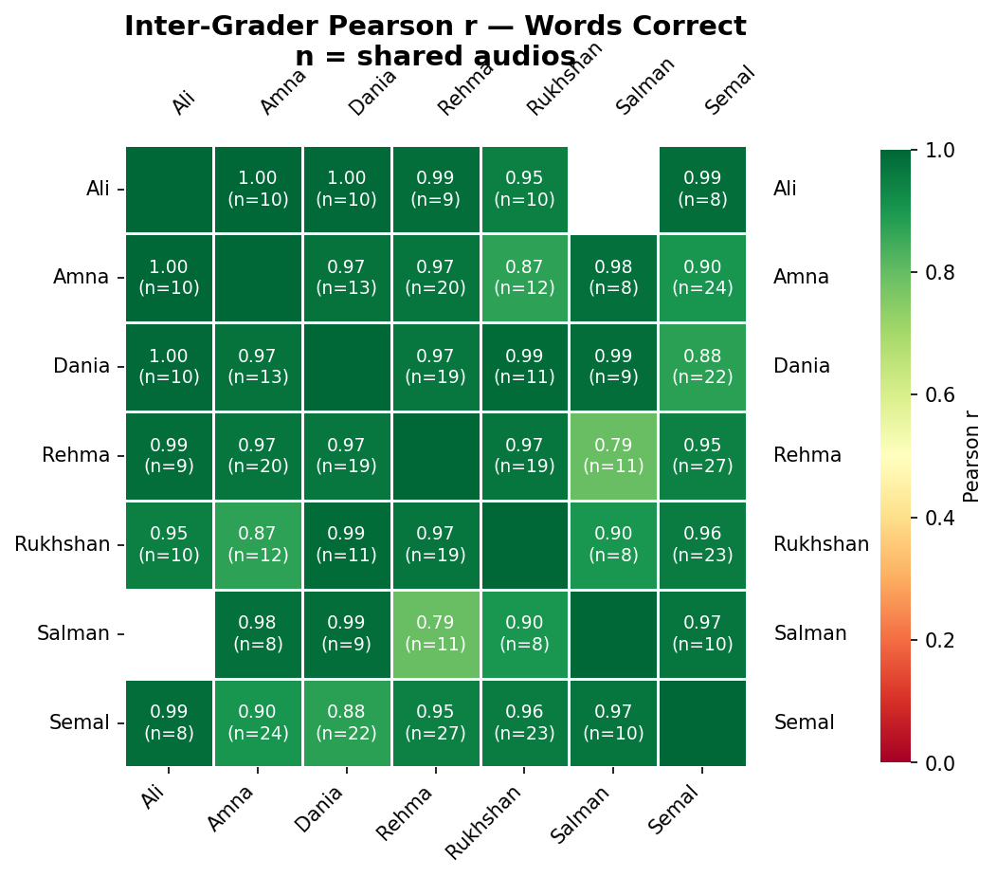4. Inter-Grader Agreement — WER
While words correct captures the student performance signal, WER measures how differently two graders transcribed the same audio — including filler words, spelling variations, and different ways of representing the same speech. A non-zero WER does not necessarily mean graders disagree on student ability; it often reflects transcription style differences.
Metric | Value
N (dual-graded audios) | 284
Mean WER | 21.4%
Median WER | 16.7%
Std | 0.21
Perfect agreement (WER=0) | 75 audios (26%)

The median WER of 16.7% means that on a typical audio, graders' transcriptions differ by about 1 in 6 words. 26% of audios have perfect inter-grader agreement. The high standard deviation (0.21) reflects considerable variability across transcriptions. Although this is expected with low-proficiency student speech, short sentence lengths amplify the effect. A single word difference on a 6-word sentence produces a 16.7% WER swing.

How WER Conflates Student Errors and Transcription Style
A high inter-grader WER can mean two very different things:
- Noise: graders heard the student the same way but wrote it differently (spelling, filler words, elongation). They agree on words correct despite high WER.
- Genuine disagreement: graders actually disagree on what the student said, leading to different words-correct counts.
Two examples illustrate this distinction:
Convention noise: grade1_profile30941_q3_QK_20251122_101834.mp3 (Inter-grader WER: 64%)
- Reference: "This is Zara. She loves to draw. This is Faiz. He loves to build things."
- Salman: 9 words correct — "This is Zara. She love to a. This is . He love to bill thin."
- Amna: 9 words correct — "This is Zara. She la va es a this is fa a az. he love to ba a - build"
Reference | this | is | zara. | she | loves | to | draw. | this | is | faiz. | he | loves | to | build | things.
Salman | Hit | Hit | Hit | Hit | Substitution | Hit | Substitution | Hit | Hit | Substitution | Hit | Substitution | Hit | Substitution | Substitution
Amna | Hit | Hit | Hit | Hit | Substitution | Substitution | Substitution | Hit | Hit | Substitution | Hit | Substitution | Hit | Hit | Deletion

WER is 64% but both graders agree on 9 words correct. The difference is purely transcription style, not a scoring disagreement.
Genuine disagreement: grade1_profile28431_q1_QK_20251122_095622.mp3 (Inter-grader WER: 100%)
- Reference: "Come on. We can do it together."
- Salman: 7 words correct — "come on. we can do it together."
- Rukhshan: 2 words correct — "Come ooonn. Come on. Wee caannn dooo ittt twogether"
Reference | come | on. | we | can | do | it | together.
Salman | Hit | Hit | Hit | Hit | Hit | Hit | Hit
Rukhshan | Hit | Hit | Substitution | Substitution | Substitution | Substitution | Substitution

WER is 100% and the graders disagree by 5 words correct. This reflects genuine uncertainty about what the student said.

5. AI Transcription Process
Sections 3–4 established inter-grader reliability on the 284 dual-graded audios. This section evaluates how closely each AI model's transcriptions align with the human baseline, and we leverage all available audios (N=588)* with at least one human transcription for this purpose.
We benchmark against the following 11 models:
- Gemini: 3 Flash, 3 Pro, 3.1 Pro
- GPT-4o: Azure, OpenAI
- Sarvam
- Scribe v2
- Universal, Universal 3 Pro
- Voxtral: Mini, Small
* AI model coverage might vary across different models as not all audios returned valid transcriptions.
Each AI model was given the student audio and the following prompt: "Transcribe the audio, if it is empty return nothing. Transcribe it exactly, don't add any extra words or fix any mistakes." This transcribes the user audio exactly and doesn't auto-fix anything.

6. Avg Human vs AI – Words Correct
8 of 11 AI models match or exceed the average human baseline on words correct. Universal 3 Pro leads at 8.1 words correct per audio (vs 7.6 for Avg Human), while both GPT-4o variants trail at 7.2. The spread across AI models is relatively narrow (7.2–8.1), indicating that most models capture student reading performance comparably to human graders.
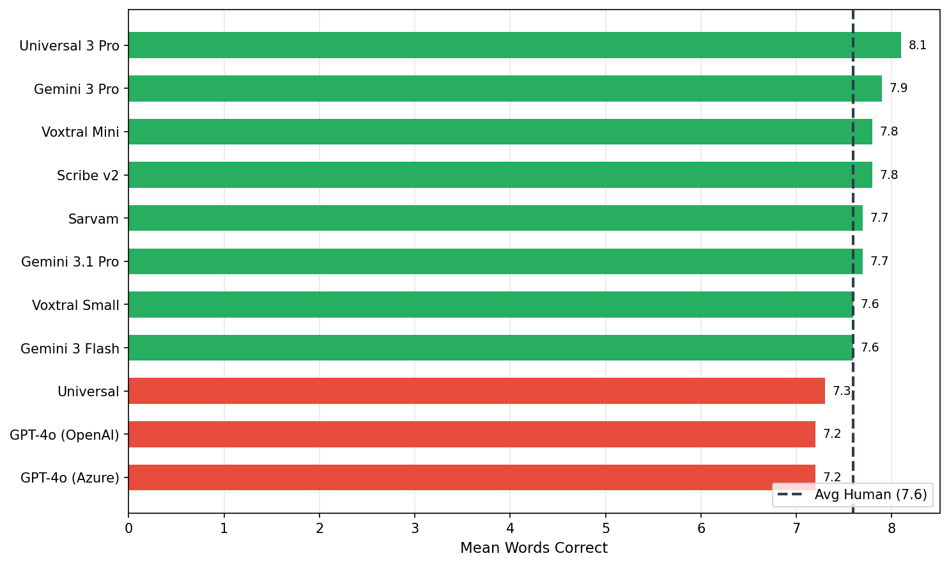

7. Avg Human vs Each AI — WER
WER here measures how closely each AI model's transcription matches the human transcriptions of the same audio. For each AI model on each audio, we compute the WER between the AI's transcription and each human grader's transcription, then average. The "Avg Human" baseline is the inter-grader WER (how much human graders differ from each other). Lower WER = closer agreement between AI and human transcriptions.
0 of 11 AI models achieve lower WER against human transcriptions than the inter-grader baseline (21.4%). Were any models to achieve a WER at or below the inter-grader baseline, these would be transcribing at least as consistently as human graders. However, Sarvam comes closest with 22.9% WER, meaning that it transcribes almost as well as human graders.
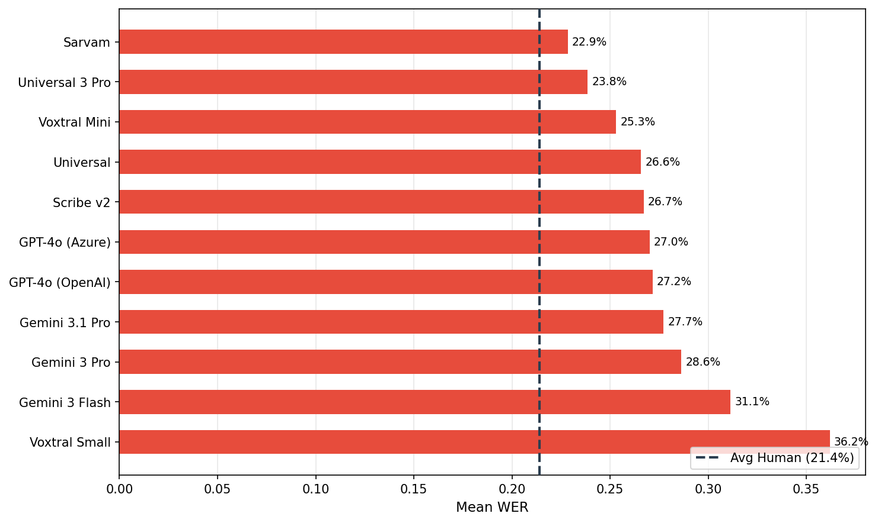
Grader-level comparison (heatmap) is shown in Appendix B.

8. WCPM — Avg Human vs Each AI
Words Correct Per Minute (WCPM) is the standard reading fluency metric, computed as total_words_correct / total_duration_minutes across all audios for each scorer. It combines accuracy (words correct) with speed (how long the student took).
Duration data is available for 578 out of 588 audios (98% coverage).
7 of 11 AI models produce WCPM scores at or above the human baseline (73.6 WCPM). Sarvam leads at 77.3 WCPM.
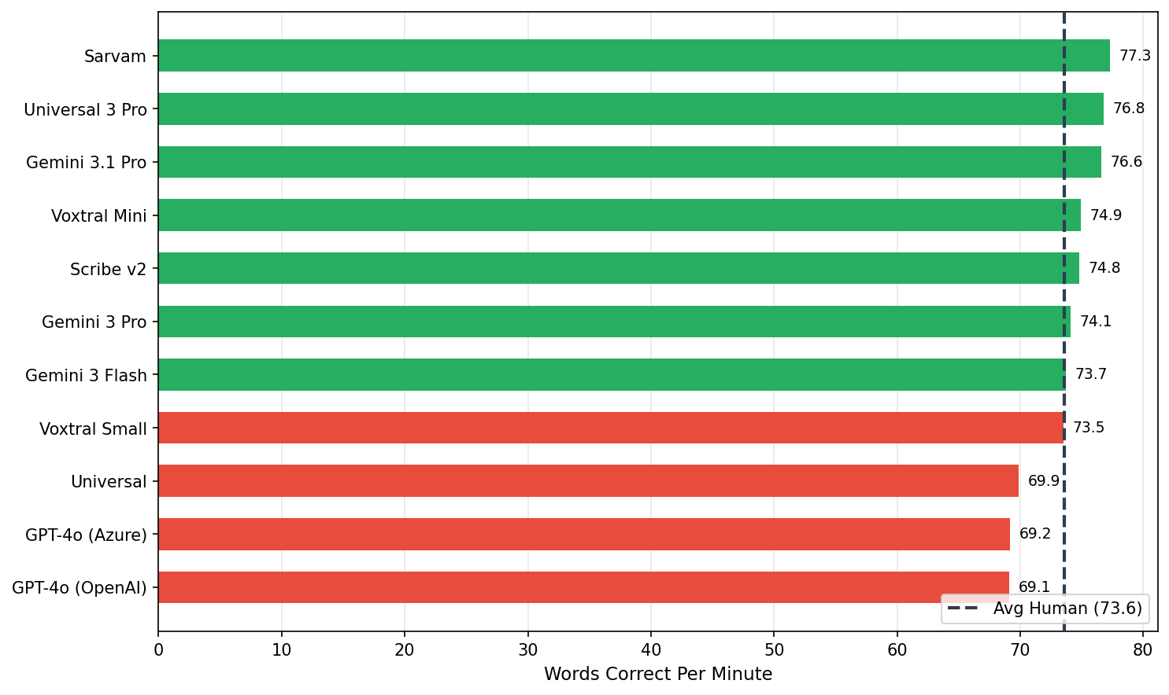

9. Pre/Post WCPM — Avg Human vs Each AI
Students are assessed before (pre-test) and after (post-test) the intervention. The key question: does AI scoring detect the same student improvement that human graders see?
Scorer | Pre WCPM | Post WCPM | Delta
Avg Human (baseline) | 61.6 | 89.7 | +28.1
Sarvam | 64.5 | 94.1 | +29.6
Universal 3 Pro | 64.3 | 93.4 | +29.1
Voxtral Mini | 62.5 | 91.4 | +28.9
Scribe v2 | 62.7 | 91.1 | +28.4
Gemini 3.1 Pro | 64.6 | 91.6 | +27.0
Gemini 3 Pro | 62.9 | 89.7 | +26.8
Gemini 3 Flash | 62.2 | 88.9 | +26.7
Universal | 58.7 | 84.9 | +26.2
Voxtral Small | 62.3 | 88.4 | +26.1
GPT-4o (OpenAI) | 58.1 | 83.9 | +25.8
GPT-4o (Azure) | 58.4 | 83.8 | +25.4
Human graders measure a +28.1 WCPM improvement from pre to post. AI models measure a mean improvement of +27.3 WCPM — closely tracking the human-observed gain. All 11 AI models detect a positive pre-to-post improvement, confirming that AI scoring reliably captures the effect of the reading intervention.

10. Conclusion
Inter-grader agreement is strong, establishing a reliable human baseline for comparing AI transcription models. On the 588 audios with human transcription:
- 8 of 11 AI models match or exceed the average human baseline on words correct
- 7 of 11 AI models meet or exceed the human WCPM baseline (73.6 WCPM)
- All 11 AI models detect a positive pre-to-post improvement, with a mean AI delta of +27.3 WCPM vs the human-observed +28.1 WCPM
WER differences between AI and human transcriptions are comparable to inter-grader WER, suggesting that much of the measured disagreement reflects transcription style rather than scoring disagreement. Additional standardization of transcription rubrics and AI prompting can help reduce WER and further refine transcription quality.
For grading reading fluency assessments of Grade 1 students, certain AI platforms can reliably replace or supplement human grading, enabling faster turnaround, greater scalability, and reduced costs without sacrificing the accuracy needed to inform instructional decisions.

11. Appendix

A. Words Correct Correlation Heatmap
Pairwise Pearson correlation of word-correct counts across shared audio files, using all graders + AI models. Color scale: 0 to 1.
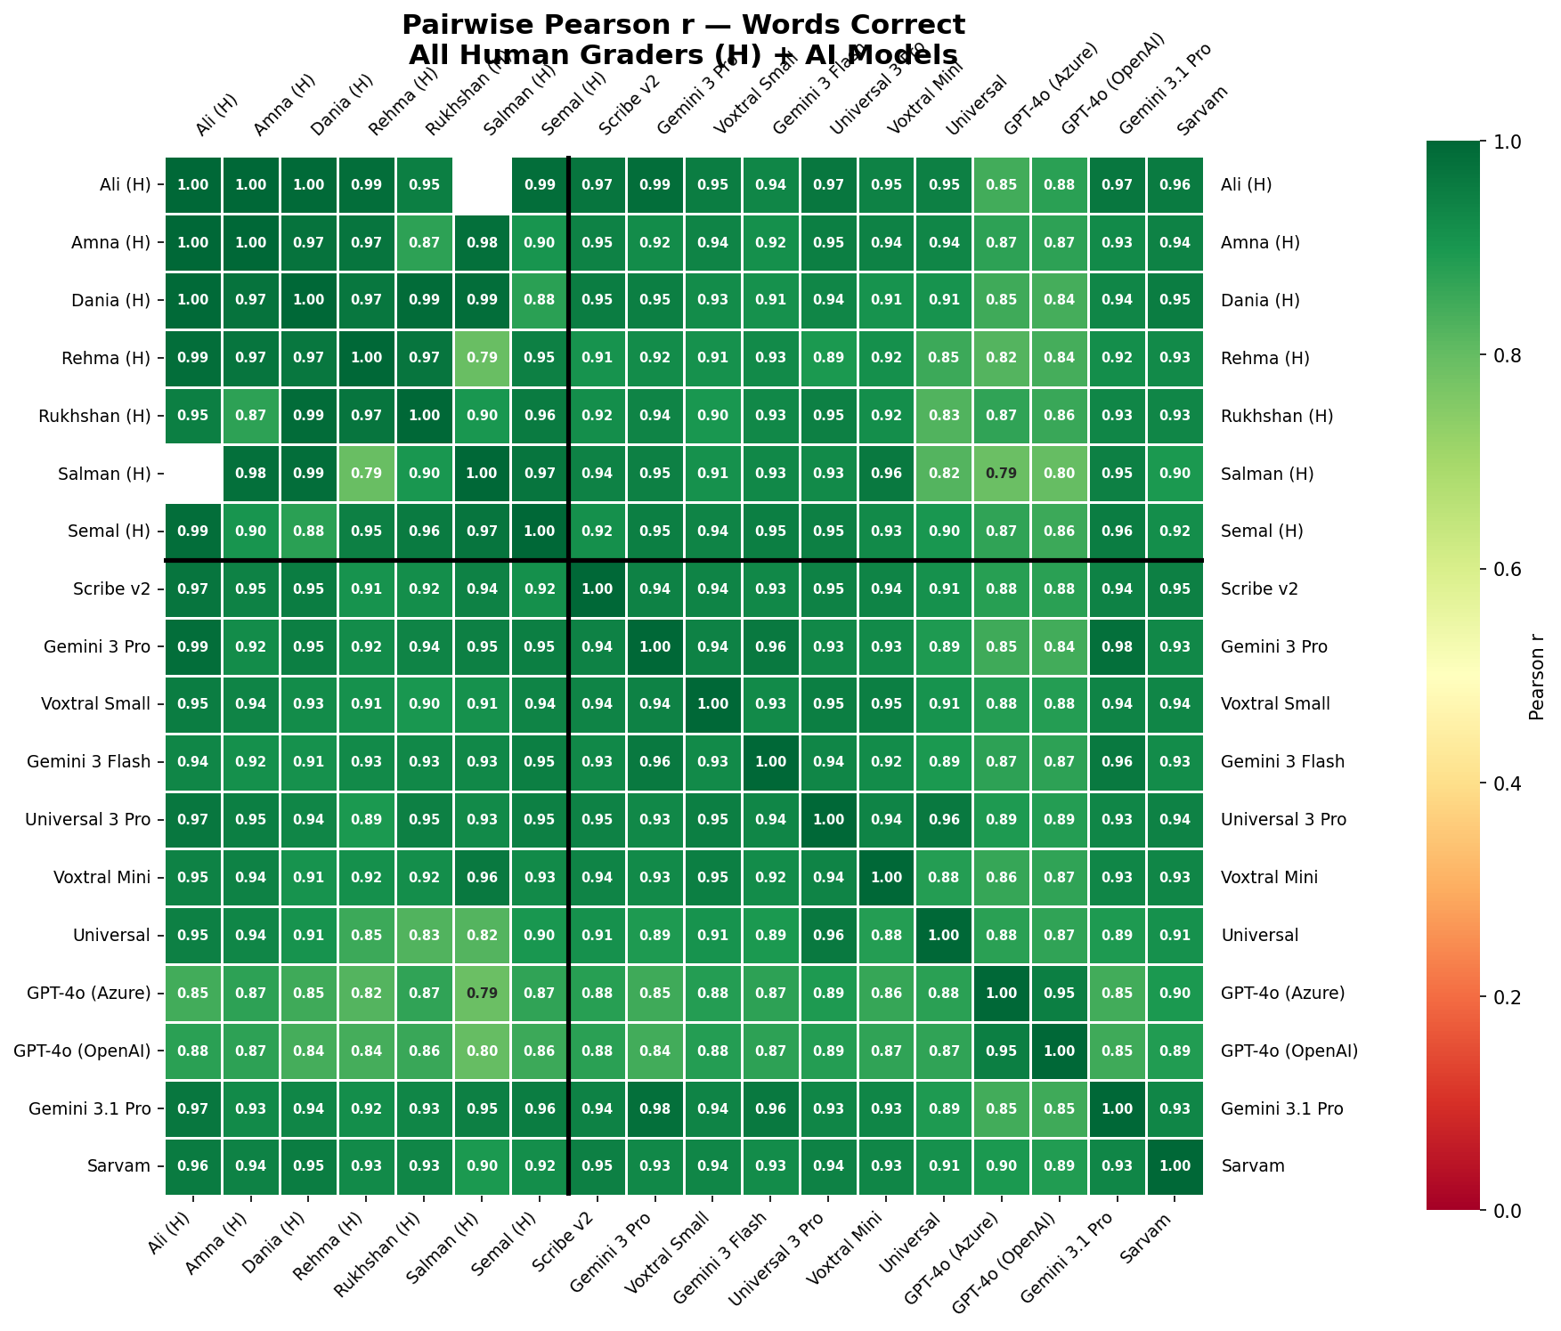

Mean Correlations by Group
Group | Mean Pearson r | N pairs
Human-Human | 0.949 | 20
Human-AI | 0.915 | 77
AI-AI | 0.914 | 55

B. WER Heatmap (lower score = more agreement)
Pairwise mean WER between all scorers on shared audio files. Color scale: 0 to 1 (0 = identical transcriptions, 1 = completely different).
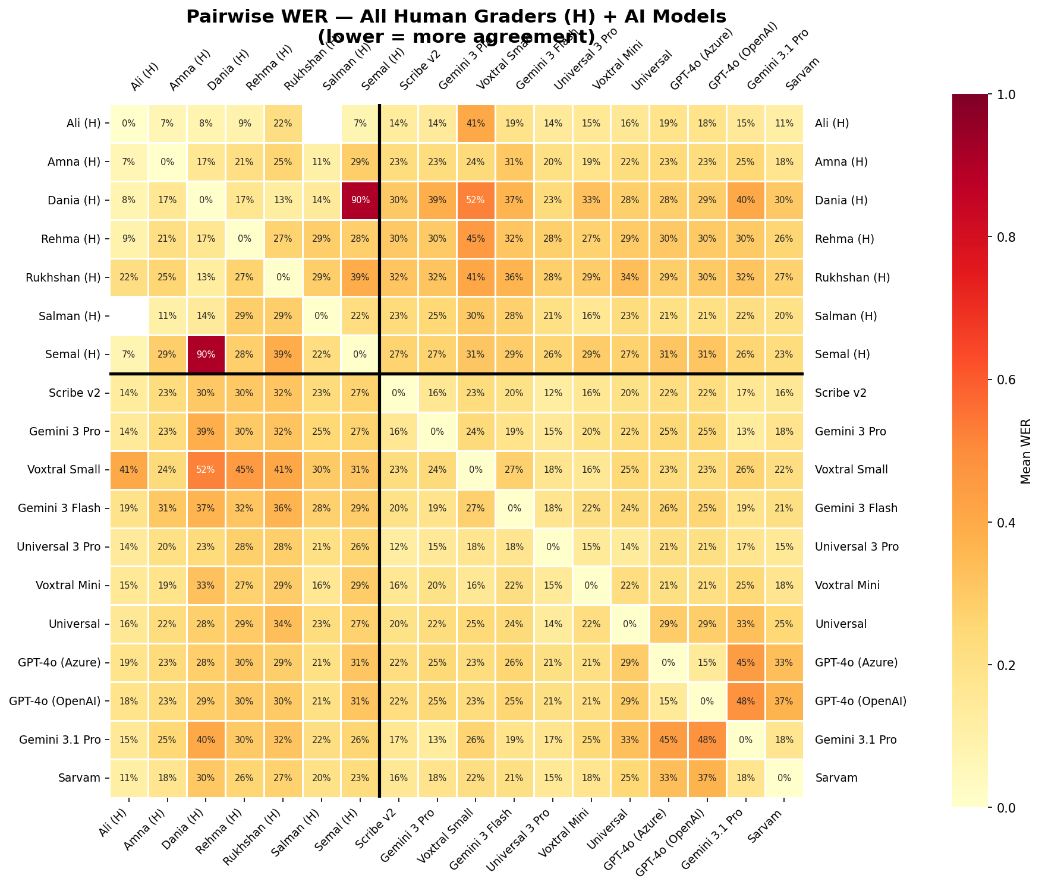

C. Words Correct — Full Rankings
AI model coverage might vary across different models as not all of the 588 audios returned valid transcriptions. That is, you might see a smaller N for some models.
Rank | Scorer | Mean Words Correct | Median | N (audios) | Statistically  Significant?
— | Avg Human (baseline) | 7.6 | 6 | 588
1 | Universal 3 Pro | 8.1 | 7 | 544 | Yes
2 | Gemini 3 Pro | 7.9 | 7 | 526 | Yes
3 | Scribe v2 | 7.8 | 7 | 581 | Yes
4 | Voxtral Mini | 7.8 | 7 | 583 | Yes
5 | Gemini 3.1 Pro | 7.7 | 7 | 562 | Yes
6 | Sarvam | 7.7 | 7 | 581 | Yes
7 | Gemini 3 Flash | 7.6 | 7 | 587 | No
8 | Voxtral Small | 7.6 | 7 | 588 | No
9 | Universal | 7.3 | 7 | 583 | Yes
10 | GPT-4o (Azure) | 7.2 | 7 | 588 | Yes
11 | GPT-4o (OpenAI) | 7.2 | 7 | 588 | Yes

D. WER — Full Rankings
AI model coverage might vary across different models as not all of the 588 audios returned valid transcriptions. That is, you might see a smaller N for some models.
Statistical significance is in comparison with the Avg Human baseline.
Rank | Scorer | Mean WER | Median WER | N (audios) | Statistically Significant?
— | Avg Human (baseline) | 21.4% | 16.7% | 284 (only for dual graded)
1 | Sarvam | 22.9% | 16.7% | 576 | Yes
2 | Universal 3 Pro | 23.8% | 17.5% | 544 | No
3 | Voxtral Mini | 25.3% | 16.7% | 580 | No
4 | Universal | 26.6% | 17.6% | 579 | No
5 | Scribe v2 | 26.7% | 16.7% | 577 | No
6 | GPT-4o (Azure) | 27.0% | 20.0% | 582 | Yes
7 | GPT-4o (OpenAI) | 27.2% | 20.0% | 582 | Yes
8 | Gemini 3.1 Pro | 27.7% | 16.7% | 557 | No
9 | Gemini 3 Pro | 28.6% | 18.8% | 521 | No
10 | Gemini 3 Flash | 31.1% | 20.0% | 581 | Yes
11 | Voxtral Small | 36.2% | 22.8% | 582 | Yes

E. WCPM — Full Rankings
AI model coverage might vary across different models as not all of the 588 audios returned valid transcriptions. That is, you might see a smaller N for some models.
Rank | Scorer | WCPM | N (audios)
— | Avg Human (baseline) | 73.6 | 578
1 | Sarvam | 77.3 | 572
2 | Universal 3 Pro | 76.8 | 542
3 | Gemini 3.1 Pro | 76.6 | 553
4 | Voxtral Mini | 74.9 | 577
5 | Scribe v2 | 74.8 | 573
6 | Gemini 3 Pro | 74.1 | 517
7 | Gemini 3 Flash | 73.7 | 577
8 | Voxtral Small | 73.5 | 578
9 | Universal | 69.9 | 575
10 | GPT-4o (Azure) | 69.2 | 578
11 | GPT-4o (OpenAI) | 69.1 | 578

