Human vs AI Transcription Analysis
Generated: 2026-03-02

1. Overview
- Total audio files: 630
- Audio files with at least one human transcription: 588
- Dual-graded audio files (both graders completed): 285
- Human graders: 7 (Ali, Amna, Dania, Rehma, Rukhshan, Salman, Semal)
- AI models evaluated: 11
- Pre-test audios: 315
- Post-test audios: 315
All human-vs-AI comparisons use "Avg Human" — the per-audio average across all human graders — as the baseline.

Transcription Counts
Grader | Transcriptions
Ali | 69
Amna | 130
Dania | 125
Rehma | 169
Rukhshan | 121
Salman | 70
Semal | 189

2. Methodology — Words Correct

How we count words correct
We use jiwer's process_words to align the scorer's transcription against the reference text (what the student was supposed to read). The algorithm finds the optimal word-level alignment that minimizes total errors, then counts hits — words that matched exactly.
The alignment handles:
- Substitutions — a word was replaced (e.g., student said "laaves" instead of "loves")
- Deletions — a word was skipped entirely
- Insertions — an extra word was added
- Hits — the word matched correctly

Worked example
Reference text: "She loves to draw"
Transcription: "She laaves to"
Reference | she | loves | to | draw
Transcription | she | laaves | to | —
Result | Hit | Substitution | Hit | Deletion

Words correct = 2 ("she" and "to" matched)

Why words correct (not WER) for correlation?
Word Error Rate (WER) measures the error rate of the transcription vs the reference. However, the transcription captures what the student actually said, not what they were supposed to say. WER therefore conflates:
- Student reading errors (the actual signal — the student skipped or mispronounced words)
- Transcription differences (noise — graders wrote slightly different things)
Words correct isolates the student performance signal: how many words did the student get right? All scorers fundamentally agree on this, which is why word-correct correlations (r > 0.90) are much higher than WER-based comparisons.

3. Inter-Grader Agreement — Words Correct
To establish whether human graders are consistent enough to serve as a reliable baseline, we compared each pair of graders on the audio files they both transcribed. For each pair, we computed the mean absolute difference in words correct (how many words apart they typically are) and the Pearson correlation (whether they agree on which students performed well vs poorly).
Across the 20 grader pairs with sufficient shared audios (n >= 3):
- Mean correlation: r = 0.95 (std: 0.05, range: 0.79 to 1.00)
- Mean absolute difference: 1.0 words (std: 0.64)
- 14 pairs have r >= 0.95 (strong agreement)
- 1 pair(s) fall below r = 0.85: Rehma-Salman
This confirms that human graders are largely consistent in identifying how many words each student reads correctly, making the human baseline reliable for AI comparison.
Full pairwise heatmap in Appendix C. Correlation p-values in Appendix K.

4. Inter-Grader Agreement — WER
While words correct captures the student performance signal, WER measures how differently two graders transcribed the same audio — including filler words, spelling variations, and different ways of representing the same speech. A non-zero WER does not necessarily mean graders disagree on student ability; it often reflects transcription style differences.
Metric | Value
N (dual-graded audios) | 284
Mean WER | 21.4%
Median WER | 16.7%
Std | 0.21
Perfect agreement (WER=0) | 75 audios (26%)
The median WER of 16.7% means that on a typical audio, graders' transcriptions differ by about 1 in 6 words. 26% of audios have perfect inter-grader agreement. The high standard deviation (0.21) reflects that some challenging audios produce very different transcriptions — this is expected with low-proficiency student speech.

How WER Conflates Student Errors and Transcription Style
A high inter-grader WER can mean two very different things:
- Convention noise — graders heard the student the same way but wrote it differently (spelling, filler words, elongation). They agree on words correct despite high WER.
- Genuine disagreement — graders actually disagree on what the student said, leading to different words-correct counts.
Two examples illustrate this distinction:
Convention noise: grade1_profile30941_q3_QK_20251122_101834.mp3 (Inter-grader WER: 64%)
Reference: "This is Zara. She loves to draw. This is Faiz. He loves to build things."
Reference | this | is | zara. | she | loves | to | draw. | this | is | faiz. | he | loves | to | build | things.
Salman | Hit | Hit | Hit | Hit | Substitution | Hit | Substitution | Hit | Hit | Substitution | Hit | Substitution | Hit | Substitution | Substitution
Amna | Hit | Hit | Hit | Hit | Substitution | Substitution | Substitution | Hit | Hit | Substitution | Hit | Substitution | Hit | Hit | Deletion
Salman: 9 words correct — "This is Zara. She love to a. This is . He love to bill thin."
Amna: 9 words correct — "This is Zara. She la va es a this is fa a az. he love to ba a - build"
WER is 64% but both graders agree on 9 words correct. The difference is purely transcription style — not a scoring disagreement.

Genuine disagreement: grade1_profile28431_q1_QK_20251122_095622.mp3 (Inter-grader WER: 100%)
Reference: "Come on. We can do it together."
Reference | come | on. | we | can | do | it | together.
Salman | Hit | Hit | Hit | Hit | Hit | Hit | Hit
Rukhshan | Hit | Hit | Substitution | Substitution | Substitution | Substitution | Substitution
Salman: 7 words correct — "come on. we can do it together."
Rukhshan: 2 words correct — "Come ooonn. Come on. Wee caannn dooo ittt twogether"
WER is 100% and the graders disagree by 5 words correct. This reflects genuine uncertainty about what the student said.

5. Avg Human vs Each AI — Words Correct
Sections 3–4 established inter-grader reliability on the 285 dual-graded audios. The following AI comparisons use all 588 audios with at least one human transcription, with "Avg Human" as the per-audio average across available human graders.

How AI transcriptions were generated
Each AI model was given the student audio and the following prompt:
"Transcribe the audio, if it is empty return nothing. Transcribe it exactly, don't add any extra words or fix any mistakes."
This transcribes the user audio exactly and doesn't auto-fix anything.
8 of 11 AI models match or exceed the average human baseline on words correct. Universal 3 Pro leads at 8.1 words correct per audio (vs 7.6 for Avg Human), while GPT-4o (OpenAI) trails at 7.2. The spread across AI models is relatively narrow (7.2–8.1), indicating that most models capture student reading performance comparably to human graders.
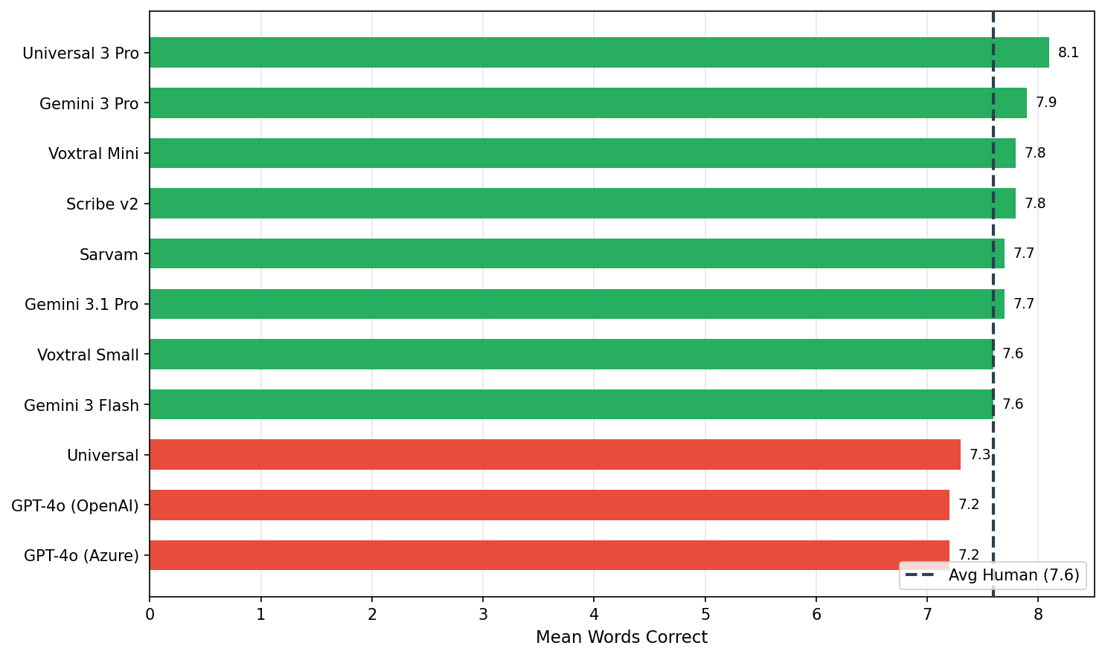
See Appendix H for Wilcoxon signed-rank tests and 95% confidence intervals.

6. Avg Human vs Each AI — WER
WER here measures how closely each AI model's transcription matches the human transcriptions of the same audio. For each AI model on each audio, we compute the WER between the AI's transcription and each human grader's transcription, then average. The "Avg Human" baseline is the inter-grader WER (how much human graders differ from each other). Lower WER = closer agreement between AI and human transcriptions.
0 of 11 AI models achieve lower WER against human transcriptions than the inter-grader baseline (21.4%). Sarvam leads with 22.9% WER. Models with WER at or below the inter-grader baseline are transcribing at least as consistently as human graders agree with each other.
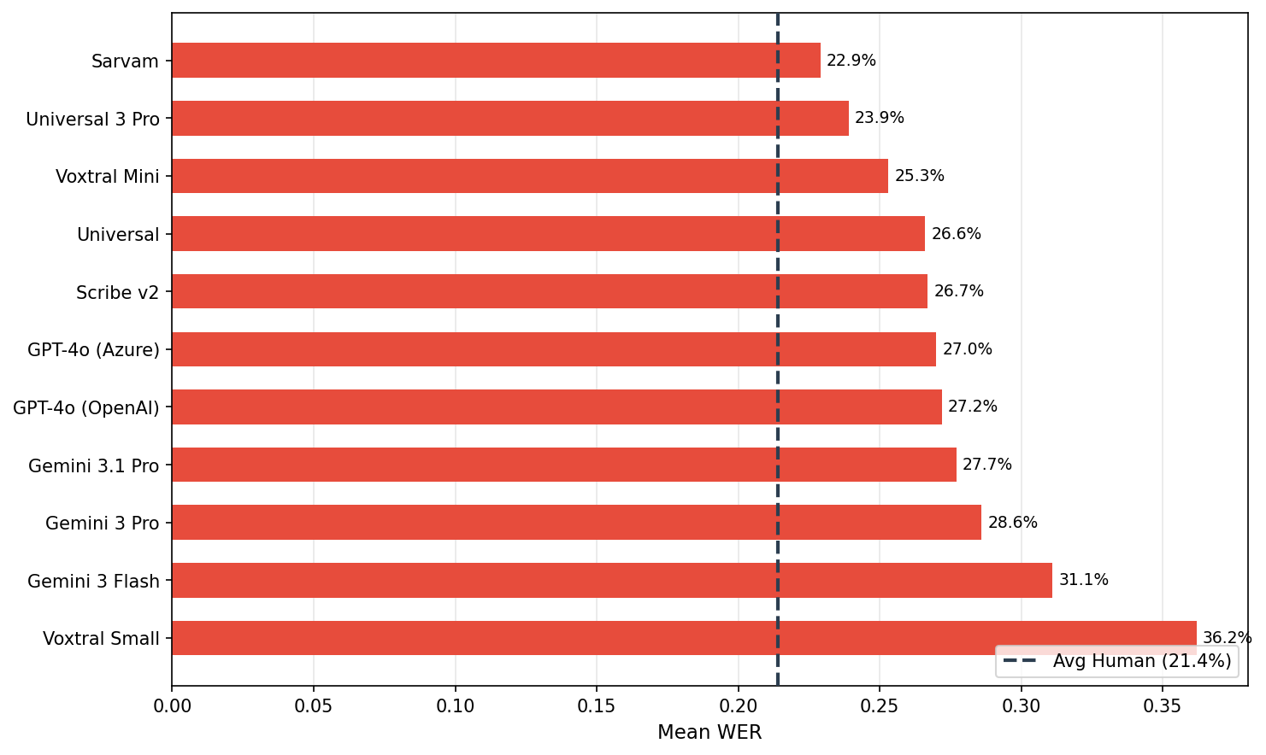
See Appendix I for Wilcoxon signed-rank tests and 95% confidence intervals.

7. WCPM — Avg Human vs Each AI
Words Correct Per Minute (WCPM) is the standard reading fluency metric, computed as total_words_correct / total_duration_minutes across all audios for each scorer. It combines accuracy (words correct) with speed (how long the student took).
Duration data is available for 578 out of 588 audios (98% coverage).
7 of 11 AI models produce WCPM scores at or above the human baseline (73.6 WCPM). Sarvam leads at 77.3 WCPM. Since WCPM is the metric that ultimately determines a student's reading level, this is the most operationally relevant comparison — it shows that AI scoring closely tracks human scoring on the metric that matters most.
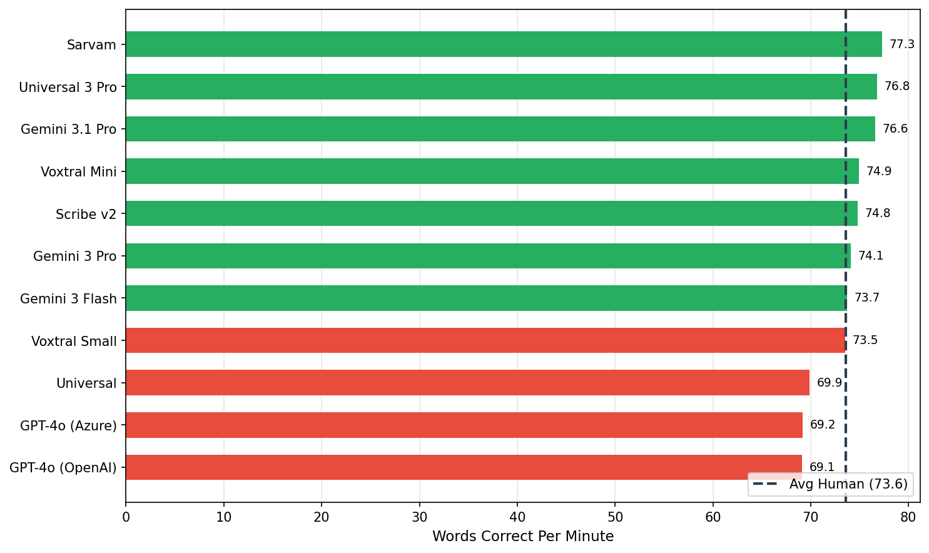
See Appendix J for bootstrap 95% confidence intervals.

8. Pre/Post WCPM — Avg Human vs Each AI
Students are assessed before (pre-test) and after (post-test) the intervention. The key question: does AI scoring detect the same student improvement that human graders see?
Scorer | Pre WCPM | Post WCPM | Delta
Avg Human (baseline) | 61.6 | 89.7 | +28.1
Sarvam | 64.5 | 94.1 | +29.6
Universal 3 Pro | 64.3 | 93.4 | +29.1
Voxtral Mini | 62.5 | 91.4 | +28.9
Scribe v2 | 62.7 | 91.1 | +28.4
Gemini 3.1 Pro | 64.6 | 91.6 | +27.0
Gemini 3 Pro | 62.9 | 89.7 | +26.8
Gemini 3 Flash | 62.2 | 88.9 | +26.7
Universal | 58.7 | 84.9 | +26.2
Voxtral Small | 62.3 | 88.4 | +26.1
GPT-4o (OpenAI) | 58.1 | 83.9 | +25.8
GPT-4o (Azure) | 58.4 | 83.8 | +25.4
Human graders measure a +28.1 WCPM improvement from pre to post. AI models measure a mean improvement of +27.3 WCPM — closely tracking the human-observed gain. All 11 AI models detect a positive pre-to-post improvement, confirming that AI scoring reliably captures the effect of the reading intervention.
See Appendix L for pre/post WCPM significance tests.

9. Conclusion
Inter-grader agreement is strong (mean r = 0.95, std = 0.05 across 20 pairs), establishing a reliable human baseline for comparing AI transcription models. On the 588 audios with human transcription:
- 8 of 11 AI models match or exceed the average human baseline on words correct
- 7 of 11 AI models meet or exceed the human WCPM baseline (73.6 WCPM)
- All 11 AI models detect a positive pre-to-post improvement, with a mean AI delta of +27.3 WCPM vs the human-observed +28.1 WCPM
WER differences between AI and human transcriptions are comparable to inter-grader WER, suggesting that much of the measured disagreement reflects transcription style rather than scoring disagreement. AI scoring can reliably replace or supplement human grading for reading fluency assessment.

10. Appendix

A. Words Correct Correlation Heatmap
Pairwise Pearson correlation of word-correct counts across shared audio files, using all graders + AI models. Color scale: 0 to 1.
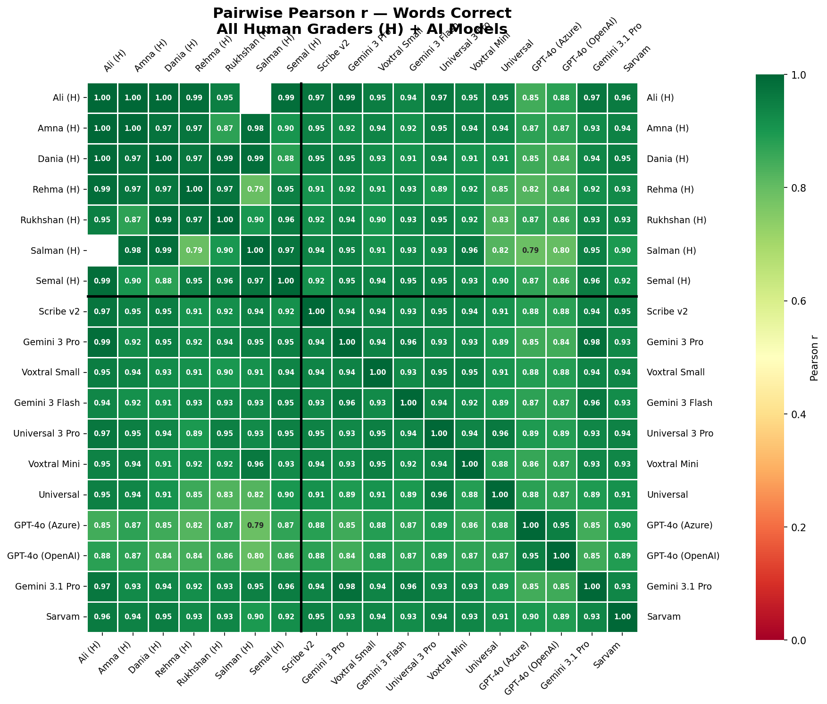

Mean Correlations by Group
Group | Mean Pearson r | N pairs
Human-Human | 0.949 | 20
Human-AI | 0.915 | 77
AI-AI | 0.914 | 55

B. WER Heatmap
Pairwise mean WER between all scorers on shared audio files. Color scale: 0 to 1 (0 = identical transcriptions, 1 = completely different).
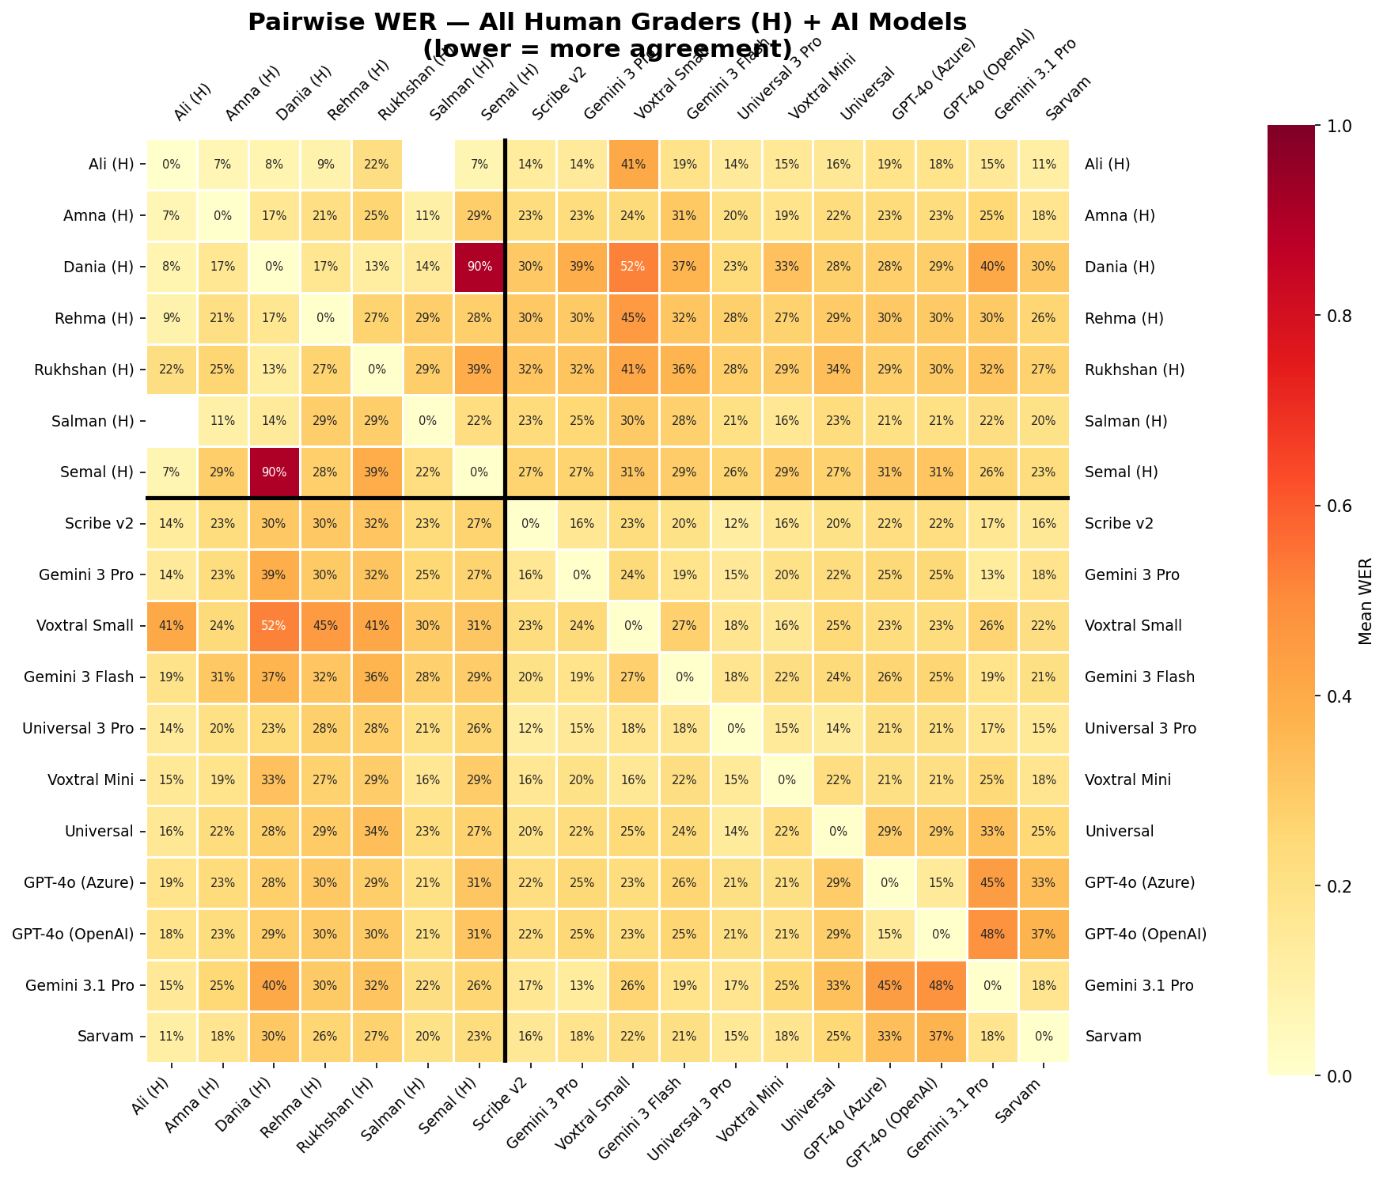

C. Inter-Grader Words Correct — Pairwise Heatmap
Pairwise Pearson correlation of word-correct counts between human graders. Each cell shows the correlation and the number of shared audios. Color scale: 0 to 1 (green = strong agreement).
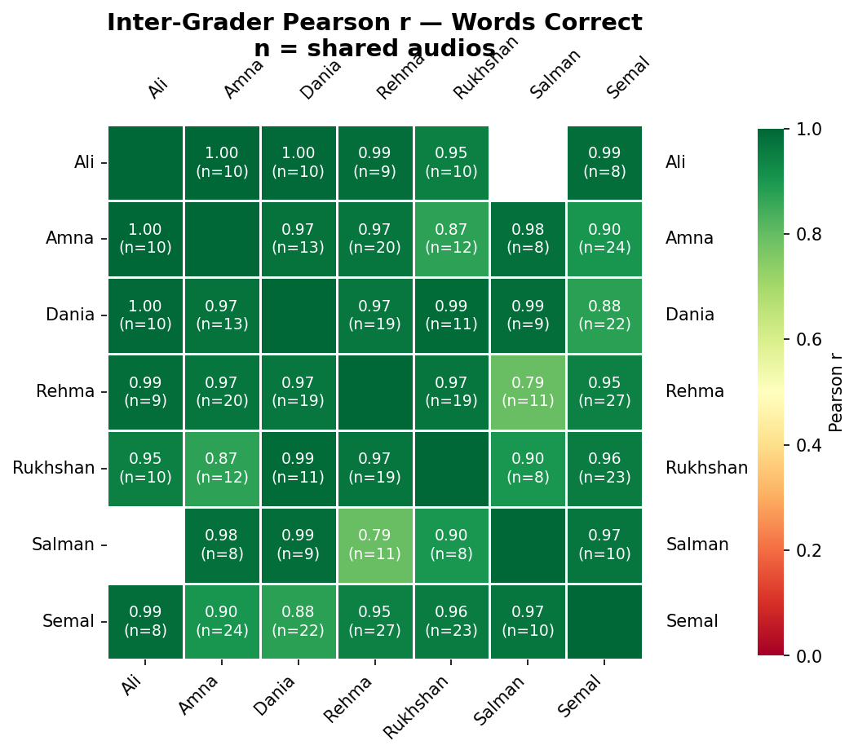

D. Transcription Examples
Three examples showing how human graders and AI models transcribe the same audio, selected by inter-grader agreement level (WER between the two human graders).

High Agreement (Inter-grader WER: 0%)
Audio: grade1_profile31204_q1_QK_20251122_095622.mp3
Reference text: "Come on. We can do it together."
Scorer | Transcription | Words Correct
Ali (Human) | Come on. We can do it together. | 7/7
Amna (Human) | Come on. We can do it together. | 7/7
Gemini 3 Pro (AI) | N/A | N/A/7

Medium Agreement (Inter-grader WER: 17%)
Audio: grade1_profile30822_q2_LP_20251122_100201.mp3
Reference text: "It's locked. I can open it."
Scorer | Transcription | Words Correct
Semal (Human) | It's locked. I can open it, | 6/6
Rukhshan (Human) | It's loocked. I can open it. | 5/6
Gemini 3 Pro (AI) | It's locked. I can open it. | 6/6

Low Agreement (Inter-grader WER: 43%)
Audio: grade1_profile28441_q1_LP_20251122_095026.mp3
Reference text: "Come on. We can do it together."
Scorer | Transcription | Words Correct
Salman (Human) | Come on. we can two each together. | 5/7
Amna (Human) | AH Come on. We can do it together. | 7/7
Gemini 3 Pro (AI) | Uhh come on we can do it together. | 7/7

E. Words Correct — Full Rankings
Rank | Scorer | Mean Words Correct | Median | N (audios)
— | Avg Human (baseline) | 7.6 | 6 | 588
1 | Universal 3 Pro | 8.1 | 7 | 544
2 | Gemini 3 Pro | 7.9 | 7 | 526
3 | Scribe v2 | 7.8 | 7 | 581
4 | Voxtral Mini | 7.8 | 7 | 583
5 | Gemini 3.1 Pro | 7.7 | 7 | 562
6 | Sarvam | 7.7 | 7 | 581
7 | Gemini 3 Flash | 7.6 | 7 | 587
8 | Voxtral Small | 7.6 | 7 | 588
9 | Universal | 7.3 | 7 | 583
10 | GPT-4o (Azure) | 7.2 | 7 | 588
11 | GPT-4o (OpenAI) | 7.2 | 7 | 588

F. WER — Full Rankings
Rank | Scorer | Mean WER | Median WER | N (audios)
— | Avg Human (baseline) | 21.4% | 16.7% | 588
1 | Sarvam | 22.9% | 16.7% | 576
2 | Universal 3 Pro | 23.9% | 17.5% | 544
3 | Voxtral Mini | 25.3% | 16.7% | 580
4 | Universal | 26.6% | 17.6% | 579
5 | Scribe v2 | 26.7% | 16.7% | 577
6 | GPT-4o (Azure) | 27.0% | 20.0% | 582
7 | GPT-4o (OpenAI) | 27.2% | 20.0% | 582
8 | Gemini 3.1 Pro | 27.7% | 16.7% | 557
9 | Gemini 3 Pro | 28.6% | 18.8% | 521
10 | Gemini 3 Flash | 31.1% | 20.0% | 581
11 | Voxtral Small | 36.2% | 22.8% | 582

G. WCPM — Full Rankings
Rank | Scorer | WCPM | N (audios)
— | Avg Human (baseline) | 73.6 | 578
1 | Sarvam | 77.3 | 572
2 | Universal 3 Pro | 76.8 | 542
3 | Gemini 3.1 Pro | 76.6 | 553
4 | Voxtral Mini | 74.9 | 577
5 | Scribe v2 | 74.8 | 573
6 | Gemini 3 Pro | 74.1 | 517
7 | Gemini 3 Flash | 73.7 | 577
8 | Voxtral Small | 73.5 | 578
9 | Universal | 69.9 | 575
10 | GPT-4o (Azure) | 69.2 | 578
11 | GPT-4o (OpenAI) | 69.1 | 578

H. Words Correct — Statistical Significance
Wilcoxon signed-rank tests comparing each AI model's per-audio words correct against the average human baseline, with Benjamini-Hochberg FDR correction for multiple comparisons. Mean Diff = AI mean minus human baseline (positive = AI scored higher).
Rank | Model | N | Mean Diff | 95% CI | p (adjusted) | Sig?
1 | Universal 3 Pro | 544 | +0.22 | [0.11, 0.33] | < 0.001 | Yes
2 | Gemini 3.1 Pro | 562 | +0.21 | [0.10, 0.33] | < 0.001 | Yes
3 | Gemini 3 Pro | 526 | +0.15 | [0.04, 0.27] | 0.003 | Yes
4 | Voxtral Mini | 583 | +0.13 | [0.01, 0.25] | < 0.001 | Yes
5 | Scribe v2 | 581 | +0.12 | [0.00, 0.23] | 0.001 | Yes
6 | Sarvam | 581 | +0.10 | [-0.01, 0.22] | 0.003 | Yes
7 | Voxtral Small | 588 | -0.01 | [-0.13, 0.11] | 0.581 | No
8 | Gemini 3 Flash | 587 | -0.02 | [-0.14, 0.11] | 0.505 | No
9 | Universal | 583 | -0.39 | [-0.53, -0.24] | < 0.001 | Yes
10 | GPT-4o (Azure) | 588 | -0.45 | [-0.63, -0.28] | 0.001 | Yes
11 | GPT-4o (OpenAI) | 588 | -0.47 | [-0.64, -0.30] | < 0.001 | Yes
With n > 500 paired observations, even small differences reach statistical significance. The 95% CI on mean difference is more informative for practical interpretation.

I. WER — Statistical Significance
Wilcoxon signed-rank tests comparing each AI model's per-audio WER (vs human transcription) against the average inter-grader WER baseline, across all audios with human transcription.Negative mean diff = AI has lower (better) WER than inter-grader baseline.
Rank | Model | N | Mean Diff | 95% CI | p (adjusted) | Sig?
1 | Sarvam | 576 | +0.0145 | [-0.0126, 0.0495] | 0.008 | Yes
2 | Universal 3 Pro | 544 | +0.0245 | [0.0054, 0.0449] | 0.699 | No
3 | Voxtral Mini | 580 | +0.0390 | [0.0107, 0.0753] | 0.478 | No
4 | Universal | 579 | +0.0518 | [0.0305, 0.0743] | 0.478 | No
5 | Scribe v2 | 577 | +0.0531 | [0.0245, 0.0867] | 0.702 | No
6 | GPT-4o (Azure) | 582 | +0.0561 | [0.0351, 0.0778] | 0.037 | Yes
7 | GPT-4o (OpenAI) | 582 | +0.0577 | [0.0366, 0.0804] | 0.037 | Yes
8 | Gemini 3.1 Pro | 557 | +0.0632 | [0.0254, 0.1111] | 0.699 | No
9 | Gemini 3 Pro | 521 | +0.0723 | [0.0349, 0.1217] | 0.699 | No
10 | Gemini 3 Flash | 581 | +0.0974 | [0.0629, 0.1377] | 0.028 | Yes
11 | Voxtral Small | 582 | +0.1480 | [0.0715, 0.2479] | 0.005 | Yes

J. WCPM — Confidence Intervals
Bootstrap 95% confidence intervals (10,000 resamples) for aggregate WCPM (total words correct / total duration minutes) per scorer.
Rank | Scorer | WCPM | 95% CI | N (audios)
1 | Sarvam | 77.3 | [74.0, 80.8] | 572
2 | Universal 3 Pro | 76.8 | [73.0, 80.8] | 542
3 | Gemini 3.1 Pro | 76.6 | [72.6, 80.6] | 553
4 | Voxtral Mini | 74.9 | [70.9, 78.9] | 577
5 | Scribe v2 | 74.8 | [71.0, 78.8] | 573
6 | Gemini 3 Pro | 74.1 | [70.3, 78.3] | 517
7 | Gemini 3 Flash | 73.7 | [70.1, 77.5] | 577
— | Avg Human (baseline) | 73.6 | [69.8, 77.5] | 578
8 | Voxtral Small | 73.5 | [69.8, 77.3] | 578
9 | Universal | 69.9 | [66.1, 73.8] | 575
10 | GPT-4o (Azure) | 69.2 | [65.3, 73.1] | 578
11 | GPT-4o (OpenAI) | 69.1 | [65.2, 73.1] | 578

K. Inter-Grader Correlation P-values
Pearson correlation p-values for each grader pair's words-correct agreement. All pairs with sufficient shared audios show highly significant correlations.
Grader 1 | Grader 2 | Pearson r | p-value | Shared Audios
Ali | Amna | 0.998 | < 0.001 | 10
Ali | Dania | 0.996 | < 0.001 | 10
Ali | Rehma | 0.987 | < 0.001 | 9
Ali | Rukhshan | 0.952 | < 0.001 | 10
Ali | Semal | 0.986 | < 0.001 | 8
Amna | Dania | 0.975 | < 0.001 | 13
Amna | Rehma | 0.971 | < 0.001 | 20
Amna | Rukhshan | 0.872 | < 0.001 | 12
Amna | Salman | 0.982 | < 0.001 | 8
Amna | Semal | 0.905 | < 0.001 | 24
Dania | Rehma | 0.967 | < 0.001 | 19
Dania | Rukhshan | 0.989 | < 0.001 | 11
Dania | Salman | 0.986 | < 0.001 | 9
Dania | Semal | 0.878 | < 0.001 | 22
Rehma | Rukhshan | 0.970 | < 0.001 | 19
Rehma | Salman | 0.794 | 0.004 | 11
Rehma | Semal | 0.947 | < 0.001 | 27
Rukhshan | Salman | 0.901 | 0.002 | 8
Rukhshan | Semal | 0.958 | < 0.001 | 23
Salman | Semal | 0.971 | < 0.001 | 10

L. Pre/Post WCPM — Statistical Significance
Bootstrap significance test (10,000 resamples) for the pre-to-post WCPM improvement. Delta = Post WCPM minus Pre WCPM. A significant result means the improvement is reliably different from zero.
Rank | Scorer | Pre WCPM | Post WCPM | Delta | 95% CI | p-value | Sig?
1 | Sarvam | 64.5 | 94.1 | +29.6 | [23.4, 35.7] | < 0.001 | Yes
2 | Universal 3 Pro | 64.3 | 93.4 | +29.1 | [22.0, 36.4] | < 0.001 | Yes
3 | Voxtral Mini | 62.5 | 91.4 | +28.9 | [21.1, 36.5] | < 0.001 | Yes
4 | Scribe v2 | 62.7 | 91.1 | +28.4 | [21.1, 36.0] | < 0.001 | Yes
— | Avg Human (baseline) | 61.6 | 89.7 | +28.1 | [20.9, 35.2] | < 0.001 | Yes
5 | Gemini 3.1 Pro | 64.6 | 91.6 | +27.0 | [19.4, 34.5] | < 0.001 | Yes
6 | Gemini 3 Pro | 62.9 | 89.7 | +26.8 | [19.2, 34.3] | < 0.001 | Yes
7 | Gemini 3 Flash | 62.2 | 88.9 | +26.7 | [19.5, 34.0] | < 0.001 | Yes
8 | Universal | 58.7 | 84.9 | +26.2 | [18.8, 33.4] | < 0.001 | Yes
9 | Voxtral Small | 62.3 | 88.4 | +26.1 | [18.7, 33.2] | < 0.001 | Yes
10 | GPT-4o (OpenAI) | 58.1 | 83.9 | +25.8 | [17.9, 33.6] | < 0.001 | Yes
11 | GPT-4o (Azure) | 58.4 | 83.8 | +25.4 | [17.6, 32.9] | < 0.001 | Yes

M. Model Pricing
Estimated cost per 1,000 minutes of audio and median processing speed for each AI model evaluated. Pricing sourced from provider documentation as of March 2026. Empty cells indicate pricing was not publicly available.
Model | Price (USD / 1,000 min) | Median Speed Factor | Benchmark WER
Scribe v2 | $6.67 | 31.6x | 2.30%
Gemini 3 Pro | — | 6.0x | 2.90%
Voxtral Small | $4.00 | 70.1x | 3.00%
Gemini 3 Flash | — | 12.7x | 3.10%
Universal 3 Pro | $3.50 | 40.0x | 3.30%
Voxtral Mini | $3.00 | 68.1x | 3.70%
Universal | $2.50 | 112.1x | 4.00%
GPT-4o (Azure) | $6.00 | 33.7x | 4.10%
GPT-4o (OpenAI) | $6.00 | 33.7x | 4.10%
Gemini 3.1 Pro | — | — | —
Sarvam | $5.49 | — | —

Speed factor = how many times faster than real-time the model transcribes (higher = faster). Benchmark WER is the provider-reported word error rate on standard English benchmarks, which may differ from WER observed on Pakistani English child speech.

