Human vs AI Transcription Analysis

1. Overview
- Audio files with at least one human transcription: 481
- Dual-graded audio files (both graders completed): 133
- Human graders: 5 (Grader 1, Grader 2, Grader 3, Grader 4, Grader 5)
- AI models evaluated: 11
- Unique reference sentences: 3
- "Come on. We can do it together." (7 words)
- "This is Zara. She loves to draw. This is Faiz. He loves to build things." (15 words)
- "It's locked. I can open it." (6 words)
- Unique words across all sentences: 22
All human-vs-AI comparisons use "Avg Human" — the per-audio average across all human graders — as the baseline.

Transcription Counts
Grader | Transcriptions
Grader 1 | 69
Grader 2 | 130
Grader 3 | 125
Grader 4 | 169
Grader 5 | 121

2. Key Findings
- 6 of 11 AI models score at or above average human accuracy (0.84 on a 0–1 scale). Higher AI scores likely reflect leniency toward borderline pronunciations rather than superior assessment.
- Highest-scoring AI model: Universal 3 Pro at 0.88 normalized accuracy (vs 0.84 for Avg Human).
- WCPM: 3 of 11 AI models fall within range of the human WCPM baseline (75.5 WCPM). Sarvam leads at 77.9 WCPM.
- Pre/Post improvement: All 11 AI models detect a positive pre-to-post improvement (mean AI delta: +25.5 WCPM vs human-observed +27.1 WCPM).
- Inter-grader reliability: Human graders agree strongly (mean r = 0.83), establishing a reliable baseline for AI comparison.
So what? AI models produce accuracy and WCPM scores consistent with human graders, and all 11 detect pre-to-post improvement. However, AI transcriptions diverge more from human ones at the word level (best AI WER: 22.5%) than humans diverge from each other (14.4%) — partly reflecting AI leniency toward borderline pronunciations. For scoring purposes, AI can reliably supplement manual grading; for transcription-level applications, the gap warrants monitoring.

3. Methodology — Normalized Accuracy

How we measure accuracy
We use jiwer's process_words (see github.com/jitsi/jiwer) to align the scorer's transcription against the reference text (what the student was supposed to read). The algorithm finds the optimal word-level alignment that minimizes total errors, then counts hits — words that matched exactly.
The alignment handles:
- Substitutions — a word was replaced (e.g., student said "laaves" instead of "loves")
- Deletions — a word was skipped entirely
- Insertions — an extra word was added
- Hits — the word matched correctly

Why normalize?
Reference sentences range from 7 to 15 words. A student getting 6 out of 7 words correct is performing very differently from one getting 6 out of 15. To ensure fair comparison across sentences of different lengths, we normalize words correct by dividing by total reference words, giving a 0–1 accuracy score where 1.0 = every word read correctly.

Worked example
Reference text: "She loves to draw" (4 words)
Transcription: "She laaves to"
Reference | she | loves | to | draw
Transcription | she | laaves | to | —
Result | Hit | Substitution | Hit | Deletion

Words correct = 2 out of 4 → Normalized accuracy = 0.50

Grader exclusions
8 graders transcribed student audio. 3 were excluded due to insufficient data (too few audios for reliable pairwise correlations) or transcription convention mismatches, leaving 5 graders for the analysis. The remaining 5 use a consistent intended-word convention and achieve reliable inter-rater agreement (mean Pearson r = 0.83, mean absolute difference = 0.07 on a 0–1 scale).

Why words correct (not WER) for correlation?
Word Error Rate (WER) measures the error rate of the transcription vs the reference. However, the transcription captures what the student actually said, not what they were supposed to say. WER therefore conflates:
- Student reading errors (the actual signal — the student skipped or mispronounced words)
- Transcription differences (convention differences — graders wrote slightly different things)
Words correct isolates the student performance signal: what proportion of words did the student get right? All scorers fundamentally agree on this, which is why word-correct correlations (mean r = 0.83, with several pairs above 0.90) are substantially higher than WER-based comparisons.

A note on how WER is used in this report
WER appears in two different contexts in this report — it is important not to conflate them:
- Scorer vs Reference (accuracy): Comparing a scorer's transcription against the reference sentence (what the student was supposed to read). This measures student reading ability. We do not use WER here — we use normalized accuracy (words correct / total reference words) because it directly captures how many words the student read correctly, on a 0–1 scale.
- Scorer vs Scorer (transcription similarity): Comparing one scorer's transcription against another's (Sections 5 and 7). This measures how similarly two scorers transcribed the same audio. A high WER here does not necessarily mean they disagree on student ability — it may simply reflect different spelling or notation conventions.
Why this distinction matters — an example:
Reference sentence: "She loves to play outside"
Human transcription: "she laaves to play outside"
AI transcription: "she loves to play outside"
Scorer vs Reference WER (accuracy context): Both scorers record 4 of 5 words correct — the student mispronounced "loves." They agree on student ability.
Scorer vs Scorer WER (transcription similarity): The human wrote "laaves" while the AI wrote "loves" — a word-level mismatch that produces a non-zero WER, even though both scorers arrived at the same accuracy score.
Conflating these two contexts would lead to the mistaken conclusion that a high Scorer-vs-Scorer WER means the AI and human disagree on how well the student read — when in fact they agree on the score and only differ in how they transcribed the mispronunciation.
All key comparisons in this report (accuracy, WCPM, pre/post improvement) use words correct, not WER. However, WER provides complementary and independent evidence about how AI models differ from humans. As Section 7 shows, AI transcriptions diverge from human ones at the word level significantly more than humans diverge from each other — a real gap that is partly explained by AI leniency (Section 6) but cannot be entirely dismissed as convention differences. The answer depends on what you are measuring: for scoring (accuracy, WCPM), AI aligns with humans; for transcription fidelity, a measurable gap remains.

4. Inter-Grader Agreement — Normalized Accuracy
To establish whether human graders are consistent enough to serve as a reliable baseline, we compared each pair of graders on the audio files they both transcribed. For each pair, we computed the mean absolute difference in normalized accuracy (how far apart they score on a 0–1 scale) and the Pearson correlation (whether they agree on which students performed well vs poorly).
Across the 10 grader pairs with sufficient shared audios (n >= 3):
- Mean correlation: r = 0.83 (std: 0.14, range: 0.53 to 1.00)
- Mean absolute difference: 0.07 (std: 0.03) — on a 0–1 scale
- 1 of 10 pair has r >= 0.95 (strong agreement)
- 4 of 10 pairs fall below r = 0.85: Grader 1-Grader 4, Grader 1-Grader 5, Grader 2-Grader 5, Grader 4-Grader 5
This confirms that human graders are largely consistent in identifying how many words each student reads correctly, making the human baseline reliable for AI comparison.
Sample-size note: Per-pair shared audios range from 9 to 20. Most pairs are adequately powered, but two pairs involving Grader 5 have limited overlap — Grader 2 vs Grader 5 (n = 12, r = 0.53, p = 0.075) is not statistically significant at the 0.05 level, and Grader 1 vs Grader 5 (n = 10, r = 0.76) is borderline. These estimates should be interpreted with caution; the overall mean r = 0.83 is driven primarily by the remaining pairs, which show consistently strong agreement (r = 0.84–1.00).
Full pairwise heatmap in Appendix C. Correlation p-values in Appendix K.

5. Inter-Grader Agreement — WER
WER (Word Error Rate) measures how similar two transcriptions are at the word level. It does not measure student ability — it measures transcription similarity. For example, if the student says "I like to play" and one grader writes "I like to play" while the other writes "I like to plaay", WER is 25% (1 word differs out of 4), even though both graders agree the student got all 4 words correct.
Metric | Value
N (dual-graded audios) | 132
Mean WER | 14.4%
Median WER | 13.3%
Std | 0.16
Perfect agreement (WER=0) | 51 audios (39%)
A median WER of 13.3% means graders' transcriptions typically differ by about 1 in 6 words — but this usually reflects transcription style differences, not disagreement about how well the student read.

Convention Differences vs Genuine Disagreement
A high inter-grader WER can mean two very different things:
- Convention differences — graders heard the student the same way but wrote it differently (spelling, filler words, elongation). They agree on words correct despite high WER.
- Genuine disagreement — graders actually disagree on what the student said, leading to different words-correct counts.
Two examples illustrate this distinction:
Convention differences: grade1_profile30581_q2_LP_20251122_100201.mp3 (Inter-grader WER: 43%)
Reference: "It's locked. I can open it."
Reference | it's | locked. | i | can | open | it.
Grader 4 | Hit | Substitution | Hit | Hit | Hit | Substitution
Grader 2 | Substitution | Hit | Hit | Hit | Hit | Substitution
Grader 4: 5 words correct — "It's isss lock. I can open it"
Grader 2: 5 words correct — "tiks is locked. I can open it"
WER is 43% but both graders agree on 5 words correct. The difference is purely transcription style — not a scoring disagreement.

Genuine disagreement: grade1_profile30544_q1_QK_20251122_095622.mp3 (Inter-grader WER: 71%)
Reference: "Come on. We can do it together."
Reference | come | on. | we | can | do | it | together.
Grader 3 | Hit | Hit | Hit | Substitution | Hit | Hit | Hit
Grader 2 | Substitution | Deletion | Hit | Hit | Substitution | Substitution | Deletion
Grader 3: 6 words correct — "Come on. We caan do it together."
Grader 2: 3 words correct — "comeon. we can doit together"
WER is 71% and the graders disagree by 3 words correct. This reflects genuine uncertainty about what the student said.

6. Avg Human vs Each AI — Normalized Accuracy
Sections 4–5 established inter-grader reliability on the 133 dual-graded audios. The following AI comparisons use all 481 audios with at least one human transcription, with "Avg Human" as the per-audio average across available human graders.

How AI transcriptions were generated
Each AI model was given the student audio and the following prompt:
"Transcribe the audio, if it is empty return nothing. Transcribe it exactly, don't add any extra words or fix any mistakes."
This transcribes the user audio exactly and doesn't auto-fix anything.

Why do some AI models score higher than humans?
AI models are prompted to transcribe exactly what they hear, but they are trained on standard English and tend to normalize mild mispronunciations toward dictionary words. For example, if a child says "togather," a human grader writes "togather" (substitution — no credit), while an AI model is more likely to output "together" (hit — credit). For severe mispronunciations (e.g., "flock" for "locked"), AI models still produce incorrect words (e.g., "block", "plot"), so the effect is limited to borderline cases.
This means AI models that score above the human baseline are likely more lenient, not more accurate — they give students credit for words that were approximately correct. This is not necessarily wrong (the child may have read the word recognizably), but it means higher AI accuracy should not be interpreted as superior assessment. The more reliable comparisons are WCPM and pre/post improvement (Sections 8–9), where any consistent leniency bias cancels out.
6 of 11 AI models score at or above the average human baseline on normalized accuracy (likely reflecting leniency rather than superior assessment — see above). Universal 3 Pro scores highest at 0.88 (vs 0.84 for Avg Human), while GPT-4o (OpenAI) trails at 0.77. The spread across AI models is relatively narrow (0.77–0.88), indicating that most models capture student reading performance comparably to human graders.
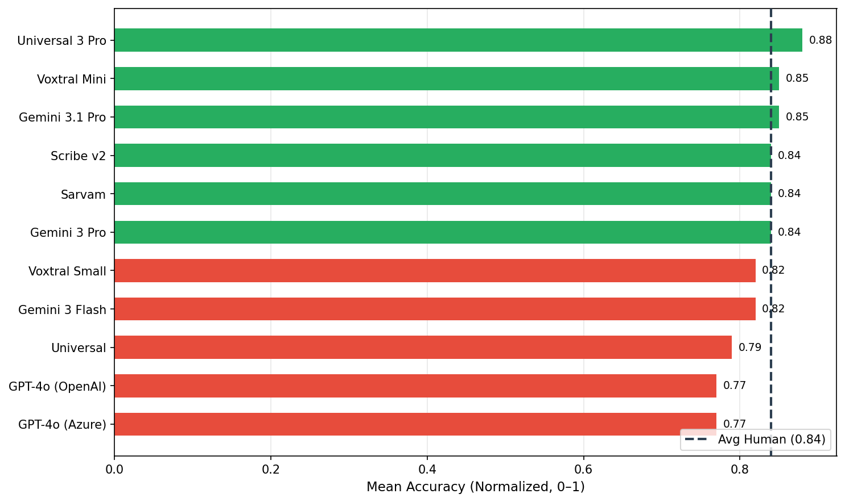
See Appendix H for Wilcoxon signed-rank tests and 95% confidence intervals.

7. Avg Human vs Each AI — WER
In this section, WER measures how closely each AI model's transcription matches what human graders wrote for the same audio. A lower WER means the AI's word-by-word output is more similar to the human transcription. For each audio, we compute the WER between the AI transcription and each available human transcription, then average. The baseline is the inter-grader WER from Section 5 — how much human graders differ from each other. An AI model with WER at or below this baseline is transcribing as consistently as humans do.
0 of 11 AI models achieve lower WER against human transcriptions than the inter-grader baseline (14.4%). Universal 3 Pro leads with 22.5% WER. Most AI models show higher WER than the inter-grader baseline — a gap that is partly explained by the leniency pattern described in Section 6 (AI models normalize mispronunciations toward standard English), but the size of the gap is notable: even the best AI model (Universal 3 Pro at 22.5%) exceeds the inter-grader baseline by a substantial margin. This tells a different story from the accuracy and WCPM metrics, where AI and humans largely align. For scoring purposes, AI models are reliable; for transcription-level fidelity, a real and measurable gap remains.
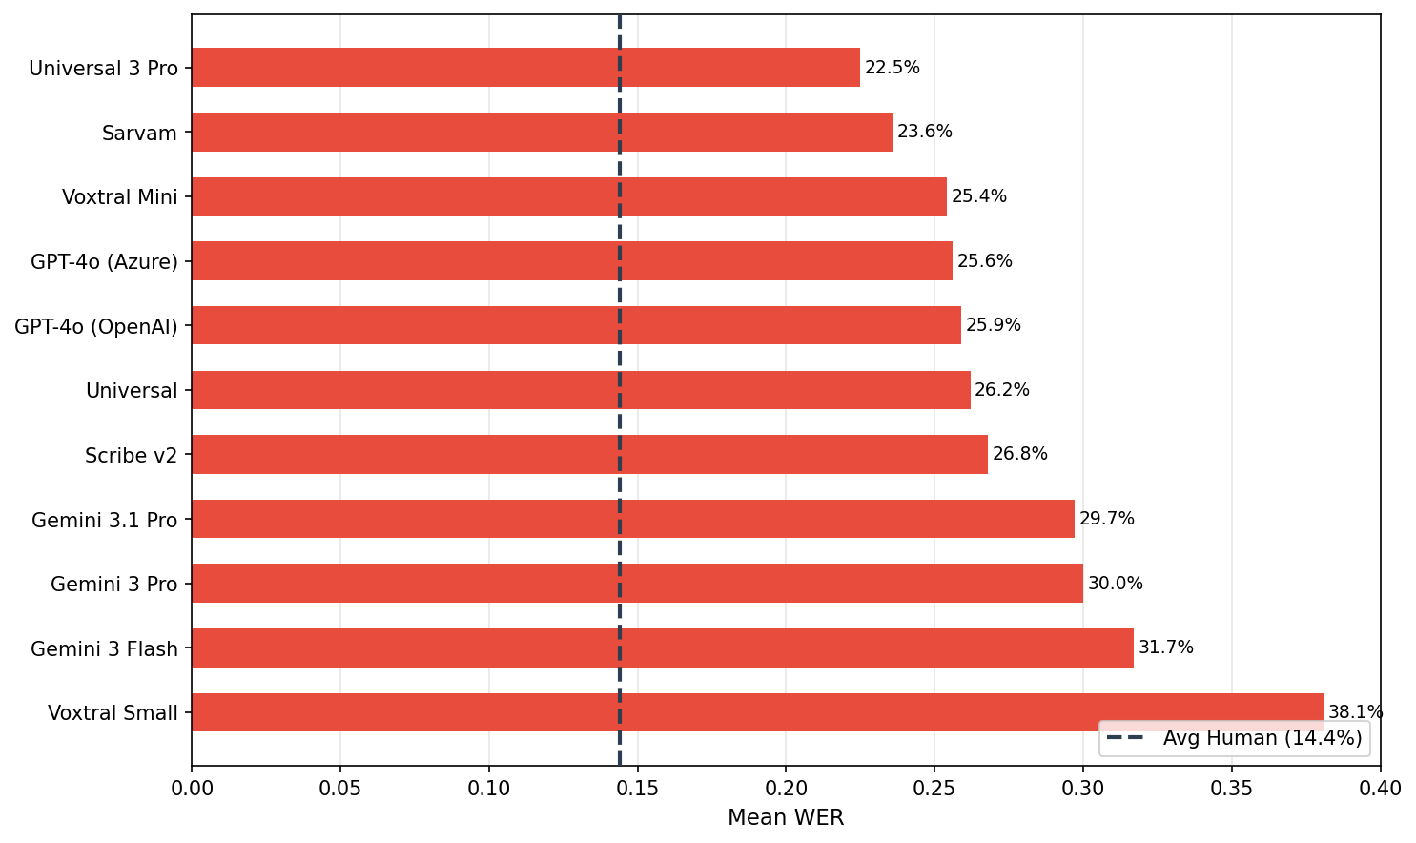
See Appendix I for Wilcoxon signed-rank tests and 95% confidence intervals.

8. WCPM — Avg Human vs Each AI
Words Correct Per Minute (WCPM) is the standard reading fluency metric, computed as total_words_correct / total_duration_minutes across all audios for each scorer. It combines accuracy (words correct) with speed (how long the student took).
Duration data is available for 471 out of 481 audios (98% coverage).
3 of 11 AI models produce WCPM scores at or above the human baseline (75.5 WCPM). Sarvam leads at 77.9 WCPM. Since WCPM is the metric that ultimately determines a student's reading level, this is the most operationally relevant comparison — it shows that AI scoring closely tracks human scoring on the metric that matters most.
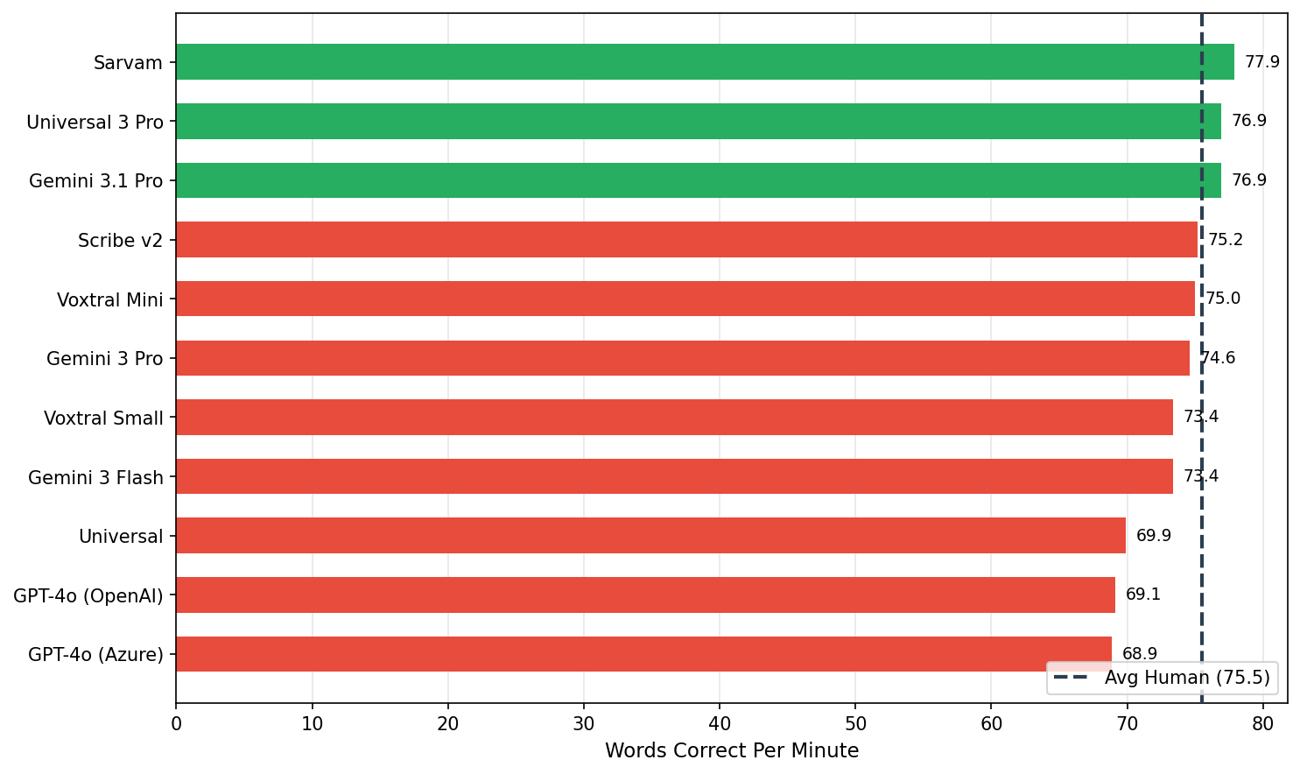
See Appendix J for bootstrap 95% confidence intervals.

9. Pre/Post WCPM — Avg Human vs Each AI
Students are assessed before (pre-test) and after (post-test) the intervention. The key question: does AI scoring detect the same student improvement that human graders see?
Scorer | Pre WCPM | Post WCPM | Delta
Avg Human (baseline) | 63.8 | 90.9 | +27.1
Universal 3 Pro | 64.7 | 93.1 | +28.4
Sarvam | 65.8 | 93.6 | +27.8
Scribe v2 | 63.3 | 90.8 | +27.5
Voxtral Mini | 63.2 | 90.5 | +27.3
Gemini 3.1 Pro | 65.5 | 91.0 | +25.5
Gemini 3 Flash | 62.5 | 87.8 | +25.3
Gemini 3 Pro | 64.1 | 88.8 | +24.7
Universal | 59.3 | 83.9 | +24.6
Voxtral Small | 62.9 | 87.4 | +24.5
GPT-4o (OpenAI) | 59.3 | 82.0 | +22.7
GPT-4o (Azure) | 59.2 | 81.7 | +22.5
Human graders measure a +27.1 WCPM improvement from pre to post. AI models measure a mean improvement of +25.5 WCPM — closely tracking the human-observed gain. All 11 AI models detect a positive pre-to-post improvement, confirming that AI scoring reliably captures the effect of the reading intervention.
See Appendix L for pre/post WCPM significance tests.

10. Conclusion
Inter-grader agreement is strong (mean r = 0.83, std = 0.14 across 10 pairs), establishing a reliable human baseline for comparing AI transcription models. On the 481 audios with human transcription:
- 6 of 11 AI models score at or above the average human baseline on normalized accuracy (likely reflecting leniency toward borderline pronunciations)
- 3 of 11 AI models produce WCPM within range of the human baseline (75.5 WCPM)
- All 11 AI models detect a positive pre-to-post improvement, with a mean AI delta of +25.5 WCPM vs the human-observed +27.1 WCPM
However, WER tells a different story: AI transcriptions diverge from human ones significantly more than humans diverge from each other (best AI: 22.5% vs inter-grader baseline: 14.4%). This gap is partly explained by AI leniency toward borderline pronunciations, but it is too large to dismiss entirely as convention differences. The practical implication is twofold: for scoring, AI can reliably supplement human grading — accuracy, WCPM, and pre/post improvement all align closely. For transcription fidelity, a measurable gap remains and warrants monitoring in production.

11. Recommendation

Can AI replace human graders for scoring?
For scoring purposes, yes. All 11 AI models reliably detect pre-to-post improvement, and the best-performing models produce WCPM scores within the range of human inter-grader variation. AI models that score above the human accuracy baseline are likely more lenient toward borderline pronunciations, but this does not prevent them from tracking student progress — which is the primary use case.
However, AI transcriptions themselves diverge more from human transcriptions than humans diverge from each other (best AI WER: 22.5% vs inter-grader baseline: 14.4%). If transcription-level fidelity matters for downstream applications (e.g., error analysis, qualitative review), this gap should be monitored.

Best candidate models
- Universal 3 Pro — highest normalized accuracy (0.88 vs 0.84 human baseline)
- Sarvam — highest WCPM (77.9 vs 75.5 human baseline)

Cost considerations
Model | Accuracy | WCPM | Price (USD / 1,000 min)
Universal 3 Pro | 0.88 | 76.9 | $3.50
Gemini 3.1 Pro | 0.85 | 76.9 | —
Voxtral Mini | 0.85 | 75.0 | $3.00
Gemini 3 Pro | 0.84 | 74.6 | —
Sarvam | 0.84 | 77.9 | —
Full pricing details in Appendix M.

Suggested next steps for Beaj
- Pilot deployment — Run the top 2–3 AI models in parallel with human graders on a new cohort to validate results in production.
- Establish acceptance threshold — Define the maximum acceptable deviation from human scores (e.g., mean accuracy difference < 0.05).
- Monitor edge cases — Track audios where AI and human scores diverge significantly; these may reveal audio quality or dialect challenges.
- Phase out human grading gradually — Start with AI-only scoring for pre-tests (lower stakes), then expand to post-tests once confidence is established.

12. Appendix

A. Normalized Accuracy Correlation Heatmap
Pairwise Pearson correlation of normalized accuracy scores across shared audio files, using all graders + AI models. Color scale: 0 to 1.
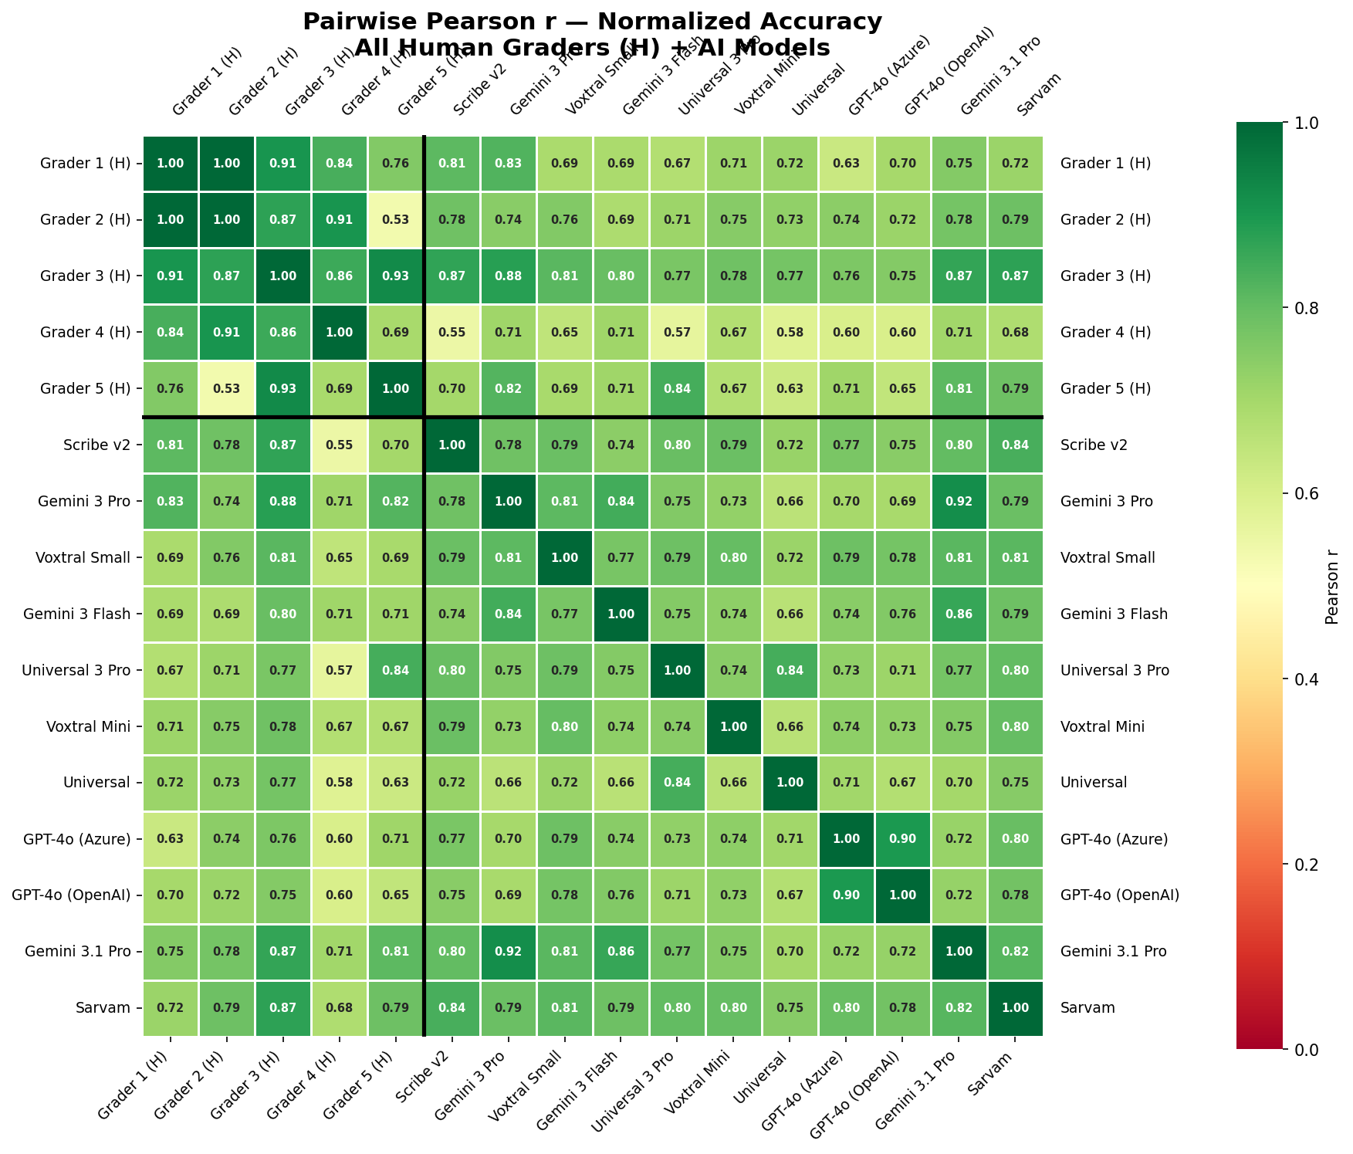

Mean Correlations by Group
Group | Mean Pearson r | N pairs
Human-Human | 0.828 | 10
Human-AI | 0.729 | 55
AI-AI | 0.765 | 55

B. WER Heatmap
Pairwise mean WER between all scorers on shared audio files. Color scale: 0 to 1 (0 = identical transcriptions, 1 = completely different).
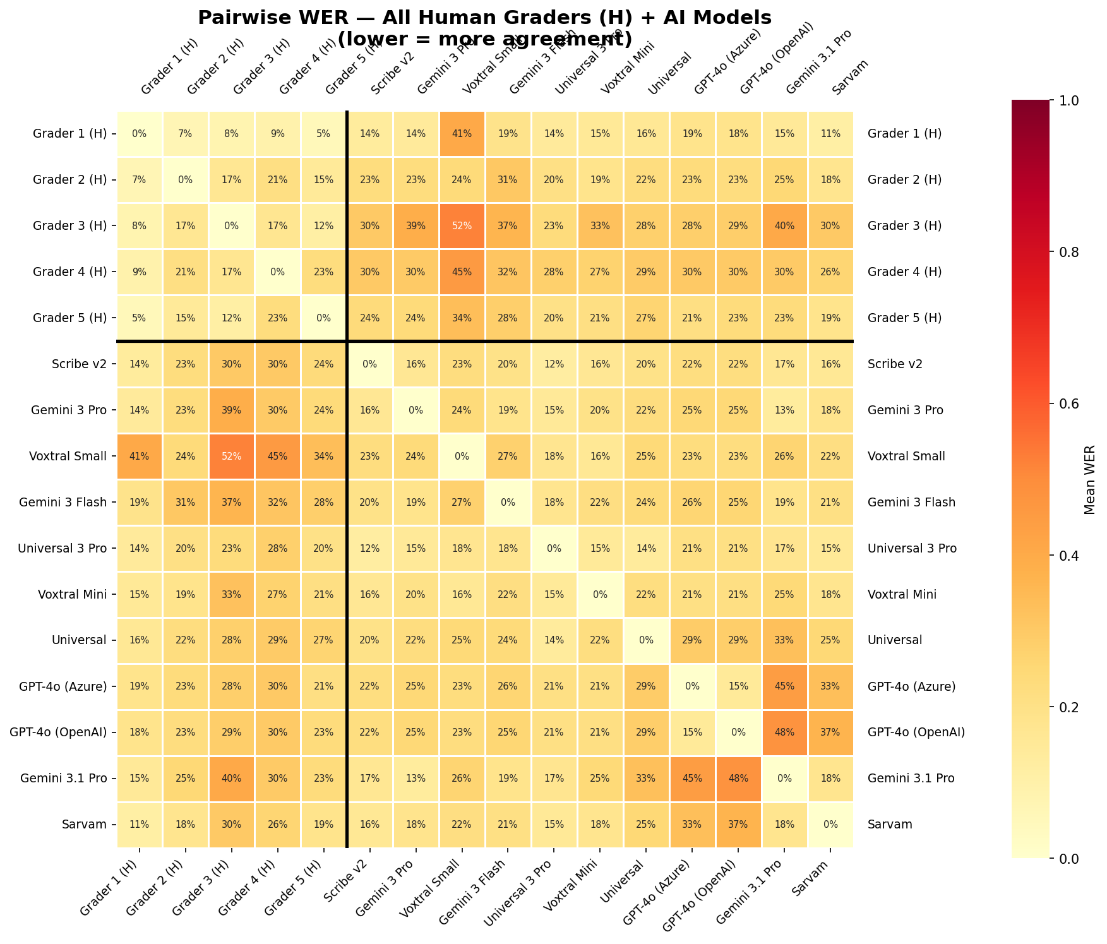

C. Inter-Grader Normalized Accuracy — Pairwise Heatmap
Pairwise Pearson correlation of normalized accuracy between human graders. Each cell shows the correlation and the number of shared audios. Color scale: 0 to 1 (green = strong agreement).
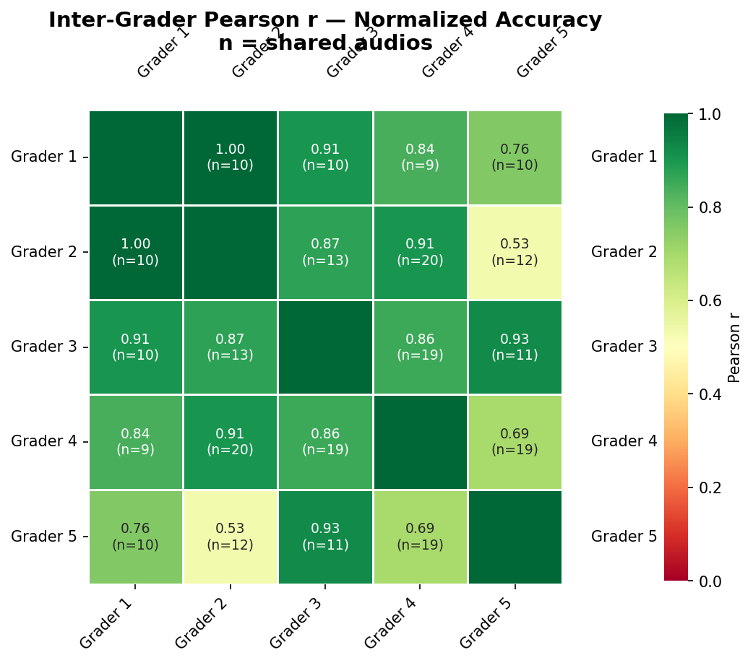

D. Transcription Examples
Three examples showing how human graders and AI models transcribe the same audio, selected by inter-grader agreement level (WER between the two human graders).

High Agreement (Inter-grader WER: 0%)
Audio: grade1_profile30596_q2_QK_20251122_100724.mp3
Reference text: "It's locked. I can open it." (6 words)
Scorer | Transcription | Words Correct | Normalized
Grader 2 (Human) | It's locked. I can open it. | 6/6 | 1.00
Grader 3 (Human) | It's locked. I can open it. | 6/6 | 1.00
Gemini 3 Pro (AI) | It's locked I can open it. | 6/6 | 1.00

Medium Agreement (Inter-grader WER: 13%)
Audio: grade1_profile28444_q3_LP_20251122_101304.mp3
Reference text: "This is Zara. She loves to draw. This is Faiz. He loves to build things." (15 words)
Scorer | Transcription | Words Correct | Normalized
Grader 4 (Human) | This is Zara. She loves to draw. This is Face. He loves to blid things. | 13/15 | 0.87
Grader 2 (Human) | This is Zara. She loves to draw. This is Faiz. He loves to bilaid things. | 14/15 | 0.93
Gemini 3 Pro (AI) | This is Zara she loves to draw This is Faiz he loves to build things | 15/15 | 1.00

Low Agreement (Inter-grader WER: 40%)
Audio: grade1_profile28421_q2_LP_20251122_100201.mp3
Reference text: "It's locked. I can open it." (6 words)
Scorer | Transcription | Words Correct | Normalized
Grader 4 (Human) | It's loooocked. I can open. | 4/6 | 0.67
Grader 5 (Human) | It's loocked. I can open it | 5/6 | 0.83
Gemini 3 Pro (AI) | It's locked, I can't open it. | 5/6 | 0.83

E. Normalized Accuracy — Full Rankings
Rank | Scorer | Mean Accuracy | Median | N (audios)
— | Avg Human (baseline) | 0.84 | 0.92 | 481
1 | Universal 3 Pro | 0.88 | 0.93 | 444
2 | Gemini 3.1 Pro | 0.85 | 0.93 | 464
3 | Voxtral Mini | 0.85 | 0.93 | 477
4 | Gemini 3 Pro | 0.84 | 0.93 | 421
5 | Sarvam | 0.84 | 1.00 | 475
6 | Scribe v2 | 0.84 | 0.93 | 475
7 | Gemini 3 Flash | 0.82 | 0.87 | 481
8 | Voxtral Small | 0.82 | 0.87 | 481
9 | Universal | 0.79 | 0.87 | 478
10 | GPT-4o (Azure) | 0.77 | 0.86 | 481
11 | GPT-4o (OpenAI) | 0.77 | 0.87 | 481

F. WER — Full Rankings
Rank | Scorer | Mean WER | Median WER | N (audios)
— | Avg Human (baseline) | 14.4% | 13.3% | 481
1 | Universal 3 Pro | 22.5% | 16.7% | 444
2 | Sarvam | 23.6% | 14.3% | 470
3 | Voxtral Mini | 25.4% | 16.7% | 474
4 | GPT-4o (Azure) | 25.6% | 16.7% | 475
5 | GPT-4o (OpenAI) | 25.9% | 16.7% | 475
6 | Universal | 26.2% | 16.7% | 474
7 | Scribe v2 | 26.8% | 16.7% | 471
8 | Gemini 3.1 Pro | 29.7% | 16.7% | 459
9 | Gemini 3 Pro | 30.0% | 16.7% | 416
10 | Gemini 3 Flash | 31.7% | 16.7% | 475
11 | Voxtral Small | 38.1% | 16.7% | 475

G. WCPM — Full Rankings
Rank | Scorer | WCPM | N (audios)
— | Avg Human (baseline) | 75.5 | 471
1 | Sarvam | 77.9 | 466
2 | Gemini 3.1 Pro | 76.9 | 455
3 | Universal 3 Pro | 76.9 | 442
4 | Scribe v2 | 75.2 | 467
5 | Voxtral Mini | 75.0 | 471
6 | Gemini 3 Pro | 74.6 | 412
7 | Gemini 3 Flash | 73.4 | 471
8 | Voxtral Small | 73.4 | 471
9 | Universal | 69.9 | 470
10 | GPT-4o (OpenAI) | 69.1 | 471
11 | GPT-4o (Azure) | 68.9 | 471

H. Normalized Accuracy — Statistical Significance
Wilcoxon signed-rank tests comparing each AI model's per-audio normalized accuracy against the average human baseline, with Benjamini-Hochberg FDR correction for multiple comparisons. Mean Diff = AI mean minus human baseline (positive = AI scored higher). Values on 0–1 scale.
Rank | Model | N | Mean Diff | 95% CI | p (adjusted) | Sig?
1 | Universal 3 Pro | 444 | +0.02 | [0.00, 0.03] | 0.003 | Yes
2 | Gemini 3.1 Pro | 464 | +0.01 | [-0.01, 0.02] | 0.160 | No
3 | Gemini 3 Pro | 421 | +0.00 | [-0.01, 0.02] | 0.621 | No
4 | Sarvam | 475 | +0.00 | [-0.01, 0.02] | 0.430 | No
5 | Voxtral Mini | 477 | +0.00 | [-0.02, 0.02] | 0.144 | No
6 | Scribe v2 | 475 | -0.00 | [-0.02, 0.01] | 0.718 | No
7 | Gemini 3 Flash | 481 | -0.02 | [-0.04, -0.01] | 0.059 | No
8 | Voxtral Small | 481 | -0.02 | [-0.04, -0.01] | 0.028 | Yes
9 | Universal | 478 | -0.05 | [-0.07, -0.03] | < 0.001 | Yes
10 | GPT-4o (OpenAI) | 481 | -0.06 | [-0.08, -0.05] | < 0.001 | Yes
11 | GPT-4o (Azure) | 481 | -0.06 | [-0.08, -0.05] | < 0.001 | Yes
With n > 500 paired observations, even small differences reach statistical significance. The 95% CI on mean difference is more informative for practical interpretation.

I. WER — Statistical Significance
Wilcoxon signed-rank tests comparing each AI model's per-audio WER (vs human transcription) against the average inter-grader WER baseline, across all audios with human transcription.Negative mean diff = AI has lower (better) WER than inter-grader baseline.
Rank | Model | N | Mean Diff | 95% CI | p (adjusted) | Sig?
1 | Universal 3 Pro | 444 | +0.0815 | [0.0583, 0.1055] | < 0.001 | Yes
2 | Sarvam | 470 | +0.0920 | [0.0433, 0.1711] | 0.025 | Yes
3 | Voxtral Mini | 474 | +0.1097 | [0.0616, 0.1872] | < 0.001 | Yes
4 | GPT-4o (Azure) | 475 | +0.1119 | [0.0851, 0.1416] | < 0.001 | Yes
5 | GPT-4o (OpenAI) | 475 | +0.1149 | [0.0860, 0.1481] | < 0.001 | Yes
6 | Universal | 474 | +0.1182 | [0.0909, 0.1479] | < 0.001 | Yes
7 | Scribe v2 | 471 | +0.1240 | [0.0782, 0.1886] | < 0.001 | Yes
8 | Gemini 3.1 Pro | 459 | +0.1528 | [0.0872, 0.2580] | < 0.001 | Yes
9 | Gemini 3 Pro | 416 | +0.1559 | [0.0873, 0.2634] | < 0.001 | Yes
10 | Gemini 3 Flash | 475 | +0.1730 | [0.1210, 0.2434] | < 0.001 | Yes
11 | Voxtral Small | 475 | +0.2374 | [0.1308, 0.3710] | < 0.001 | Yes

J. WCPM — Confidence Intervals
Bootstrap 95% confidence intervals (10,000 resamples) for aggregate WCPM (total words correct / total duration minutes) per scorer.
Rank | Scorer | WCPM | 95% CI | N (audios)
1 | Sarvam | 77.9 | [74.3, 81.5] | 466
2 | Gemini 3.1 Pro | 76.9 | [72.7, 81.2] | 455
3 | Universal 3 Pro | 76.9 | [72.7, 81.1] | 442
— | Avg Human (baseline) | 75.5 | [71.4, 79.7] | 471
4 | Scribe v2 | 75.2 | [71.1, 79.3] | 467
5 | Voxtral Mini | 75.0 | [70.6, 79.5] | 471
6 | Gemini 3 Pro | 74.6 | [70.4, 79.0] | 412
7 | Gemini 3 Flash | 73.4 | [69.4, 77.7] | 471
8 | Voxtral Small | 73.4 | [69.3, 77.7] | 471
9 | Universal | 69.9 | [65.9, 74.2] | 470
10 | GPT-4o (OpenAI) | 69.1 | [64.9, 73.5] | 471
11 | GPT-4o (Azure) | 68.9 | [64.7, 73.3] | 471

K. Inter-Grader Correlation P-values
Pearson correlation p-values for each grader pair's words-correct agreement. All pairs with sufficient shared audios show highly significant correlations.
Grader 1 | Grader 2 | Pearson r | p-value | Shared Audios
Grader 1 | Grader 2 | 0.997 | < 0.001 | 10
Grader 1 | Grader 3 | 0.906 | < 0.001 | 10
Grader 1 | Grader 4 | 0.839 | 0.005 | 9
Grader 1 | Grader 5 | 0.757 | 0.011 | 10
Grader 2 | Grader 3 | 0.874 | < 0.001 | 13
Grader 2 | Grader 4 | 0.905 | < 0.001 | 20
Grader 2 | Grader 5 | 0.532 | 0.075 | 12
Grader 3 | Grader 4 | 0.855 | < 0.001 | 19
Grader 3 | Grader 5 | 0.928 | < 0.001 | 11
Grader 4 | Grader 5 | 0.692 | 0.001 | 19

L. Pre/Post WCPM — Statistical Significance
Bootstrap significance test (10,000 resamples) for the pre-to-post WCPM improvement. Delta = Post WCPM minus Pre WCPM. A significant result means the improvement is reliably different from zero.
Rank | Scorer | Pre WCPM | Post WCPM | Delta | 95% CI | p-value | Sig?
1 | Universal 3 Pro | 64.7 | 93.1 | +28.4 | [20.6, 36.4] | < 0.001 | Yes
2 | Sarvam | 65.8 | 93.6 | +27.8 | [21.1, 34.5] | < 0.001 | Yes
3 | Scribe v2 | 63.3 | 90.8 | +27.5 | [19.2, 35.7] | < 0.001 | Yes
4 | Voxtral Mini | 63.2 | 90.5 | +27.3 | [18.7, 35.6] | < 0.001 | Yes
— | Avg Human (baseline) | 63.8 | 90.9 | +27.1 | [18.9, 35.2] | < 0.001 | Yes
5 | Gemini 3.1 Pro | 65.5 | 91.0 | +25.5 | [17.1, 34.0] | < 0.001 | Yes
6 | Gemini 3 Flash | 62.5 | 87.8 | +25.3 | [17.3, 33.2] | < 0.001 | Yes
7 | Gemini 3 Pro | 64.1 | 88.8 | +24.7 | [16.3, 33.6] | < 0.001 | Yes
8 | Universal | 59.3 | 83.9 | +24.6 | [16.6, 32.7] | < 0.001 | Yes
9 | Voxtral Small | 62.9 | 87.4 | +24.5 | [16.3, 32.7] | < 0.001 | Yes
10 | GPT-4o (OpenAI) | 59.3 | 82.0 | +22.7 | [14.1, 31.2] | < 0.001 | Yes
11 | GPT-4o (Azure) | 59.2 | 81.7 | +22.5 | [14.1, 30.8] | < 0.001 | Yes

M. Model Pricing
Estimated cost per 1,000 minutes of audio and median processing speed for each AI model evaluated. Pricing sourced from provider documentation as of March 2026. Empty cells indicate pricing was not publicly available.
Model | Price (USD / 1,000 min) | Median Speed Factor | Benchmark WER
Scribe v2 | $6.67 | 31.6x | 2.30%
Gemini 3 Pro | — | 6.0x | 2.90%
Voxtral Small | $4.00 | 70.1x | 3.00%
Gemini 3 Flash | — | 12.7x | 3.10%
Universal 3 Pro | $3.50 | 40.0x | 3.30%
Voxtral Mini | $3.00 | 68.1x | 3.70%
Universal | $2.50 | 112.1x | 4.00%
GPT-4o (Azure) | $6.00 | 33.7x | 4.10%
GPT-4o (OpenAI) | $6.00 | 33.7x | 4.10%
Gemini 3.1 Pro | — | — | —
Sarvam | — | — | —

Speed factor = how many times faster than real-time the model transcribes (higher = faster). Benchmark WER is the provider-reported word error rate on standard English benchmarks, which may differ from WER observed on Pakistani English child speech.

