

**Alchemical Finances**

*“Hands on Personal Finance”*

Version: 1.7.5

**User Manual**

Developed By: Beaker Labs llc. [Coming Soon]

Release Date: September 9, 2020

Table of Contents

About 3

Installation Process 3

Python 3

Executable File 3

Reoccuring Definitions 4

Create New User 5

First Login Process 7

Main Window and Summary Page 8

Menu Bar 9

Net Worth: 10

Progress Bars: 10

Ledger Style 1 12

Bank, Cash, Certificates of Deposit, Treasury Bonds, Debt, Credit Cards 12

Ledger 1 Visual Display 17

Ledger Style 2 18

Equity and Retirement 18

Changes Between Ledger 1 and Ledge 2 18

Account Dialog Screen (Account Creation/Modification) 20

Receipt Display 23

Account Archive 24

Troubleshooting 25

# About

This project was brought to life to elevate my existing Microsoft® Excel Financial Spreadsheets to their next level. Integrating in native handling of receipts and invoices directly with the ledger without the fear of overloading the program. All, while maintaining a customizable ledger that allows the user to describe and categorize their finances outside of the ridged structures of finances institutions.

As you may notice there are still features Excel has that this program does not offer. Such as the use of Pivot Tables and graphs. Unlike cloud spreadsheet programs should as Google’s Sheets currently the data can only be accessed from one point of entry.

Safe to say there are a lot of features to add. Potentially more than a single hobbyist programmer can accomplish on his own. However, that will not detour me from expanding the project and adding features and functionality.

Constructive Criticism and Input is always welcome.

Jmshamberg@gmail.com

# Installation Process

## Python

1. Download all files in the repository
2. Load the program from the **Executable.pyw** file
   1. Check the requirements.txt for all associated dependencies to run this application.
   2. Imports needed may not be all inclusive. Need to test this. [PyQt5, matplotlib, numpy, reportlab, requests, urlib3, bs4, beautifulsoup4, Pillow, secrets]

## ~~Executable File~~ **Currently Obsolete. I have not maintained an up to date .exe file.**

1. ~~Download the entire “Alchemical Finances” directory~~ 
   1. ~~[~~[~~Dropbox Link~~](https://www.dropbox.com/sh/6hauvozh5ybaoad/AADGMWIEWYdYI-hOdPKZ3DCFa?dl=0)~~]~~
2. ~~Within in directory is the~~ **~~Alchemical Finances.exe~~**
3. ~~I recommend creating a shortcut and putting that where you find most accessible~~
4. ~~Application is ready to go~~
   1. ~~When creating a new user there may be a delay between the Welcome Message and the Main Window loading. This is the program generating the user.~~

# Reoccuring Definitions

1. **Local Information:** *No user data is stored in the cloud or off the user’s computer. All data will be found within the installation folders described above.*
2. **Forbidden Characters:** *These are characters the program will currently not accept as an input. Some may be implemented at a later date, but currently for simplicity almost all non-alphanumeric characters are restricted.*
   1. "login" – forbidden on the logon screen

["~", "!", "@", "#", "$", "%", "^", "&", "*", "(", ")", "=", ":", "+", "<", "?", ";", "'", "[", "]", "{", "}", '"', "-", ".", ","],

* 1. "general" – forbidden for general text inputs

["~", "!", "@", "#", "$", "%", "^", "*", "(", ")", "=", "+", "<", "?", ";", "[", "]", "{", "}", '"', "'"],

* 1. "monetary" – forbidden for financially numeric inputs.

["~", "!", "@", "#", "$", "%", "^", "&", "*", "(", ")", "=", ":", "+", "<", "?", ";", "'", "[", "]", "{", "}", '"', "-", ","],

1. **Partially Accepted Characters:** These are characters that have been re-implemented into the program. (Will vary between general and monetary.)
   1. [",", “&", ".", "-", ":"]
2. **Parent Type:** This is the designation used for different accounts: Bank, Cash, Retirement, Equity
3. **Sub Type:** This is the designation used for different account types: Checking Account, HSA, Stock, ect.

# Create New User

Quick and easy instructions on how to create a new user.

Figure 1: Login Screen – The first screen you see when executing the program.

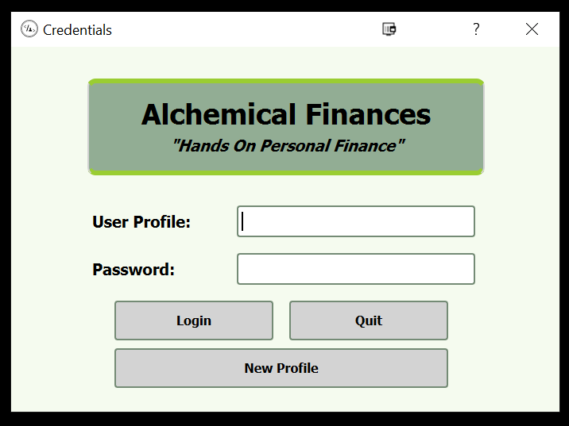

Upon launching the program for the first time. Click on New Profile to create a new account.

Figure 2: Login Screen - The view you will see to create a new profile.

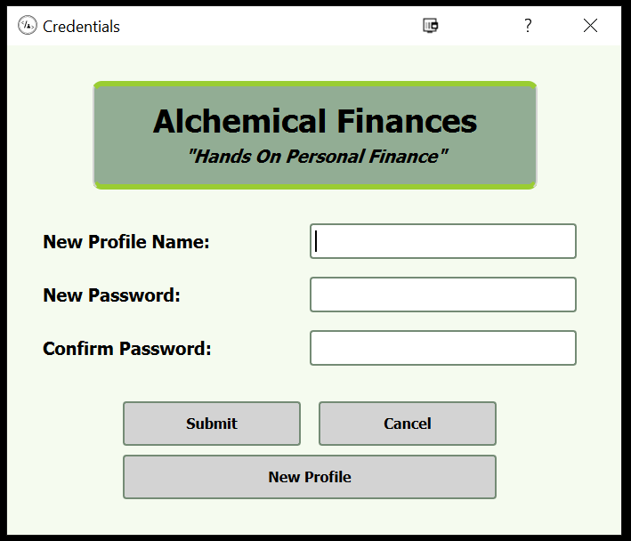

When creating a new profile keep the Profile Name and Password simple. There rules are as follows:

1. Password should be greater than 6 characters
2. Password should be alphanumeric
3. Password should not have any blank spaces
4. The Profile Name should be alphanumeric
5. The Profile Name should not contain any blank spaces

Once you have input your Profile Name and Password click Submit. You will be prompted to hit Cancelto return to the login screen.

**Passwords and Usernames are not case sensitive**

**!! There is currently no password retrieval system !!**

*If you become locked out of your account. Please reach out to me at Jmshamberg@gmail.com. I will attempt to assist you in regaining access to your information.*

# First Login Process

When logging in you will be greeted with a welcome message such as the one below.

Figure 3: The initial welcome message used to greet someone.

You can choose to hit Next and sift through the different messages. Currently there are only 2 messages, with plans for more.

Upon closing the welcome message for the first time. There may be a delay between closing the screen and the appearance of the main window. This will only occur during the creation of a new account. Subsequent instances of logging in will be met with faster turn around between the welcome screen and main interface.

# Main Window and Summary Page

When the Main Window opens you will be met with the Summary Page. This page will list out all active accounts for the profile. When creating a new profile example accounts are generated for each parent type available in the system. **These accounts can be renamed or deleted.**

**NOTE:** If a new account is created or deleted the summary page will have to be closed and re-opened to include the information visibly. Modified information about an existing account will be visible.

**TIP:** The Sub Types (displayed as Account Type in the image below) can also be modified if you have a more specific designation you wish to use.

Figure 4: Main Window of the program loads displaying the summary page when the user logs in. The Summary page displays example accounts for new users.

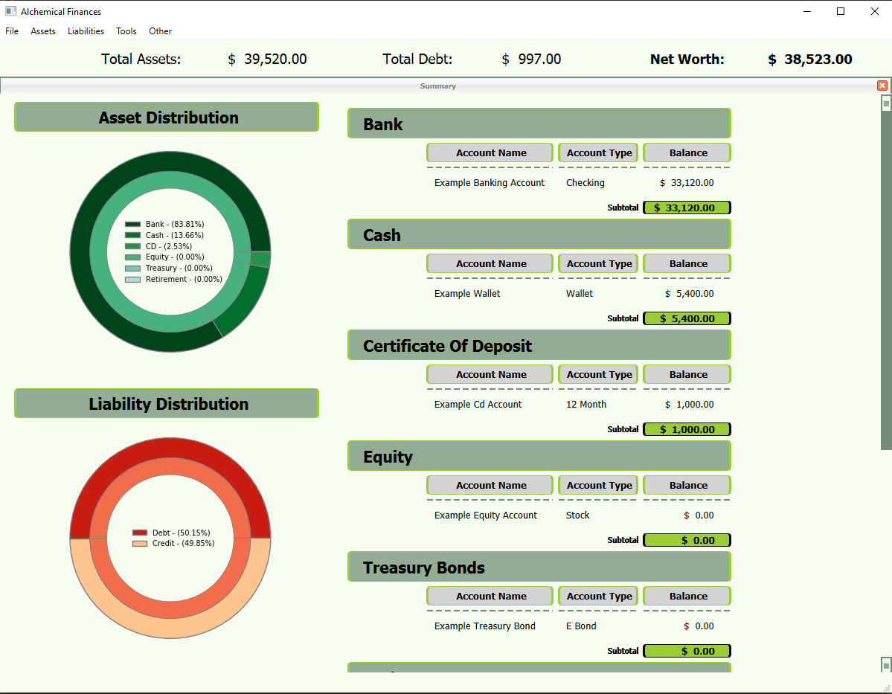

## Menu Bar

Figure 5: A close up of the menu bar located in the upper left hand corner.

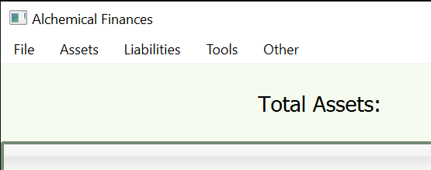

* 1. **File**
     1. Summary
     2. Generate Report
     3. Net Worth Graph
     4. Export [Future Feature]
     5. Save** [Future Feature]
     6. Close
  2. **Assets**
     1. Bank [Ledger Version 1]
     2. Cash [Ledger Version 1]
     3. Certificate of Deposit [Ledger Version 1]
     4. Equity [Ledger Version 2]
     5. Retirement [Ledger Version 2]
     6. Treasury Bonds [Ledger Version 1]
  3. **Liabilities**
     1. Debt [Ledger Version 1]
     2. Credit Cards [Ledger Version 1]
  4. **Tools**
     1. Archive
     2. Reports [Future Feature]
     3. Budgeting [Future Feature]
  5. **Other**
     1. Help
     2. About

There are different versions of the Ledger. The main difference is that Equity based finances require additional inputs. As you will see the overall functionality will be very similar.

** The program automatically saves the inputs using an Sqlite3 database. A future save feature would essentially function as creating a temp version of the database until the user commits it to the master file.

## Net Worth:

Figure 6: a closeup of the New Worth Display located on the Main Window



A Users Net worth is calculated as Assets – Liabilities. The visuals or Assets and Liabilities are provided for reference.

***Warning with Multiple Account Transactions:***The design of this program does not have transactions post to multiple accounts simultaneously. As such, if you post a transaction in a Checking account that you will be paying off X amount of a given credit card but do not post that transaction in the Credit Card you will get dinged twice in your Net Worth. This applies to other accounts as well. Make sure both ends of a transaction are input for an accurate calculation.

Alternatively, you could input transactions as/after they occur rather than pre-emptively. This will avoid this issue.

## Progress Bars:

Figure 7: Summary Page examples of Credit and Debt Accounts.

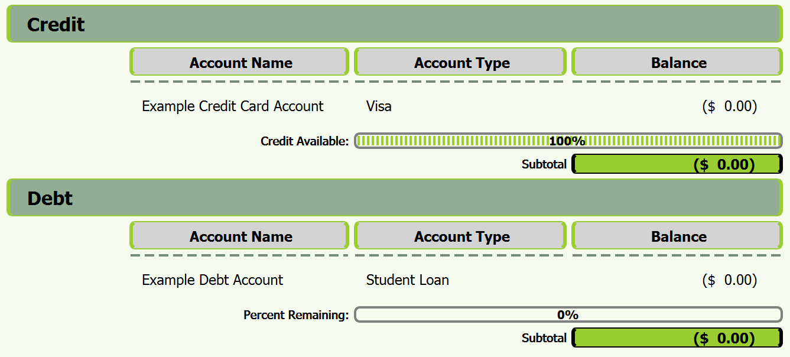

Progress bars were included for Credit and Debt accounts as an additional visual for the user. A Credit account will display the amount of available credit to the user. While, a debt account shows the users progress towards paying off the account in full.

## Generate Report

Within the “File” drop down menu is the option to generate a report. The report is Summary Report and will display the same information as depicted on the Summary tab of the home screen.

This really makes the information portable for the user if they want to quickly share with a family member or financial advisor without giving any pertinent information about the account away. (That will be dependent on how the user names the accounts. Not recommended to give the numerical bank account number)

Figure 8: Request Summary Report screen that appears upon requesting to Generate Report. User can select account types and report destination.

## Net Worth Graph

User transactions are recorded upon login and exiting the program. This allows the program to account for Equity accounts that may change with the open market. It also helps fill in some gaps between user sessions. If the user has not been on for 1 day or more the program will add a data point for the previous day.

*Please ignore the weird example data in the image below. It was used to test the development of the graph.

Figure 9: Net worth line graph. Will display Gross worth (Dark Green) – Net Worth (Light Green) – Liability (red). The program will also show peak and valley data points for the free categories.

* Currently the program will not track the value of a specific account over time. This could be implemented in the future.

# Ledger Style 1

## Bank, Cash, Certificates of Deposit, Treasury Bonds, Debt, Credit Cards

Figure 10: A full view of ledger style 1

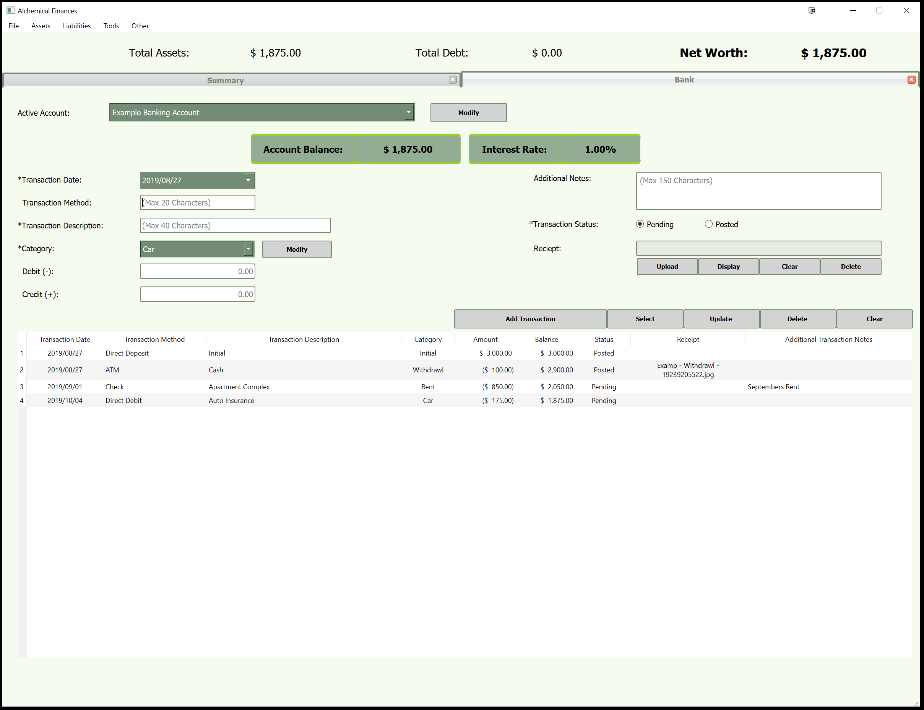

The program utilizes two primary Ledger Layouts. They differ primarily in the documentation of the users qty of shares for a given holding. More on that later.

**NOTE:** The account types are separated from each other. As such, a transaction in a Bank account will not be able to generate an associated transaction with a Credit Card. Transactions will also not affect multiple bank accounts. This requires the user to make similar inputs multiple times.

**TIP:**  A transaction description and/or receipt can be re-used across accounts within a given type. Just simply select the posted transaction then modify and re-add to the account or to a separate account **within a given type**.

This style of ledger will hold consistent for 6 different account types that use it. The primary changes will be seen in what Account information is displayed. This information will be manually input by the user when the accounts are created or modified.

Also, whenever a transaction is input into any active ledger the Total Assets, Total Debt and Net Worth will update automatically to reflect the new information. This is in addition to the Account Balance being updated.

|  |  |
| --- | --- |
| **Account Type** | **Information Displayed on Ledger** |
| Bank | Account Balance, Interest Rate |
| Cash | Account Balance |
| Certificate of Deposit (CD) | Account Balance, Interest Rate, Maturity Date |
| Treasury Bonds | Account Balance, Interest Rate, Maturity Date |
| Debt | Account Balance, Interest Rate, Starting Balance |
| Credit Cards | Account Balance, Credit Limit |

Figure 11: Close up of Transaction inputs (Left Side)

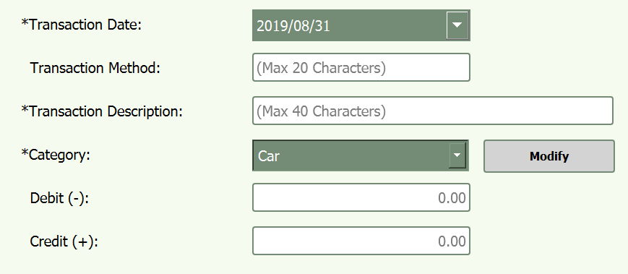

|  |  |
| --- | --- |
| **Input Type** | **Description** |
| *Transaction Date | This date will automatically load to and reset to the current date for the computer in use.  The date can be changed by selected and typing in the year/month/day or by selecting on a drop-down calendar.  **You cannot change the order. This is used to maintain proper sorting in the system by date.** |
| **Input Type** | **Description** |
| Transaction Method | This will allow the user to denote how they transaction was made.  ATM, Cashier, Check, Direct Deposit, Internet, Google Pay, Apple Pay, etc..  (Partially Accepted Characters Allowed) |
| Transaction Description | A short generic description of the transcription.  **NOTE:** Recommended to be more specific than Dinner or Movie. The use of Buisness Names / People is Recommended  (Partially Accepted Characters Allowed) |
| Debit (-) & Credit (+) | To simplify the value inputs Debit and Credit amounts are input seperatly. No need to worry about including a negative sign or parenthesis. The program will even add .00 if no change is denoted.  **NOTE:** When working with Credit Cards and Debt. Each transaction is a Credit and the payment is a Debit. Think of it as each time you purchase something you increase the amount of debt you accrue while payment reduces it. |

Figure 12: Close up of Transaction Inputs (Right Side)

|  |  |
| --- | --- |
| **Input Type** | **Description** |
| Additional Notes | This allows the user to add a little extra detail. Such as an associated person or a brief cause for the transaction.  (Partially Accepted Characters Allowed) |
| *Transaction Status  (Pending or Posted) | * Allows the user to know if they added an anticipated transaction or have already completed it. * The value doesn’t affect the calculations as one input into the ledger the money is spent or added. |
| Receipt | * The user cannot interact with the name. * The name is generated based upon the Account Name and the Category. * All receipts can be found on the pc for direct access but beware moving/renaming the files as the program will not be able to find them. * Accepted File Types: .png, .jpg, .jpeg, .gif, .pdf |

Figure 13: Close up of Account Modify Button

|  |  |
| --- | --- |
| **Button** | **Action** |
| Modify (Active Account) | This button when clicked will load the account dialog. [page X]  This screen when loaded will allow the user to Create/Modify/View an accounts information. |
| Upload  [Figure 10] | This button triggers the File Dialog screen for the user to find and pic the receipt in question.  Current File types accepted are (*.png, *.jpg, *jpeg, *gif, *.pdf)  **Warning**: sometimes there are issues with an “accepted file type”. A quick fix is to resave the image as a different file type.  Please let me know if this occurs so I can address it. |
| Display  [Figure 10] | Once an image/pdf file has been uploaded this button will display the image for you. |
| **Button** | **Action** |
| Display Cont.  [Figure 10] | Once an image/pdf file has been uploaded this button will display the image for you.  **TIP:** If you would like to see a specific Receipt you can select the transaction with the *Select* button and then click display. The *Clear (transaction) will reset the inputs without deleting the receipt.* |
| Clear  [Figure 10] | This button was made to clear the receipt input incase the user wants to upload a new image without deleting the existing file.  **TIP:** A user can use a receipt file more than once if desired within a given ledger. Different ledgers will require separate uploads of the image.  This will also delete an unposted receipt, so if you upload a receipt and do not post the transaction the receipt will be deleted. |
| Delete  [Figure 10] | This button was made to delete a given receipt.  To achieve this the file name must be present in the input dialog. To do this simply select the transaction and then the delete button.  **Note:** The program will request to know what row the receipt resides in prior to being deleted. If not posted use the clear button instead.  **TIP:** The program will not remove duplicates of a receipt. Only the desired instance |

Figure 14:Close up of Buttons used for interacting with transactions



|  |  |
| --- | --- |
| **Button** | **Action** |
| Add Transaction | This button will post the 9 inputs to the ledger as depicted above in the example. |
| Select | This button will ask what transaction you will to load into the inputs |
| Update | The program will ask which existing transaction the user wishes to replace with the new information.  **TIP:** The transaction with receipt can be selected prior to updating. If you do not you will simply replace an existing receipt with a new one. **The old one will not be deleted from the computer in this instance.** |
| Delete | This button will ask the user which transaction to delete. |
| Clear | Simply clears the 9 transaction inputs to allow the user to start fresh. |

**NOTE: ALL TRANSACTIONS ARE SAVED AUTOMATICALLY ONCE POSTED. THERE IS NO NEED CURRENTLY FOR A SAVE BUTTON.**

In the future I will implement a temporary file to allow the user to modify the account and then determine if they wish to save the new information or delete it. Currently this is not necessary.

## Ledger 1 Visual Display

An example of the ledger can be seen above in Figure 7. There are 9 columns displayed that mirror the 9 inputs for each transaction. The primary difference is that the Debit and Credit inputs are displayed as a singular Amount column and a Balance column is added.

The widths of the 9 columns can be adjusted to widen or narrow. The user can not sort the columns to order them by a given input.

**NOTE:** Every new transaction will be posted at the bottom of the ledger. The ledger will automatically scroll down to display this transaction. This is inversed from most Bank websites where they display the transactions Newest on top and as you scroll down they get older.

*Potential Future Input:*

A search feature to display transactions during a given time period, associated category or other value. Please provide feedback if such features would be desired.

# Ledger Style 2

## Equity and Retirement

Figure 15: Ledger style 2 used for Equity and Retirement Accounts.

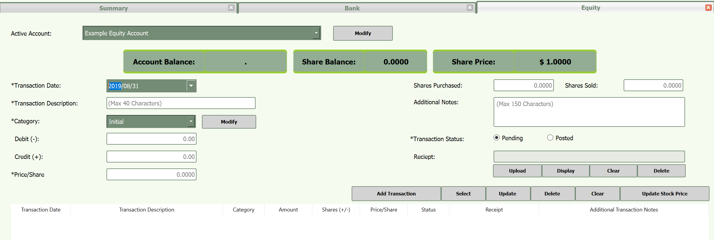

The screen displayed above in Figure 15 is very similar to the ledger displayed in figure 10. The primary thing worth noting is that Equity based accounts (and Retirement Accounts) track the quantity of shares owned. As such this ledger incorporates that into the transaction inputs.

Equity and Retirement function in the same manner. There are no differences between them. This is just so that the user can differentiate between what is a general investment versus a retirement restricted investment.

## Changes Between Ledger 1 and Ledge 2

|  |  |
| --- | --- |
| **Change** | **Description** |
| Removal of Transaction Method | Just one less input for this ledger. |
| Inclusion of Price/Share | Allows the user to track the market price at the time of purchase / sale.  Depending on the ticker program you track the value is calculated to 4 decimal places. This program can accommodate that. |
| Inclusion of Shares Purchased/Sold | These inputs work very similar to Debit(-) and Credit(+)  These values are recorded to 4 decimals places. |
| Update Stock Price Button | This button allows the user to update the market value of the Equity directly from the ledger.  **Note:** This doesn’t update all accounts. That has to be done manually. |

The display for the ledger is also adjusted to show the slightly different data.

|  |  |
| --- | --- |
| **Ledger Version 1** | **Ledger Version 2** |
| 1. Transaction Date 2. Transaction Method 3. Transaction Description 4. Category 5. Amount 6. Balance 7. Status 8. Receipt 9. Additional Notes | 1. Transactions Date 2. Transaction Description 3. Category 4. Amount 5. Share (+/-) 6. Price/Share 7. Status 8. Receipt 9. Additional Notes |

# Account Dialog Screen (Account Creation/Modification)

Figure 16: The Account Dialog Screen. Accessed via the modify button next to the account name drop down menu.

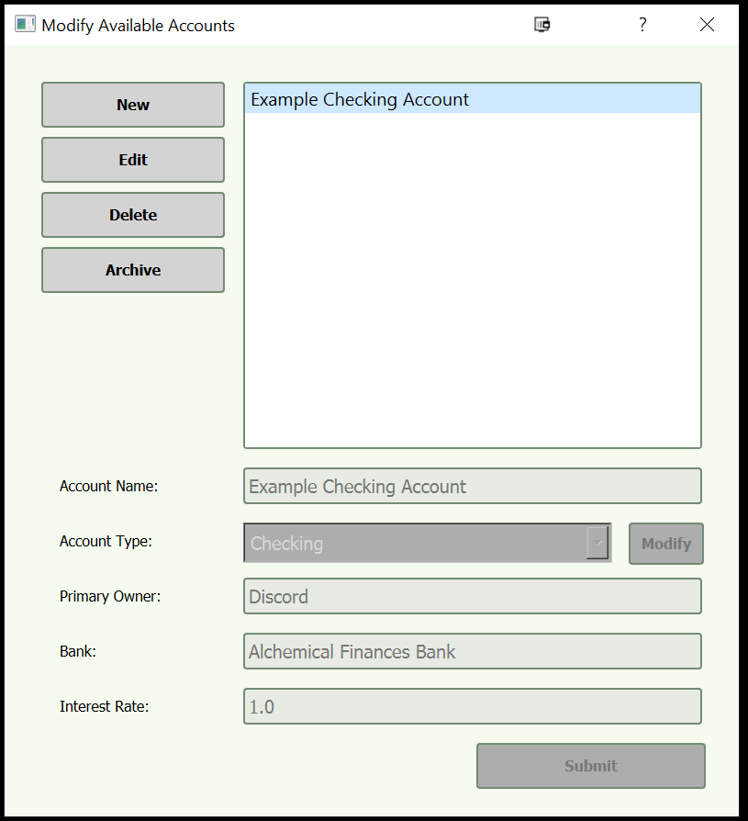

This dialog screen is opened by clicking on the modify button on the ledger screen located next to the Active Account Drop-down list. [Same for both ledgers]. When opened this screen allows the user to Create, Modify, Delete, and Archive an account of the designed Parent Type.

Each Parent Type account has different information associated with it.

|  |  |
| --- | --- |
| **Account Parent Type** | **Account Details** |
| Bank | Account Name  Account Type  Primary Owner  Bank  Interest Rate |
| Cash | Account Name  Account Type  Primary Owner  Bank |
| Certificate of Deposit  Treasury Bond | Account Name  Account Type  Primary Owner  Bank  Interest Rate  Maturity Date |
| Equity  Retirement | Account Name  Account Type  Primary Owner  Bank  Ticker Symbol  Ticker Price |
| Debt | Account Name  Account Type  Primary Owner  Bank  Interest Rate  Starting Balance |
| Credit | Account Name  Account Type  Primary Owner  Bank  Credit Limit |

**NOTE:** All input values allow the Partially Accepted Characters Allowed

The functionality of this screen is intended to be striaght forward.

|  |  |
| --- | --- |
| **Button** | **Action** |
| New | Creates a new account |
| Edit | Will modify the information associated with the account. |

|  |  |
| --- | --- |
| **Button** | **Action** |
| Delete | Will **PERMANENTLY** remove all information associated with the account. This includes any uploaded receipts. |
| Archive | Allows the User to save an account that is no longer active.  Intended for accounts that have been closed. |
| Modify | Allows the User to Add / Remove account sub types for use.  **Note:** Just make sure not to remove an account sub type in use. |

# Receipt Display

Figure 17: Receipt Display

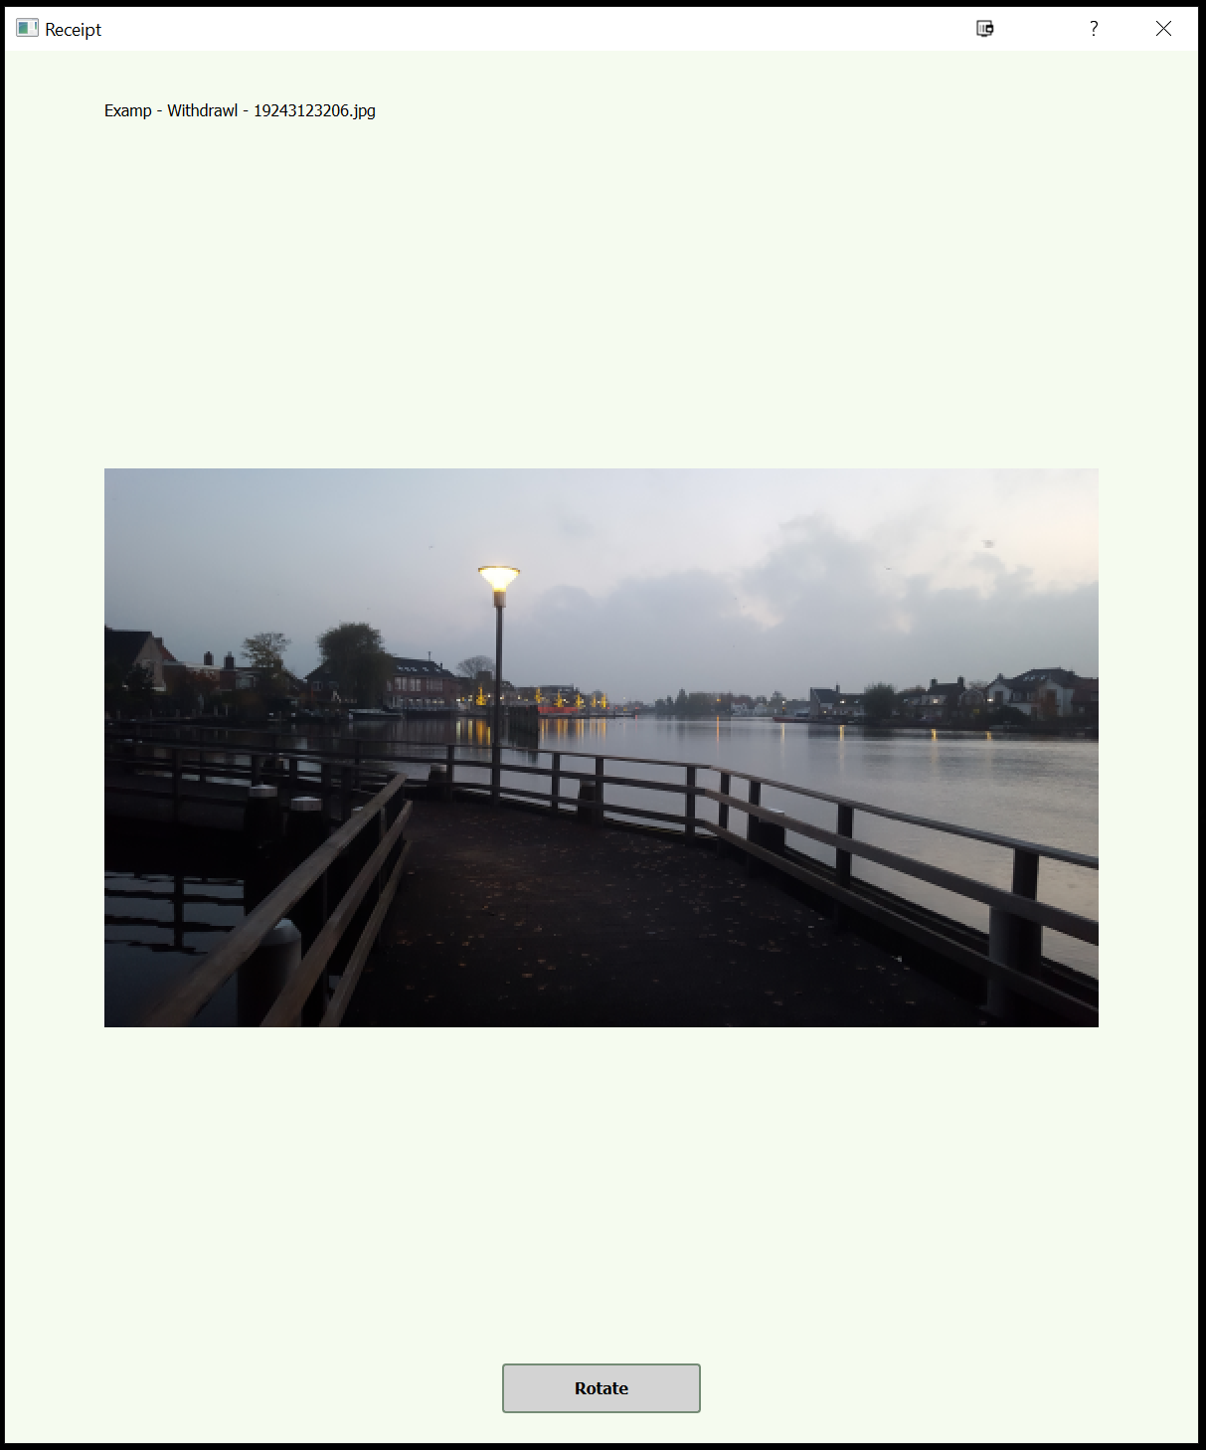

When displaying an image receipt (non-PDF) the screen seen in Figure 14 will be opened. This screen will display the image file name and a rotate button. Currently there is no feature to zoom in on the image.

However, if the receipt being opened is a PDF the program will open the native PDF viewer for the user’s PC.

# Account Archive

This ledger screen allows the user to view their archived accounts and receipts.

Figure 18: Archive Ledger Screen.

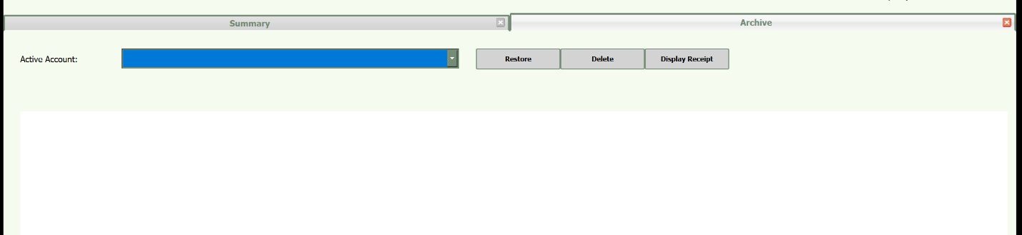

The Archive will display the ledger associated with the archived account selected with the ability to displaying the receipts.

The user can also **PERMENETLY** delete the archived account. This will remove all associated information about the account from the computer included uploaded receipts.

The restore button will allow the user to reopen an account to full functionality.

# Troubleshooting

If you encounter any issues with the program, such as unanticipated crashes. Please try to reproduce the instance, document and reach out to me. I will attempt to assist you if the problem is user error related or a work around exists.

Otherwise, I will appreciate the information and will work to fix the error and push out a new release of the program to correct.

Contact me at: **Jmshamberg@gmail.com**