Beaked Whale Acoustic Detection Report

Date created: 2023-12-07

This report summarizes daily presence of beaked whale detections in the **GBK-2020-09** dataset, deployed at 41.5°N 65.82°W and analyzed from 2020-09-22 to 2021-08-20 (294 days, not including 39 days of missing data).

## Daily Presence Summary

| Species | Days present (#) | Days possibly present (#) | Days present (%) | Days possibly present (%) |
| --- | --- | --- | --- | --- |
| Sowerby's | 253 | 1 | 86 | 0.34 |
| True's/Gervais' | 202 | 0 | 69 | 0.00 |
| Cuvier's | 234 | 1 | 80 | 0.34 |

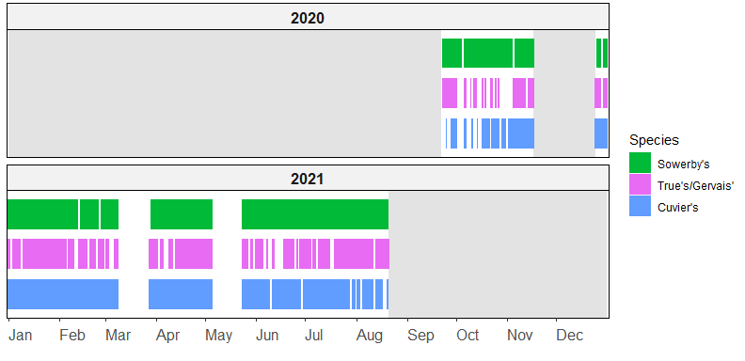  
**Figure 1:** Daily presence of beaked whale species in the GBK-2020-09 dataset.  
  
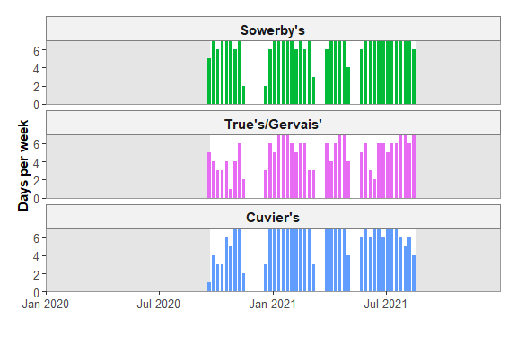  
**Figure 2:** Number of days per week with beaked whale clicks in the GBK-2020-09 dataset.