Beta

number1: actor-tanh critic-tanh lr=2e-4 hidden_width=64

number2: actor-tanh critic-tanh lr=3e-4 hidden_width=64

number3: actor-tanh critic-relu lr=3e-4 hidden_width=64

number4: actor-relu critic=relu lr=3e-4 hidden_width=64

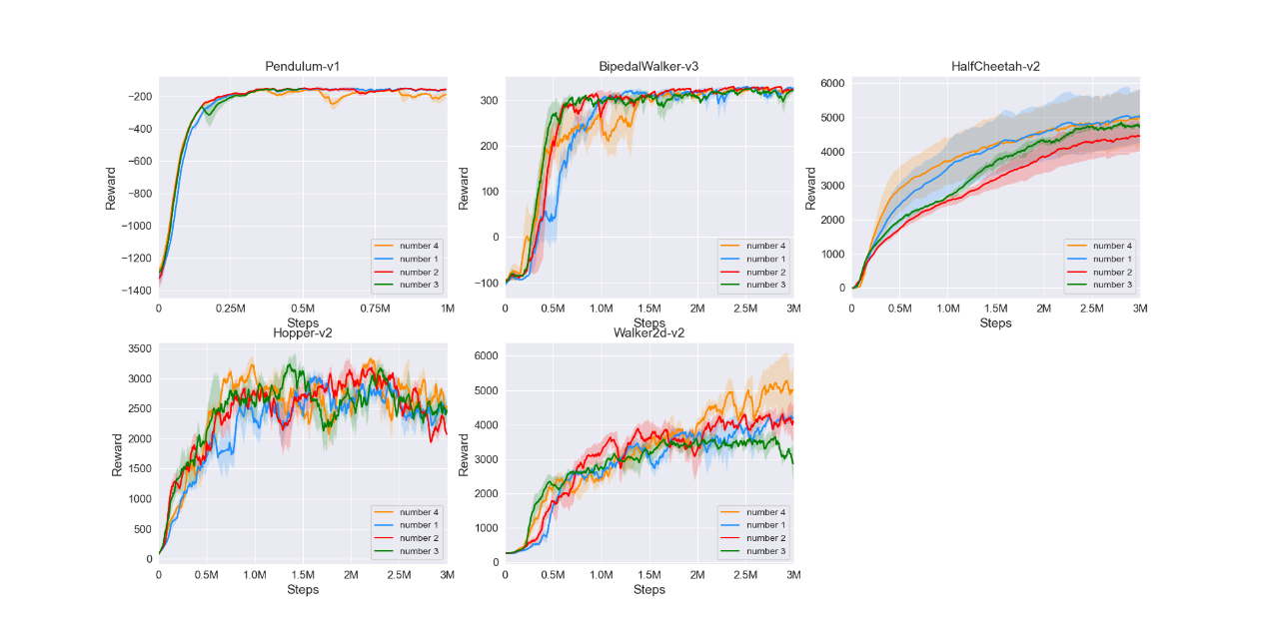

Gaussian

number1: actor-tanh critic-tanh lr=3e-4 hidden_width=64