Interoffice Memorandum
To: CCO Jeb Bergensten
From: Team <>
Date: September 26, 2026
Subject: Re: Palo Alto Firewall Research
This memo is a summary of our findings regarding the Palo Alto Next-Generation Firewall (NGFW).
Packet Inspection Mechanisms:
NGFWs off a robust set of inspection mechanisms. They offer full layer 7 processing, which includes full decryption and analysis of how it will be received by the users. This combined with its AI capabilities allow the NGDF to assess and eliminate risk with much more efficiency than standard firewalls. This is also done very efficiently, in one pass over the data, to maximize efficiency and reduce latency. Please see the graphic below for a representation of this process.
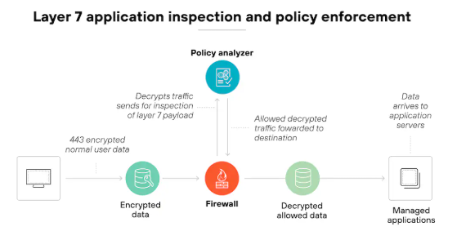
Figure 1. NGFW Packet Inspection Diagram
Data Loss prevention:
Regarding its data loss prevention capabilities, we have found that it does not currently offer such services. The NGFWs focus more on data analysis and filtering rather than loss prevention. See the image below for Palo Alto’s explanation
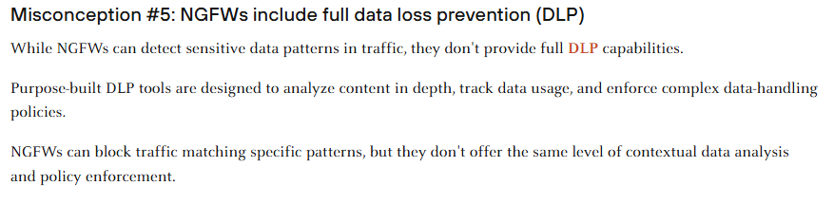
Figure 2. Data Loss Prevention Explained by Palo Alto
General Security Features:
NGFWs offer a variety of useful and effective security measures that would help keep our environment safe and allow us to focus on our mission. Its AI tools allow for the implementation and enforcement of hyper specific rules, and its ability to learn from our traffic would allow for protections designed specifically for each user and machine. These are only a few highlights that stood out to our team during the review. Below is a graphic with highlights from Palo Alto.

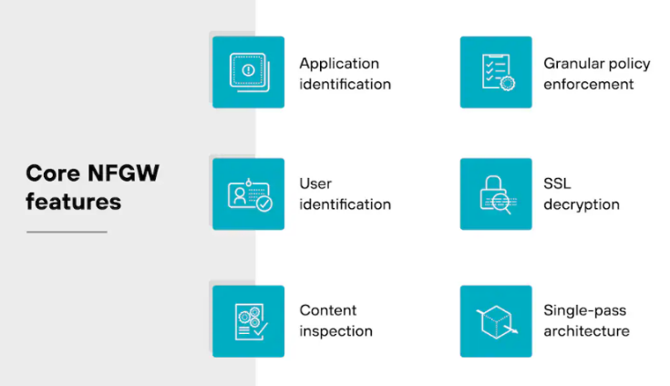
Figure 3. NGFW Security Features
Consensus:
We believe that a Palo Alto Next-Generation Firewall would make a strong addition to our security system. Given the size of our current network, we recommend a smaller, more affordable model such as the PA-220R. Models can be found on the Palo Alto Pricelist at ItPrice. Below is a viable and affordable option.
Figure 4. PA-220R Price Listing on ItPrice

Please reach out if you have any questions or concerns.
With Regards,
Team <>

