Mask-RCNN with OpenVINO Summary：

  - About OpenVINO：
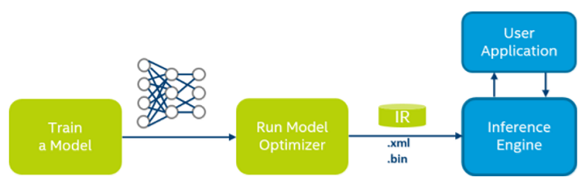
- Train a deep learning model： tensorflow， caffe ， mxnet
- Freezeing the model:
  - TensorFlow .pb
  - Caffe .caffemodel
- Transform the frozen model to an IR file by Model Optimizer 。（The IRf file is the only file Inference Engine can recognize）
- In user application， call the Inference Engine to practice the relevant task。

  - Done jobs：
- Frozen an open source TensorFlow version Mask-RCNN model.（Link https://github.com/matterport/Mask_RCNN）
- Tested the frozen model.
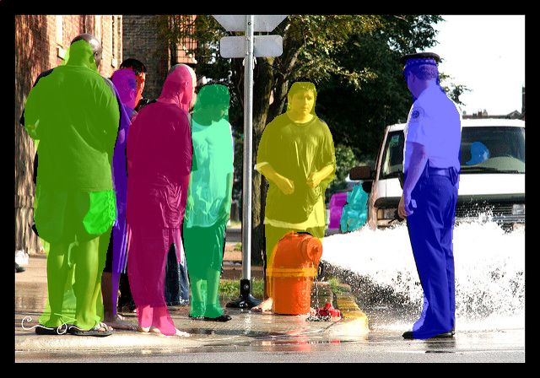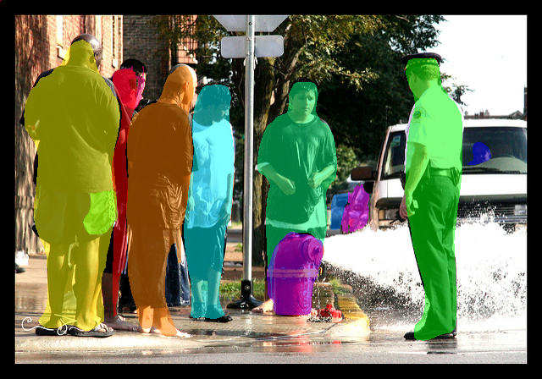
Testimgpb(~70s)
Testimg(~8s)

3, All the test relevant files are stored in :
liubin@10.239.89.137:/home/liubin/kerasmrcnn/Mask_RCNN

  - Some debug advices；
- When freezing a model, make sure the present graph is the graph you wanted. This can be fixed by declare a graph explicitly. If the graph is in a function, return the graph or globally declare it.
- I have tested the .pb file. So if there are any problems, the input may be the problem.
- You can get any tensor value in the .pb file by its name or part of its name through the testmrcnnpb.py file to check if it works well.
- When you want to get a tensor value from an active tensorflow model(not a frozen model),you must run it or you will get the initialization value.
  - Files description:
1,Folders;
- assets: some example images and gif.
- images : example images.
- samples: some demo of Mask_RCNN and inter face of dataset.
- mrcnn: significant folders contains mrcnn model file and other implement files
2, Files :
- samples/demo.py: to run the original tensorflow model
- samples/demo.py: to freeze the tensorflow model
- testmrcnnpb.py: to test and run the frozen mrcnn.pb file
- mask_rcnn_coco.h5: original keras frozen model
- mrcnn.pb: tensorflow fozen model
- visualize.py: to visualize image in mask, bbox and cls
- setup.py: set the customer lib to default python path: this may cause problem, please set python path to current folder if you need to rewrite the source code.

  - Work to be done:
The working flow is shown below:
Train a mrcnn network
Freeze the net work
Test the frozen network
Write some customer layers
Get IR file and rewrite Inference Engine according to the new layer
IR file
Test images
.pb file
.h5 file

The red word and orange blocks are works needed to be done.
Git_hub addr: https://github.com/BeanLeo/intelMaskrcnn

