**Model Comparison**

* Naïve Bayes
  + 1. Model Performance

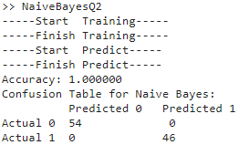

* + 1. Advantage
       - Based on probabilistic and statistical methods
       - Effective for small datasets
       - Fast training and prediction speeds
    2. Disadvantage
       - Assumes independence between features ( might not always hold true in real-life scenarios )
* Perceptron
  + 1. Model Performance

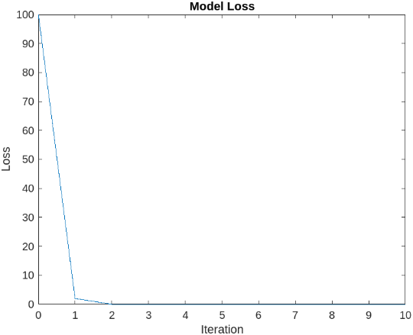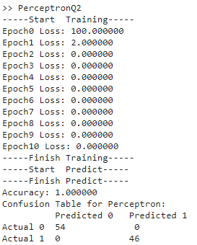

* + 1. Advantage
       - Simple to understand
    2. Disadvantage
       - Might not perform well on non-linear data
* Logistic Regression
  + 1. Model Performance

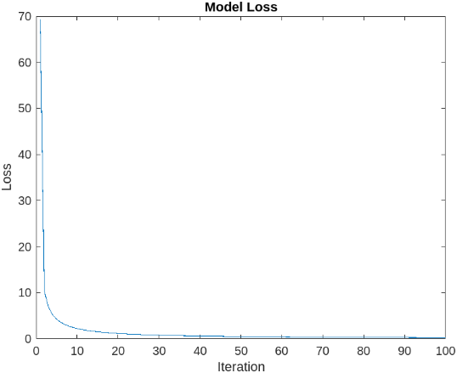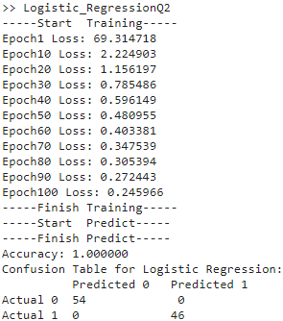

* + 1. Advantage
       - Can estimate feature importance
    2. Disadvantage
       - Might not capture non-linear patterns
* Adaboost
  + 1. Model Performance

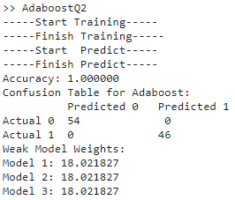

* + 1. Advantage
       - Enhances model performance by combining multiple weak classifiers
       - Can focus on harder-to-classify samples
    2. Disadvantage
       - Might overfit(especially when the data has noise)
* Why every Model’s accuracy is 100%
  1. IMU data is very distinguishable. For example, when the Minibot is inclined, there might be a noticeable change in acceleration on a particular axis. This suggests that the data might have a very clear and distinct boundary on a specific axis.
  2. IMU data has an equal number of inclined and non-inclined data, making the models less likely to be biased.
  3. There might not be much noise in IMU data, making it easier for the models to learn and predict.