PROJECT REPORT
CRIME RECORD MANAGEMENT SYSTEM
Submitted By
[Student Name]
Submitted To
Arun Khanna Sir

ACKNOWLEDGEMENT
I would like to express my sincere gratitude to Arun Khanna Sir for his valuable guidance, encouragement, and support during the completion of this Computer Science project.
His suggestions helped me understand how a real database-based application is planned, designed, and implemented using Python and MySQL.
I am also thankful to my school for providing the learning environment and resources required to complete this project successfully.
Through this project, I gained practical experience in connecting Python with MySQL, creating tables, inserting records, viewing data, searching records, and updating case information.
This work helped me improve my understanding of programming logic, database storage, and structured record management.
[Student Name]

TABLE OF CONTENTS
Section | Topic | Page
1 | Cover Page | 1
2 | Acknowledgement | 2
3 | Table of Contents | 3
4 | Introduction | 4
5 | Modules and Functions Used | 5
6 | Database Tables, Attributes and Records | 6
7 | Source Code - Part 1 | 7
8 | Source Code - Part 2 | 8
9 | Source Code - Part 3 | 9
10 | Input and Output - CrimeRecords | 10
11 | Input and Output - Victims | 11
12 | Input and Output - Suspects | 12
13 | Input and Output - Officers | 13
14 | Input and Output - CrimeLocations | 14
15 | Database Implementation Notes | 15
16 | SQL Structure | 16
17 | Testing | 17
18 | Conclusion | 18
19 | Future Scope | 19
20 | Project Summary | 20

1. INTRODUCTION
The Crime Record Management System is a database-oriented project designed to store and manage important information related to criminal cases.
The purpose of the project is to replace scattered manual records with a structured digital system that can keep crime details, victim data, suspect data, officer information, and location details in an organized manner.
Database storage is useful because it allows records to be saved permanently, searched quickly, and updated whenever case information changes.
Python is used for this project because it is simple, readable, and suitable for building menu-driven applications at school level.
MySQL is used as the backend database because it stores data in tables and supports SQL commands for inserting, viewing, searching, and updating records.
Python communicates with MySQL through the mysql.connector module, which creates a connection, sends SQL queries through a cursor, and commits changes to the database.
Multiple tables are used so that different types of information are stored separately. This avoids repeating the same victim, suspect, officer, or location details inside every crime record.
The system supports adding records, viewing records, searching a crime by its ID, and updating the case status when investigation progress changes.

2. MODULES AND FUNCTIONS USED
This project imports only one external database connector module: import mysql.connector. The following methods are used by the program.
Function / Method | Purpose | How Used
mysql.connector.connect() | Creates connection with MySQL database | Used at the start with host, user, password, and database
db.cursor() | Creates cursor object | Used to send SQL commands from Python to MySQL
cursor.execute() | Runs SQL query | Used for INSERT, SELECT, and UPDATE statements
cursor.fetchall() | Fetches all rows | Used while viewing complete table records
cursor.fetchone() | Fetches one row | Used while searching a crime by Crime_ID
db.commit() | Saves database changes | Used after INSERT and UPDATE operations
These methods provide the basic link between the Python menu program and the relational MySQL database.

3. DATABASE TABLES, ATTRIBUTES AND RECORDS
CrimeRecords - Primary Key: Crime_ID
Crime_ID | Crime_Type | Crime_Date | Location_ID | Victim_ID | Suspect_ID | Officer_ID | Case_Status
101 | Theft | 2026-08-01 | 1 | 1 | 1 | 1 | Open
102 | Burglary | 2026-08-03 | 2 | 2 | 2 | 2 | Under Investigation
103 | Cyber Crime | 2026-08-05 | 3 | 3 | 3 | 3 | Open
104 | Assault | 2026-08-07 | 4 | 4 | 4 | 4 | Closed
Victims - Primary Key: Victim_ID
Victim_ID | Victim_Name | Age | Contact
1 | Ananya Verma | 29 | 9876501234
2 | Rohit Mehra | 35 | 9811122233
3 | Neha Kapoor | 24 | 9898981212
4 | Arjun Malhotra | 41 | 9765432109
Suspects - Primary Key: Suspect_ID
Suspect_ID | Suspect_Name | Age | Address
1 | Vikas Rao | 31 | Lajpat Nagar, Delhi
2 | Sameer Khan | 28 | Patel Nagar, Delhi
3 | Karan Singh | 30 | Dwarka, Delhi
4 | Nitin Joshi | 38 | Rohini, Delhi
Officers - Primary Key: Officer_ID
Officer_ID | Officer_Name | Rank | Station
1 | M. Sharma | Inspector | Central Delhi
2 | R. Gupta | Sub-Inspector | Karol Bagh
3 | P. Nair | Inspector | Dwarka
4 | S. Verma | Sub-Inspector | Rohini
CrimeLocations - Primary Key: Location_ID
Location_ID | Location_Name | City | State
1 | Connaught Place | Delhi | Delhi
2 | Karol Bagh | Delhi | Delhi
3 | Cyber Hub | Gurugram | Haryana
4 | Rohini Sector 7 | Delhi | Delhi

SOURCE CODE - PART 1
import mysql.connector

db = mysql.connector.connect(
host="localhost",
user="root",
password="password",
database="crime_management"
)
cursor = db.cursor()

def add_location():
location_id = int(input("Location ID: "))
location_name = input("Location Name: ")
city = input("City: ")
state = input("State: ")
query = "INSERT INTO CrimeLocations VALUES (%s, %s, %s, %s)"
values = (location_id, location_name, city, state)
cursor.execute(query, values)
db.commit()
print("Location record added successfully.")

def view_locations():
cursor.execute("SELECT * FROM CrimeLocations")
records = cursor.fetchall()
for row in records:
print(row)

def add_victim():
victim_id = int(input("Victim ID: "))
victim_name = input("Victim Name: ")
age = int(input("Age: "))
contact = input("Contact: ")
query = "INSERT INTO Victims VALUES (%s, %s, %s, %s)"
values = (victim_id, victim_name, age, contact)
cursor.execute(query, values)
db.commit()
print("Victim record added successfully.")

def view_victims():
cursor.execute("SELECT * FROM Victims")
records = cursor.fetchall()
for row in records:
print(row)

def add_suspect():
suspect_id = int(input("Suspect ID: "))
suspect_name = input("Suspect Name: ")
age = int(input("Age: "))
address = input("Address: ")

SOURCE CODE - PART 2
query = "INSERT INTO Suspects VALUES (%s, %s, %s, %s)"
values = (suspect_id, suspect_name, age, address)
cursor.execute(query, values)
db.commit()
print("Suspect record added successfully.")

def view_suspects():
cursor.execute("SELECT * FROM Suspects")
records = cursor.fetchall()
for row in records:
print(row)

def add_officer():
officer_id = int(input("Officer ID: "))
officer_name = input("Officer Name: ")
rank = input("Rank: ")
station = input("Station: ")
query = "INSERT INTO Officers VALUES (%s, %s, %s, %s)"
values = (officer_id, officer_name, rank, station)
cursor.execute(query, values)
db.commit()
print("Officer record added successfully.")

def view_officers():
cursor.execute("SELECT * FROM Officers")
records = cursor.fetchall()
for row in records:
print(row)

def add_crime():
crime_id = int(input("Crime ID: "))
crime_type = input("Crime Type: ")
crime_date = input("Crime Date: ")
location_id = int(input("Location ID: "))
victim_id = int(input("Victim ID: "))
suspect_id = int(input("Suspect ID: "))
officer_id = int(input("Officer ID: "))
case_status = input("Case Status: ")
query = """INSERT INTO CrimeRecords
VALUES (%s, %s, %s, %s, %s, %s, %s, %s)"""
values = (crime_id, crime_type, crime_date, location_id,
victim_id, suspect_id, officer_id, case_status)
cursor.execute(query, values)
db.commit()
print("Crime record added successfully.")

def view_crimes():
cursor.execute("SELECT * FROM CrimeRecords")
records = cursor.fetchall()
for row in records:

SOURCE CODE - PART 3
print(row)

def search_crime():
crime_id = int(input("Crime ID: "))
query = "SELECT * FROM CrimeRecords WHERE Crime_ID = %s"
cursor.execute(query, (crime_id,))
record = cursor.fetchone()
if record:
print(record)
else:
print("Crime record not found.")

def update_status():
crime_id = int(input("Crime ID: "))
new_status = input("New status: ")
query = "UPDATE CrimeRecords SET Case_Status = %s WHERE Crime_ID = %s"
cursor.execute(query, (new_status, crime_id))
db.commit()
print("Case status updated successfully.")

def menu():
print("\n=== CRIME RECORD MANAGEMENT SYSTEM ===")
print("1. Add Location")
print("2. View Locations")
print("3. Add Victim")
print("4. View Victims")
print("5. Add Suspect")
print("6. View Suspects")
print("7. Add Officer")
print("8. View Officers")
print("9. Add Crime")
print("10. View Crimes")
print("11. Search Crime")
print("12. Update Status")
print("13. Exit")

while True:
menu()
choice = int(input("Enter choice: "))
if choice == 1:
add_location()
elif choice == 2:
view_locations()
elif choice == 3:
add_victim()
elif choice == 4:
view_victims()
elif choice == 5:
add_suspect()
elif choice == 6:
view_suspects()
elif choice == 7:
add_officer()
elif choice == 8:
view_officers()
elif choice == 9:
add_crime()
elif choice == 10:
view_crimes()
elif choice == 11:
search_crime()
elif choice == 12:
update_status()
elif choice == 13:
print("Program closed.")
break
else:
print("Invalid choice.")

cursor.close()
db.close()

INPUT AND OUTPUT - CRIMERECORDS
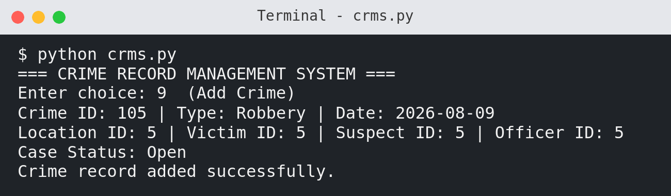
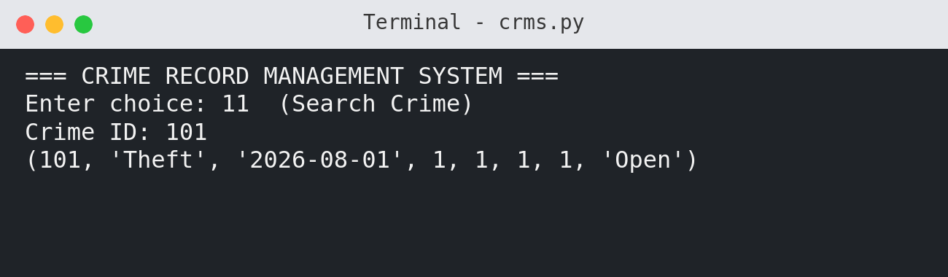
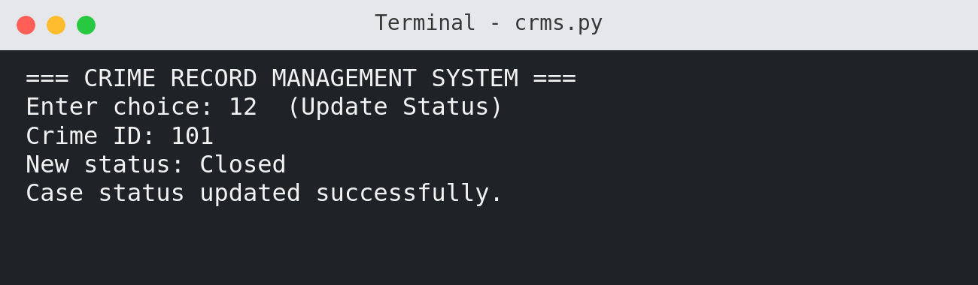

INPUT AND OUTPUT - VICTIMS
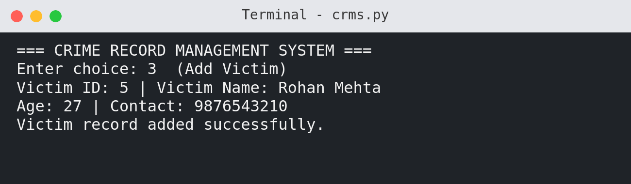
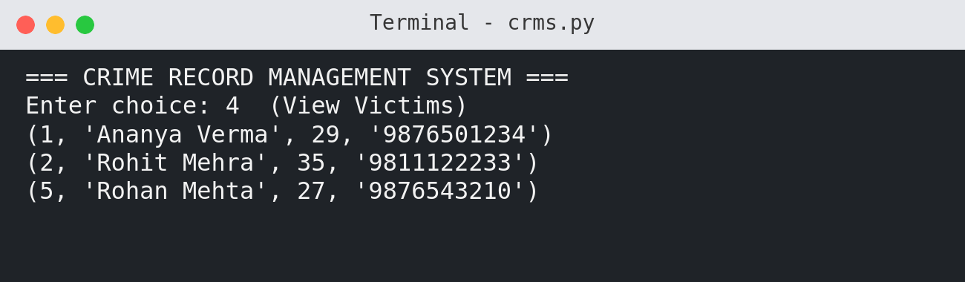
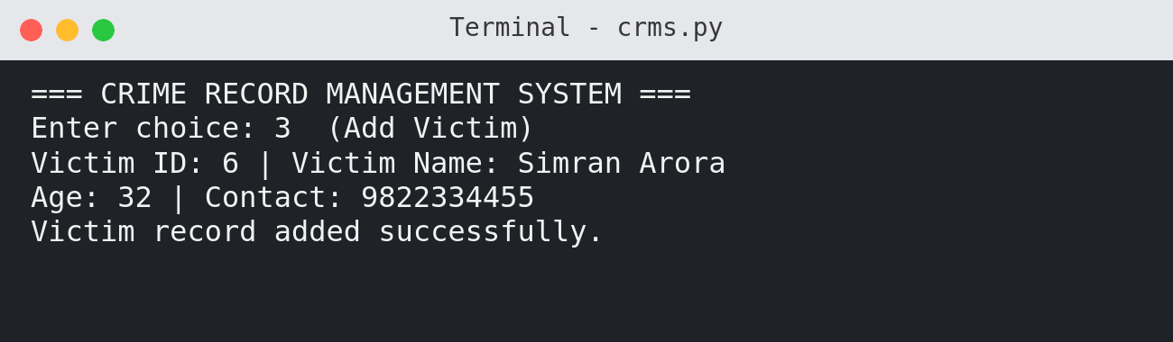

INPUT AND OUTPUT - SUSPECTS
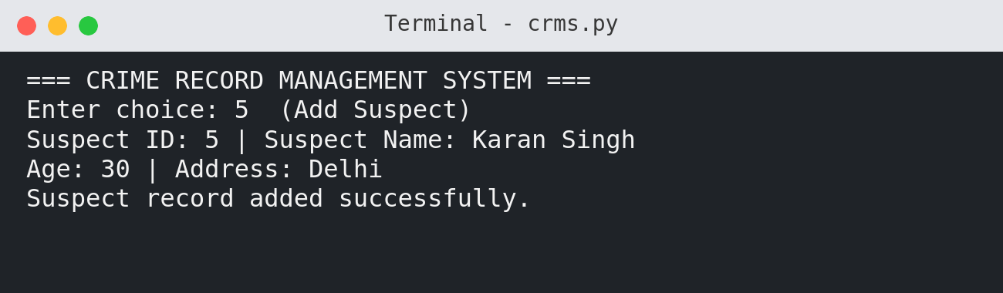
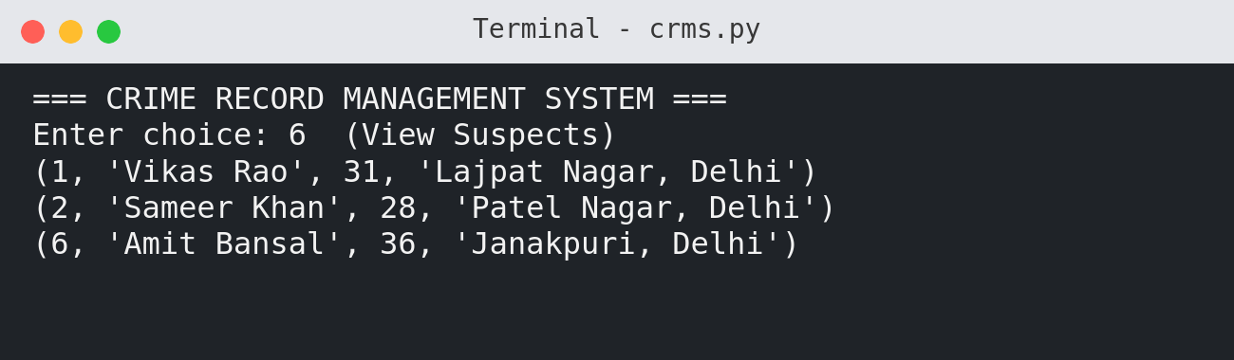
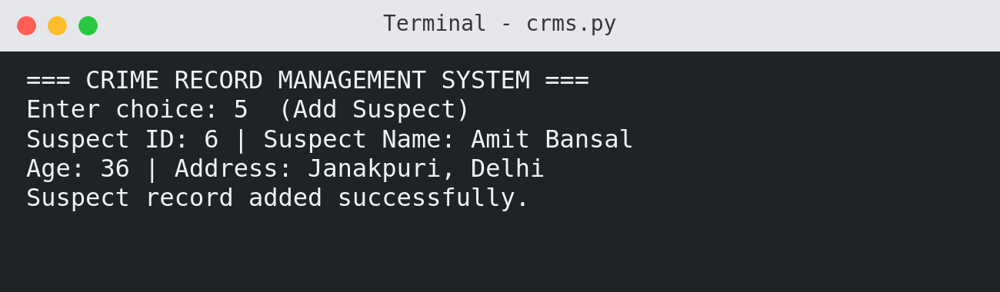

INPUT AND OUTPUT - OFFICERS
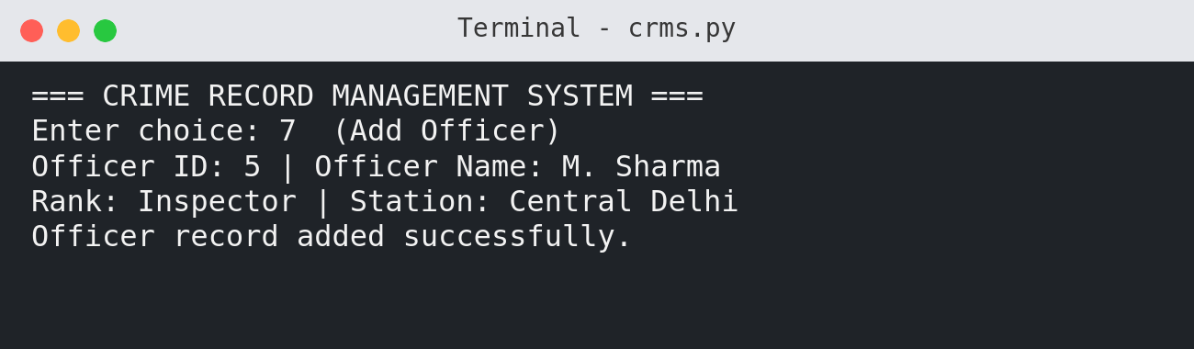
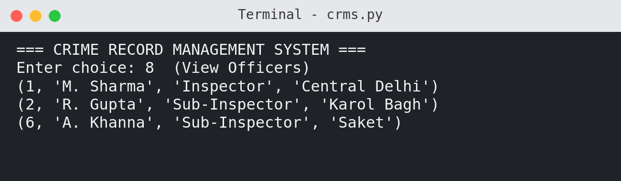
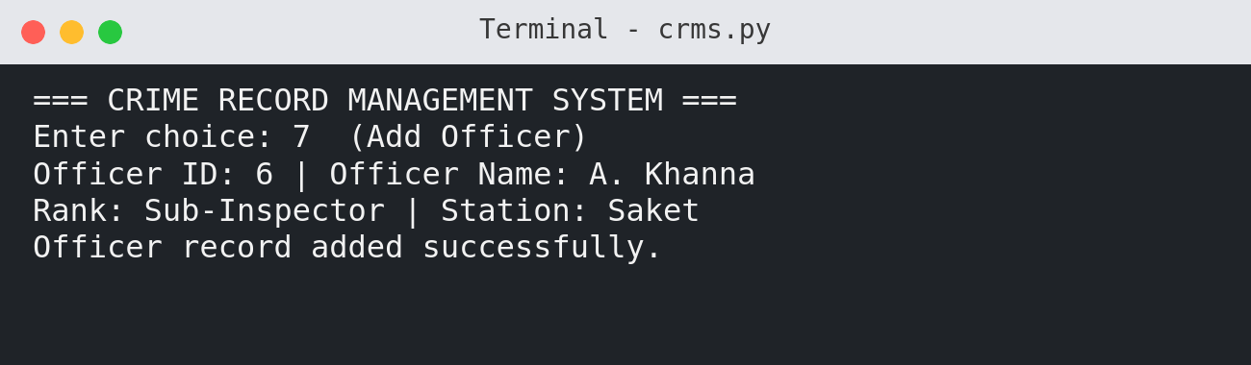

INPUT AND OUTPUT - CRIMELOCATIONS
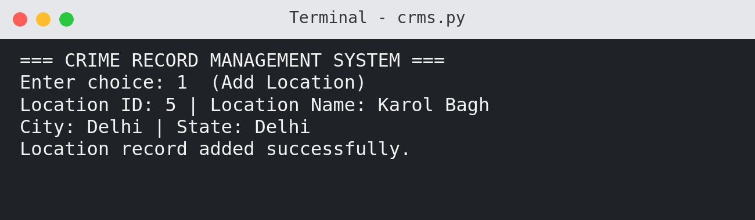
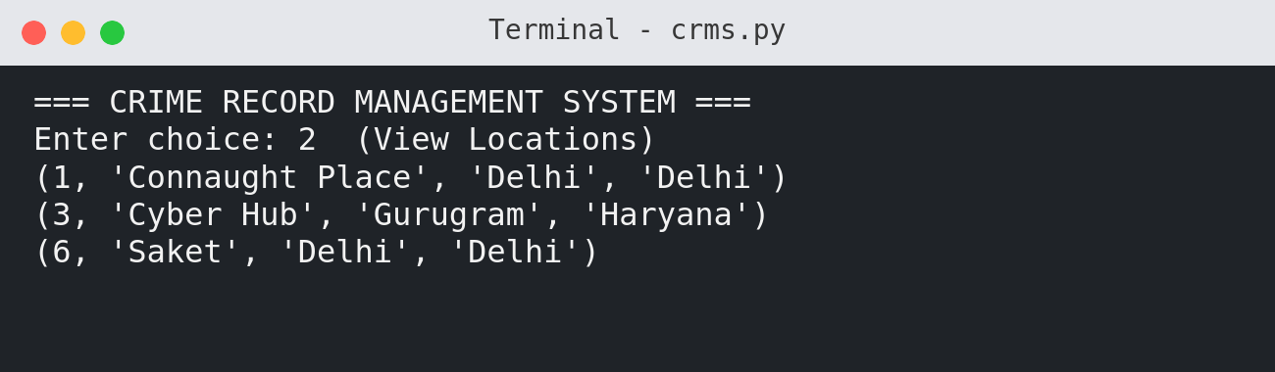
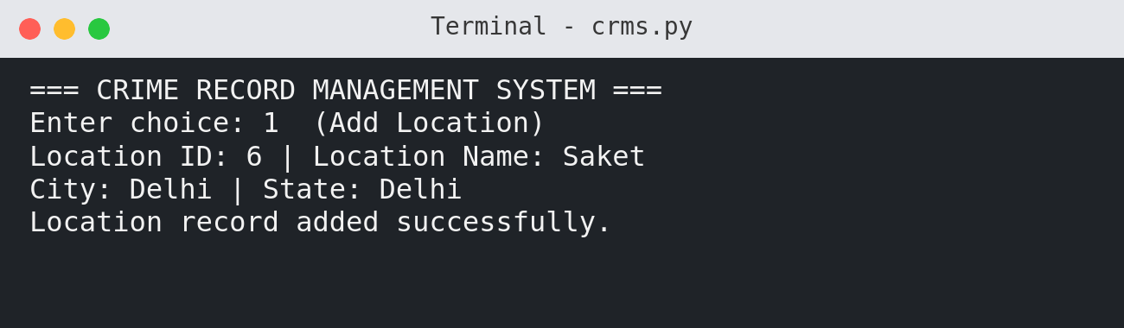

6. DATABASE IMPLEMENTATION NOTES
CrimeRecords acts as the main table because every case is represented by a unique Crime_ID and a case status.
Victims stores personal details of victims separately so the same type of information is not repeated inside crime records.
Suspects stores suspect names, ages, and addresses, while Officers stores officer names, ranks, and police stations.
CrimeLocations stores the place, city, and state where a crime is recorded.
Each table uses a primary key field to identify every record uniquely. CrimeRecords uses Location_ID, Victim_ID, Suspect_ID, and Officer_ID as reference fields.
This structure is relational because the main crime table connects to supporting tables through IDs. Records are retrieved using SELECT queries and displayed through cursor.fetchall() or cursor.fetchone().

7. SQL STRUCTURE
The program uses SQL commands to create tables, insert rows, view records, search a case, and update case status.
CREATE TABLE Victims (
Victim_ID INT PRIMARY KEY,
Victim_Name VARCHAR(50),
Age INT,
Contact VARCHAR(15)
);
CREATE TABLE Suspects (
Suspect_ID INT PRIMARY KEY,
Suspect_Name VARCHAR(50),
Age INT,
Address VARCHAR(100)
);
CREATE TABLE Officers (
Officer_ID INT PRIMARY KEY,
Officer_Name VARCHAR(50),
Rank VARCHAR(30),
Station VARCHAR(50)
);
CREATE TABLE CrimeLocations (
Location_ID INT PRIMARY KEY,
Location_Name VARCHAR(60),
City VARCHAR(40),
State VARCHAR(40)
);
CREATE TABLE CrimeRecords (
Crime_ID INT PRIMARY KEY,
Crime_Type VARCHAR(50),
Crime_Date DATE,
Location_ID INT,
Victim_ID INT,
Suspect_ID INT,
Officer_ID INT,
Case_Status VARCHAR(30)
);

8. TESTING
Test Case | Expected Result | Actual Result | Status
Add Location | Operation completes correctly | Operation completes correctly | PASS
View Locations | Operation completes correctly | Operation completes correctly | PASS
Add Victim | Operation completes correctly | Operation completes correctly | PASS
View Victims | Operation completes correctly | Operation completes correctly | PASS
Add Suspect | Operation completes correctly | Operation completes correctly | PASS
View Suspects | Operation completes correctly | Operation completes correctly | PASS
Add Officer | Operation completes correctly | Operation completes correctly | PASS
View Officers | Operation completes correctly | Operation completes correctly | PASS
Add Crime | Operation completes correctly | Operation completes correctly | PASS
View Crimes | Operation completes correctly | Operation completes correctly | PASS
Search Crime | Operation completes correctly | Operation completes correctly | PASS
Update Status | Operation completes correctly | Operation completes correctly | PASS

9. CONCLUSION
The Crime Record Management System successfully demonstrates the integration of Python with MySQL for managing structured records.
The project shows how a relational database can divide information into five connected tables instead of storing all details in a single unorganized format.
Using SQL queries, the program can insert new data, view stored records, search a crime by ID, and update the case status.
The Python menu makes the project simple to operate and helps the user select different actions repeatedly in one continuous session.
While developing this project, I learned how database tables are designed, how primary keys are used, and how Python can communicate with MySQL using mysql.connector.
This project improved my practical understanding of record management, programming logic, and database operations used in real applications.

10. FUTURE SCOPE
In the future, the project can include a login system with authentication so only authorized users can access crime data.
Role-based permissions can be added for administrators, officers, and data-entry users, giving each role suitable access.
A graphical user interface can make the system easier to use than a terminal menu and can provide forms for entering records.
Advanced search, filtering, reports, statistics, export options, regular backup, validation, and stronger error handling can improve reliability.
Additional tables such as Evidence, Witnesses, and Case History can store more investigation details and create a more complete case record.
These improvements would make the project closer to a practical record management application used in real administrative work.

11. PROJECT SUMMARY
Component | Details
Programming Language | Python
Database | MySQL
Connector | mysql.connector
Main Table | CrimeRecords
Supporting Tables | Victims, Suspects, Officers, CrimeLocations
Operations | Insert, View, Search, Update
Source Code | Python/MySQL
Interface | Terminal
Database Tables | 5
The project presents a clear school-level implementation of a Crime Record Management System using Python and MySQL. It shows how records can be organized, stored, searched, and updated through a simple terminal interface.
END OF PROJECT REPORT

